SOC CASE STUDY REPORT
SOC Alert Monitoring and Log Correlation
Sysmon, Windows Event Viewer, Wireshark and a Python-Based SOC Incident Analyzer

Sysmon • Event Viewer • Wireshark • Python SOC Analyzer
Kshitij Rajesh Randhire
Cybersecurity (BIA)
Academic Year 2025 – 2026

Table of Contents
Table of Contents 1
Abstract 1
1. Introduction 1
2. Objectives 1
3. Methodology 1
3.1 Lab Environment Setup 1
3.2 Telemetry and Log Generation 1
3.3 Network Reconnaissance and Packet Capture 1
3.4 Automated Log Analysis 1
3.5 Incident Reporting 1
4. Tools Used 1
5. Project Implementation 1
5.1 Network Configuration of the Lab 1
5.2 Reconnaissance Scan from Kali Linux 1
5.3 Endpoint Telemetry Collection with Sysmon 1
5.4 Authentication Monitoring with Windows Event Viewer 1
5.5 Packet-Level Analysis with Wireshark 1
5.6 Automated Analysis with the Python SOC Incident Analyzer 1
6. Screenshot Explanations 1
6.1 Windows 11 Network Configuration 1
6.2 Nmap Reconnaissance Scan from Kali Linux 1
6.3 Sysmon Event ID 1 – Process Creation 1
6.4 Sysmon Event ID 3 – Network Connection 1
6.5 Failed Logon Events (Event ID 4625) 1
6.6 Successful Logon Events (Event ID 4624) 1
6.7 Wireshark TCP Handshake Capture 1
6.8 SOC Incident Analyzer – Main Menu 1
6.9 SOC Incident Analyzer – Log Analysis 1
6.10 SOC Incident Analyzer – Live Dashboard 1
6.11 SOC Incident Analyzer – MITRE ATT&CK Mapping 1
6.12 Generated Report – Executive Summary 1
6.13 Generated Report – Incident Summary (INC-0013) 1
6.14 Generated Report – Indicators of Compromise (IOCs) 1
6.15 Generated Report – Conclusion 1
7. Results 1
7.1 Alert Tuning & Recommendations 1
8. Conclusion 1
9. References 1

Abstract
Security Operations Centers (SOCs) rely on continuous log monitoring, network analysis, and alert correlation to detect malicious activity within an organisation's IT environment. This project presents a small-scale, hands-on SOC monitoring and log correlation exercise built entirely inside a virtualized lab environment using Windows 11 as the monitored host and Kali Linux as the attacking machine, both running under VMware Workstation Pro.
Sysmon was configured on the Windows 11 host to capture detailed process creation and network connection events, while Windows Event Viewer was used to review authentication activity through Security log Event IDs 4624 and 4625. Wireshark was used to capture and inspect raw network traffic, including TCP handshake behaviour generated during reconnaissance activity performed from Kali Linux using Nmap. A custom Python-based command-line tool, the SOC Incident Analyzer, was developed to ingest the exported logs, classify events into incidents, calculate a risk score, map detected behaviour to the MITRE ATT&CK framework, extract indicators of compromise (IOCs), and automatically generate a structured incident report.
The exercise produced nine classified incidents with an overall environment risk score of 69 out of 100, rated HIGH, and successfully demonstrated the correlation of host-based telemetry, authentication logs, and network traffic into a single, MITRE ATT&CK-mapped incident report. Multi-source log collection, correlation, detection, triage, and reporting were carried out end-to-end, reflecting the centralised, SIEM-style analysis workflow used by SOC analysts to turn raw telemetry into actionable, prioritised incidents.

1. Introduction
A Security Operations Center (SOC) is responsible for the continuous monitoring, detection, and response to cybersecurity threats within an organisation. Analysts working in a SOC depend on multiple data sources, including endpoint logs, authentication records, and network traffic, to identify suspicious behaviour and respond before damage occurs. Manually reviewing thousands of log entries is time-consuming, which is why log correlation and automated analysis tools play an important role in modern security monitoring.
This capstone project was designed to simulate, on a small scale, the core responsibilities of a SOC analyst. A controlled and isolated lab environment was built using VMware Workstation Pro, hosting a Windows 11 virtual machine as the target system and a Kali Linux virtual machine as the source of simulated reconnaissance activity. Telemetry was collected from the Windows 11 host using Sysmon and the native Windows Event Viewer, while Wireshark was used to capture and analyse network packets exchanged between the two virtual machines. A Python-based command-line tool, referred to throughout this report as the SOC Incident Analyzer, was built to automate log ingestion, incident classification, MITRE ATT&CK mapping, risk scoring, and final report generation.
This report documents the design, implementation, and results of the project, and explains each piece of evidence collected during the exercise, including command-line captures, Event Viewer logs, Wireshark packet captures, and the screens produced by the Python analyzer tool.

2. Objectives
The project was carried out with the following objectives:
- To build an isolated virtual lab environment using VMware Workstation Pro with a Windows 11 host and a Kali Linux attacking machine.
- To configure Sysmon on the Windows 11 host to capture detailed process creation (Event ID 1) and network connection (Event ID 3) telemetry.
- To use Windows Event Viewer to monitor authentication activity, specifically successful logons (Event ID 4624) and failed logons (Event ID 4625).
- To perform reconnaissance activity from Kali Linux using Nmap and capture the resulting network traffic using Wireshark.
- To design and implement a Python-based SOC Incident Analyzer capable of reading exported logs, classifying incidents, calculating a risk score, and mapping detected activity to the MITRE ATT&CK framework.
- To generate a structured, automated incident report containing an executive summary, incident details, indicators of compromise (IOCs), and recommendations.
- To document and explain the complete workflow with supporting screenshots as evidence of each stage of the exercise.

3. Methodology
The project followed a structured, five-stage methodology that mirrors the collect → analyze → correlate → detect → report pipeline used in real-world SOC environments: environment setup, multi-source telemetry collection (endpoint, network, and authentication), traffic capture and analysis, automated correlation and detection, and incident reporting.

3.1 Lab Environment Setup
A virtual lab was created using VMware Workstation Pro. A Windows 11 virtual machine was configured as the monitored endpoint, and a Kali Linux 2026.1 virtual machine was configured as the source of simulated attacker activity. Both virtual machines were connected through VMware's internal virtual networking (VMnet adapters), allowing traffic to be generated and captured without exposing the lab to any external network.

3.2 Telemetry and Log Generation
On the Windows 11 host, Sysmon was installed and configured to log process creation events and network connection events to the Windows Event Log under the Microsoft-Windows-Sysmon/Operational channel. Windows Event Viewer was used separately to monitor the built-in Security log for authentication-related events, specifically Event ID 4624 (successful logon) and Event ID 4625 (failed logon).

3.3 Network Reconnaissance and Packet Capture
From the Kali Linux virtual machine, Nmap was used to perform TCP connect scans (nmap -Pn -sT) against the Windows 11 host to simulate reconnaissance behaviour, a common early-stage attacker activity. Simultaneously, Wireshark was run to capture the raw packets exchanged between the two machines, allowing the TCP three-way handshake and connection teardown behaviour generated by the scan to be inspected at the packet level.

3.4 Automated Log Analysis
The logs generated by Sysmon and Windows Event Viewer were exported and fed into a custom-built Python command-line application, the SOC Incident Analyzer (version 3.0). The tool reads the log entries, classifies them into incidents, calculates a numeric risk score, correlates events into an attack timeline, extracts indicators of compromise, and maps each event to the relevant MITRE ATT&CK tactic and technique.

3.5 Incident Reporting
Finally, the SOC Incident Analyzer's built-in reporting function was used to automatically generate a structured incident report containing an executive summary, a per-incident breakdown, a consolidated list of indicators of compromise, and a concluding risk assessment with recommended remediation steps.

4. Tools Used
The following tools and software were used throughout this project. No tools other than those listed below were used in any stage of the exercise.
Tool / Software | Purpose in this Project
Windows 11 | Monitored endpoint (victim host) on which telemetry was generated and collected.
VMware Workstation Pro | Hosted both virtual machines and provided isolated internal networking for the lab.
Kali Linux | Attacking machine used to generate reconnaissance traffic for analysis.
Nmap | Performed TCP connect port scans against the Windows 11 host to simulate reconnaissance.
Sysmon | Captured detailed process creation (Event ID 1) and network connection (Event ID 3) telemetry on Windows 11.
Windows Event Viewer | Reviewed Security log authentication events (Event ID 4624 / 4625) and Sysmon operational logs.
Wireshark | Captured and inspected raw network packets, including the TCP handshake generated by the Nmap scan.
Python SOC Incident Analyzer | Custom-built command-line tool used to classify incidents, score risk, map MITRE ATT&CK techniques, and generate the final report.
MITRE ATT&CK Framework | Reference framework used to classify detected behaviour into recognised adversary tactics and techniques.

5. Project Implementation
This section describes how each tool was applied in practice during the exercise, in the order the activities were carried out.

5.1 Network Configuration of the Lab
Before generating any traffic, the IP configuration of the Windows 11 host was confirmed using the ipconfig command. This established the host's IPv4 address on the Wi-Fi adapter (192.168.0.105) as well as the internal VMware adapter addresses (VMnet1 and VMnet8) used for communication between the host and the Kali Linux virtual machine.

5.2 Reconnaissance Scan from Kali Linux
From the Kali Linux virtual machine, Nmap TCP connect scans (nmap -Pn -sT) were run against the Windows 11 host's IP address (192.168.0.105). The scans identified several open TCP ports associated with Windows networking services, including ports 135 (msrpc), 139 (netbios-ssn), and 445 (microsoft-ds), along with two additional ports reported as open (808 and 9001) in the earlier scan runs. Multiple scans were performed in sequence to observe consistency in the results.

5.3 Endpoint Telemetry Collection with Sysmon
Sysmon was used to capture two categories of endpoint telemetry on the Windows 11 host. Event ID 1 (Process Create) entries were reviewed in Event Viewer to observe process execution activity, including process image paths, command lines, and parent process information. Event ID 3 (Network Connection) entries were reviewed to observe outbound and inbound network connections made by processes on the host, including the source and destination IP addresses, ports, and the responsible process image.

5.4 Authentication Monitoring with Windows Event Viewer
The Windows Security event log was filtered for Event ID 4625 (failed logon) and Event ID 4624 (successful logon) to monitor authentication activity on the host. Reviewing both successful and failed logon attempts allows a SOC analyst to identify potential brute-force activity or unauthorised access attempts, and to establish a baseline of normal authentication behaviour.

5.5 Packet-Level Analysis with Wireshark
Wireshark was used to capture live traffic between the Kali Linux and Windows 11 virtual machines during the Nmap scan. A display filter (tcp.port == 135) was applied to isolate traffic relating to the Windows RPC port targeted by the scan, allowing the TCP three-way handshake (SYN, SYN-ACK, ACK) and subsequent connection resets (RST, ACK) to be clearly observed for each scan attempt.

5.6 Automated Analysis with the Python SOC Incident Analyzer
The exported log data was processed using the custom Python SOC Incident Analyzer (v3.0), a menu-driven command-line tool offering options such as Analyze Logs, SOC Dashboard, Incident Cards, Attack Timeline, IOC Panel, View MITRE Mapping, and Generate Incident Report. Running the Analyze Logs function processed 17 log entries, identified 9 incidents, extracted 13 indicators of compromise, and calculated an overall environment risk score of 69 out of 100 (HIGH risk level).
The tool's Live Dashboard function summarised the findings further, reporting 2 Critical, 4 High, 1 Medium, and 2 Low severity alerts, a 100% detection rate, and the top network indicators, users, and processes observed, including powershell.exe and the Administrator account. The View MITRE Mapping function then mapped each detected event type to its corresponding MITRE ATT&CK tactic and technique, for example linking PowerShell network connections to T1071.001 (Application Layer Protocol – Web Protocols / C2 Callback) and registry-based persistence activity to T1547 (Registry Run Keys / Startup Folder).
Finally, the Generate Incident Report function produced a structured text-based incident report containing an executive summary, individual incident cards (including a Critical-severity incident, INC-0013, describing a PowerShell process establishing a network connection consistent with a Command-and-Control callback), a consolidated indicators-of-compromise section, and a concluding risk assessment with recommended next steps.

6. Screenshot Explanations
This section presents and explains each piece of evidence collected during the project, in the order the activities were performed.

6.1 Windows 11 Network Configuration
The figure below shows the output of the ipconfig command on the Windows 11 host, confirming the IP addresses assigned to the host's network adapters, including the Wi-Fi adapter address (192.168.0.105) used as the scan target throughout the exercise.
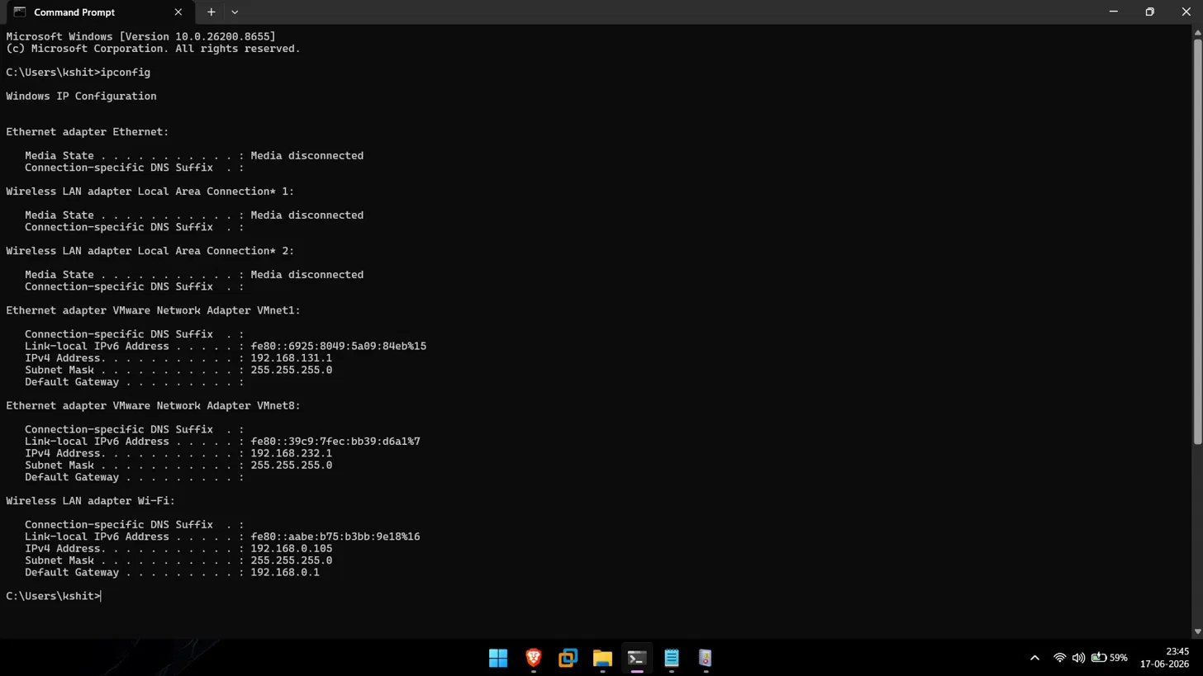
Figure 1: Output of the ipconfig command on the Windows 11 host showing the active IPv4 addresses, including the Wi-Fi adapter address used as the target of the Nmap scans.

6.2 Nmap Reconnaissance Scan from Kali Linux
The figure below shows three consecutive Nmap TCP connect scans launched from the Kali Linux virtual machine against the Windows 11 host (192.168.0.105). The scans reveal open TCP ports associated with Windows networking and file-sharing services.
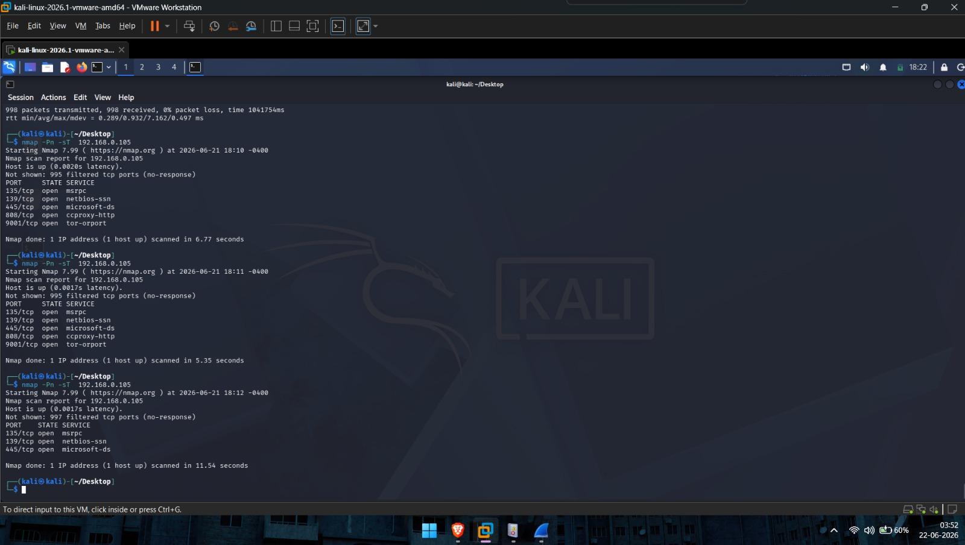
Figure 2: Nmap TCP connect scans (nmap -Pn -sT) run from Kali Linux against the Windows 11 host, showing open ports including 135, 139, and 445.

6.3 Sysmon Event ID 1 – Process Creation
The figure below shows a Sysmon Event ID 1 entry captured in Event Viewer, recording the creation of a process (OpenConsole.exe, part of Windows Terminal) on the Windows 11 host, including its full image path, command line, and the user account under which it ran.
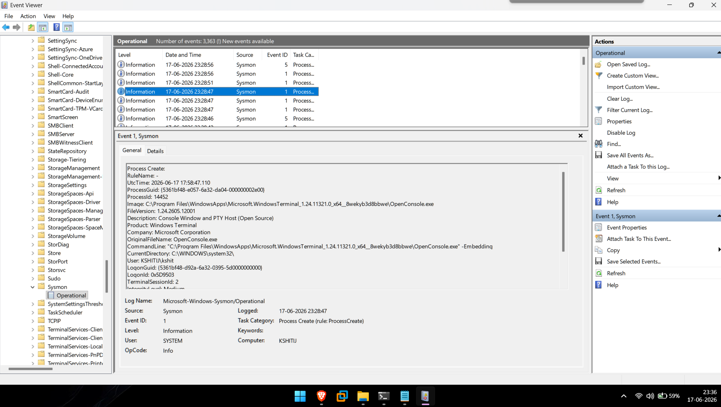
Figure 3: Sysmon Event ID 1 (Process Create) entry viewed in Windows Event Viewer, showing process image path, command line, and user context.

6.4 Sysmon Event ID 3 – Network Connection
The figure below shows a Sysmon Event ID 3 entry, recording a network connection initiated by a process on the Windows 11 host, including the source and destination IP addresses and ports involved in the connection.
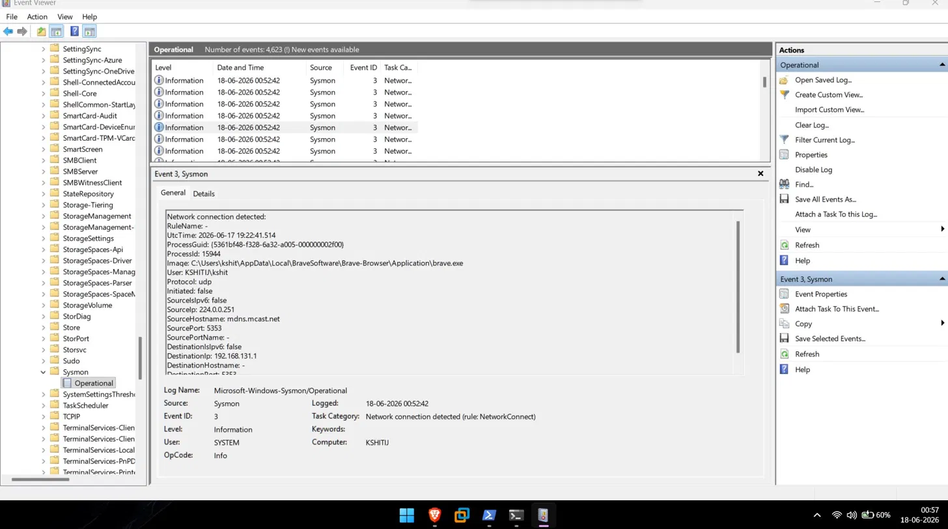
Figure 4: Sysmon Event ID 3 (Network Connection) entry viewed in Windows Event Viewer, showing the process, protocol, and source/destination connection details.

6.5 Failed Logon Events (Event ID 4625)
The figure below shows the Windows Security log filtered for Event ID 4625, listing five failed logon attempts recorded on the host. Monitoring failed logons is an important part of detecting potential brute-force or unauthorised access attempts.
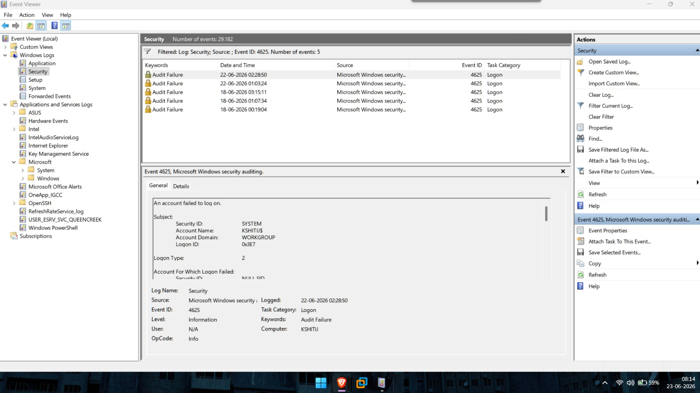
Figure 5: Windows Event Viewer filtered on Event ID 4625, showing a list of failed logon (Audit Failure) events on the Windows 11 host.

6.6 Successful Logon Events (Event ID 4624)
The figure below shows the Security log filtered for Event ID 4624, listing successful logon events on the host. Comparing successful and failed logon patterns helps establish a baseline of normal authentication behaviour.
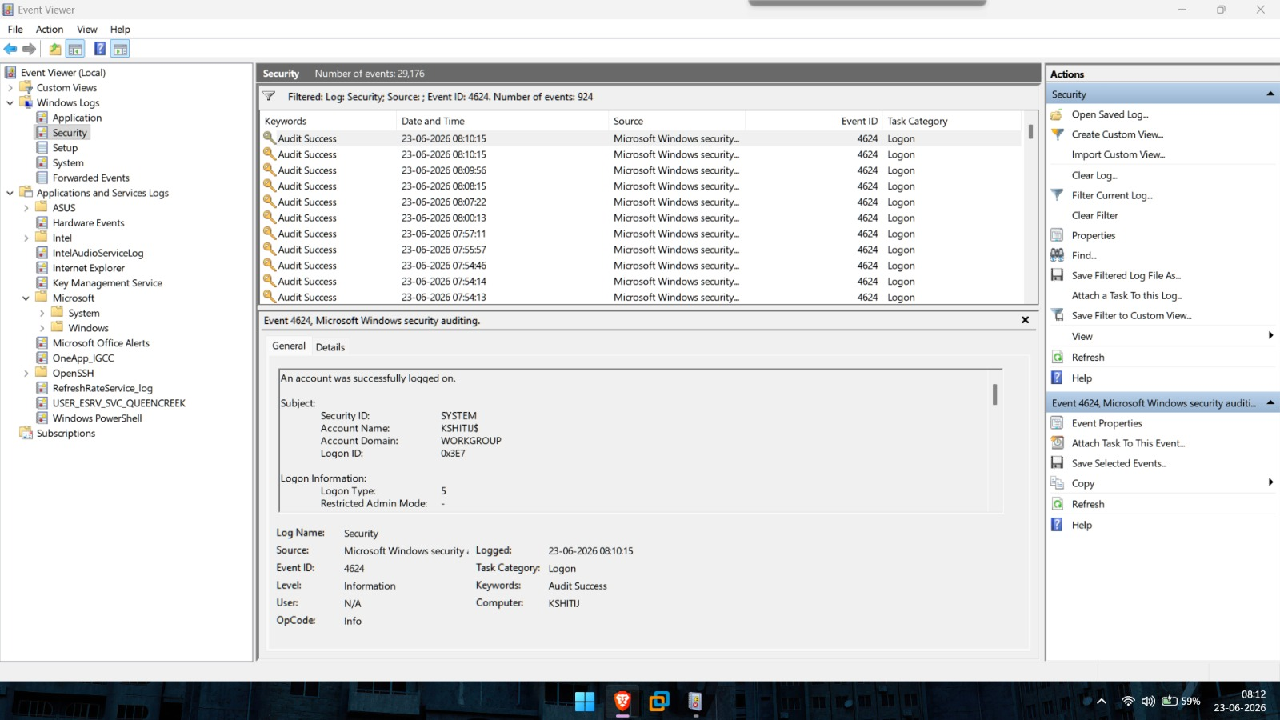
Figure 6: Windows Event Viewer filtered on Event ID 4624, showing a list of successful logon (Audit Success) events on the Windows 11 host.

6.7 Wireshark TCP Handshake Capture
The figure below shows a Wireshark capture filtered on tcp.port == 135, displaying the TCP three-way handshake (SYN, SYN-ACK, ACK) and subsequent reset (RST, ACK) packets generated during the Nmap scan between the Kali Linux and Windows 11 virtual machines.
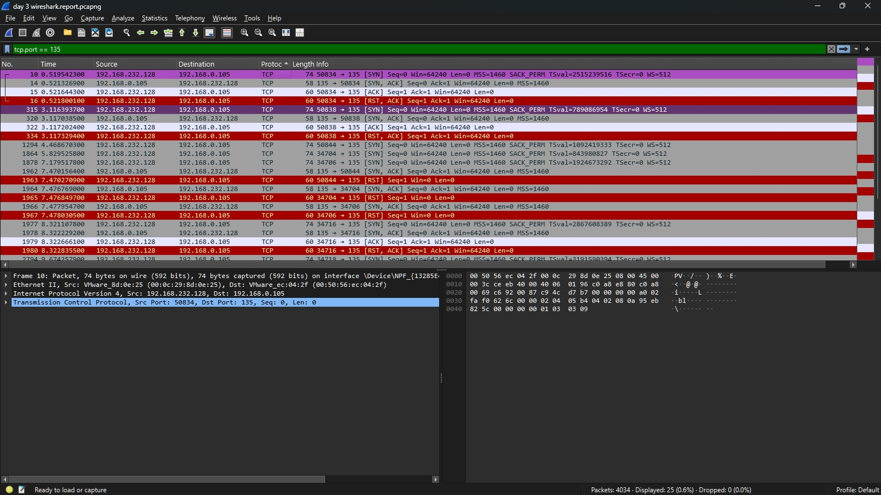
Figure 7: Wireshark packet capture filtered on tcp.port == 135, showing the TCP handshake and connection reset sequences generated by the Nmap scan.

6.8 SOC Incident Analyzer – Main Menu
The figure below shows the main menu of the custom Python SOC Incident Analyzer (v3.0), listing the available functions, including Analyze Logs, SOC Dashboard, Incident Cards, Attack Timeline, IOC Panel, and Generate Incident Report.
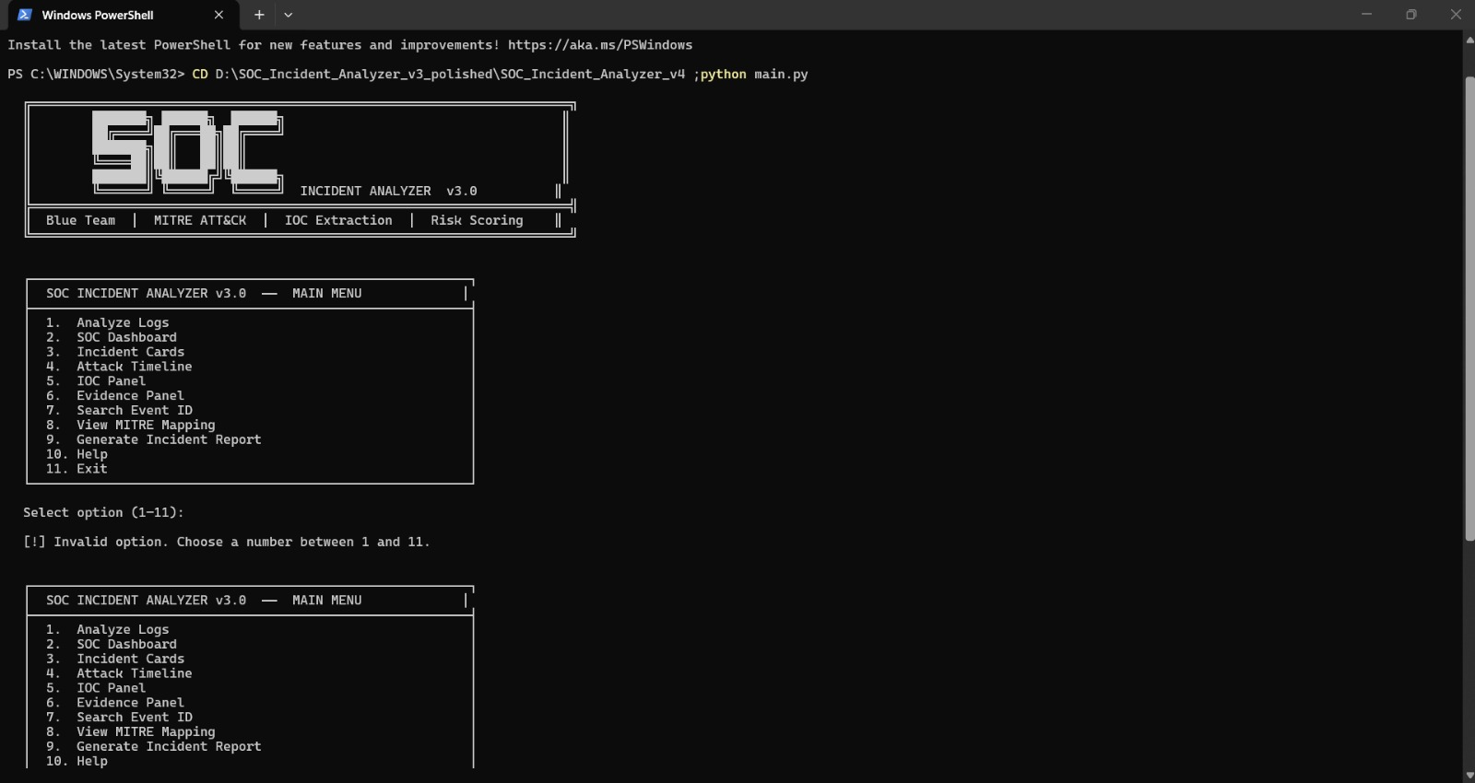
Figure 8: Main menu of the Python-based SOC Incident Analyzer (v3.0) command-line tool, listing its available analysis functions.

6.9 SOC Incident Analyzer – Log Analysis
The figure below shows the result of running the Analyze Logs function. The tool reads 17 log entries, loads the MITRE ATT&CK mapping, classifies events, correlates the attack timeline, extracts indicators of compromise, and reports a final risk score of 69 out of 100 (HIGH), with 9 incidents and 13 IOCs identified.
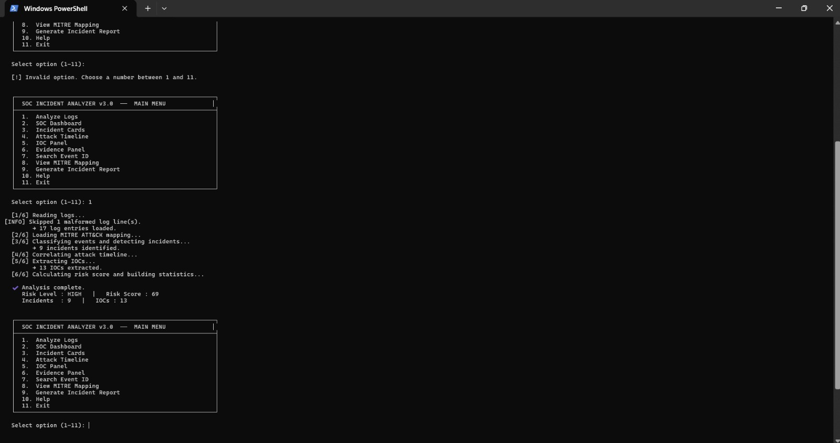
Figure 9: SOC Incident Analyzer log analysis output, showing the processing pipeline and the resulting risk score, incident count, and IOC count.

6.10 SOC Incident Analyzer – Live Dashboard
The figure below shows the tool's live dashboard, summarising the alert severity distribution (2 Critical, 4 High, 1 Medium, 2 Low), investigation status, overall risk assessment, top network indicators, top users and processes, and a MITRE ATT&CK technique summary.
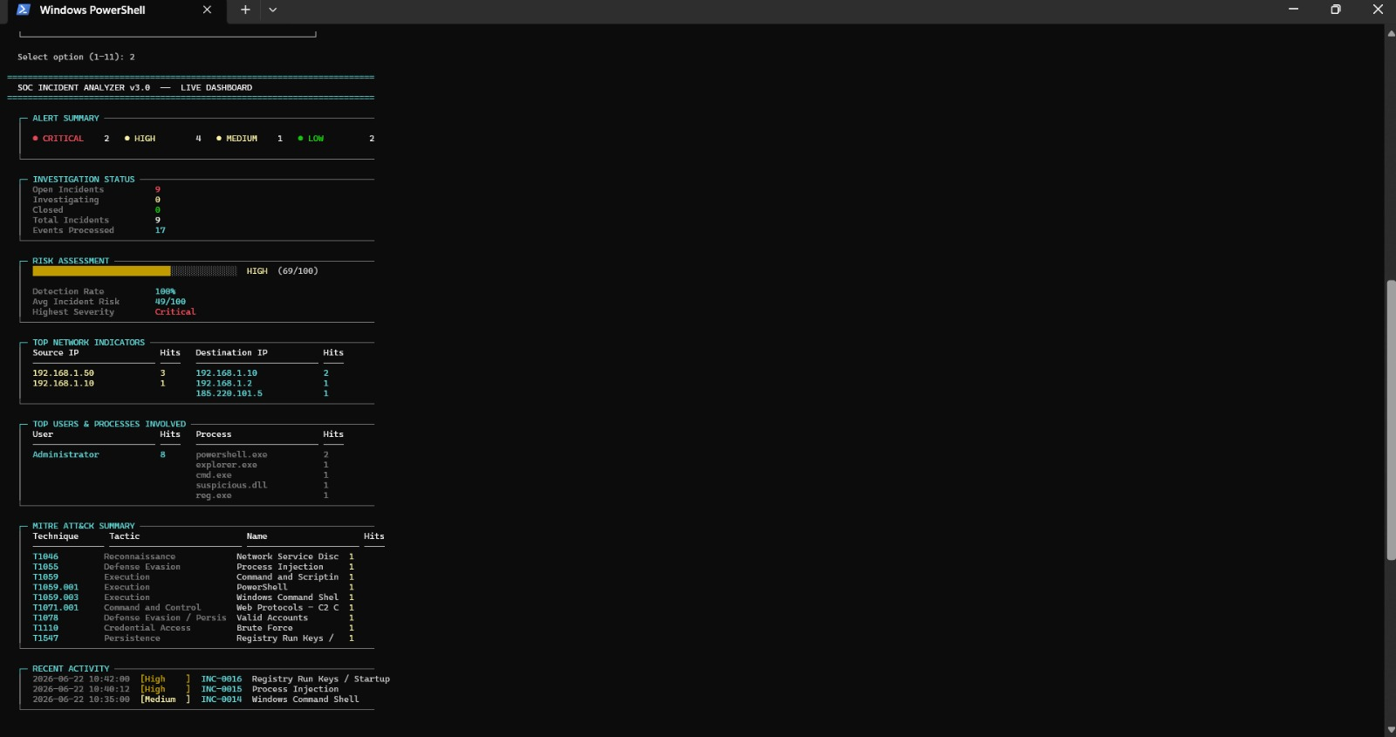
Figure 10: SOC Incident Analyzer live dashboard, summarising alert severity, risk assessment, top indicators, and MITRE ATT&CK technique hits.

6.11 SOC Incident Analyzer – MITRE ATT&CK Mapping
The figure below shows the tool's MITRE ATT&CK mapping reference, linking each detected event type (such as process creation, network connection, and logon events) to its corresponding MITRE tactic, technique ID, and severity rating.
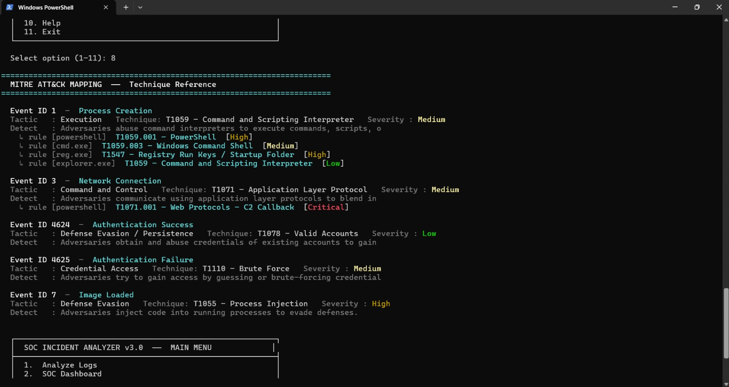
Figure 11: SOC Incident Analyzer MITRE ATT&CK mapping view, showing detected event types linked to MITRE tactics, technique IDs, and severity levels.

6.12 Generated Report – Executive Summary
The figure below shows the executive summary section of the automatically generated incident report, summarising the number of logs processed, incidents detected, severity distribution, and the attack categories identified during the analysis.
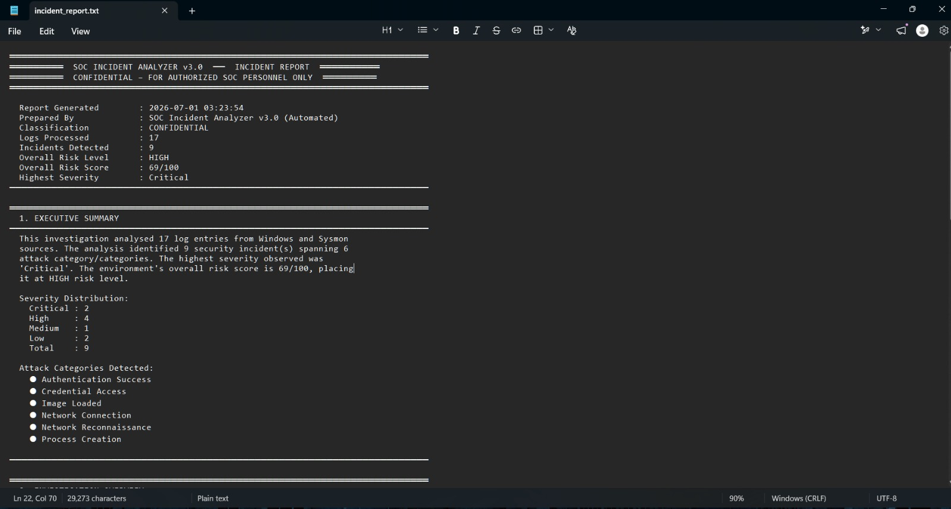
Figure 12: Executive summary section of the automatically generated SOC incident report, showing overall findings and severity distribution.

6.13 Generated Report – Incident Summary (INC-0013)
The figure below shows a detailed incident card, INC-0013, classified as Critical severity. The incident describes a PowerShell process establishing a network connection to an external IP address, mapped to MITRE technique T1071.001 (Web Protocols – C2 Callback), along with the tool's recommended response actions.
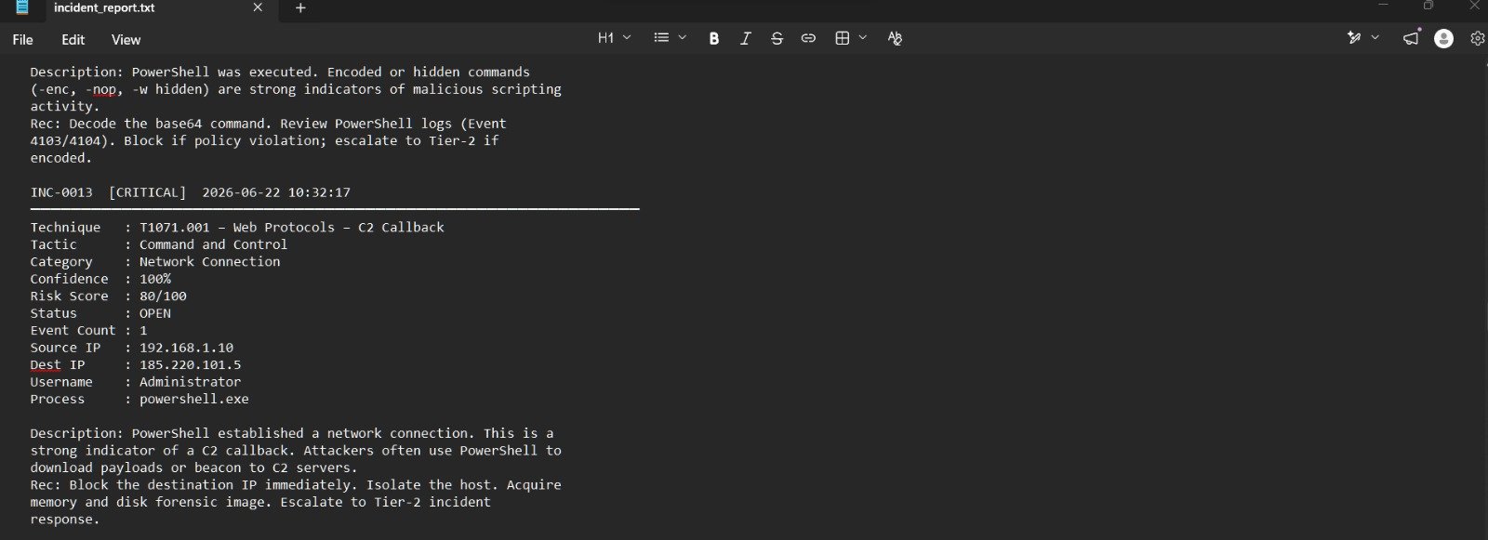
Figure 13: Detailed incident card for INC-0013, a Critical-severity PowerShell network connection event mapped to MITRE technique T1071.001.

6.14 Generated Report – Indicators of Compromise (IOCs)
The figure below shows the indicators of compromise section of the generated report, consolidating 16 IOCs identified during the analysis, including suspicious IP addresses, the affected user account, suspicious process names, and related hostnames.
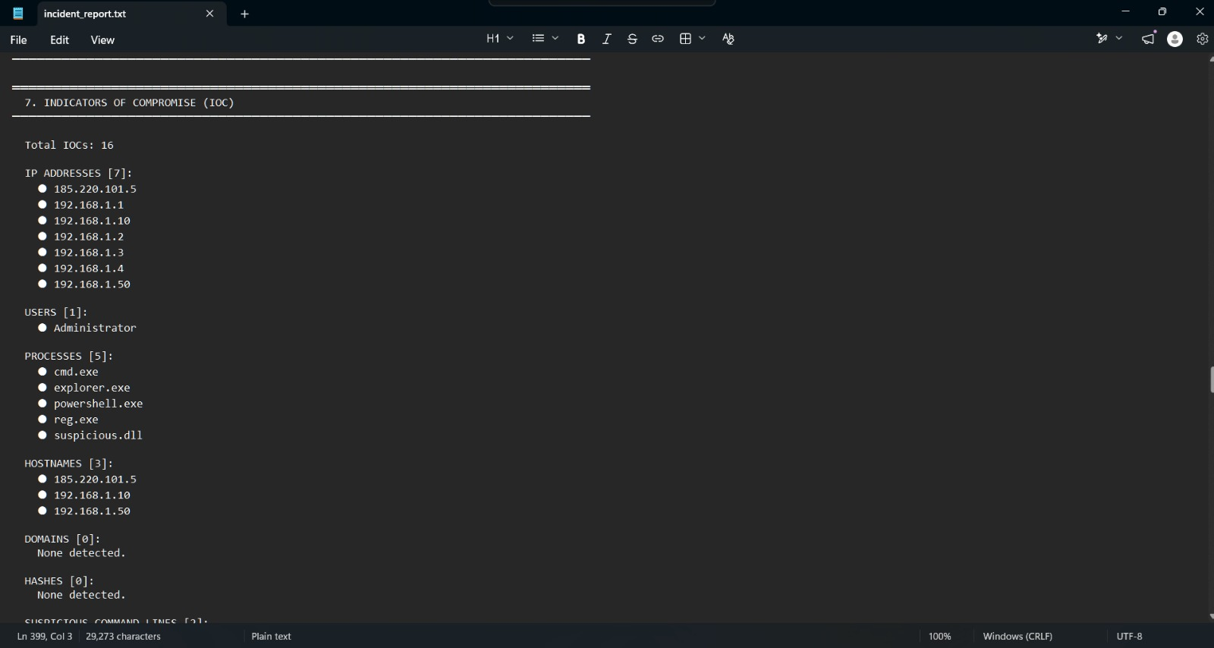
Figure 14: Indicators of Compromise (IOC) section of the generated report, listing suspicious IP addresses, processes, and the affected user account.

6.15 Generated Report – Conclusion
The figure below shows the conclusion section of the generated report, summarising the overall findings (9 incidents, including 2 Critical and 4 High severity events), the overall HIGH risk rating, and the recommendation that all Critical and High severity incidents be escalated for further review.
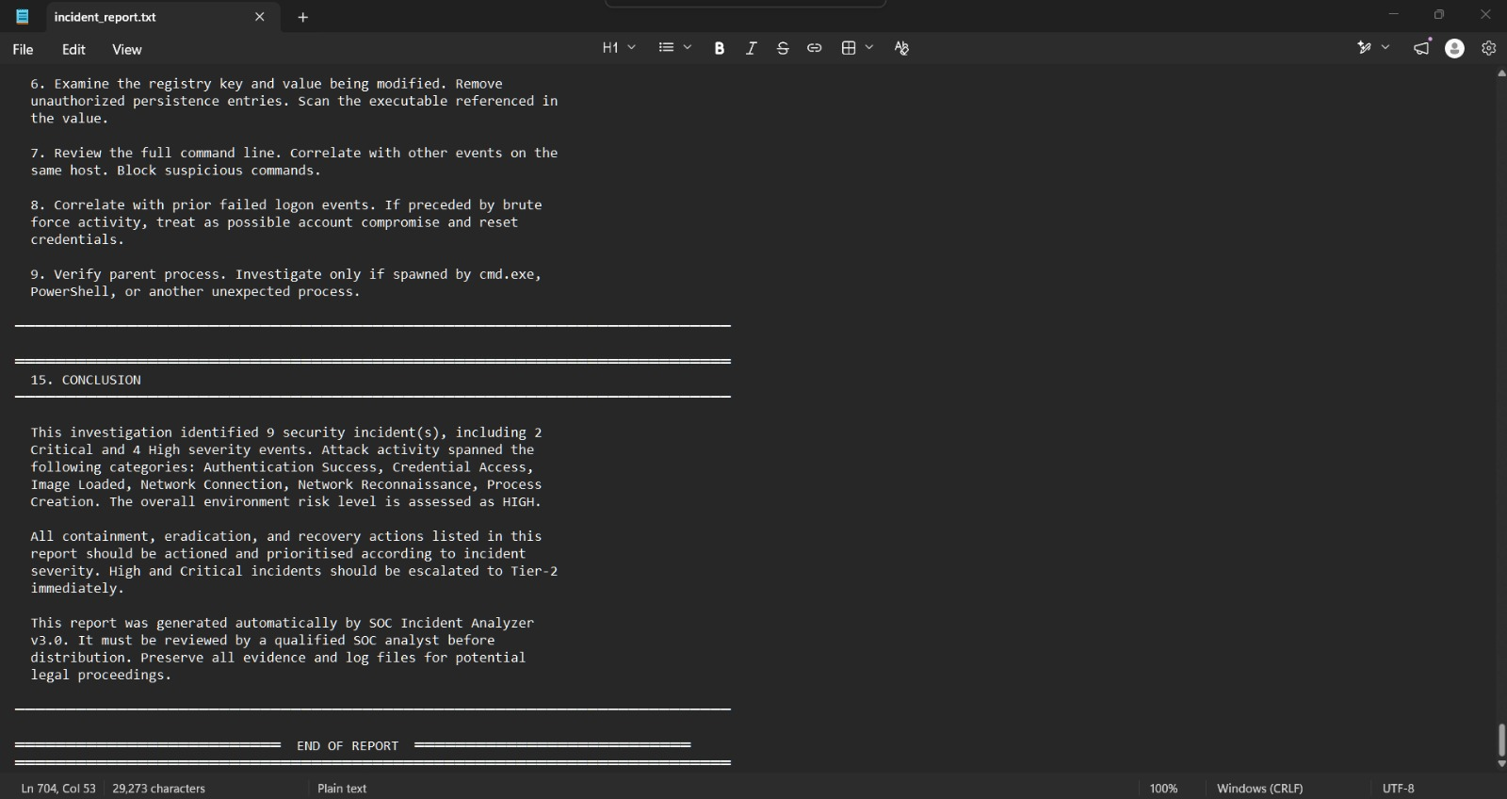
Figure 15: Conclusion section of the automatically generated SOC incident report, summarising overall findings and the HIGH environment risk rating.

7. Results
The combined evidence collected from Sysmon, Windows Event Viewer, Wireshark, and the Python SOC Incident Analyzer produced the following overall results for this exercise:
Metric | Result
Log entries processed | 17
Incidents identified | 9
Overall risk score | 69 / 100 (HIGH)
Critical severity incidents | 2
High severity incidents | 4
Medium severity incidents | 1
Low severity incidents | 2
Indicators of Compromise (IOCs) extracted | 16
Detection rate reported by tool | 100%
Attack categories detected | Authentication Success, Credential Access, Image Loaded, Network Connection, Network Reconnaissance, Process Creation

The reconnaissance phase confirmed that the Windows 11 host exposed several TCP ports commonly associated with Windows file and printer sharing services (135, 139, 445), which were visible to the Kali Linux attacking machine. Sysmon successfully captured both process creation and network connection telemetry that allowed individual process behaviour to be traced and correlated with later analysis.
Authentication monitoring through Event Viewer showed a mix of failed (Event ID 4625) and successful (Event ID 4624) logon attempts, illustrating how repeated failed logons followed by a successful logon can be a useful indicator for an analyst to investigate further. Wireshark confirmed, at the packet level, the precise handshake and reset behaviour generated by the Nmap scan, validating the higher-level findings observed in the other log sources.
The SOC Incident Analyzer successfully consolidated all of this evidence into a single workflow, correctly mapping detected behaviour to recognised MITRE ATT&CK techniques such as T1046 (Network Service Discovery), T1059 (Command and Scripting Interpreter), T1071.001 (Application Layer Protocol – C2 Callback), T1110 (Brute Force), and T1547 (Registry Run Keys / Startup Folder). The most severe finding, INC-0013, identified a PowerShell process establishing an external network connection, a behaviour pattern strongly associated with Command-and-Control activity, and the tool correctly flagged this as a Critical-severity incident requiring escalation.

7.1 Alert Tuning & Recommendations
Based on the results of this exercise, the following tuning actions would improve the accuracy and coverage of the monitoring pipeline in a production SOC environment:
- Reduce false positives by refining detection thresholds for routine administrative activity.
- Improve Sysmon visibility by expanding the configuration to additional event types beyond process creation and network connections.
- Refine correlation logic to better link related low-severity events into single, higher-confidence incidents.
- Strengthen MITRE ATT&CK mapping accuracy by expanding technique coverage beyond the current rule set.
- Improve detection coverage by onboarding additional log sources, such as firewall and proxy telemetry.

8. Conclusion
This project demonstrated, at an undergraduate level, the fundamental workflow followed by SOC analysts when monitoring an environment for malicious activity: collecting telemetry from multiple sources, correlating that telemetry into meaningful incidents, mapping observed behaviour to a recognised threat framework, and producing a clear, structured report for further action.
By combining endpoint telemetry from Sysmon, authentication logs from Windows Event Viewer, packet-level evidence from Wireshark, and reconnaissance activity generated using Nmap from a Kali Linux attacking machine, the project successfully simulated a realistic, small-scale security monitoring scenario inside an isolated VMware Workstation Pro lab. The custom-built Python SOC Incident Analyzer proved effective at automating the otherwise time-consuming tasks of log classification, MITRE ATT&CK mapping, risk scoring, and incident reporting, ultimately identifying 9 incidents and assigning the environment an overall HIGH risk rating of 69 out of 100.
Overall, the project met its stated objectives and provided practical, hands-on experience with the core tools and techniques used in real-world security operations centers. Future extensions of this project could include expanding the Python analyzer to support real-time log ingestion, integrating additional log sources such as firewall or proxy logs, and testing the tool against a wider range of simulated attack techniques.

9. References
- Microsoft. (2026). Windows Event Viewer documentation. Microsoft Learn.
- Microsoft Sysinternals. (2026). Sysmon – System Monitor documentation. Microsoft Learn.
- Wireshark Foundation. (2026). Wireshark User's Guide. wireshark.org.
- Nmap Project. (2026). Nmap Reference Guide. nmap.org.
- Offensive Security. (2026). Kali Linux Documentation. kali.org.
- VMware Inc. (2026). VMware Workstation Pro Documentation. vmware.com.
- MITRE Corporation. (2026). MITRE ATT&CK Framework. attack.mitre.org.
- Python Software Foundation. (2026). Python 3 Language Documentation. python.org.

