National Institute of Technology Karnataka, Surathkal
Department of Information Technology
Major Project-I (IT898) — Mid-Semester Report
SHIA-RAG: A Semantic Hierarchy Induction
Architecture for Retrieval-Augmented Generation
Submitted by
Kshitij Khede
Roll No. 252IT010
Under the guidance of
Prof. Ananthanarayana V. S.
Department of Information Technology
M.Tech (Information Technology) · Third Semester · 2026

Certificate
This is to certify that the Major Project-I (IT898) mid-semester report entitled “SHIA-RAG: A Semantic Hierarchy Induction Architecture for Retrieval-Augmented Generation” is a bonafide record of the work carried out by Kshitij Khede (252IT010), a student of the third semester M.Tech in Information Technology, in partial fulfilment of the requirements for the Major Project-I of the M.Tech degree at the National Institute of Technology Karnataka, Surathkal, during the academic year 2026–27.
The work reported here has been carried out under my supervision and, to the best of my knowledge, has not been submitted elsewhere for the award of any degree.

_____________________________
Prof. Ananthanarayana V. S.
Project Guide, Department of Information Technology, NITK Surathkal
_____________________________
Head of the Department
Department of Information Technology, NITK Surathkal

Declaration
I hereby declare that the report of the Major Project-I work entitled “SHIA-RAG: A Semantic Hierarchy Induction Architecture for Retrieval-Augmented Generation” which is being submitted for the mid-semester evaluation of IT898, is the outcome of my own work. The work has been carried out by me under the guidance of Prof. Ananthanarayana V. S., and the material contained in this report has not been reproduced from any source without due acknowledgement. Where the work of others has been used, it has been cited and referenced.
Kshitij Khede
Roll No. 252IT010
Department of Information Technology, NITK Surathkal

Abstract
Retrieval-augmented generation (RAG) has become a standard way of grounding large language models in external text, but most RAG systems treat a document as a bag of independent chunks or re-cluster it by embedding similarity. In doing so they throw away the section hierarchy that the author of the document deliberately created. When a passage is later retrieved, it often arrives at the language model without the heading and parent section that give it meaning, which weakens the model's ability to answer questions that depend on structure.
This project develops SHIA-RAG, a structure-aware retrieval-augmented generation system that recovers a document's own hierarchy and keeps it intact during retrieval. Unlike recent tree- and graph-based methods, which build their structure using large language models or clustering, SHIA-RAG induces the hierarchy directly from the document's layout and section numbering, so the tree is built deterministically and without any per-document model calls. A semantic concept forest is then grown over this tree, giving a two-tier representation in which every retrieved concept can be traced back to its section and its ancestors.
This mid-semester report covers the problem formulation, a survey of the relevant literature, the proposed architecture and methodology, and the part of the system implemented so far: the ingestion, structural parsing, hierarchy-induction and concept-forest layers, together with an initial structure-aware retrieval path. A preliminary experiment on a fourteen-paper corpus shows that, under an equal retrieval budget, SHIA-RAG locates the target content far more often than a flat and a clustering-tree baseline while preserving parent context almost completely. The full end-task evaluation against competing methods is planned for the end-semester phase, following the timeline in Chapter 5.

Table of Contents
Certificate 2
Declaration 3
Abstract 4
1. Introduction 6
2. Literature Survey 8
3. Proposed System and Methodology 10
4. Implementation and Preliminary Results 12
5. Conclusion and Future Work 14
References 16
List of Figures
Fig. 1.1 SHIA-RAG end-to-end pipeline 6
Fig. 3.1 Nine-layer SHIA-RAG architecture 10
Fig. 3.2 Document tree from section numbering 11
Fig. 4.1 Dual-tier representation 12
Fig. 4.2 Preliminary retrieval comparison 13
Fig. 5.1 Objective timeline for Major Project-I 15
List of Tables
Table 2.1 Comparison of structure-aware RAG methods 8
Table 4.1 Preliminary retrieval comparison 13
Table 5.1 Status of the Major Project-I objectives 14

1. Introduction

1.1 Background and Motivation
Large language models can write fluent answers, but on their own they cannot be trusted to state facts about a specific document or a private collection of documents. Retrieval-augmented generation addresses this by first fetching relevant text from a store and then asking the model to answer using that text. The quality of the final answer therefore depends heavily on the retrieval step: if the wrong passages are fetched, or the right passage is fetched without the context that explains it, the model's answer suffers no matter how capable the model is.
Most documents that people actually work with — research papers, manuals, reports, contracts — are not flat. They are organised into a hierarchy of sections and subsections, and the meaning of a paragraph often depends on the heading above it. A sentence such as “we use a batch size of 32” is only meaningful once we know it sits under “Experimental Setup” rather than “Related Work”. Common RAG pipelines, however, cut a document into fixed-size chunks and index them independently, so this structural context is lost at the very first step. More recent methods rebuild some structure — by clustering embeddings or by asking a large model to parse the document — but they do so at the cost of extra model calls, and the structure they recover is not always the document's real one.
This motivates a different approach. A document already carries its structure on its surface: numbered headings, indentation, and reading order. If this structure can be recovered directly and cheaply, retrieval can be made to respect it — returning not just a relevant passage but the passage together with the section it belongs to. The system proposed in this project, SHIA-RAG, is built on exactly this idea. Figure 1.1 shows the overall flow.
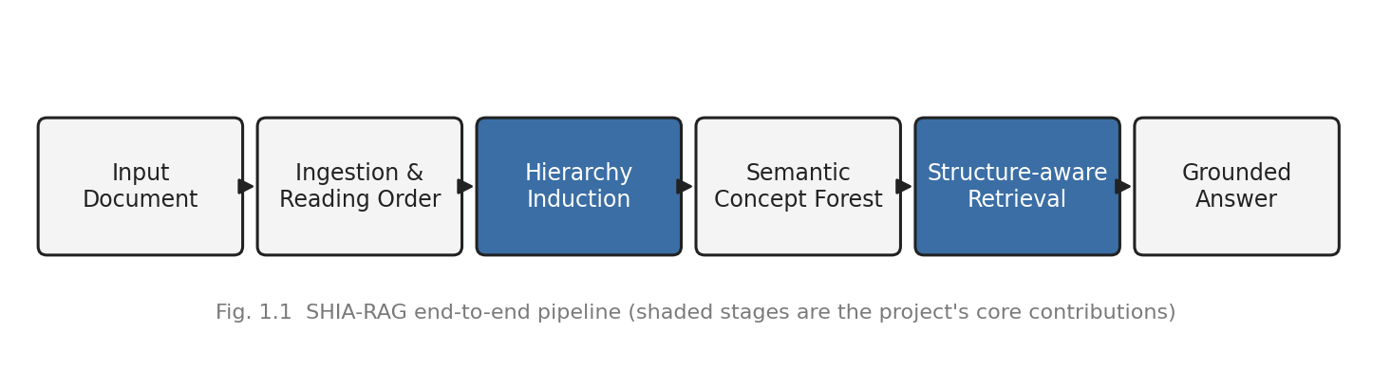

1.2 Problem Statement
Problem: Existing RAG systems flatten or re-cluster a document and lose its section hierarchy, so retrieved evidence reaches the language model without the parent context needed to interpret it correctly.
Aim: To build a training-free, structure-aware RAG system that recovers a document's own hierarchy and preserves it through retrieval.

1.3 Objectives
The objectives of Major Project-I, to be completed by the end-semester evaluation (5 November 2026), are:
- O1 To study existing RAG approaches — flat, tree-based, graph-based and dual-tree — and identify the loss of document structure and parent context as a shared limitation.
- O2 To design a training-free architecture (SHIA-RAG) that induces a document's hierarchy from its own layout and section numbering, without any per-document language-model calls.
- O3 To implement the document ingestion, structural parsing and hierarchy-induction layers that build and validate a document tree.
- O4 To construct a dual-tier representation by extracting a semantic concept forest, with typed relations and confidence, over the document tree.
- O5 To develop a structure-aware, precedence-constrained retrieval mechanism that keeps parent and ancestor context within a fixed token budget.
- O6 To evaluate SHIA-RAG against representative RAG baselines on measures of structural fidelity and retrieval quality, and to analyse the results.
Objectives O1–O4 have been substantially met in the present phase; O5 is in progress and O6 is planned for the end-semester phase, as detailed in Chapters 4 and 5.

1.4 Organisation of the Report
Chapter 2 surveys the relevant literature and states the research gap. Chapter 3 presents the proposed architecture and the methodology for hierarchy induction. Chapter 4 describes the implementation completed so far and reports a preliminary result. Chapter 5 concludes and gives the plan and timeline for the remaining objectives.

2. Literature Survey
The work related to this project falls into three groups: the foundational RAG methods, the more recent structure-aware (tree and graph) methods, and the self-reflective or agentic methods. Each is discussed below, followed by the gap this project addresses.

2.1 Foundational Retrieval-Augmented Generation
The idea of coupling a parametric model with a non-parametric text store was popularised by Lewis et al., whose RAG model retrieves passages with a dense retriever and conditions generation on them. Earlier, REALM introduced retrieval into language-model pre-training, and RETRO showed that retrieval could scale to very large token stores. Atlas later demonstrated strong few-shot performance from a retrieval-augmented model. These methods established the retrieve-then-read pattern but treat the corpus as a flat set of passages; the internal structure of any single document plays no role in how evidence is selected.

2.2 Structure-Aware (Tree and Graph) RAG
A second line of work tries to add structure back. RAPTOR builds a tree by recursively clustering and summarising chunks, and retrieves from a collapsed view of that tree. GraphRAG constructs an entity-relationship graph over the corpus and answers using community summaries. TreeRAG parses a document into a title tree and prepends ancestor titles during retrieval. HiChunk learns to split a document into a multi-level chunk tree and merges children into parents when needed. DTE-RAG maintains two trees — one semantic, one lexical — for multi-hop reasoning, and T-Retriever recasts graph retrieval as tree-based retrieval over textual graphs. These methods confirm that structure helps, which supports the direction of this project. However, they build their structure either by clustering embeddings, which does not follow the document's real sections, or by invoking a large or fine-tuned language model for every document, which is expensive and non-deterministic. Table 2.1 summarises the differences.
Table 2.1 Comparison of structure-aware RAG methods with SHIA-RAG
Aspect | RAPTOR / clustering | TreeRAG / HiChunk / DTE-RAG | SHIA-RAG (this work)
How structure is built | Bottom-up clustering of embeddings | Parsed / generated by a large or fine-tuned LLM | Layout + section numbering, validated
Model calls to build | One summary per node | Per-document / per-chunk LLM use | None (deterministic)
Parent-context guarantee | No | Partial / ancestor prefix | Yes (precedence-constrained)
Follows the real document tree | No (similarity groups) | Partly | Yes

2.3 Self-Reflective and Agentic RAG
A third group focuses on control and self-correction rather than structure. Self-RAG trains a model to decide when to retrieve and to critique its own output, while recent agentic approaches add planning, reranking and groundedness checks around the retriever. These ideas are relevant to the later stages of this project — particularly to citation verification and self-evolution — but they are largely orthogonal to the structural problem tackled here.

2.4 Research Gap
Across all three groups, no method recovers a document's true hierarchy cheaply and then guarantees that retrieved evidence carries its parent context. Clustering methods lose the real structure; LLM-based parsers recover it but at a cost; and self-reflective methods do not address structure at all. This is the gap SHIA-RAG targets: a training-free way to build the document's actual tree from its layout, and a retrieval step that is constrained to preserve the ancestor context of whatever it returns.

3. Proposed System and Methodology

3.1 Overview
SHIA-RAG is organised as a stack of layers, shown in Figure 3.1. The lower layers turn a raw document into a validated tree and a concept forest; the middle layer retrieves from this representation under a budget; and the upper layers generate a grounded answer and, in later phases, let the system improve from feedback. The design principle throughout is that structure should be recovered once, cheaply and deterministically, and then respected at every subsequent step.
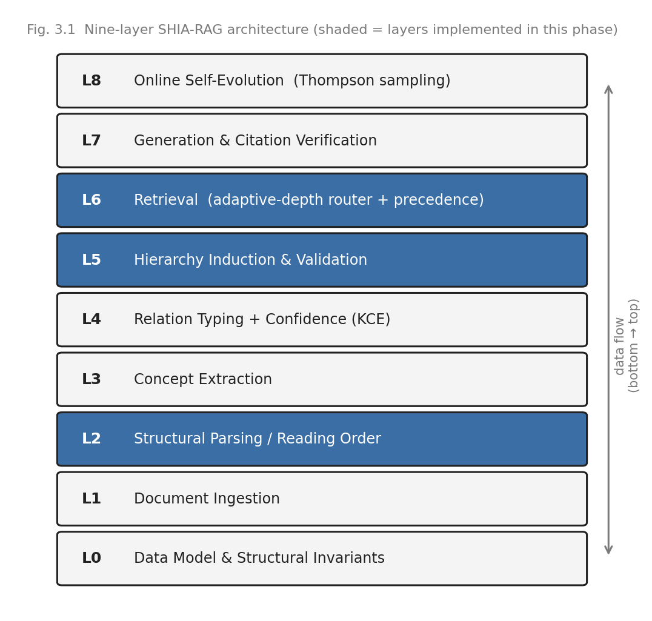

3.2 Document Ingestion and Reading Order
The ingestion layer reads a document and produces an ordered list of text blocks. For multi-column material the naive top-to-bottom order is wrong, because it interleaves the two columns; the parser therefore uses the column gutter to sort blocks into the correct human reading order before any structure is inferred. Each block keeps its position and, where present, its section label, so that later layers can reason about order and nesting.

3.3 Hierarchy Induction
The core of the present phase is hierarchy induction — assigning every block its correct parent so that the document becomes a tree. The primary signal is the document's own section numbering: a block headed “3.1” is attached under “3”. Where explicit numbering is absent, a fallback ranks candidate parents by a combination of structural position, textual similarity and heading level, and attaches the block to the best earlier, shallower heading. The result is validated against a set of invariants — the graph must remain acyclic, every non-root block must receive exactly one parent, and no block may be left orphaned. Figure 3.2 shows a small example of the tree produced.
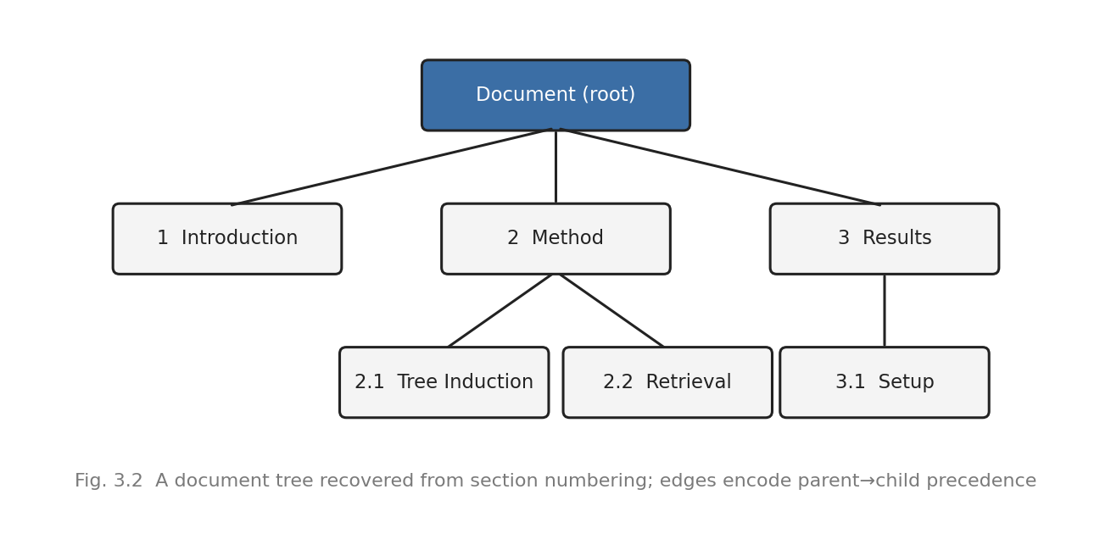
This numbering-primary strategy with a semantic fallback is what makes the method both accurate and training-free. It uses no language model to build the tree, so the process is deterministic, auditable and fast, and it follows the structure the author actually wrote rather than an approximation inferred from embeddings.

3.4 Retrieval Methodology
Retrieval is designed to exploit the tree rather than ignore it. Given a question, the system first identifies the blocks most relevant to it, and then uses the tree to attach the parent and ancestor sections of those blocks, so that the evidence handed to the language model always arrives with the context that frames it. The amount of text is kept within a fixed token budget, and the selection is constrained so that a child is never returned without a path to its ancestors — the precedence constraint. The detailed retrieval mechanism and its evaluation form the main work of the end-semester phase (objectives O5 and O6).

4. Implementation and Preliminary Results

4.1 What Has Been Built
The system is implemented in Python as a layered package. The data model and its invariants (Layer 0), document ingestion (Layer 1), structural parsing and reading-order recovery (Layer 2), concept extraction (Layer 3), relation typing with confidence (Layer 4) and hierarchy induction with validation (Layer 5) are all in place and run end to end on real documents. An initial retrieval path (Layer 6) is also working and is currently being extended into the full precedence-constrained mechanism. The implementation relies on lightweight, deterministic components — geometric parsing and standard vector and numerical libraries — rather than heavy external services, which keeps the pipeline reproducible on a single machine.
Building on the document tree, the system extracts a semantic concept forest and links each concept back to the block and section it came from. This gives the dual-tier representation illustrated in Figure 4.1: a structural tier that preserves the document's sections and a semantic tier that captures the concepts, with every concept anchored in the structure. This anchoring is what later lets retrieval return a concept together with its parent context.
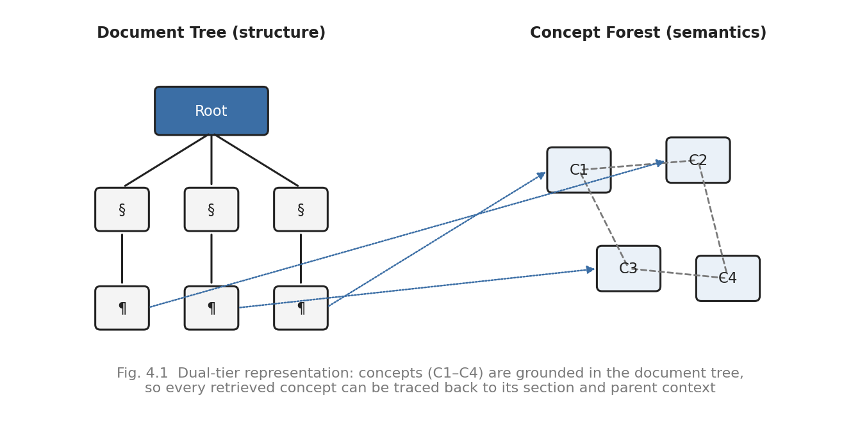

4.2 Preliminary Result: Structural Fidelity of Retrieval
To check whether the structural design behaves as intended, an initial experiment was run on a corpus of fourteen research papers. A set of realistic queries was posed, and three retrieval strategies were compared under the same tight token budget: SHIA-RAG, a RAPTOR-style clustering-tree retriever, and a flat top-k retriever. Because this experiment measures retrieval behaviour rather than final answer quality, it needs no language model, which makes it fully reproducible. Two things were measured: how often the retriever located the intended target content, and how often it kept the parent or ancestor context of what it returned.
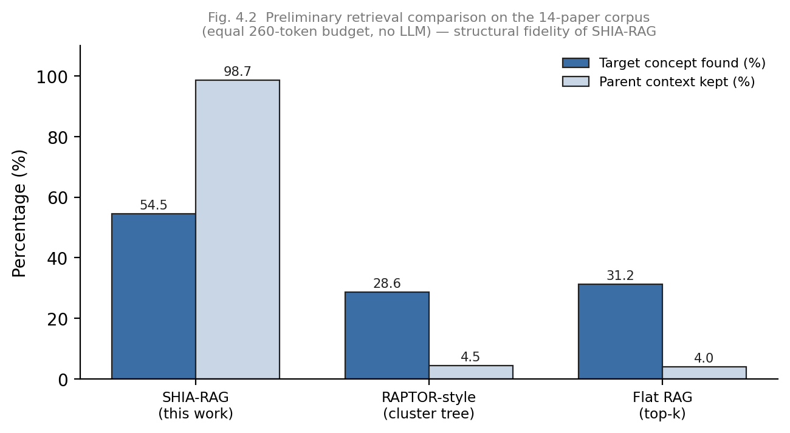
Table 4.1 Preliminary retrieval comparison on the fourteen-paper corpus (equal budget, no LLM)
Method | Target concept found (%) | Parent context kept (%)
SHIA-RAG (this work) | 54.5 | 98.7
RAPTOR-style (clustering tree) | 28.6 | 4.5
Flat RAG (top-k) | 31.2 | 4.0
The pattern is clear and matches the design intent. SHIA-RAG found the target content markedly more often than either baseline, and it preserved parent context almost completely (98.7%), against roughly four to five per cent for the clustering-tree and flat methods. The reason is structural: the clustering-tree groups text by similarity and so does not follow the document's real sections, while flat retrieval has no notion of a parent at all; SHIA-RAG follows the induced tree and enforces precedence, so the ancestor context is retained by construction.
This is a preliminary, retrieval-level result and is deliberately limited in scope. It shows that the structural machinery works, which is the milestone for this phase. It does not yet measure end-task question-answering accuracy against the full set of competing systems — that larger evaluation, using a shared reader model on standard datasets, is the main deliverable of the end-semester phase and is described next.

5. Conclusion and Future Work

5.1 Summary
This report has set out the problem of structure loss in retrieval-augmented generation and proposed SHIA-RAG as a training-free, structure-aware solution. The problem was framed, the relevant literature was surveyed and the gap identified, and an architecture was designed around the idea of recovering a document's own hierarchy from its layout and then respecting that hierarchy during retrieval. The lower layers of the system — ingestion, structural parsing, hierarchy induction and the dual-tier concept forest — have been implemented and shown to run on real documents, and a preliminary experiment confirmed that the structural retrieval behaves as intended, preserving parent context far better than flat and clustering-tree baselines.

5.2 Objective Status
Table 5.1 Status of the Major Project-I objectives
Obj. | Description | Status
O1 | Literature study and gap analysis | Completed
O2 | Training-free architecture design | Completed
O3 | Ingestion, parsing and hierarchy induction | Completed
O4 | Dual-tier concept forest | Substantially done
O5 | Precedence-constrained retrieval | In progress → end-sem
O6 | Evaluation against baselines and analysis | Planned → end-sem

5.3 Work Planned for the End-Semester Phase
The remaining objectives complete the system and put its claims to the test. The immediate task (O5) is to finish the precedence-constrained retrieval mechanism, so that leaf relevance and ancestor context are combined within a fixed budget. The larger task (O6) is a fair, like-for-like evaluation: SHIA-RAG will be compared against representative baselines — such as RAPTOR, TreeRAG, GraphRAG, HiChunk and DTE-RAG — on standard question-answering benchmarks, using one shared reader model and an equal retrieval budget for every method, so that any difference reflects retrieval quality alone. Alongside end-task accuracy, the structural-fidelity measurement begun in this phase will be extended, and an ablation will be used to show that each design choice earns its place.

5.4 Timeline
Figure 5.1 shows the plan from the mid-semester point to the end-semester evaluation on 5 November 2026. The foundational objectives are essentially complete; the remaining weeks are devoted to finishing the retrieval mechanism and running the comparative evaluation, leaving time for analysis and the end-semester report.
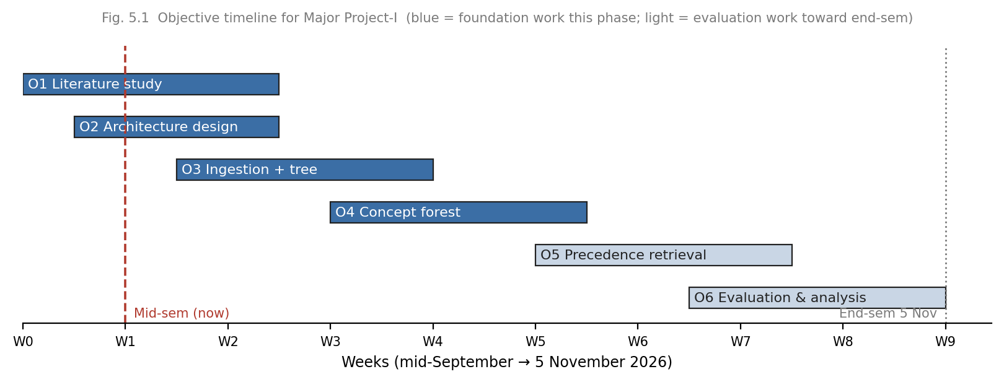

References
[1] P. Lewis, E. Perez, A. Piktus, et al., “Retrieval-Augmented Generation for Knowledge-Intensive NLP Tasks,” in Advances in Neural Information Processing Systems (NeurIPS), 2020.
[2] K. Guu, K. Lee, Z. Tung, P. Pasupat, and M.-W. Chang, “REALM: Retrieval-Augmented Language Model Pre-Training,” in Proc. International Conference on Machine Learning (ICML), 2020.
[3] S. Borgeaud, A. Mensch, J. Hoffmann, et al., “Improving Language Models by Retrieving from Trillions of Tokens (RETRO),” in Proc. ICML, 2022.
[4] G. Izacard, P. Lewis, M. Lomeli, et al., “Atlas: Few-shot Learning with Retrieval Augmented Language Models,” Journal of Machine Learning Research, 2023.
[5] P. Sarthi, S. Abdullah, A. Tuli, et al., “RAPTOR: Recursive Abstractive Processing for Tree-Organized Retrieval,” in Proc. International Conference on Learning Representations (ICLR), 2024.
[6] A. Asai, Z. Wu, Y. Wang, A. Sil, and H. Hajishirzi, “Self-RAG: Learning to Retrieve, Generate, and Critique through Self-Reflection,” in Proc. ICLR, 2024.
[7] D. Edge, H. Trinh, N. Cheng, et al., “From Local to Global: A Graph RAG Approach to Query-Focused Summarization,” arXiv preprint, 2024.
[8] “TreeRAG: Hierarchical Title-Tree Retrieval for Structured Documents,” in Proc. Annual Meeting of the Association for Computational Linguistics (ACL), 2025.
[9] “HiChunk: Hierarchical Document Chunking for Retrieval-Augmented Generation,” 2025.
[10] “DTE-RAG: A Dual-Tree Structure for Multi-Hop Reasoning,” in Proc. IEEE ISBDAS, 2026.
[11] “T-Retriever: Tree-based Hierarchical Retrieval for Textual Graphs,” arXiv preprint, 2026.
[12] “Agentic RAG for Structure-Aware Long-Document Reasoning,” in Proc. IEEE ATiGB, 2026.

