MESA Cohort C4 · AI and its Applications · Section 1 Final Examination
VC Fundraising Pipeline Intelligence
Components Map and implementation document
Item | Link / value
Live app (Vercel) | https://vc-pipeline-intel.vercel.app
Dashboard access | Open: no key needed. Setting DASHBOARD_KEY in Vercel locks it again.
GitHub repository | https://github.com/kshitijkhrn1996-byte/vc-pipeline-intel
AI model | Gemini Flash (gemini-3.5-flash) for every AI task; no Claude API
Stack | Vercel (functions + cron), Supabase (Postgres), Google News RSS, firm blog RSS, Gemini with Google Search grounding

1. The problem
Vikram is a first-time founder raising Seed for a B2B logistics SaaS. He tracks 50 VCs in a sheet that records what he did (last contact, status) but cannot tell him the one thing he needs twice a week: which VCs are worth reaching out to right now, and why. A VC who just backed a logistics company, wrote about supply chains or spoke at an industry event is in a receptive moment. A VC who has been publicly quiet for a month is not worth chasing this week.

Root cause
The deciding information, the VC's current attention, is external, scattered across news sites, firm blogs and event pages, and changes every week. Vikram's system only holds static internal records, and nothing joins the two on a schedule in a way he can trust.
- Scattered and changing: checking 50 people across several sources twice a week takes hours, so it does not happen.
- A signal is not a decision: "posted about logistics" means reach out, nudge or wait depending on his own status and last contact.
- Trust: every recommendation needs checkable evidence, not an AI hunch, and the system must never damage his notes.

What the system does
- Runs automatically every Monday and Thursday at 6:30 am IST (plus a catch-up run at 8:30 am), or on demand from the dashboard.
- For each of the 50 VCs, collects live public activity from the last 30 days and keeps only items with a real link and a date in the window.
- Gemini Flash decides whether each item is about the partner, the firm or neither, its type, and how relevant it is to logistics/B2B SaaS.
- A deterministic, unit-tested formula turns this into a follow-up score (0–100). Rules combine it with Vikram's status and last contact to recommend an action.
- Gemini writes an outreach or nudge email for each VC worth contacting, opening with that VC's specific signal. Vikram opens it in Gmail with one click.
- Updates only the four signal columns in Supabase: last signal date, signal summary, follow-up score, recommended action.

2. Components Map
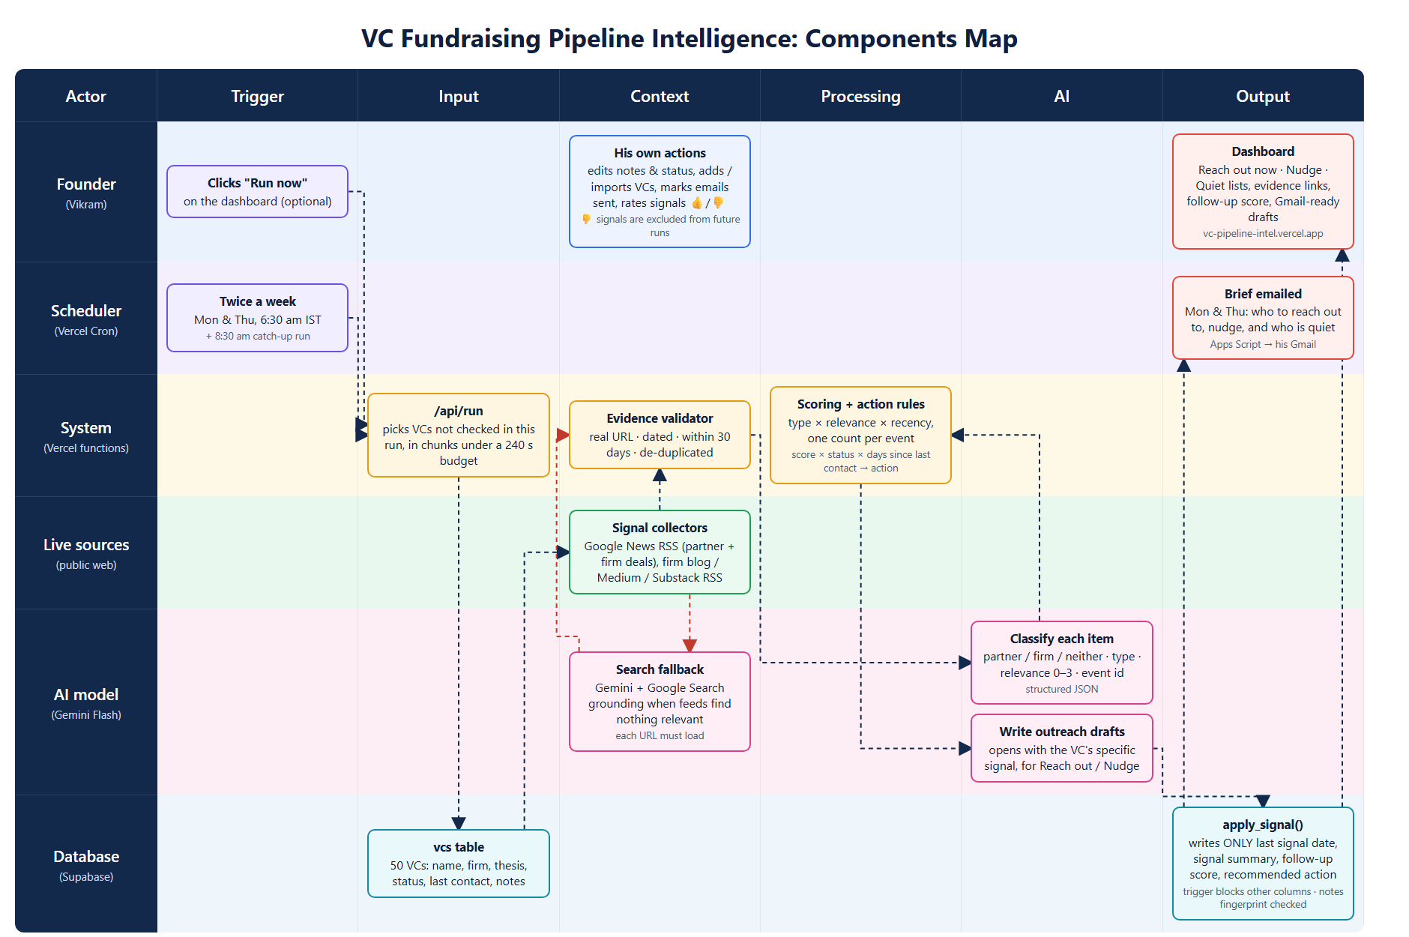
Read left to right: Trigger → Input → Context → Processing → AI → Output. Dashed red arrows show the web-search fallback, which only runs when the feeds find nothing relevant about a VC.

3. Components by stage
Stage | Component | Tool | What it does
Trigger | Scheduler | Vercel Cron | Calls /api/run on Mon and Thu at 01:00 UTC (6:30 am IST), plus a 03:00 UTC catch-up run that only processes VCs not yet checked.
Trigger | Run now | Dashboard button | Starts a full refresh; the page calls /api/run repeatedly until every VC is checked.
Input | VC pipeline | Supabase table vcs | 50 VCs: partner name, firm, thesis, firm email, blog feed, plus Vikram's status, last contact, contact history and notes.
Context | Signal collectors | Google News RSS, blog RSS | Two news searches per VC (the partner, anchored to investing terms, and the firm's deals) plus the firm's own blog/Medium/Substack feed.
Context | Evidence validator | src/validate.js | Drops anything without a URL, without a date, outside the last 30 days, or duplicated across outlets.
Context | Search fallback | Gemini + Google Search | Only when feeds return nothing relevant. Gemini searches the web; every URL it reports must actually load before it is kept.
AI | Classifier | Gemini Flash, JSON schema | Per item: about partner / firm / neither, type (investment, blog, interview, event), relevance 0–3, 18-word summary, event id so several outlets covering one deal count once.
Processing | Scoring + actions | src/scoring.js | Score = type weight × relevance × recency, one count per event, off-topic activity capped at 15. Action = score × status × days since last contact.
AI | Draft writer | Gemini Flash | For "Reach out now" and "Nudge now": a short email that opens with the VC's concrete signal and asks for a 20-minute call.
Output | Safe writer | Postgres apply_signal() | The only way the pipeline writes to vcs. Sets exactly the four signal columns.
Output | Evidence + run log | Tables signals, vc_checks, signal_runs | Every signal with its link; drafts per VC; each run's counts and the before/after fingerprint of Vikram's columns.
Output | Dashboard | Vercel static page + /api/vcs, /api/actions | Reach out now, Nudge, In progress and Quiet lists with evidence links; what changed since the last run; email drafts to Gmail; mark as sent; 👍/👎 feedback; add, import and export VCs.
Output | Brief email | Apps Script → Gmail | After each scheduled run, emails Vikram who to reach out to, who to nudge and who is quiet.
Context | Feedback | Supabase signal_feedback | Signals Vikram marks not relevant are excluded from future runs for that VC; the ratings give an accuracy figure.

4. How Vikram's notes are protected
The brief says the system must update only the signal-derived columns and never overwrite his contact history or notes. This is enforced in three independent layers:
Layer | Mechanism | What it prevents
1. Code | The pipeline never runs UPDATE or UPSERT on vcs. Its only write is the RPC apply_signal(vc_id, last_signal_date, summary, score, action). | A coding mistake that writes a whole row back.
2. Database | apply_signal() sets exactly four columns. A BEFORE UPDATE trigger raises an error if a pipeline write changes name, firm, thesis, email, status, last_contact, contact_history or notes. | Any future code path silently touching Vikram's columns: the database refuses the write.
3. Proof | protected_hash() fingerprints all of Vikram's columns before and after each run. The dashboard shows "untouched" only when they match. | Undetected changes. It is visible evidence for Vikram (and the examiner) on every run.
Tested: a deliberate pipeline write to notes was rejected by the trigger, and every run so far reports matching fingerprints. Vikram can still edit his own columns from the dashboard; that endpoint only accepts his columns, not the signal ones.

5. Scoring and recommended actions
Factor | Values
Signal type weight | investment 1.0 · blog 0.8 · event 0.7 · interview 0.6 · other 0.3
Relevance (Gemini) | 3 logistics / supply chain → ×1.0 · 2 B2B SaaS → ×0.6 · 1 general startup activity → ×0.15 · 0 unrelated → ×0.05
Recency | full weight within 7 days, fading linearly to zero at 30 days
Per event | up to 40 points; several outlets covering the same deal count once
Off-topic cap | relevance 0–1 activity adds at most 15 points, so it can never trigger outreach alone

Vikram's status | Condition | Recommended action
Yet to reach out | score ≥ 30 | Reach out now (with email draft)
Yet to reach out | score < 30 | Deprioritise this week
Waiting for response | contacted ≤ 10 days ago | Hold: awaiting reply
Waiting for response | > 10 days and score ≥ 30 | Nudge now (with follow-up draft)
Waiting for response | > 10 days and score < 30 | Deprioritise: nudge when they resurface
In conversation | any | Continue conversation (mention the signal if score ≥ 30)
Passed | any | Skip

6. Results from the live run
Latest run: 12 Oct 2026, 01:35 IST (manual, on Vercel). 50 VCs checked, 237 validated signals from the last 30 days, completed in 3 min 17 s. Vikram's columns: untouched (fingerprints match).
Recommended action | VCs
Deprioritise this week (quiet / off-topic) | 22
Continue conversation | 10
Nudge now | 7
Hold: awaiting reply | 5
Skip: passed | 5
Reach out now | 1

Worth reaching out to this week
VC | Score | Action | Why (signal summary)
Shailendra Singh, Peak XV Partners | 75 | Nudge now | 11 Oct: Peak XV-backed supply chain platform Zetwerk prepares its IPO. 8 Oct: Peak XV led Plum's Rs 193 crore round.
Mukul Arora, Elevation Capital | 53 | Nudge now | 26 Sep: Dextr AI's $6.7M seed. 22 Sep: Elevation article on pairing AI with on-ground fulfilment in India.
Joe Lonsdale, 8VC | 45 | Nudge now | 9 Oct: Gallatin AI raised a $50M Series A for its military logistics platform.
Rachel Holt, Construct Capital | 43 | Reach out now | 17 Sep: co-led BackOps' $42M round for AI supply chain automation. 6 Oct: co-led Torch Systems' $11.5M round.
Kunal Bahl, Titan Capital | 38 | Nudge now | 30 Sep: e-commerce fulfilment startup Blitz starts its pre-Series B at a higher valuation.
Steve Sarracino, Activant Capital | 34 | Nudge now | 6 Oct: blog on value capture in legal AI. 29 Sep: post on intelligent routing in AI systems.
Anand Lunia, India Quotient | 34 | Nudge now | 30 Sep: portfolio company Blitz (quick-commerce fulfilment) starts its pre-Series B.
Shripati Acharya, Prime Venture Partners | 30 | Nudge now | 8 Oct: led Desible.ai's Rs 32 crore round (BFSI AI operating layer).

7. The dashboard
Vikram opens one page on Monday and Thursday morning. It is built to be scanned in under a minute:
- Weekly brief: one sentence with the plan ("Reach out to 1 and nudge 7. 22 are quiet"), a bar showing all 50 VCs by action, last and next run times, and the notes-untouched check.
- Priority queue: only the VCs worth contacting, ranked by score. Each card shows the evidence (date, type, relevance, link), a 30-day signal strip, the score against the outreach line, and his own note.
- Email drafts: open in a side panel, editable, with Open in Gmail and Copy. The draft opens with the specific signal.
- Run proof: which columns a run writes and which it never writes, plus a history of recent runs with a notes-safe check on each.
- Full pipeline: all 50 VCs with filters and search. Clicking a VC opens the details panel where Vikram edits status, last contact, email, contact history and notes. Signal columns are shown locked.
- What changed: each VC is compared with the previous run: "New this run", "heating up", "went quiet", new signals, and a score sparkline over recent runs.
- Mark as sent: after sending a draft, one click sets status to waiting for reply, last contact to today and adds a line to his contact history. The recommendation switches to Hold, so the next run will not chase that VC for 10 days. These are his columns, changed by his own action, never by a run.
- Feedback loop: 👍 / 👎 on every signal. 👎 removes that item from future runs for that VC, and the ratings give a live accuracy figure (share of rated signals that were useful).
- Pipeline management: add a VC (it is checked within about 20 seconds), import his spreadsheet as CSV (his own headings such as "Partner" and "Fund" are recognised, duplicates skipped), and export to CSV.
- Brief by email: after each scheduled run, the same brief is emailed to him from his own Gmail through a small Apps Script, so it is waiting before he starts work.
- Run now: starts a full refresh with a live progress bar. Light and dark themes, and it works on a phone.
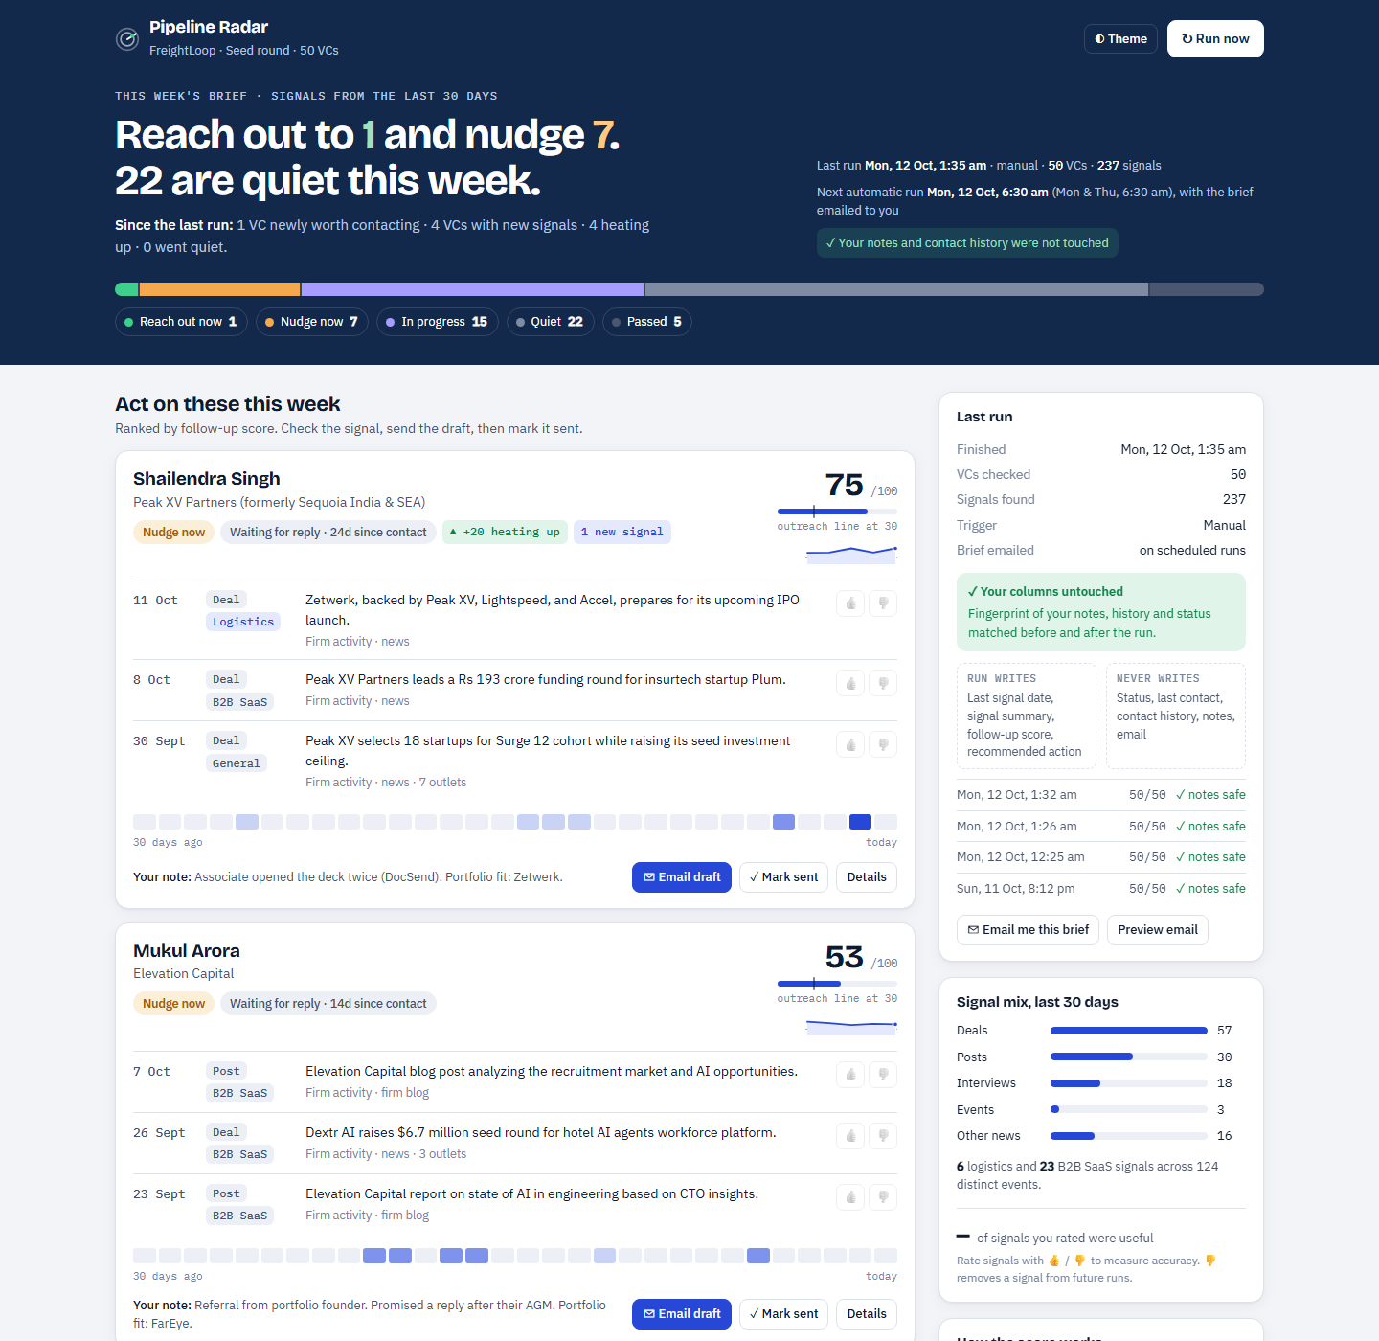
Live dashboard after the final run (light theme, desktop width).

8. Testing and verification
Two full live runs were made on the production deployment, each followed by an automated end-to-end audit (npm run audit) and a manual review of every email draft. The audit reads the stored run and checks it independently of the pipeline code.
Check | Test 1 (run 9) | Test 2 (run 10)
All 50 VCs checked, notes fingerprint unchanged | ✓ 3 min 19 s, 259 signals | ✓ 3 min 17 s, 237 signals
Every signal has a real link and a date within 30 days | ✓ | ✓
No investor-database pages (Tracxn, Crunchbase…) | ✓ | ✓
Score recomputed from stored evidence = stored score (all 50) | ✓ | ✓
Action recomputed from the rules = stored action (all 50) | ✓ | ✓
Signal columns in vcs match the run | ✓ | ✓
A draft exists exactly for Reach out / Nudge VCs | ✓ | ✓
Every draft opens with that VC’s own recent signal | ✗ 1 draft (fixed, see below) | ✓ 8 of 8
Greeting, sign-off, length, first email vs nudge | ✓ | ✓
Bug found and fixed: in Test 1, the Construct Capital draft opened with "your investment in Nauta", an old portfolio company taken from Vikram’s notes rather than a signal from the last 30 days. The prompt now requires the first sentence to name one of the VC’s recent signals; a code check verifies it and regenerates the draft once if not; and drafts now receive the most on-topic signals first. In Test 2 the draft opened with BackOps’ $42M round, which the source confirms Construct co-led.
Consistency between runs: 49 of 50 VCs received the same recommendation in both runs; the median score change was 0. The one change (Activant, 24 → 34) came from a new blog post found in the second run.
Draft review: all 8 drafts address the right partner, never mention another VC on the list, use the correct type (1 first email, 7 nudges), quote the real date of Vikram’s last contact in each nudge, and use only figures that appear in that VC’s evidence. 20 unit tests cover scoring, actions, validation, change detection and the draft-citation check.
Sample draft (Construct Capital, first outreach):
Hi Rachel,
Saw that Construct Capital co-led BackOps’ $42M round to scale AI supply chain automation.
Given your focus on supply chain technology, I thought you might be interested in FreightLoop. We build B2B logistics SaaS for Indian mid-market shippers, providing a single workspace to book carriers, track shipments, and reconcile freight invoices.
We are currently raising our Seed round and I would love to connect. Are you open to a 20-minute call next week?
Best, Vikram

9. Assumptions and limitations
- Thresholds (score 30 for outreach, 10 days before a nudge) are starting assumptions in one file, src/scoring.js, and can be tuned with Vikram.
- Investor-database pages (Tracxn, Crunchbase and similar) are filtered out: they list old rounds, not something the VC did.
- A deal made by the firm counts as a signal for the partner on the list, and is labelled "firm signal" on the dashboard.
- LinkedIn and X posts are not covered: there is no free API, and scraping breaks their terms. News, firm blogs and web search are covered.
- Publicly quiet does not mean not investing; "Deprioritise" means not this week, not never.
- VC emails are public firm-level addresses only (20 of 50 VCs). For the rest Vikram adds the address in the draft or the table.
- The 50-VC list was researched for this build (35 India-focused, 15 global seed funds with logistics or B2B SaaS exposure). Vikram's status, contact history and notes are fictional seed data.

