AIM: To understand how to Encrypt long messages using various modes of operation using AES and DES
Theory:
DES (Data Encryption Standard) and AES (Advanced Encryption Standard) are two widely used symmetric-key encryption algorithms that serve to protect data confidentiality by converting plaintext data into ciphertext using a secret key. Here's a brief overview of both:

1. DES (Data Encryption Standard):
● Key Length: DES uses a 56-bit encryption key. This relatively short key length is one of the primary reasons why DES is no longer considered secure against modern attacks.
● Block Size: DES operates on 64-bit blocks of plaintext data.
● Encryption Process: DES uses a Feistel network structure. The encryption process involves multiple rounds (typically 16 rounds). During each round, the plaintext block is divided into two halves, and various mathematical operations, including substitution (S-boxes), permutation (P-boxes), and bitwise operations, are applied to each half using a round-specific subkey derived from the main encryption key. The results from each round are mixed and swapped, creating the ciphertext.
● Security Concerns: DES is no longer considered secure against modern cryptographic attacks, primarily due to its short key length. It can be vulnerable to brute-force attacks where an attacker tries all possible 2^56 keys to decrypt the data.
2. AES (Advanced Encryption Standard):
● Key Length: AES supports multiple key lengths, including 128-bit, 192-bit, and 256-bit keys. Longer key lengths provide higher security.
● Block Size:AES operates on 128-bit blocks of plaintext data.
● Encryption Process: AES uses a substitution-permutation network (SPN) structure. The encryption process involves several rounds, with the number of rounds depending on the key length (10 rounds for 128-bit keys, 12 rounds for 192-bit keys, and 14 rounds for 256-bit keys). Each round consists of several operations, including a substitution step (SubBytes), permutation step (ShiftRows), mixing step (MixColumns), and adding a round key (XOR with a round-specific key derived from the main encryption key).
● Security: AES is widely regarded as highly secure against both brute-force and cryptographic attacks when used with sufficient key lengths. It has withstood extensive scrutiny and is widely adopted in various applications, including data encryption, secure communication protocols, and more.

Cipher mode-EBC(128 bits)
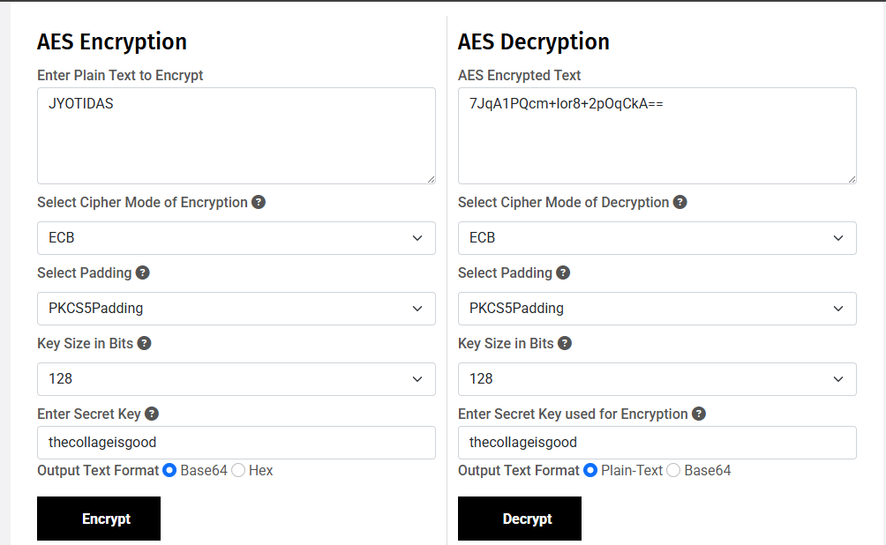

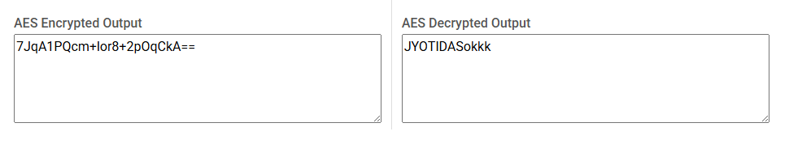

Cipher mode-ECB(192 bits)
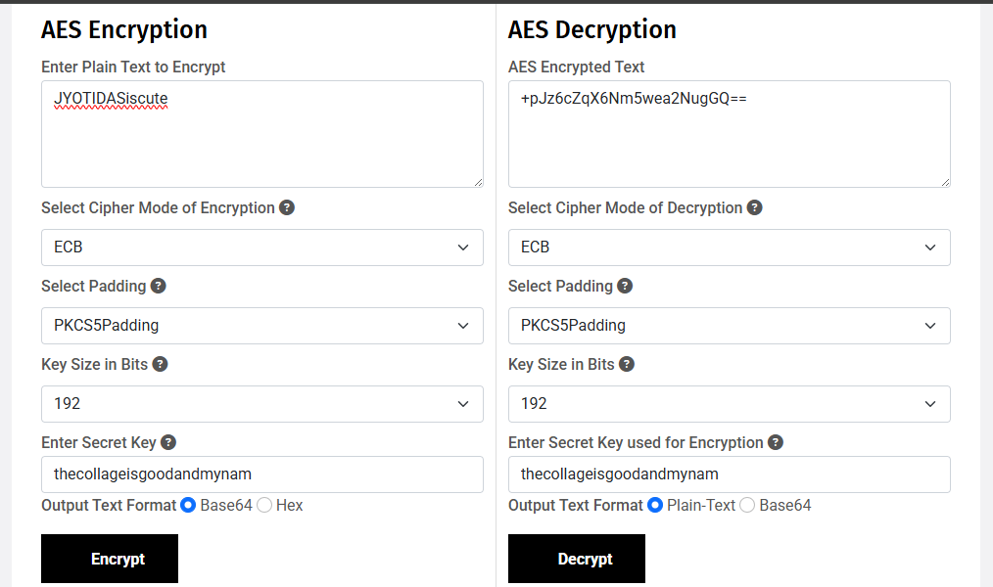
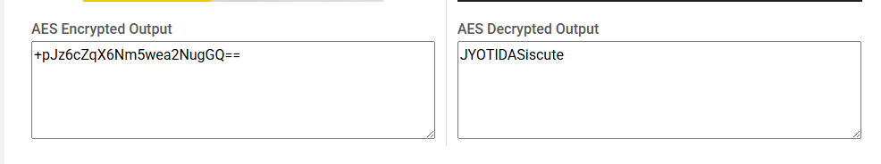

Cipher mode-ECB(256 bits)

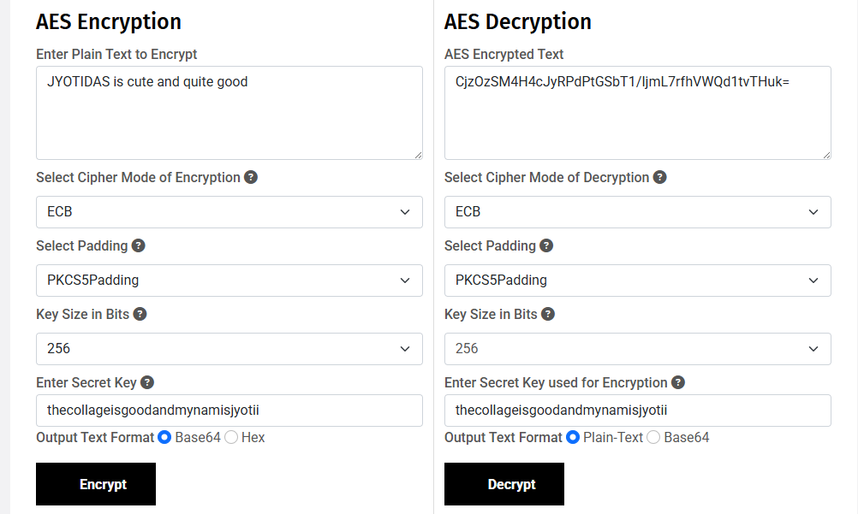
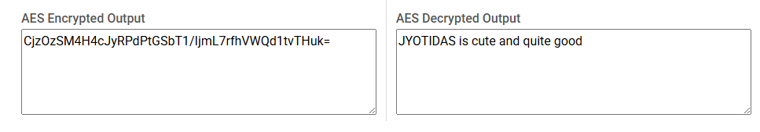

Cipher mode-CBC(128 bits)

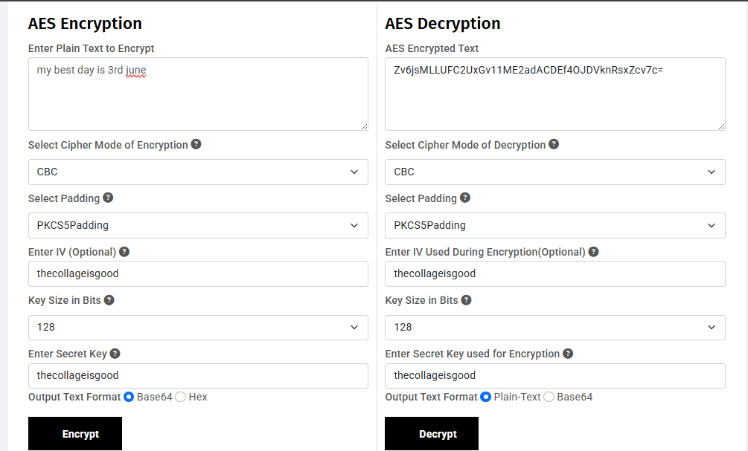
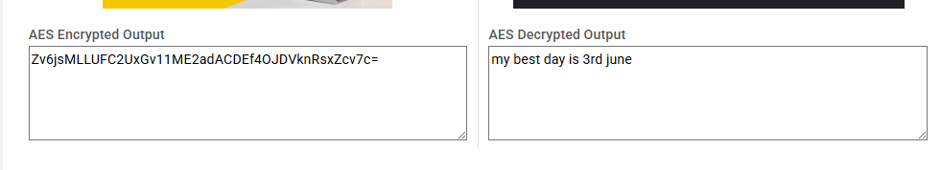

Cipher mode-CBC(192 bits)
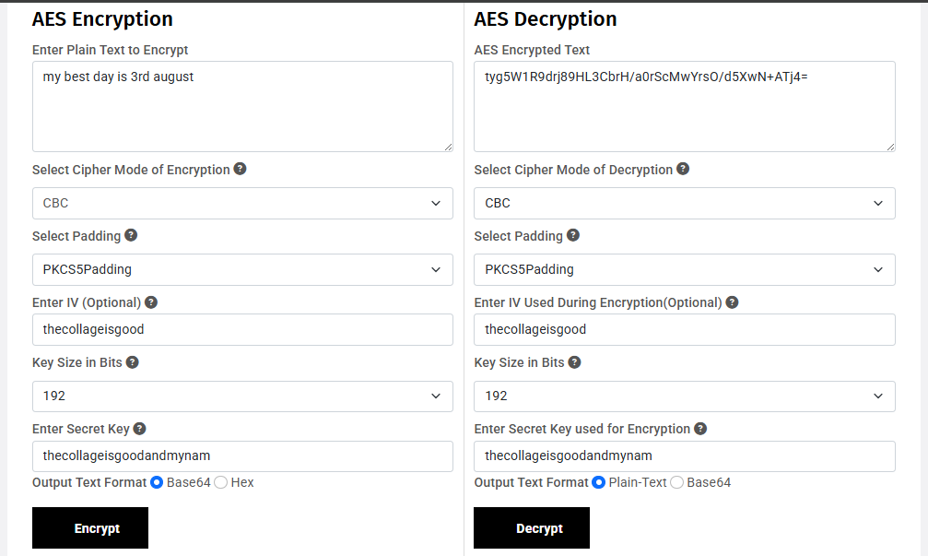
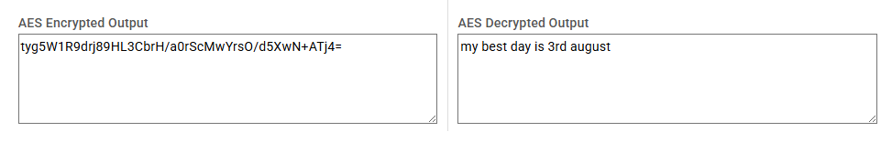

Cipher mode-CBC(256 bits)
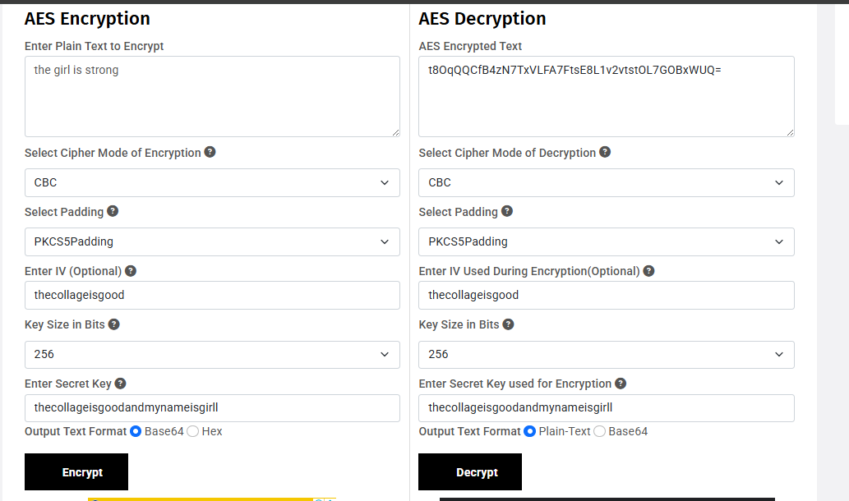
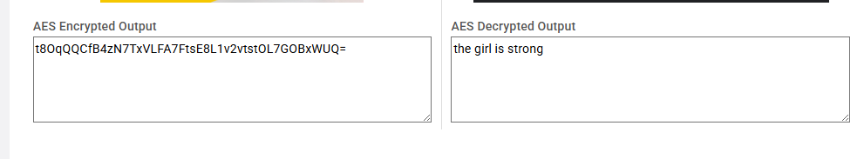

DES(ECB)-
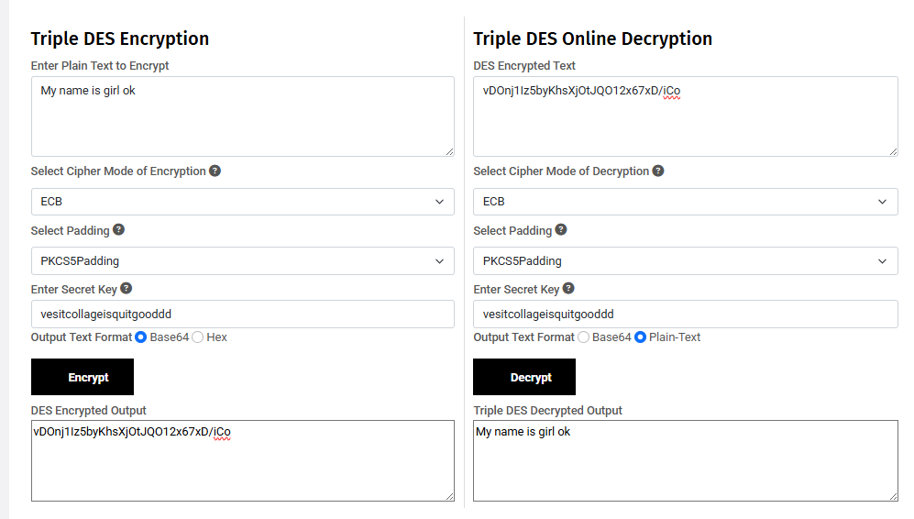
DES-CBC
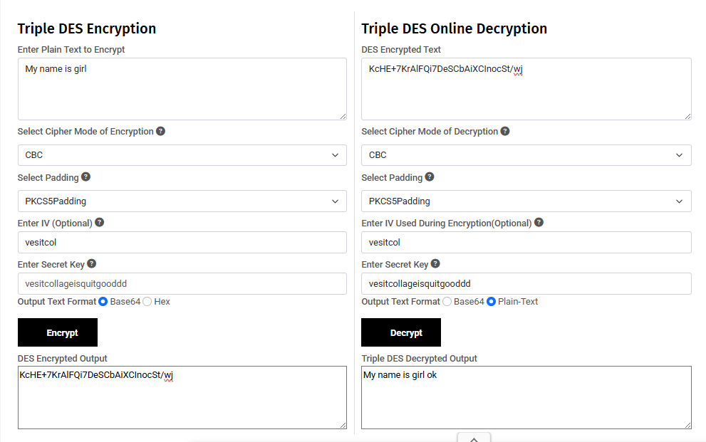

Q1.Define confusion and diffusion. Give specific examples of how DES and AES achieve these properties.
Ans.These are two key properties that contribute to the security of a block cipher, ensuring that the relationship between the plaintext, ciphertext, and the key is complex and non-linear.
- Confusion: This refers to making the relationship between the plaintext and the ciphertext as complex as possible. In simple terms, confusion tries to obscure the relationship between the plaintext and the key so that no pattern can be easily discerned.
  - Example: In AES, confusion is achieved through the use of the SubBytes operation, where each byte of the data block is substituted with a different byte from a fixed substitution table (S-box). This substitution is non-linear and helps to obscure any patterns in the plaintext.
- Diffusion: This refers to spreading out the influence of each plaintext bit across many ciphertext bits. The goal is to ensure that changing a single bit of the plaintext results in a substantial change in the ciphertext, making it hard to predict the effect of a given change in the plaintext.
  - Example: In AES, diffusion is achieved using ShiftRows (where rows of the block are shifted cyclically) and MixColumns (where the data is mixed across the entire block). These steps ensure that bits from all positions in the plaintext affect multiple positions in the ciphertext.

- DES (Data Encryption Standard):
Confusion: In DES, confusion is achieved through the S-boxes during the Feistel network structure. The S-boxes perform a non-linear substitution of input bits into output bits, making it harder to reverse-engineer the relationship between the key and the ciphertext.
- Diffusion: DES achieves diffusion through the P4 permutation (in each round), the permutation function applied after the S-box operation, and the mixing of data across rounds. The input block is split, transformed, and mixed in a way that ensures that each bit of the ciphertext depends on all bits of the plaintext.
AES (Advanced Encryption Standard):
- Confusion: As mentioned, AES achieves confusion through the SubBytes step, which uses a substitution operation based on an S-box.
- Diffusion: AES achieves diffusion through the ShiftRows and MixColumns operations. The ShiftRows operation shifts the rows of the block, and the MixColumns operation mixes data across columns. This ensures that each bit of the ciphertext depends on many bits of the plaintext, achieving good diffusion.

Q2.Describe the key expansion process for both DES and AES. How does the size of the key affect the number of rounds in AES?.
Ans.Key Expansion Process for DES and AES:
DES:DES uses a 56-bit key (though the key is typically represented as 64 bits, with 8 bits being used for parity).
The key is expanded into 16 subkeys, one for each round. Each 56-bit key is divided into two 28-bit halves. For each round, a combination of bit rotation and permutation is applied to generate a 48-bit round key.
Key schedule:
Divide the key into two 28-bit parts.
Rotate the halves and apply a permutation.
Select 48 bits from the expanded halves to form a subkey.
Repeat this process 16 times to generate 16 subkeys.
AES:
AES uses keys of three possible sizes: 128 bits, 192 bits, and 256 bits.
The key expansion process generates a set of round keys from the initial key. The number of round keys depends on the key length:
For 128-bit keys: 10 rounds (11 round keys).
For 192-bit keys: 12 rounds (13 round keys).
For 256-bit keys: 14 rounds (15 round keys).
Key schedule:
The original key is placed in the first part of the expanded key array.
Each subsequent word in the expanded key is generated using a combination of previous words, rotations, and a non-linear operation (called the Rcon for the round constant).
The final set of keys is used in each round for encryption.

Q3.What is the importance of the Initialisation Vector(IV) and CTR?
Ans.
- Initialization Vector (IV):
The IV is a random value used to ensure that the same plaintext encrypted multiple times with the same key produces different ciphertexts. It prevents attackers from deducing information about the plaintext by analyzing multiple ciphertexts that are encrypted using the same key.
- Usage: In modes like CBC (Cipher Block Chaining), the IV is XOR'd with the first block of plaintext before encryption. Each subsequent block is XOR'd with the previous ciphertext.
Counter (CTR) Mode:
- In CTR mode, an initial counter value is encrypted with the key to produce a "keystream," which is then XOR'd with the plaintext to generate the ciphertext.
- The key advantage of CTR is that it allows parallelization, unlike other modes like CBC, making it faster in some contexts. The counter ensures that each encryption operation produces a unique output, even when the same plaintext is encrypted multiple times with the same key.

Q4.Compare the computational complexity of implementing DES versus AES based on your practical experience. Which algorithm is more resource-intensive and why?
Ans-
Here's a simple comparison between AES and DES in table form:
Aspect | AES (Advanced Encryption Standard) | DES (Data Encryption Standard)
Key Size | 128, 192, or 256 bits | 56 bits
Block Size | 128 bits | 64 bits
Rounds | 10 (128-bit), 12 (192-bit), 14 (256-bit) | 16 rounds
Security | More secure (due to larger key sizes and complex structure) | Weaker (vulnerable to brute-force attacks, 56-bit key)
AES is more resource-intensive than DES because it has larger key sizes, more rounds, and more complex operations per round. The larger block size (128 bits in AES compared to 64 bits in DES) and the increased number of rounds in AES require more CPU cycles to complete the encryption or decryption.
However, AES is also more secure than DES, making the increased resource requirement a trade-off for better cryptographic strength. With the advent of faster processors and more efficient hardware implementations, AES is widely used today for secure communications and data encryption.

Conclusion-
For encrypting long messages, AES is the preferred choice due to its larger key sizes (128, 192, or 256 bits) and more secure modes of operation like CBC, CTR, and GCM, which provide strong encryption and efficiency. DES, with its smaller 56-bit key size, is considered insecure for modern use, especially for long messages, and should be avoided due to vulnerability to brute-force attacks.

