**Pizza Sales SQL Queries**

1. **KPI’s**
2. **Total Revenue:**

select sum(total_price) as Total_Revenue from pizza_sales;

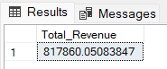

1. **Average Order Value:**

select sum(total_price) / count(distinct(order_id)) as Average_Order_Value from pizza_sales;

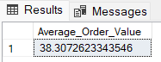

1. **Total Pizzas Sold:**

select sum(quantity) as Total_Pizzas_Sold from pizza_sales;

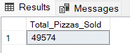

1. **Total Orders:**

select count(distinct(order_id)) as Total_Orders from pizza_sales;

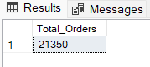

1. **Average Pizzas Per Order:**

select cast(sum(quantity) as decimal(10,2)) / cast(count(distinct(order_id)) as decimal(10,2)) as Average_Pizzas_Per_Order from pizza_sales;

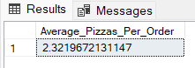

1. **Charts Requirement**
2. **Daily Trends For Total Orders:**

select datename(dw , order_date) as Order_Day, count(distinct(order_id)) as Total_Order

from pizza_sales

group by datename(dw, order_date)

order by Total_Order;

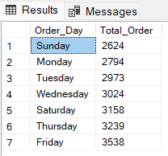

1. **Hourly Trend For Total Orders:**

select datepart(hour , order_time) as Order_Hours, count(distinct(order_id)) as Total_Order

from pizza_sales

group by datepart(hour , order_time)

order by datepart(hour , order_time);

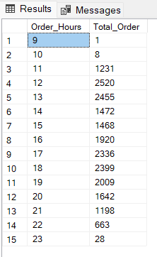

1. **Percentage Of Sales By Pizza Category:**

select pizza_category, sum(total_price) as Total_Sales, sum(total_price) * 100 / (select sum(total_price) from pizza_sales) as Perctange_Pizza_Category

from pizza_sales

group by pizza_category

order by pizza_category;

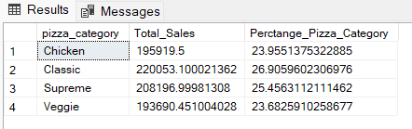

1. **Percentage Of Sales By Pizza Size:**

select pizza_size , sum(total_price) as Total_Sales, sum(total_price) * 100 / (select sum(total_price) from pizza_sales) as Perctange_Pizza_Size

from pizza_sales

group by pizza_size

order by pizza_size;

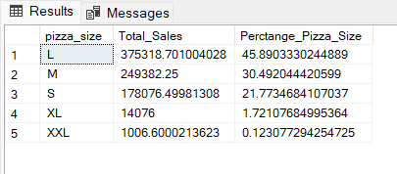

1. **Total Pizzas Sold By Pizza Category:**

select pizza_category , sum(quantity) as Total_Pizzas_Sold

from pizza_sales

group by pizza_category

order by pizza_categor;

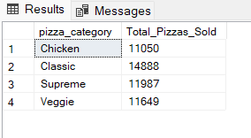

1. **Top 5 Best Sellers By Total Pizzas Sold:**

select top 5 pizza_name , sum(quantity) as Top_Pizzas

from pizza_sales

group by pizza_name

order by Top_Pizzas desc;

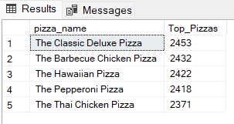

1. **Bottom 5 Worst Sellers By Total Pizzas Sold:**

select top 5 pizza_name , sum(quantity) as Top_Pizzas

from pizza_sales

group by pizza_name

order by Top_Pizzas asc;

