

**Estimate and**

**Scope of Work (SOW)**

**For**

**HealTrail**

Contents

2 Introduction 3

3 System Structure 4

4 Patient’s Application 5

5 Doctor’s Application 5

6 Diagnostic’s Application 5

7 Suggested Steps to Build the System 6

8 Assumptions 7

9 Estimates 7

# Introduction

Techtm will develop a website along with an android application for HealTrail, whose primary goal is to provide functionalities from a Doctor’s view which include scheduling of appointments online, getting payments online, and track patient medical history and display charge list of doctors, hospitals and diagnostics to a patient.

Techtm will develop the following:

1. Website
   1. Doctor
   2. Patient
   3. Diagnostic
2. Android Application
   1. Doctor
   2. Patient

In this SOW the details discussed will be in context with the website. Specific feature list will be included for the android applications as well.

# System Structure

Following are the modules for the system:

1. GUI
   1. Website (Patient)
   2. Website (Doctor)
   3. Website (Diagnostic)
   4. Android App (Patient)
   5. Android App (Doctor)
2. Database Design
3. Login
4. User Profile
5. E-Report
6. Prescription
7. Display of Doctor and Diagnostic Charge list
8. Display list of Doctors and Diagnostics
9. Booking Appointment
10. Contacts misc. services
11. Request Service (Nurse)
12. Payment

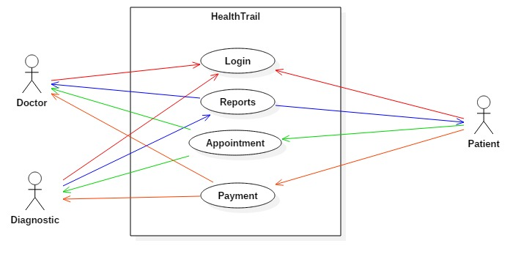

# Patient’s Application

**Features:**

1. Login
2. User Profile
3. E-Report
4. Prescription
5. Display of Doctor and Diagnostic Charge list
6. Display list of Doctors and Diagnostics
7. Booking Appointment
8. Contacts misc. services
9. Request Service (Mail)
10. Payment

# Doctor’s Application

**Features:**

1. Login
2. Patient List
3. Appointment
4. Request Diagnostic
5. Prescription
6. Track Payments

# Diagnostic’s Application

1. Login
2. Appointment
3. Request Pending
4. Track Payments

# Suggested Steps to Build the System

Once the proposal is accepted then we suggest the following steps for building the application-

1. Techtm spends time in understanding the requirements in detail and makes an RUD and sends it for approval.
2. Once RUD (Requirement Understanding Document) gets approved, further changes are considered as CR (Change Request) and will be considered during UAT (User Acceptance Testing).
3. Techtm sends test cases and needs approval from client.
4. Development of the mobile application starts
5. Project planning is done and few interim releases are given to client
   1. They test it and give their feedback
   2. Each release will have some sign offs to be done e.g. in one of the initial interim releases client will need to sign off functionality
6. Final release is given. UAT is done
7. Project closure

# Assumptions

* The app will run in portrait mode only.
* The app will run on Android Smartphones only
* Android: Application will support Lollipop 5.0 and above.
* Wireframes will be provided by client for both website and application
* Application and website will be in English language only.
* Application will run in a not updated in offline mode.
* Drugstore and Wellness Centre modules are not included

# Estimates

|  |  |  |  |
| --- | --- | --- | --- |
| # | Module | Website (Hrs.) | Android (Hrs.) |
| 1 | DB Modelling | 8 | |
| 2 | DB Generation | 5 | |
| 3 | Wireframe | 8 | 8 |
| 4 | GUI Design | 20 | 20 |
| 5 | Login Module | 20 | 10 |
| 6 | Front-end Scripting | 10 | 10 |
| 7 | Back-end Scripting | 26 | 25 |
| 8 | Testing and implementation | 15 | 15 |
| Total |  | **200** | |

**Cost per Hour: Rs.150**

**Number of Resources: 3**