Samraddhi Gupta

Nishit Mehta

Payroll Management System

2016

# Objective

Managing the payroll system these days turn out to be highly complex and full of errors. Some of the Problems faced by Companies are:

## **1. Administrative Overwhelm**

Many businesses, especially smaller ones, still carry out their payroll process in-house and manually. A manual payroll system typically requires a great deal of paperwork. A manual process also creates an administrative burden for you and your HR staff.

Errors in data entry, for example, can create payment [issues](http://blog.accuchex.com/3-common-payroll-management-errors-that-can-derail-you) and the misapplication of rules. This can resolved by using an integrated software. In fact, a great initial solution is to simply invest in payroll software, which can be far more cost-effective than hiring additional staff to handle a growing manual process.

Another approach that even smaller businesses can afford is to outsource your payroll management. This allows some or all of your payroll and HR processes to be managed by a professional firm.

## **2. Organizational Issues**

A related problem is one of simply keeping all of your important payroll and employee records and information organized in an effective and accurate manner. Sometimes it is simply a matter of work flow: keeping files and documents in a central location and creating uniform filing processes.

Gradually minimizing, or even eliminating, paper forms and files can be an effective solution, this, too, can be accomplished by using a payroll [software](http://blog.accuchex.com/top-5-software-tools-for-payroll-management) that has all your human resources and payroll functions integrated. But whether you retain a manual approach or invest in a robust payroll software package, it is important to analyze and re-think your organizational process.

## **3. Incompatible Software**

If you haven't experienced it already, you may find that not all payroll programs are compatible. For example, the program used for your employee profiles or records may be different from the system you use for pay and benefits. And what about the program used for your employee performance?

Finding and investing in a program that can integrate all of these functions will streamline your overall process, reduce the amount of time spent tracking and with data input, and even allow your entire department to become more [efficient](http://blog.accuchex.com/3-primary-tools-of-payroll-management) and cost-effective.

## **4. Tracking Employee Absence**

Manually tracking your employees' vacation and [sick days](http://blog.accuchex.com/how-to-address-sick-leave-abuse-in-the-workplace) can be a task fraught with potential for mistakes. Paper time cards and even simple digital time sheets are notoriously prone to misuse and unintended errors. In addition to the payroll, tracking which employees are not available due to various types of absence, is critical for effective planning and optimum productivity.

# Flow

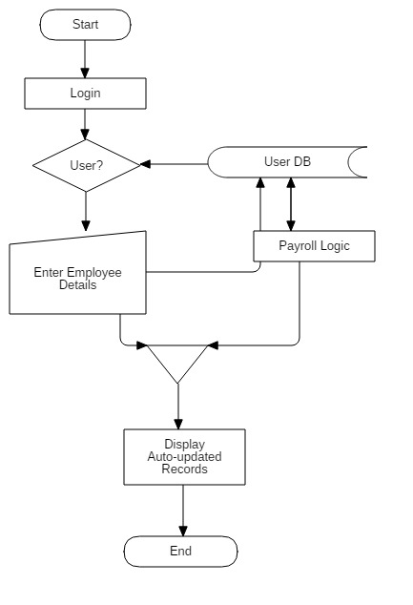

# Application

* Web App for the authentic users to add, update, modify records
* Interface according to user role.
* Operations on DB can be performed on the basis of Roles
* An Employee can view his/her Payroll Structure and find the supporting documents

# Technologies Supported

* Front-end – Bootstrap
* Back-end – PHP5
* Works fine on any device with a browser

# Assumptions

* WebApp is responsive
* Logics and wireframes will be provided by the company
* System should support PHP5 or above

# Estimates

|  |  |  |
| --- | --- | --- |
| # | Module | Website (Hrs.) |
| 1 | DB Modelling | 8 |
| 2 | DB Generation | 5 |
| 3 | Wireframe | 8 |
| 4 | GUI Design | 20 |
| 5 | Login Module | 10 |
| 6 | Front-end Scripting | 10 |
| 7 | Back-end Scripting | 25 |
| 8 | Testing and implementation | 15 |
| Total |  | **200** |

**Cost per Hour: Rs.350**

**Number of Resources: 4**