TRAFFIC & ACCIDENT
INTELLIGENCE SYSTEM
PROJECT DOCUMENTATION

Item | Details
Project Type | Data Analytics / Traffic & Accident Intelligence
Primary Data | 911 emergency-event JSON data
Database | SQLite
Programming | Python
Query Language | SQL
Dashboard | Traffic and accident intelligence dashboard

This documentation describes the proposed data model, data processing workflow, analytics, database design, dashboard requirements, and implementation plan.

Table of Contents
- 1. Introduction
- 2. Project Overview
- 3. Problem Statement
- 4. Objectives
- 5. Scope of the Project
- 6. Data Source and Data Fields
- 7. Data Understanding
- 8. System Architecture
- 9. Data Model / ER Design
- 10. Database Design
- 11. Data Cleaning and Preparation
- 12. Data Classification
- 13. SQL Analytics
- 14. Python Analytics
- 15. Risk Analysis
- 16. Dashboard Design
- 17. Functional Requirements
- 18. Non-Functional Requirements
- 19. Project Workflow
- 20. Testing Strategy
- 21. Limitations
- 22. Future Enhancements
- 23. Conclusion

1. Introduction
The Traffic & Accident Intelligence System is a data analytics project intended to convert emergency-event records into structured information that can be analyzed by location, time, incident category and other derived indicators. The supplied data is an event-level 911 JSON feed containing geographic coordinates, timestamps, township, ZIP code, address, title, description and an event flag.
The system is designed around a SQLite database so that the raw records can be cleaned, organized and queried efficiently. Python can be used for data preparation and analysis, while SQL provides the main relational analytics layer. The final dashboard presents the results through KPI cards, trend charts, distributions, hotspot views and critical-incident tables.

2. Project Overview
The project follows an end-to-end analytics pipeline:
- Collect or load the 911 event JSON data.
- Clean and standardize the raw records.
- Extract date, time, category and other analytical attributes.
- Store the organized data in SQLite.
- Run SQL queries to generate analytical summaries.
- Use Python for transformation, analysis and visualization.
- Calculate location/time-based risk indicators where the required data exists.
- Expose the results in a dashboard for monitoring and decision support.

3. Problem Statement
Emergency and traffic-related events may occur at many locations and times. A flat event dataset makes it difficult to answer questions such as which locations experience repeated accidents, when incidents are most frequent, which categories dominate, and where potential hotspots exist. The project addresses this problem by creating a structured analytics system that transforms individual event records into useful summaries and visual insights.

4. Objectives
- Create a structured SQLite database for emergency and traffic event data.
- Clean and standardize event timestamps, locations and text categories.
- Classify incident titles into useful categories and subcategories.
- Analyze incidents by location, date, hour and category.
- Identify frequently occurring accident locations and geographic clusters.
- Create severity and risk indicators as derived analytics when sufficient source data is available.
- Build dashboard-ready datasets for KPIs, charts and maps.
- Provide a foundation for future live data integration and predictive analytics.

5. Scope of the Project

5.1 Included
- 911 event ingestion and storage.
- SQLite database design.
- Data cleaning and transformation.
- Traffic and accident event classification.
- Temporal analysis.
- Location and hotspot analysis using latitude/longitude.
- Severity distribution using derived rules or supplied severity data.
- SQL and Python analytics.
- Dashboard-oriented reporting.

5.2 Optional / Requires Additional Data
- Real traffic volume from sensors.
- Actual emergency response time.
- Weather conditions.
- Road surface/road condition information.
- Live CCTV or traffic-camera feeds.
- Verified operational severity and response SLA fields.

6. Data Source and Data Fields
The supplied 911 JSON data contains event records. The provided records demonstrate fields including latitude, longitude, description, ZIP code, title, timestamp, township, address and an event flag. Examples in the supplied data include vehicle accidents, disabled vehicles, EMS incidents and fire incidents.
Field | Type / Meaning | Use
lat | Numeric latitude | Map plotting and hotspot analysis
lng | Numeric longitude | Map plotting and hotspot analysis
desc | Event description | Detailed event context
zip | ZIP code; may be missing | Geographic grouping
title | Event title | Primary classification
timeStamp | Date and time | Trend, hour and day analysis
twp | Township | Location-level aggregation
addr | Address/intersection | Location identification
e | Event/source flag | Source-level event indicator

7. Data Understanding
The data is event-oriented rather than a complete traffic-sensor dataset. Therefore, the strongest directly supported analyses are incident frequency, incident type, township, address, timestamp and geographic distribution. Fields such as traffic volume, response time and weather impact should not be presented as measured facts unless those additional datasets are integrated.
Repeated locations may appear in the source records, and the same physical event may also have related emergency-service records. The final analytical logic should define clearly whether the system counts every emergency event or only records classified as traffic/accident incidents.

8. System Architecture
The recommended architecture separates raw data, processing, database storage, analytics and presentation.
Layer | Responsibility | Suggested Technology
Data Layer | Raw 911 event records | JSON / CSV
Processing Layer | Cleaning, parsing, classification | Python
Database Layer | Structured storage and queries | SQLite + SQL
Analytics Layer | Aggregations, trends, risk indicators | SQL + Python
Visualization Layer | Charts, maps and dashboard KPIs | Python / Web / BI-style dashboard
Presentation Layer | Operational dashboard | Web dashboard

9. Data Model / ER Design
A normalized/star-style model is recommended. FACT_INCIDENT is the central table, while dimension tables contain reusable location, category, date, time and station information. DERIVED_RISK_ANALYSIS stores location-level analytical summaries.
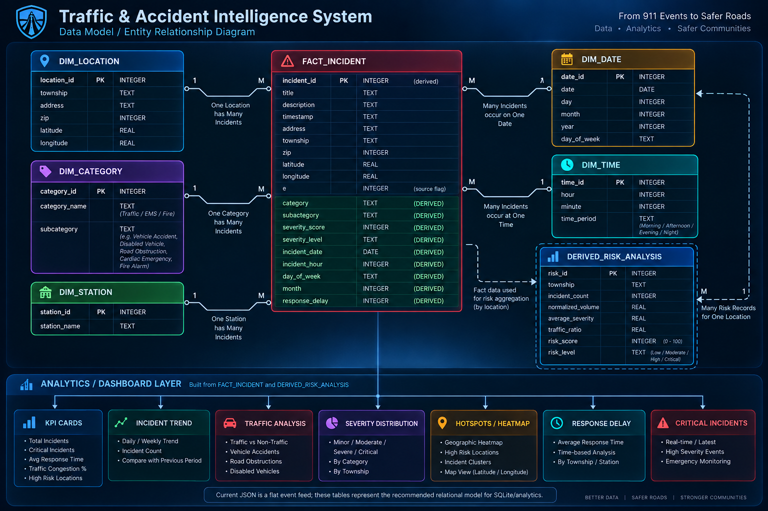
Figure 1. Proposed data model / entity relationship design.

10. Database Design
Table | Key Fields | Purpose
DIM_LOCATION | location_id, township, address, zip, latitude, longitude | Stores reusable geographic information
DIM_CATEGORY | category_id, category_name, subcategory | Stores incident classifications
DIM_STATION | station_id, station_name | Stores emergency/service station references when available
DIM_DATE | date_id, date, day, month, year, day_of_week | Supports date-based analysis
DIM_TIME | time_id, hour, minute, time_period | Supports hour and day-period analysis
FACT_INCIDENT | incident_id plus dimension keys and event fields | Central event/fact table
DERIVED_RISK_ANALYSIS | risk_id, location, incident_count, severity, risk_score | Stores calculated location-level risk summaries

10.1 Relationship Logic
- One location can have many incident records.
- One category can contain many incident records.
- One date can contain many incident records.
- One time period can contain many incident records.
- One station can be associated with many incidents when station information is available.
- Risk analysis aggregates many incident records into location-level summaries.

11. Data Cleaning and Preparation
- Load the JSON file into Python.
- Validate required fields such as title, timestamp and geographic coordinates.
- Convert timestamps into a consistent datetime format.
- Separate date and time components.
- Normalize text such as title, township and address.
- Handle missing ZIP codes and other missing values without inventing data.
- Validate latitude and longitude ranges.
- Remove exact duplicates when a duplicate rule is justified.
- Create category and subcategory fields from event titles.
- Load cleaned records into the SQLite database.

12. Data Classification
The dashboard requires a consistent classification layer. The supplied titles can be mapped into broad groups such as Traffic, EMS and Fire, followed by more detailed subcategories.
Source Example | Broad Category | Possible Subcategory
Traffic: VEHICLE ACCIDENT - | Traffic | Vehicle Accident
Traffic: DISABLED VEHICLE - | Traffic | Disabled Vehicle
EMS: VEHICLE ACCIDENT | EMS | Vehicle Accident
EMS: FALL VICTIM | EMS | Fall
Fire: FIRE ALARM | Fire | Fire Alarm
Fire: HAZARDOUS MATERIALS INCIDENT | Fire | Hazardous Materials

The exact classification rules should be documented in the implementation so that the same rules are applied every time new data is loaded.

13. SQL Analytics
Typical SQL analysis questions include:
- How many incidents occurred in each township?
- Which locations have the highest number of traffic accidents?
- What are the most common incident categories?
- Which hours have the highest incident counts?
- How do incidents vary by day of week?
- How many critical/severe incidents occur in a selected period?
- Which locations repeatedly appear in accident records?

13.1 Example SQLite Queries

Total incidents
SELECT COUNT(*) AS total_incidents FROM fact_incident;

Incidents by township
SELECT township, COUNT(*) AS incident_count
FROM fact_incident
GROUP BY township
ORDER BY incident_count DESC;

Incidents by category
SELECT category, COUNT(*) AS incident_count
FROM fact_incident
GROUP BY category
ORDER BY incident_count DESC;

Incidents by hour
SELECT incident_hour, COUNT(*) AS incident_count
FROM fact_incident
GROUP BY incident_hour
ORDER BY incident_hour;

14. Python Analytics
Python is used as the processing and analytics layer. The Python program can connect to SQLite using the built-in sqlite3 module, execute SQL statements, retrieve result sets and perform additional calculations. Data can then be transformed into chart-ready structures.
- Read JSON data.
- Clean and transform records.
- Create or update SQLite tables.
- Run analytical SQL queries.
- Calculate derived metrics.
- Prepare chart and map data.
- Export results for the dashboard.
For the basic SQLite implementation, no external database driver is required because Python includes the sqlite3 module.

15. Risk Analysis
Risk analysis is a derived layer. A risk score should be based only on measurable fields. A simple location-level model can combine incident frequency, severity and recency. If traffic volume is later integrated, accident frequency can be normalized by exposure.
Indicator | Meaning | Data Requirement
Incident Frequency | Number of relevant incidents | Available from event data
Severity | Relative seriousness of an incident | Derived rule or verified severity field
Recency | Weight for recent incidents | Timestamp
Traffic Exposure | Incidents relative to traffic volume | Traffic sensor/volume data
Hotspot Density | Concentration of nearby events | Latitude/longitude

The dashboard may categorize locations as Low, Moderate, High or Critical after a transparent scoring formula is defined and validated.

16. Dashboard Design
The supplied dashboard concept contains an operational dark-themed interface with quick filters, KPI cards, time-series charts, traffic analysis, hotspot mapping, severity/type distributions, critical incidents and a performance/insights section.
Component | Purpose
Quick Filters | Filter by location, incident type, severity, road condition and date
Total Accidents | Display the total classified accident count
Critical Accidents | Display high-severity/critical incident count
Traffic Incidents | Display traffic-related event count
High Risk Locations | Display locations meeting risk criteria
Average Response Time | Display only when response-time data exists
Traffic Congestion | Display only when traffic-volume/congestion data exists
Accident Trend | Show incident counts over time
Traffic Volume | Show vehicle volume over time when sensor data exists
Hotspots | Show geographic concentration using coordinates
Severity Distribution | Show incident share by severity
Type Distribution | Show incident share by type
Critical Incidents | Show recent/high-priority records

17. Functional Requirements
- The system shall load event records from the selected data source.
- The system shall validate and clean the incoming records.
- The system shall store cleaned records in SQLite.
- The system shall support incident searches by date, location and category.
- The system shall calculate incident counts and distributions.
- The system shall support geographic hotspot analysis.
- The system shall generate dashboard-ready analytical outputs.
- The system shall clearly distinguish directly measured data from derived metrics.

18. Non-Functional Requirements
- Accuracy: Calculations should be reproducible from the stored data.
- Performance: SQL aggregation should remain efficient for the selected dataset size.
- Usability: Dashboard filters and charts should be easy to understand.
- Maintainability: Data cleaning and classification rules should be separated from visualization logic.
- Scalability: The design should allow later integration of additional traffic, weather and response datasets.
- Reliability: Database operations should use transactions and handle invalid records safely.

19. Project Workflow
Step | Stage | Output
1 | Raw Data | 911 JSON event feed
2 | Cleaning | Missing values, timestamps, text normalization
3 | Transformation | Date/time extraction and category derivation
4 | Database | Load into SQLite tables
5 | SQL | Aggregate and filter data
6 | Python | Perform additional analysis and prepare visuals
7 | Risk | Generate location-level derived indicators
8 | Dashboard | Present KPIs, trends, maps and critical incidents

20. Testing Strategy
Test | Expected Result
Database connection | SQLite database opens successfully
Table creation | Required tables are created without errors
Data insertion | Valid records are stored
Data retrieval | SELECT queries return expected records
Update/delete | Changes affect only intended records
Timestamp parsing | Dates and hours are extracted consistently
Classification | Known titles map to expected categories
Missing values | Missing fields are handled without fabricated values
Hotspot calculation | Coordinates are plotted/aggregated correctly
Dashboard filters | Selected filters update analytical outputs

21. Limitations
- The supplied JSON is primarily an emergency-event feed and does not itself provide complete traffic sensor measurements.
- Actual response time is not directly available in the supplied records.
- Weather and road-condition analysis require additional datasets.
- Traffic congestion and traffic volume require sensor or equivalent traffic data.
- Severity and risk levels are derived unless verified source fields are supplied.
- Some source records have missing ZIP values.
- The system should not claim real-time capabilities unless a live ingestion source is actually connected.

22. Future Enhancements
- Integrate live traffic sensor data.
- Integrate weather information.
- Integrate emergency dispatch and response-time records.
- Add automated geographic clustering and hotspot detection.
- Add live dashboard refresh.
- Add user authentication and role-based dashboard access.
- Add scheduled ETL/data-refresh jobs.
- Add predictive modeling after obtaining suitable historical labeled data.
- Deploy the dashboard as a web application.

23. Conclusion
The Traffic & Accident Intelligence System provides a practical framework for turning raw 911 emergency-event records into structured analytics. The proposed SQLite model creates a reliable foundation for SQL analysis, while Python supports cleaning, transformation and advanced analytical processing. The dashboard then converts the analytical outputs into understandable KPIs, trends, distributions and geographic insights.
The current dataset supports meaningful analysis of event frequency, category, time and location. Additional data sources are required for validated traffic-volume, congestion, weather, road-condition and emergency-response metrics. With those integrations, the project can be extended into a more comprehensive traffic and accident intelligence platform.

Appendix A — Suggested Project Folder Structure
TrafficAccidentIntelligence/
│
├── data/
│ ├── raw/
│ │ └── 911.json
│ └── processed/
│
├── database/
│ └── traffic_accident.db
│
├── python/
│ ├── data_cleaning.py
│ ├── database.py
│ ├── analytics.py
│ └── risk_analysis.py
│
├── sql/
│ ├── schema.sql
│ ├── analysis_queries.sql
│ └── views.sql
│
├── dashboard/
│ ├── frontend/
│ └── backend/
│
├── reports/
│ ├── Project_Report.pdf
│ └── Documentation.docx
│
└── README.md

Appendix B — Key Definitions
Term | Definition
Incident | One event record in the source/event dataset
Hotspot | A geographic area with relatively concentrated incident activity
Severity | A classification representing the seriousness of an incident
Risk Score | A calculated indicator derived from selected measurable factors
Fact Table | Central table containing event-level analytical records
Dimension Table | Table containing descriptive attributes used to group facts
ETL | Extract, Transform and Load process used to prepare data
KPI | Key Performance Indicator displayed for quick monitoring

