HERO STEELS LIMITED · ZEDRAL PLATFORM

M1 Data Capture Layer ↔ Zedral Platform
Integration Specification — Developer Handover
Audience: M1 capture team + Zedral platform engineering (Manifold, Data Lake, Operational Monitoring, Platform/Security).
Status: v1 for build. Date: 31 May 2026. Classification: Confidential.
Companion documents: M1 Technical Blueprint (M1-00…M1-09); Zedral Technical Design Document specs 00–09. This document is the contract between them.

Contents
1. Purpose, Audience & Scope 3
2. How M1 and Zedral Relate 3
3. Binding Principles That Govern the Integration 4
4. The Three Connection Channels 5
5. Channel 1 — Batch Ingest & Conformance (Manifold) 5
6. Channel 2 — Real-time Events (Kafka → Monitoring) 7
7. Channel 3 — Shared Foundations (Design-time) 8
8. Where M1 Data Lands — Data Lake Zones 9
9. Interface Reference 9
10. Mapping Reference Tables 10
11. Security, Tenancy, Lineage & Audit 11
12. Build Phasing & Sequencing 11
13. Developer Integration Checklist 12
14. Open Items & Assumptions 12
15. Glossary & Source References 13

1. Purpose, Audience & Scope
This document specifies how the M1 Data Capture Layer connects to the Zedral platform. M1 is the build-ready, offline-first PWA that digitises the Hero Steels cold-rolling shop floor along the COIL_NO traceability spine. Zedral is the multi-tenant intelligence platform that ingests many sources, conforms them to a single Canonical Model, and serves intelligence, monitoring and reporting on top.
The relationship is one-directional in the runtime sense: M1 is a source that feeds Zedral — Zedral never reaches into M1. M1 was deliberately built with stable contracts (versioned REST APIs, domain events, a read replica, canonical naming) precisely so the platform can attach without disturbing capture.

In scope
- The three connection channels between M1 and Zedral, with their flows, contracts and sequencing.
- Interface reference (M1 surfaces, Manifold endpoints, Data Lake serving endpoints, event topics).
- Entity/field mapping from the M1 schema to the Zedral Canonical Model, and the planning auto-source map.
- Security, tenancy, lineage and audit obligations across the boundary; build phasing and a developer checklist.

Out of scope
- M1 internal capture design (process forms, UX, offline sync) — see the M1 Technical Blueprint.
- Zedral component internals — see specs 01 Data Lake, 02 Canonical Model, 03 Manifold, 04 UIL, 05 Monitoring, 06 Reporting, 08 Platform/Security.

2. How M1 and Zedral Relate
M1 is one source among several the platform is designed to ingest (ERP/SAP, generic files and databases, and PLC/sensor streams). Everything that enters the platform passes through Manifold, lands in the Data Lake, is conformed to the Canonical Model, and is then read by every consumer from the canonical Serving zone. M1 occupies the privileged position of being the first-party, highest-fidelity source — and the reference implementation the canonical model itself was generalised from.
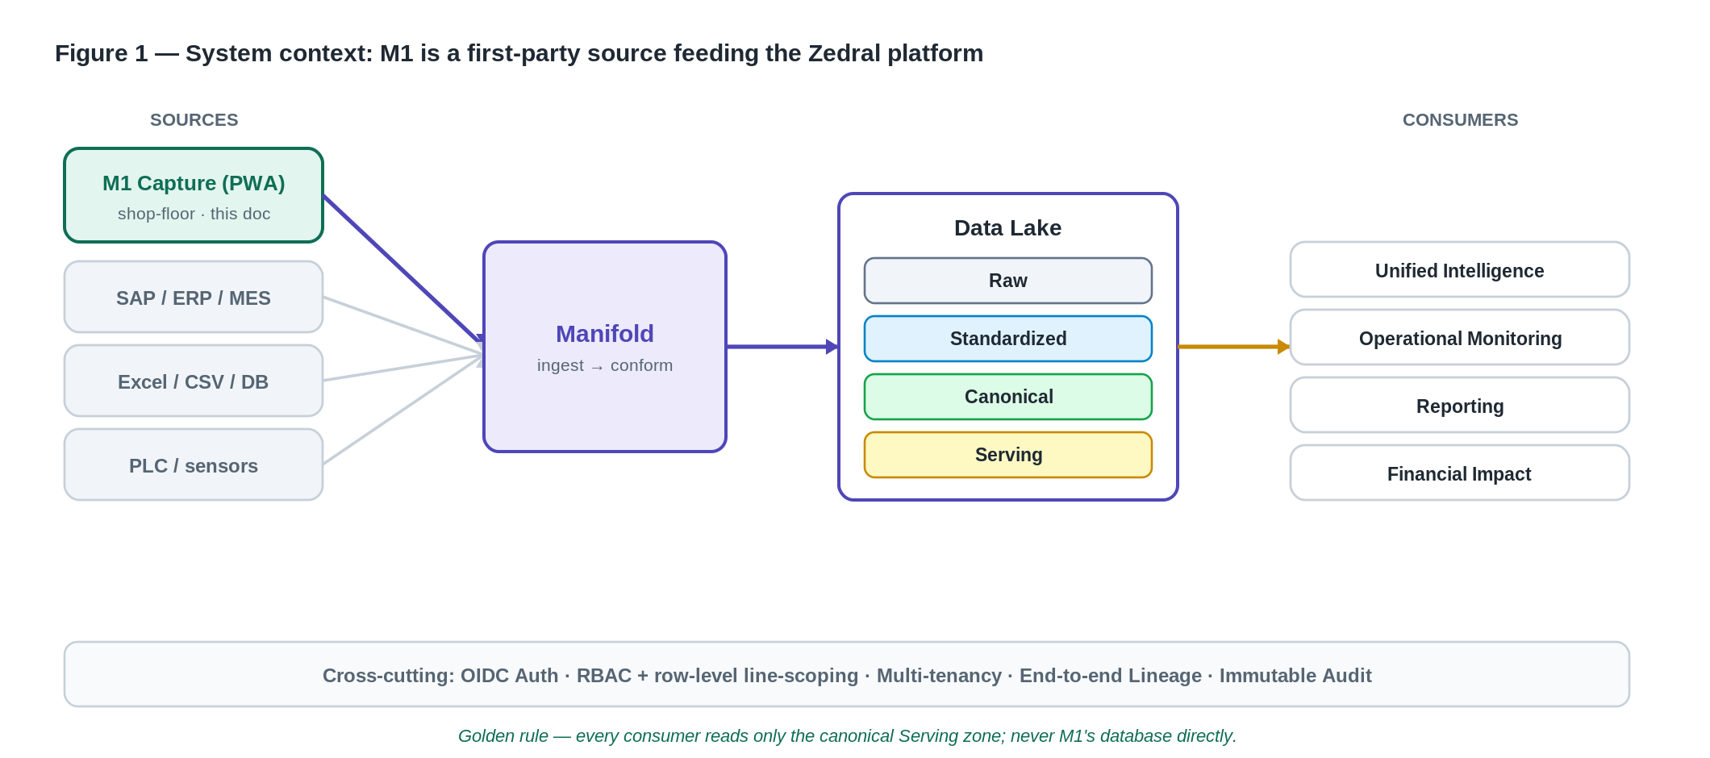
Figure 1 — M1 is a first-party source feeding the Zedral platform through Manifold.
Concretely, M1 plugs into Zedral over three distinct channels, described in section 4 and detailed in sections 5–7.

3. Binding Principles That Govern the Integration
These constraints are inherited from the platform's ratified architectural decisions (D1–D11) and the M1 blueprint. Treat them as constraints, not suggestions.
The golden rule
Every consumer (Unified Intelligence, Monitoring, Reporting, Financial Impact, future modules) reads ONLY the canonical Serving zone.
No component ever reads M1's database, M1's APIs, or another component's store directly. The Canonical Model is the contract that decouples everyone.
Capture is never blocked (D2). Zedral pulls (batch) and subscribes (events); it never sits in M1's write path. M1 keeps capturing through network loss and even if the platform is down. Near-real-time (minutes) is the default latency target, tunable per tenant.
Decoupling via stable contracts. M1 exposes versioned REST APIs, domain events on Kafka, and a read replica — and forbids direct table access. Zedral consumes exactly those contracts, so each side can evolve independently.
Conservative, auditable ingestion (D5, D3). Auto-mapping only auto-accepts high-confidence matches; everything else goes to a human review queue. Entity resolution is deterministic-first (keyed on COIL_NO). Every mapping, override and survivorship decision is versioned and audit-logged.
Connector roadmap order (D4). File (CSV/XLSX) + generic DB (JDBC) connectors are the v1 baseline; SAP/Oracle/MES and PLC/streaming come later. This determines how M1 is first wired in (section 5.1).
Tenant isolation (D8). A tenant_id is stamped on every record and enforced at the data-access layer; no cross-tenant path exists.

4. The Three Connection Channels
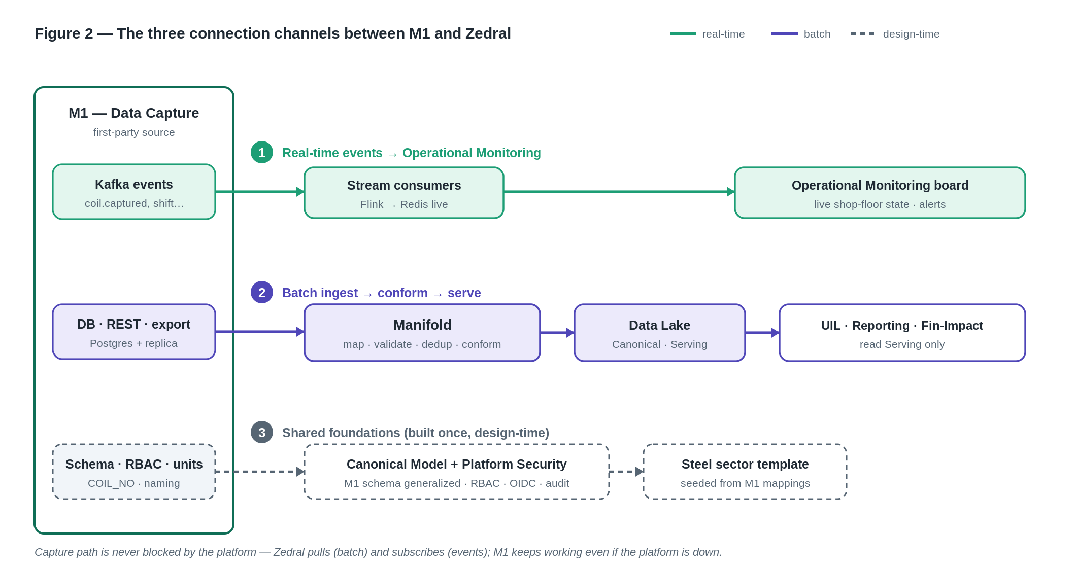
Figure 2 — The three channels: real-time events, batch ingest, and shared design-time foundations.
Channel 1 — Batch ingest & conformance (via Manifold). M1's stored data (Postgres/read replica, REST APIs, or interim CSV/XLSX exports) is pulled by Manifold, mapped and validated, conformed to canonical, and upserted into the Data Lake. This is the path for history, master data, and any record that is not time-critical.
Channel 2 — Real-time events (Kafka → Operational Monitoring). M1 emits domain events the moment they are captured; stream consumers turn them into live state for the shop-floor board and alerts. This is the near-real-time path and bypasses the slower batch lane.
Channel 3 — Shared foundations (design-time). Not a data flow: the Zedral Canonical Model, naming, identity, RBAC, OIDC and audit patterns are generalised directly from M1, and the steel sector mapping template is seeded from M1. This is the deepest coupling and the reason M1 plugs in cleanly.

5. Channel 1 — Batch Ingest & Conformance (Manifold)
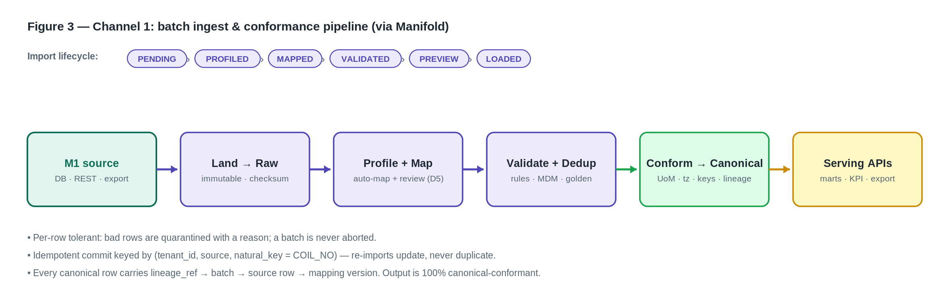
Figure 3 — The Manifold batch pipeline and import lifecycle for M1 data.

5.1 Connector contract (how M1 is wired in)
Every source reaches Manifold through a connector that implements a fixed SDK interface — adding a source is implementing the interface, with no core change:
Method | Responsibility
discover() | Return schema / tables / columns + metadata
sample(n) | Return n rows for profiling
read(mode) | mode ∈ full | incremental(CDC) | stream
write(scope, format) | Export projection (CSV/XLSX) — used by exports
auth() / health() | Credential handshake; liveness/readiness
capabilities{} | Declares { cdc, stream, schema_discovery }
For M1, per D4 the v1 wiring uses the generic DB (JDBC) connector against M1's read replica, or the file connector against M1's CSV/XLSX export. A dedicated, schema-aware M1 connector (and SAP) is a later-phase add. Either way the downstream pipeline is identical.

5.2 Import lifecycle & error handling
Each import is a state machine: PENDING → PROFILED → MAPPED → VALIDATED → PREVIEW → LOADED | PARTIAL | FAILED. The preview is a dry-run with an impact summary before commit.
- Per-row tolerant (reuse Zinance pattern, D10): a bad row is quarantined with a reason; the batch is never aborted. Result shape: { success, failed, skipped, errors[], batch_id }.
- Idempotent commit keyed by (tenant_id, source, natural_key = COIL_NO) — re-importing a corrected file updates, never duplicates.
- Every run produces an import batch record (source, file/query, counts, status, who, when) for audit.

5.3 Field mapping engine
The mapping engine scores each source field against canonical fields using weighted signals — name (token + synonym/abbreviation dictionary, edit distance), metadata (type/unit/length), instance (profiled values vs the canonical field profile), and template/historical (sector templates). Thresholds are conservative (D5):
- ≥ auto_accept → auto-mapped.
- mid confidence → review queue (human confirms).
- low → unmapped / flagged. A manual override always wins, is versioned, and is learned back into the steel template.

5.4 Dedup & master-data resolution (D3 deterministic-first)
Pipeline: blocking → match (deterministic keys) → cluster → survivorship → golden record + source_key_map. For M1, COIL_NO is the deterministic match key; survivorship favours source priority, recency and completeness, with manual override. A probabilistic matcher (Splink/Zingg) is an isolated later-phase add.

5.5 Conformance to Canonical
Conformance applies the confirmed mapping, converts units of measure, normalises timezone, maps coded values to the canonical taxonomy, assigns a surrogate canonical key, attaches lineage, and upserts into the Canonical zone: map → UoM → tz → code-map → surrogate key + lineage → upsert. Output is 100% canonical-conformant with full lineage.

5.6 Readiness
Manifold computes a per-tenant × per-module readiness score so the platform knows what it can light up: Readiness% = 100·(0.5R + 0.2A + 0.2·Q/100 + 0.1H) with the Required-coverage gate R = 100%. Status bands: Ready ≥ 85, Partial 60–84, Blocked < 60. With M1 alone, the M1 column of the module matrix (section 10.1) drives readiness.

6. Channel 2 — Real-time Events (Kafka → Monitoring)
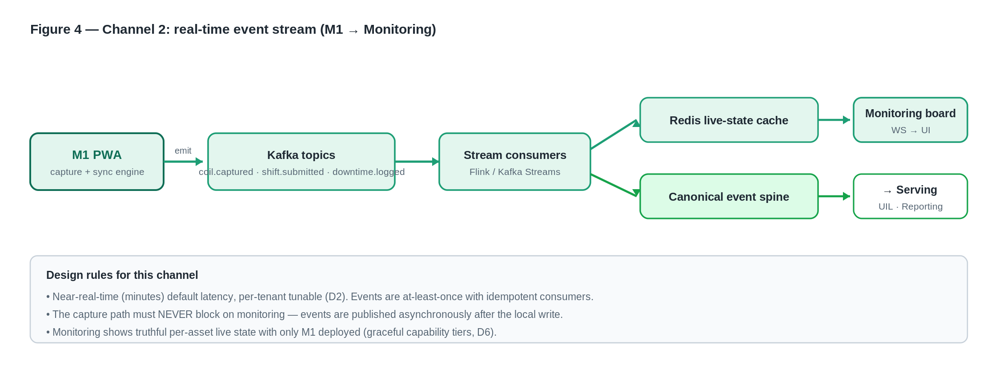
Figure 4 — M1 emits domain events that stream consumers turn into live state and alerts.
This channel exists so the shop-floor board is truthful in near-real-time without waiting for the batch lane. M1 publishes canonical domain events the moment a capture is committed; the platform subscribes.

6.1 Events M1 emits
Topic (event) | Emitted when | Primary consumer
coil.captured | A process entry is saved against a coil | Monitoring (live state, production vs target)
shift.submitted | A shift log is approved / handed over | Monitoring, Reporting (shift rollups)
downtime.logged | A stoppage is recorded | Monitoring (downtime), later UIL/OEE
Eventing is at-least-once with idempotent consumers. Events are published asynchronously after the local write — the capture path must never block on the platform.

6.2 Stream processing & surfaces
- Stream consumers (Flink / Kafka Streams) write to a Redis live-state cache (sub-second current state) and append to the canonical event spine.
- The Operational Monitoring board shows per-asset live state, production-vs-target, live metrics and an alert panel; updates push to the UI over WebSocket.
- Alerts: rule types state-change | threshold | missed-capture | anomaly, financial-tagged, de-duplicated, and role-routed by reusing M1's RBAC (e.g. a missed Pickling hourly-chart slot raises a missed-capture alert).
Works with M1 alone
Monitoring MUST show truthful per-asset live state with only M1 deployed; richer tiers (live OEE, shift/handover, yield/quality/energy + cost) unlock as platform modules M4/M3/M5/M6/M7 come online (graceful capability tiers, D6).

7. Channel 3 — Shared Foundations (Design-time)
The deepest coupling is not a pipe but a shared design lineage. The platform's foundation is generalised from M1, which is why M1 data conforms with little friction and why M1's roles and conventions carry through unchanged.

7.1 Canonical model generalises the M1 schema
The full M1 schema (M1_schema.sql, 40 tables across six schemas) is the reference implementation of the capture side; the canonical entities are its generalisation. The headline mappings:
M1 (steel-specific) | Zedral Canonical | Note
coil (COIL_NO spine) | asset / material identity | COIL_NO → canonical surrogate + source key
shift_log | event (shift/state) | Shift calendars define planned time
prod_* (per-process) | production_count / event | One Event spine; specialisations per type
stoppage | downtime + reason | Reason codes → Six Big Losses / OEE
defect | quality / defect | Coded against canonical defect master
master.customer / grade | reference masters | FK-enforced; no free-text codes

7.2 Identity, naming, units, time
- Identity: surrogate canonical IDs with source_key_map(canonical_id, source_system, native_key) preserving COIL_NO and other native keys.
- Naming: UPPER_SNAKE_CASE with the unit embedded (e.g. COIL_WIDTH_MM) — inherited from M1; one canonical field = one column.
- Units: store native value + canonical base value via to_base_factor; weight in MT plant-wide (CTL kg → MT on entry).
- Time: store UTC (TIMESTAMPTZ), carry site timezone for display, bucket to shift/day for aggregates.

7.3 Auth, RBAC & line-scoping inheritance
- OIDC SSO (Keycloak / plant IdP) — the platform uses the same identity scheme as M1; M1's short-lived JWT + badge/PIN fallback model carries over.
- Roles extend M1's set: OPERATOR · SUPERVISOR · PLANT_HEAD · ADMIN plus platform roles IMPLEMENTATION (connectors/mappings/templates) and CLIENT_ADMIN (uploads/exports/config).
- Row-level line scoping reuses M1's line_access model, enforced server-side at the data layer so capture, reporting and export inherit it automatically.

7.4 Steel sector template
Confirmed M1 mappings seed a reusable steel sector mapping template, so the next steel client (or line) onboards by reusing the bundle rather than re-mapping from scratch.

8. Where M1 Data Lands — Data Lake Zones
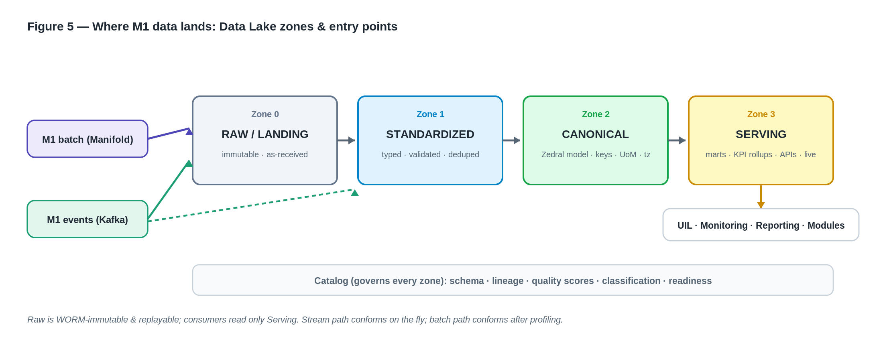
Figure 5 — Both M1 channels converge on the Canonical zone; consumers read only Serving.
The lake is a four-zone pipeline. Raw is immutable and checksummed (s3://{tenant}/raw/{source}/{yyyy}/{mm}/{dd}/{batch}.{ext}); Standardized is typed/validated/deduped with the source schema intact; Canonical is 100% conformed to the model; Serving holds query-fast marts plus the Redis live cache.
- M1 batch (Channel 1) lands in Raw, then is profiled and conformed up to Canonical.
- M1 events (Channel 2) append to the Raw event log and the standardized time-series, conform on the fly, and update the live cache + incremental marts.
- Pipelines are idempotent and replayable from Raw with no double-counting; the catalog records schema, lineage, quality and readiness for every zone.

9. Interface Reference

9.1 M1-side surfaces (what M1 exposes)
Surface | Purpose / notes
Versioned REST APIs | Capture, reporting, export — OpenAPI, OIDC-secured, the long-term integration surface
Domain events (Kafka) | coil.captured, shift.submitted, downtime.logged — the real-time surface
Read replica (Postgres) | Streaming replica for BI/extract; JDBC connector source for Manifold v1
Temporary export (CSV/XLSX) | Interim bridge; retired once APIs + events + downstream modules are live

9.2 Manifold endpoints (platform ingest)
Endpoint | Purpose
POST /v1/connectors · GET /v1/connectors/{id}/discover | Register / introspect a source
POST /v1/imports (+ /{batch}/preview, /commit) | Run the import lifecycle
GET|PUT /v1/mappings/{dataset} | View / confirm / override mappings (versioned)
GET /v1/classification/{tenant}/{module} | Required / Additional / Not-Required status
POST /v1/dedup/run · GET /v1/golden/{entity} | Resolution + golden records
GET /v1/readiness/{tenant}/{module} | Readiness score + missing/recommended
Manifold emits: mapping.confirmed, import.completed, golden.merged, readiness.changed.

9.3 Data Lake serving endpoints (what consumers call)
Endpoint | Purpose
GET /v1/canonical/{entity} | Read canonical entities/events; filters: site, area, line, asset, from, to
GET /v1/kpi/{kpiId} | Pre-aggregated KPI by scope + grain (shift/day/month)
GET|WS /v1/live/state | Current machine state + live counts (Redis); WS for push
POST /v1/canonical/derived | Module write-back of derived intelligence
GET /v1/catalog/lineage/{recordRef} | Lineage trace back to the raw source row

10. Mapping Reference Tables

10.1 Module data-contract matrix (drives classification + readiness)
● Required, ○ Additional. With only M1 deployed, the M1 column is the contract Manifold gates readiness against.
Entity group | M1 | M4 OEE | M5 Yield | M6 Qual | M7 Energy
Asset hierarchy | ● | ● | ● | ● | ●
StateEvent | ● | ● |  |  | ○
Downtime + Reason |  | ●
ProductionCount | ● | ● | ● | ● | ○
Quality / Defect |  | ○ | ○ | ●
SensorReading | ○ | ○ | ○ | ○ | ○

10.2 Planning auto-source map (what M1 receives, and what the operator never types)
Context for the platform: M1 is itself fed by Planning (SAP PP / PP&C CSV). These same objects are candidates for the platform to source later. Roughly 55–70% of a form is pre-populated before the operator touches it.
Field group | Auto-sourced from | Operator supplies
Date / Shift / Line / Operator | System clock, device binding, login | —
Target MT, planned coil list | Planning (SAP PP / CSV) | —
Customer, Grade, Surface finish | Plan order → coil master | Confirm only
Nominal width / thickness | Coil master | Actual measured width / thickness
Incoming thickness / weight | Previous process output | Output thickness / weight achieved
Spec limits (hardness/UTS/Ra) | Grade / customer spec | Measured values

10.3 SAP ↔ M1 objects (Phase-2 inbound to M1)
SAP object | Dir. | Maps to M1 | Key
Production order (PP) | In | planning.plan_order | sap_order_no
Order operations / routing | In | planning.coil_plan | order+seq
Customer master | In | master.customer | customer_code
Material / grade master | In | master.grade | grade_code
Confirmations (actuals) | Out | from shift_log / prod_* | sap_order_no

11. Security, Tenancy, Lineage & Audit
- Auth: OIDC tokens validated at the API gateway; short-lived JWTs; least-privilege service accounts for connectors.
- Tenancy (D8): tenant_id on every record; logical isolation by default (physical on request); enforced in every query path.
- Lineage: every canonical record carries lineage_ref → batch → source row → mapping version — traceable end-to-end via the catalog.
- Audit: every write, mapping/override, export and distribution is logged (who / what / when / before-after), generalising M1's immutable audit pattern.

12. Build Phasing & Sequencing
Phase | What lands | M1 relevance
0 · Foundations | Canonical schema, Raw+Std zones, catalog skeleton, auth/RBAC/tenancy, gateway | M1 Postgres schema is the reference; roles/OIDC inherited
1 · Ingest & Conform | Manifold file/DB connectors, profiler, mapping, validate, dedup, conform, readiness | Channel 1 goes live — M1 data in Canonical/Serving
2 · Serve & See | Serving marts, Monitoring (Redis + board + alerts), Reporting, Financial Impact | Channel 2 goes live — M1 events on the live board
3 · Synthesize | UIL cross-module correlation, rule-based insights, trend/anomaly | Consumes M1 canonical data via Serving
4 · Scale & Integrate | SAP/Oracle/PLC connectors, CDC, probabilistic dedup, sector templates | Dedicated M1/SAP connector; M1 SAP write-back

13. Developer Integration Checklist

Zedral platform team
- Stand up the JDBC (read-replica) or file connector for M1 and run discover() → profile → mapping against a real M1 extract.
- Confirm the M1 → canonical mappings in the review queue; persist them versioned into the steel template.
- Verify idempotent commit on (tenant_id, source, COIL_NO) with a re-import of a corrected file (no duplicates).
- Subscribe stream consumers to coil.captured / shift.submitted / downtime.logged; render per-asset live state with M1 only.
- Wire missed-capture alerts (e.g. Pickling hourly slot) and verify role-routing reuses M1 line scoping.
- Prove lineage: pick a canonical row and trace it back to the M1 source row + mapping version via the catalog.

M1 capture team
- Expose / confirm the read replica and the OpenAPI surface; publish the three domain events on Kafka with stable schemas.
- Guarantee events are emitted asynchronously after the local write (capture never blocks).
- Keep COIL_NO globally unique per tenant and stable; document any parent/child (slit) and charge/coil relationships for survivorship.
- Treat the temporary export as a transition bridge only; plan its retirement once APIs + events + modules are live.

14. Open Items & Assumptions
- Dedicated M1 connector vs. JDBC/export bridge for v1 — decide based on Phase-1 scope (default: JDBC replica).
- Canonical reason-code / loss taxonomy + state model to be confirmed against real M1 data before lock.
- SAP write-back (actuals round-trip) is a later phase (per M1-06); not on the M1→Zedral critical path.
- Platform modules M2–M7 functional specs are separate deliverables; their canonical contracts live in spec 02. (Note: the M1 blueprint's own M2–M7 numbering is unrelated.)
- D11 — validate the canonical model against a second, non-steel sector to keep it general.

15. Glossary & Source References
Term | Meaning
Manifold | Zedral's ingest→conform engine (connectors, mapping, dedup, conformance, readiness) — spec 03
Canonical Model | The sector-neutral schema all consumers read — spec 02; generalised from M1
Serving zone | The only zone consumers may read (marts + live cache) — spec 01
COIL_NO | M1's traceability spine; generalises to canonical asset/material identity
Readiness | Per tenant×module score gating what the platform can light up — spec 03
Primary sources: Zedral specs 00 (index/architecture), 01 (Data Lake), 02 (Canonical Model), 03 (Manifold), 05 (Operational Monitoring), 08 (Platform/Security); M1 Technical Blueprint M1-01 (System Architecture), M1-04 (Data Model), M1-05 (RBAC/Security), M1-06 (Planning Integration & Export).

