Zedral — Technical Design Document
Developer Handover · Foundation Components · v1 for Build
Prepared for Z Company
30 May 2026
Contents

Zedral — Technical Design Document (Developer Handover)

00 · Master Index, System Architecture, Stack & Conventions
Audience: engineering team · Status: v1 for build · Date: 2026-05-30
This document set is the build-ready specification for the Zedral platform foundation. Each component has its own spec (full developer detail: interfaces, data model, NFRs, acceptance criteria, build phasing). This index gives the system context, the binding architectural decisions, the recommended technology stack, shared conventions, and the cross-component build roadmap. Read this first.

1. Document set & reading order
# | Spec | Build priority
00 | This index — architecture, stack, conventions, roadmap | Read first
01 | Data Lake — zones, storage, processing, serving, governance | Phase 0–1
02 | Canonical Data Model — entities, schema, keys, reference data | Phase 0
03 | Manifold — connectors, import/export, mapping, dedup/MDM, conformance, readiness | Phase 1
04 | Unified Intelligence — KPI engine, correlation, financial-impact, insights | Phase 2–3
05 | Operational Monitoring — live cache, streaming consumers, surfaces, alerts | Phase 2
06 | Reporting — definition model, engine, renderers, scheduler, distribution | Phase 2
07 | Financial Impact — cost-rate model, formulas, computation service | Phase 2
08 | Platform & Security — multi-tenancy, auth/RBAC, gateway, deploy, observability | Phase 0 (cross-cutting)
09 | Glossary — canonical terms | Reference
Companion material included in this folder for full context:
- Reference_Plans/ — the planning deep-plans (the why behind each spec), the consolidated review & decisions doc, and a Diagrams/ gallery (all 20 architecture diagrams as PNG + mermaid source). Start at Reference_Plans/README.md.
- M1 Data Capture Layer blueprint (../M1_Technical_Blueprint/) — build-ready spec for the first-party shop-floor source, referenced throughout.
Spec → deep-plan map: 01/02 ← DataLake+Canonical · 03 ← Manifold · 04/05 ← UIL+Monitoring · 06 ← Reporting · 07/08 + decisions ← Consolidated Review.

2. System context
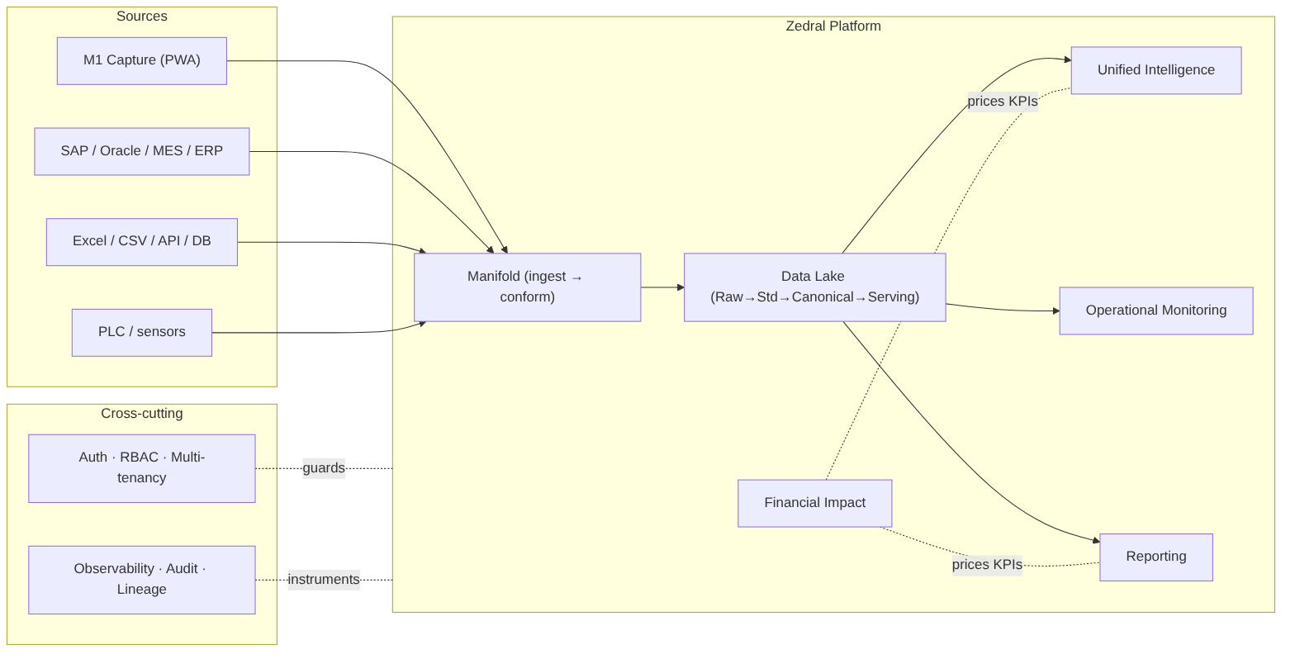
diagram
Golden rule for the team: consumers (UIL, Monitoring, Reporting, modules) read only the canonical Serving zone — never a source or another component’s database. Modules write derived intelligence back through the canonical write-back API. The canonical model is the contract that decouples everyone.

3. Binding architectural decisions (D1–D11)
These were ratified during planning review (04_Consolidated_Review...). Treat them as constraints, not suggestions.
# | Decision | Build constraint
D1 | Hybrid-ready deployment, split per client | Every service containerized; support cloud + on-prem edge. No cloud-only assumptions.
D2 | Near-real-time (minutes) default latency, tunable per tenant | Monitoring/KPIs target minutes; capture path never blocks. Latency is per-tenant config.
D3 | Deterministic entity resolution first | Build rule/key-based matching now; probabilistic (Splink/Zingg) is a later, isolated module.
D4 | Excel/CSV + generic DB connectors first, then SAP/API | Connector roadmap order; file + JDBC connectors are the v1 baseline.
D5 | Conservative auto-map + review queue | Auto-accept only high-confidence mappings; everything else is human-reviewed.
D6 | “Standard” v1 KPI tier | Status, production-vs-target, downtime-by-reason, basic OEE where data allows.
D7 | Cost-rates client-owned, implementation-seeded, “rate as of” provenance | Rates are versioned reference data with effective dates.
D8 | Logical tenant isolation default, physical on request | Tenant key on every record; isolation enforced at the data-access layer.
D9 | Rule-based insights v1, ML later | Insight engine is rule/template driven; reserve ML plug points, don’t build them yet.
D10 | Reuse Zinance import UX patterns, rebuild server-side | Port the wizard/smart-map/validation UX; the engine is new and server-side.
D11 | Validate canonical model against a 2nd (non-steel) sector | Keep the model sector-neutral; exercise the extension namespace early.

4. Recommended technology stack
Concrete recommendation with rationale; the team may substitute equivalents, but interfaces and NFRs are fixed.
Concern | Recommended | Rationale / alternative
Raw/landing + exports | S3-compatible object store (AWS S3 / MinIO on-prem) | Cheap, immutable; MinIO gives hybrid parity (D1)
Canonical core, masters, config (OLTP) | PostgreSQL 15+ | Matches M1 schema; integrity; JSONB for extension fields
Time-series (PLC/sensor) | TimescaleDB (Postgres extension) | One ecosystem, hypertables/downsampling; ClickHouse if volume extreme
Analytical marts / KPI store | ClickHouse (or Postgres columnar to start) | Fast roll-ups for UIL/Reporting
Event/stream bus | Apache Kafka (Redpanda for edge/on-prem) | M1 events, PLC streams, write-backs; Redpanda lighter for edge (D1)
Stream processing | Flink or Kafka Streams | Live conformance + incremental aggregates (D2)
Live cache (monitoring) | Redis | Sub-second current-state reads
Metadata catalog / lineage | Postgres-backed catalog service (+ OpenLineage) | v1 build; evaluate DataHub/OpenMetadata later
Orchestration / scheduling | Apache Airflow (Dagster/Prefect alt) | Batch ingest, scheduled sync, report scheduling
Entity resolution | Deterministic (SQL/Python); Splink/Zingg later | Per D3
API layer | REST + OpenAPI, gateway; GraphQL optional | Stable contracts
Auth / SSO / RBAC | OIDC via Keycloak | Matches M1 OIDC; on-prem capable (D1)
Backend services | Python 3.11 + FastAPI (data/ML); JVM/.NET acceptable for enterprise connectors | Python for data/ML; team skill + SAP may favor JVM/.NET
Frontend | React + TypeScript (PWA) | Matches M1 + Zinance; reuse Zinance import UX (D10)
Report rendering | HTML templates → Playwright/WeasyPrint (PDF); openpyxl (Excel) | Pixel control; locked PDF + Excel/CSV delivery
Containerization / deploy | Docker + Kubernetes (cloud); Compose/k3s (edge) | Hybrid (D1)
Observability | OpenTelemetry + Prometheus + Grafana; Loki/ELK logs | Per-service + per-tenant
ML platform (later) | Feast (feature store) + MLflow (registry) | Reserve for D9 predictive phase

5. Shared conventions (apply to every component)
- Canonical naming: UPPER_SNAKE_CASE with unit embedded (e.g. COIL_WIDTH_MM) — inherited from M1; one canonical field = one column.
- Identifiers: surrogate canonical IDs (*_id), with native/source keys preserved + source_ref for lineage.
- Time: store UTC (TIMESTAMPTZ); carry site timezone for display; bucket to shift/day for aggregates.
- Units: store native value + canonical base value (to_base_factor); weight in MT plant-wide.
- Multi-tenancy: tenant_id on every record; all queries tenant-scoped at the data-access layer (D8).
- APIs: REST, versioned (/v1/...), OpenAPI-documented, OIDC-secured, idempotent writes, cursor pagination, RFC-7807 error bodies.
- Eventing: canonical domain events on Kafka (e.g. coil.captured, shift.submitted, downtime.logged, mapping.confirmed); at-least-once + idempotent consumers.
- Lineage: every canonical record carries lineage_ref → batch + source row + mapping version.
- Audit: every write + export logged (who/what/when), reusing the M1 audit pattern.
- Status legend in specs: MUST / SHOULD / MAY (RFC-2119).

6. Cross-component build roadmap (epic map)
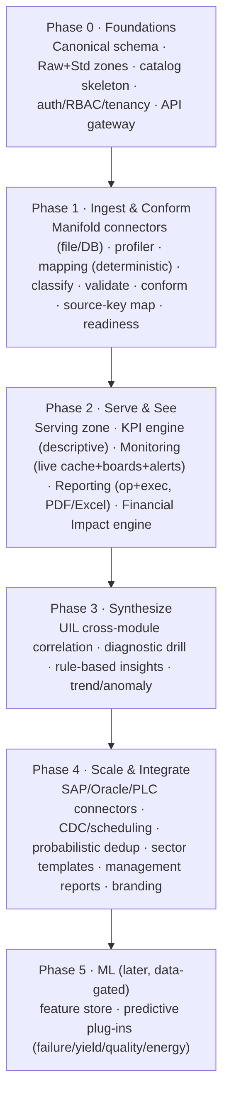
diagram
Each component spec (§01–08) restates which phase(s) its build epics fall into.

7. Global non-functional baseline
Every component inherits these unless its spec tightens them:
- Multi-tenant, logical isolation default (D8); no cross-tenant data path exists.
- Hybrid deployable (D1): cloud default, on-prem edge for capture/PLC; 12-factor, containerized, externalized config.
- Latency: near-real-time (minutes) default (D2), per-tenant tunable; ingestion never blocks capture.
- Availability: v1 target 99.5% for serving/monitoring; graceful degradation when a source/module is absent.
- Scalability: horizontal scale on stateless services; partition data by tenant + time.
- Security: OIDC auth, RBAC, encryption in transit (TLS) + at rest, full audit, least privilege.
- Data integrity: idempotent + replayable pipelines; end-to-end lineage; no destructive transforms on Raw.
- Observability: OpenTelemetry traces, Prometheus metrics, structured logs — tagged by tenant + component.

8. Open items & assumptions (carry into build)
- D11 second-sector validation client/dataset to be identified — the top generality risk.
- Canonical reason-code / loss taxonomy + state model to be confirmed against real client data before lock.
- Reporting cadences/distribution lists and retention per tenant — defaults proposed in spec 06.
- SAP write-back (actuals round-trip) is a later phase (per M1-06).
- Modules M2–M7 functional specs are separate upcoming deliverables; their canonical data contracts are defined in spec 02 §(module matrix).

Next: component specs 01–08, then the Glossary (09). The compiled Word/PDF package combines all of these into one Software Design Document.

01 · Data Lake — Developer Specification
Component owner: Platform/Data · Phase: 0–1 · Depends on: 08 Platform/Security, 02 Canonical Model · Consumed by: all

1. Purpose & scope
The Data Lake is the storage + processing + serving substrate of Zedral. It receives data (via Manifold), stores it immutably, standardizes and conforms it to the Canonical Model, and serves it to every consumer through stable APIs.
In scope: zone storage (Raw→Standardized→Canonical→Serving), the metadata/lineage catalog, batch + stream processing orchestration, the serving APIs, retention/governance. Out of scope: field mapping / dedup / conformance logic (that is Manifold, spec 03 — the lake provides the zones it operates on); KPI computation (UIL, spec 04); source capture (M1).

2. Responsibilities
- Land every inbound payload immutably (Raw) with provenance.
- Hold Standardized, Canonical, and Serving representations per the zone contracts.
- Run batch + streaming pipelines (idempotent, replayable).
- Maintain the metadata catalog: schema, lineage, quality scores, classification, readiness.
- Expose canonical read, KPI/aggregate, live-state, write-back, and export APIs.
- Enforce tenant isolation, retention, and encryption.

3. Architecture
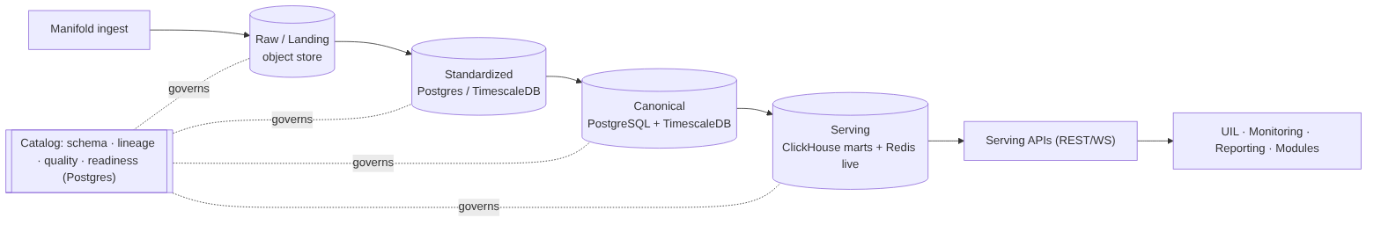
diagram
Zone contracts: Raw = immutable, as-received, checksummed. Standardized = typed/validated/deduped, source schema intact. Canonical = 100% conformed to spec 02 (keys, UoM, tz, codes). Serving = query-fast marts + live cache. No consumer reads upstream of Serving.

4. Interfaces & API contracts
All REST, /v1, OIDC-secured, tenant-scoped, RFC-7807 errors, cursor pagination.
Endpoint | Method | Purpose
/v1/canonical/{entity} | GET | Read canonical entities/events; filters: site,area,line,asset,from,to,cursor
/v1/kpi/{kpiId} | GET | Pre-aggregated KPI by scope (asset…enterprise) + grain (shift/day/month)
/v1/live/state | GET / WS | Current machine state + live counts (Redis); WS for push
/v1/canonical/derived | POST | Module write-back of derived intelligence (e.g. downtime classification, risk score)
/v1/export | POST | Request CSV/XLSX export of a canonical scope (async job → file URL)
/v1/catalog/lineage/{recordRef} | GET | Lineage trace back to raw source
/v1/catalog/readiness/{module} | GET | Per-module readiness (delegates to Manifold, spec 03)
Internal contracts: ingestion publishes to Kafka topics (raw.landed, canonical.upserted, *.event); pipelines consume idempotently keyed by (tenant_id, source_ref, natural_key).

5. Data model (storage)
- Raw: object store path s3://{tenant}/raw/{source}/{yyyy}/{mm}/{dd}/{batch}.{ext} + a raw_object catalog row {object_id, tenant_id, source_id, batch_id, checksum, ingest_ts, byte_count}.
- Standardized: typed tables mirroring source schema + std_meta{dedup_key, quality_flags}; time-series in TimescaleDB hypertables.
- Canonical: per spec 02 (PostgreSQL) + canonical time-series (TimescaleDB).
- Serving marts: ClickHouse tables per KPI/grain/scope; Redis keys live:{tenant}:{asset}:state.
- Catalog (Postgres): dataset, field, mapping_version, lineage_edge, quality_score, classification, readiness_score.

6. Key flows
Batch: land(Raw) → profile → [Manifold map/validate/dedup/conform] → upsert Canonical → refresh marts. Stream: event → append Raw log + Std TS → conform → Canonical event + Redis live + incremental mart. Replay: re-run Raw→Canonical when logic changes, without re-touching sources.

7. Technology
Object store (S3/MinIO), PostgreSQL 15+ (canonical/catalog), TimescaleDB (time-series), ClickHouse (marts), Redis (live), Kafka (bus), Flink/Kafka-Streams (stream), Airflow (batch/orchestration). See index §4.

8. Non-functional requirements
- Throughput: sustain PLC/sensor stream at target tag-rate per tenant (design for ≥10k events/s/tenant headroom); batch historical loads of millions of rows.
- Latency: canonical event visible in Serving within the tenant’s latency target (default minutes, D2).
- Retention: tiered (hot full-res → warm downsampled → cold archived Raw), per-tenant configurable.
- Durability: Raw is WORM-style immutable; backups + point-in-time recovery on Postgres.
- Isolation: tenant_id enforced in every query path (D8).

9. Dependencies & integration points
Manifold (writes Std→Canonical), Platform/Security (auth, tenancy), Canonical Model (schema), UIL/Monitoring/Reporting (read Serving), Modules (write-back).

10. Configuration
Per-tenant: storage endpoints, retention policy, isolation mode (logical/physical, D8), latency target (D2), enabled zones. Externalized (12-factor); secrets via vault.

11. Acceptance criteria
- MUST store every ingested payload immutably in Raw with checksum, source, ingest timestamp, tenant.
- MUST make pipelines idempotent and replayable from Raw with no double-counting.
- MUST serve consumers only from the Serving zone; no consumer can reach Raw/Std/source.
- MUST assign canonical surrogate keys and preserve the source-key map at conformance.
- MUST record end-to-end lineage for every canonical record.
- MUST enforce tenant isolation on every API and query.
- SHOULD expose readiness + quality scores via catalog APIs.

12. Build phasing
Phase 0: Raw + Standardized zones, catalog skeleton (schema/lineage/quality hooks), object store + Postgres/Timescale. Phase 1: Canonical zone + conformance integration with Manifold + source-key map + Serving canonical/KPI APIs. Phase 2: ClickHouse marts + Redis live + write-back + export APIs.

13. Risks & edge cases
Late-arriving / out-of-order events (use event-time + watermarks); schema drift at source (catalog detects, Manifold re-maps); replay storms (throttle + idempotency); huge PLC volume (downsample + retention tiers); partial-batch failures (quarantine, never abort batch).

02 · Canonical Data Model — Developer Specification
Component owner: Data/Domain · Phase: 0 · Depends on: 08 Platform · Consumed by: all

1. Purpose & scope
The single shared schema every module speaks. Standards-anchored (ISA-95 hierarchy, ISO 22400 KPIs, Six Big Losses). In scope: entity definitions, keys/identity, the universal Event Spine, reference data, units/time rules, versioning/extensibility, the module data-contract matrix. Out of scope: how data gets mapped into it (Manifold, 03).

2. Modeling rules (MUST)
- One canonical field = one column, UPPER_SNAKE_CASE, unit embedded (COIL_WIDTH_MM).
- Surrogate *_id PK + preserved (source_system, native_key) + source_ref.
- Every time-stamped fact is an Event specialization (the spine) — unifies real-time + historical.
- Reference data (reason/defect/state/UoM/cost-rate) is shared, FK-enforced, no free-text codes.
- Client-specific fields live in a namespaced extension area (JSONB), never altering the core (supports D11 generality).

3. Entity catalog

3.1 Master / reference
enterprise · site · area · work_center · work_unit (ISA-95 hierarchy via node_id, parent_id, level) · asset (the machine; maps Machine_ID/Asset_Code/Equipment_Number → Machine Identifier; ideal_cycle_time) · material (type raw/WIP/finished) · bom_line · shift / shift_pattern / calendar (drives Planned Production Time) · personnel / crew · uom (to_base_factor) · reason_code (→ loss_category, oee_component) · loss_category (Six Big Losses) · defect_code · state_model (is_planned, counts_as) · cost_rate (scope, value, currency, effective_from/to — D7) · tenant / source / connector (with priority).

3.2 Event Spine (transactional core)
event { event_id PK, event_type, asset_ref, order_ref, shift_ref, start_ts, end_ts, duration_s, value, uom_ref, reason_ref, source_ref, lineage_ref, tenant_id }
Specializations: state_event(state_ref, is_planned) · downtime_event(reason_ref, loss_category_ref, oee_component) · production_count(good_qty, scrap_qty, rework_qty, total_qty) · quality_inspection / defect_record(defect_ref, qty, disposition) · energy_reading(utility_type, consumption, meter_ref) · sensor_reading(tag, value, quality_flag) (TimescaleDB) · maintenance_work_order / pm_schedule / failure_event · yield_record(input_qty, output_qty, yield_pct).

4. ERD
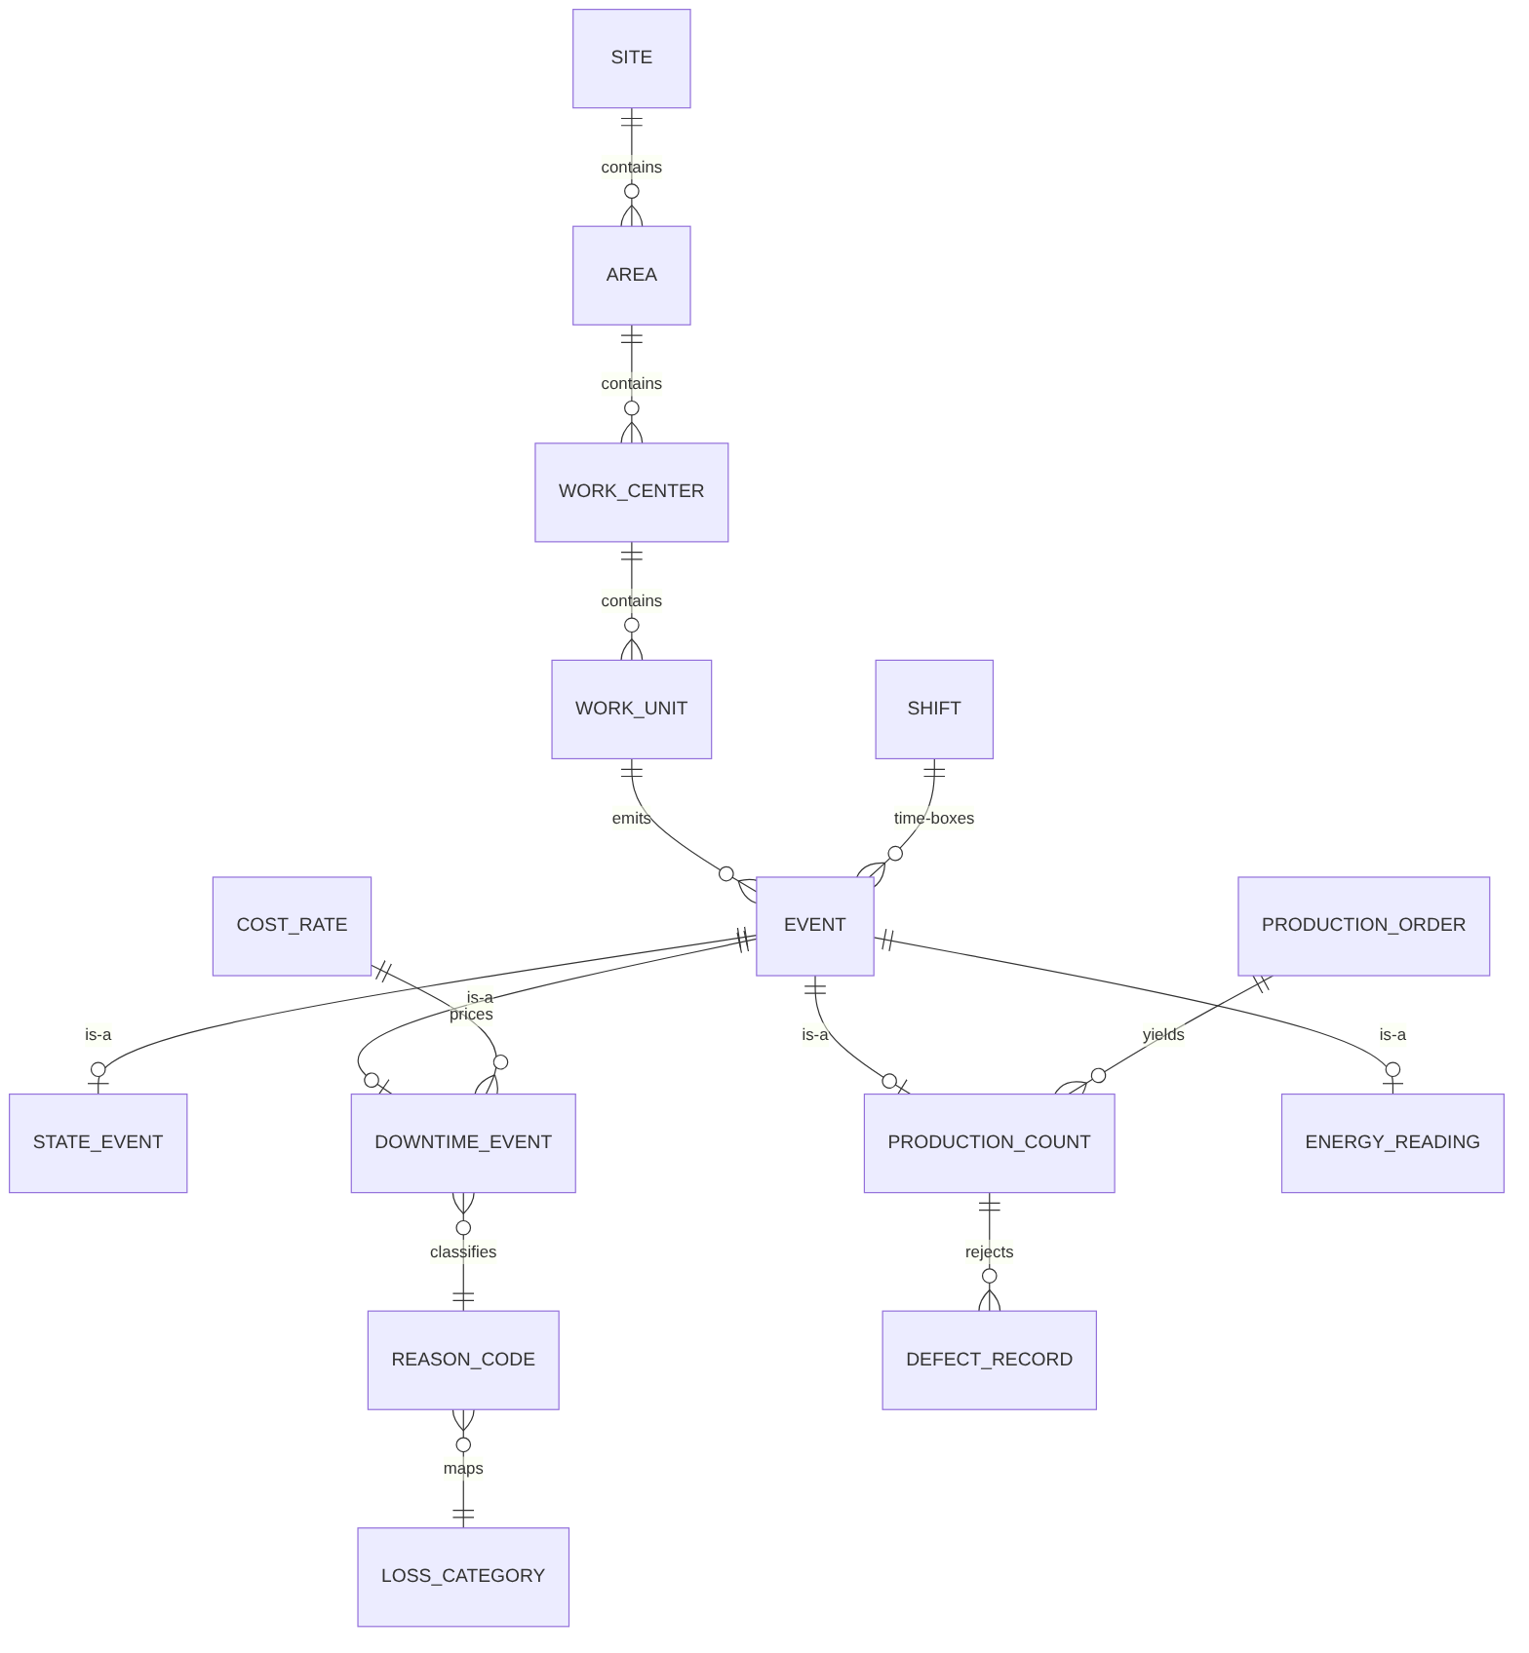
diagram

5. Reference DDL conventions (PostgreSQL)
-- hierarchy node (ISA-95) — one table, self-referential
CREATE TABLE canon.equipment_node (
node_id BIGINT PRIMARY KEY,
tenant_id UUID NOT NULL,
parent_id BIGINT REFERENCES canon.equipment_node(node_id),
level TEXT NOT NULL CHECK (level IN ('ENTERPRISE','SITE','AREA','WORK_CENTER','WORK_UNIT')),
name TEXT NOT NULL,
native_code TEXT,
source_ref TEXT,
ext JSONB DEFAULT '{}'::jsonb -- client extension namespace
);
-- event spine (partition by tenant_id, range on start_ts)
CREATE TABLE canon.event (
event_id BIGINT PRIMARY KEY,
tenant_id UUID NOT NULL,
event_type TEXT NOT NULL,
asset_ref BIGINT REFERENCES canon.equipment_node(node_id),
order_ref BIGINT,
shift_ref BIGINT,
start_ts TIMESTAMPTZ NOT NULL,
end_ts TIMESTAMPTZ,
duration_s NUMERIC,
value NUMERIC,
uom_ref TEXT,
reason_ref TEXT,
source_ref TEXT,
lineage_ref TEXT
) PARTITION BY RANGE (start_ts);
The full M1 schema (M1_schema.sql, 40 tables) is the reference implementation of the capture side; canonical tables generalize it (e.g. M1 coil/shift_log/prod_* → canonical asset/event/production_count).

6. Module data-contract matrix (drives Manifold classification + readiness)
● Required, ○ Additional. (Abbrev — full matrix in planning doc 01 §15.)
Entity group | M1 | M2 Maint | M3 Ops | M4 OEE | M5 Yield | M6 Qual | M7 Energy
Asset hierarchy | ● | ● | ● | ● | ● | ● | ●
StateEvent | ● | ○ | ○ | ● |  |  | ○
Downtime + Reason |  | ● | ○ | ●
ProductionCount | ● |  | ○ | ● | ● | ● | ○
Quality/Defect |  |  |  | ○ | ○ | ●
Energy/Meter |  |  |  |  |  |  | ●
SensorReading | ○ | ● |  | ○ | ○ | ○ | ○
Maintenance WO/PM |  | ● | ○
CostRate | ○ | ○ | ○ | ○ | ○ | ○ | ○

7. Identity, units, time, versioning
- Identity: canonical surrogate keys; source_key_map(canonical_id, source_system, native_key); resolution rules in Manifold (03 §dedup).
- Units: native value + to_base_factor; canonical base per dimension.
- Time: UTC storage; site tz for display; shift calendars define Planned Production Time.
- Versioning: additive schema changes; schema_version; Serving APIs versioned independently; extension fields in ext JSONB.

8. Non-functional requirements
- Event table partitioned by tenant + time; indexed on (asset_ref, start_ts), event_type.
- Reference data cached in Serving; changes are effective-dated (esp. cost_rate, D7).
- Schema migrations via versioned migration tool (e.g. Flyway/Alembic); backward compatible.

9. Acceptance criteria
- MUST represent every operational fact as an Event or specialization.
- MUST enforce FK to reference masters (no free-text coded values).
- MUST preserve source keys + lineage on every canonical row.
- MUST support client extension fields without core schema change.
- MUST encode reason codes against Six Big Losses + OEE component.
- SHOULD pass the M1 capture data through conformance with zero loss (validation test).

10. Build phasing
Phase 0: core entities (hierarchy, event spine, shift/calendar), reference data (UoM, state, reason/loss, defect, cost-rate), migrations, seed taxonomies. Then exercised by Manifold conformance in Phase 1.

11. Risks
Over-fitting to steel (mitigate via D11 second-sector test + ext); taxonomy churn (effective-date reference data); event-table growth (partition + retention via Data Lake).

03 · Manifold (Data Integration & Mapping) — Developer Specification
Component owner: Data Integration · Phase: 1 (scale in 4) · Depends on: 01 Data Lake, 02 Canonical, 08 Platform · Consumed by: Data Lake (writes Canonical), readiness consumers

1. Purpose & scope
The engine that turns any source into the Canonical Model. In scope: connector framework, import/export, profiling, field-mapping engine, classification, validation/quality, dedup + master-data resolution, canonical conformance, readiness. Out of scope: zone storage (01), KPI logic (04).

2. Architecture
diagram

3. Sub-components & contracts

3.1 Connector framework (SDK)
Each connector implements: discover() → schema/tags/columns + metadata · sample(n) → rows for profiling · read(mode) where mode ∈ full | incremental(CDC) | stream · write(scope, format) for export · auth() · health(). Connectors declare capabilities{cdc, stream, schema_discovery}. D4 order: file (CSV/XLSX) + generic DB (JDBC) first → then SAP/Oracle/MES → PLC/streaming (Phase 4). Adding a connector = implement the interface; no core change.

3.2 Import/Export
Lifecycle state machine: PENDING → PROFILED → MAPPED → VALIDATED → PREVIEW(dry-run/impact) → LOADED | PARTIAL | FAILED. Per-row tolerant errors → {success, failed, skipped, errors[], batch_id} (reuse Zinance pattern, D10). Export: field-projection, CSV/XLSX, scheduled/on-demand. UX reused from Zinance, rebuilt server-side (D10).

3.3 Profiler
Computes per field: type, regex/pattern, range, null %, cardinality, sample, unit hints → feeds mapping + quality.

3.4 Mapping engine
Signals → weighted confidence: name (token + synonym/abbrev dictionary, edit distance), metadata (type/unit/length), instance (profile vs canonical field profile), template/historical (sector templates). Thresholds (D5 conservative): ≥ auto_accept → auto-map; mid → review queue; low → unmapped/flag. Manual override always wins. Confirmed mappings are versioned and learned into the template library.
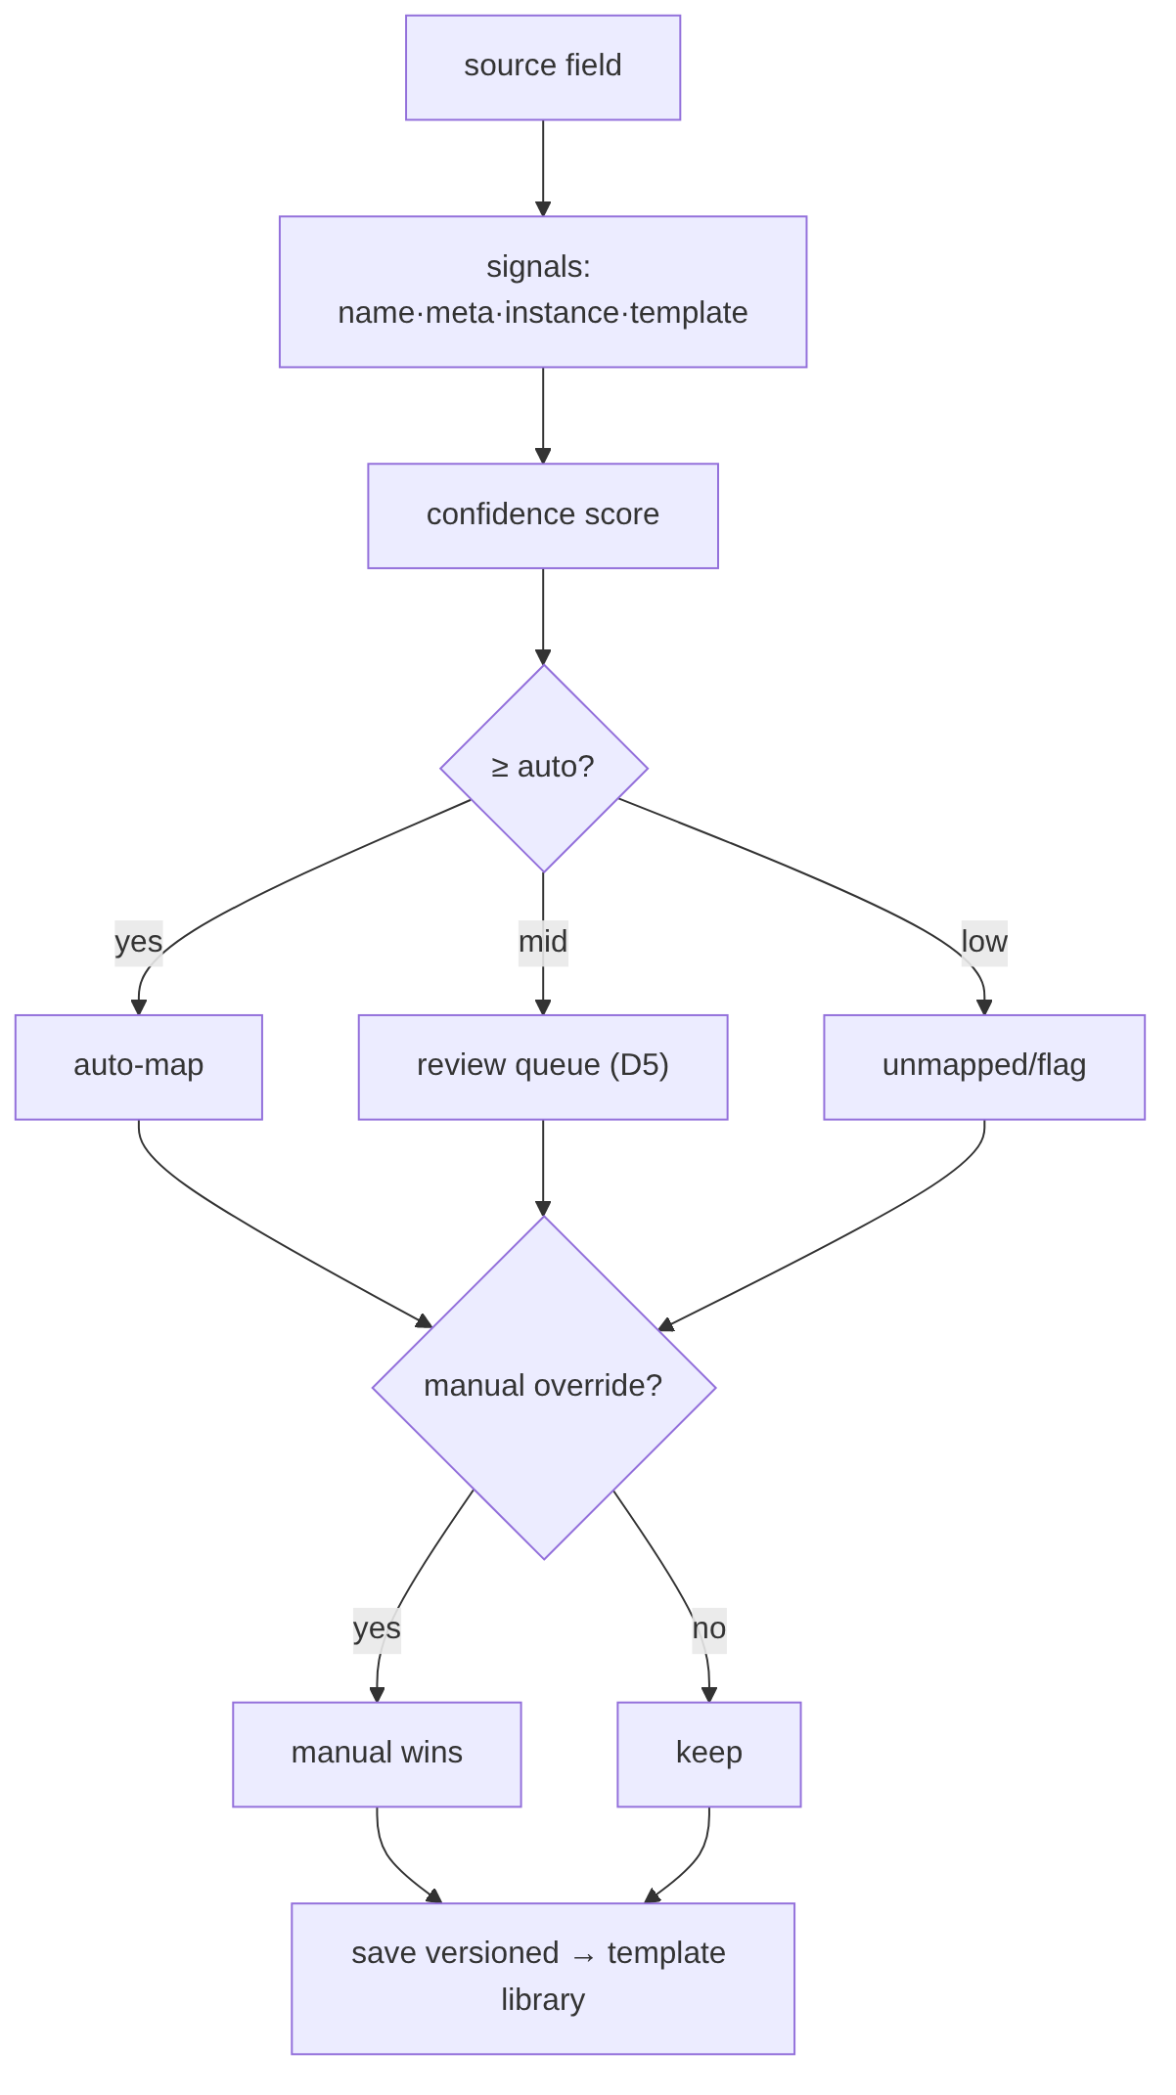
diagram

3.5 Classification
Per module data contract (spec 02 §6): Required / Additional / Not-Required. Unknown columns → namespaced extension fields (reconciled across imports).

3.6 Validation & quality
Rule layers: structural, format (date/number/unit normalization), mandatory (Required gate), range/sanity (e.g. output_thk < input_thk), dependency/integrity (FK to masters), duplicate. Quality scored on validity/completeness/consistency/timeliness/uniqueness → readiness.

3.7 Dedup & master-data (D3: deterministic first)
blocking → match(deterministic keys; probabilistic later) → cluster → survivorship(source priority·recency·completeness·manual) → golden record + source_key_map. Detects duplicate fields, sources, records. Probabilistic matcher (Splink/Zingg) is an isolated Phase-4 add.

3.8 Conformance
Apply mapping → UoM convert → tz normalize → code-taxonomy map → assign surrogate key + lineage → upsert Canonical.

3.9 Readiness
Per tenant×module: R (Required coverage, hard gate) · A (Additional) · Q (quality) · H (history). Readiness% = 100·(0.5R + 0.2A + 0.2·Q/100 + 0.1H) with R=100% gate. Status: Ready ≥85, Partial 60–84, Blocked <60.

4. Interfaces (REST)
Endpoint | Purpose
POST /v1/connectors / GET /v1/connectors/{id}/discover | register / introspect source
POST /v1/imports (+ /{batch}/preview /commit) | run import lifecycle
GET/PUT /v1/mappings/{dataset} | view/confirm/override mappings (versioned)
GET /v1/classification/{tenant}/{module} | Required/Additional/Not-Required status
POST /v1/dedup/run · GET /v1/golden/{entity} | resolution + golden records
GET /v1/readiness/{tenant}/{module} | readiness score + missing/recommended
POST /v1/exports | export job
Emits events: mapping.confirmed, import.completed, golden.merged, readiness.changed.

5. Technology
Python 3.11 + FastAPI (services), Postgres (mappings/templates/golden), Airflow (batch/scheduled sync), Kafka (events), JDBC drivers (DB connectors), SheetJS/openpyxl (files); Splink/Zingg later. React/TS mapping UI (reuse Zinance).

6. Non-functional requirements
- Bulk import of millions of rows without UI block (async + progress).
- Mapping auto-suggest < 2s for a typical source schema.
- Idempotent commits keyed by (tenant, source, natural_key).
- All mapping/override/survivorship decisions audit-logged + versioned.

7. Acceptance criteria
- MUST add a new source type via connector SDK with no core change.
- MUST default to conservative auto-accept + review queue (D5); manual override always persists and wins.
- MUST never abort a batch on a bad row; quarantine with row-level reason.
- MUST deduplicate to a golden record + maintain source_key_map (deterministic v1).
- MUST output 100% canonical-conformant data with lineage.
- MUST compute per-module readiness with the Required hard gate.
- SHOULD improve a sector template on each confirmed mapping.

8. Build phasing
Phase 1: file + DB connectors, profiler, mapping (name+meta+instance), classification, validation, conformance, source-key map, deterministic dedup, readiness, mapping UI. Phase 4: SAP/Oracle/PLC connectors, CDC/scheduling, probabilistic matcher, sector template library.

9. Risks & edge cases
Silent mis-map (mitigated by D5 + lineage + review); huge schemas (incremental profiling); conflicting sources (survivorship + source priority); evolving source schemas (catalog drift detection → re-map); SAP complexity (Phase-4, allow JVM/.NET connector).

04 · Unified Intelligence Layer — Developer Specification
Component owner: Analytics/Intelligence · Phase: 2–3 · Depends on: 01 Serving, 02 Canonical, 07 Financial Impact · Consumed by: UI, Reporting

1. Purpose & scope
The synthesis brain: turns canonical data into KPIs, cross-module insight, financial impact, trends, and executive views. In scope: KPI engine, cross-module correlation, trend/anomaly detection, insight generation, ML plug points. Out of scope: live “now” state (05 Monitoring), report rendering (06), $ formulas (07 — UIL calls it), KPI source data (01/02).

2. Architecture
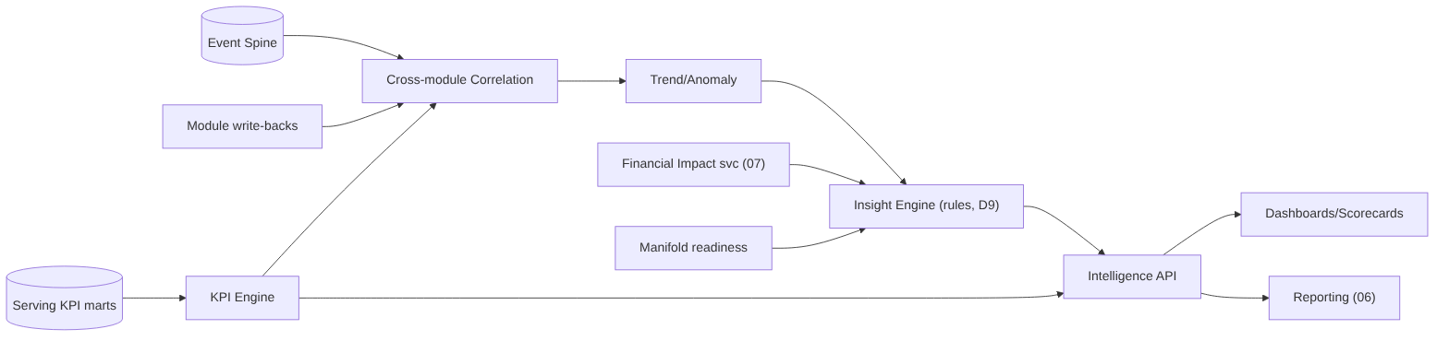
diagram

3. Sub-components
- KPI engine: evaluates a central KPI registry (each KPI = id, formula, inputs, unit, grain) over canonical events; rolls up the ISA-95 hierarchy (asset→…→enterprise) and time grains (shift/day/month). ISO 22400 definitions: OEE = Availability × Performance × Quality. v1 = Standard tier (D6).
- Cross-module correlation: joins one event to its multi-module lenses (downtime → yield/quality/energy/$); correlates KPIs to state/grade/shift/crew.
- Trend/anomaly: moving baselines per KPI/asset; drift/spike flags; ranked by financial impact.
- Insight engine (D9 = rules v1): templated insights ("{line} lost {qty} to {reason} = {₹}, {x}% vs {n}-day norm"); lifecycle detect→rank($)→explain(lineage)→route(role)→track. ML/LLM narratives reserved (Phase 5).
- ML readiness: feature store (Feast) over the Event Spine; reserved plug points for forecast/predict; not built in v1 (D9).

4. KPI registry (definition-as-data)
- id: OEE
formula: availability * performance * quality
grain: [shift, day, month]
scope: [asset, work_center, area, site, enterprise]
- id: AVAILABILITY
formula: operating_time / planned_production_time # planned_production_time from shift calendar
- id: YIELD_PCT
formula: good_qty / input_qty
- id: ENERGY_PER_UNIT
formula: energy_kwh / production_mt
Both UIL and Reporting bind to this registry by id → numbers always agree (consistency guarantee).

5. Interfaces (REST)
Endpoint | Purpose
GET /v1/intelligence/kpi/{id}?scope&grain&from&to | KPI value(s) + trend + $ twin
GET /v1/intelligence/insights?tenant&scope&since | ranked insight feed
GET /v1/intelligence/correlate?event_id | cross-module lenses for an event
GET /v1/intelligence/scorecard/{scope} | exec scorecard payload
POST /v1/intelligence/alerts/rules | threshold/anomaly alert rules (shared w/ 05)

6. Technology
Python + FastAPI; ClickHouse marts; Redis cache; rule engine (lightweight, config-driven); Feast + MLflow (later). Computation orchestrated by Airflow (batch marts) + stream incremental (05).

7. Non-functional requirements
- KPI/scorecard reads sub-second from marts (pre-aggregated).
- Module-aware graceful degradation: render the deepest intelligence the tenant’s data supports (reads readiness); never show broken widgets when a module/data is absent.
- Every KPI/insight traceable to canonical events (lineage).
- Deterministic, reproducible KPI math (versioned registry).

8. Acceptance criteria
- MUST compute KPIs only from the shared registry (no ad-hoc recomputation).
- MUST attach the financial-impact ($) twin wherever a cost-rate exists (07).
- MUST degrade gracefully by module readiness (D6 Standard baseline for M1-only).
- MUST produce rule-based insights with lineage + role routing (D9).
- SHOULD expose ML plug points without implementing models in v1.

9. Build phasing
Phase 2: KPI registry + engine (descriptive, Standard tier) + scorecards + financial twins. Phase 3: correlation + diagnostic drill + rule insights + trend/anomaly. Phase 5: feature store + predictive models (data-gated).

10. Risks
KPI definition drift (single registry + version); mart refresh lag vs latency target (incremental + D2 config); premature ML expectations (D9 keeps promise descriptive/diagnostic).

05 · Operational Monitoring Layer — Developer Specification
Component owner: Realtime/Platform · Phase: 2 · Depends on: 01 (streaming), 02 Canonical, 08 Platform · Consumed by: UI

1. Purpose & scope
Live shop-floor/production/state visibility. In scope: streaming consumers, live-state cache, monitoring surfaces (boards, production tracking, metrics), alert framework. Out of scope: historical synthesis (04 UIL), report generation (06). Depth scales with installed modules.

2. Architecture
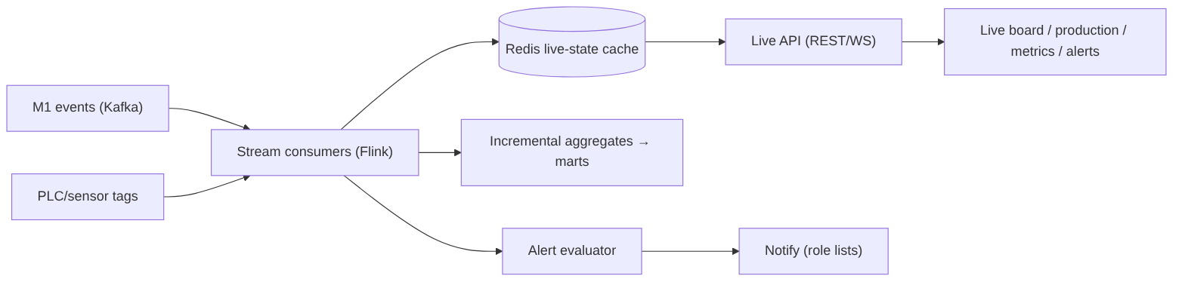
diagram

3. Sub-components
- Stream consumers: conform live events (delegating to canonical rules), update current-state per asset.
- Live-state cache (Redis): live:{tenant}:{asset} → {state, since, running_count, target, open_stoppage}; last-write-wins by event-time.
- Surfaces: live shop-floor board (state per asset, color chips), production tracking (vs target), live metrics, alert panel. Capability tiers by installed module (M1 status → +M4 live OEE → +M3 shift/handover → +M5/6/7 yield/quality/energy + $).
- Alert framework: rule types state-change | threshold | missed-capture | anomaly; financial-tagged; deduped; role-routed (reuse M1 RBAC); escalation. (Rules shared with UIL, spec 04 §5.)

4. Interfaces
Endpoint | Purpose
GET /v1/live/state?scope | current state snapshot
WS /v1/live/stream?scope | push state/metric/alert updates
GET /v1/live/production?scope | live produced-vs-target
POST /v1/alerts/rules · GET /v1/alerts/active | manage + read alerts

5. Technology
Kafka + Flink (stream), Redis (live cache), FastAPI + WebSocket (API), React/TS (boards). Latency target = tenant config (D2 minutes default, sub-second optional).

6. Non-functional requirements
- Live state reflects new events within the tenant latency target (D2); capture path must never block on monitoring.
- WebSocket fan-out scales per tenant; back-pressure safe.
- Truthful “now” even with only M1 deployed (graceful tiers).
- Alert evaluation idempotent; no alert storms (dedupe + cooldown).

7. Acceptance criteria
- MUST show per-asset live state from M1 events with only M1 deployed.
- MUST scale monitoring depth automatically with installed modules + readiness.
- MUST raise missed-capture alerts (e.g. M1 pickling hourly slot) and threshold/state alerts, financial-tagged, role-routed.
- MUST meet the per-tenant latency target without blocking ingestion.
- SHOULD support both minutes and sub-second targets via config.

8. Build phasing
Phase 2: stream consumers + Redis live state + live board/production/metrics + alert framework (state/threshold/missed-capture). Phase 3+: anomaly alerts (shared with UIL), deeper module tiers.

9. Risks
Out-of-order/late events (event-time + watermark); cache/source divergence (periodic reconcile from canonical); high PLC volume (sampling + Flink scaling); alert fatigue (dedupe, severity, cooldown).

06 · Reporting Layer — Developer Specification
Component owner: Reporting/Platform · Phase: 2 · Depends on: 04 KPI registry, 03 export framework, 07 Financial Impact · Consumed by: clients (PDF/Excel), UI viewer

1. Purpose & scope
Formatted, distributable documents from canonical KPIs — scheduled + on-demand. In scope: report-definition model, engine, renderers (PDF/Excel/CSV), scheduler, distribution, in-app viewer. Boundary (adopted): distinct scheduled/static layer reading the same KPI registry as UIL (numbers always agree); may snapshot a UIL view. v1 scope (locked): Operational/shift + Executive/financial-impact reports; templated catalog; scheduled PDF + Excel/CSV delivery (+ in-app viewer); branding in v1; management reports fast-follow.

2. Architecture
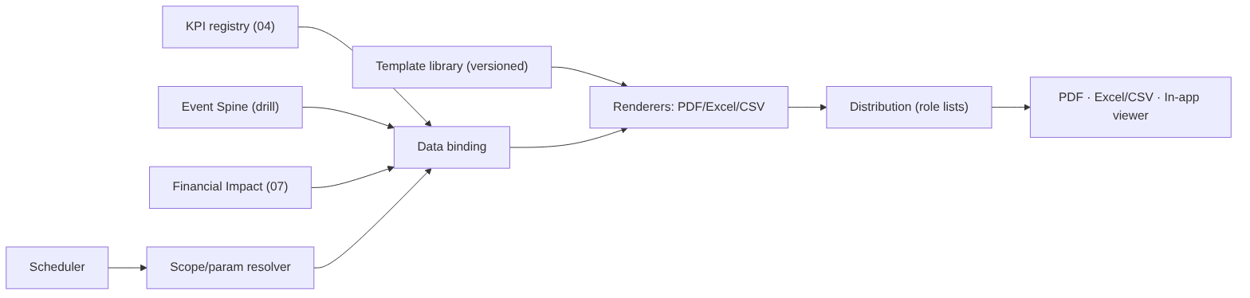
diagram

3. Report-definition model (declarative)
report:
id: shift_production
template: templates/shift_production.html
audience_roles: [SUPERVISOR, PLANT_HEAD]
parameters: [tenant, site, line, date, shift]
bindings: # reference KPI registry by id → consistency guarantee
- kpi: PRODUCTION_VS_TARGET
- kpi: DOWNTIME_BY_REASON
- kpi: YIELD_PCT
financial_twin: true # attach $ via Financial Impact (07), "rate as of"
formats: [pdf, xlsx]
schedule: end_of_shift
distribution: role_list
Adding/altering a report = config, not code. Templates versioned + sector-reusable.

4. v1 catalog
Operational/shift: Shift Production · Downtime & Loss (Six Big Losses + $) · Yield & Quality · Production Log/Traceability (COIL_NO, Excel/CSV). Executive/financial: Executive Scorecard (snapshot of UIL exec view) · Financial Impact Report (loss ranking, rate-as-of) · Performance Trend. (Management roll-ups = fast-follow.)

5. Interfaces
Endpoint | Purpose
GET /v1/reports / GET /v1/reports/{id} | catalog
POST /v1/reports/{id}/generate | on-demand (params, formats) → job → file URL
GET/PUT /v1/reports/{id}/schedule | cadence + distribution list
GET /v1/reports/runs | run history (audit)

6. Technology
HTML templates → Playwright/WeasyPrint (PDF), openpyxl (Excel), CSV writer. Scheduler = Airflow. Reuses Manifold export framework (03) for file gen + delivery. Distribution via email/notification service. Renders are async jobs.

7. Non-functional requirements
- A figure in a generated report equals the live dashboard figure (shared registry) — verifiable in tests.
- Tenant-scoped data only (D8); per-tenant branding/white-label on PDFs.
- Scheduled generation reliable + retried; every run + distribution audit-logged.
- $ figures show “rate as of” (D7).

8. Acceptance criteria
- MUST bind report values to the KPI registry by id (no independent KPI math).
- MUST deliver scheduled PDF + Excel/CSV, plus in-app viewing.
- MUST scope by tenant/site/line/date/shift params from one template.
- MUST embed financial twins with rate provenance (D7).
- MUST audit every generation + distribution.
- SHOULD apply per-tenant branding (v1).

9. Build phasing
Phase 2: definition model + bindings, PDF/Excel/CSV renderers (extend Manifold export), 4 operational + 3 executive templates, scheduler + role distribution + audit, branding. Phase 4: management reports, self-serve builder, external-system push.

10. Configuration & open items
Per-tenant: branding assets, default cadences (proposed: shift report per shift, downtime/yield daily, exec/financial weekly+monthly), distribution lists by role, retention (default = data-lake tiers). Confirm cadences/recipients with client.

11. Risks
Number divergence (eliminated by shared registry binding — test it); heavy PDF rendering (async + queue); schedule misfires (Airflow retries + alerting); CSV-injection on export (sanitize leading = + - @, a Zinance gap to fix).

07 · Financial Impact Layer — Developer Specification
Component owner: Analytics · Phase: 2 (cross-cutting) · Depends on: 02 Canonical (CostRate), 04 KPI engine · Consumed by: UIL (04), Reporting (06), Monitoring (05) alerts

1. Purpose & scope
Translates operational outcomes into money, in real time, alongside every applicable KPI. In scope: cost-rate reference model, impact formulas, a stateless computation service, provenance. Out of scope: the KPIs themselves (04) and the cost-rate values (client-owned data, D7).

2. Cost-rate model (reference data, effective-dated — D7)
CREATE TABLE canon.cost_rate (
rate_id BIGINT PRIMARY KEY,
tenant_id UUID NOT NULL,
scope TEXT NOT NULL, -- DOWNTIME | SCRAP | REWORK | ENERGY | LABOR | OPPORTUNITY
asset_ref BIGINT, -- NULL = applies tenant/site-wide
value NUMERIC NOT NULL,
currency TEXT NOT NULL,
uom_ref TEXT, -- e.g. per HOUR, per MT, per kWh
effective_from DATE NOT NULL,
effective_to DATE, -- NULL = current
source TEXT -- seeded_by_impl | client_entered
);
D7: client-owned, implementation-seeded; the rate’s effective_from is the “rate as of” shown on every figure.

3. Impact formulas
KPI / event | Formula
Downtime cost | downtime_hours × rate(DOWNTIME) (+ lost_units × margin for OPPORTUNITY)
Yield loss | scrap_mt × rate(SCRAP)
Quality loss | rework_mt × rate(REWORK) (or scrap if non-recoverable)
Energy waste | excess_kwh × rate(ENERGY)
Maintenance | repair_events × rate(LABOR/maintenance)
Rate selection: most-specific asset_ref + effective on the event date.

4. Service interface
Stateless compute(impactType, quantity, context{tenant, asset, date}) → {amount, currency, rate_id, rate_as_of}. Exposed in-process to UIL/Reporting and via GET /v1/financial/impact?event_id / POST /v1/financial/impact:batch.
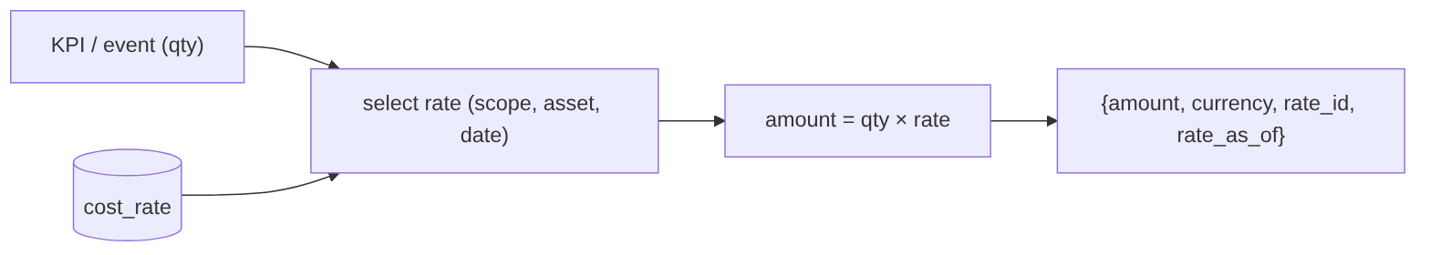
diagram

5. Technology
Python service (library + thin API); reads cost_rate from Postgres (cached); pure functions, fully unit-testable. Multi-currency aware.

6. Non-functional requirements
- Deterministic + reproducible; same inputs → same output.
- Always returns the rate provenance (rate_id, rate_as_of).
- Sub-millisecond per computation (cacheable rates).
- Missing-rate handling: return null amount + reason, never a wrong number.

7. Acceptance criteria
- MUST price every supported KPI/event where a valid rate exists.
- MUST select the effective-dated, most-specific rate and return its provenance (D7).
- MUST degrade safely (no rate → no $, flagged) — never fabricate.
- MUST be consumable by UIL, Reporting, and Monitoring alerts uniformly.
- SHOULD support multi-currency + per-asset overrides.

8. Build phasing
Phase 2: cost-rate schema + seeding tooling + computation service + integration into UIL/Reporting/alerts.

9. Risks
Stale/wrong rates mislead executives (mitigate: effective-dating, “rate as of” everywhere, client ownership + review cadence per D7); currency/timezone edge cases; double-counting (single computation service, no per-consumer math).

08 · Platform & Security (Cross-cutting) — Developer Specification
Component owner: Platform · Phase: 0 (foundational) · Consumed by: every component

1. Purpose & scope
The cross-cutting foundation every service builds on: multi-tenancy, authentication/authorization, API gateway, deployment, observability, audit. In scope: these platform concerns + their contracts. Out of scope: component business logic.

2. Multi-tenancy (D8)
- Logical isolation default, physical on request. tenant_id (UUID) on every record + every event + every object-store prefix.
- Tenant scoping enforced at a data-access layer (row-level security in Postgres + mandatory tenant filter in repositories) — not left to callers.
- Per-tenant configuration object: deployment mode (D1), latency target (D2), retention, enabled modules, isolation level, branding, cost-rate ownership.
- No cross-tenant query path exists; cross-tenant access attempts are denied + audited.

3. Authentication & RBAC
- OIDC (Keycloak) — matches M1 SSO; supports on-prem (D1). Services validate JWT; short-lived tokens.
- Roles (extend M1): OPERATOR · SUPERVISOR · PLANT_HEAD · ADMIN + platform IMPLEMENTATION (connectors/mappings/templates) and CLIENT_ADMIN (uploads/exports/config).
- Authorization model: (role, resource, action) + row-level line/site scoping (reuse M1 line_access). Permissions checked at the gateway + service.
diagram

4. API gateway & conventions
REST /v1, OpenAPI per service, OIDC-secured, rate-limited, RFC-7807 errors, idempotency keys on writes, cursor pagination, correlation-id propagation. Internal service-to-service via mTLS + service identity.

5. Deployment (D1 hybrid)
- All services containerized (Docker), 12-factor, externalized config + secrets (Vault).
- Cloud: Kubernetes. On-prem/edge: k3s or Compose for capture + PLC + a local cache, syncing to core.
- Per-client topology chosen from config; no cloud-only assumptions anywhere.
- CI/CD with environment promotion; DB migrations versioned (Flyway/Alembic).

6. Observability
OpenTelemetry traces, Prometheus metrics, structured logs (Loki/ELK) — all tagged tenant_id + component + correlation_id. Golden signals per service; pipeline + readiness dashboards (Grafana). Alerting on platform health.

7. Audit & lineage
Every write, mapping/override, export, and distribution is audit-logged (who, what, when, before/after) — generalizing the M1 audit pattern. Data lineage end-to-end (canonical record → batch → source row → mapping version).

8. Non-functional baseline (inherited by all)
Multi-tenant, hybrid-deployable, near-real-time (minutes) default latency, 99.5% serving availability v1, horizontal scale, TLS + at-rest encryption, least privilege, idempotent/replayable data flows, full observability.

9. Acceptance criteria
- MUST stamp + enforce tenant_id on every record and API call; no cross-tenant path.
- MUST authenticate via OIDC and authorize by role + row scope on every request.
- MUST run every service containerized and deployable cloud or on-prem (D1).
- MUST emit traces/metrics/logs tagged by tenant + component.
- MUST audit every write/export/mapping/distribution.
- SHOULD support physical tenant isolation on request (D8).

10. Build phasing
Phase 0: OIDC + gateway + RBAC + tenant data-access layer + config service + observability baseline + CI/CD + migrations. Everything else builds on this.

11. Risks
Tenant-isolation leaks (enforce centrally + test); on-prem drift from cloud (one container set, config-driven); secret sprawl (Vault); auth complexity on edge (cache tokens, offline-tolerant like M1).

09 · Glossary
Term | Meaning
Data Lake | The storage + processing + serving substrate; the platform’s core wedge. Zones: Raw → Standardized → Canonical → Serving.
Manifold | The data-integration & mapping engine inside the Data Lake (connectors, mapping, classification, validation, dedup/MDM, conformance, readiness).
Canonical Data Model | The single shared schema every module speaks; standards-anchored (ISA-95, ISO 22400).
Event Spine | The universal canonical Event entity that all time-stamped facts specialize from (state, downtime, count, quality, energy, sensor…).
Unified Intelligence (UIL) | The synthesis layer: KPIs, cross-module correlation, trends, financial impact, insights.
Operational Monitoring | The live, low-latency “what’s happening now” layer off the streaming path.
Reporting | Formatted, scheduled, distributable documents bound to the shared KPI registry.
Financial Impact | Cross-cutting service that prices KPIs/events using effective-dated cost-rates.
Zone (Raw/Standardized/Canonical/Serving) | The four Data-Lake tiers (medallion); each with a strict contract.
Golden record | The single resolved master record for an entity after dedup + survivorship.
Source-key map | Mapping of every (source_system, native_key) to one canonical surrogate id.
Readiness % | Per tenant×module score (Required gate + Additional + Quality + History) deciding deployability.
Data contract | A module’s declared Required/Additional canonical entities/fields.
Sector template | A reusable mapping bundle per industry (steel seeded from M1) for fast onboarding.
Write-back | Modules pushing derived intelligence (e.g. risk score, downtime class) into the Canonical zone.
OEE | Overall Equipment Effectiveness = Availability × Performance × Quality (ISO 22400).
Six Big Losses | Loss taxonomy mapping reason codes to OEE components (Availability/Performance/Quality).
ISA-95 | Equipment hierarchy: Enterprise → Site → Area → Work Center → Work Unit.
ISO 22400 | Standard manufacturing KPI definitions.
COIL_NO | M1 traceability spine (steel); generalizes to canonical asset/material identity.
M1–M7 (platform) | Modules: M1 Shopfloor Digitization, M2 Maintenance, M3 Shopfloor Ops, M4 OEE/Downtime, M5 Yield, M6 Quality, M7 Energy.
M1 blueprint M2–M7 | Different numbering — the Hero Steels downstream roadmap; do not confuse with platform M2–M7.
D1–D11 | The locked architectural decisions (see 00 §3).
Zinance (FAMS) | The user’s other product; its import/export module is reused UX prior art (D10).
CDC | Change Data Capture (incremental ERP sync).
MDM | Master Data Management (dedup + survivorship → golden record).
NFR | Non-Functional Requirement.

