**Kshitisha Negi**

**500107178**

**Batch-9**

**SRS for the Project**

***Table of Contents***

1. *Introduction*

* *Scope*
* *Description*
* *Interface*
* *Constraints*

1. *Functional Requirements*
2. *Non-Functional Requirements*
3. *Miscellaneous*
4. ***Introduction***

The Software Requirements Specification (SRS) document outlines the requirements for the development of my web technologies project named Caffinated By Kshitisha, a coffee brand. The application aims to provide information about the brand, its products, facilitate online shopping, and enable user interaction through various features.

*Scope:-*

Display information about the brand, including contact details and a brief overview.

Display featured products with details such as name and price.

Allow users to add products to their shopping cart.

Provide a user registration and login system.

Allow users to sign up for an account.

Enable users to explore and purchase products.

Provide a checkout process for purchasing selected items.

Enable users to apply coupons during checkout.

*Description:-*

The website is an online platform dedicated to providing a rich coffee experience for users. It offers a diverse selection of coffee products, including blends from renowned brands like Davidoff, Nescafe, and Rage. The website aims to cater to both casual coffee enthusiasts and connoisseurs by providing detailed descriptions of each product's flavor profile and origin.

Users can explore the website's offerings through the homepage, which showcases featured products and invites visitors to browse the catalog further. The site also includes interactive elements such as coffee origin maps and personalized flavor profiles to guide users in their selection process.

Registered customers have the convenience of adding products to their shopping cart for easy checkout. They can also apply coupon codes during the checkout process to receive discounts on their purchases. Additionally, customers can contact the website administrators for inquiries or feedback through the contact page.

*Interface:-*

* User Interface:- This page includes the Home, Featured Products and Contact Us part where home page also contains information about the other section of the pages like new launches and explore button from where it takes users to different page.

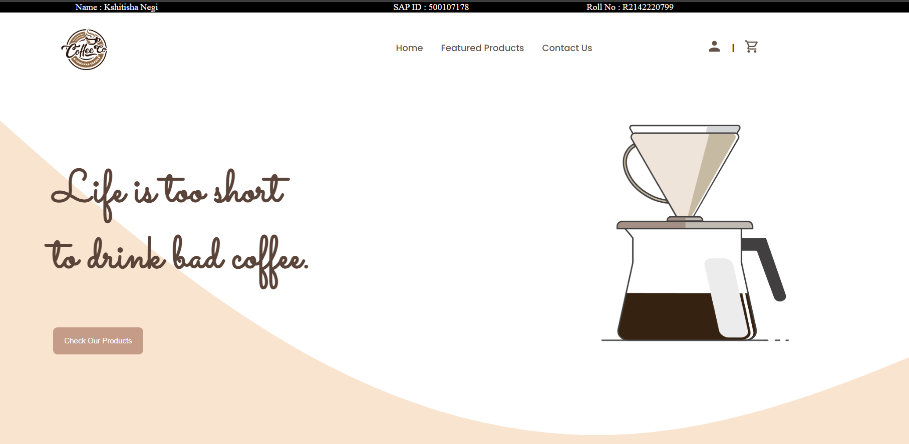

Provide a confirmation page after successful checkout.

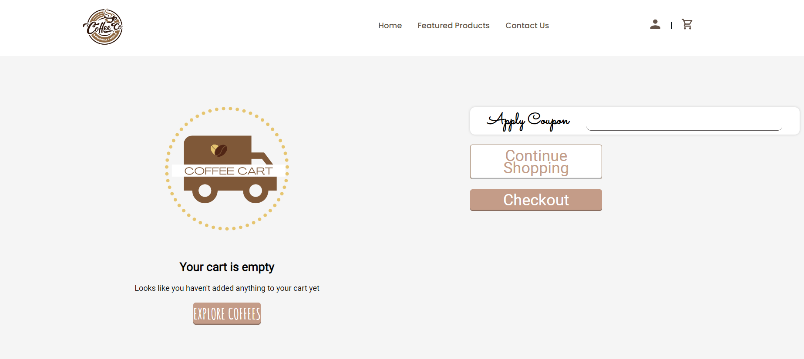

LOGIN and SignUP:-

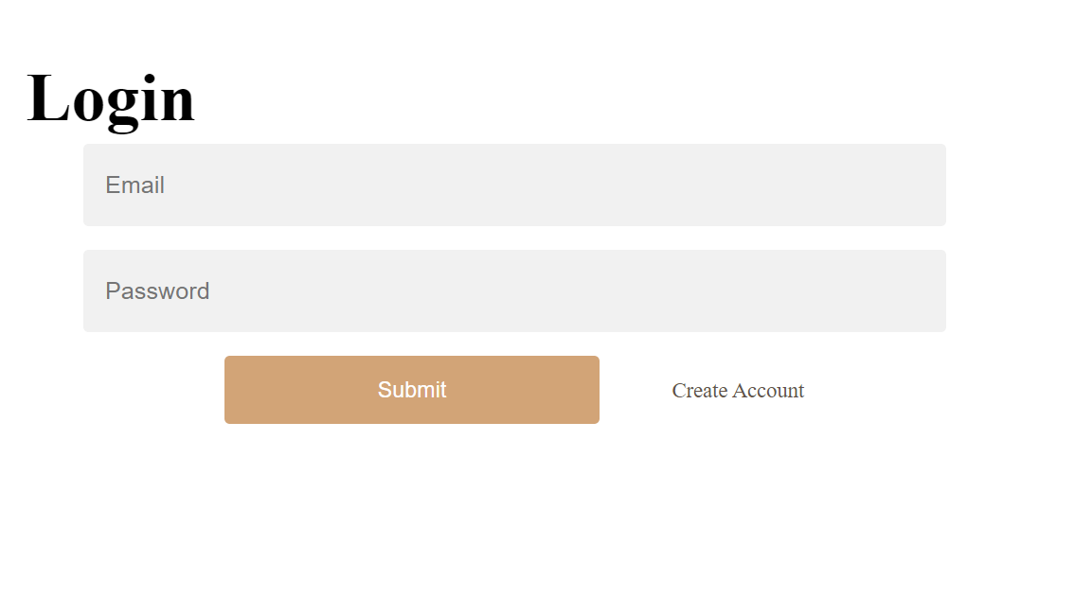

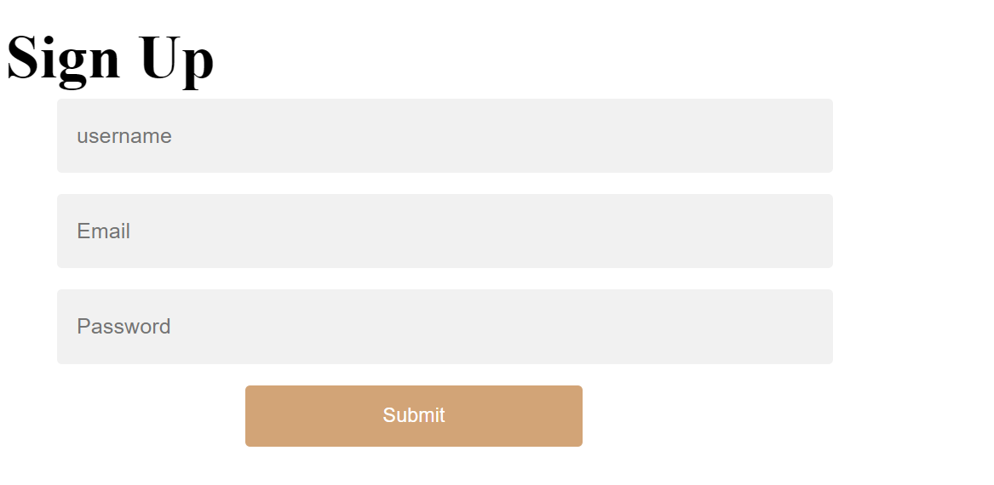

*Constraints:-*

Technology Stack Dependency: My website relies on specific technologies and frameworks such as AngularJS for client-side scripting and EJS (Embedded JavaScript) for server-side includes. This may limit the flexibility to switch to alternative technologies or frameworks.

Browser Compatibility: My code may have compatibility issues with older browsers or browsers that do not support certain features used in the code, such as AngularJS directives or CSS styles.

Performance Overhead: The use of AngularJS for client-side scripting may introduce performance overhead, especially for larger applications, due to the framework's digest cycle and data-binding mechanism.

Maintainability: The code organization is somewhat fragmented across multiple files, which could make maintenance and updates challenging, especially for developers unfamiliar with my project structure.

Documentation: The website is a part of my undergraduate project and this may hinder understanding and collaboration among team members, leading to difficulties in maintenance and future development.

Backend Integration: The HTML code interacts with server-side scripts (PHP) for functionalities like form submission and dynamic content generation. Integration with backend systems and databases must be carefully implemented to ensure data consistency and security.

Testing: As of now my code may lack sufficient unit tests and end-to-end tests to ensure robustness and reliability. Implementing automated testing strategies is essential to detect and prevent regressions in functionality.

2. ***Functional Requirements***

*Information Display:-*

Display brand name and brief description on the homepage.

Display contact information, including phone number and email.

Showcase recently launched products with images and descriptions.

Display featured products with images, names, and prices.

*User Interaction:-*

Allow users to add products to the shopping cart.

Provide interactive buttons for increasing or decreasing product quantities in the cart.

Enable users to apply coupons during checkout.

*User Management:-*

Provide a registration form for users to sign up for an account.

Allow users to log in using their credentials.

Implement validation for user input during registration and login**.**

*Shopping Cart:-*

Display selected products in the shopping cart.

Show individual product details such as name, quantity, and price.

Calculate and display the total price of all items in the cart.

Allow users to remove items from the cart.

*Checkout Process:-*

Provide a checkout button for users to proceed to payment.

Redirect users to a checkout page to review and confirm their order.

Enable users to enter shipping and billing information.

Provide a summary of the order, including total price and selected items.

Allow users to confirm and place the order.

3*.* ***Non-Functional Requirements***

*Performance:-*

The web application should load quickly and respond promptly to user actions.

Ensure scalability to handle a large number of simultaneous users.

Optimize database queries for efficient retrieval of product information.

*Usability:-*

Design an intuitive user interface with clear navigation and interactive elements.

Ensure compatibility across multiple devices and screen sizes.

Implement accessibility features to accommodate users with disabilities.

*Security:-*

Implement secure authentication and authorization mechanisms.

Encrypt sensitive user data such as passwords and payment information.

Regularly update and patch software components to address security vulnerabilities**.**

*Conclusion:-*

The proposed web application for Caffinated By Kshitisha aims to provide users with a seamless shopping experience while showcasing the brand's products and fostering user engagement. By adhering to the specified requirements, the application will meet the needs of both the business and its customers.

1. ***Miscellaneous***

*References:-*

*Code With Harry- Youtube channel for the tutorials*

*W3School*