Loan Default Prediction System: Explainable Credit Risk Scoring with Drift Monitoring
HCLTech Career Shaper Programme | III Year Industry Project | Project No. 137
Output screenshots
Screens of the working system, captured on 01 November 2026 from the FastAPI service running locally at http://127.0.0.1:8000 (Swagger UI) and from the console runs of the pipeline, 1440 x 900 browser window.

Swagger UI and service health
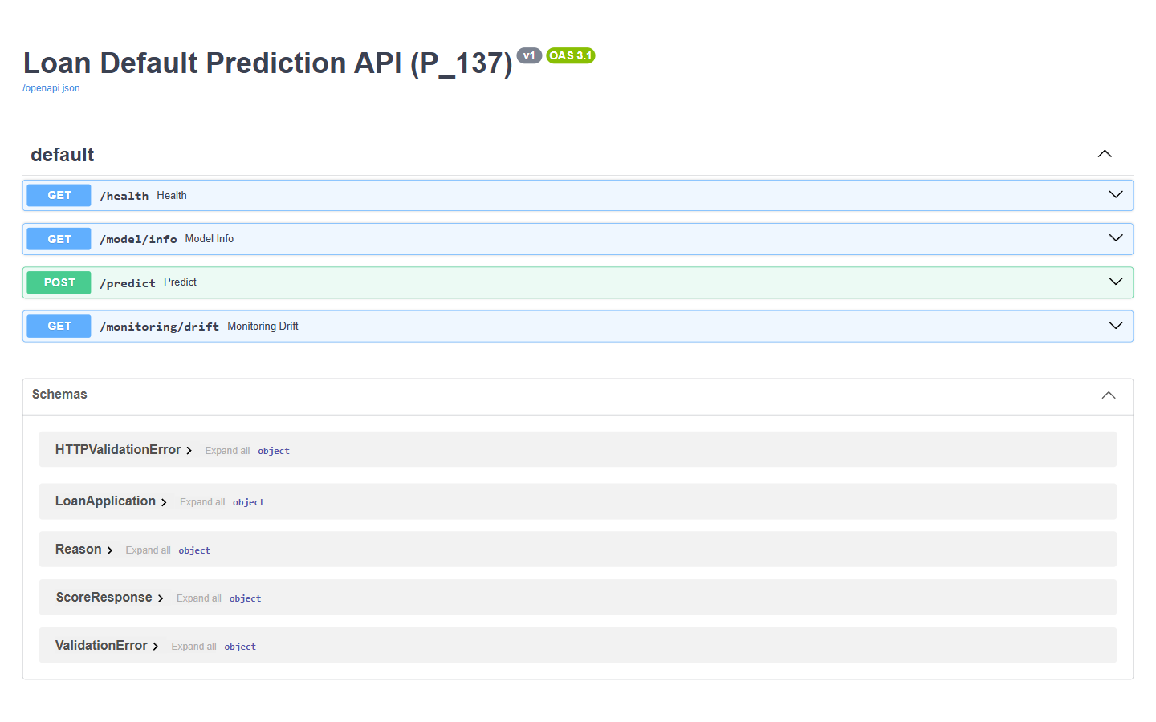
Screenshot 1: Swagger UI of the scoring API. FastAPI generates this interactive documentation at http://127.0.0.1:8000/docs; it lists the four endpoints (GET /health, GET /model/info, POST /predict, GET /monitoring/drift) and the request and response schemas.
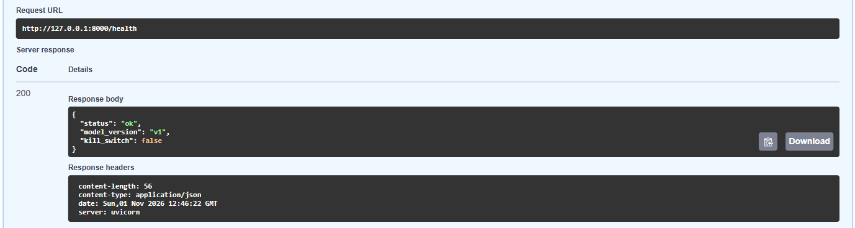
Screenshot 2: GET /health. The service answers HTTP 200 with status ok, model version v1 and kill_switch false.
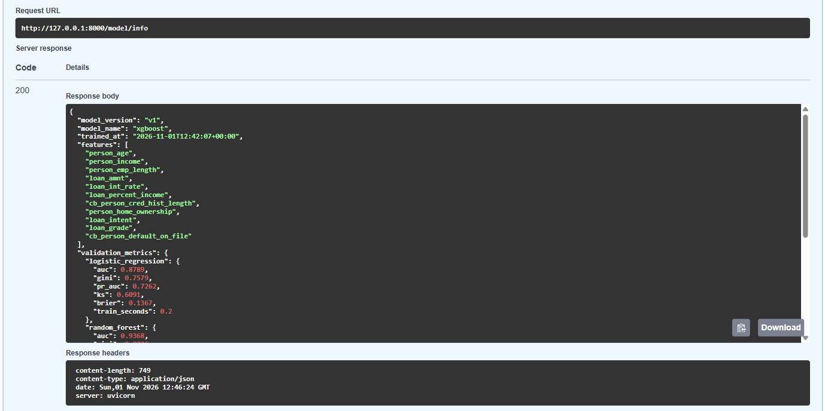
Screenshot 3: GET /model/info. Training metadata of the deployed model (xgboost, 22,686 training rows, validation AUC 0.9511 against 0.9368 for random forest and 0.8789 for logistic regression) plus the policy cut-offs approve_below 0.2 and reject_from 0.5.

Scoring applications (POST /predict)
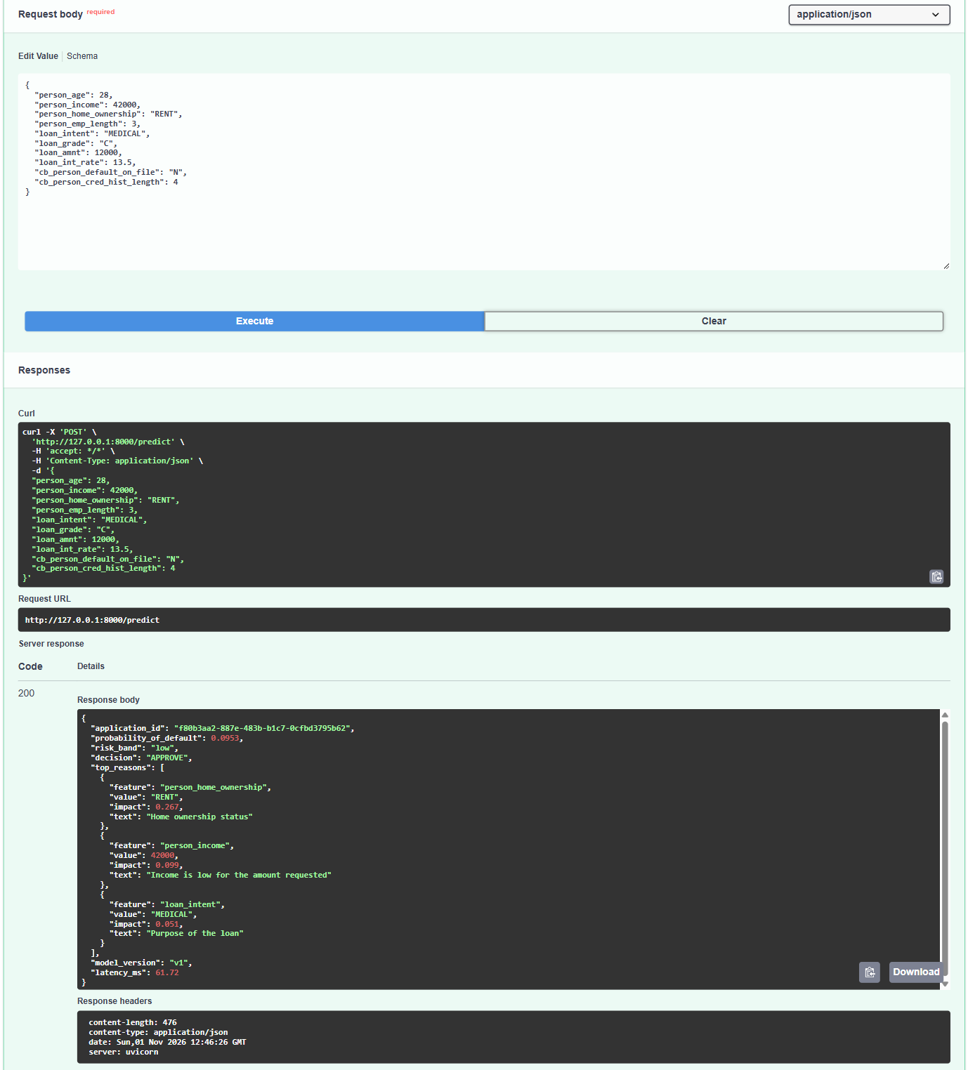
Screenshot 4: Low-risk applicant approved. A 28-year-old renter earning 42,000 asks for 12,000 at 13.5% (grade C): PD 0.0953, risk band low, decision APPROVE, with the three factors that still raised the risk (home ownership RENT +0.267, income +0.099, purpose MEDICAL +0.051).
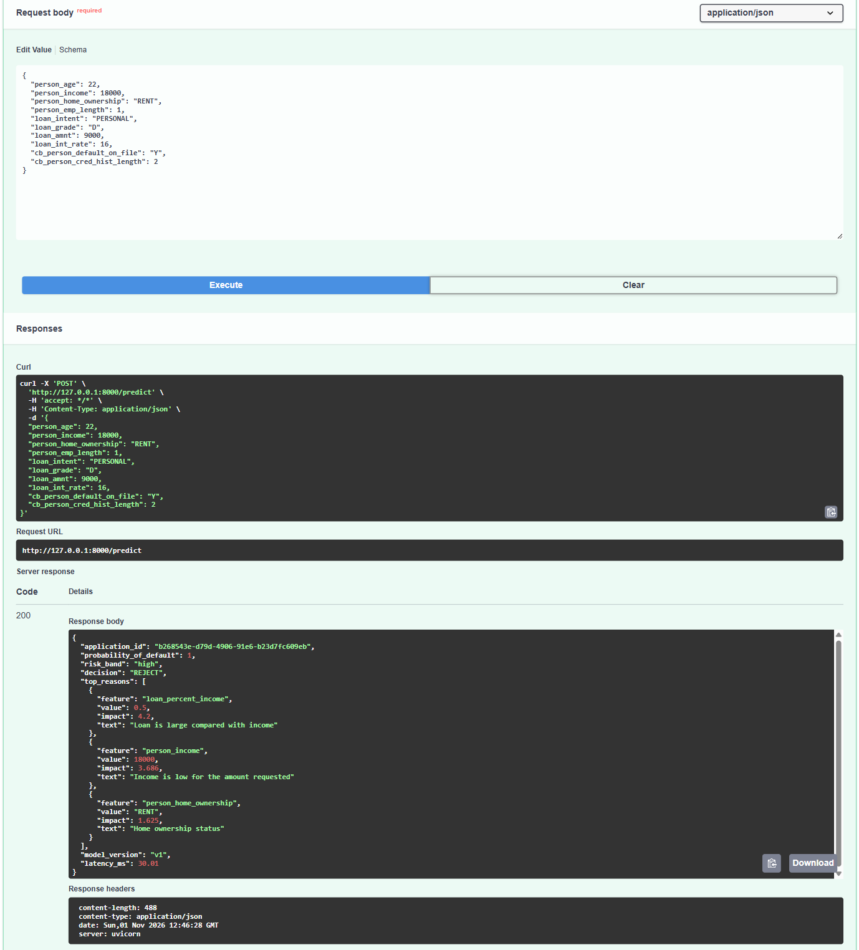
Screenshot 5: High-risk applicant rejected. A 22-year-old earning 18,000 asks for 9,000 at 16% (grade D, past default Y): PD 1.0, risk band high, decision REJECT; reasons: loan is half of income (+4.2), low income (+3.686), renting (+1.625).
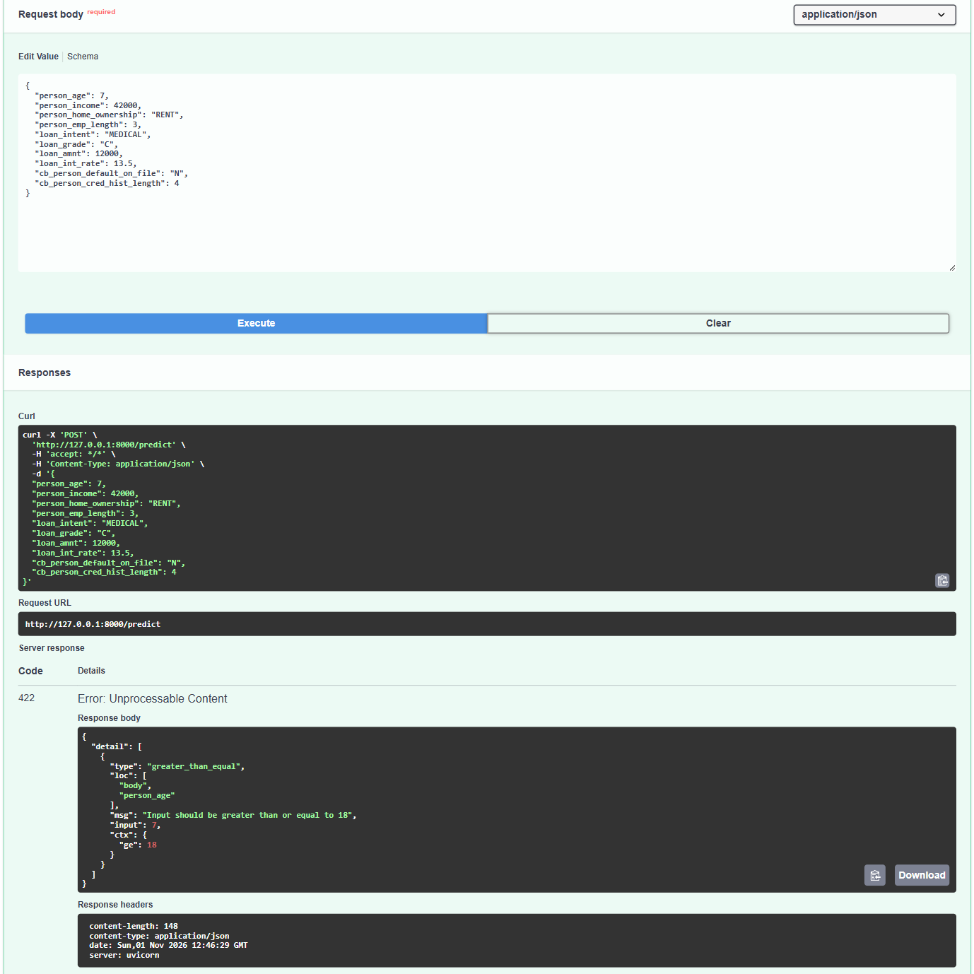
Screenshot 6: Invalid input rejected with HTTP 422. The same applicant with age 7 is stopped by Pydantic validation before the model runs: HTTP 422, 'Input should be greater than or equal to 18'.

Drift monitoring
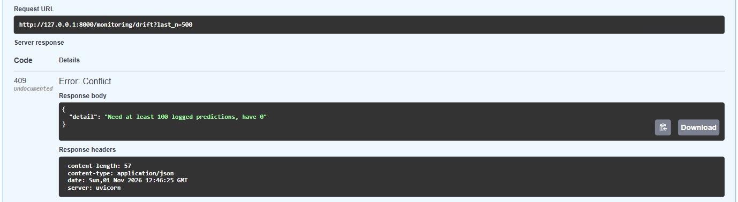
Screenshot 7: Drift report refused on an empty log. With no logged predictions, GET /monitoring/drift returns HTTP 409 'Need at least 100 logged predictions, have 0', so a drift verdict is never computed on too few rows.
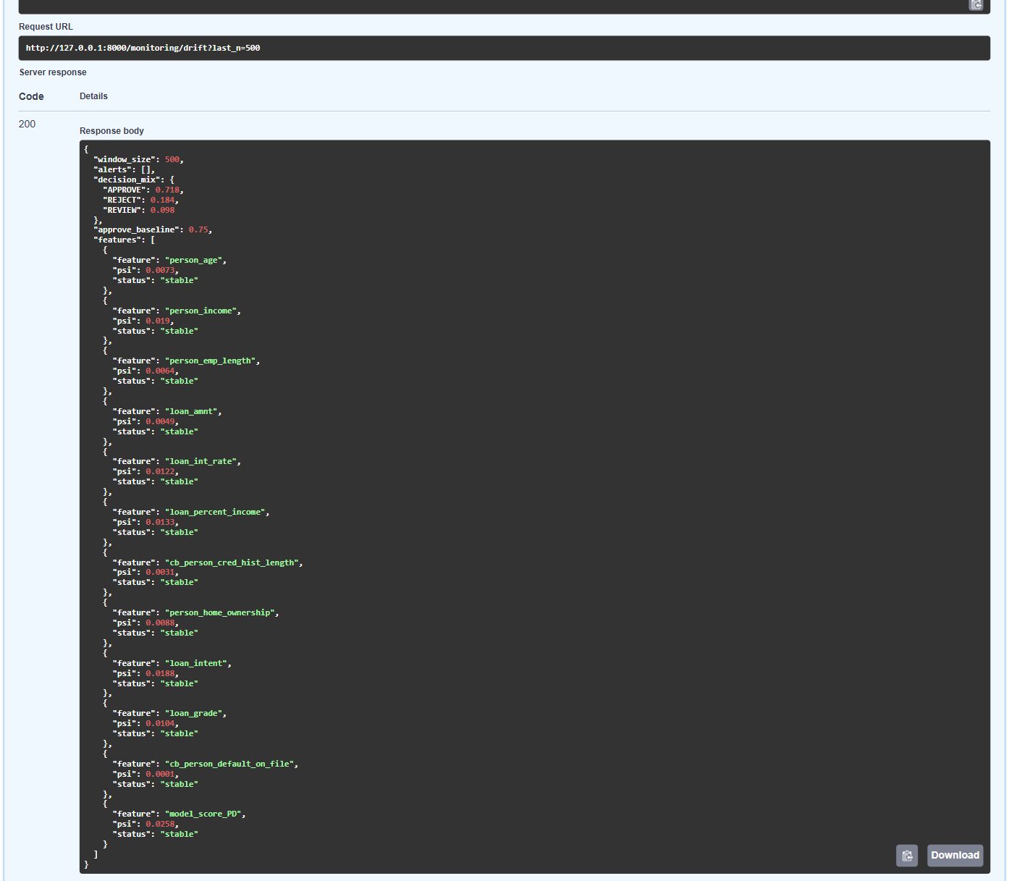
Screenshot 8: Drift check after 500 normal applications. After 500 test-set applicants were scored, every feature PSI is below 0.10 (stable), the decision mix is APPROVE 0.718 / REVIEW 0.098 / REJECT 0.184 against an approval baseline of 0.75, and the alerts list is empty.
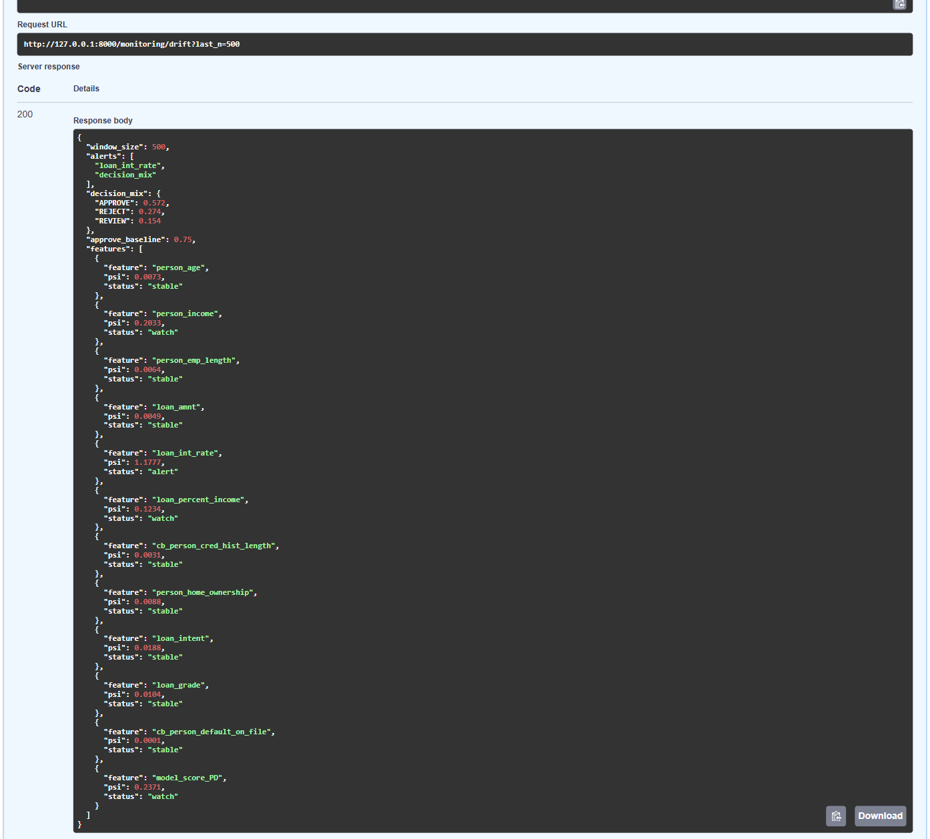
Screenshot 9: Drift alerts after a simulated downturn. After 500 applicants with incomes cut by 20% and rates raised by 2 points, loan_int_rate PSI is 1.1777 (alert), person_income 0.2033 and loan_percent_income 0.1234 (watch), approvals fall to 0.572, and the alerts are loan_int_rate and decision_mix.
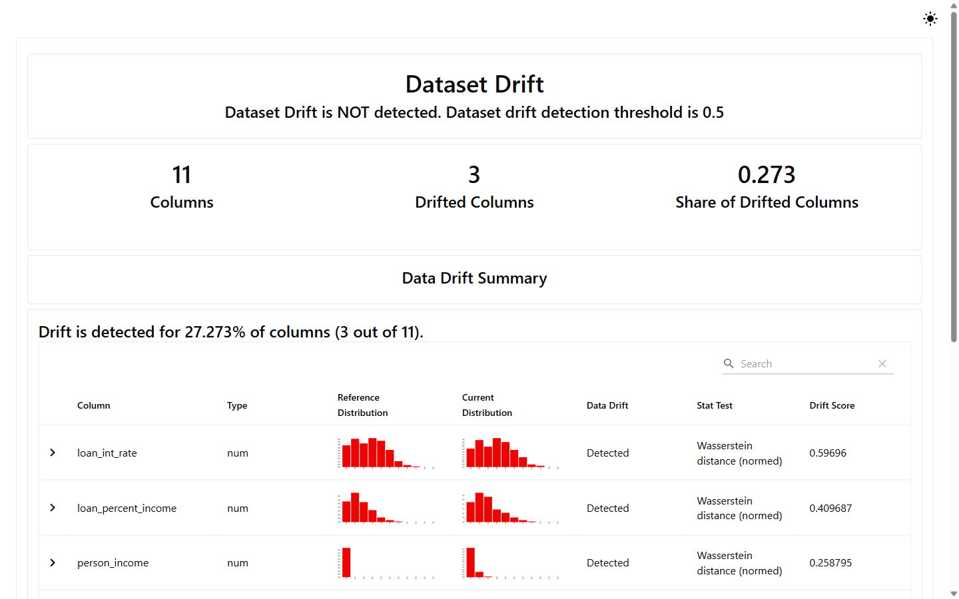
Screenshot 10: Evidently data drift report (downturn). The Evidently 0.7 report (reports/drift_report_downturn.html) compares the stressed test set with the training data: 3 of 11 columns drifted (share 0.273), below its 0.5 dataset-level threshold.
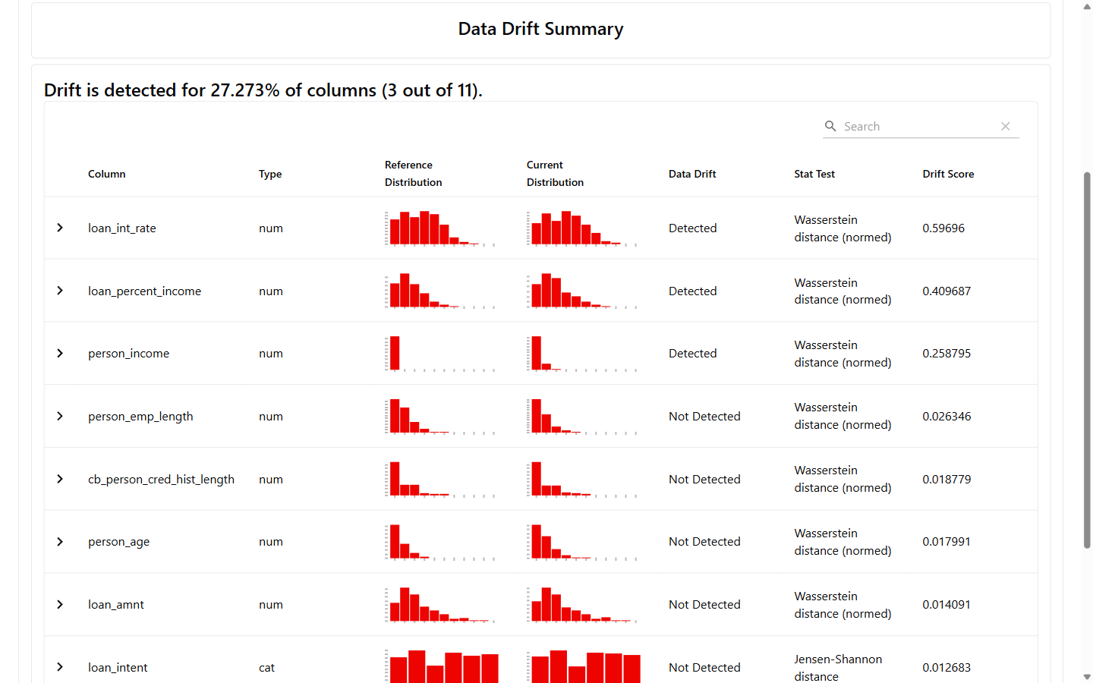
Screenshot 11: Evidently per-column drift table. Per-column detail of the same report: loan_int_rate (Wasserstein 0.597), loan_percent_income (0.410) and person_income (0.259) drifted; the other columns did not.

Kill switch
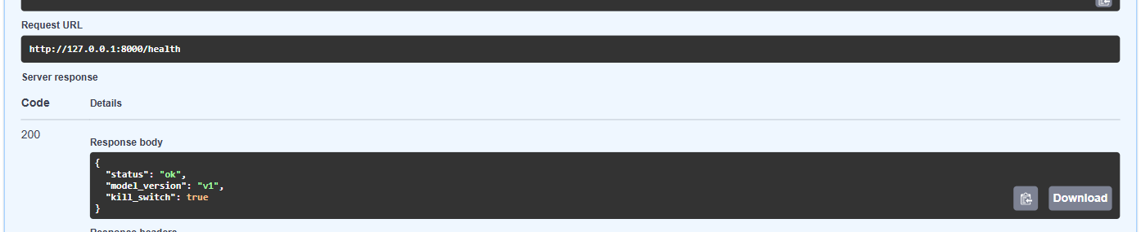
Screenshot 12: Kill switch on. The API started with SCORING_DISABLED=1 reports kill_switch true on GET /health.
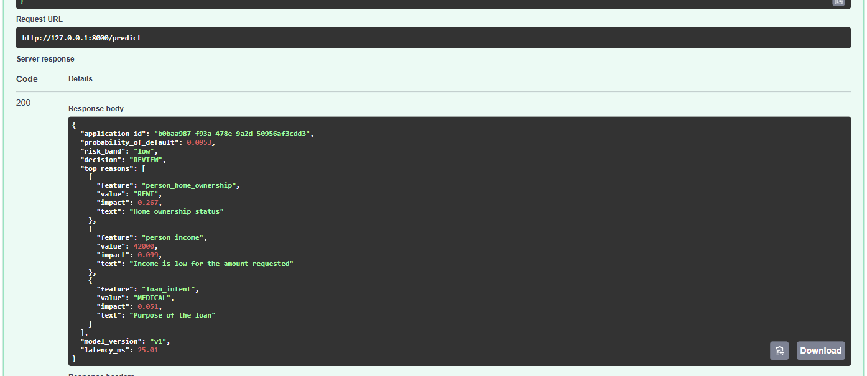
Screenshot 13: Every decision sent to a person. With the kill switch on, the low-risk applicant is still scored (PD 0.0953, band low) and logged, but the decision becomes REVIEW.

Pipeline runs (console)
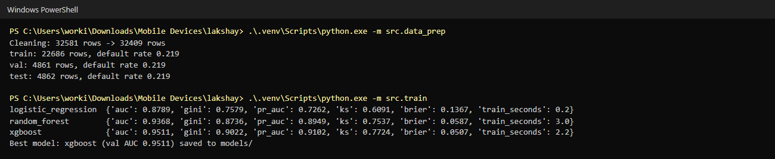
Screenshot 14: Cleaning, splitting and training. Console output of src.data_prep (32,581 to 32,409 rows; train 22,686 / val 4,861 / test 4,862, default rate 0.219 each) and src.train (validation AUC: logistic regression 0.8789, random forest 0.9368, XGBoost 0.9511, which is saved as model_v1).
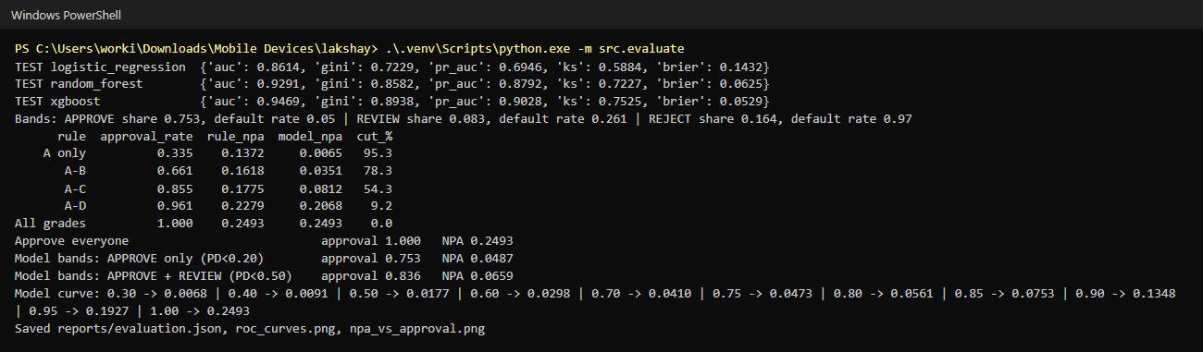
Screenshot 15: Test-set evaluation and NPA back-test. src.evaluate on the untouched test set: XGBoost AUC 0.9469; at the grade A-C rule's 85.5% approval rate the NPA ratio falls from 17.75% to 8.12% (54.3% lower).
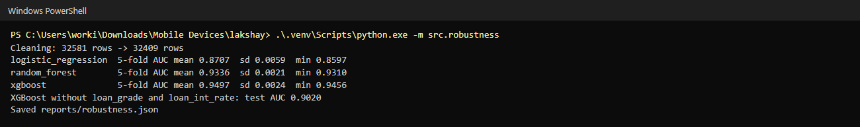
Screenshot 16: 5-fold cross-validation and ablation. src.robustness: XGBoost 5-fold AUC 0.9497 with standard deviation 0.0024; without loan_grade and loan_int_rate the test AUC is still 0.9020.
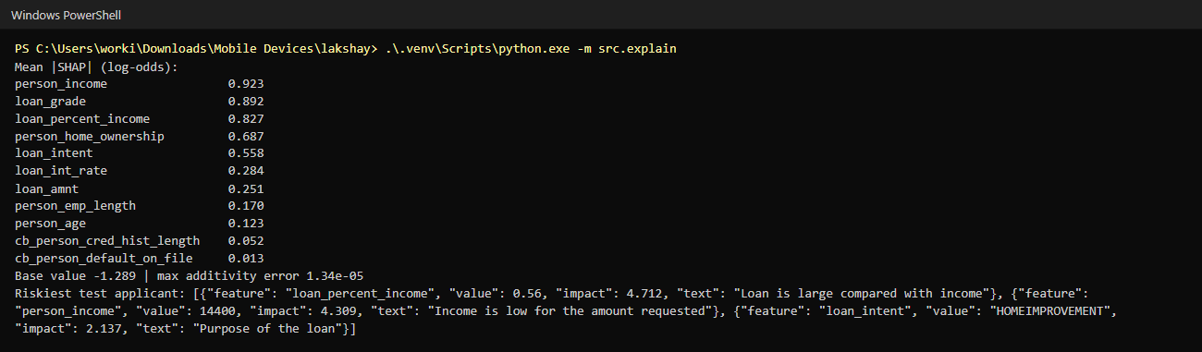
Screenshot 17: SHAP importance and reasons. src.explain: income, grade and loan-to-income ratio have the largest mean |SHAP|; base value -1.289 and maximum additivity error 1.34e-05; the riskiest test applicant gets three plain-language reasons.
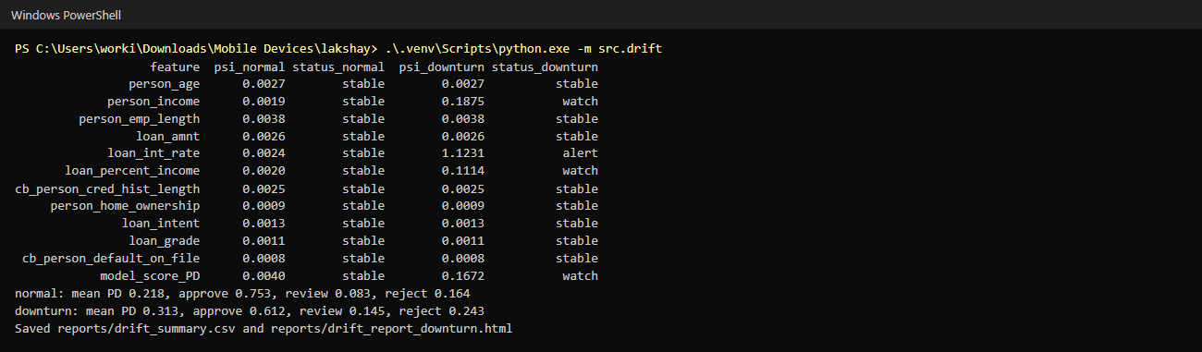
Screenshot 18: Offline PSI table. src.drift compares the test set and its stressed copy with the training data: loan_int_rate PSI 1.1231 (alert) in the downturn, mean PD rising from 0.218 to 0.313.

Traffic simulation, prediction log and tests
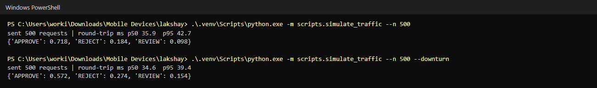
Screenshot 19: Simulated loan-app traffic. scripts.simulate_traffic sent 500 normal and 500 downturn applications to the running API; in this run, made while recording the screenshots, round-trip p95 was 42.7 ms and 39.4 ms (the Phase 8 check run gave 45.6 ms and 44.9 ms), all under the 100 ms target.
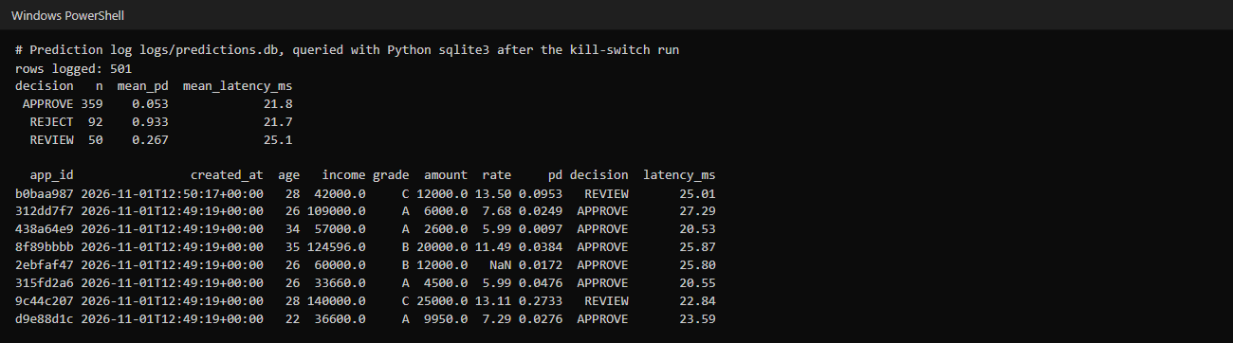
Screenshot 20: SQLite prediction log. logs/predictions.db holds one row per scored application (501 rows here: 500 normal applications and the kill-switch request), with inputs, PD, decision and latency.
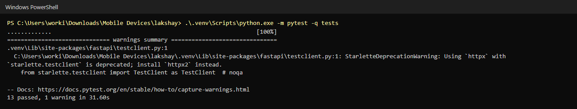
Screenshot 21: Automated tests. pytest runs the 13 tests (data, model and API) against a temporary database: 13 passed.

