Loan Default Prediction System: Exploratory Data Analysis (EDA notebook)
Source notebook: notebooks/01_eda.ipynb (executed). Code, outputs and charts in cell order.

Loan Default Prediction System (P_137) — Exploratory Data Analysis
Dataset: Credit Risk Dataset by laotse on Kaggle (https://www.kaggle.com/datasets/laotse/credit-risk-dataset). This notebook reads the raw CSV, checks quality (missing values, duplicates, impossible values) and looks at how default varies with grade, purpose and the numeric columns. Every chart is saved to reports/eda/ at 150 dpi.
import matplotlib
matplotlib.use("Agg") # file output only, no window needed
import matplotlib.pyplot as plt
import numpy as np
import pandas as pd
import seaborn as sns
from pathlib import Path

ROOT = Path.cwd().parent if Path.cwd().name == "notebooks" else Path.cwd()
EDA_DIR = ROOT / "reports" / "eda"
EDA_DIR.mkdir(parents=True, exist_ok=True)
df = pd.read_csv(ROOT / "data" / "raw" / "credit_risk_dataset.csv", encoding="utf-8")
print(df.shape)
df.head()
(32581, 12)
person_age person_income person_home_ownership person_emp_length \
0 22 59000 RENT 123.0
1 21 9600 OWN 5.0
2 25 9600 MORTGAGE 1.0
3 23 65500 RENT 4.0
4 24 54400 RENT 8.0

loan_intent loan_grade loan_amnt loan_int_rate loan_status \
0 PERSONAL D 35000 16.02 1
1 EDUCATION B 1000 11.14 0
2 MEDICAL C 5500 12.87 1
3 MEDICAL C 35000 15.23 1
4 MEDICAL C 35000 14.27 1

loan_percent_income cb_person_default_on_file cb_person_cred_hist_length
0 0.59 Y 3
1 0.10 N 2
2 0.57 N 3
3 0.53 N 2
4 0.55 Y 4

1. Target: how many loans defaulted?
counts = df["loan_status"].value_counts().sort_index()
print(f"counts {counts.to_dict()}, default rate {df['loan_status'].mean():.3f}")
fig, ax = plt.subplots(figsize=(5, 4))
ax.bar(["Repaid (0)", "Defaulted (1)"], counts.values, color=["#4C72B0", "#C44E52"])
for i, v in enumerate(counts.values):
ax.text(i, v, f"{v:,}", ha="center", va="bottom")
ax.set_title("Loans repaid vs defaulted"); ax.set_xlabel("loan_status"); ax.set_ylabel("Number of loans")
plt.tight_layout(); plt.savefig(EDA_DIR / "01_default_rate.png", dpi=150); plt.close()
counts {0: 25473, 1: 7108}, default rate 0.218
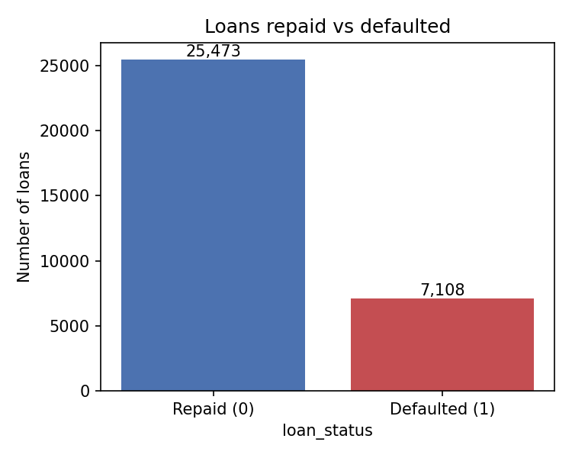

2. Missing values
missing = df.isna().sum()
missing = missing[missing > 0]
print("missing", missing.to_dict())
fig, ax = plt.subplots(figsize=(5, 4))
ax.bar(missing.index, missing.values, color="#DD8452")
for i, v in enumerate(missing.values):
ax.text(i, v, f"{v:,}", ha="center", va="bottom")
ax.set_title("Missing values per column"); ax.set_xlabel("Column"); ax.set_ylabel("Missing rows")
plt.tight_layout(); plt.savefig(EDA_DIR / "02_missing_values.png", dpi=150); plt.close()
missing {'person_emp_length': 895, 'loan_int_rate': 3116}
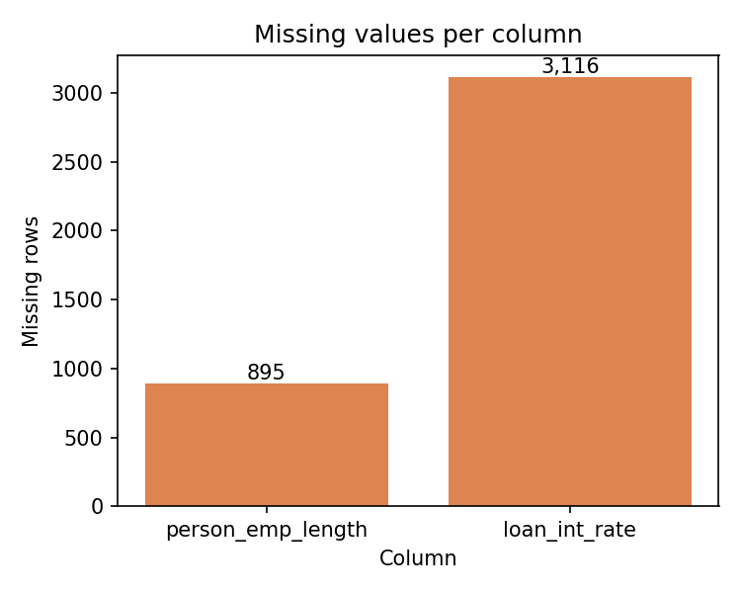

3. Duplicates and outliers
print(f"duplicates: {df.duplicated().sum()} | age > 100: {(df['person_age'] > 100).sum()} | "
f"employment > 60 years: {(df['person_emp_length'] > 60).sum()}")
fig, axes = plt.subplots(1, 3, figsize=(13, 4))
axes[0].boxplot(df["person_age"].dropna()); axes[0].set_title("Age"); axes[0].set_ylabel("Years")
axes[1].boxplot(df["person_emp_length"].dropna()); axes[1].set_title("Employment length"); axes[1].set_ylabel("Years")
axes[2].boxplot(df["person_income"].dropna()); axes[2].set_yscale("log")
axes[2].set_title("Income (log scale)"); axes[2].set_ylabel("Annual income")
for a in axes:
a.set_xticks([])
fig.suptitle("Outliers in age, employment length and income")
plt.tight_layout(); plt.savefig(EDA_DIR / "03_outliers.png", dpi=150); plt.close()
duplicates: 165 | age > 100: 5 | employment > 60 years: 2
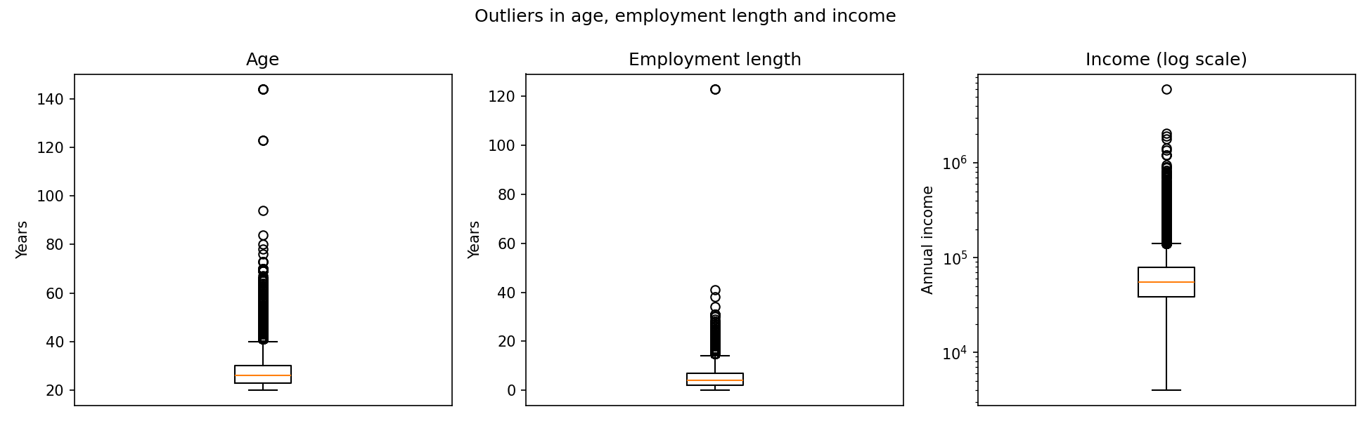

4. Default rate by the lender's grade
by_grade = (df.groupby("loan_grade")["loan_status"].mean() * 100).round(1).sort_index()
print("default % by grade ", by_grade.to_dict())
fig, ax = plt.subplots(figsize=(6, 4))
ax.bar(by_grade.index, by_grade.values, color="#55A868")
for i, v in enumerate(by_grade.values):
ax.text(i, v, f"{v}", ha="center", va="bottom")
ax.set_title("Default rate by loan grade"); ax.set_xlabel("loan_grade (A = best)"); ax.set_ylabel("Default rate (%)")
plt.tight_layout(); plt.savefig(EDA_DIR / "04_default_by_grade.png", dpi=150); plt.close()
default % by grade {'A': 10.0, 'B': 16.3, 'C': 20.7, 'D': 59.0, 'E': 64.4, 'F': 70.5, 'G': 98.4}
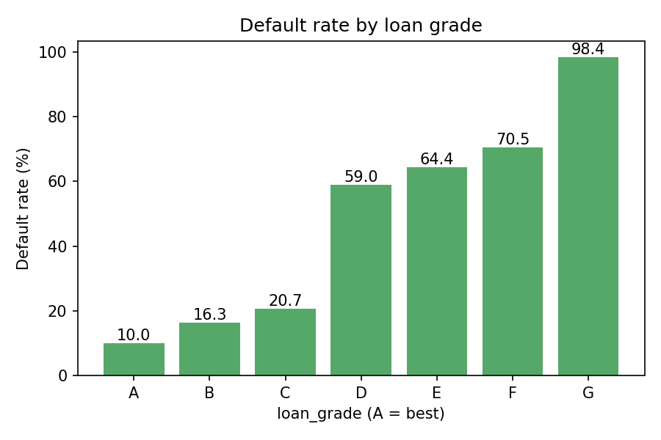

5. Default rate by loan purpose
by_intent = (df.groupby("loan_intent")["loan_status"].mean() * 100).round(1).sort_values()
print("default % by intent", by_intent.to_dict())
fig, ax = plt.subplots(figsize=(7, 4))
ax.barh(by_intent.index, by_intent.values, color="#8172B3")
for i, v in enumerate(by_intent.values):
ax.text(v, i, f" {v}", va="center")
ax.set_title("Default rate by loan purpose"); ax.set_xlabel("Default rate (%)"); ax.set_ylabel("loan_intent")
plt.tight_layout(); plt.savefig(EDA_DIR / "05_default_by_intent.png", dpi=150); plt.close()
default % by intent {'VENTURE': 14.8, 'EDUCATION': 17.2, 'PERSONAL': 19.9, 'HOMEIMPROVEMENT': 26.1, 'MEDICAL': 26.7, 'DEBTCONSOLIDATION': 28.6}
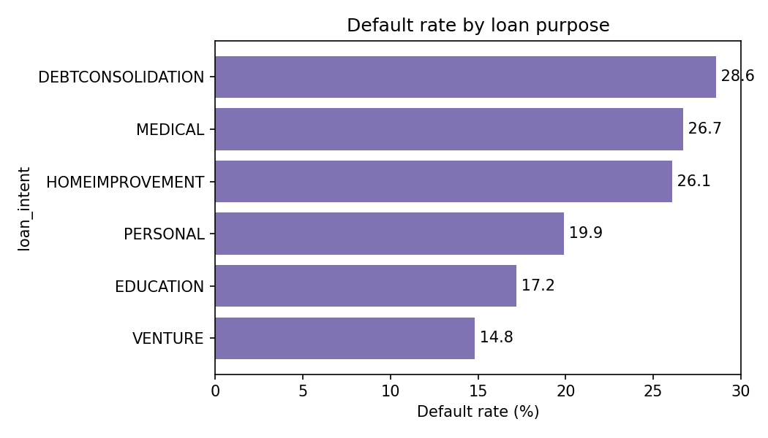

6. Correlation between numeric columns
corr = df.select_dtypes("number").corr()
with_target = corr["loan_status"].drop("loan_status").round(2).sort_values(key=abs, ascending=False)
print("correlation with loan_status:", ", ".join(f"{k} {v}" for k, v in with_target.items()))
fig, ax = plt.subplots(figsize=(9, 7))
sns.heatmap(corr, annot=True, fmt=".2f", cmap="coolwarm", center=0, ax=ax)
ax.set_title("Correlation between numeric columns (incl. loan_status)")
plt.tight_layout(); plt.savefig(EDA_DIR / "06_correlation.png", dpi=150); plt.close()
correlation with loan_status: loan_percent_income 0.38, loan_int_rate 0.34, person_income -0.14, loan_amnt 0.11, person_emp_length -0.08, person_age -0.02, cb_person_cred_hist_length -0.02
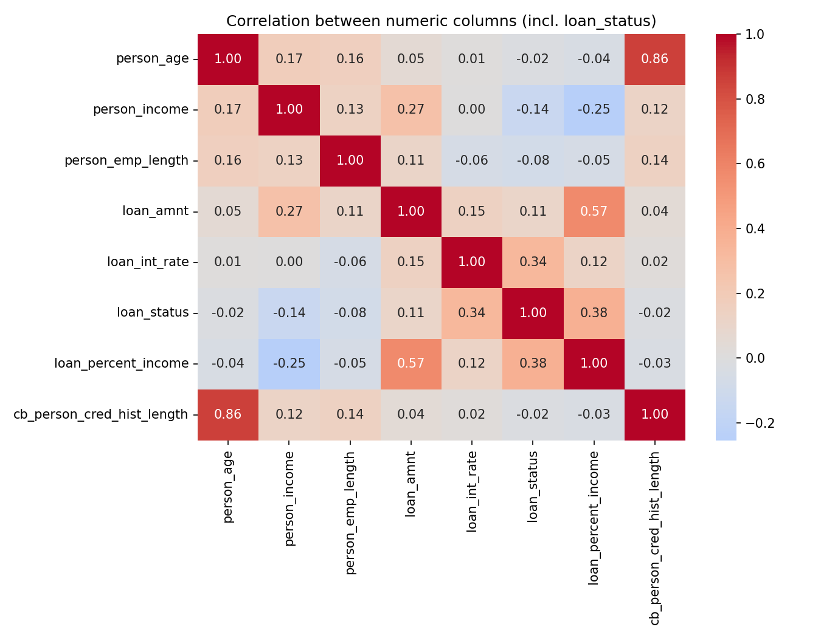

Findings
- Imbalanced target: 7,108 of 32,581 loans defaulted (21.8%), so accuracy alone would mislead; the models are judged on ROC-AUC, PR-AUC and KS instead.
- Data quality: 895 rows miss person_emp_length and 3,116 miss loan_int_rate (filled later with training medians); 165 exact duplicates, 5 ages over 100 and 2 employment lengths over 60 years are removed in cleaning.
- Grade is a strong but blunt signal: default rises from 10.0% in grade A to 20.7% in C and then jumps to 59.0% in D and 98.4% in G; purpose matters less (14.8% VENTURE to 28.6% DEBTCONSOLIDATION).
- Affordability drives risk: loan_percent_income (0.38) and loan_int_rate (0.34) correlate most with default, while higher income (-0.14) and longer employment (-0.08) lower it.

