**MINI-PROJECT (2020-2021)**

**LAST HOPE**

**(Web Development)**

**PROJECT REPORT**

**Department of Computer Engineering & Applications**

Institute of Engineering & Technology



**Submitted by** :- **Submitted to** :-

Kshitiz Gupta (181500338) Mrs. Harvinder Kaur

Gopal Gupta (181500240)

Lokesh Yadav (181500351)

Aditya Kumar Dubey (181500042)

Alok Kumar Upadhyay (181500068)

|  |
| --- |
| **TABLE OF CONTENTS** |
| **Certificate 4**  **Synopsis 5**  **Acknowledgement 7**  **Abstract… 8** |
| **1. Introduction….…………………………………………………………….** |
| 1.1 Overview 9 |
| 1.2 Motivation 9 |
| 1.3 Problem Statement 10 |
| 1.4 Objective… 10 |
| **2. Software Requirement Analysis…………………………………………..** |
| 2.1 System Analysis 11 |
| 2.2 Role of System Analyst 11 |
| 2.2.1 Main roles of System Analyst 12 |
| 2.3 Users 12 |
| * 1. Methodology 12   2. Dependencies /External Systems 13   3. DFD 15   4. Use-case Diagram 17 |
| 1. **Implementation details 18=** 2. **Contribution Summary 18** 3. **Tables 19** |

|  |
| --- |
| 1. **Project Work 25** 2. **Future Scope… 40** |
| **Reference 40** |

**Certificate**

This is to certify that Kshitiz Gupta , Gopal Gupta , Lokesh Yadav , Aditya Kumar Dubey, Alok Kumar Up adhyay students of B.Tech (CSE) 3rd year has successfully Completed the MINI PROJECT named LAST HOPE on Web Development under the Guidance of Mrs. Harvinder Kaur . During 2020-21.

**Signature:**

**Mrs. Harvinder Kaur** (Mentor)

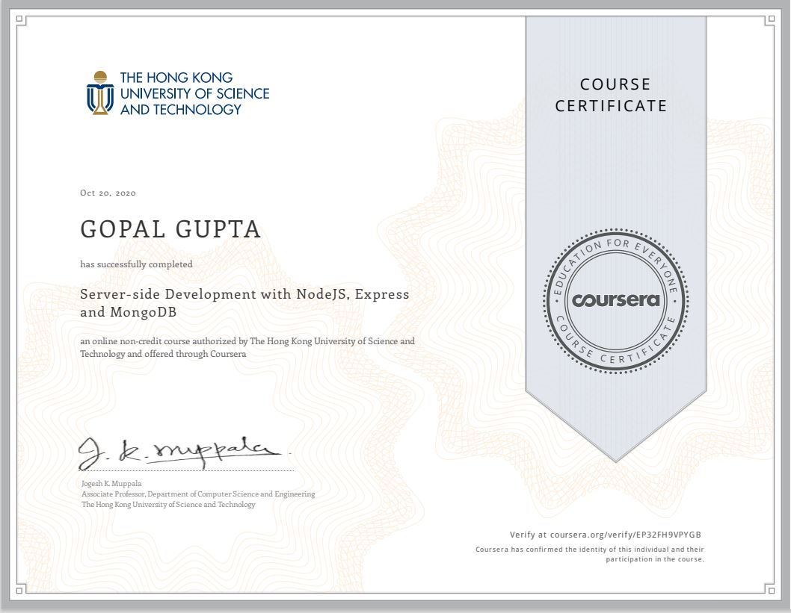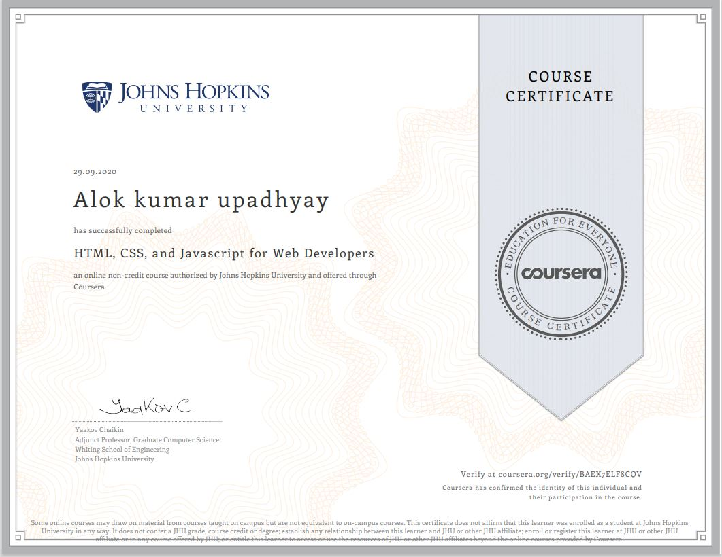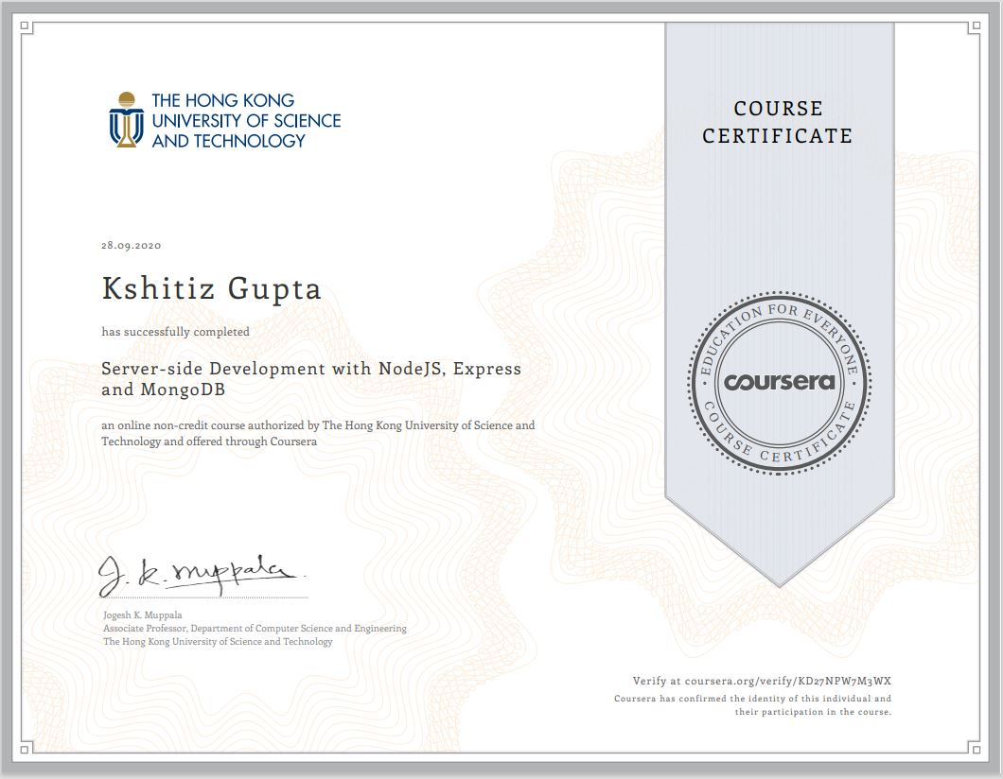

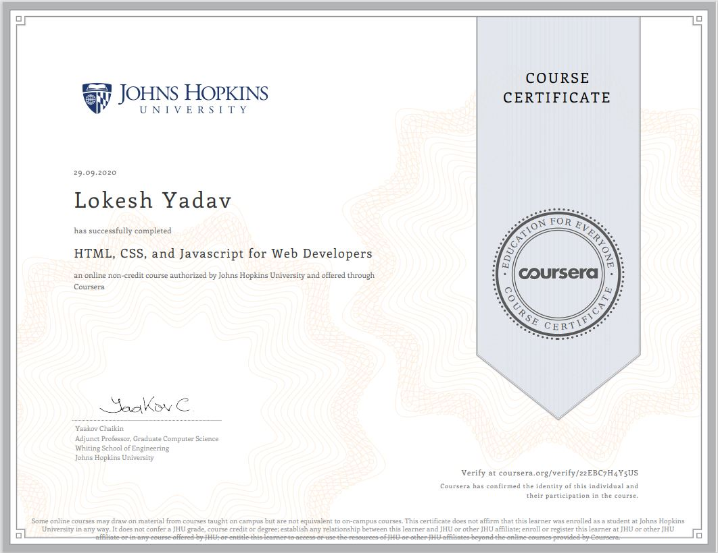



Project Information:

|  |  |
| --- | --- |
| Title Of Project/Training/Task | Last Hope |
| Role & Responsibility | Kshitiz Gupta: Front-end ,Back-end and Designer  Gopal Gupta: Front-end and Designer  Lokesh Yadav : Front- end designer and documentation work  Alok Kumar Upadhyay : Front-End  Aditya Kumar Dubey : documentation work |
| Technical Details | Hardware Requirements:   * Minimum Marshmallow version 7.0 ( for android ) * Pentium IV or higher, (PIV-300GHz recommended) * Hard-Disk 250GB or more * RAM 4GB or more * Processor i3 (7th Gen) * 1024 x 768 Display * Internet   Software Requirements:   * SYSTEM SOFTWARE :-   Operating System (Windows , Linux , MacOS )   * APPLICATION SOFTWARE :-   a) HTML  b) CSS  c) JavaScript  d) BootStrap  e) MySQL  f) php  g) Github  h)Xampp server  i) Web Browser ( Google Chrome , Firefox , Safari , Mozilla , Internet Explorer ) |

**Summary of the Work:**

During the completion of this project Snakbok we learnt about HTML , CSS, JavaScript, BootStrap, MySQL , php.

**Kshitiz Gupta**  implemented front-end , back-end and design the webpages.

**Gopal Gupta** implemented front-end part and designt the webpages.

**Lokesh Yadav** also helped in Front-end and completed modules according to the design given by Kshitiz Gupta along with documentation work required doing the project building period.

**Alok Kumar Upadhyay** worked on front-end along with Kshitiz Gupta and Lokesh Yadav.

**Aditya Kumar Dubey** worked on front-end along with documentation work required doing the project building period.

Our mentor **Mrs. Harvinder Kaur** guided us and helped a lot whenever required by us.

**Acknowlegment**

We have taken efforts in this project. However, it would not have been possible without the kind support and help of many Teachers . I would like to extend my sincere thanks to all of them.

We are highly indebted to Mrs. Harvinder Kaur for her guidance and constant supervision as well as for providing necessary information regarding the project & also for his support in completing the project.

We would like to express my gratitude towards our parents & member of GLA University for their kind co-operation and encouragement which help us in completion of this project.

**Abstract**

The report presents the three tasks that is being in continuation which are listed below:

1. Understanding of the Problem objective & implication.
2. Understanding of the data & building of the model.
3. Evaluation of the model.

All these tasks have been completed successfully and results were according to expectations. All the tasks were need very systematic approach, starting from the collection of the data to the implementation of the solution and till evaluation of the System. The most challenging task was the domain knowledge, to understand the language. It is one of the major areas and really need very fundamental and conceptual knowledge of HTML, JS, CSS, BootStrap.

# Introduction

* 1. Overview
     + All the functional/non-functional requirements, corresponding DFD’s, UML and Use Case Diagrams have been organized in this report. Along with these designs, this report also contain the essential data of this project.
     + The complete description of the application followed by the functionalities has been listed initially. Later on, the Webpage has been described diagrammatically with the help of different designing tools like Data Flow Diagram, Use Case Diagram, Interaction Diagram and E-R Diagram.
  2. Motivation

In today’s generation students are more depended on the internet to find the solutions and notes and they often waste their time in searching notes and solutions so they have to visit different websites for finding proper notes and solutions to accomplish their needs. And we often find that some websites have some issue of downloading the notes and solutions and it is difficult to download. Or maybe it’s difficult to get the sample papers with different sets and according to regions .

So, we come up with this idea of making a webpage for helping such student where they can find all the needed information at one place. This website is mainly for school level and college students and it Provides notes, solutions and sample paper. It`s easy to download notes, solutions and sample paper on one click. And Students can easily get all the content of learning in free of cost.

The basic advantage of this project is that it is time saving as it saves the time of the student which was wasted in browsing the same information on different sites.

* 1. Problem Statement

In today’s generation students are more depended on the internet to find the solutions and notes. Students often waste their time in searching notes and solutions so they have to visit different websites for finding proper notes and solutions to accomplish their needs.

Some websites have some issue of downloading the notes and solutions and it is difficult to download. It’s difficult to get the sample papers with different sets and according to regions.

So, we design a website which solves all these problems.

* 1. Objective
* This website is mainly for school level and college students
* Providing notes , solutions , videos lecture and sample paper
* Easy to download notes , solutions and sample paper on one click
* Easily get all the content of learning in free of cost
* Enhance the learning of students
* Reliable and Efficient for users
* Our first approach for website is to analysis the problems that students is facing in their daily life in field of online study.
* As it is a E-Learning website , the most important is to download the proper notes , solutions and sample papers.
* We download the content or study material from various website ( websites are provides in references ).
* Next approach is to make our website attractive and easy to use .
* Here comes the stage of implementation where we have to code and developing the required webpages according to the requirements.
* After implementation , the most important is testing and to find the bugs in our website.

1. System and Requirement Analysis
   1. System Analysis

System analysis is a process of collecting and interpreting facts, identifying the problems, and decomposition of the system into its components.

It is a process of studying a system in order to define its goals or purposes and to discover operations and procedures for accomplishing them most efficiently.

Here the problem is new students face a common problem of exposure. Most of the time, Students often waste their time in searching notes and solutions so they have to visit different websites for finding proper notes and solutions to accomplish their needs.

Some websites have some issue of downloading the notes and solutions and it is difficult to download. It’s difficult to get the sample papers with different sets and according to regions.

So, we design a website which solves all these problems.

Role of System Analyst

The system analyst is a person who is thoroughly aware of the system and guides the system development project by giving proper directions. He is an expert having technical and interpersonal skills to carry out development tasks

required at each phase.

* + 1. Main Roles of System Analyst:
       - Defining and understanding the requirement of user through various fact finding techniques.
       - Prioritizing the requirements by obtaining user consensus.
       - Maintains analysis and evaluation to arrive at appropriate system which is more user friendly.
       - Draw certain specifications which are easily understood by users and programmer in precise and detailed form.
       - Implement the logical design of system which must be modular.
  1. Users

The User of the web portal would be the Students (who have been signed up for the website irrespective of course and year) and Admin of this portal only.

* 1. Methodology

Our methodology is designed to help you take maximum advantage of the internet technologies. It incorporate all aspects related to our website and allows us to ensure that the final product is of the highest standards. Below are the steps we will take to ensure that all your deliverables are completed in time ,within budget also we will try to solve each and every problem efficiently.

Requirements analysis

The first step for us is to analyze your and your target`s requirements. Who will be visiting your website, what will be the purpose of their visit, what is the primary goal of your website, how can your organization best cater to their needs etc. Many such questions are analysed for the Needs Analysis stage.

If we are given access to the current website statistics, we would also like to analyze your current page views, average user time spent on the site, top landing pages, existing search engine rankings, existing bounce rates and many such factors. We analyze your online target audience and assess your differentiation strategy to best attract and retain your online visitors.

Your website will also undergo comprehensive search engine analysis twice during the course of the project; once during this stage and once again after the deployment (Go Live phase) of your website.

Website handover

Once the site is setup on your destination server, upon your approval we make the website live. One final set of testing is done on the live website for the quality assurance purposes. We then hand over the control of the site to you.

* 1. Dependencies/External Systems

User Interfaces:

UI-1: The Snakbok webpage shall permit complete navigation; including all the functionalities described above, starting from a simple login or registration to access the company information , to go through the feedbacks given by placed students ,to see the references to study the specified subjects ,users can give their suggestion to the admins and to give a quiz of several subjects . The portal is universally accessible on almost all PCs and smart phones.

Hardware Interfaces:

There are three external machines/devices used by the portal, each related to a user interface. These are a server machine at the admin end, hosting the portal, a PC at club’s end, keeping log of the registration and membership entries made to them & providing them with an interface to do their part of

functionality offered, last one is a PC or a smart phone at user’s end to access the portal. The devices at the user end behave as terminals and not for storing any type of data. Also capable of taking user input. All order and transaction should be stored on server.

HARDWARE REQUIREMENT (MINIMUM)

* 20 GB OF HARDDISK
* Processor i3 (7th Gen)
* 1024 x 768 Display
* Internet
* Minimum Marshmallow version 7.0 ( for android )
* Pentium IV or higher, (PIV-300GHz recommended)
* Hard-Disk 250GB or more
* RAM 4GB or more
* Processor i3 (7th Gen)

SOFTWARE REQUIREMENT-

* SYSTEM SOFTWARE
  + Operating System (Windows 7, Linux)
* APPLICATION SOFTWARE
  + - HTML ( front-end )
    - CSS
    - JavaScript (back-end )
    - BootStrap
    - MySQL (back-end )
    - php
    - Github
    - Xampp server
* Web Browser :-
  + - Google Chrome , Firefox , Safari , Mozilla , Internet Explorer
  1. DFD

**LEVEL 0 DFD**

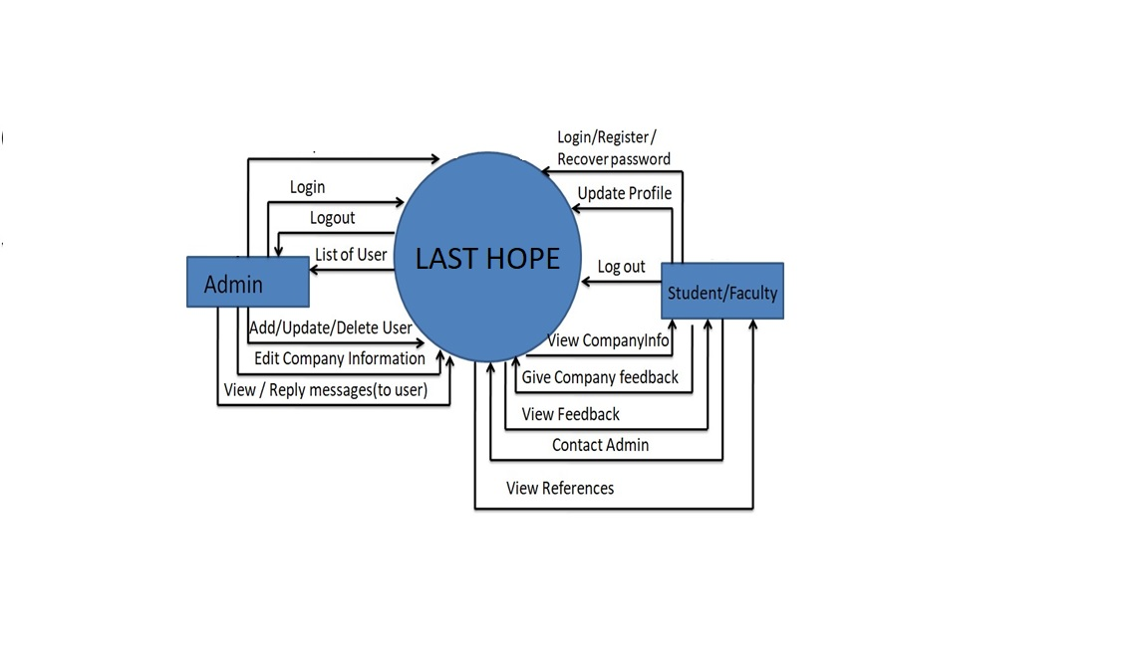

**LEVEL 1 DFD**

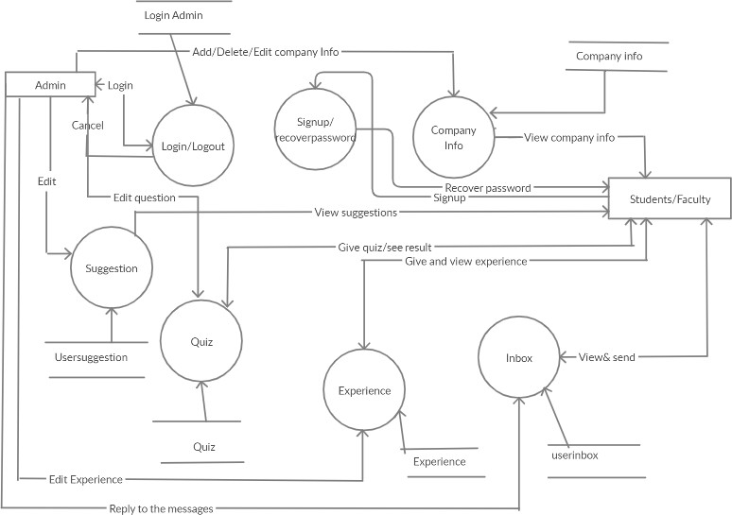

**USE-CASE DIAGRAM**

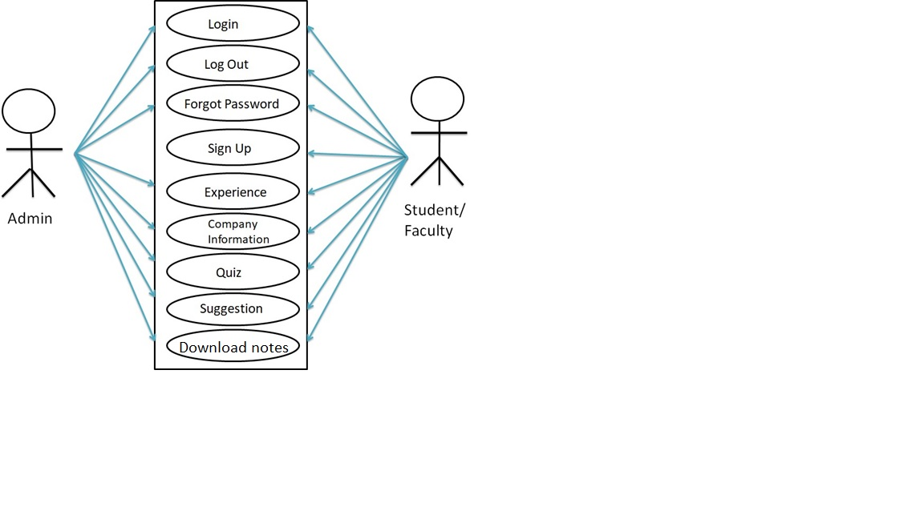

1. Implementation Details

I am creating a website in which i am using HTML, CSS and other web development languages and for backend , i m using PHP. For server and database we are using XAMPP (Apache server and MySQL database).

## Contribution Summary

OUR TEAM:

Kshitiz Gupta: Front-end , Back-end and Designer

Gopal Gupta: Front-end and Designer

Lokesh Yadav : Front- end designer and documentation work

Alok Kumar Upadhyay : Front-End

Aditya Kumar Dubey : documentation work

.

1. **Tables:**

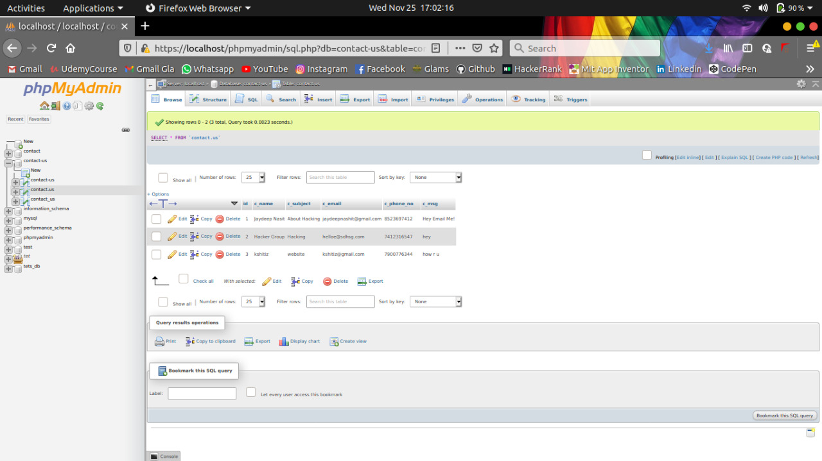

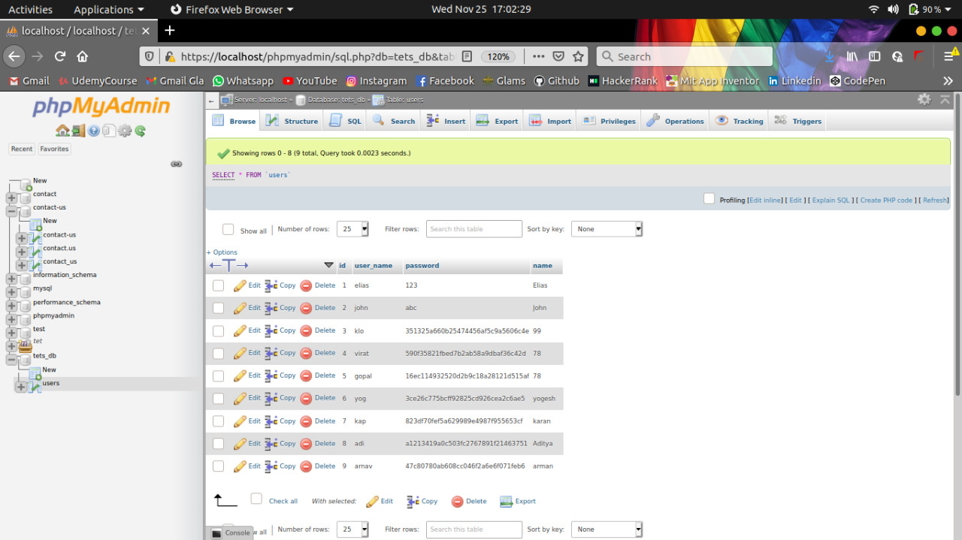

**Project Work:**

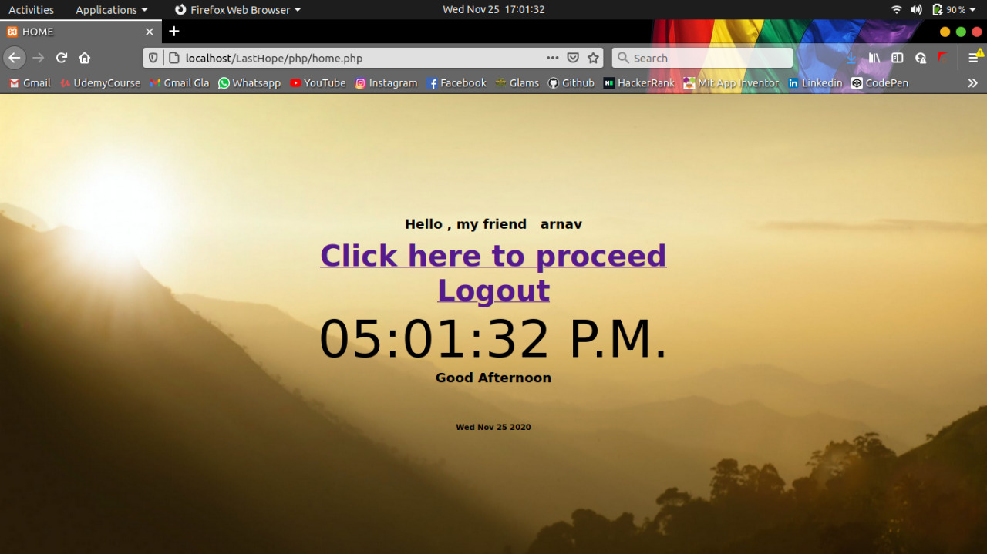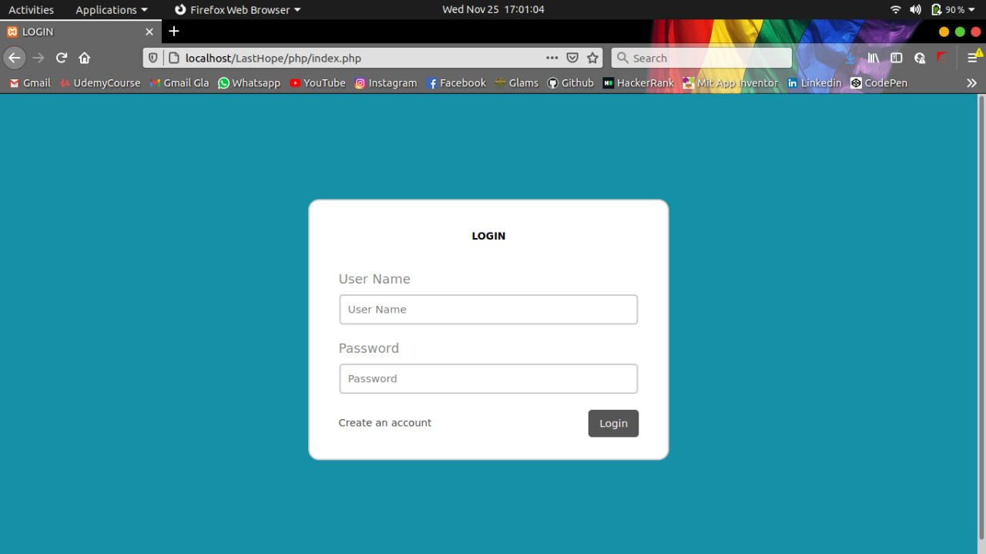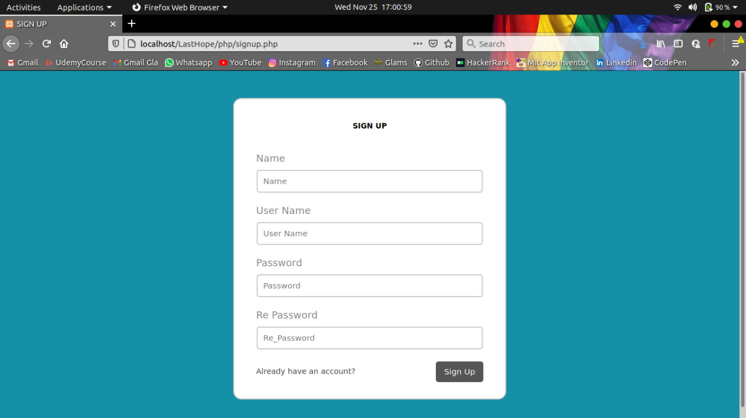

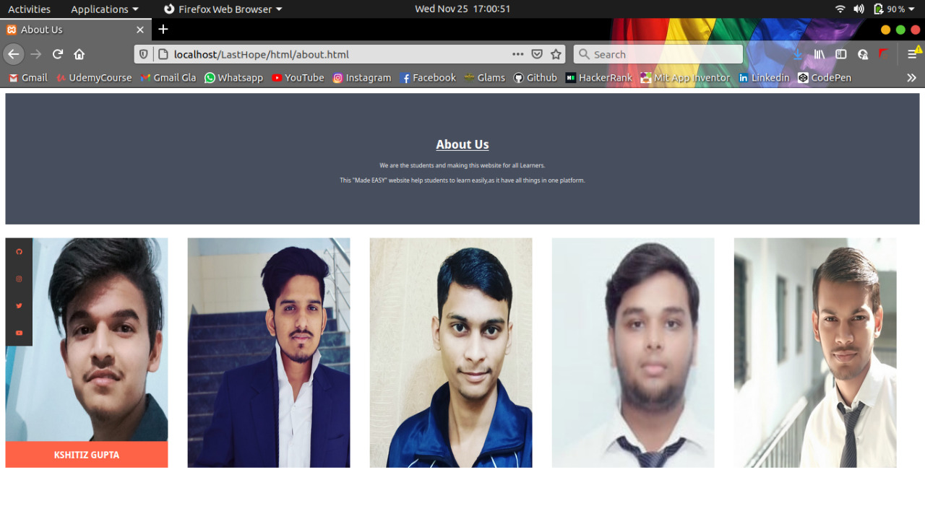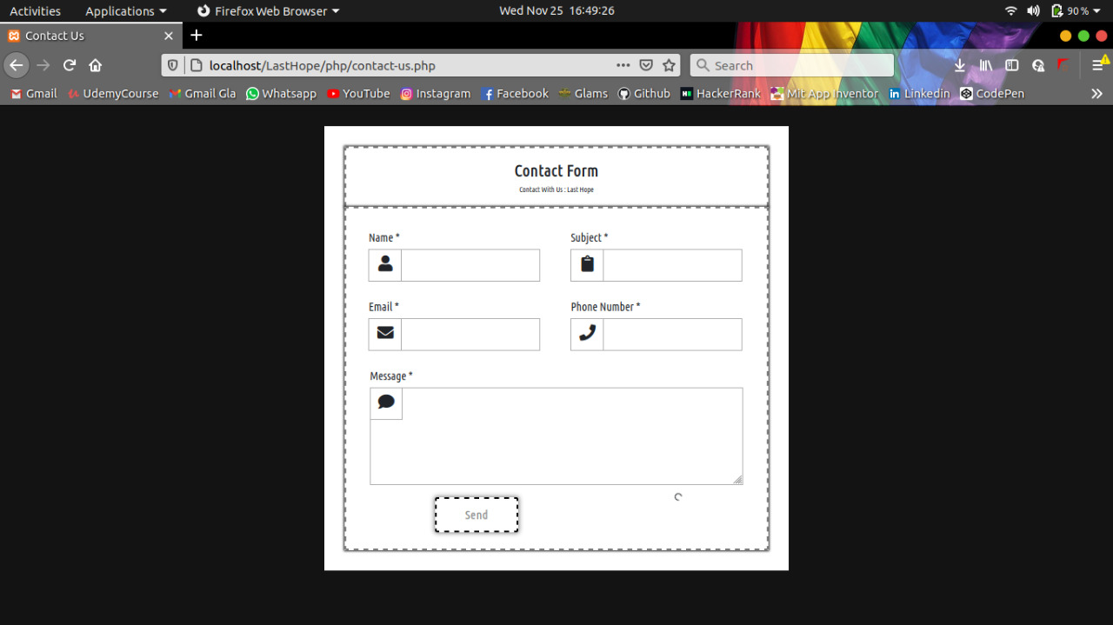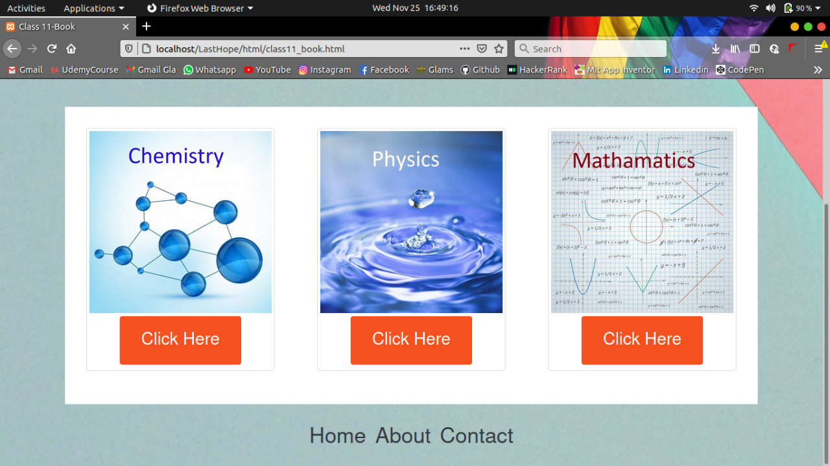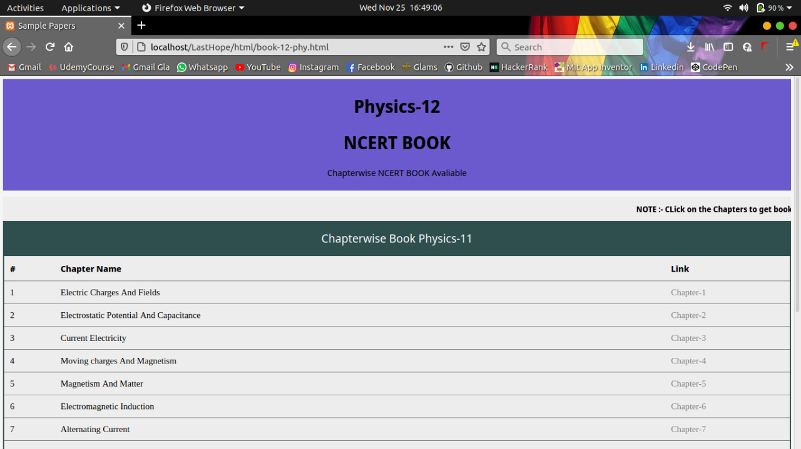

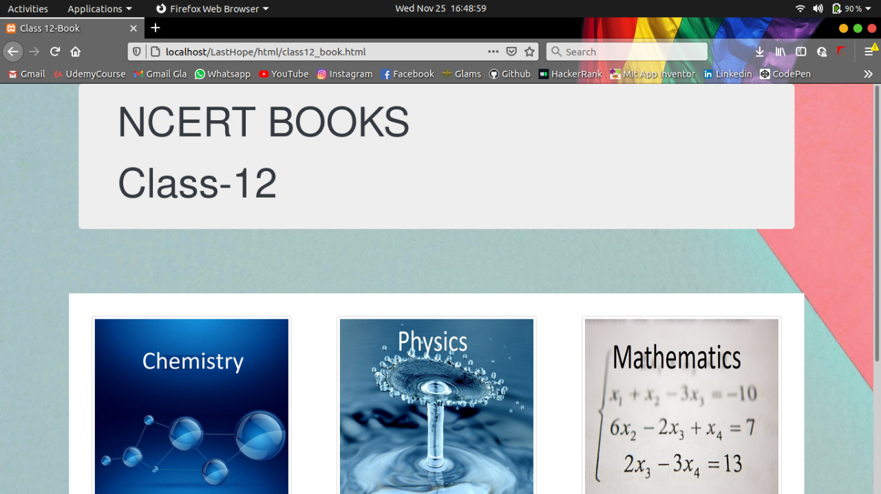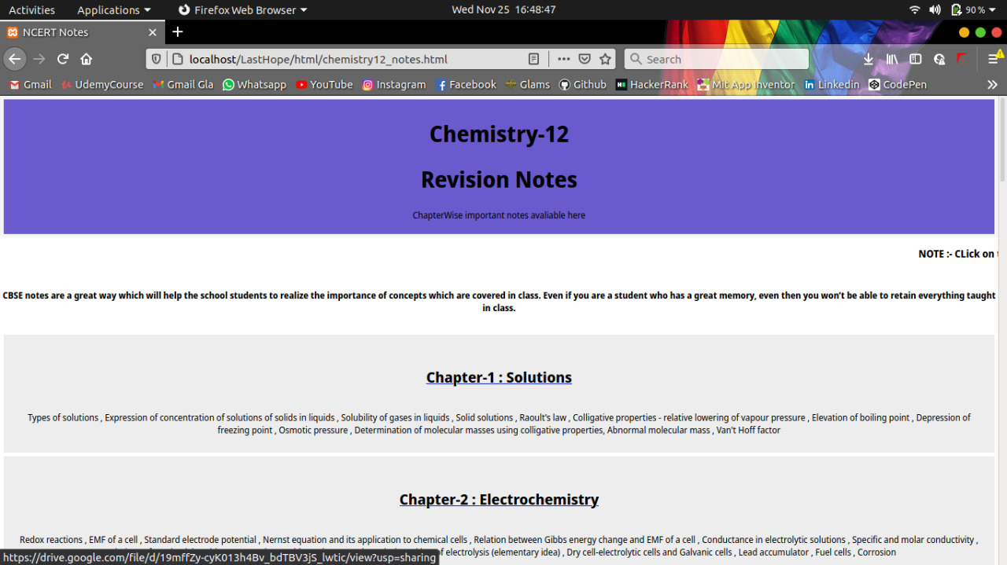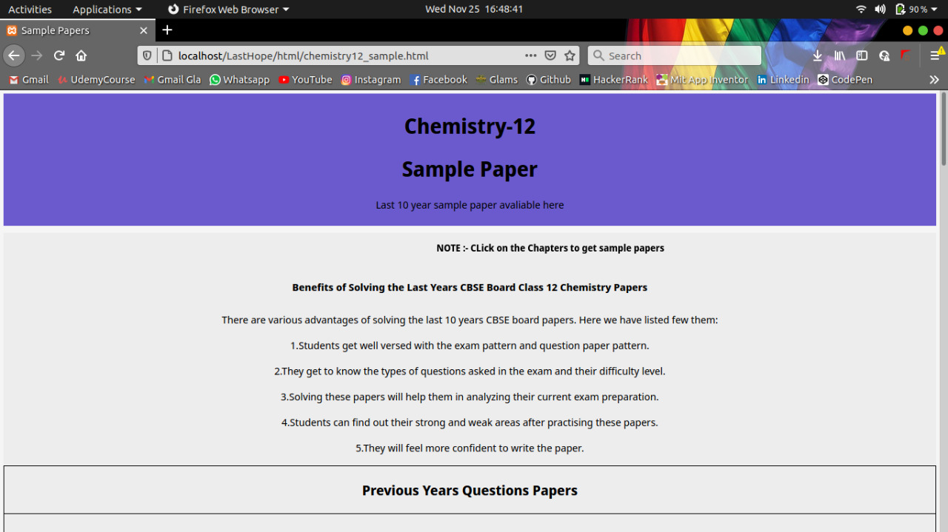

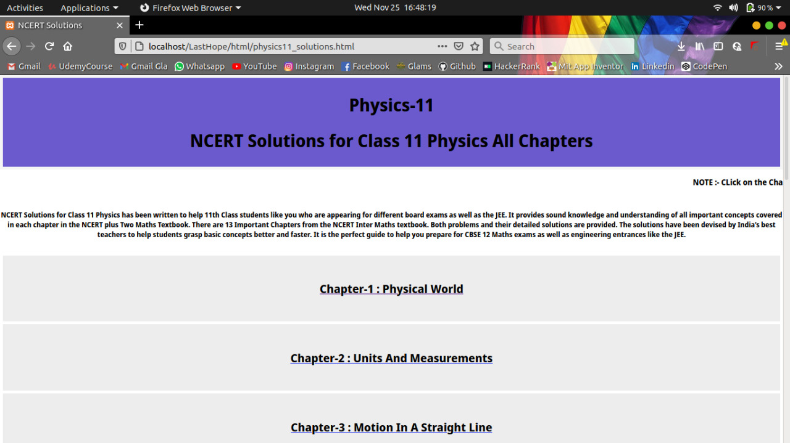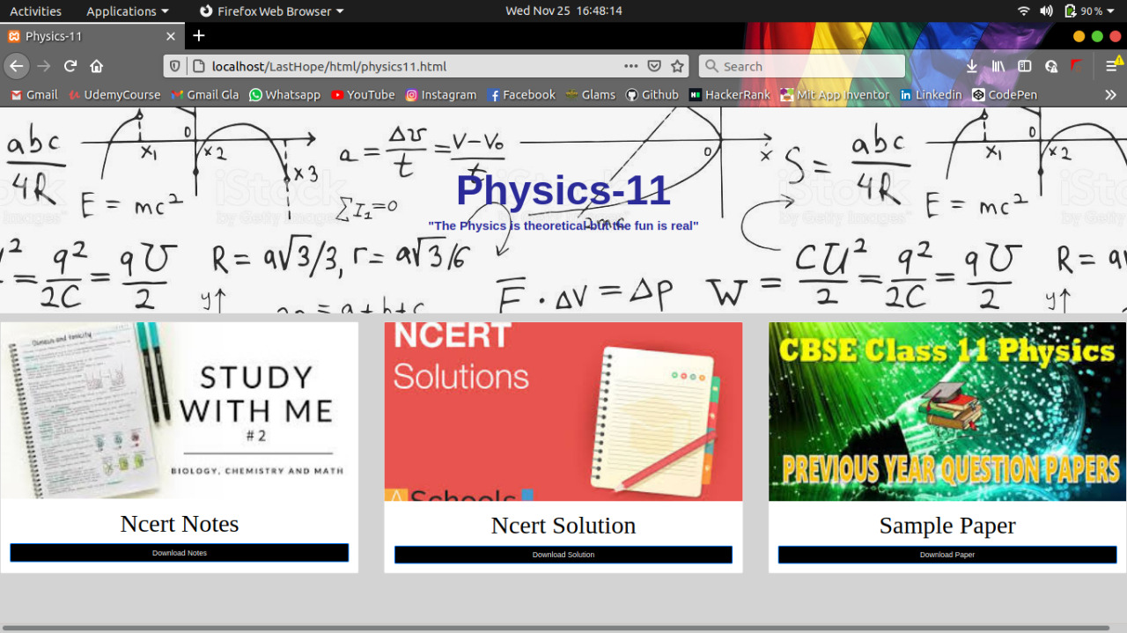

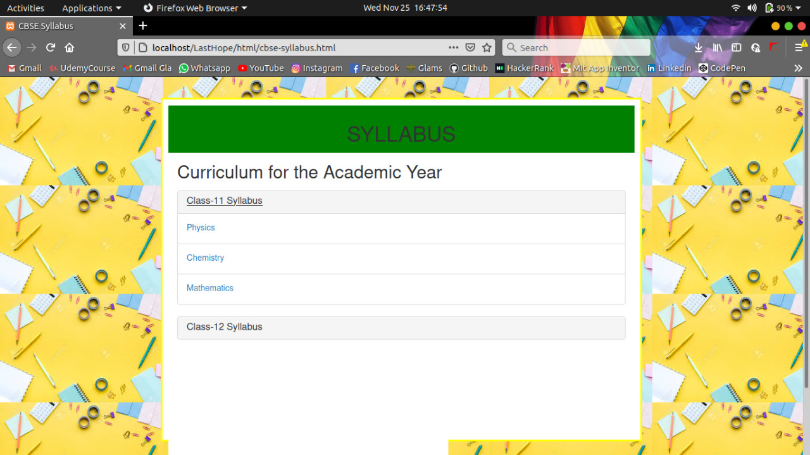

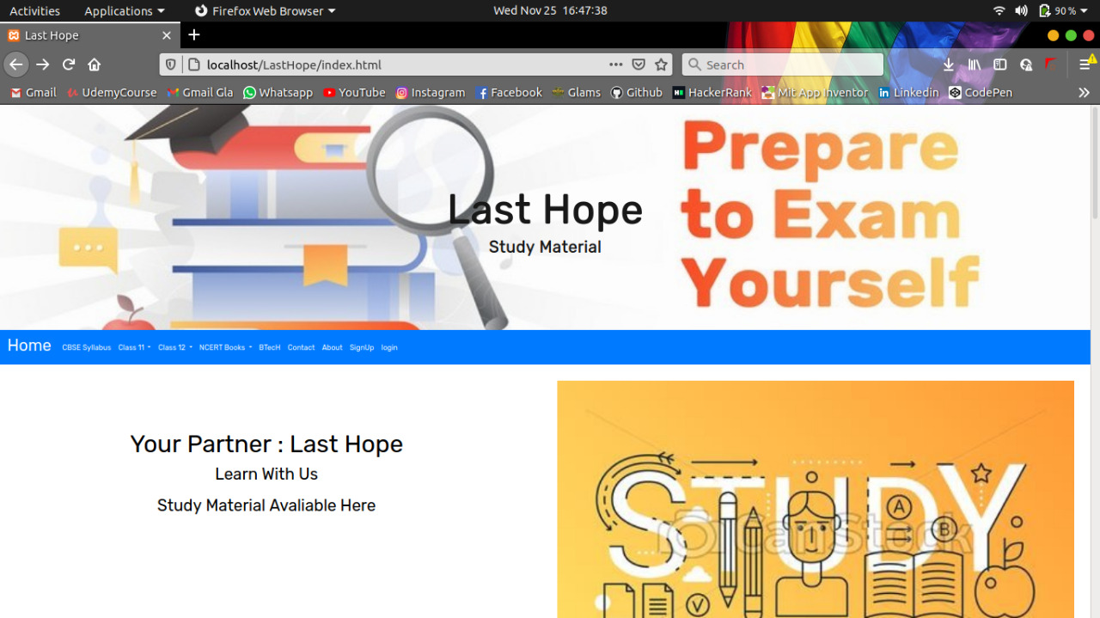

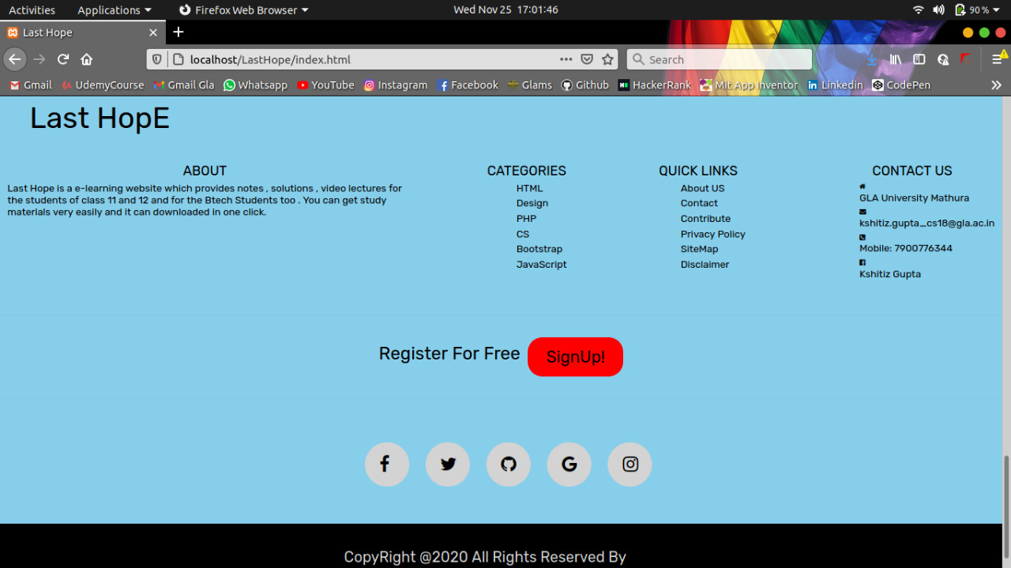

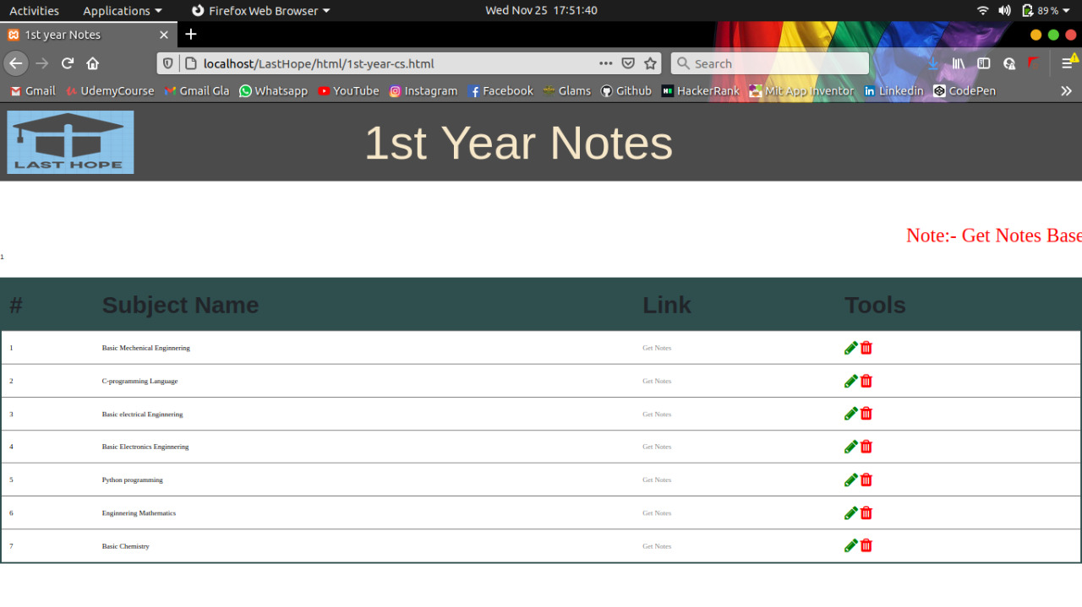

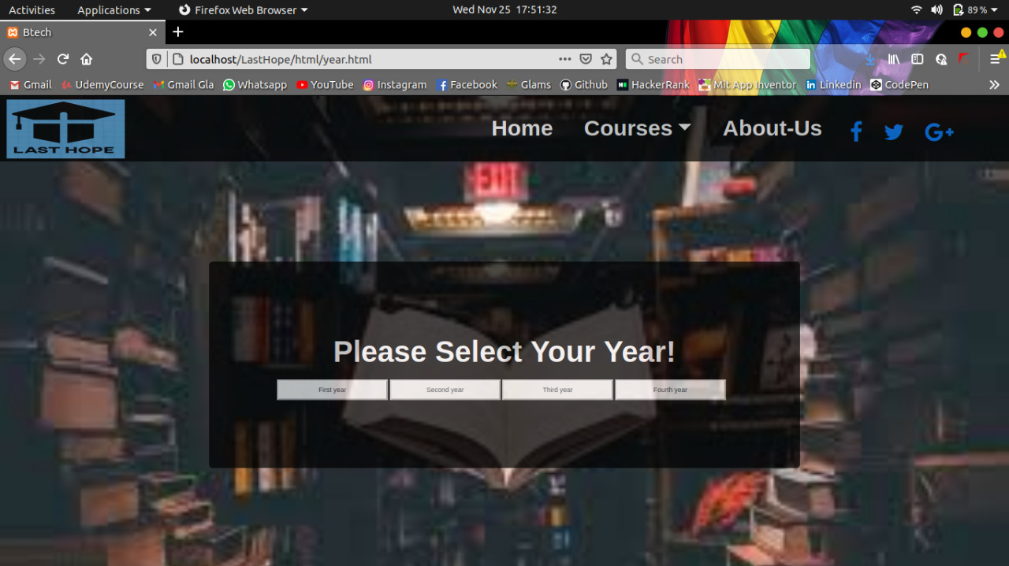

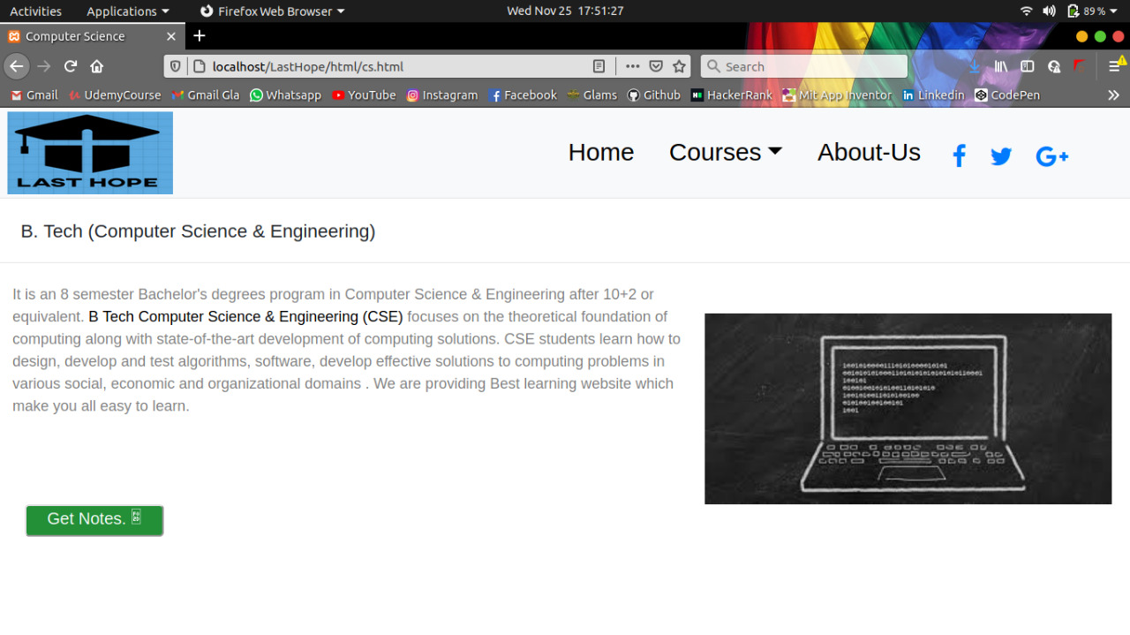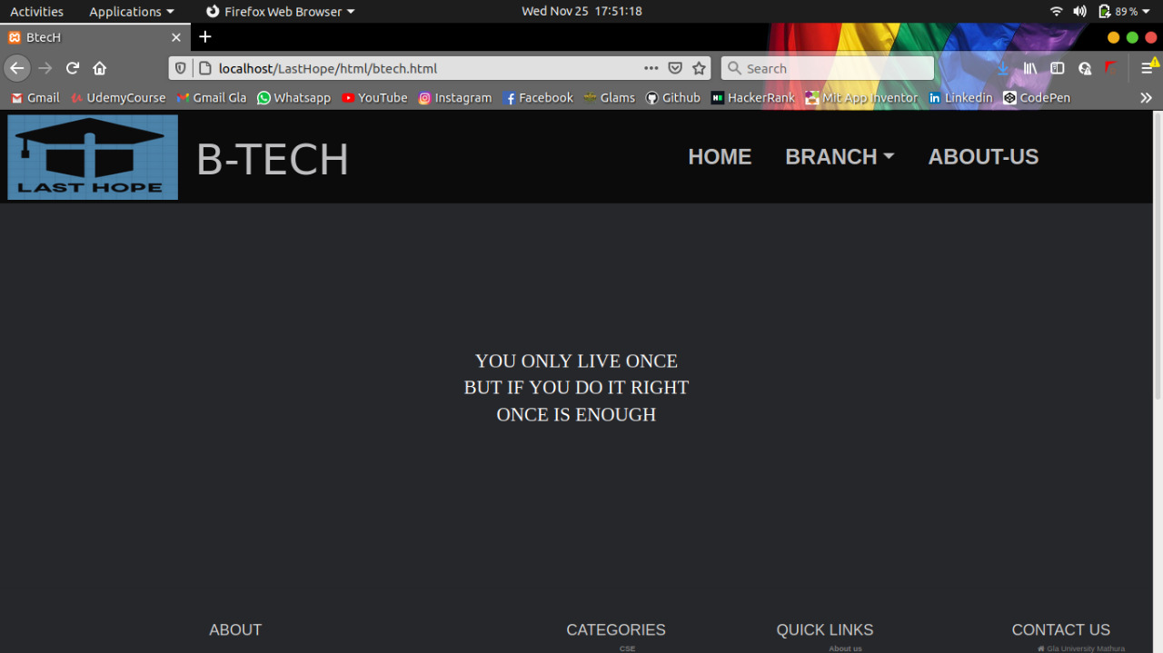

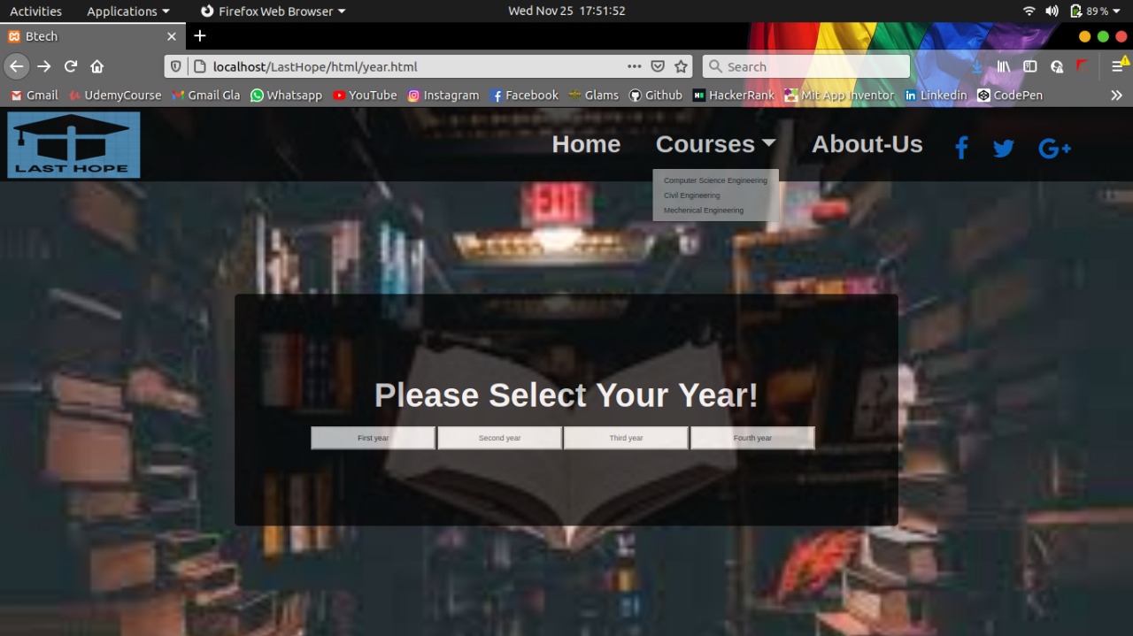

**Future Scope:**

Last Hope is going to help the student who wants to access notes, sample papers, ncert books, Syllabus and even B.tech notes. Not only it will save time but all the options available under single website will save lots of efforts for them.

This will help them a lot as many times we don’t get a source to get to know about this information.

**References:**

* [**www.javatpoint.com**](http://www.javatpoint.com/)
* [**www.w3school.com**](http://www.w3school.com/)
* [**www.tutorialspoint.com**](http://www.tutorialspoint.com/)
* [**www.youtube.com**](http://www.youtube.com/)
* **www.google.com**
* **Faculty Guideline:**
  + **Mrs. Harvinder Kaur**