# Institute of Engineering & Technology

**Mini-Project Synopsis**

**Travel and Explore Website**

**Submitted By:- Submitted To :**

**Name : Kshitiz Gupta Mr. Akash Choudhary**

**Uid : 181500338**

**Name : Gopal Gupta**

**Uid : 181500240**

**Name : Divyansh Sharma**

**Uid : 181500223**

**Name : Amit Varshney**

**Uid : 181500087**

## DECLARATION

I hereby declare that the project work entitled “**Travel and Explore Website**”, submitted to Department of Computer Science & Engineering, GLA University, Mathura in mentorship of Mr. Akash Choudhary for the session 2020-2021. All the coding are result of my personal effort.

Name of Candidates :-

* Kshitiz Gupta (181500338)
* Gopal Gupta (181500240)
* Divyansh Sharma (181500223)
* Amit Varshney (181500087)

## ACKNOWLEDGEMENT

I have taken efforts on this project. However, it would not be possible without the help and kindness of many people and organizations. I would like to extend my gratitude to all.

I am indebted to Department of Computer Science & Engineering, GLA University, Mathura for their guidance and regular supervision and to provide the necessary information about the project and their support for the completion of the project.

I would like to express my gratitude to my parents and to the member of Department of Computer Science & Engineering, GLA University, Mathura for their good cooperation and encouragement which helps me in completing this work.

My thanks and thanks go to my colleagues in building the project and the people who volunteered to help me with their skills.

**INDEX**

|  |  |
| --- | --- |
| S.NO | Topic |
| 1 | Introduction |
| 2 | System Requirements |
| 3 | Hardware Requirements |
| 4 | Front End and Back End |
| 5 | Idea |
| 6 | Objective |
| 7 | Module Description |
| 8  9 | Availability  DFD 0level and 1 level |

# INTRODUCTION: -

A **travel website** is a website that is dedicated travel. The site may be focused on travel reviews, trip fares, or a combination of both. Over 1.5 billion people book travel per year, 70% of which is done online.

**Travel** is the movement of people between distant geographical locations. Travel can be done by foot, bicycle, train, boat, bus, airplane, ship or other means, with or without luggage, and can be one way or round trip. Travel can also include relatively short stays between successive movements, as in the case of tourism.

**2. Software Requirements: -**

a) HTML (front-end)

b) CSS

c) ReactJs

d) Mongo dB (back-end)

e) GitHub

f) VS Code

g) NodeJS

h) Express

h) Web Browser (Google Chrome)

i) Operating System (Windows, Linux, MacOS)

**3. Hardware Requirements: -**

a) Minimum Marshmallow version 7.0 (for android)

b) Window 8 or more

c) Hard-Disk 250GB or more

d) RAM 4GB or more

**4. Frontend and Backend: -**

**4.1 Frontend**

Reactjs is library of JavaScript. It is open source, front-end, for building user interface. It is maintained by Facebook and a community of individual developers and companies. React can be used as a base in the development of single-page or mobile applications.

**4.2 Backend**

The backend lies on mongo dB,Mongo DB is an open-source document database and leading NoSQL database. database used for high volume data storage. Instead of using tables and rows as in the traditional relational databases.

# 5. Idea : -

Idea behind this website is built to enhance the tourist in India and also their experience of trips , With the help of this website tourists are able to find better destination for their trips very easily , our motive is to provide all the facilities(places to explore , convenience , hotels ,etc) at the same place , in all over the India .It contains selected and popular destinations of country. We also suggest best hotels at low prices with respected our destination with all convenience which we select for our trip. We also adding the information of best beaches, hill stations and Mountains for destination in World wide. And adding location to respective destination.

## 6. Objective: -

a.The main objective of the project is to enhance tourism.

b.It will help tourists to find better destination for their trips easily.

# 7. Module Description:

**Login And SignUp :** User can signup and login easily.

**Searching**: User can search best places like historical monuments, famous landmarks, hill stations, etc to visit throughout the India.

**Cart**: User can also add the best places that he/she wants to experience in the future.

**Live Location :** User can see the live location of their destination place.

**8. DFD: -** A data flow diagram (DFD) illustrates how data is processed by a system in terms of inputs and outputs. As its name indicates its focus is on the flow of information, where data comes from, where it goes and how it gets stored.

1. **Level DFD: -**DFD Level 0 is also called a Context Diagram. It’s a basic overview of the whole system or process being analyzed or modeled. It’s designed to be an at-a-glance view, showing the system as a single high-level process, with its relationship to external entities. It should be easily understood by a wide audience, including stakeholders, business analysts, data analysts and developers.

Hotel Management

Login/Register

Geo Location of destination

Travel and Explore Website

Package Management

Add to cart

Admin Management

Search destination place

1. **level DFD: -** DFD Level 1 provides a more detailed breakout of pieces of the Context Level Diagram. You will highlight the main functions carried out by the system, as you break down the high-level process of the Context Diagram into its sub processes.

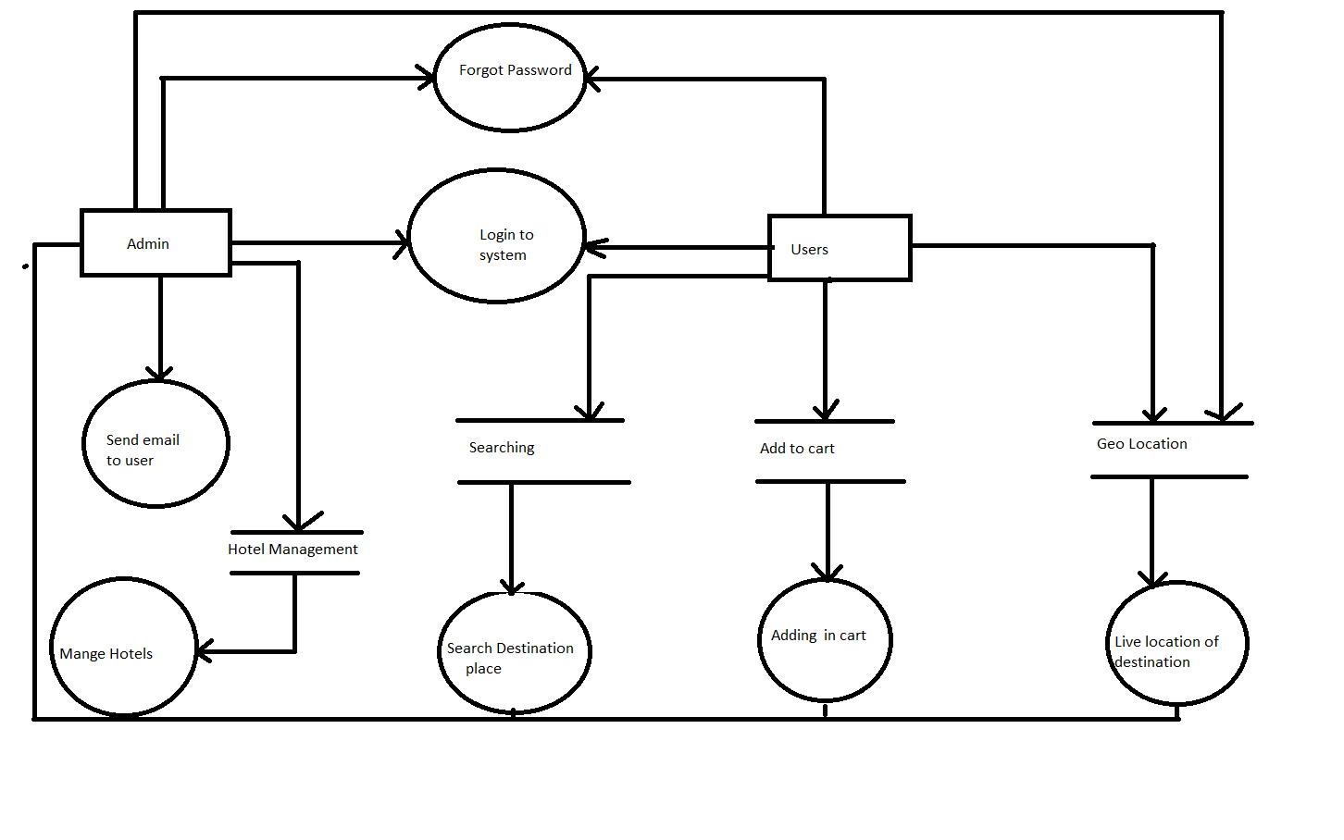

**9. AVAILABILITY: -**

This website is available for every user who use internet.