EDA_ASSESSMENT-2
NAME: Kshitiz Bishnoi
Reg No :25BAI0154
TASK : To Apply dataframes on the csv file : 1000 sales record;
1)
Reading the dataframe:
import pandas as pd
import numpy as np
# Read the CSV file
df = pd.read_csv("1000 Sales Records.csv")
print("Original DataFrame:")
print(df.head())
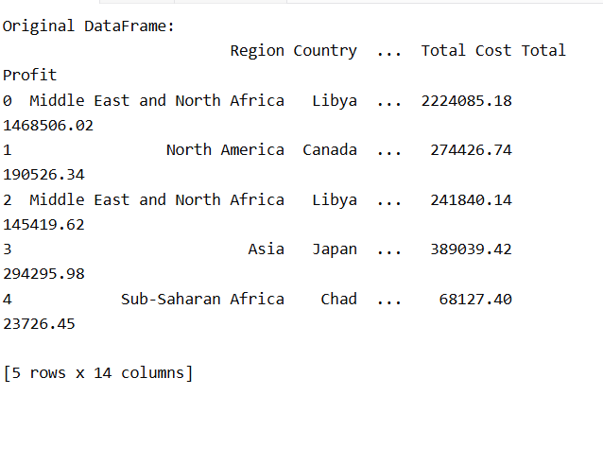

2) Catenation of Dataframes:

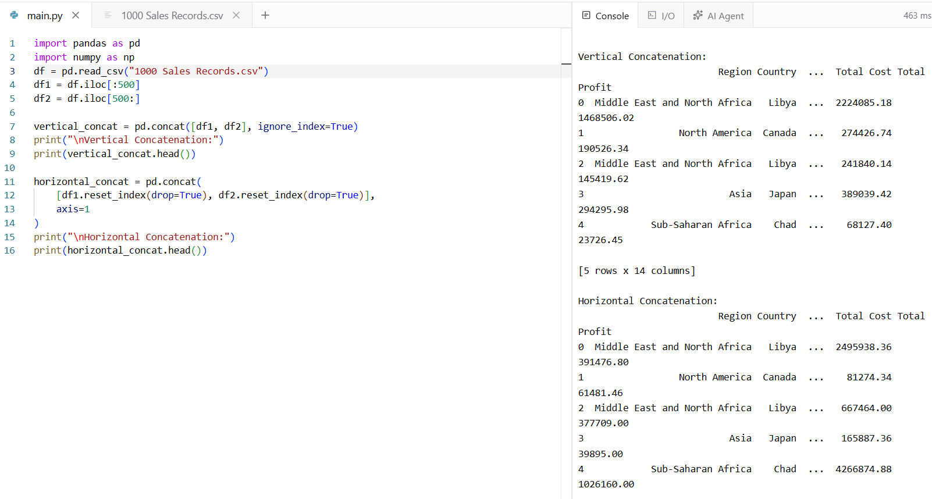

3)Merging of dataframes:
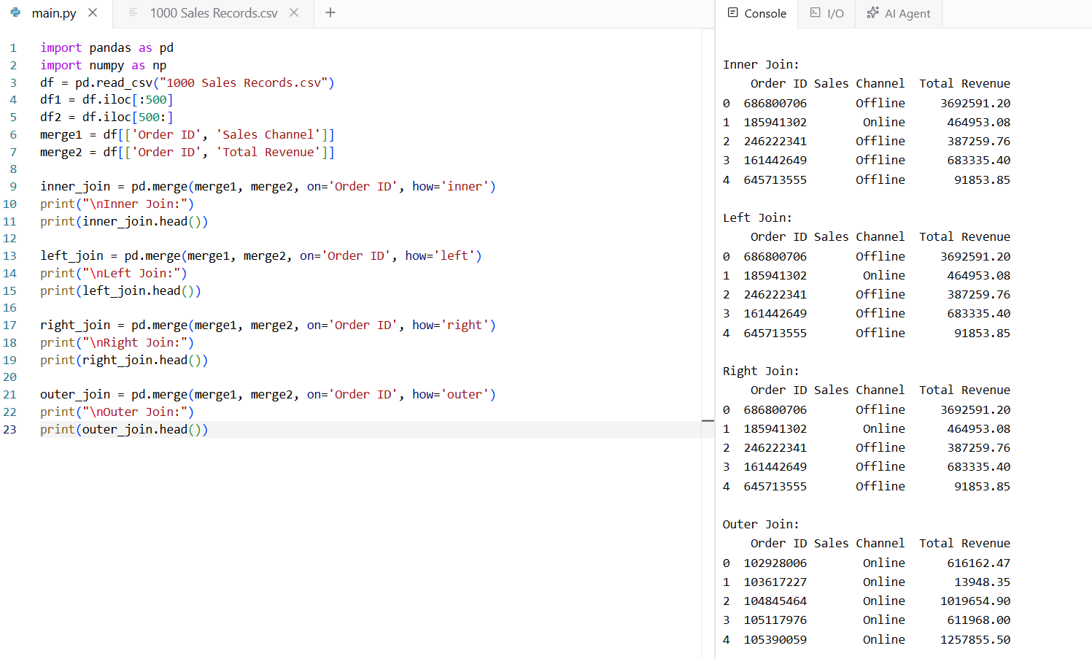

4) Adding a new column:
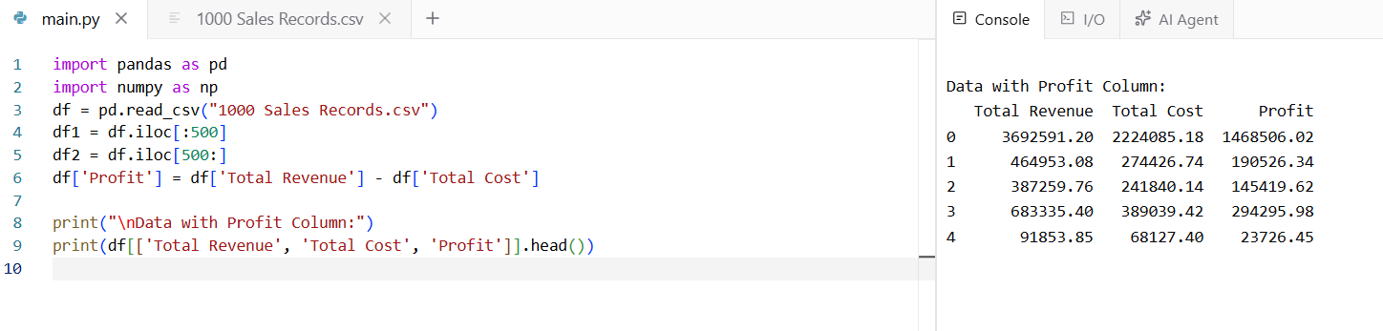
5) Descriptive statistics;
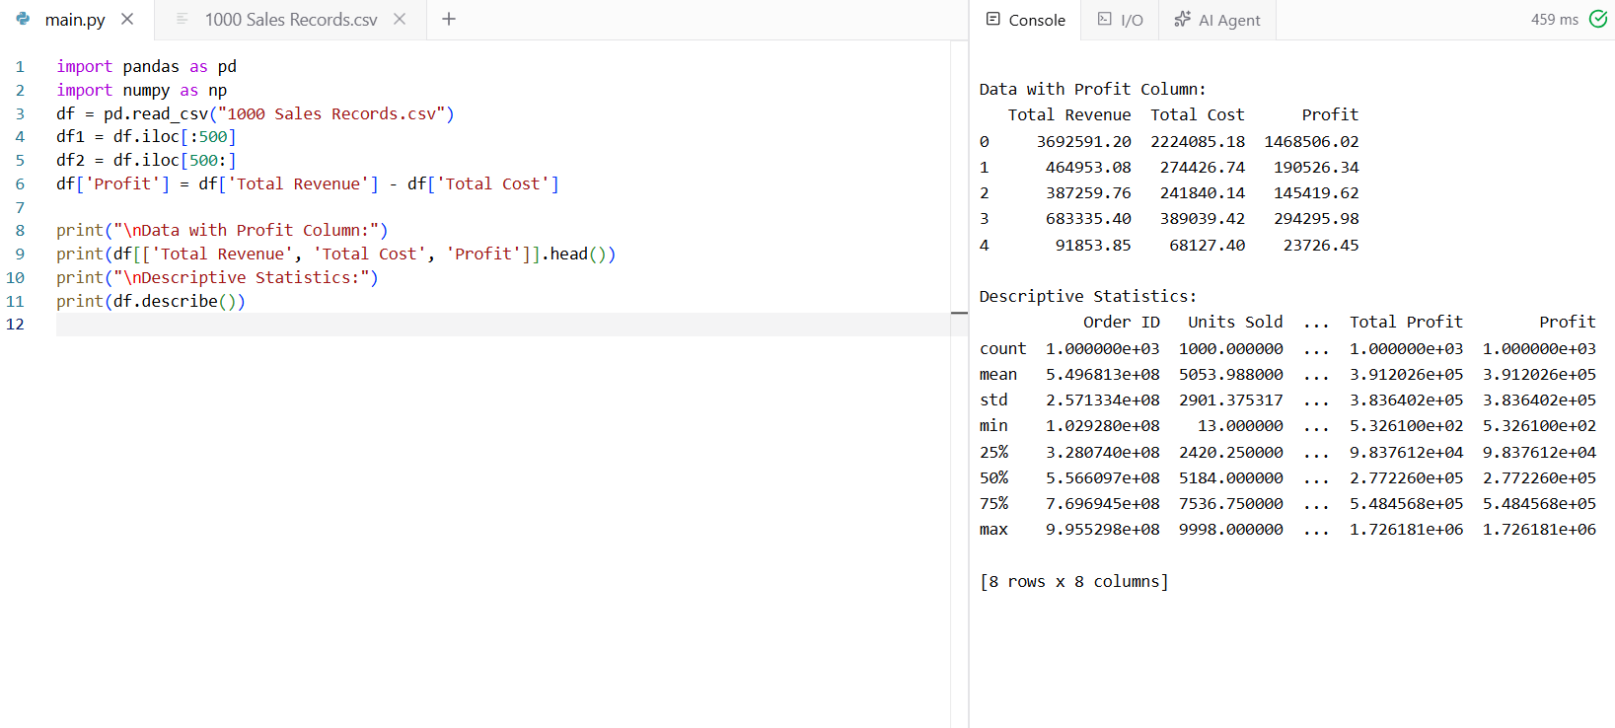
6)Value count:
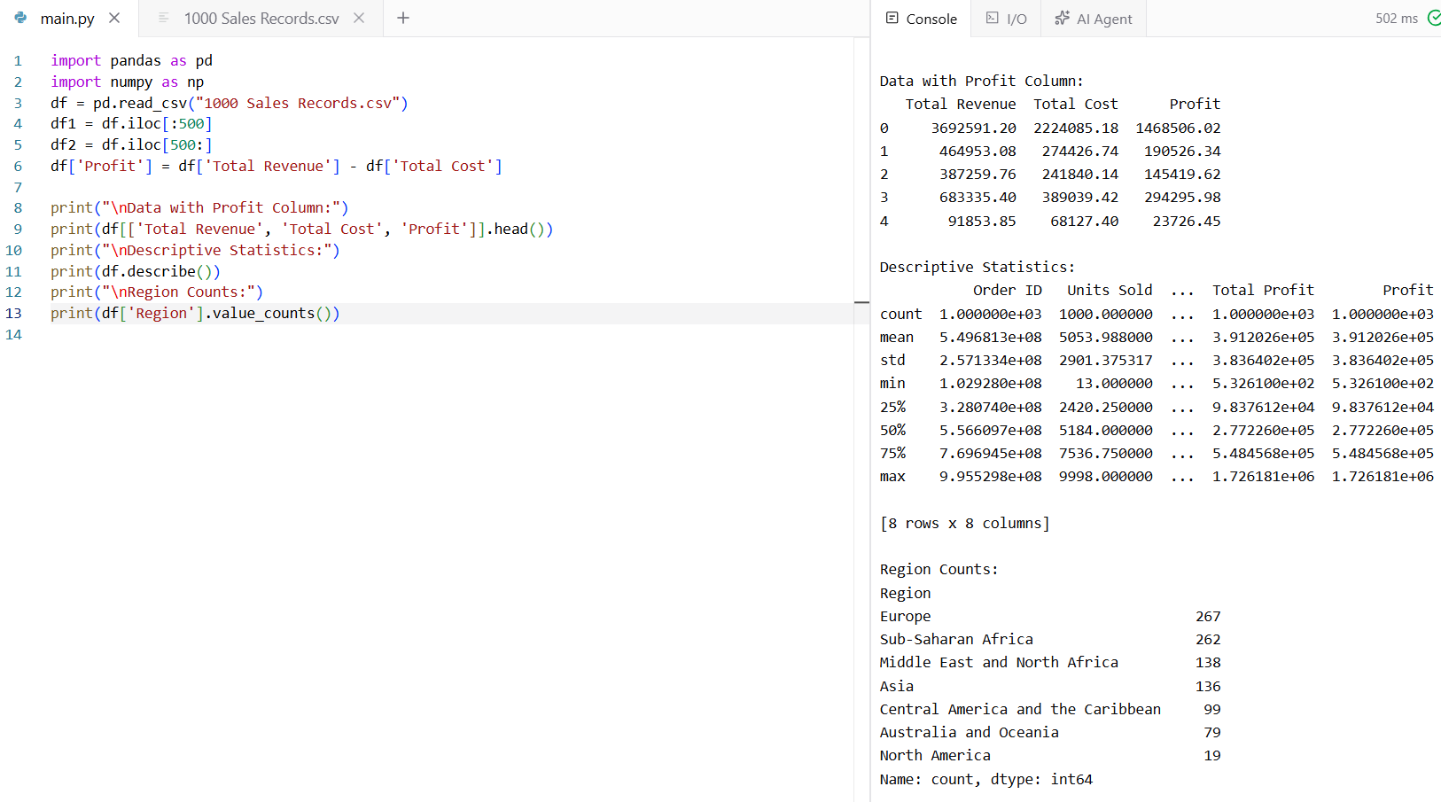
7)Hierarchical indexing:
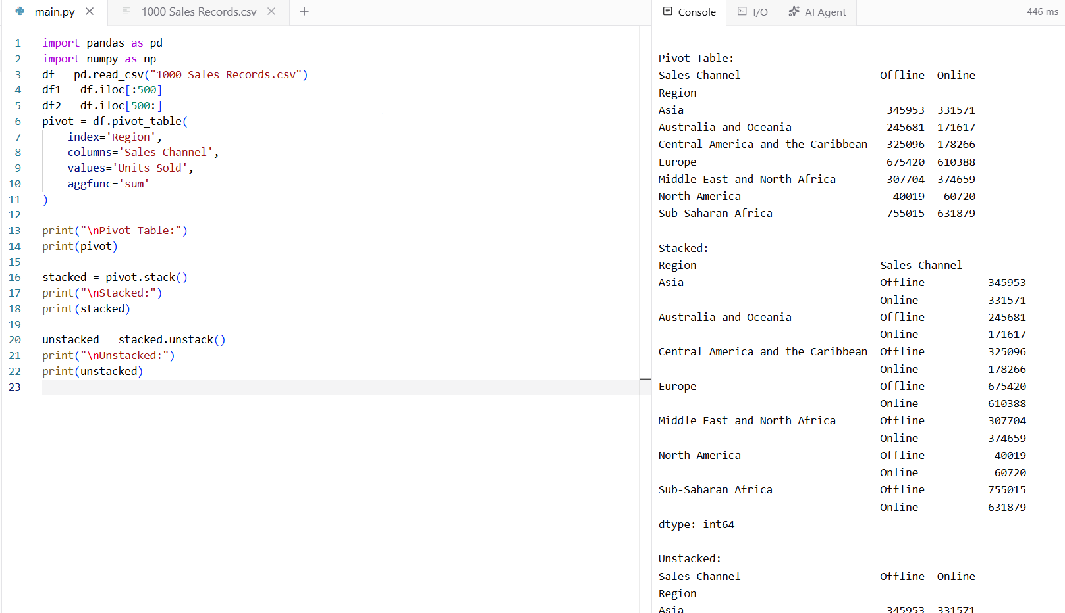

8) Series concatenation with keys:
