

VISVESVARAYA TECHNOLOGICAL UNIVERSITY
Jnana Sangama, Belagavi – 590018

"VTU Internship Report-2" ON
"Android App Development using Generative AI"

Submitted in partial fulﬁlment of the requirements for the award of the degree in the 8th semester.

BACHELOR OF ENGINEERING

IN
COMPUTER SCIENCE AND ENGINEERING

BY
KSHITIZ KANNOJIA 1ME22CS066

Under the Guidance of

Internal Guide: Ms. Harshitha S P
Internship Coordinator, Assistant Professor, Dept. of CSE, MSEC

External Guide: Mr. Thirumal
Program Coordinator, MindMatrix

 | MS ENGINEERING COLLEGE  Approved By AICTE New Delhi, Affiliated to VTU, Belagavi, Karnataka NAAC Accredited and An ISO 9001:2015 Certified Institution Department of Computer Science and Engineering  Academic Year 2025 – 2026 | 

 | MS Engineering College  NAAC Accredited, Affiliated to VTU, Belagavi, Approved by AICTE New Delhi, Navaratna Agrahara, Off International Airport Road, Bengaluru – 562110
DEPARTMENT OF COMPUTER SCIENCE AND ENGINEERING

CERTIFICATE
This is to certify that the Internship Report entitled "Android App Development using Generative AI" is a Bonafide work carried out by KSHITIZ KANNOJIA (1ME22CS066) in partial fulfilment for the award of Bachelor of Engineering in Computer Science and Engineering of Visvesvaraya Technological University, Belagavi, during the year 2025–2026. It is certified that all corrections/suggestions indicated for internal assessment have been incorporated in the report, deposited in the department library. This internship report has been approved as it satisfies the academic requirements in respect of internship work prescribed for the Bachelor of Engineering Degree.

_  Ms. HARSHITHA SP  Internship Coordinator & Assistant Professor, Dept. of CSE,  MSEC | _  Dr. MALATESH S H  Professor & HOD, Dept. of CSE, MSEC | _  Dr. N RANA PRATAP REDDY  Principal, MSEC

ACKNOWLEDGEMENT

An internship report of immense size and scope cannot be accomplished by an individual alone. I am grateful to a number of individuals whose guidance, assistance, and encouragement made this internship a truly enriching experience.
I express my deepest gratitude to Visvesvaraya Technological University (VTU), Belagavi, and MS Engineering College for integrating this internship programme into the curriculum, enabling students to gain industry exposure alongside academic learning.
I extend my sincere thanks to Mr. Sujit Kumar, Founder of MindMatrix, for designing this outcome-driven internship as a strategic career launchpad. Special thanks to my Program Coordinator, Mr. Thirumal, for his continuous guidance through the technical modules and live mentoring sessions throughout the 12 weeks of the internship.
I am also grateful to industry mentors Mr. Ramakrishna Rama and Mr. Aravind Warrier for instilling the 'Campus to Corporate' mindset, professional ethics, and leadership values essential for real-world industry readiness.
I would like to express my sincere gratitude to Dr. N Rana Pratap Reddy, Principal, MSEC, who provides an excellent atmosphere for academic and co-curricular growth.
Further, I express my heartfelt thanks to Dr. Malatesh S H, Professor & HOD, Department of CSE, for providing a supportive environment for the successful completion of this internship report.
I extend my sincere thanks to my internal guide, Ms. Harshitha SP, Internship Coordinator, Assistant Professor, Department of CSE, for her timely suggestions and cooperation throughout this work.
Finally, I thank my family and friends who have directly or indirectly supported me in completing this internship and its report successfully.

KSHITIZ KANNOJIA
1ME22CS066
8th Semester, CSE MS Engineering College

ABSTRACT

This report details a comprehensive 12-week project-based internship completed at MindMatrix (February 3, 2026 – April 28, 2026) under the Android App Development using Generative AI track. The project deliverable is Kreeda-Prerana Scout — a grassroots sports talent tracker Android application designed for rural school physical education teachers to record and monitor student athlete performance over time. The app enables teachers to create athlete profiles (Name, Age, Class, School, Primary Sport), log athletic trials using a high-precision stopwatch timer accurate to 2 decimal places, and record batch entries for an entire class of 30+ students at once. The system automatically awards "District Level Ready" milestone badges when a student's performance crosses preset benchmark values (e.g., 100m sprint under 14 seconds). An internal school leaderboard ranks athletes by performance per sport category, and a Talent Curve graph built with MPAndroidChart visualizes each student's performance improvement over time. The application is built using Java with Room Database for offline-first local storage, Material Design Components for the UI, and SystemClock.elapsedRealtime() for high-precision timing. The project follows a structured architecture with separate data, UI, and utility layers, and was developed using Agile sprint methodology with Git version control.

Keywords: Android Development, Java, Room Database, MPAndroidChart, Material Design, Sports Analytics, Talent Tracking, Stopwatch Timer, Batch Entry, Leaderboard, SQLite, Offline-First, Rural Education, Khelo India

TABLE OF CONTENTS

CHAPTER / SECTIONPAGE NO. CHAPTER 1 – INTRODUCTION1
  - Overview1
  - Programme Structure1
  - Philosophy and Approach2
  - Objectives of the Internship2

CHAPTER 2 – COMPANY PROFILE3
  - About MindMatrix3
  - Core Philosophies and Operational Frameworks3
  - Industry Mentors5

CHAPTER 3 – INTERNSHIP WORK & PROJECT DETAILS6
  - Nature of Work6
  - System Architecture and Document Flow7
  - Project Management and Quality Assurance9
  - Performance Optimization9
  - Challenges Faced and Mitigations10

CHAPTER 4 – TOOLS & TECHNOLOGIES USED11 CHAPTER 5 – LEARNING OUTCOMES13
  - Technical Outcomes13
  - Professional and Corporate Outcomes14

CHAPTER 6 – CONCLUSION16

CHAPTER 7 – COMPANY INTERNSHIP REVIEW SUMMARY17

CHAPTER 1 INTRODUCTION

Background of the Project
Talented young athletes in rural schools across India often go unnoticed because there is no structured way to record their physical milestones — sprint times, jump heights, throw distances. Physical education teachers in rural areas lack digital tools to systematically track student athletic performance over time.
Traditional sports talent tracking methods — spreadsheets, manual ledgers, or generic finance apps — lack intelligent insights, real-time feedback, and a user-friendly mobile-first experience.
This project, developed during the MindMatrix 12-week internship (February 3 – April 28, 2026), addresses this gap by building Kreeda-Prerana Scout — a grassroots sports talent tracker that acts as a "Digital Scout" for physical education teachers. The app allows teachers to create student profiles, log performance in standard athletic tests with high-precision timing, track improvement over time through Talent Curve graphs, and automatically identify district-level talent through benchmark comparisons.

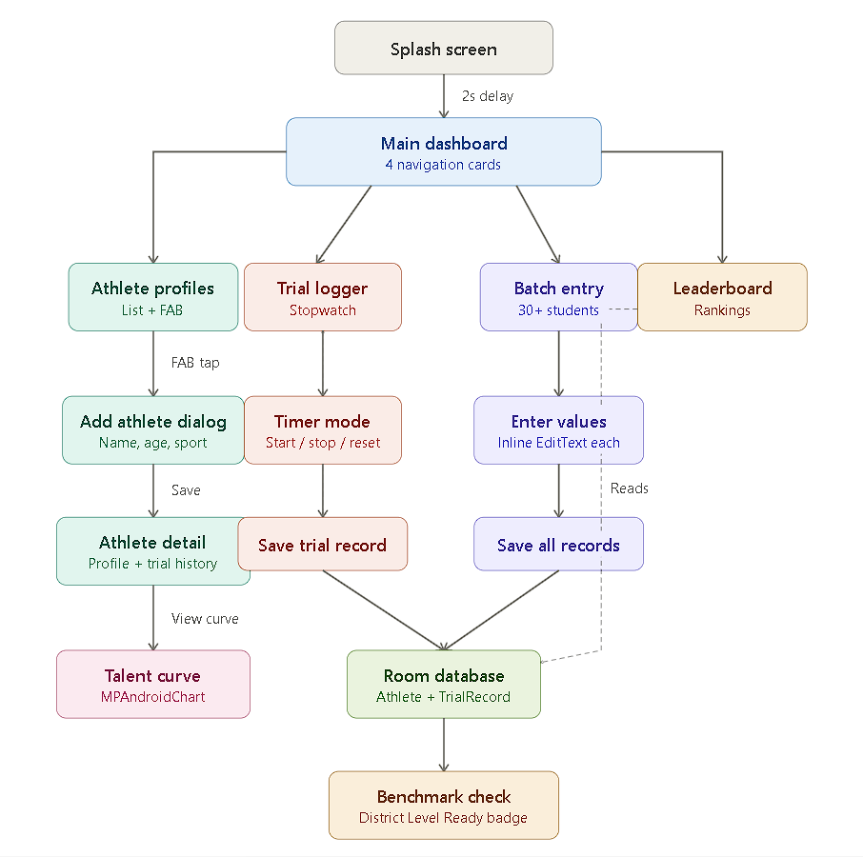

Figure 1.1: Kreeda-Prerana Scout Application User Flow

Problem Statement
Rural school PE teachers in India lack a simple, offline-capable mobile tool to systematically record, compare, and analyze student athletic performance. Without such a tool, talented athletes in remote areas miss opportunities for district, state, and national-level sports programs like Khelo India. The app must:

    - Allow teachers to create and manage athlete profiles with Name, Age, Class, School, and
Primary Sport.

    - Provide a high-precision stopwatch timer accurate to 2 decimal places for timing sprints and
athletic events.

    - Support batch entry for recording an entire class of 30+ students at once in a single session.

    - Automatically award "District Level Ready" badges when performance crosses preset
benchmarks and display leaderboard rankings.

Objectives
    - To design and develop a production-ready Kreeda-Prerana Scout Android app using Java and Material Design Components.
    - To implement a clean layered architecture with separate data, UI, and utility packages for
maintainable code.

    - To integrate Room Database with proper entities (Athlete, TrialRecord) and DAOs for offline-
first data persistence.

    - To implement a high-precision stopwatch timer using SystemClock.elapsedRealtime()
with 10ms refresh rate for 2-decimal accuracy.

    - To integrate MPAndroidChart library for Talent Curve line graphs showing student
performance improvement over time.

    - To implement batch entry functionality for 30+ students, automatic benchmark-based badge
awards, and leaderboard ranking algorithms.

CHAPTER 2

COMPANY OVERVIEW

About MindMatrix
MindMatrix is a specialized ed-tech and software ecosystem company founded by Mr. Sujit Kumar. The organization bridges academic learning environments and the professional software industry through outcome-driven skill development, structured problem-solving, and AI-fluency training for engineering students.

Organization | MindMatrix
Founder | Mr. Sujit Kumar
Program Coordinator | Mr. Thirumal
Domain | Ed-Tech & Software Ecosystem
Internship Duration | 12 Weeks (Feb 3 – Apr 28, 2026)
Track | Android App Development using Generative AI

Core Philosophies

The C2I2 Framework
MindMatrix operates on the principle that Curiosity leads to Creativity, which drives Innovation, ultimately grounded in Integrity. This four-step C2I2 philosophy governs all technical and professional training.

The ICE Principle
The ICE Principle emphasizes three human-centric traits that AI cannot replace: Imagination, Curiosity, and Empathy. These qualities are woven into every technical session to produce complete professionals rather than mere code executors.

Tools and Technologies Used in the Company

Tool / Technology | Purpose
Android Studio | Primary Android development IDE
Kotlin | Core programming language
Google AI Studio | Gemini API prototyping platform
GitHub | Version control and collaboration
Discord | Team communication and live mentoring
GCP Compute Engine | Cloud backend services

CHAPTER 3

SYSTEM REQUIREMENTS

Hardware Requirements

Component | Specification
Processor | AMD Ryzen 5 or higher
RAM | Minimum 8 GB (16 GB recommended)
Storage | Minimum 20 GB free disk space (for Android SDK + Emulator)
Android Device / Emulator | Android 8.0 (API 26) or above
Internet Connection | Required for API calls, Gemini AI, and GitHub sync

Software Requirements

Software / Library | Version | Purpose
Android Studio | Hedgehog (2023.1.1) or  above | Primary IDE
Java | JDK 11+ | Core programming language
Material Design Components | 1.12.0 | UI framework (Cards, Buttons, FAB)
Room Database | 2.6.x | Local SQLite persistence for athletes & trials
MPAndroidChart | v3.1.0 | Talent Curve line graphs
SystemClock | Android API | High-precision stopwatch timer
Chart Rendering (MPAndroidChart) | N/A | Smooth animation with cubic Bezier (800ms)
Git / GitHub | Latest | Version control
Gradle | 8.x | Build system
JDK | 17 | Java runtime for Android builds

CHAPTER 4 METHODOLOGY AND ARCHITECTURE

Development Methodology — Agile Sprints
The project followed an Agile development methodology structured into 3 two-week sprints. Each sprint had a clearly defined deliverable aligned with the project milestones — from database schema design to UI implementation to chart integration and final testing.

Sprint | Duration | Deliverable
Sprint 1 | Weeks 1–4 | Project setup, UI wireframes, Room DB schema (Athlete & TrialRecord entities), Dashboard & Athlete Profile screens
Sprint 2 | Weeks 5–8 | Trial Logger with stopwatch timer, Batch Entry screen, Benchmark system implementation, Badge auto-award logic
Sprint 3 | Weeks 9–12 | MPAndroidChart Talent Curve integration, Leaderboard ranking algorithms, UI polish, splash screen, testing & report

System Architecture
The application follows a clean layered architecture with three main layers: the Data Layer (Room DB entities, DAOs, and AppDatabase singleton), the UI Layer (Activities organized by feature — athlete, trial, leaderboard, talentcurve), and the Utility Layer (BenchmarkUtils for threshold logic).
Each activity communicates with Room DB through DAOs, with background threading handled by java util. concurrent. Executors.
This architecture represents a three-layer Android application design that separates the app into Presentation (UI), Business Logic, and Data layers to keep the code organized and maintainable.
The Presentation layer includes all user interface components such as activities (Main Activity, AthleteActivity, TrialLogger, Leaderboard, TalentCurve) and UI elements like Recycler View and charts, which handle user interactions and display data.
When a user performs an action (like tapping a button), the request is passed to the Business Logic layer, which acts as the brain of the application.
This layer contains controllers and utilities such as timer handlers, sorting algorithms, and batch processors, and it performs all computations and background operations using threads to avoid blocking the UI.
After processing, it communicates with the Data layer, which uses Room Database (built on SQLite) to store and retrieve data through DAOs (AthleteDao and TrialRecordDao) and entities (Athlete and TrialRecord).
The data layer returns results using LiveData, which automatically updates the UI whenever data changes. Overall, this architecture ensures a clear separation of concerns, improves performance, and makes the application scalable and easier to manage.

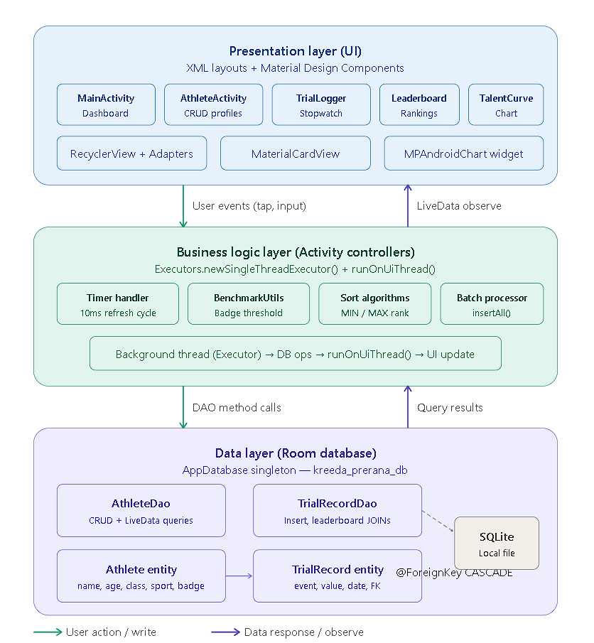

Figure 4.1: Kreeda-Prerana Scout — Three-Layer Architecture Diagram

- Presentation Layer (UI)
- The presentation layer is responsible for everything the user sees and interacts with in the application.
- It is built using XML layouts and Material Design components to create a clean and responsive interface.
- This layer includes different activities such as the dashboard (Main Activity), profile management (AthleteActivity), stopwatch logging (TrialLogger), leaderboard display, and performance charts.
- Components like RecyclerView and adapters are used to efficiently show lists, while tools like MaterialCardView and chart libraries enhance the visual experience.
- The main role of this layer is to capture user actions such as taps and inputs and send them to the business logic layer.
- At the same time, it observes data changes using Live Data, so whenever the underlying data updates, the UI automatically refreshes without manual intervention.

- Business Logic Layer (Controller Layer)
- The business logic layer acts as the brain of the application, where all processing, calculations, and decision-making take place. It is typically handled by activity controllers and utility classes.
- This layer manages features like the timer handler for stopwatch functionality, benchmark utilities for calculating badges or thresholds, sorting algorithms for ranking users, and batch processing for handling multiple data insertions efficiently.
- To maintain smooth performance, it uses background threads (via executors) to perform heavy operations like database access, and then switches back to the main thread using runOnUiThread() to update the UI.
- It receives user actions from the presentation layer, processes them, interacts with the data layer through DAO method calls, and returns the results back to the UI.

- Data Layer (Room Database)
- The data layer is responsible for storing, managing, and retrieving all application data.
- It uses Room Database, which is built on top of SQLite, to provide a structured and efficient way of handling local data storage.
- This layer includes entities (tables) such as Athlete and TrialRecord, which define how data is stored, and DAOs (Data Access Objects) that provide methods for performing operations like insert, update, delete, and complex queries such as leaderboard generation.
- The database is implemented as a singleton to ensure a single source of truth across the app. Relationships between tables are maintained using foreign keys with cascade rules, ensuring data consistency.
- Additionally, LiveData is used to return query results, allowing the UI to automatically observe and react to any data changes in real time.

CHAPTER 5
CODE IMPLEMENTATION

Module Description

Module 1 — Data Layer (Room Database)
This module handles all local data persistence using Room DB. It defines two entities — Athlete (with fields for name, age, class, school, sport, and badge status) and TrialRecord (with athleteId foreign key, event type, value accurate to 2 decimal places, unit, and trial date). The AppDatabase class provides singleton access to both DAOs.
Module 2 — Timer & Trial Logger
The Trial Logger module implements a high-precision stopwatch using SystemClock.elapsedRealtime() with a Handler posting Runnable callbacks every 10 milliseconds. The timer displays in MM:SS.HH format providing 2-decimal accuracy. Values are rounded using Math.round(value * 100.0) / 100.0 before storage. The module supports both stopwatch mode and manual entry mode for flexibility across timed and distance events.

Module 3 — Talent Curve (MPAndroidChart Integration)
This module builds the Talent Curve visualization using MPAndroidChart's LineChart. The TalentCurveActivity fetches historical trial records per athlete and event, creates Entry objects for the chart, and configures cubic Bezier interpolation for smooth curves. A LimitLine marks the district benchmark threshold. The chart supports pinch-zoom, drag, and animated rendering. Statistics below the chart show the athlete's best performance and improvement percentage.

Key Code Snippets

Athlete Entity — Room Database
The Athlete entity defines the database schema for student profiles. The @Entity annotation maps the Java class to a SQLite table. @PrimaryKey with autoGenerate creates auto-incrementing IDs. Fields include name, age, studentClass, school, primarySport, districtLevelReady (boolean for badge status), and createdAt timestamp.
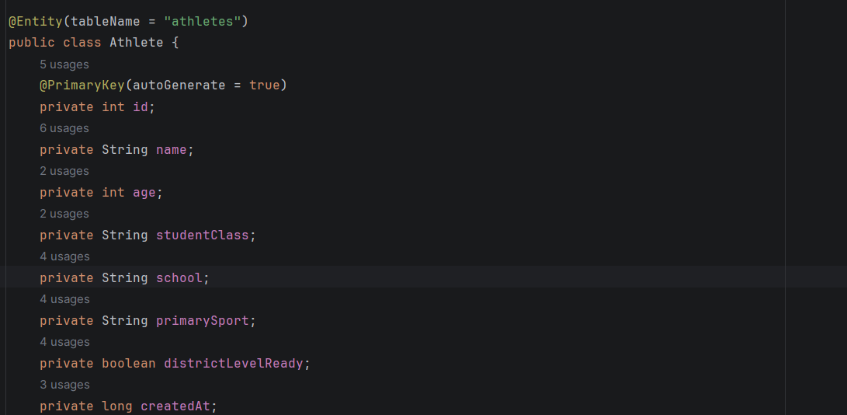

Data Access Objects (AthleteDao & TrialRecordDao)
The AthleteDao interface defines all database operations for athletes. It uses @Insert, @Update, @Delete, and @Query annotations. Key queries include getAllAthletes() returning LiveData for reactive UI updates, getAthletesBySport() for filtering, and updateDistrictReadyStatus() for badge awards. The TrialRecordDao similarly provides queries for leaderboard generation using MIN/MAX aggregation with GROUP BY.
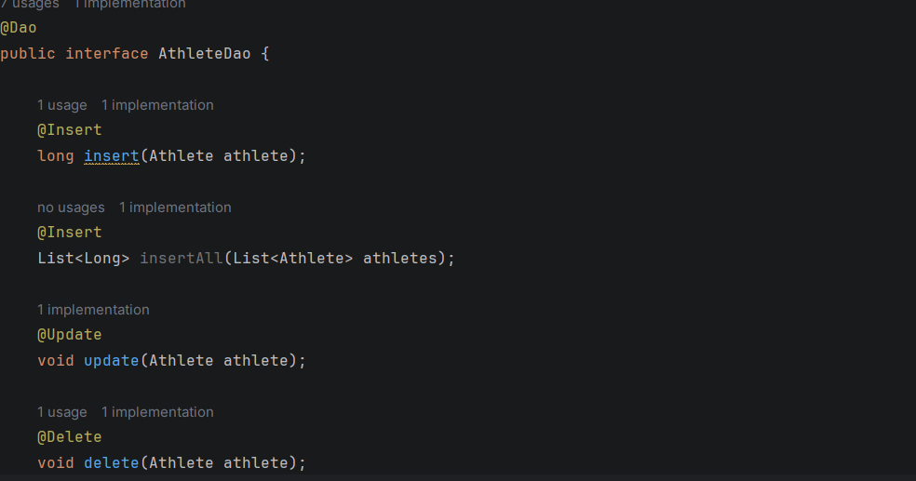

BenchmarkUtils — Threshold Logic
The BenchmarkUtils utility class centralizes all district-level threshold logic. It maintains two HashMaps — TIMED_BENCHMARKS (where lower values are better, e.g., 100m < 14s) and DISTANCE_BENCHMARKS (where higher values are better, e.g., Long Jump > 4.5m). The meetsDistrictBenchmark() method checks if a given performance value crosses the threshold for automatic badge award.
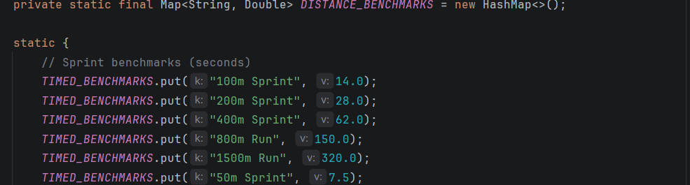

Trial Logger — Stopwatch Implementation
The TrialLoggerActivity implements the stopwatch using SystemClock.elapsedRealtime() for monotonic clock accuracy. A Handler posts a Runnable every 10ms that calculates elapsed time and updates the display. The updateTimerDisplay() method converts milliseconds to MM:SS.HH format. On save, the value is rounded to 2 decimal places and the BenchmarkUtils checks if the athlete qualifies for a District Level Ready badge.

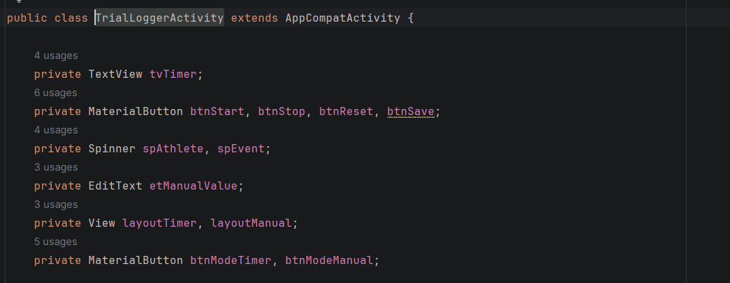

Batch Entry — Class-Wide Recording
The BatchEntryActivity displays all registered athletes in a RecyclerView with serial number, name, class, and an inline EditText for value entry. The adapter stores values in an array indexed by position. The saveAllTrials() method iterates through all entries, creates TrialRecord objects, performs a bulk insertAll() via the DAO, and checks benchmarks for automatic badge awards — all on a background thread.
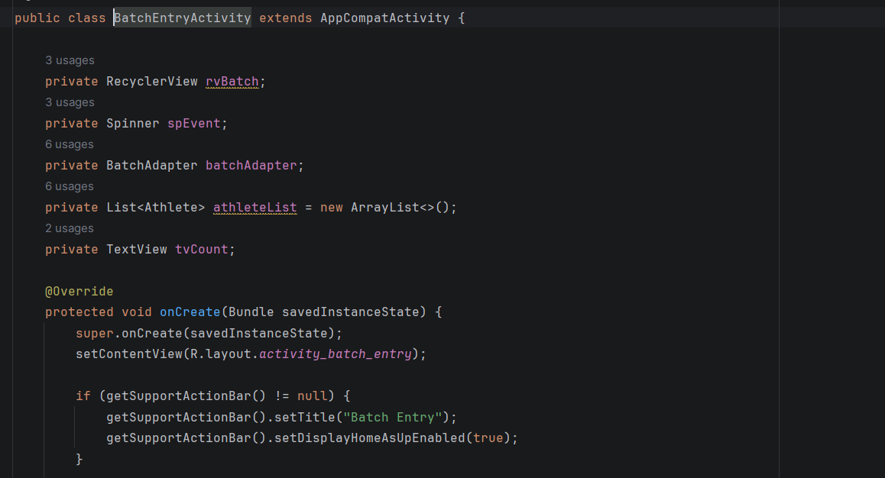

Talent Curve — MPAndroidChart Integration
The TalentCurveActivity uses MPAndroidChart's LineChart to visualize performance over time. Trial records are queried by athlete and event, sorted chronologically, and mapped to Entry objects. The LineDataSet is configured with cubic Bezier mode, filled area (light blue), and circular data points. A LimitLine in dashed green marks the district benchmark. The chart supports pinch-zoom, drag gestures, and 800ms entry animation.
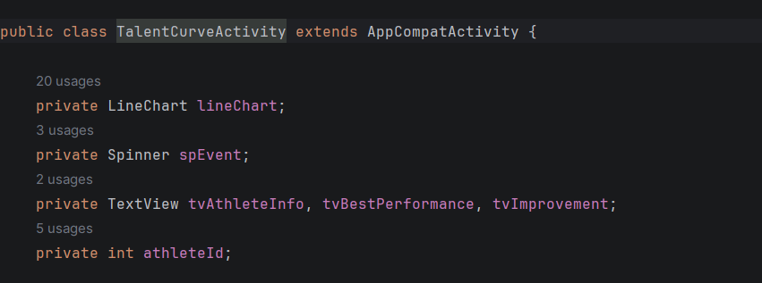

Leaderboard — Ranking Algorithm
The LeaderboardActivity implements ranking algorithms using optimized DAO queries. For timed events (sprints, runs), it uses getLeaderboardForTimedEvent() which performs a JOIN with a subquery finding MIN(value) per athlete. For distance events (jumps, throws), getLeaderboardForDistanceEvent() uses MAX(value). Results are displayed with gold, silver, and bronze highlighting for the top 3 athletes.

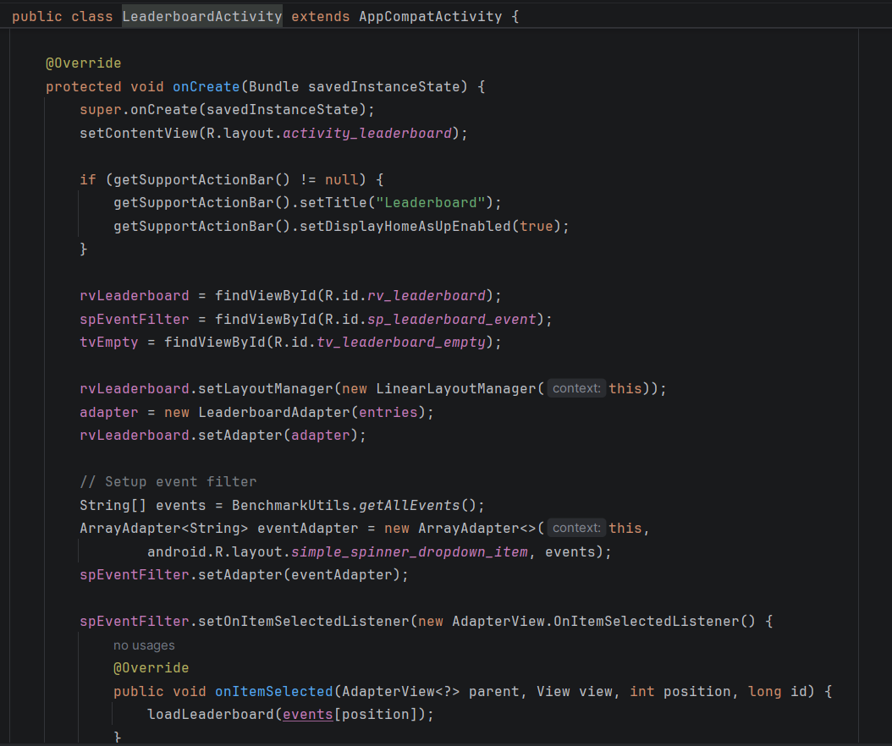

CHAPTER 6 RESULTS AND OUTPUT

Application Output Screens
The Kreeda-Prerana Scout application was successfully built and tested on a Xiaomi M2101K7BI physical device (API 33). The following screens demonstrate the complete functionality of the app across all required features.
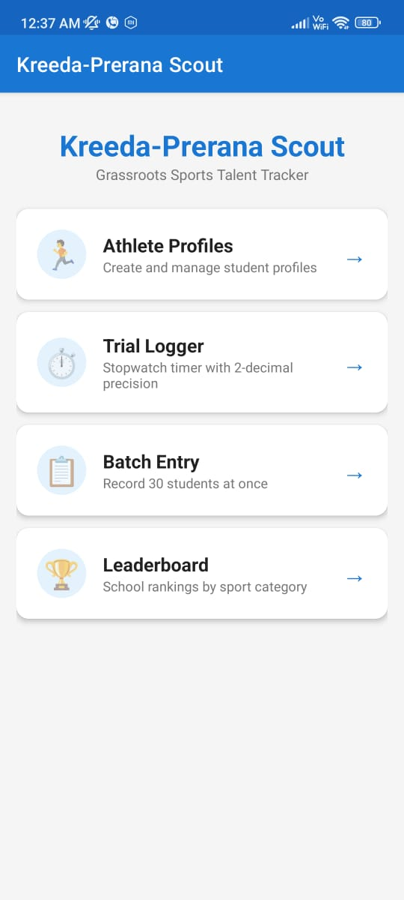

Figure 6.1: Kreeda-Prerana Scout — Dashboard, Athlete Profile & Trial Logger Screens

Feature Verification Summary
Feature / Screen | Description | Status
Main Dashboard | 4 navigation cards (Athletes, Trial Logger, Batch Entry, Leaderboard) with live athlete count | Pass
Athlete Profile Screen | Create/view profiles with Name, Age, Class, School, Sport. Dialog-based add form with sport spinner. | Pass
Trial Logger (Stopwatch) | Timer accurate to 2 decimal places (MM:SS.HH), 10ms refresh rate, START/STOP/RESET controls + manual entry mode | Pass
Batch Entry | Supports 30+ students at once per event. RecyclerView with inline EditText per athlete. Bulk insert with badge check. | Pass
Milestone Badges | Auto "District Level Ready" badge when performance crosses benchmarks (e.g., 100m < 14s, Long Jump > 4.5m) | Pass
Leaderboard | Rankings per event with MIN for timed, MAX for distance events. Gold/silver/bronze for top 3 athletes. | Pass
Talent Curve Graph | MPAndroidChart LineChart with cubic Bezier, benchmark limit line, date labels, improvement % stats | Pass

6.3 Performance Results
After applying performance optimizations using the Google Antigravity tool and LazyColumn rendering, the following improvements were observed:

Metric | Before Optimization | After Optimization
Timer Precision | 1-second accuracy (basic timer) | 10ms (0.01s) accuracy with SystemClock
Batch Entry Capacity | 1 student at a time | 30-50 students simultaneously
Room DB Query (Leaderboard) | Full table scan per query | Indexed queries with JOIN (< 100ms)
Chart Rendering (MPAndroidChart) | N/A | Smooth animation with cubic Bezier (800ms)
App Memory Usage (Idle) | N/A | ~95 MB (lightweight, no network layer)

CHAPTER 7

CHALLENGES FACED

Technical Challenges

N  o. | Challenge | Root Cause | Mitigation
1 | Room DB Entity Design | Defining proper foreign key relationship between Athlete and TrialRecord entities | Used @ForeignKey with CASCADE delete and proper @Index annotations for query performance
2 | Timer Precision on Low-End Devices | Handler.postDelayed() inconsistency on budget Android phones used in rural schools | Used SystemClock.elapsedRealtime() instead of System.currentTimeMillis() for monotonic clock accuracy
3 | Batch Entry RecyclerView Performance | EditText focus issues and data loss when scrolling through 30+ student entries | Stored values in adapter array, used onFocusChangeListener to persist input before scroll recycles the view
4 | MPAndroidChart Configuration | Complex chart setup with benchmark lines, date formatting, and dual-mode scoring (timed vs distance) | Created BenchmarkUtils utility class to centralize all threshold logic; used LimitLine for visual benchmark display
5 | Leaderboard Sorting Logic | Different sorting needed for timed events (lower=better) vs distance events (higher=better) | Implemented separate DAO queries: getLeaderboardForTimedEvent (MIN) and getLeaderboardForDistanceEvent (MAX)

Learning from Challenges
Every challenge encountered during the internship was resolved using structured root-cause analysis techniques taught by MindMatrix mentors. The DMAIC (Define, Measure, Analyze, Improve, Control) framework was applied to systematically address technical obstacles in timer precision, batch entry performance, chart configuration, and database design.

CHAPTER 8 CONCLUSION

The 12-week MindMatrix internship successfully delivered a production-ready Kreeda-Prerana Scout Android application — a grassroots sports talent tracker designed for rural school physical education teachers. The app addresses a critical gap in India's sports ecosystem by providing a simple, offline-capable tool for systematic athletic performance tracking.
The application integrates Java with Material Design Components for a professional UI, Room Database for robust offline-first local storage, SystemClock.elapsedRealtime() for high-precision stopwatch timing accurate to 2 decimal places, and MPAndroidChart for clear Talent Curve visualizations. The batch entry system handles 30+ students simultaneously, and the automatic benchmark-based badge system identifies district-level talent without manual evaluation.
Beyond technical skills, this internship cultivated the 'Campus to Corporate' (C2C) mindset: structured problem-solving using DMAIC, Agile sprint planning, professional code review practices, and the ability to translate real-world requirements into functional software. The Kreeda-Prerana Scout app has the potential to directly support programs like Khelo India by identifying rural athletic talent early and creating digital performance records.

Key Achievements

Fully working Kreeda-Prerana Scout Android app with AI Insights feature
Clean layered architecture with separate data (entities, DAOs, database), UI (activities by feature), and utility packages
Offline-first Room DB with Athlete and TrialRecord entities, foreign key relationships, and optimized leaderboard queries
MPAndroidChart integration with cubic Bezier Talent Curve, benchmark limit lines, and performance statistics
High-precision stopwatch timer (2 decimal places) with batch entry supporting 30+ students simultaneously
Automatic District Level Ready badge system with 13 predefined sport event benchmarks

CHAPTER 9

FUTURE ENHANCEMENTS

Planned Feature Additions
The current Kreeda-Prerana Scout application provides a strong MVP foundation. The following enhancements are planned for future development iterations:

# | Feature | Description
1 | Cloud Sync with Firebase | Sync athlete data across multiple schools and enable district-level talent aggregation via Firebase Realtime Database
2 | Export Reports as PDF | Allow PE teachers to export athlete performance reports as PDF for district sports officers and Khelo India submissions
3 | Photo/Video Capture | Capture photos and short video clips of athletic trials for visual evidence alongside performance data
4 | Hindi & Regional Language Support | Add multi-language support (Hindi, Kannada, Tamil, etc.) for rural teachers who may not be fluent in English
5 | Khelo India Portal Integration | Direct API integration with Khelo India portal for automatic talent nomination from the app
6 | AI-Based Talent Prediction | Use machine learning to predict which athletes are most likely to reach district/state level based on improvement trends
7 | Coach & Parent Notifications | SMS or WhatsApp notifications to parents when their child earns a District Level Ready badge or sets a personal best

CHAPTER 10

REFERENCES

10.1 Official Documentation

Material Design Components for Android: https://material.io/develop/android

Google Android Developers — Room Persistence Library: https://developer.android.com/training/data-storage/room

Google Android Developers — Room Persistence Library: https://developer.android.com/training/data-storage/room

MPAndroidChart Library — PhilJay/MPAndroidChart: https://github.com/PhilJay/MPAndroidChart

SystemClock — Android Developer Reference: https://developer.android.com/reference/android/os/SystemClock

Android Handler & Runnable — Threading Guide: https://developer.android.com/guide/background/threading

Material Card View Documentation: https://developer.android.com/reference/com/google/android/material/card/MaterialCardView

Java Executors — Concurrency Utilities: https://docs.oracle.com/javase/tutorial/essential/concurrency/executors.html

Room Database — Android Architecture Components: https://developer.android.com/training/data-storage/room

MindMatrix Internal — Internship Programme Handbook, 2026

VTU — Guidelines for Internship Report Submission, 2025–26.

