December 10, 2024
2615 Begin place
Thunder Bay, ON
P7B El5

RE: Your Upcoming Program at Confederation College
Dear Ridham,
Congratulations on being accepted into the college! I am excited to have you join our college. As you prepare for the start of your studies, there are a few important things to consider.
Make sure to complete all necessary paperwork, including your program registration, photo submission for id card and any required health or insurance forms. If you haven’t already, familiarize yourself with the program outline, including the courses you’ll be taking. You may also reach out to the college website or my campus portal.
At Confederation College, you can expect a challenging yet rewarding academic experience. You will receive practical based learning/training, supported by experienced instructors who are committed to your success. Class sizes are large with less students, which allows you for more personalized attention, so make the most of the opportunity to ask questions and engage with your professors. There will be group projects, exams, and practical assignments designed to prepare you for your future career.
I want to ensure you succeed, both academically and personally. Our campus offers a variety of support services, including tutoring, career counseling, and wellness resources. Be sure to visit the Student Success Center for academic help or guidance on study strategies. There is also a mental health support team available if you ever need someone to talk to. As well as that you can have the information accessed easily about immigration and international students’ policy from international sections.
If you are moving out of town, make sure to arrange your housing before arrival. There are several student accommodations close to campus like Sibley residence, and there are different social media pages and websites that provide detailed information on local housing options. For transportation, Thunder Bay has a reliable public transit system and college pays for the students’ transportation so you just need an college id card to access it but you might also consider having a car for easier travel, especially if you are living farther from the campus.
I hope this information helps you feel prepared for your upcoming journey to Confederation College. Should you have any questions, please don’t hesitate to contact me.
Sincerely,
Kshitiz Katwal
Using calculations – ‘C’ for Currency
 Now Let’s type:
Select OrderLineID, Quantity, UnitPrice,TaxRate,
format ((Quantity * UnitPrice), 'C') AS ExtendedPrice,
format ((Quantity * UnitPrice * (TaxRate/100)), 'C') AS TaxDue
From Sales.OrderLines

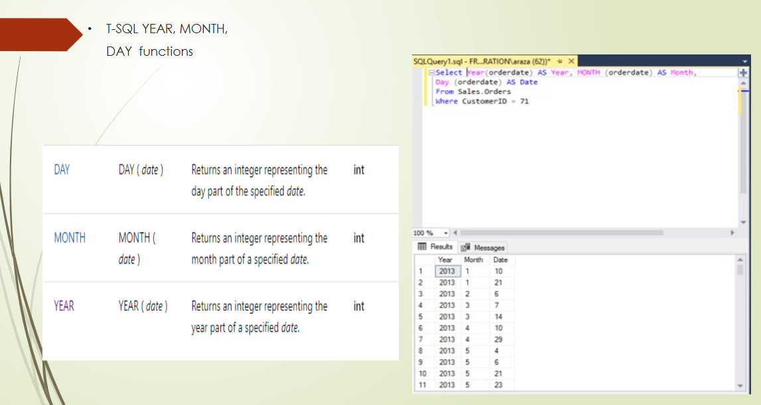

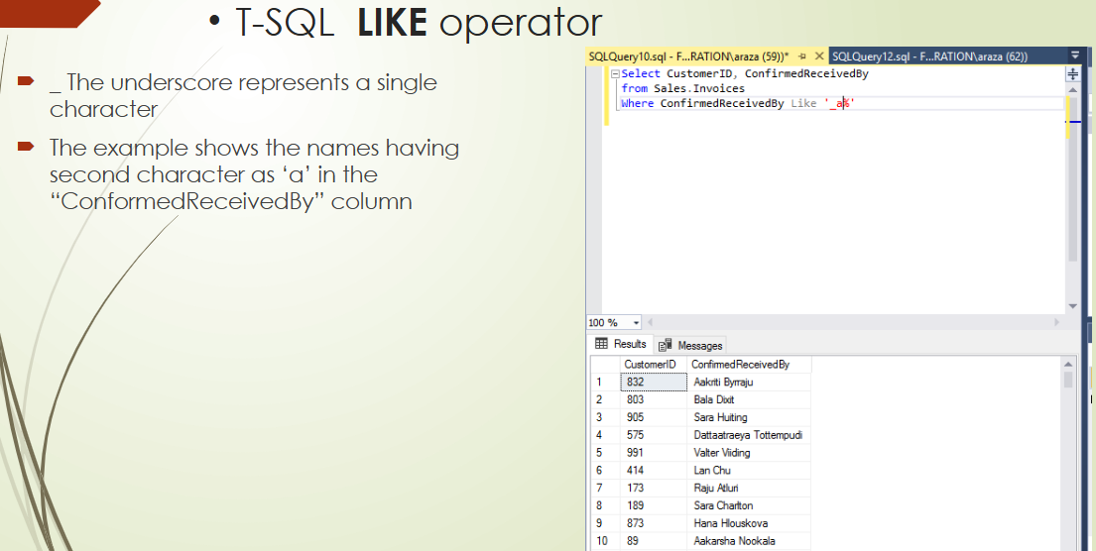
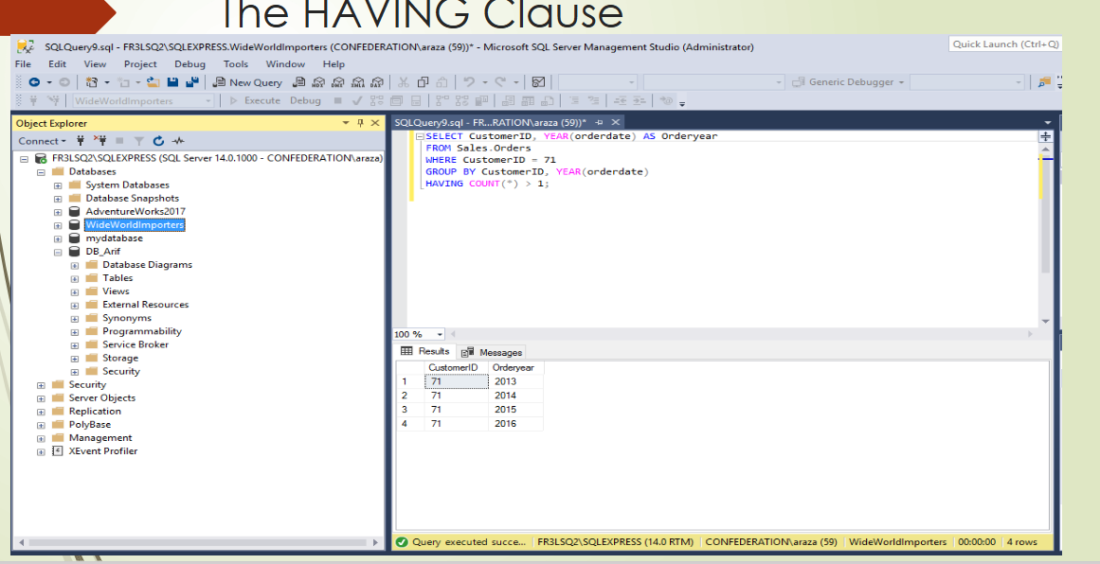
INSERT INTO dbo.Customers(FirstName, LastName, DateofBirth,
Address_Line1, Address_Line2)
VALUES ('Peter', 'Johnson', '2000-01-10', '222 Valley Lane', 'London
ON');
Example:
SELECT department_id, AVG(salary) AS avg_salary
FROM employees
GROUP BY department_id;
SELECT department_id, MAX(salary) AS max_salary
FROM employees
GROUP BY department_id;
SELECT department_id, MIN(salary) AS min_salary
FROM employees
GROUP BY department_id;
