
IC 410 – eCommerce Solutions II
Lab #8 – In Person Payments & Loyalty
Name: _____________________________
Abstract
In this lab, you will be learning how to setup a loyalty program and make adjustments. We establish your WooCommerce site as a mobile POS for in person payments. When doing the loyalty program, please work in your groups collectively to determine the best plugin and design for your loyalty program.

Step One: Add Loyalty Program Plugin
- Login to {confedid}.ict410con.com/wp-admin
- Hover Over Plugins > Add New
- Search for Loyalty
Compare and Contrast two different loyalty program plugins that can assign points for actions, can display points to logged in users, allows users to collect loyalty points for various activities, and can use points in checkout to pay for items.
Answer:
Plugin 1: myCRED
- Highly customizable points system
- Supports hooks (user actions → points)
- Displays points in user dashboard
- Allows redemption at checkout
- Advanced add-ons (badges, coupons, payments)
Plugin 2: WooCommerce Points and Rewards
- Simpler and more user-friendly
- Built specifically for WooCommerce
- Earn points from purchases, sign-ups
- Redeem points at checkout
- Less flexible than myCRED
Comparison:
- myCRED → More powerful, flexible, customizable
- WooCommerce Points → Easier but limited features
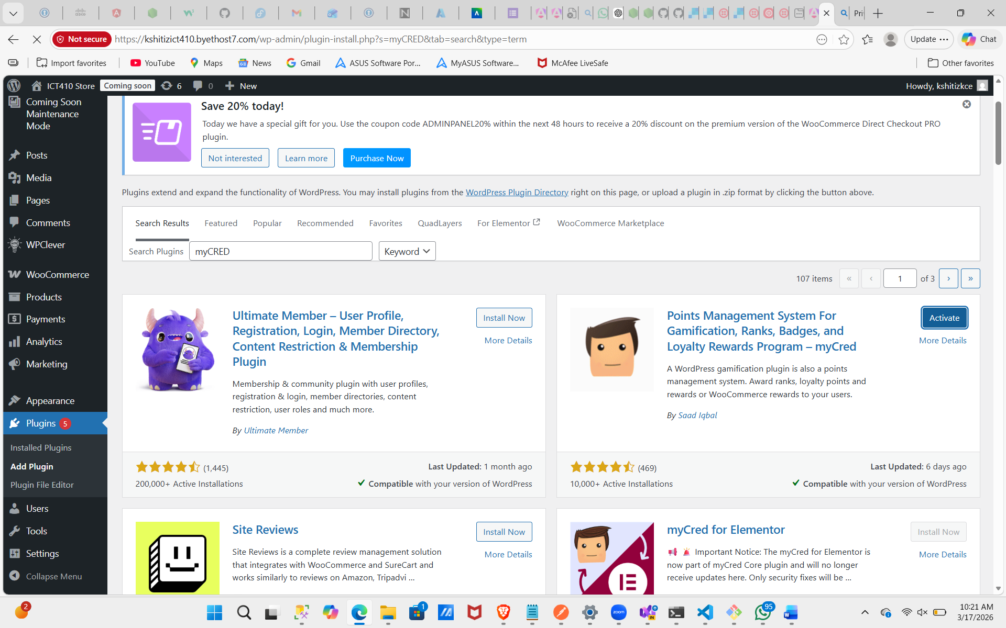

- Install and Activate myCRED > Hover Over Points on Console > Hooks
What type of ‘Hooks’ are eligible to receive points?
Points for registration
Points for login
Points for daily visit
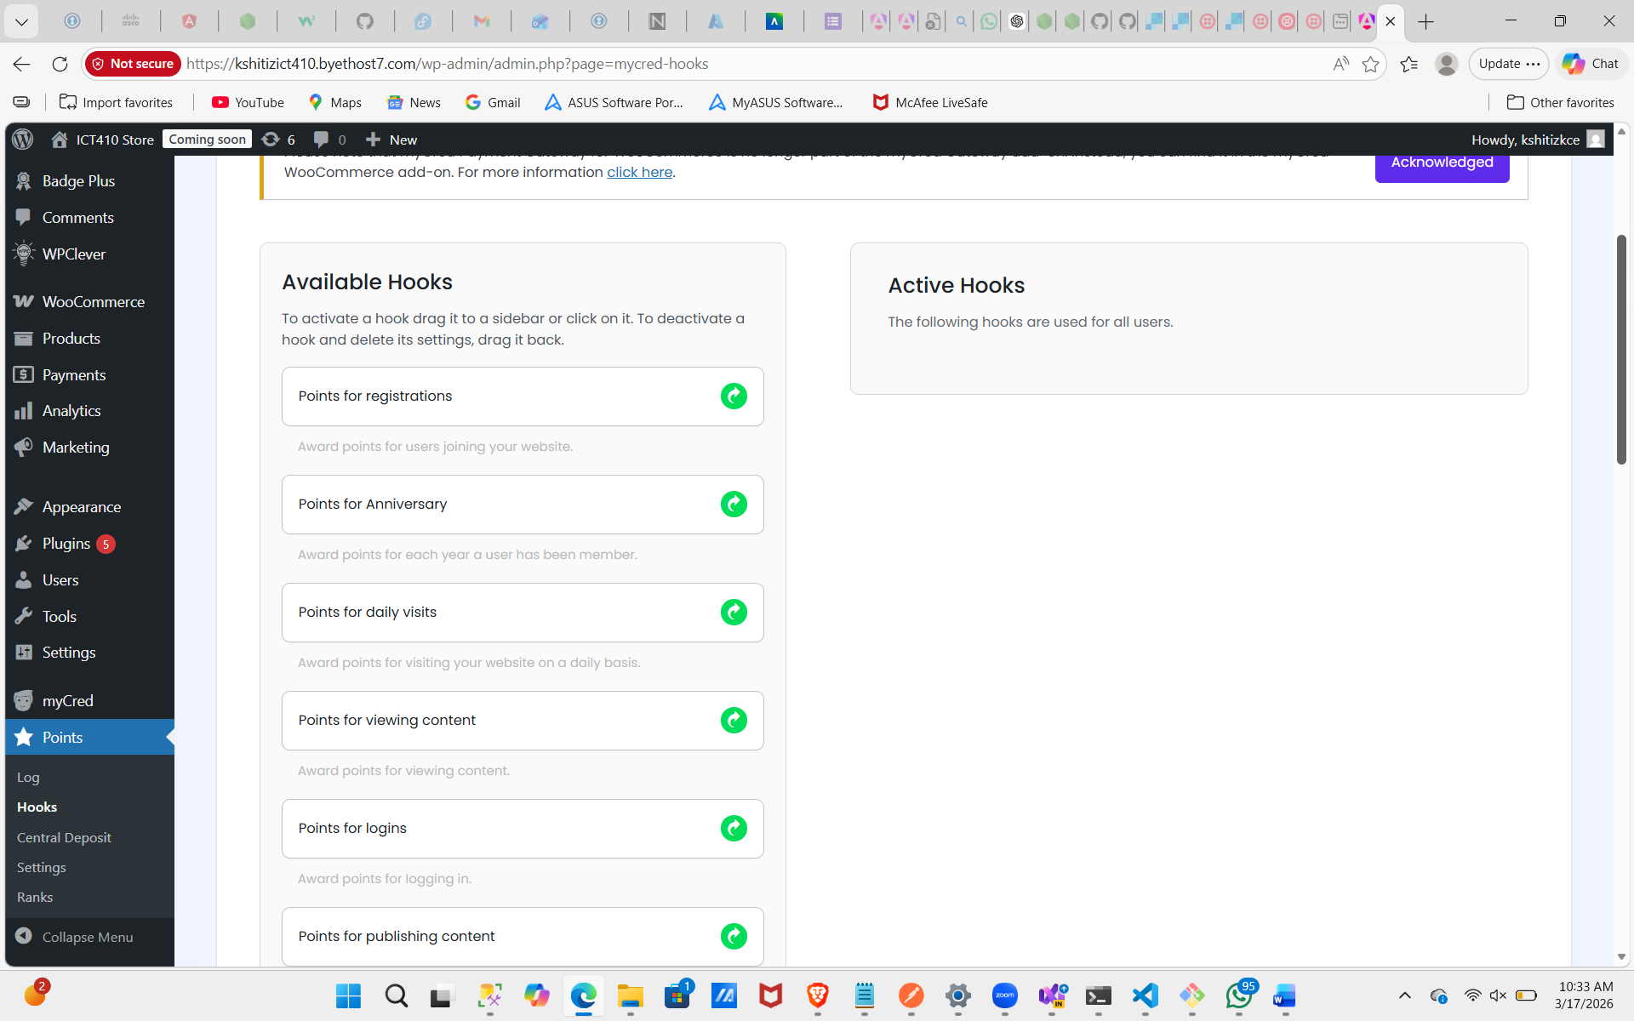

If you were to customize your loyalty program, which are the best three points and the worst three points you could offer, explain.
Answer
Best & Worst Points to Offer
Best 3:
- Product purchase → drives revenue
- Registration → increases user base
- Referrals → brings new customers
Worst 3:
- Login points → can be abused
- Commenting → spam risk
- Page visits → no real business value

- Create a Hook for Registration and assign a point value of 10
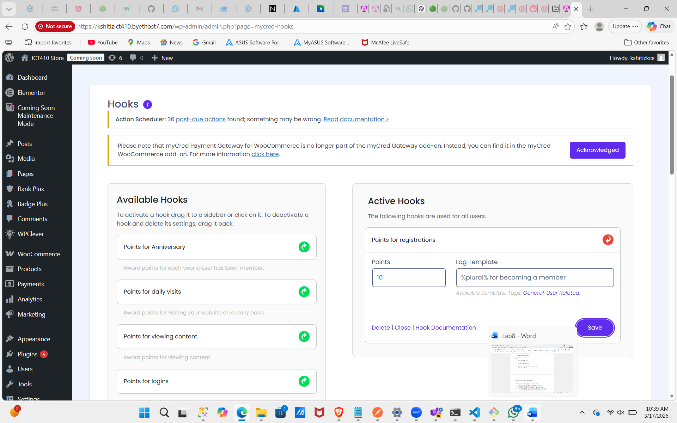
- Hover over Users > All Users
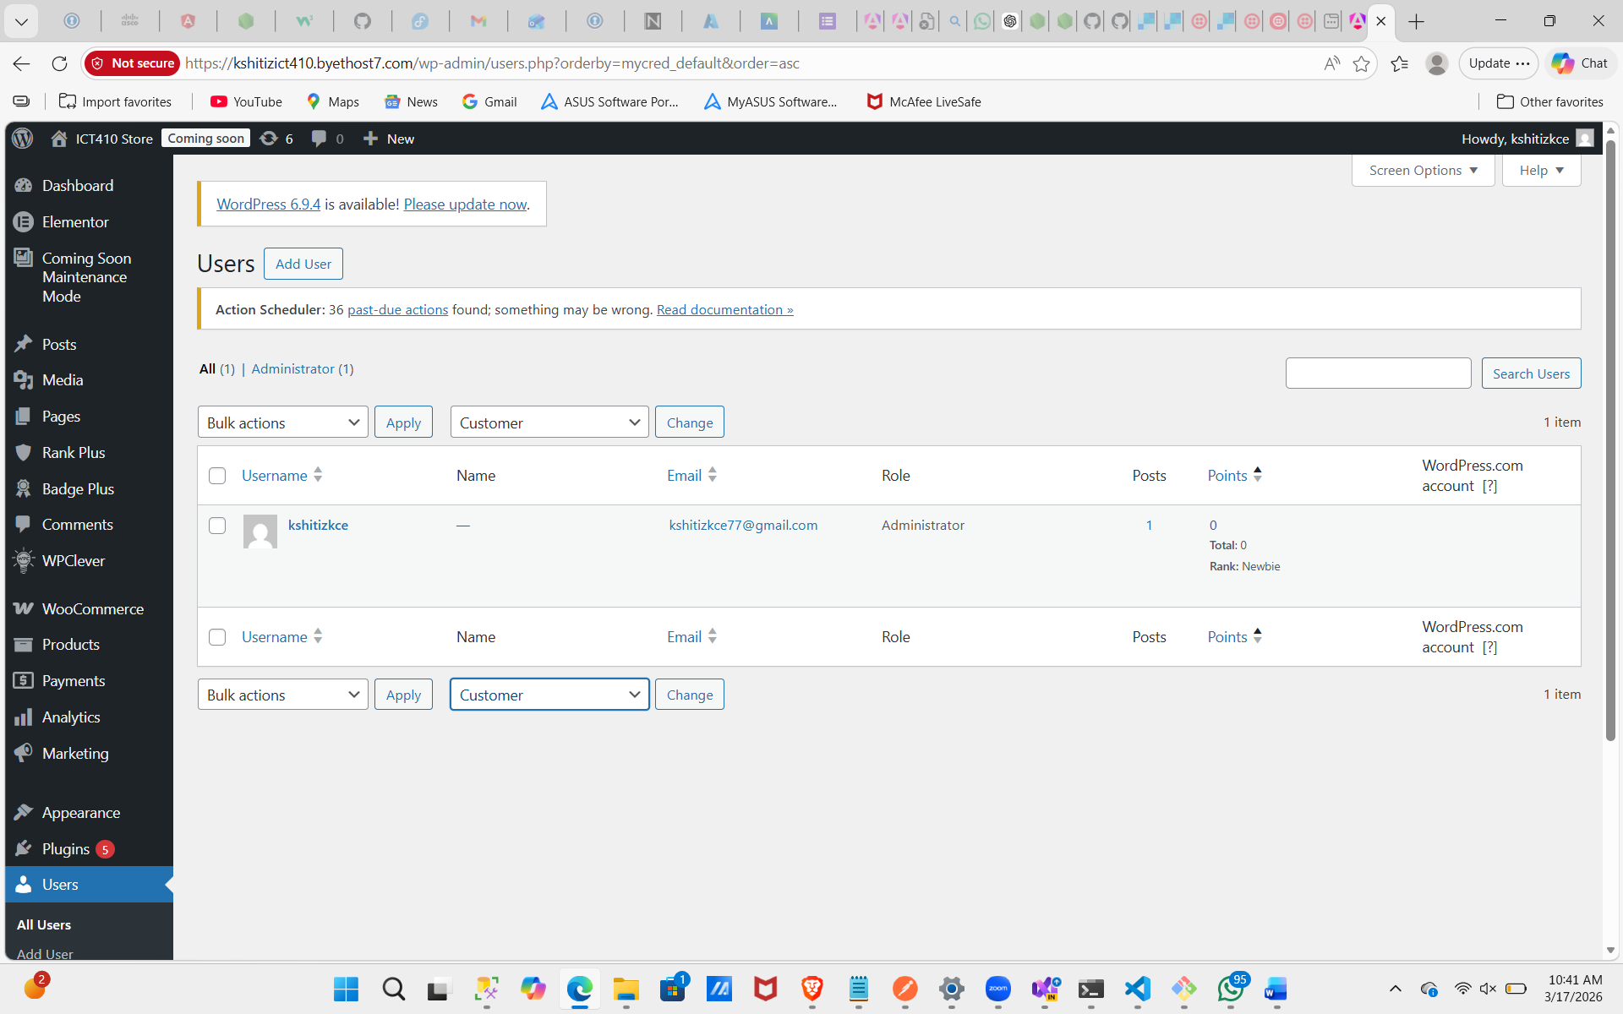
What do you notice that is different about this table?
Users Table Difference
- A new Points Balance column appears
- You can view logs and track user activity
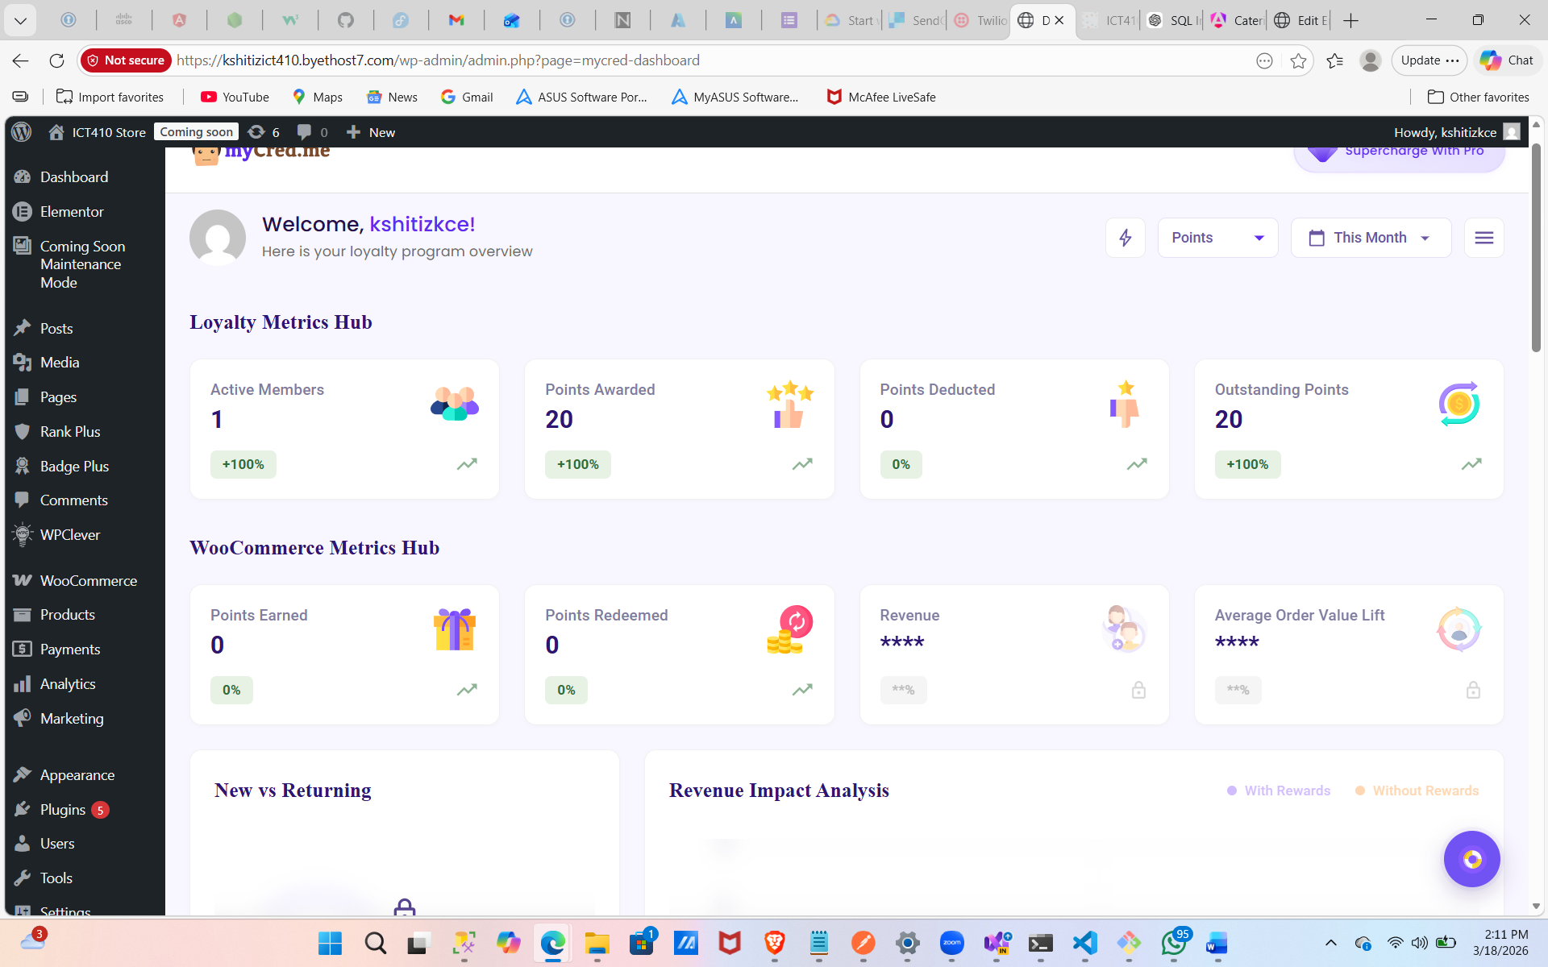

Step Two: Loyalty Welcome eMail with Points Balance
- Hover over the Points plugin > Add-Ons > eMail Notifications > Activate
- Hover over Points > eMail Notifications > Add New
- Mark the eMail Trigger as when a custom event occurs > Website Registration
- Write a subject line for the email and a body welcoming the new member while informing them how many points they earned and their balance using the template tags at the bottom.
- In incognito, register yourself as a new user with your email. (may have to delete yourself if previous user, do not delete if you are Admin account however.) http://{firstname}.ict410con.com/register/
Take a screenshot of the tags in use in your email template and take a screenshot of the email sent to your account after registration.
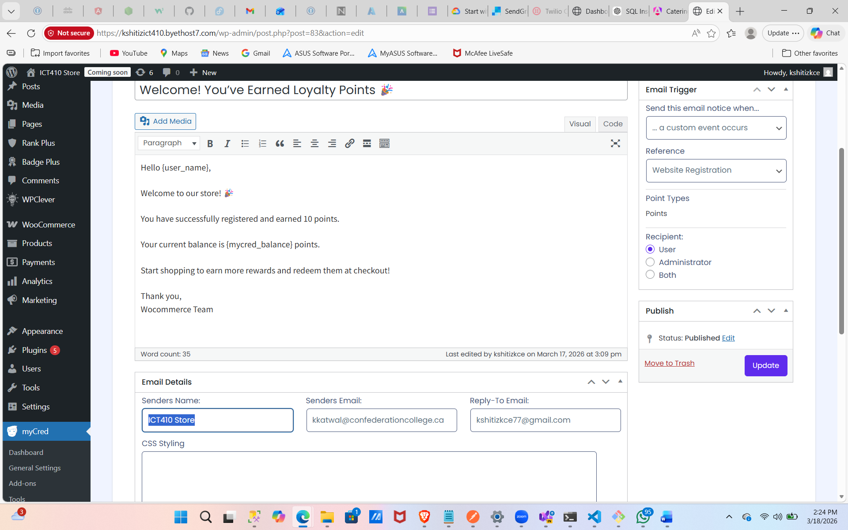
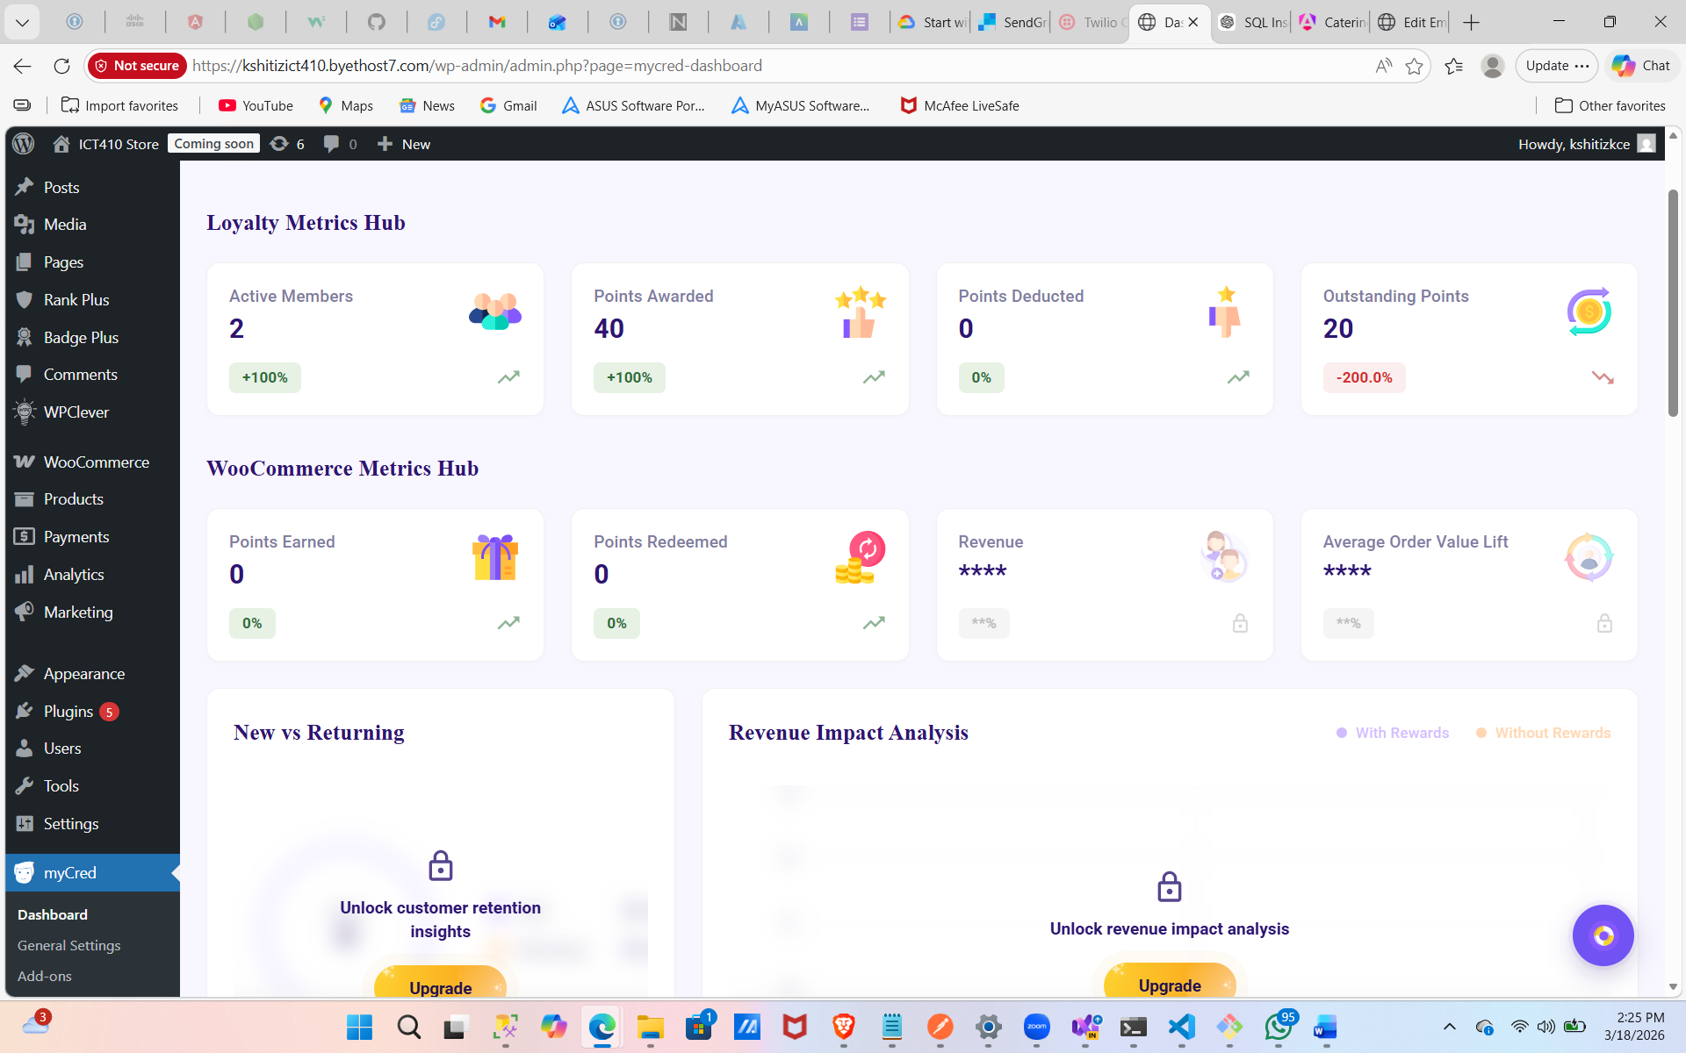
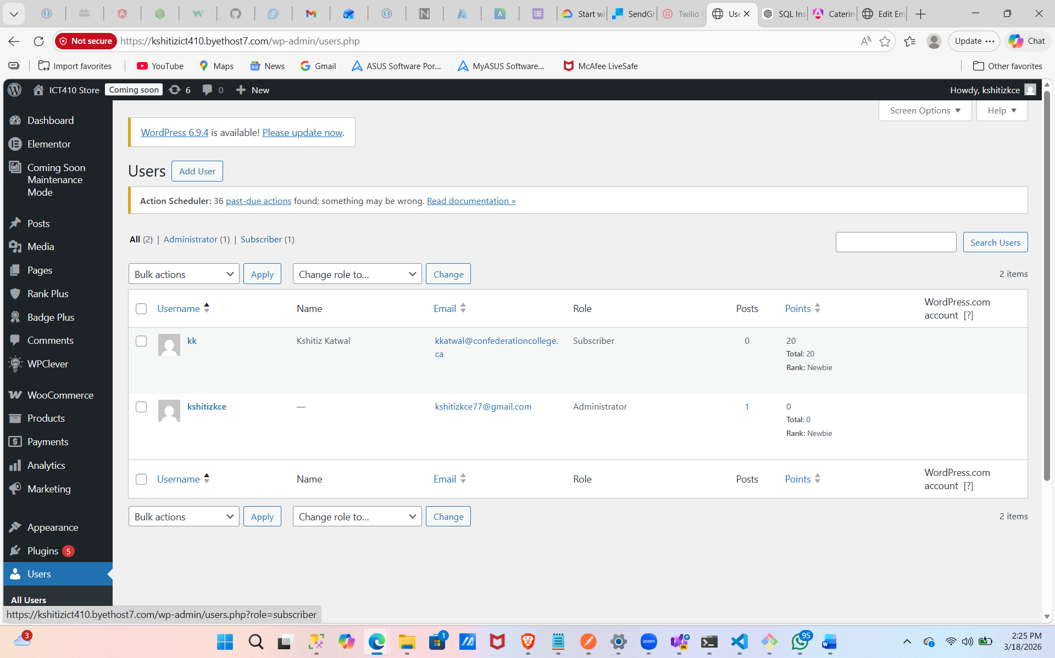

- Hover over Users > All Users
Notice that the table has a new points balance, click to find out the logs.
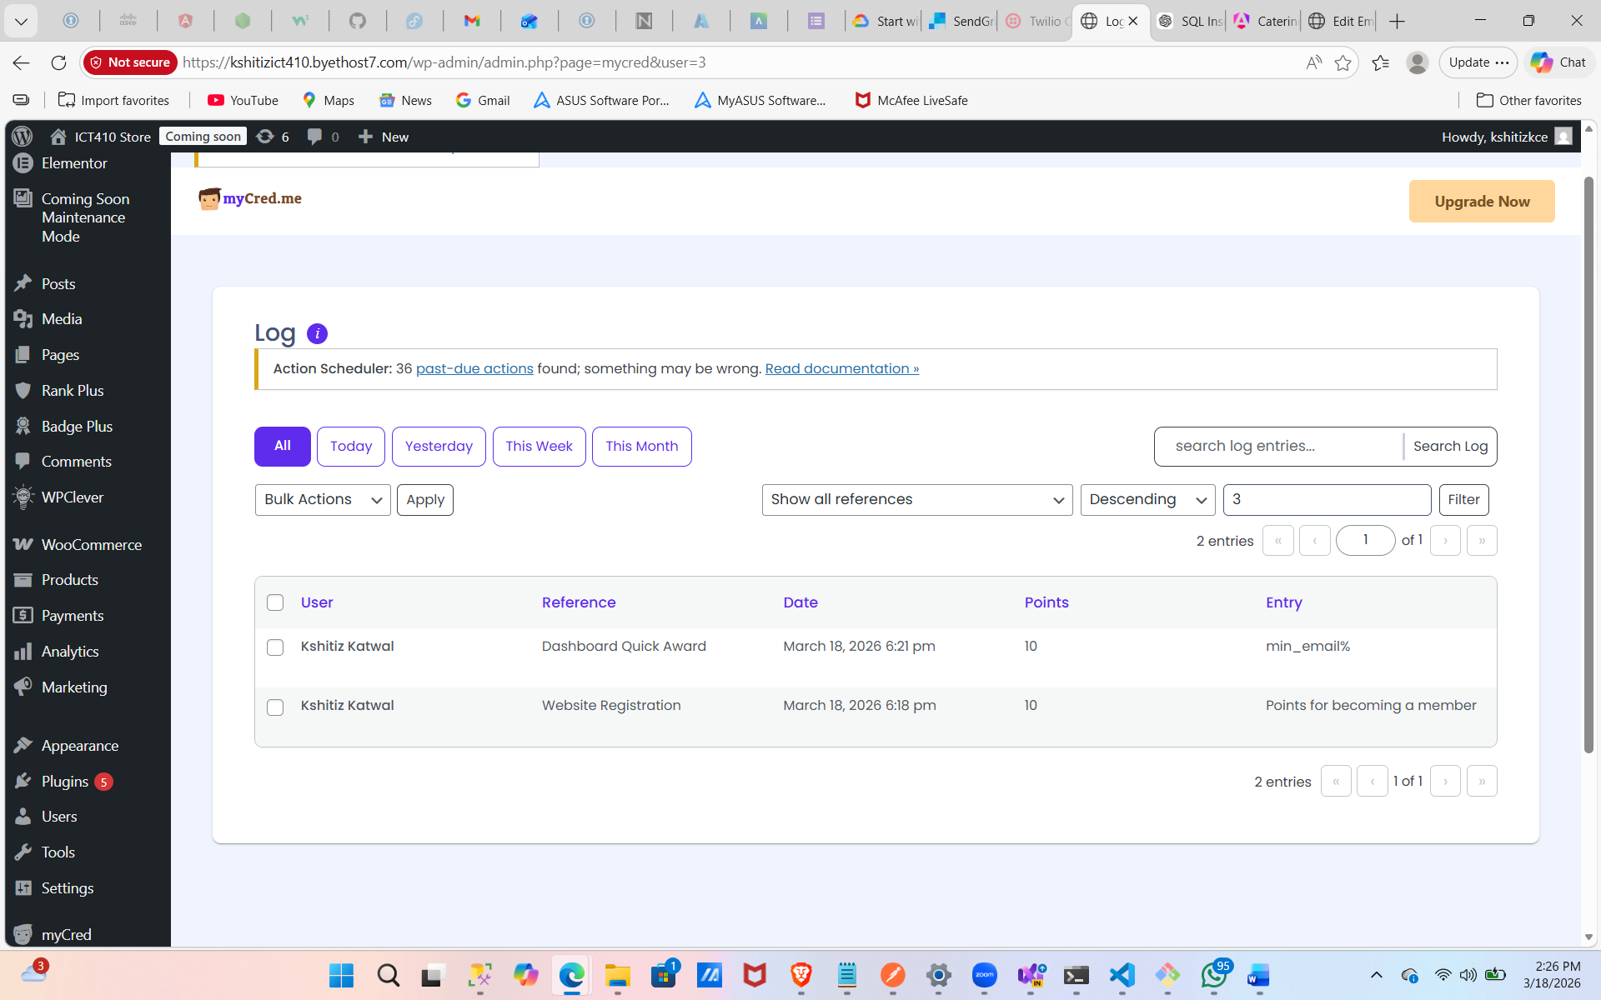

Go back and look to see what other emails you might create. Give me two more examples of emails you think would be effective to create in a loyalty program.
>>> 1. Points Expiring Soon Reminder (Creates urgency) via email
2. Reward Redemption Confirmation (Builds satisfaction) via email

Step Three: Discount Loyalty Bonus
Say you want to provide your members only a special discount, could be a one time sign-up or special promotion where they earn both a discount and points for using the discount.
- Hover over Points > Add Ons > Activate Coupons
- Hover over Points > Coupons
Notice how we can create a coupon code that we can obtain points for.
- Create a discount code with the same name as the one you assigned in your loyalty program
- Checkout with your signed in user who has access to the code
- Take a screenshot of your log with your user name demonstrating the discount was used

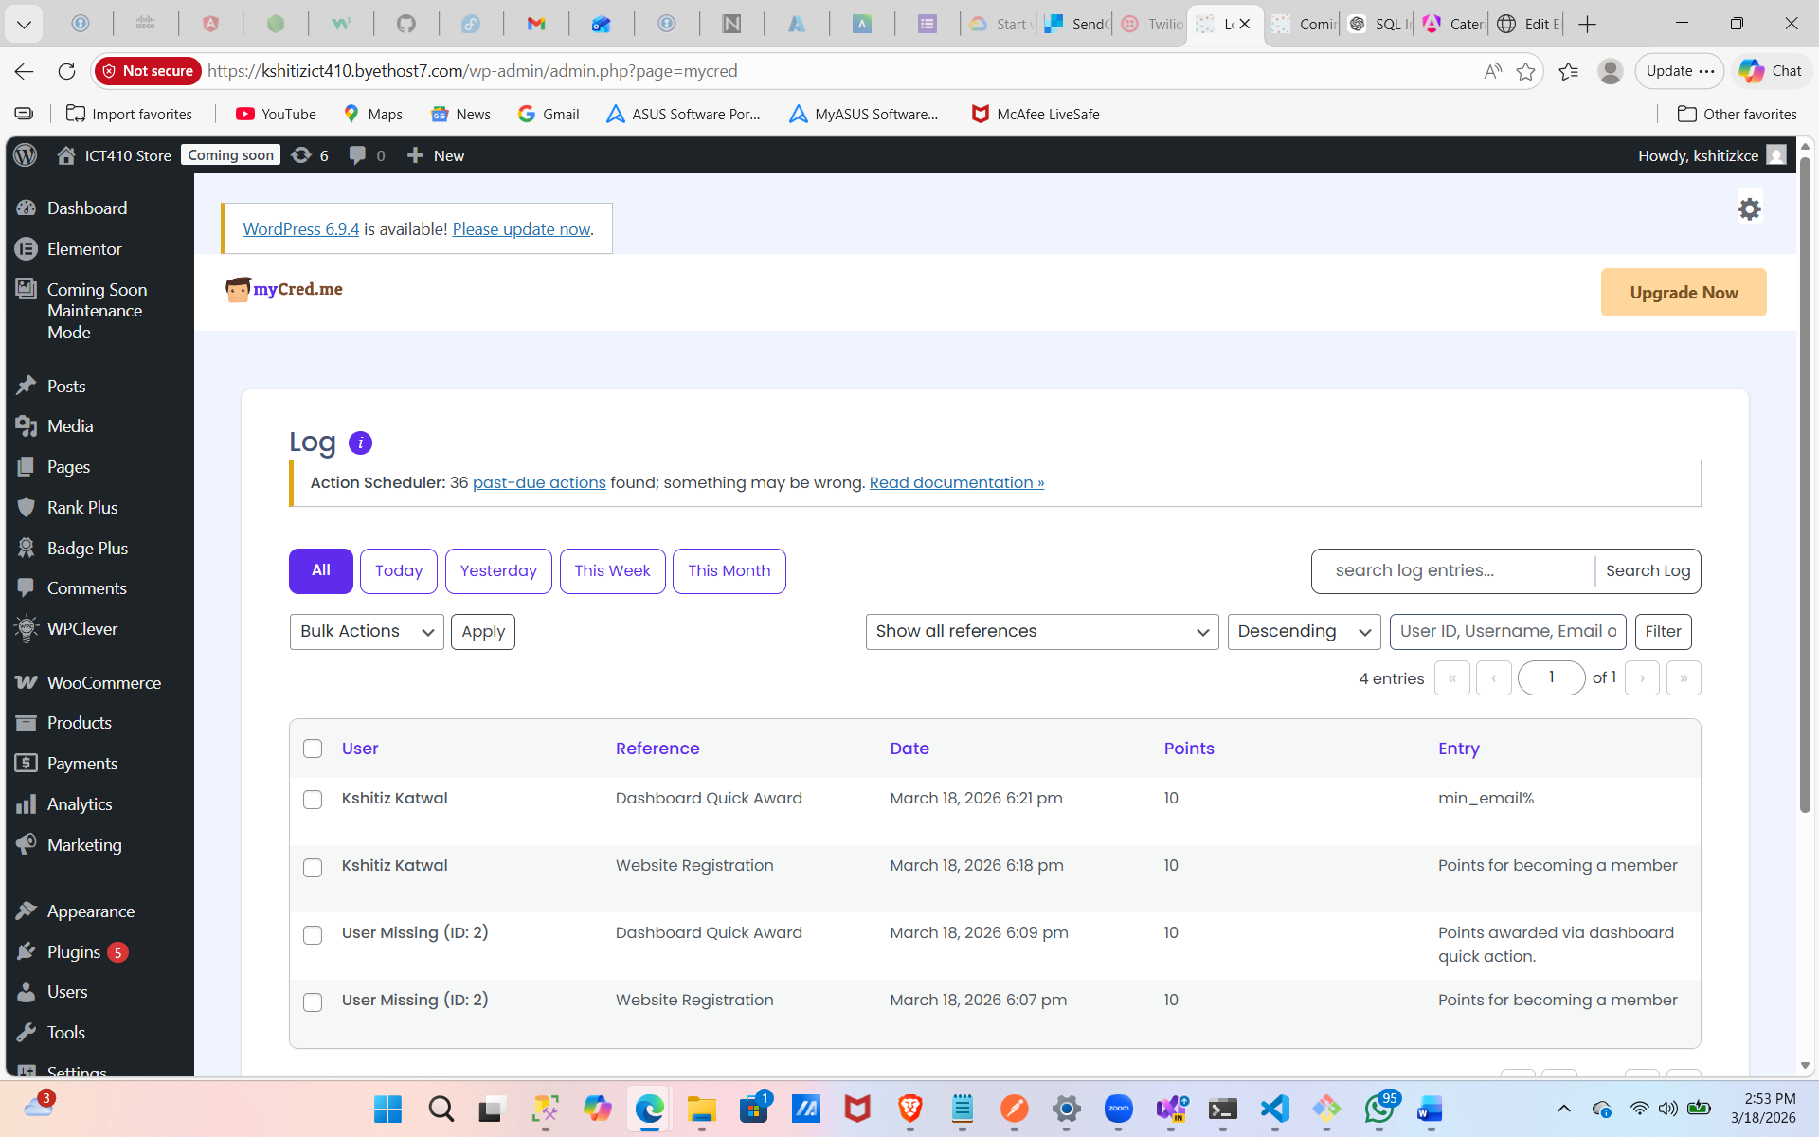
Step Four: Points for Buying Products & Manual Adjustments to Points Balance
- Click on Products > Select the White T-Shirt
- Notice how there is a points you can assign to buying the T-Shirt > Give 5 Points for a T-Shirt
- Update
- In incognito, buy the white T-Shirt while logged in as your user
- Hover Over Users > All Users > Logs > Take a screenshot of the log
- Go back to All Users > Make Adjustment > Add 70 Points
When would you ever have to make a manual adjustment to a loyalty program user balance?

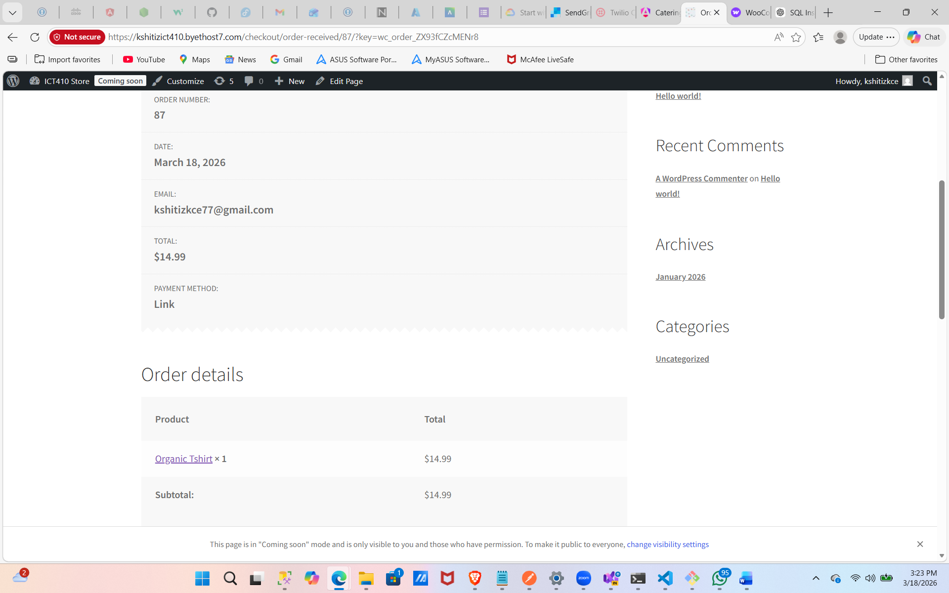
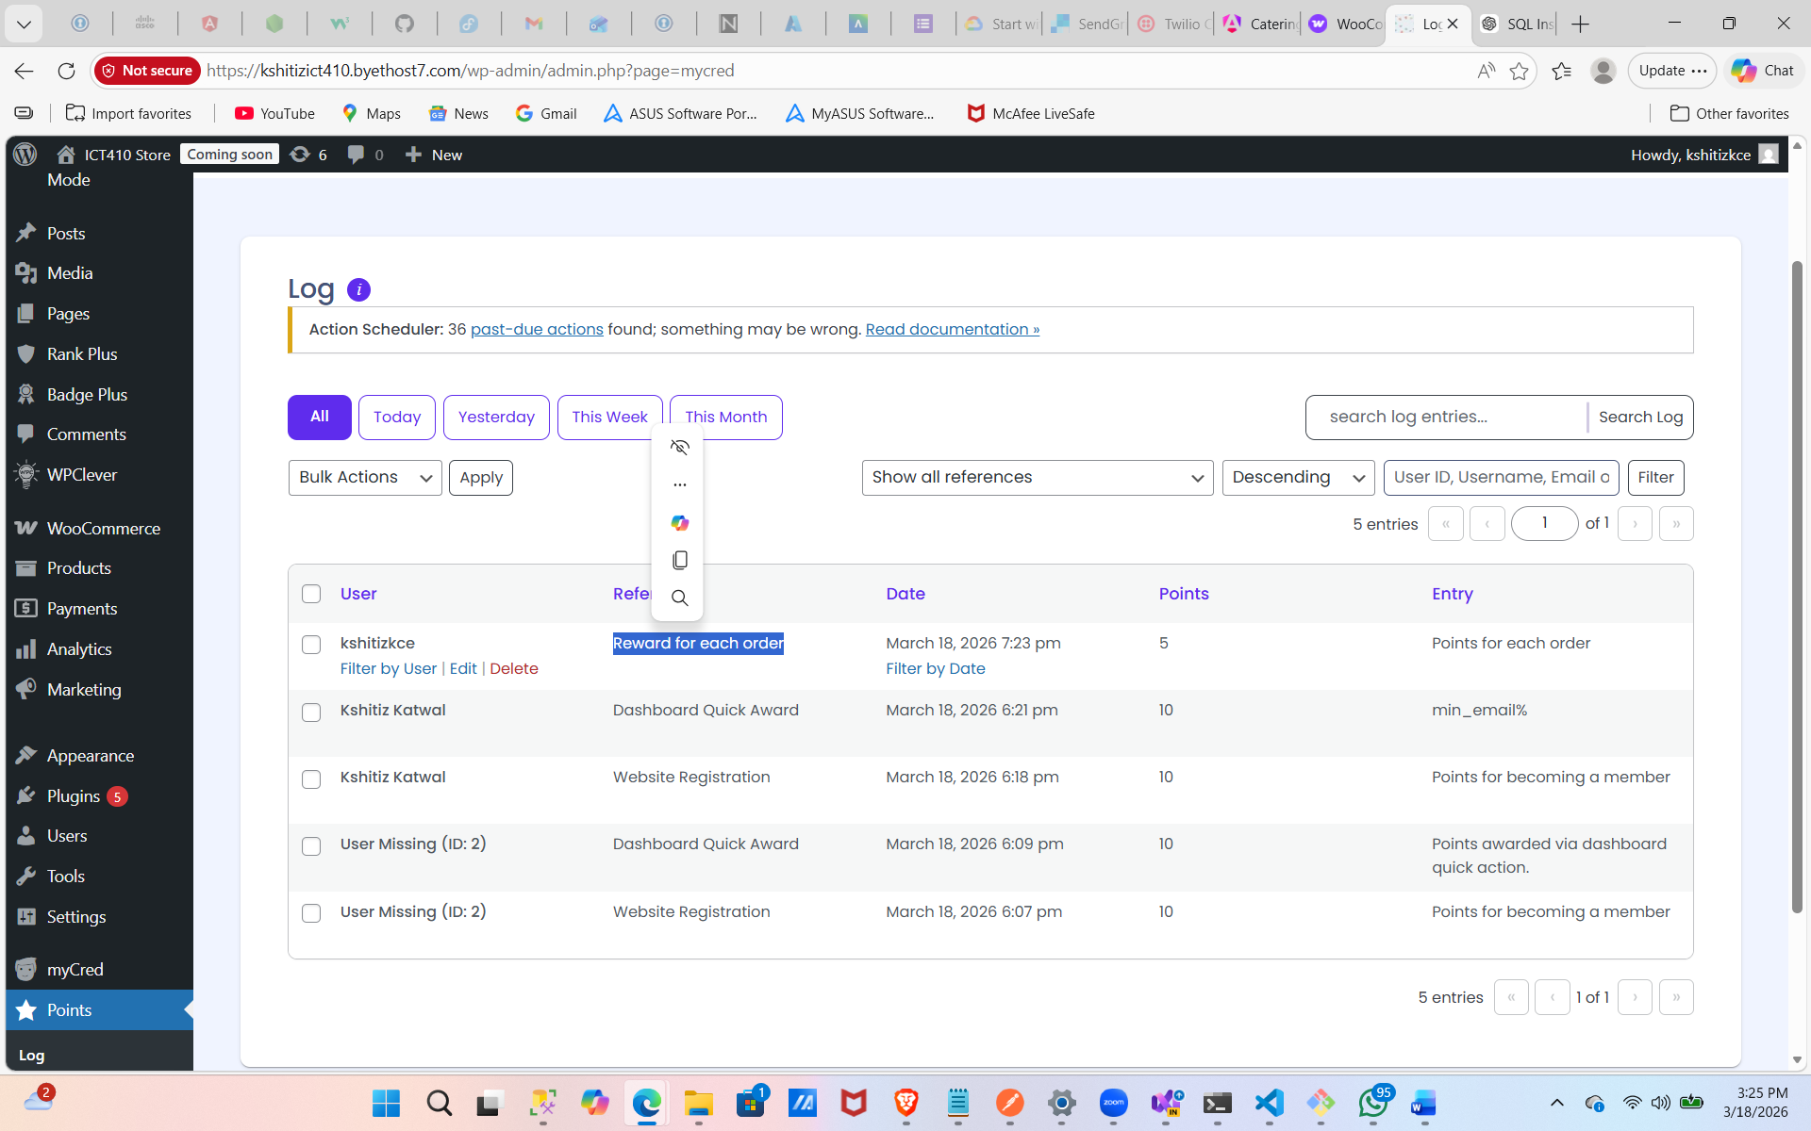
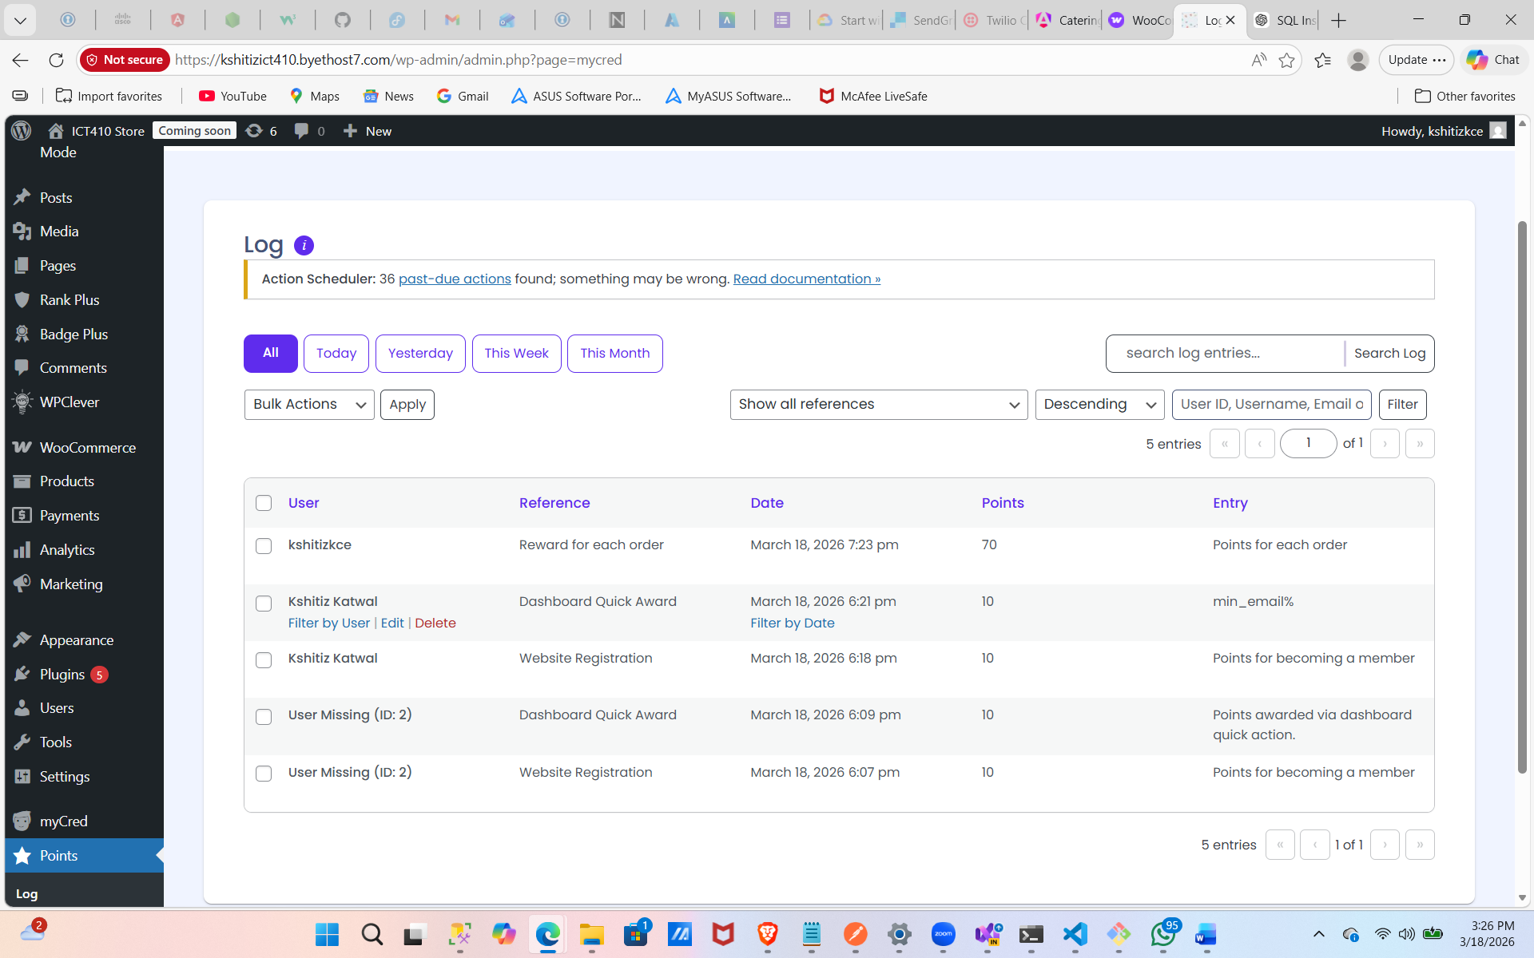

Step Five: Pay with Rewards
- Hover over Points > Add Ons > Payment Gateway > Activate
- WooCommerce > Settings > Payments > Activate myCred as a payment method
- Make myCred to display Loyalty Points instead of myCred as payment gateway
- In Incognito, sign into your user account, place an order for under $70 to use your points
- Place the transaction using Loyalty Points
- In your WordPress admin > Users > All Users > Select your account and show the log deducting the loyalty points on the last transaction
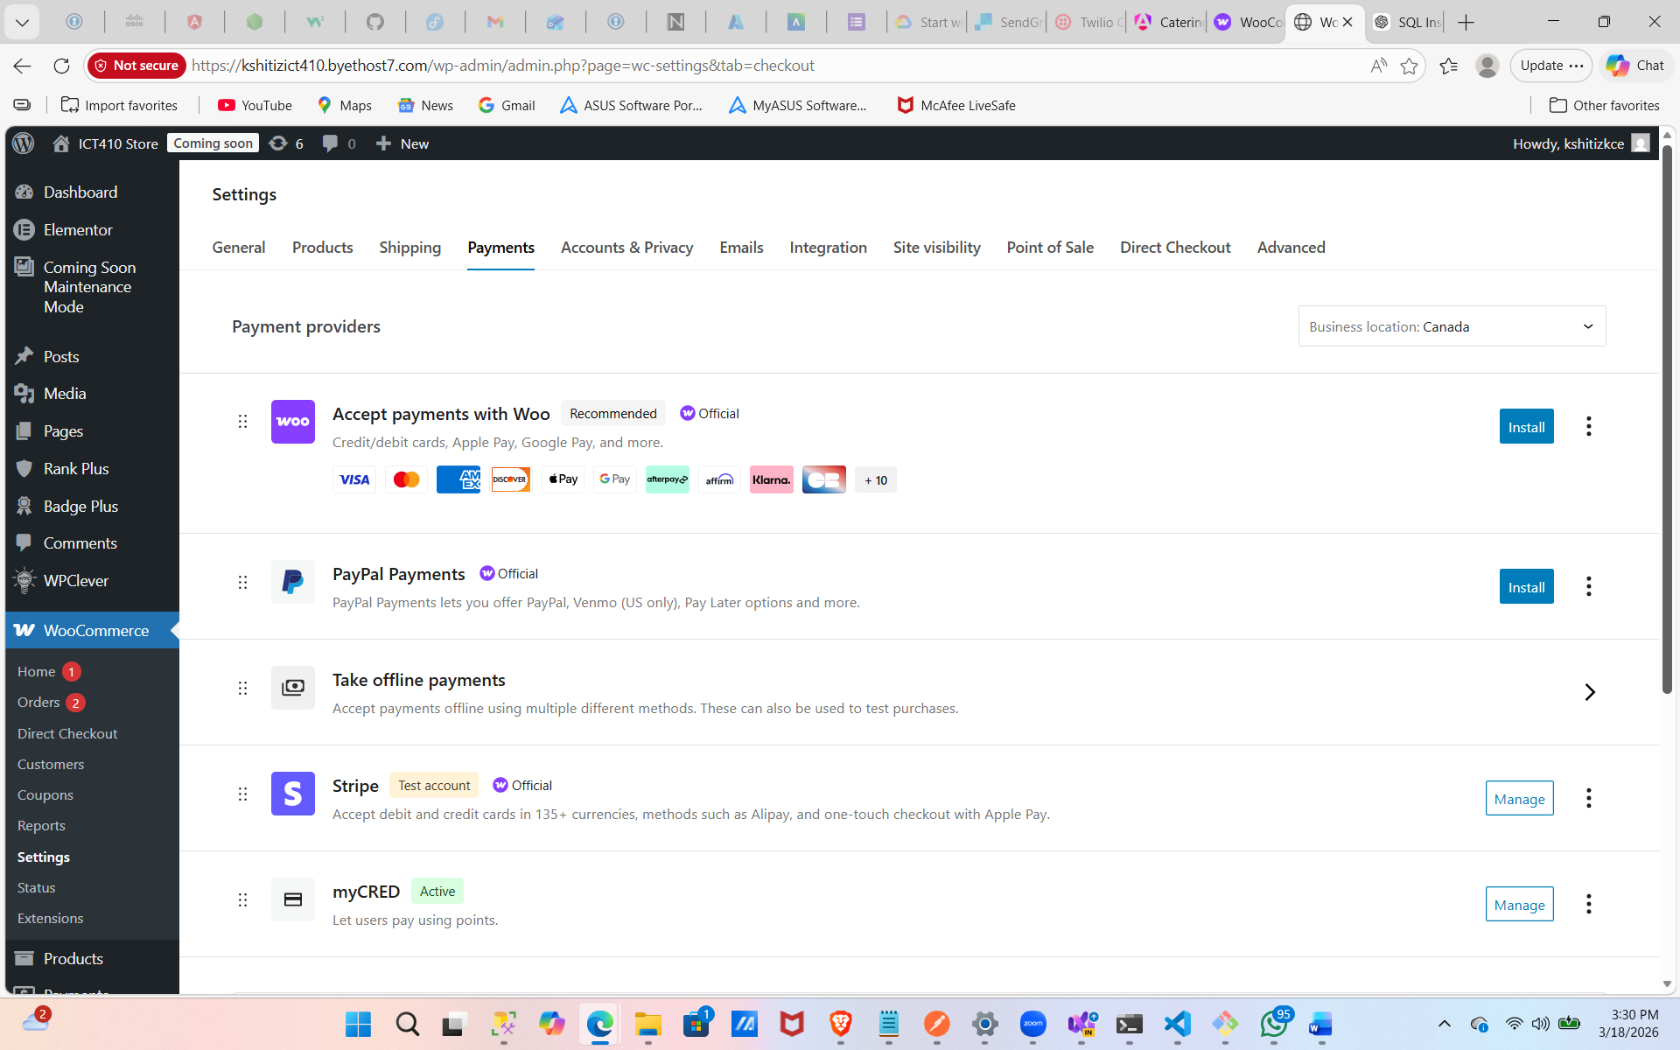
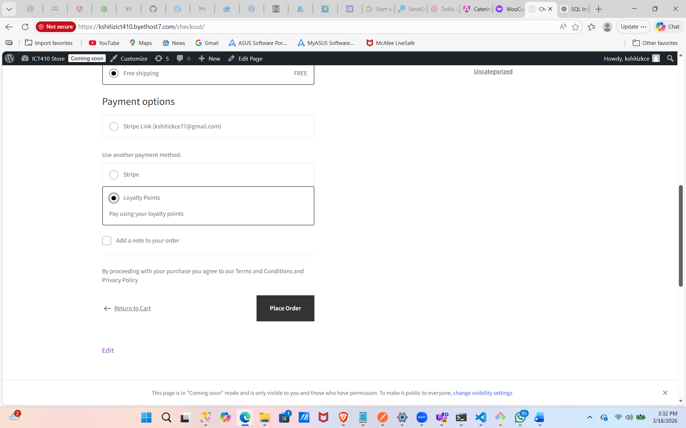
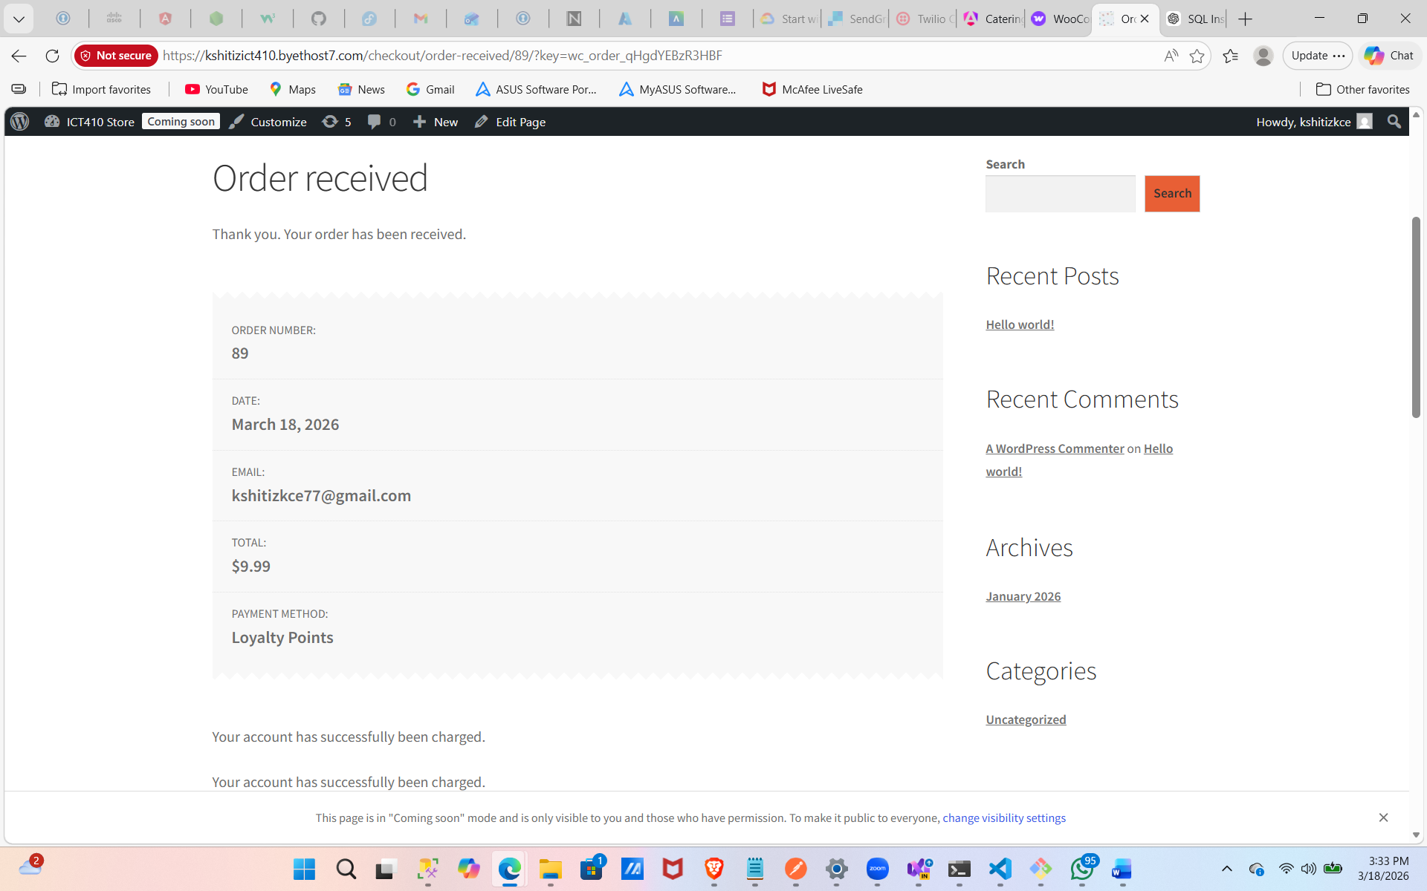
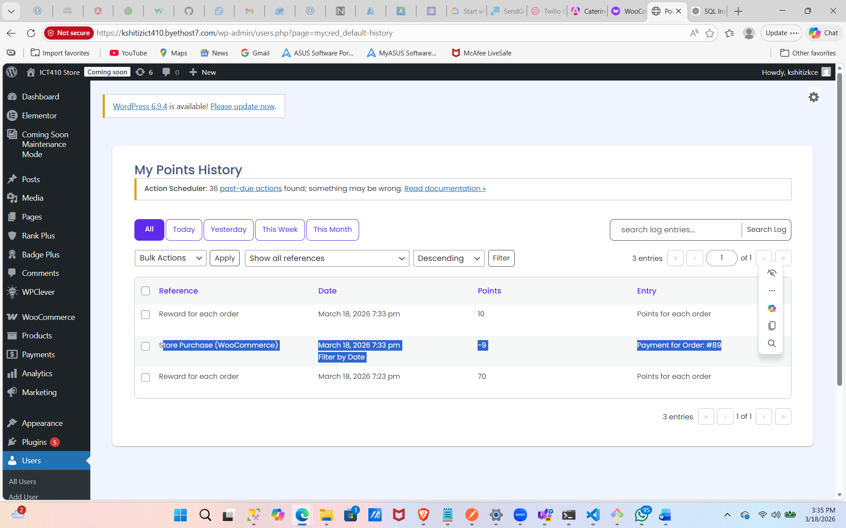

How would you use the badges add on, give examples of how you would set the program up
The badges add-on can be used to reward users for specific achievements and increase engagement through gamification. For example, a user can earn a “New Member” badge after signing up, a “Frequent Buyer” badge after completing five purchases, or a “Top Spender” badge after spending over a certain amount.

How would you use the BuyCred Add On? Do you find this add on useful?
The BuyCred add-on allows users to purchase loyalty points using real money. This can be useful in situations where users want to quickly redeem rewards but do not have enough points.

Step Six: Turn your WooCommerce Store Into a POS
- Hover over Plugins > Add New > Search POS > Select WooCommerce POS
- Hover over POS > Settings > Click Checkout Bar
- Notice how it says Online Gateways vs POS Gateways
Are we able to access Stripe without paying for the Pro Version?
Answer:
No, Stripe is usually only available in the Pro version of most POS plugins. The free version has limited payment options like cash or basic methods.

- Hover over POS > View POS
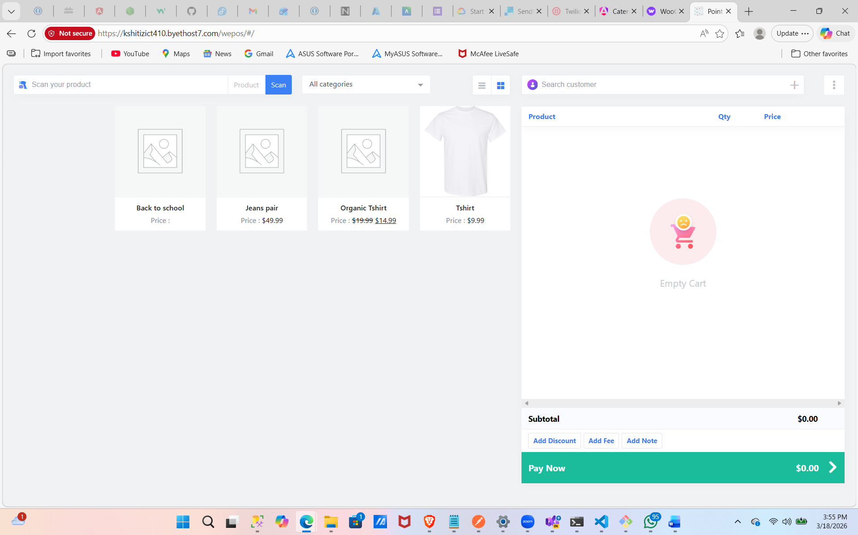
How does the POS vary versus a regular eCommerce screen? What would you use to sell in person?
I would use the POS system because it is optimized for in-person sales, allowing quick checkout, easy product selection, and better customer interaction.

Try the POS on your phone or tablet, which would you prefer the online store or POS?
I would prefer the POS system on a phone or tablet for in-person sales because it is faster and easier to use. However, for remote shopping, the online store is better.

What are the benefits of a POS over just the web store?
The POS system allows faster transactions, works well in physical stores, and supports real-time customer interaction. It is ideal for handling walk-in customers, while the web store is better for online purchases.

