
IC 410 – eCommerce Solutions II
Lab #9 – Selling Virtual Products
Name: _____________________________
Abstract
In this lab, you will be learning about how to sell products that are virtual or service based and on subscription. We will also cover how to sell digital products like downloads.

Step One: Setup a Digital Download Product
- Login to {firstname}.ict410.com/wp-admin
- Products > Add New
- Create a new product called ‘School Photo’
  - Give a short description
  - Price it at $10, yes people will pay for your picture because you are a star!
- Under General, select that the product is downloadable
- Upload a photo
- Set download limit to 1 to make the picture exclusive or a limited quantity
- Publish Product and Checkout
Notice how shipping is charged for the virtual download, should there be? How can we go about ensuring this product has no shipping cost? (Hint… Create Shipping Class > Apply to Product > Adjust Flat Rate Shipping)
https://www.youtube.com/watch?v=Vyt5xIewlOs
- Setup a Shipping Class for Downloads so no shipping is charged
Take a screenshot of how you would set this up on Flat Rate Shipping so that download product has zero cost and item that has shipping will be charged.
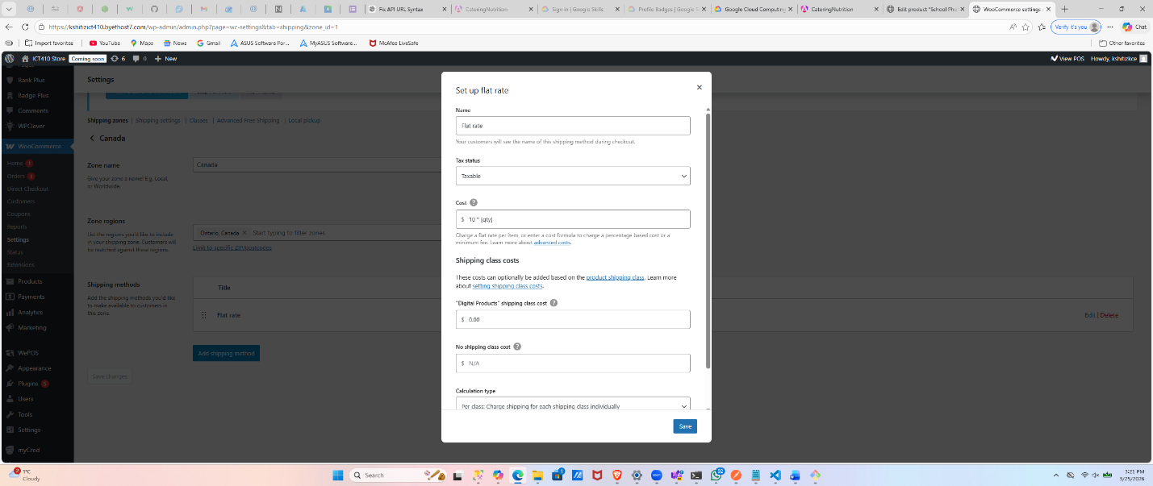

- Checkout
Take a screenshot of the success page and email you received to show the download
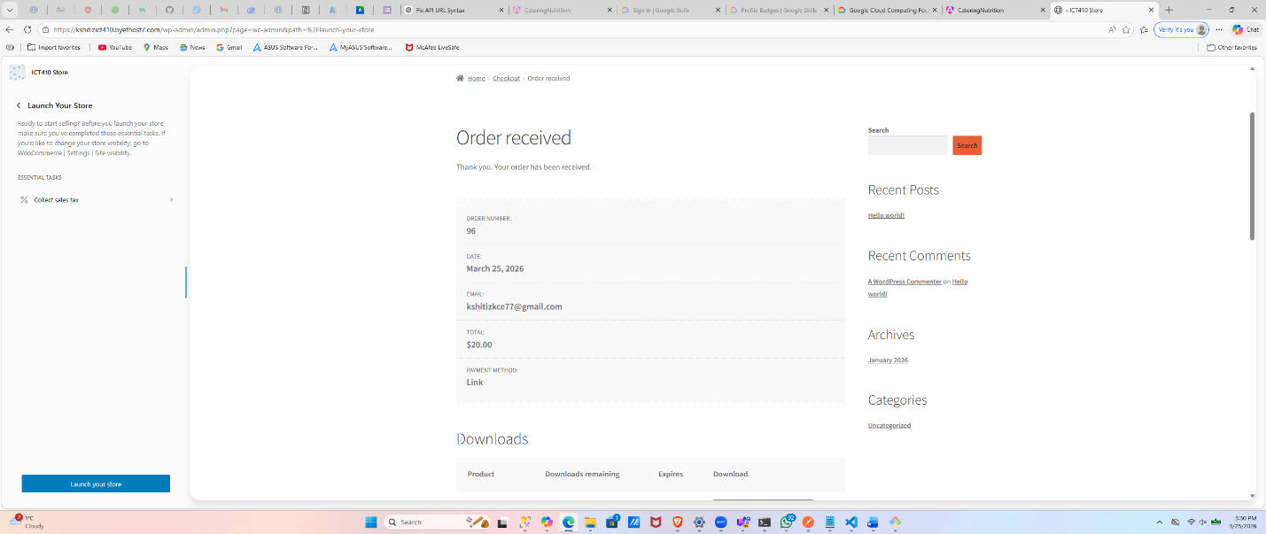
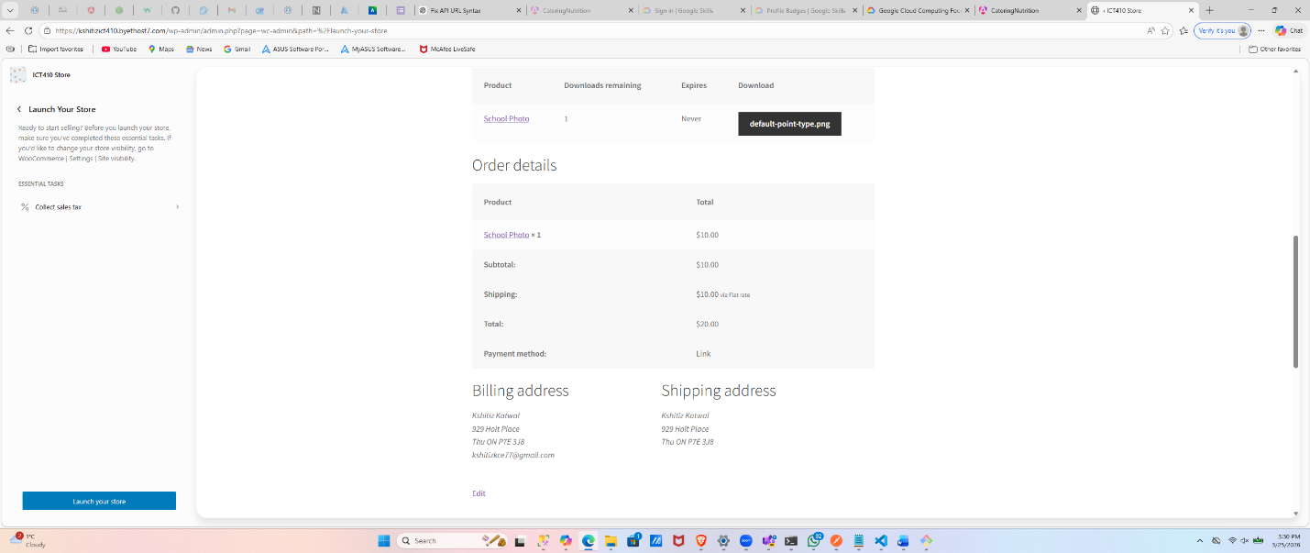
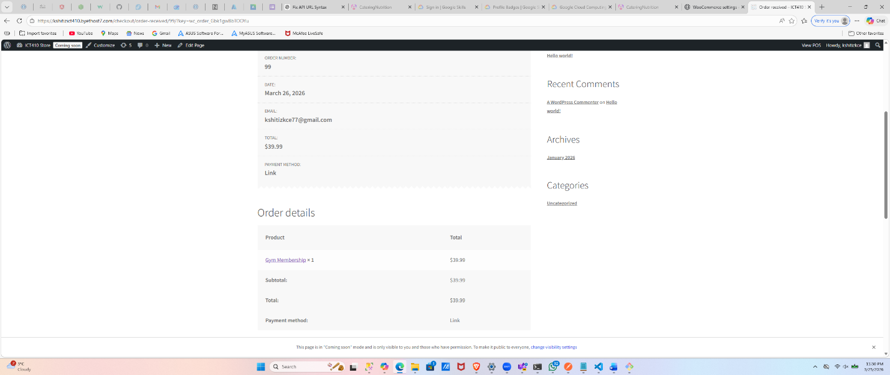
Step Two: Virtual Product with Subscription
Say we need to set up a membership where you get unlimited downloads or a service. We can sell these virtually and automatically renew subscription payments every month.
- Products > Add New > Create New Product Called ‘Gym Membership’ for $39.99
- Set the product as Virtual, notice the shipping options go away on the product
  - We probably could have done that at the top but wanted to show how we get different rates for different product types
How would you go about charging a monthly subscription after this first month? Should the user agree to some terms and conditions first letting them know you will be charging their card?
Explain the steps or plugins you would do to accomplish this.
To implement recurring payments, I installed a WooCommerce subscription plugin(YITH WooCommerce Subscription), configured the product as a subscription, and set monthly billing. I also enabled terms and conditions to inform users about automatic recurring charges.
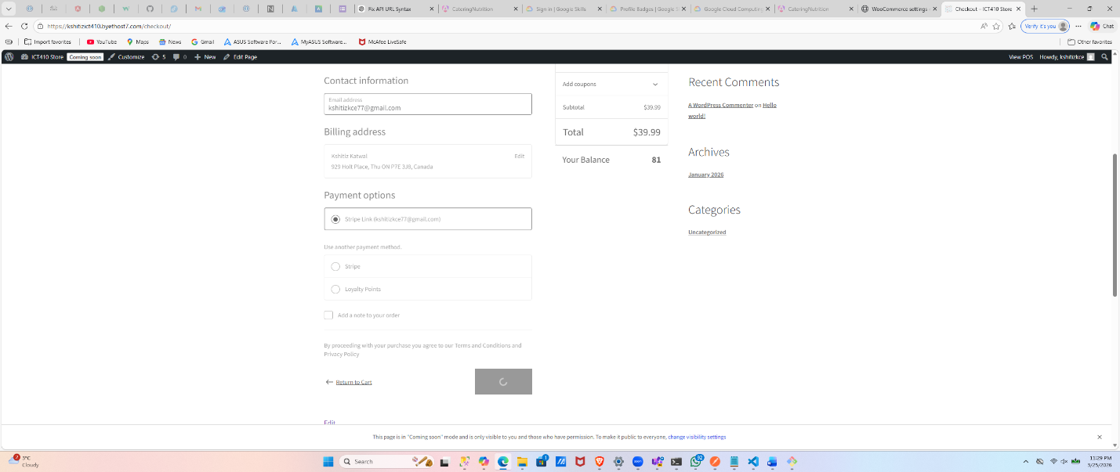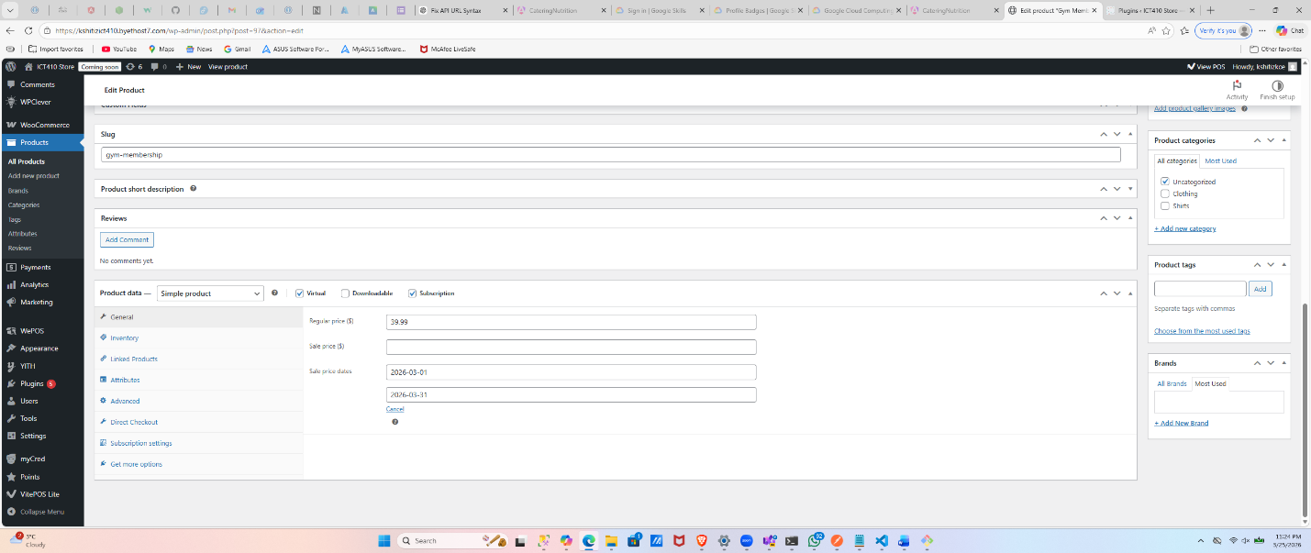


Step Three: Collect User eMail Before Downloading Content
- Design a landing page to advertise a piece of content on your website (Pages > Add New)
- Promote the content on your home page with a link to it
- Create a contact form on the page (Contact Form 7 plugin or other as you see fit)
Take screenshot of landing page with contact form, explain the plugin and steps used to create the contact, did the email generate automatically? Use your problem solving skills to locate and use the right app for the job!

Answer:
Th plugin userd is Contact Form 7 for contact form
1. Create Landing Page
- Pages → Add New
- Title:
👉 Free Guide Download
- Content:
Download our exclusive content by entering your email below!

✅ 2. Install Contact Form Plugin
Install:
👉 Contact Form 7

✅ 3. Create Form
- Go to Contact → Add New
- Default form is fine, or use:
Name [text* your-name]
Email [email* your-email]
Submit [submit "Download"]
- Save
- Copy shortcode

✅ 4. Add Form to Page
Paste shortcode into landing page
👉 Publish page

✅ 5. Link from Homepage
- Go to homepage
- Add button or link:
👉 “Download Now”
- Link to landing page

✅ 6. Email Setup (IMPORTANT)
- In Contact Form:
  - Go to Mail tab
- Set:
  - To: your email
  - From: wordpress site
- Save
