

**Funnel Analysis Report for Swiggy**

Kshitiz Prasad

3rd June, 2024

**Overview**

**Objective**

This project aims to analyse the Swiggy dataset and conduct an in-depth analysis using funnel analysis. The goal is to understand the reasons behind the rise and fall in orders.

This project demonstrates how funnel analysis can help to optimize processes, enhance user experience, and make data-driven decisions.

**Key Metrices**

* Key metrics such as total orders, listings, restaurant availability, out of stock items, payment success rate, average discount, delivery and packaging charges has been analysed using Advanced-Excel.

**Introduction**

Swiggy is one of the largest food eCommerce platform in the country. Every day more than 1 million users are transacting on the platform. As a growth and strategy analyst of swiggy its one’s responsibility to generate insight on the company’s performance for the given year.

Here as we’ve been provided with three sheets;

* Session Details sheet has date wise session count. Where we can find listing sessions, menu sessions, cart sessions, payment sessions and order sessions day over day.
* Channel wise traffic sheet has traffic (listing sessions) breakup at the date level.
* Supporting Data sheet has other information at the date level.

This specific project is focused to achieve the organisational goals while collecting insights from the data so provided. The objective for the same is to identify the increase or decrease in the number of orders, to Check if there is change in traffic as compared to same day last week and to Check if there is change in Overall Conversion as compared to previous dates.

**Methodology**

The data so provided has been collected primarily, although for the author of this project this is “Secondary Data Collection Method”.

Further, the author has scrutinised the data and created related dashboards to make the understanding clearer.

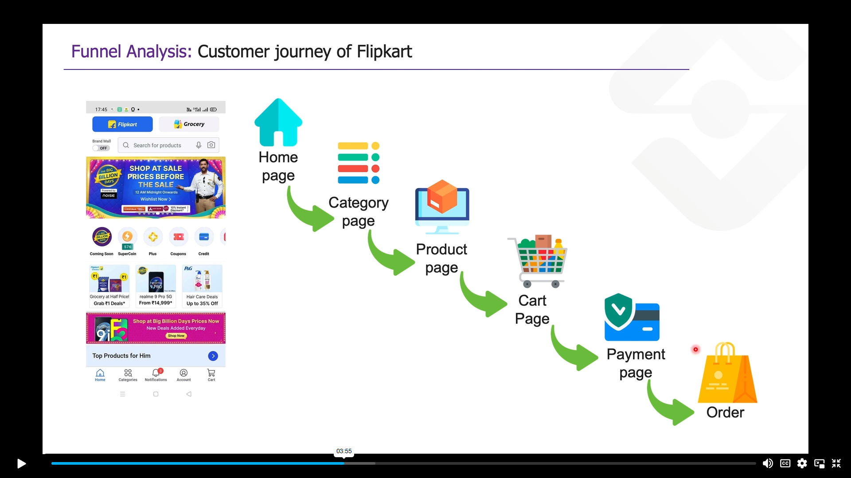

Customer Journey Of Swiggy

**Key Metrices**

* Overall conversion = Order/Listings
* Order Change with respect to same day last week = Order of current date/ Orders of same day last week -1
* Traffic Change with respect to same day last week = Traffic of current date/ Traffic of same day last week -1
* Conversion change with respect to same day last week = Overall Conversion of current date/ Overall Conversion of same day last week -1
* L2M = Menu/Listings
* M2C = Cart/Menu
* C2P = Payment/Cart
* P2O = Order/Payment

**Analysis**

Let us first understand how funnel actually works.

1. Session ID is an unique Id that defines every new visit on the app/website.

As soon as we click on the link shown in the image, a new session id would be recognised. Using these session ids we build the basis of our analysis.

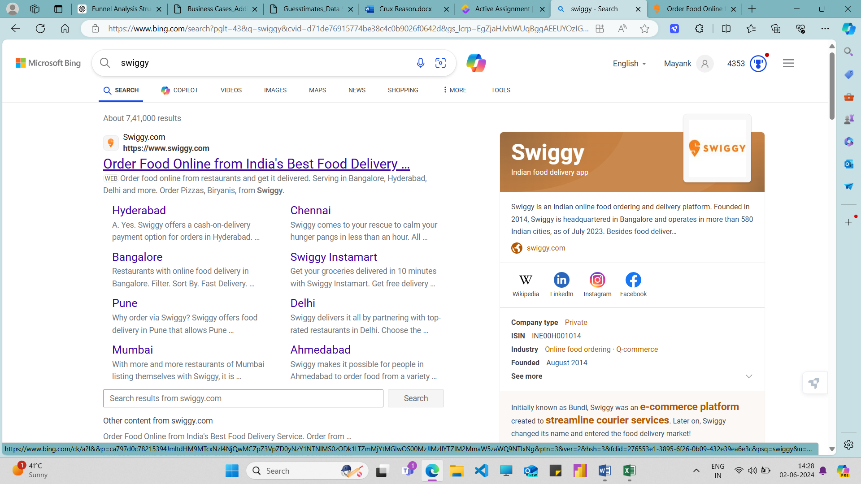

1. Home Page (Listings) : The first page is homepage, customer searches their preference from here only. One can continue either by clicking out of so many categories and land on the Menu Page, or search for their tastes directly and may land on the add to cart page.

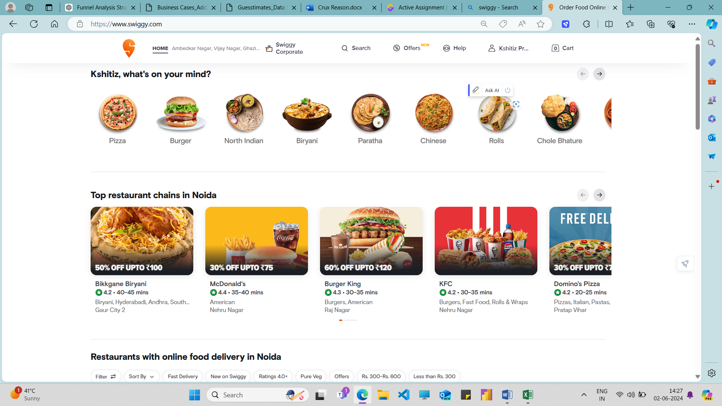

1. Category Page (Listing 2 Menu) : One can be here after making their mind for some specific category, example paratha.

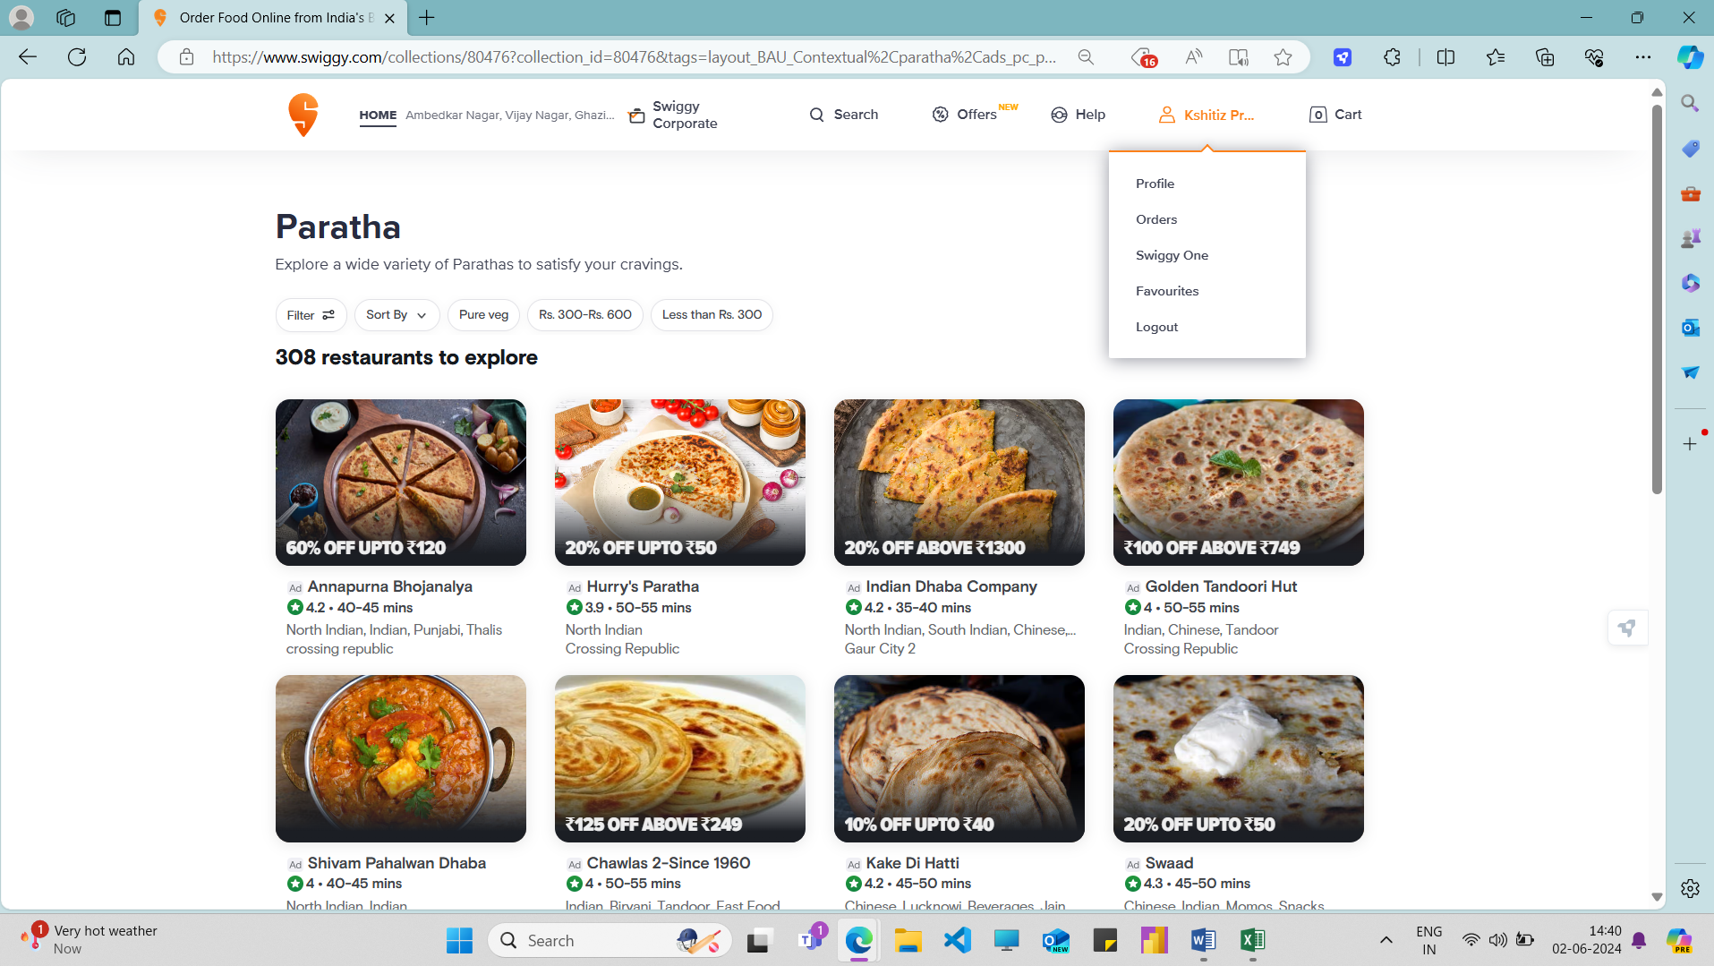

Further the customer can select any specific item from any store as per their wish. And hence after clicking on that particular item they land on product description page. For example we clicked on “Ananapurna bhojanalya”. Then we will reach on the following page.

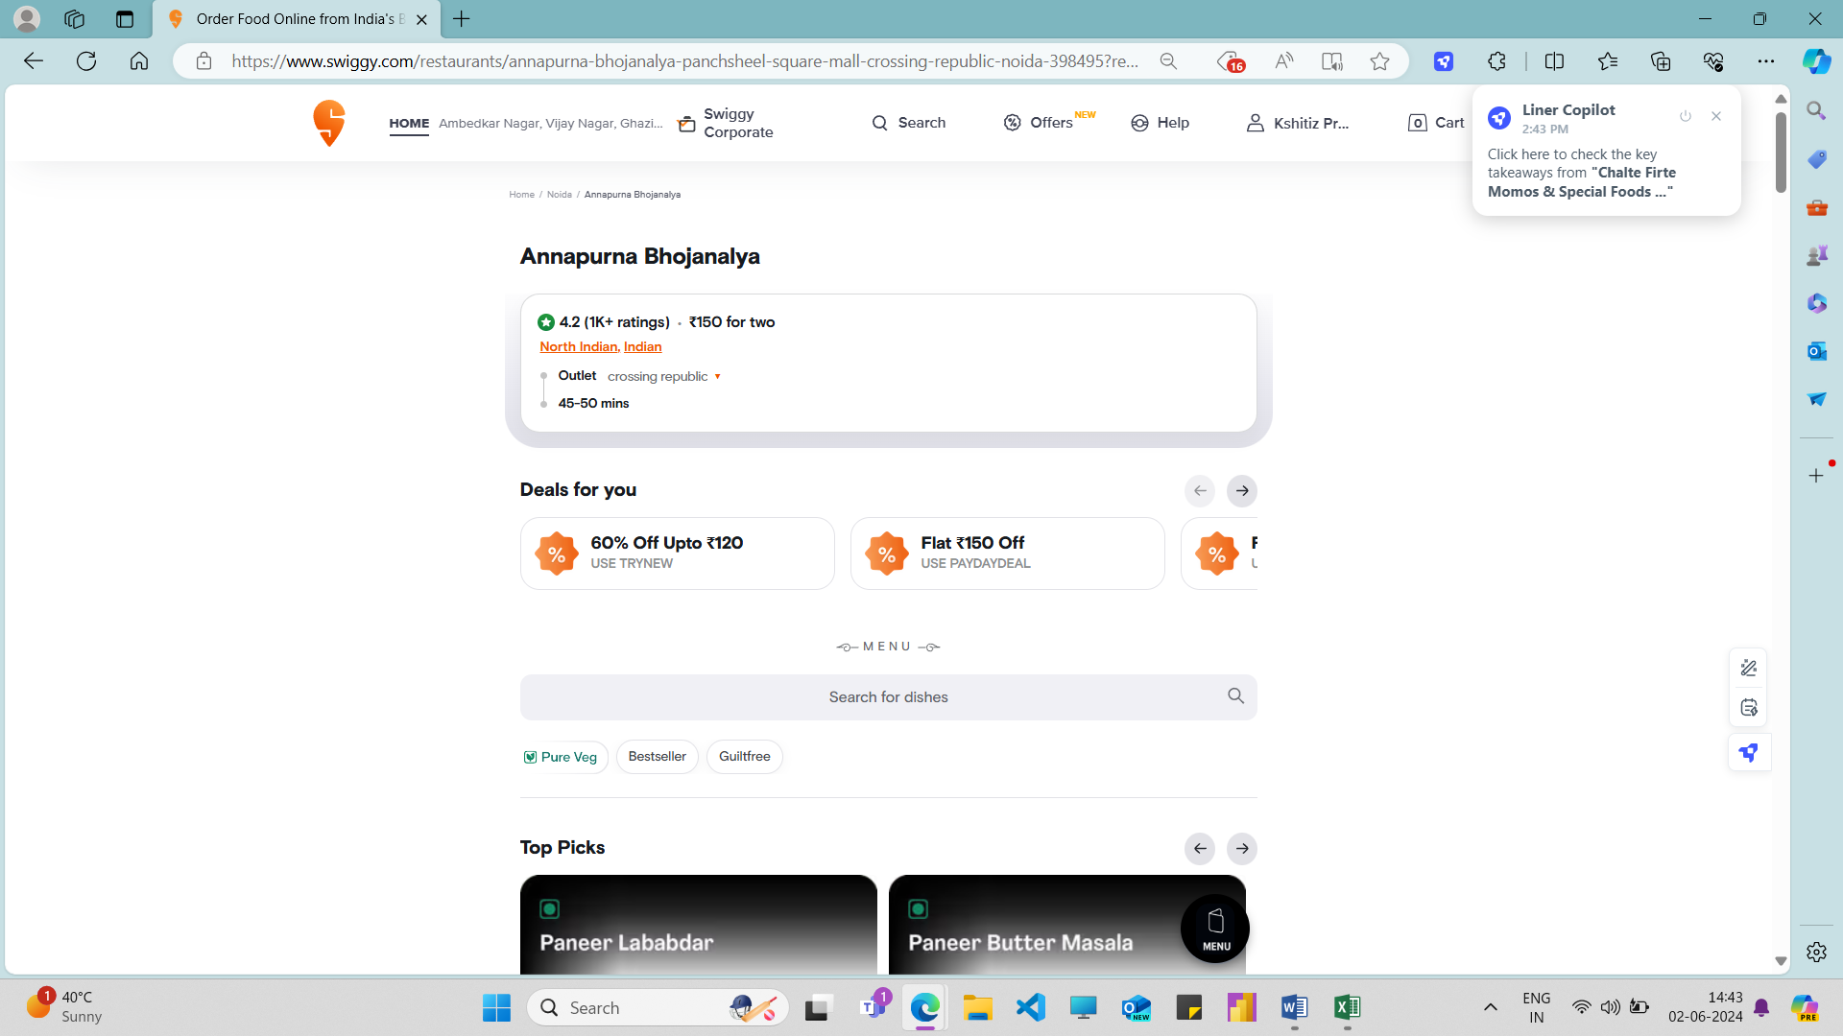

1. Add to cart Page (Menu 2 Cart) : here the customer goes for the add the item to their cart if the like some the product they clicked on, they view ratings, offers, images, etc.., and decide either to add it to the cart or back off. As shown in fig below.

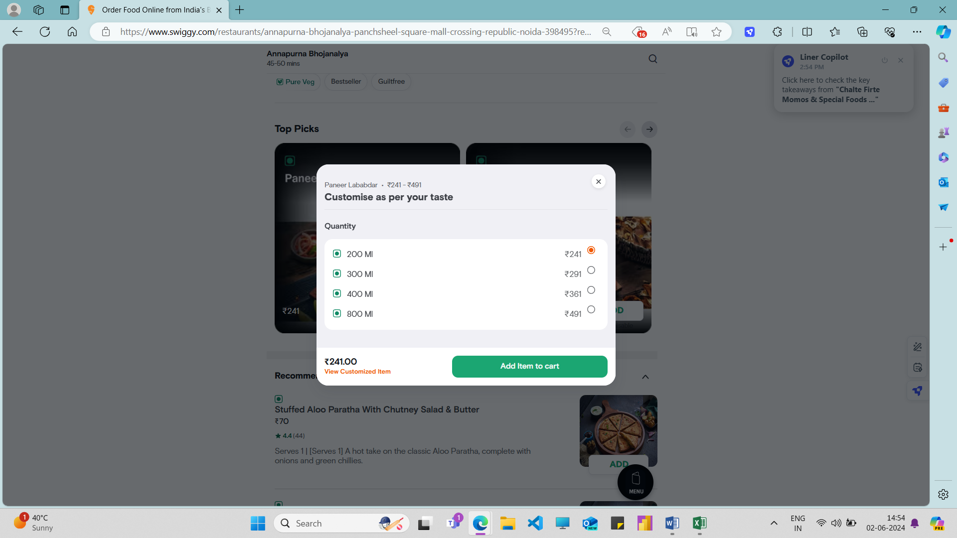

1. Payment Gateway (Cart 2 Payment) : On this page when the customer is satisfied by the product description and everything and made their mind to finally buy the product, they then proceed to pay.

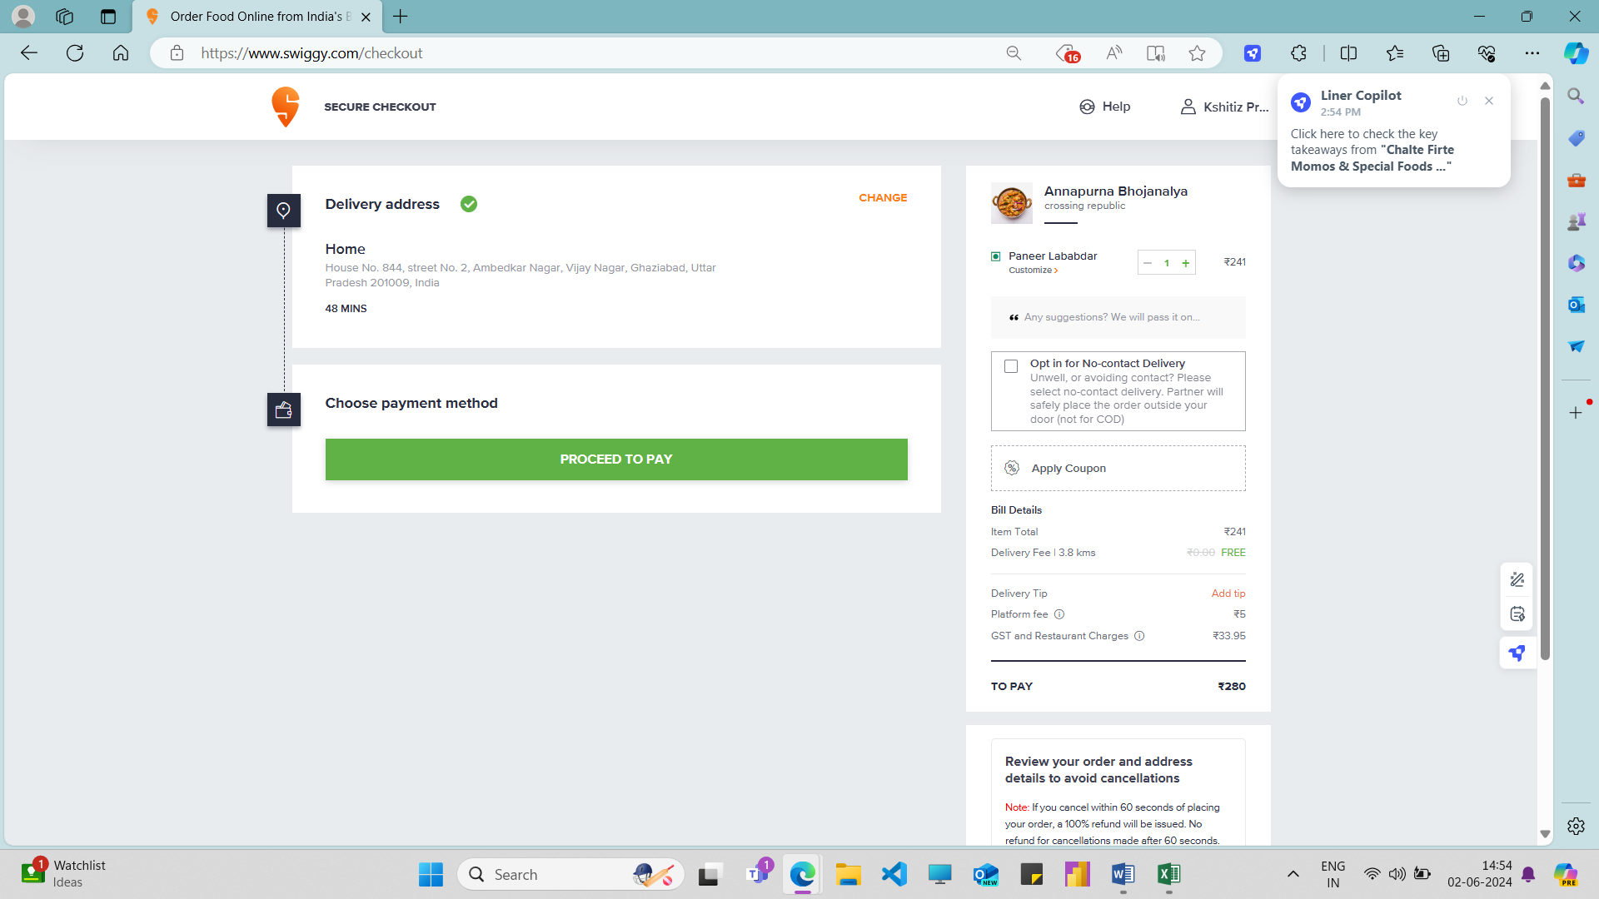

After selectin procced to pay customer reaches to the actual payment gateway where they witness different modes of payment available, and choose one out of many.  
As shown in the below image.

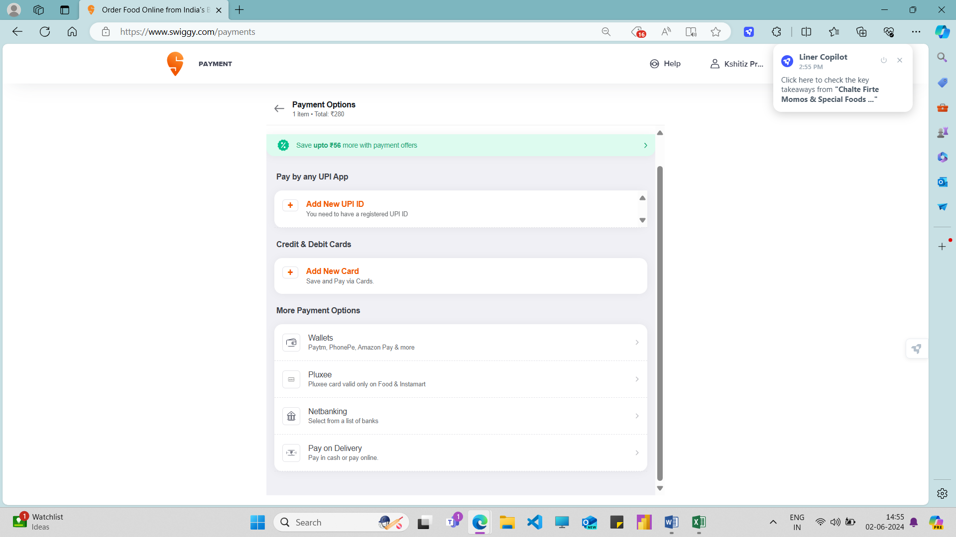

1. Order Placed (Payment to Order) : if the payment is successful then the order is placed and hence this Journey to order the item of the customer ends here. But if the payment fails for any reason the customer may either if willing try again or may leave the platform and hence the order is not considered as placed.

Now as we’ve seen the entire journey of the customer that visit the swiggy platform now we can deduce our deductions as per the insights we had from the data so provided.

The approach or the methodology we have used here is, we compare current scenario with respect to the scenario was at the same day last week.

But first we shall make a few points clear as follows:

* Order change value would decrease if today’s orders are less than on the same day of last week and vice versa.
* Traffic change value would decrease if today’s Traffic is less than on the same day of last week and vice versa.
* Conversion change value would decrease if today’s orders are less than on the same day of last week and vice versa.
* When analyzing funnels, it's essential to keep certain assumptions in mind to ensure that your analysis is accurate and meaningful. These assumptions help set the context for the data and guide the interpretation of the results. Here are some key assumptions to consider:
* The data provided is Complete and accurate.
* Tracking mechanisms have been consistently implemented across all funnel steps.
* The users' behaviour during the analysis period is representative of typical behaviour.
* External factors influencing user behaviour (e.g., market trends, seasonality) are consistent throughout the analysis period.
* Drop-offs at each step are due to user behaviour and not technical issues (e.g., page load errors, broken links).

|  |  |  |  |
| --- | --- | --- | --- |
| **Date** | **Order Change** | **Traffic Change** | **Conversion change** |
| 10-01-2019 | -45.23% | -48.96% | 7.31% |
| 17-01-2019 | 105.95% | 110.20% | -2.02% |
| 21-01-2019 | 23.35% | 5.15% | 17.31% |
| 22-01-2019 | 85.43% | 76.53% | 5.04% |
| 29-01-2019 | -71.71% | -40.46% | -52.48% |
| 31-01-2019 | 20.06% | 1.05% | 18.81% |
| 05-02-2019 | 114.77% | 0.00% | 114.77% |
| 19-02-2019 | -55.84% | -3.81% | -54.09% |
| 26-02-2019 | 120.04% | 1.98% | 115.77% |
| 28-02-2019 | 22.32% | 8.33% | 12.92% |
| 02-03-2019 | -37.59% | 8.33% | -42.39% |
| 09-03-2019 | 102.02% | 0.00% | 102.02% |
| 19-03-2019 | -45.55% | 2.02% | -46.63% |
| 24-03-2019 | 22.26% | 6.32% | 15.00% |
| 26-03-2019 | 77.96% | -4.95% | 87.23% |
| 04-04-2019 | -52.09% | 3.03% | -53.50% |
| 11-04-2019 | 92.39% | -6.86% | 106.57% |
| 12-04-2019 | -27.31% | -8.65% | -20.43% |
| 14-04-2019 | 28.38% | 8.33% | 18.50% |
| 18-04-2019 | 73.02% | 10.53% | 56.54% |
| 19-04-2019 | 24.72% | 7.37% | 16.17% |
| 25-04-2019 | -38.69% | 0.00% | -38.69% |
| 20-06-2019 | -54.37% | -53.00% | -2.92% |
| 27-06-2019 | 114.72% | 119.15% | -2.02% |
| 16-07-2019 | -63.08% | -9.52% | -59.20% |
| 23-07-2019 | 135.03% | 3.16% | 127.84% |
| 11-08-2019 | -54.35% | 0.00% | -54.35% |
| 18-08-2019 | 106.62% | 3.06% | 100.48% |
| 14-09-2019 | -53.59% | -4.81% | -51.25% |
| 21-09-2019 | 111.53% | -1.01% | 113.69% |
| 09-10-2019 | 21.87% | -4.04% | 27.00% |
| 21-10-2019 | 32.38% | 9.38% | 21.04% |
| 22-10-2019 | 19.87% | -0.99% | 21.07% |
| 09-11-2019 | 26.26% | 7.37% | 17.60% |
| 17-11-2019 | -57.00% | -6.67% | -53.93% |
| 24-11-2019 | 135.48% | 5.10% | 124.05% |
| 01-12-2019 | 20.75% | 0.97% | 19.59% |
| 22-12-2019 | 21.03% | 0.00% | 21.03% |
| 28-12-2019 | 17.70% | -1.94% | 20.03% |

|  |  |  |  |  |  |  |
| --- | --- | --- | --- | --- | --- | --- |
| **Date** | **Traffic Change** | **Reasoning** | **Order Change** | **Reasoning** | **Conversion Change** | **Reasoning** |
| 10-01-2019 | -48.96% | Reduction In traffic from FB (-95%), lowest customer base experienced, Youtube (-49%) and Twitter (49%), although other sources gathered traffic 14.57% more.  Further we can see, although count of restraunts increased by only 0.21% but unavailbility of items incresed by 6.67% and averagefor two has also been increased. | -45.23% | It can be seen as traffic has reduced so does orders, as they both are directly proportionate to each other. But somehow we can see that orders were completed more today than on the same day last week, this is because of the increase in discounts and reduced delivery charges. | 7.31% |  |
| 17-01-2019 | 110.20% | Massive increase can be seen majorly because of increase traffic from FB (1980%), yet YouTube (110.20%) and Twitter (110.2%) did better to gain better traffic. Although, a decrement can be seen in other channels. Further, we can see number of restraunts has also increased, somehow availibiloty of stocks decreased by 12.5% that can be because of such a huge traffic. | 105.95% | Traffic increases, so does the orders but not in same proportion, this is because many of the customers who could have converted didn’t proceeded further because discounts were reduced by 10.5%, but on the other hand packaging charges, delivery charges and average cost for two were all decreased. | -2.02% |  |
| 21-01-2019 | 5.15% |  | 23.35% | Traffic didn't increased as much as orders did, this is because Menu to cart and Cart to payment Increased by astonishing figures, that increased probability of increase in orders and hence resulted in same. | 17.31% |  |
| 22-01-2019 | 76.53% | Major impact has been fallen because of the massive traffic so occurred from Twitter (747%) maximmum number of customers from twitter were attracted on this date. Secondaly, the availability of stocks also increased by 3%. | 85.43% | Orders were increased as traffic increased, but orders increased more as 9.47% more customers visited from Listings to Menu. This is clearly because there were more stocks available on the Home page, More discount was available, packaging charges and delivery charges were also reduced. | 5.04% |  |
| 29-01-2019 | -40.46% | Traffic decreased because of decrement of a lot of restraunts 28.26%. On this day count of restraunts were lowest, i.e. 0.27 Mn only. | -71.71% | orders were decreased as first of all traffic itself decreased, further as we can see Listing to Menu hits the second lowest conversion i.e. 54.81% because discounts were reduced by 5.56% as well, and Packing Charges were hicked by 29.41%. | -52.48% | Conversion decreased as decrement of traffic was lesser than decrement of Orders. |
| 31-01-2019 | 1.05% |  | 20.06% | Orders were increased as L2M, M2Cand P2O all three of them incresed positiviely, Furthermore, Discount were increased, pakcing charges decreased, so did delivery charges and average cost for two as well. | 18.81% |  |
| 05-02-2019 | 0.00% |  | 114.77% | orders inreased as L2M change w.r.t same day last week had an explosive convesrion rate of 123.40%. Similarly as on same day previous week the count of restraunts were the lowest but as of today they are good hence the cahnge in restraunts has also impacted the increase. in addition to, discount has increased, packing charges has been decreased as well. | 114.77% | Conversions increased as traffic didn’t increased at all but orders were increased by 114.77%. |
| 19-02-2019 | -3.81% |  | -55.84% | Orders were decreased as Carts and Payments witnessed the lowest customer base, due to which M2C has also suffered a decrease of almost 57%. Furthermore, Packaging charges(11.76%) and Delivery charges(16.00%) were also increased | -54.09% | Conversion decreased because orders decreased, although traffic also decreased yet, orders fall with high intensity. |
| 26-02-2019 | 1.98% |  | 120.04% | Orders Increased as M2C change has increased phenomenly by 145.24%, payment mode are safer and more reliable now, both delivery charges and packing charges have been decreased. | 115.77% | Conversions increased as traffic increased only by 1.98% but orders were increased by 120.04%. |
| 28-02-2019 | 8.33% |  | 22.32% | increment at all level other than C2P is one of the main cause for the increase of orders, further restraunts have been increased, discounts increased, availability of stocks increased, delivery charges decreased. | 12.92% |  |
| 02-03-2019 | 8.33% |  | -37.59% | Massive decrease in C2P level caused the decrement of Orders on this date, as the items were out of stock, delivery charges were twice than previous week. | -42.39% | Conversion decreased because orders decreased, although traffic also decreased yet, orders fall with high intensity. |
| 09-03-2019 | 0.00% |  | 102.02% | Massive increase in C2P Level caused the increment of Orders on this day, this had been happened because of high availablity of items in stocks, delivery charges being halved. | 102.02% | Conversions increased as traffic didn’t increased at all but orders were increased by 102.02%. |
| 19-03-2019 | 2.02% |  | -45.55% | Decrease has been happened because of the last moment of the final order that is P2O level, as payment payment successful rate fallen by 28.57% which is consdered as a huge loss, as it is very sensitive case. | -46.63% | Conversion decreased because orders decreased, although traffic also decreased yet, orders fall with high intensity. |
| 24-03-2019 | 6.32% |  | 22.26% | At all levels we can see the postive increase hence lead to the overall increase in the orders, this majorly happened as packing charges were reduced, and so were the delivery cahrges, and for the average cost for two items as well. | 15.00% |  |
| 26-03-2019 | -4.95% |  | 77.96% | Exceptional Increase in P2O Level caused the increase of Orders today, this happened because rate of successful payments increased w.r.t. to same day of the previous week. Further we can see decrease in packing charges, and average cost for two items as well. | 87.23% | Conversions increased as traffic increased only by a few percents but orders were increased by 77.96%. |
| 04-04-2019 | 3.03% |  | -52.09% | decrease in M2C level caused the decrement of orders, this has been done as, discount offered are decreased. | -53.50% | Conversion decreased because orders decreased, although traffic also decreased yet, orders fall with high intensity. |
| 11-04-2019 | -6.86% |  | 92.39% | increase In M2C level by 94% caused the increment of orders as, discounts has been offered at 80% more than same day of the previous week. Furthermore, pakcaging charges and delivery charges are also been decreased. | 106.57% | Conversions increased although traffic decreased by a few percents but orders were increased by 92.39%. |
| 12-04-2019 | -8.65% |  | -27.31% | decrease at all level caused the orders to be decreased as well, everything seem to be constant but discount seems to be decreased. | -20.43% | Conversion decreased because orders decreased, although traffic also decreased yet, orders fall with high intensity. |
| 14-04-2019 | 8.33% |  | 28.38% | Increase at all level casued the orders to be increased as well. | 18.50% |  |
| 18-04-2019 | 10.53% |  | 73.02% | increase In M2C level by 73.20% caused the increment of orders as, discounts has been offered at 61.11% more than same day of the previous week. Furthermore, pakcaging charges has also been decreased. | 56.54% | Conversions increased as traffic increased only by a few percents but orders were increased by 73.02% |
| 19-04-2019 | 7.37% |  | 24.72% | Increase at all level casued the orders to be increased as well. | 16.17% |  |
| 25-04-2019 | 0.00% |  | -38.69% | Highly decreased at M2C level casued the orders to be declined, this might be happened because of less discount offered than before. | -38.69% | Conversion decreased because orders decreased, although traffic also decreased yet, orders fall with high intensity. |
| 20-06-2019 | -53.00% | On this date traffic fell the most, as clear be seen all the channels were at their lowest w.r.t. same day previous week, either it be Fb, YouTube, Twitter or even other channles. Twitter attracted least amount of customers on today. | -54.37% | The main cause of decrement of orders is decrement of traffic it self, as the listings were low hence the orders were. | -2.92% |  |
| 27-06-2019 | 119.15% | All of the channels increased the traffic by 119.15% indicidually. Moreover, the restraunts also increased by almost 5% w.r.t previous day of the same week. | 114.72% | The main cause of Increment of orders is increment of traffic it self, as the listings were high hence the orders were. | -2.02% |  |
| 16-07-2019 | -9.52% |  | -63.08% | Clearly the problem lies at the very first step that is L2M level, this is because the average cost of two items has been increased by 18.04%. Furthermore,delivery charges has been increased as well. | -59.20% | Conversion decreased because orders decreased, although traffic also decreased yet, orders fall with high intensity. |
| 23-07-2019 | 3.16% |  | 135.03% | Clearly the L2M level is responsible for such a hike in the orders, this has happened as restraunts increased, discounts offered more, items were more in stock, packing charges and delivery charges were low as well. | 127.84% | Conversions increased as traffic increased only by a few percents but orders were increased by 135.03%. |
| 11-08-2019 | 0.00% |  | -54.35% | The problem lies in the 3rd level i.e. C2P level, as packing charges and cost for two items have been increased so much that the users are backing off from the product. | -54.35% | Conversion decreased because orders decreased, although traffic also decreased yet, orders fall with high intensity. |
| 18-08-2019 | 3.06% |  | 106.62% | At level C2P the increase of 97.92% casued the increase in orders, as packing cahrges have been decreased by 32.1% fading off all other increased in delviery charges and decerase in discount rates. | 100.48% | Conversions increased as traffic increased only by a few percents but orders were increased by 106.62%. |
| 14-09-2019 | -4.81% |  | -53.59% | On this day the major reason for the order decrease is, unavailibility of stocks as 64 items were not in inventory, thus M2C is fall down by 56% almost. Moreover, Packing Charges were also increased and so were delivery charges. | -51.25% | Conversion decreased because orders decreased, although traffic also decreased yet, orders fall with high intensity. |
| 21-09-2019 | -1.01% |  | 111.53% | At M2C level customers used to stuck more and procedded further and hence caused orders to increase, as customers could see that items were in stock and hence motivated them to purchase the product. | 113.69% | Conversions increased although traffic decreased by a few percents but orders were increased by 111.51%. |
| 09-10-2019 | -4.04% |  | 21.87% | Increase at all level casued the orders to be increased as well. | 27.00% | Conversions increased although traffic decreased by a few percents but orders were increased by 21.87%. |
| 21-10-2019 | 9.38% |  | 32.38% | Increase at all level casued the orders to be increased as well. | 21.04% | Conversions increased as traffic increased only by a few percents but orders were increased by 32.38%. |
| 22-10-2019 | -0.99% |  | 19.87% |  | 21.07% | Conversions increased although traffic decreased by a few percents but orders were increased by 19.87%. |
| 09-11-2019 | 7.37% |  | 26.26% | Increase at all level casued the orders to be increased as well. | 17.60% |  |
| 17-11-2019 | -6.67% |  | -57.00% | On this day the major reason for the order decrease is, unavailibility of stocks as 112 items were not in inventory the most anytime, thus M2C is fall down by 58% almost. Restraunts were decreased by 4%. Packing charges were increased, although delivery charges were reduced yet it couldn't helped a lot. Moreover, Packing Charges were also increased and so were delivery charges. | -53.93% | Conversion decreased because orders decreased, although traffic also decreased yet, orders fall with high intensity. |
| 24-11-2019 | 5.10% |  | 135.48% | Increase at M2C level by 150% is responsible for such increment in orders, but M2C increased as availability of stocks were increased by almost 70%. | 124.05% | Conversions increased as traffic increased only by a few percents but orders were increased by 135.48%. |
| 01-12-2019 | 0.97% |  | 20.75% | Increase at all level casued the orders to be increased as well. | 19.59% |  |
| 22-12-2019 | 0.00% |  | 21.03% | Increase at all level casued the orders to be increased as well, other than at c2P level which was recovered at M2c Level. | 21.03% | Conversions increased as trafficdidn't increased single percents but orders were increased by 21.03%. |
| 28-12-2019 | -1.94% |  | 17.70% |  | 20.03% | Conversions increased although traffic decreased by a few percents but orders were increased by 17.70%. |

**Findings**

Insights from the data;

* Highest monthly sales observed in January, 2019, where count of running restraunts were also the highest.
* Lowest monthly sales observed in February, 2019 and the count of operating restraunts were also the lowest.
* Primary Source of Traffic is Facebook(36%), followed by Youtube(27%), Twitter and others.

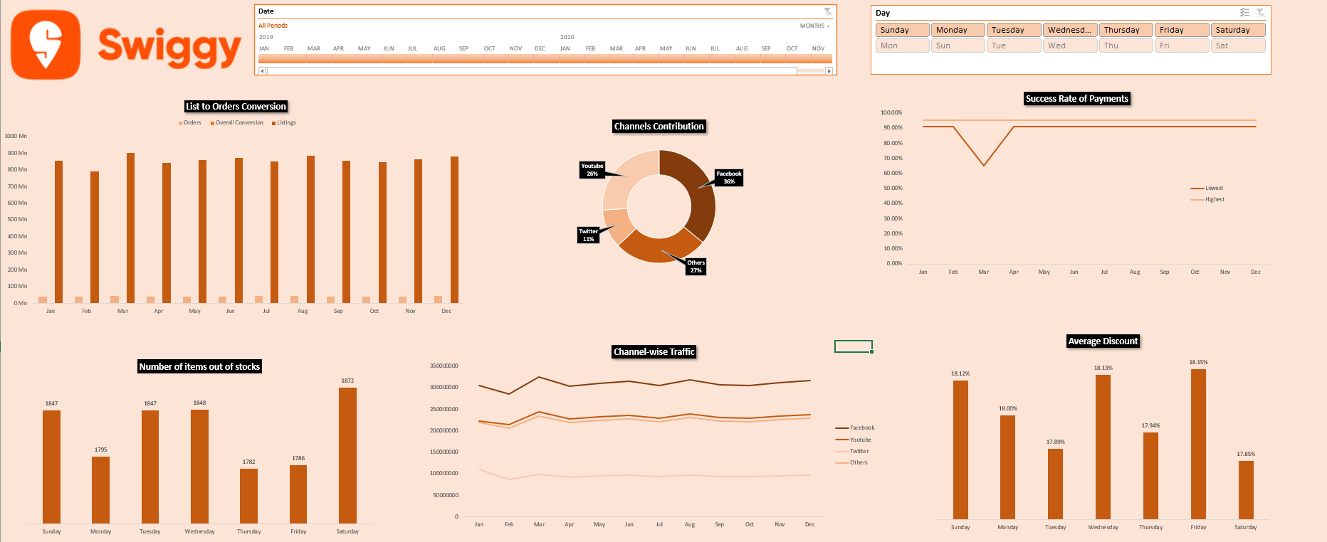

Thank You…