# VariantChecker a’la Jukka Inkeri

Version: 2022-10-05

The actual instructions can be found at <https://github.com/kshji/viestihajonta>

This tutorial describes how to generate the source data from the Sport Software OS12 (relay) result program.

OS12 can be used to do everything you need in one file.

In OS12, **Courses :: Reports :: Course distribution :: Export :: Standard**

* Character separated columns (CSV)
* Delimiter Semicolon (;)
* String delimiter “ or empty
* File: **os.team.comp1.csv** (name must contain the string: **os.team**), that will be used by the VariantChecker to identify the source data type of the file format.
* OK

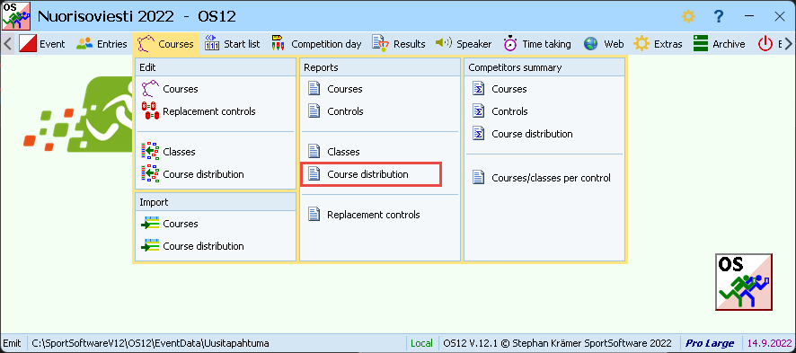

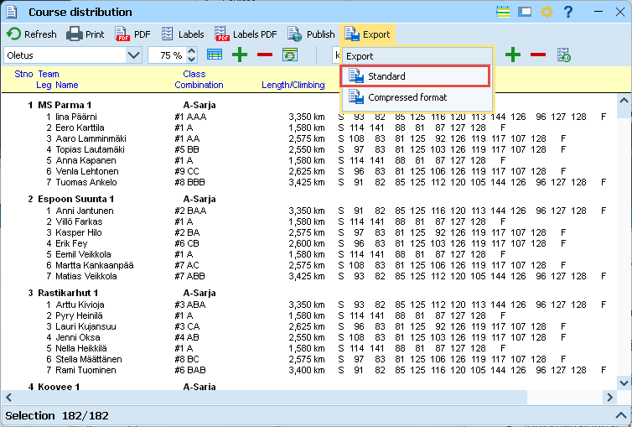

File: os.team.SOMESTRING.csv

The resulting csv file is given to the VariantChecker (https://awot.fi/variantcheck/ ).