

**DEPARTMENT OF COMPUTER SCIENCE & ENGINEERING,**

**SCHOOL OF ENGINEERING AND TECHNOLOGY, SHARDA UNIVERSITY, GREATER NOIDA**

**FAKE PRODUCT DETECTION USING BLOCKCHAIN**

***A project submitted***

***in partial fulfillment of the requirements for the degree of Bachelor of Technology in Computer Science and Engineering***

**by**

**OM VAIBHAV (2019007923)**

**MUKUL. (2019664038)**

**ABHISHEK SHARMA (2019551388)**

**Supervised by:**

**DR. VIVEK SHARMA, ASSOCIATE PROF (CSE)**

May 2023

# CERTIFICATE

This is to certify that the report entitled **“Fake Product Detection using Blockchain”** submitted by **“**OM VAIBHAV (2019007923), MUKUL. (2019664038) and ABHISHEK SHARMA (2019551388)**”** to Sharda University, towards the fulfillment of requirements of the degree of **“Bachelor of Technology”** is record of bonafide final year Project work carried out by them in the **“**Department of Computer Science & Engineering, School of Engineering and Technology, Sharda University**”**.

The results/findings contained in this Project have not been submitted in part or full to any other University/Institute for award of any other Degree/Diploma.

### Signature of the Guide

**Name:** Dr. Vivek Sharma

**Designation:** Associate Professor (CSE)

**Signature of Head of Department Name:** Prof. (Dr.) Nitin Rakesh

**Place:** Sharda University

### Date:

### Signature of External Examiner Date:

# ACKNOWLEDGEMENT

A major project is a golden opportunity for learning and self-development. We consider our self very lucky and honored to have so many wonderful people lead us through in completion of this project.

First and foremost, we would like to thank Dr. Nitin Rakesh, HOD, CSE who gave us an opportunity to undertake this project.

Our grateful thanks to Dr. Vivek Sharma for his guidance in our project work. Dr. Vivek Sharma, who in spite of being extraordinarily busy with academics, took time out to hear, guide and keep us on the correct path. We do not know where we would have been without her help.

CSE department monitored our progress and arranged all facilities to make life easier. We choose this moment to acknowledge their contribution gratefully.

Name and signature of Students

OM VAIBHAV (2019007923)

MUKUL. (2019664038)

ABHISHEK SHARMA (2019551388)

# ABSTRACT

In recent years, the use of counterfeit goods in the manufacturing of goods has increased. The company's brand, sales, and profitability are impacted by this. The blockchain technology is utilized to distinguish between real goods and fakes.

Blockchain technology keeps transactional data in the form of blocks in a network of databases connected by chains. It is a distributed, decentralized, and digital ledger. No block can be changed or compromised since blockchain technology is a secure technology. When a product is verified to be safe utilizing Blockchain technology, customers or users do not need to rely on outside users. Quick response (QR) codes offer a potent tool to combat the practice of counterfeiting goods in this project, given the expanding trends in mobile and wireless technology. A QR code scanner that connects the product's QR code to a Blockchain can be used to detect counterfeit goods. As a result, this technique may be used to store database blocks for both the product's produced unique code and its specifications. It uses the user's special code to check against Blockchain database records. The client will be informed if the code matches, and if it doesn't, the consumer will be informed that the goods is fake.

**CONTENTS**

TITLE i

CERTIFICATE ii

ACKNOWLEDGEMENT iii

ABSTRACT iv

LIST OF FIGURES vi

LIST OF TABLES vii

CHAPTER 1: INTRODUCTION 8

* 1. Problem Statement 8
  2. Project Overview 9
  3. Expected Outcome 10
  4. Hardware & Software Specifications 11
  5. Other Non-Functional Requirements 11
  6. Report Outline 13

CHAPTER 2: LITERATURE SURVEY 14

* 1. Existing Applications 14
  2. Proposed System 19
  3. Feasibility Study 20

CHAPTER 3: SYSTEM DESIGN & ANALYSIS 22

* 1. Project Perspective 22
  2. Performance Requirements 24
  3. System Features 25
  4. Methodology 26
  5. Testing Process 32

CHAPTER 4: RESULTS AND OUTPUTS 38

* 1. Result of literature survey 38
  2. Proposed mode outputs 39

CHAPTER 5: CONCLUSION 44

* 1. System Usability 44
  2. Future Scope 45

CHAPTER 6: REFERENCES 47

ANNEXURE I 48

# LIST OF FIGURES

|  |  |  |
| --- | --- | --- |
| Fig 1.2.1 | Basic overview of fake product | 10 |
| Fig 2.2.1 | Proposed Architecture of fake product detection | 19 |
| Fig 3.1.1 | Data Flow Diagram | 23 |
| Fig 3.4.1 | ER diagram | 28 |
| Fig 3.4.2 | Architecture overview of system | 32 |
| Fig 4.2.1 | Manufacturer & User login page | 40 |
| Fig 4.2.2 | Product details for transferring | 41 |
| Fig 4.2.3 | Product transferring | 41 |
| Fig 4.2.4 | Product transferred | 42 |
| Fig 4.2.5 | Confirmation page | 42 |
|  |  |  |
|  |  |  |
|  |  |  |

# LIST OF TABLES

|  |  |  |
| --- | --- | --- |
| Table 2.1.1 | Literature Survey | 15 |
| Table 3.5.1 | Description of test cases | 36 |
| Table 4.1.1 | Comparison between existing methodologies and proposed methodologies | 38 |

# CHAPTER 1 INTRODUCTION

## Problem Statement

The increase of counterfeit products has become a pressing issue in today's global market. Counterfeit goods not only cause significant financial losses to legitimate manufacturers but also pose a severe threat to consumers' safety and health. With the increasing availability of low-cost technology, counterfeiters have become more sophisticated in producing fake products that can be difficult to differentiate from genuine ones. Blockchain network has emerged as a better solution to tackle the problem of fake products by providing a secure and transparent system for tracking and verifying products. This project aims to explore the use of blockchain network in detecting fake products. The main objective of our study is to develop and design a system for detecting fake products using blockchain technology. The system will be able to detect fake products by comparing the product's unique identification code with the records stored on the blockchain. To achieve this goal, the study will investigate the current methods for detecting fake products in the market and explore how blockchain technology can be leveraged to detect fake products. The study will rely on the advantages and limitations of using blockchain in detecting counterfeit products.

This study will conduct a comprehensive literature review of existing methods for detecting fake products and blockchain technology's application. The study will also design a blockchain-based system for detecting fake products and conduct a feasibility study to assess the system's effectiveness. The proposed system will consist of two main components: product identification and blockchain ledger. Each product will be assigned a unique identification code that will be recorded on the blockchain. This code will be used to track the product's movement and verify its authenticity. The blockchain ledger will store the records of all transactions related to the product. The system will also include a user interface that will allow consumers to easily verify the authenticity of a product by scanning its barcode. In conclusion, the proposed study will investigate the use of blockchain in detecting fake or counterfeits products. This research will contribute to the development of a system that can give us a secure as well as a transparent platform for tracking and verifying the authenticity of products. The proposed system has a potential to significantly reduce or lesser down the prevalence of counterfeit products in the market and protect consumers' safety and health.

## Project Overview

The proliferation of counterfeit products has become a significant problem in today's global market, posing a threat to both consumers' safety and legitimate manufacturers' financial well-being. The growing availability of low-cost technology has made it easier for scammers to produce fake products that are difficult to distinguish from the real ones. Blockchain network has been proposed as a promising easy solution to combat fake products by providing a secure and transparent system for tracking and verifying products. The objective of our project is to develop a blockchain based system for detecting fake products. The system will be able to detect counterfeit products by comparing the product's unique identification code with the records stored on the blockchain. The project will begin with a comprehensive literature review of existing methods for detecting fake products and blockchain technology's application. The review will identify the limitations of current methods and explore the advantages and limitations of using blockchain technology in detecting counterfeit products. Next, the project will design a blockchain-based system for detecting fake products. The system will consist of two main components: product identification and blockchain ledger. Each product will be assigned a unique identification code that will be recorded on the blockchain. The blockchain ledger will store the records of all transactions related to the product. The system will also include a user interface that will allow consumers to easily verify the authenticity of a product by scanning its barcode. Once the system is designed, a feasibility study will be conducted to assess the system's effectiveness. The study will involve testing the system with a variety of fake products to determine its accuracy in detecting counterfeit products. The project's outcome will be a blockchain-based system that can effectively detect counterfeit products, providing a secure and transparent platform for tracking and verifying product authenticity. The proposed system has the potential to significantly reduce the prevalence of counterfeit products in the market, protecting consumers' safety and health while promoting fair competition in the global market.

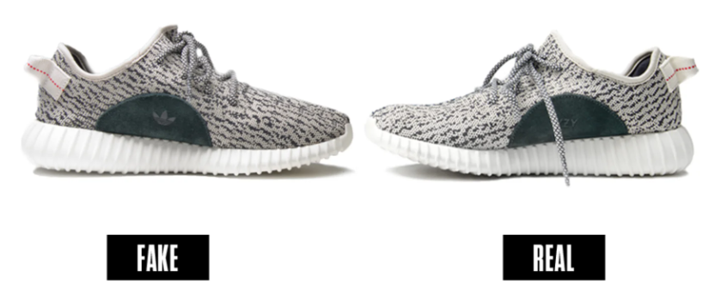

Fig.1.2.1 A Basic Overview of Fake Product

## 

## 1.3 Expected Outcome

A false product identification system utilizing blockchain is anticipated to significantly lower the prevalence of counterfeit products in the market by giving a visible and immutable record of the product's path from maker to end-user. One could predict the precise outcomes listed below:

Improve consumer confidence: Consumers' confidence in the veracity of the goods they purchase will rise knowing that the product's journey has been recorded on a tamper-proof blockchain ledger. Sales for genuine producers may increase as a result, while sales for copycats may decline.

Reduced brand reputation risk: Manufacturers would be able to protect the reputation of their brand and reduce the likelihood of having counterfeit goods associated with it by giving a verifiable and transparent record of their product's journey.

Enhanced supply chain transparency: The blockchain-based technology will increase supply chain transparency by tracing the product's movement from the manufacturer to the end consumer. Stakeholders would then be able to identify and address supply-chain inefficiencies and halt the introduction of counterfeit goods to the market.

Increased regulatory compliance: The technology may also help manufacturers comply with regulatory obligations by providing an auditable and visible record of their products' journey, reducing the chance of fines and penalties.

Additionally, the system can significantly reduce the costs associated with detecting and removing counterfeit products from the market, which can have a substantial impact on the profitability of businesses. The reduction in counterfeit products can also lead to a decrease in the number of consumer complaints and legal disputes, which can be both costly and time-consuming for businesses.

Overall, the expected outcome of a fake product detection system using blockchain is a more secure, efficient, and trustworthy supply chain that benefits both businesses and consumers. The system can help build consumer trust and confidence in products and create a more transparent and accountable supply chain that ultimately benefits all stakeholders involved.

## 1.4 Hardware & Software Specifications

For the implementation of the project, following things would be used.

### Hardware Requirements

* Laptop/Desktop that supports Windows / MacOS or any other, with minimum 4GB
* 2.5GB Graphic card
* 256GB SSB
* i7 gen
* Stable internet connectivity

### Software/Framework/Tools

* Ethereum for smart coins
* Solidity for smart contracts
* Language – JavaScript, React Native, HTML, CSS
* Database – React Native database
* Metamask wallets

## Other Non-Functional Requirements

For the purpose of detecting counterfeit goods using blockchain, the performance, security, and usability requirements that the system must satisfy to ensure that it operates smoothly and efficiently are regarded as non-functional requirements. The system's success and its ability to fulfil user requests depend on these requirements. The following is a list of the specific non-functional requirements for blockchain-based fake product detection:

* Performance: This illustrates how efficiently and quickly the system can handle transactions. Even when managing a large number of transactions, the system shouldn't experience any significant performance issues. The system must also have a high level of availability so that users can access it whenever they need to.
* Security: The success of the system depends on its security. The system must be made impermeable and safe from attacks by hackers and other bad actors. The usage of encryption and other security measures will be implemented to sure that the data stored in the blockchain network is secure and cannot be modified without the proper authorization.
* Usability: The system should be designed with an intuitive user interface that is easy to use and explore. The system ought to be accessible to a wide range of users, including those who might not be familiar with blockchain technology. The system should tell users in a straightforward manner about the authenticity of the commodities they are purchasing.
* Scalability: The system needs to be scalable in order to handle an increase in the volume of transactions. This suggests that even as the system handles an increasing number of users and transactions, there shouldn't be any significant performance issues.
* Interoperability: Easy platform and system integration must be built into the system. This will ensure that the system can communicate with existing supply chain management systems, payment gateways, and other systems used in the industry.
* Reliability: The system must function reliably and be always available. The system must therefore be extremely dependable and able to quickly recover from any downtime or system issues.

### Generally speaking, the non-functional requirements for fake product detection using blockchain must be met for the system to be successful. By ensuring sure it conforms with these requirements, the system can provide a secure, expandable, and user-friendly solution for verifying the authenticity of commodities in a variety of organizations.

## Report Outline

Chapter 2 focuses on the previous work done to highlight the existing applications in the domain of counterfeiting which make use of Blockchain.

Chapter 3 focuses on the proposed model, how it proceeds, what are the requirements, who are the users and what all will be the methodology to build our solution.

Chapter 4 provides the results of our system.

Chapter 5 finally concludes the whole paper and talks about the future scope of the proposed system.

# CHAPTER 2 LITERATURE SURVEY

## Existing Applications

A number of researchers have suggested several plans for creating a blockchain based system for detecting bogus products :-

A number of researchers have suggested several plans for creating a blockchain based system for detecting bogus products. One of them demonstrated a blockchain-based supply chain for identifying counterfeit goods, where participants must first verify their OTPs on their mobile devices before receiving any goods [1]. In another publication, researchers developed a pharma-cosurveillance blockchain technology system and tested their functionality in the simulated network system in order to use blockchain technology to identify counterfeit and subpar medications in distribution [2]. A comprehensive analysis of the literature on current trends and potential uses. Examining the current state, anticipated applications, and potential advancements of blockchain network in the chain is the goal of the survey [3].

Blockchain is also applied in logistics monitoring and also in supply chain monitoring, in one of the papers, where the model specifies how the item produced by the company will be connected to the blockchain using sensors like RFID [4].

A blockchain based supply chain based system: Analysis, Challenge, and Future work was provided in another study [5]. The goal of this strategy is to improve bogus goods identification utilizing AI-based technology that uses image and word recognition [6]. One paper suggested Blockchain role in meeting management objective of supply chain [7]. Another paper examines the relationship between technology and counterfeiting.

A cross-border e-commerce supply chain management was given a blockchain architecture with a multi chain structuring model for information or product traceability [9] advanced Detecting Fake Drugs using Blockchain. The authors of this article noted that consumers who use fake medications run the risk of dying as well as experiencing serious health problems. They consequently developed a blockchain capability to stop medicine fraud and to make it easier for drugs to flow around the blockchain network. Fabio Della Valle and Miquel Oliver came up with Information Management using Blockchain for Supply Chain Data Platforms. The authors of this paper examined the interplay between supply chain and logistical procedures and public blockchain.

A team of researchers created an effective anti-product forgery system that leverages digital signatures for verification [10].

Despite the encouraging outcomes, there are still certain restrictions and difficulties in using blockchain for false product detection. Scalability, for instance, poses a significant challenge for blockchain-based systems because an increase in transactions may result in a decline in performance. Privacy is a problem as well because blockchain's transparency may make private information about a product and its supply chain public. A problem with blockchain-based systems is their potential for using various protocols, which makes information sharing between them challenging.

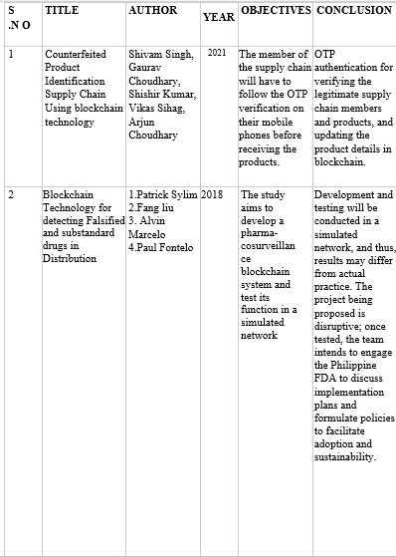

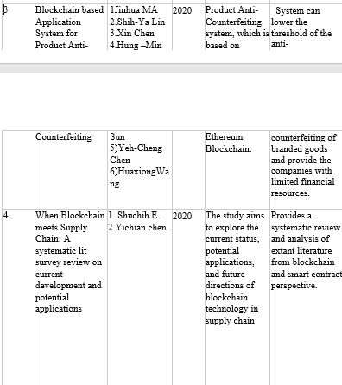

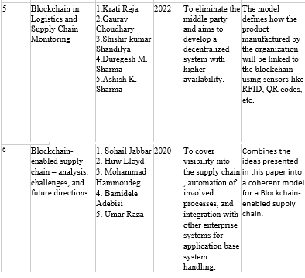

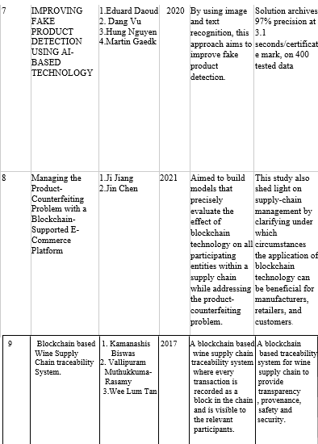

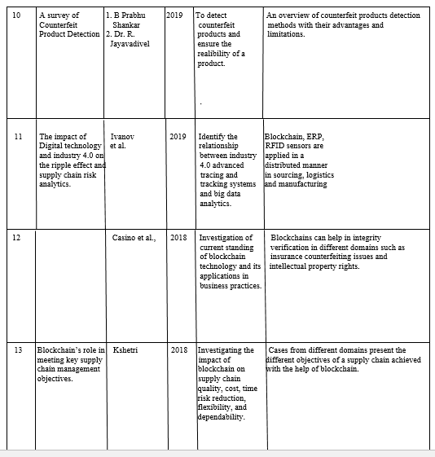

Table 2.1.1 Literature Survey

**Limitations -** Technical Difficulties: Despite the potential advantages of blockchain, there are still several technical difficulties that need to be resolved before it can be widely adopted. For instance, still there is less industry standardization and interoperability between various blockchain technology platforms.

Implementation costs can be high and involve major investments in infrastructure, staff, and technology when using blockchain solutions for false product detection.

Lack of Adoption: Due to a lack of business usage, blockchain adoption for bogus product identification is still limited.

## Proposed System

In our system, the manufacturer and the user both will be able to do some sort of transactions in the smart contract. Each company's smart contract will be unique, allowing them to add or edit product details, see things that are offered, and transfer ownership to customers. All of the company's transactions will instantly update the smart contract, and after they have been verified, the transaction record will be transferred to the blockchain.

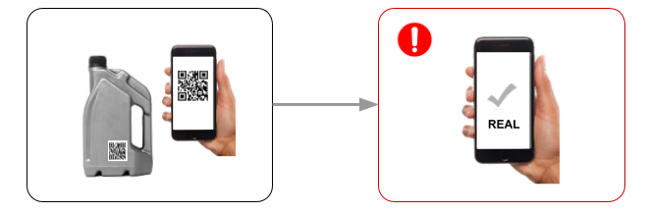

Fig.2.2.1 Proposed Architecture for Fake Product Detection [11]

Blockchain network can be used to develop a system for spotting fraudulent goods by providing a safe, secure and unbreakable record of the product's destination from the manufacturer to the end customer. In the suggested system, each product would be given a unique identity via a serial number or QR code, which would subsequently be documented on the blockchain at each stage of the product's lifecycle.

This would include the manufacturing process, shipping, storage, and distribution. Every time the goods changed hands, the new owner would record it on the blockchain, including any important information like the place, date, and time of the transfer.

Customers can then scan the product's barcode with a mobile app to verify that it hasn't been tampered with or replaced with a fake and to check the product's whole history. The blockchain-based system may potentially merge data from many sources, such as product testing facilities or customs and border control groups, to add an additional degree of verification.

This approach would make it far more difficult for counterfeiters to produce and distribute fake goods by using blockchain technology to give an unchangeable and transparent record of the product's journey. Customers would have better confidence in the validity of the products they purchase as a result, and manufacturers could protect the income and reputation of their brand.

## Feasibility Study

The potential of using blockchain for fake products identification is great due to the unique characteristics of blockchain that make it suitable for management of supply chain. With the use of the blockchain technology, it will be possible to create an immutable ledger that records every transaction involving a product. This allows for extremely precise tracking of items from their place of manufacture to the final consumer. Blockchain technology can enhance supply chain traceability while reducing fraud risk and halting the proliferation of fake goods. Blockchain technology also enables the development of smart contracts, which can automatically complete activities in accordance with established rules, such as stopping the sale of fake goods or initiating a recall. Even though the implementation of a blockchain-based fake product detection solution necessitates careful consideration of both functional and non-functional requirements, the potential benefits, such as increased transparency, improved authentication, enhanced brand reputation, and lower costs, make it a useful and valuable tool for both businesses and consumers.

In order to test whether it would be possible to connect the blockchain-based solution with the current supply chain management system, the research would need to assess the system's technical requirements, including the hardware and software infrastructure. This would entail evaluating the blockchain infrastructure's ability to handle massive amounts of data in real-time as well as its scalability, security, and interoperability. The research would also need to analyze if the necessary resources are available for the system's deployment and maintenance, as well as the hardware and software needs. The technical feasibility evaluation would also need to consider the technical expertise required for designing, deploying, and maintaining the system.

The study would need to assess the system's potential costs and benefits in terms of its viability from an economic standpoint. This would entail estimating potential financial savings brought on by fewer counterfeit items as well as potential revenue increases brought on by a surge in consumer confidence in genuine goods. The cost of establishing and maintaining the blockchain-based system, including costs for personnel, equipment, and software, would also need to be assessed. In addition, the system's return on investment and long-term viability would need to be evaluated as part of the economic feasibility study.

To ascertain the project's legal viability, it is vital to examine the regulatory and legal requirements associated with creating a blockchain-based system for fraudulent product detection. This would involve a study of the current laws and regulations governing product authentication, data privacy, and cybersecurity in addition to an analysis of any potential legal issues related to the system. The implementation of the system's potential liabilities and compliance duties would also need to be evaluated in the research.

A feasibility study would require a multidisciplinary approach made up of experts in technology, economics, and the law in reference to assess the feasibility and viability of our planned project. The project's technological, economic, legal, and risk assessment feasibility would all need to be considered in order to determine whether it is a viable solution to the problem of widespread counterfeit goods.

**CHAPTER 3**

**SYSTEM DESIGN & ANALYSIS**

## Project Perspective

## The identification of fraudulent products using blockchain technology is one potential strategy for preventing counterfeit goods and supply-chain fraud. Using blockchain technology, products can be tracked securely and immutably from the point of origin to the end user, ensuring their integrity and validity. By using distinct IDs and capturing all necessary details about the product, such as its manufacture date and location, the system may be able to produce an exhaustive and trustworthy supply chain record. Product traceability may be made possible with the use of this record, enabling the detection of any potential fraud or tampering. Additionally, smart contracts can be used to enforce preset limitations, such as halting the sale of fake goods or initiating a recall. It's a useful tool for both clients and customers because of the possible benefits, which include greater authentication, increased brand reputation, increased transparency, and lower expenses. A blockchain-based solution for false product detection may need a substantial investment in time and money, but it may also offer additional benefits.

One of the primary challenges to implementing a blockchain-based fraudulent product identification system is the need for data standardization and interoperability. Cooperation across different supply chain participants, including manufacturers, distributors, retailers, and consumers, would be required to ensure that data is acquired, preserved, and shared in a uniform and compatible manner.

From a project perspective, the necessity of effective communication and stakeholder interaction is a vital element to consider. To do this, it would be necessary to develop a communication plan stating how stakeholders will be informed about the project and how they may offer input or voice concerns. Along with ensuring that stakeholders are involved and that their needs and expectations are met throughout the project, the project team must also ensure that stakeholders are included.

The project also needs to be managed to ensure sustainability and long-term viability. The system would need to be updated and maintained throughout time, as well as how it will be supported and sustained, according to a maintenance and support plan that would need to be developed for this. The project team would also need to consider the system's capacity for scalability and growth to make sure that it can be altered for meeting the changing needs of the industry, market and the chain of supply.

## 

## Fig. 3.1.1 Data Flow Diagram

## The project perspective of fake product detection using blockchain involves several critical aspects that need to be considered. Firstly, the system architecture needs to be designed, including selecting the appropriate blockchain platform, creating smart contracts, and data structures. Once the architecture is designed, the relevant product data needs to be collected and integrated into the blockchain. This data can include information such as the product's origin, manufacturing process, and distribution channels. A user-friendly interface is also essential for the success of the project. The interface should allow users to access and interact with the product information stored on the blockchain easily. Security is also a crucial consideration, and the system needs to be designed with robust security measures to prevent unauthorized access, tampering, and data breaches. The fake product detection system using blockchain has the potential to revolutionize supply chain management by providing an immutable and transparent ledger for tracking products' entire lifecycle. With this technology, manufacturers and consumers can trust that products are authentic and of high quality. Overall, the success of the project relies on a well-designed system architecture, user-friendly interface, and strong security measures.

## Performance Requirements

Performance criteria for blockchain fake product identification are concerned with how quickly and efficiently transactions can be handled by the system. Even when managing a large number of transactions, the system shouldn't experience any significant performance issues. The following are some specific performance requirements for fake goods identification using blockchain technology:

Transaction Speed: The system must be able to execute transactions quickly to allow customers to verify the validity of the goods before making a purchase. The system should be able to complete a transaction in a matter of seconds to guarantee that users don't experience any delays.

Throughput: The system should be able to handle numerous transactions without experiencing any major performance issues. The system must be built to withstand peak loads in order to guarantee that it can process numerous transactions at once.

Scalability: The system must be scalable in order to support a growing number of transactions. This suggests that even as the system handles an increasing number of users and transactions, there shouldn't be any significant performance issues.

Latency: The system must have low latency so that users may quickly verify the legitimacy of a product. As a result, there should be as little time as possible between when a user initiates a transaction and when it is processed.

Accessibility: To ensure that users can utilize the system when needed, it should be very accessible. The system should be designed to have as minimal downtime as possible so that users can access it at all times.

Response Time: The system must be able to react fast to user inquiries so that users may easily verify the legitimacy of the product. Users must be provided with a rapid and responsive experience by the system.

Overall, the system's effectiveness hinges on achieving the performance standards for utilizing blockchain to identify fake goods. By achieving these goals, the system will be able to provide customers with a rapid, dependable, and efficient way to check the authenticity of products, empowering them to make informed decisions.

## System Feature

A system function called "blockchain-based fake product detection" makes use of the technology's ability to create a tamper-proof, decentralized record of a product's legitimacy. This system feature is notably useful in industries with a high prevalence of counterfeit goods, such as fashion, luxury goods, and pharmaceuticals.

The main idea behind fake product detection using blockchain is to provide each product that is stored on a blockchain a unique digital identity. This digital identification contains the manufacturer, production date, and unique identifier of this product. When a product is sold, its digital identity is transferred to the buyer, creating a permanent record of the transaction.

Image recognition: A fake product detection system may use image recognition technology to identify fake products. The system would analyze images of the product and compare them to a database of authentic product images to identify any discrepancies.

Authentication: The system should enable verification of product authenticity by comparing the product data on the blockchain with the physical product. This can be done using a smartphone app or other scanning device.

Smart contracts: The system should allow for the creation of smart contracts that can automatically trigger actions based on predefined rules. For example, if a fake product is detected, the smart contract can automatically initiate a recall or block the sale of the product.

Data analytics: The system should enable the analysis of product data to identify trends, such as the geographic distribution of counterfeit products, and to improve supply chain efficiency.

Text recognition: The system may also analyze text on the product, such as the label or packaging, to identify any spelling or grammatical errors, which could indicate that the product is fake.

Reporting: The system should allow for reporting of product data to relevant stakeholders, such as manufacturers, distributors, retailers, and regulators. This can help to improve transparency and accountability in the supply chain.

## 3.4 Methodology

This project on fake product detection via blockchain technology will involve the following methodologies:

Literature Review: A literature review will be conducted to gain a thorough understanding of the existing research and methodologies for fake product detection using blockchain technology. The literature review will involve collecting and analyzing published research articles, white papers, and other relevant sources. The review will focus on identifying the strengths and limitations of the existing methodologies and gaps in the research.

Blockchain Design: The blockchain design methodology will involve designing a blockchain network that can be used for fake product detection. The blockchain design will include the selection of the appropriate blockchain platform, consensus mechanism, and smart contract design. The blockchain network will be designed to ensure the security and transparency of the product authentication process.

Product Registration: Product registration methodology involves registering each product on the blockchain network. The product registration process will involve assigning a unique identifier to each product and recording the product's details, such as manufacturing date, batch number, and location, on the blockchain ledger. The product registration process will be designed to ensure that only authentic products can be registered on the blockchain network.

Transaction Recording: Transaction recording methodology involves recording each transaction involving the product on the blockchain ledger. The transaction recording process will be designed to ensure that each transaction is authentic and cannot be tampered with.

Hashing and Digital Signatures: The hashing and digital signatures methodology involves using a combination of hashing and digital signatures to ensure the authenticity of each product and transaction. A unique cryptographic hash will be assigned to each product, and each transaction will be digitally signed. The combination of hashing and digital signatures will provide a robust and secure authentication mechanism that is resistant to tampering.

Smart Contracts: Smart contracts methodology involves using self-executing contracts to automate the product authentication process using blockchain technology. Smart contracts can be used to enforce product registration, transaction recording, and product authentication rules automatically. The smart contract can automate the product authentication process by verifying the authenticity of each transaction involving the product. If the transaction is authentic, the smart contract can execute the next step in the transaction process.

In conclusion, the proposed methodologies for the research paper on fake product detection using blockchain technology will involve a combination of literature review, data collection, blockchain design, product registration, transaction recording, hashing and digital signatures and smart contracts. The combination of these methodologies will provide a robust and secure product authentication system that is resistant to tampering and can help protect consumers.

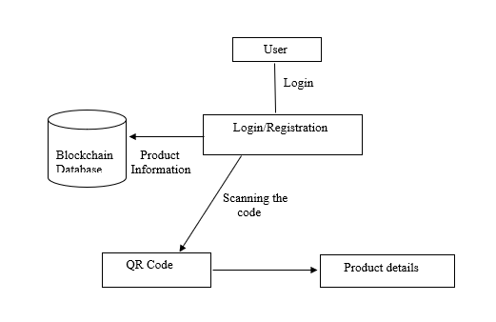

Fig.3.4.1 ER Diagram

**The Algorithm –**

1. Login Process: Users benefit from a high level of security and confidence during the login process of a blockchain-based fraudulent product detection system. Users often start by visiting the login page and entering their login details, which may include a username, email address, and password. Yet, the process of authentication does not finish there. Users may also be required to authenticate with their blockchain credentials, such as a private key or another kind of secure authentication, in order to prove their identity on the blockchain. This additional layer of verification, only authorized individuals are able to access the system and perform tasks like adding new products to the blockchain or verifying the legality of products. After successfully authenticating, users are granted access to the appropriate features and functions based on their role and permissions. The system keeps track of any suspicious activity or unauthorized user tries to access the platform during the login process, adding an extra layer of protection against fraud and unauthorized access.
2. Product Details: Product details are safely stored on the blockchain to protect authenticity and prevent counterfeiting. Each product is assigned a distinct QR code, which is saved on the blockchain together with details about the manufacturer, the date of manufacturing, and the batch number. These details are open to the public and unalterable, providing consumers and regulators with a way to track a product from its place of manufacture to its point of sale.

|  |
| --- |
| **Algorithm 1** SendingProductDeatilsToServer |
| SET json_data = JSON.stringify(product_data)    // Send the JSON string to the server  SEND_DATA_TO_SERVER(json_data)    // Check for a response from the server  IF SERVER_RESPONSE_OK THEN  PRINT "Product details sent successfully" ELSE  PRINT "Error sending product details  END IF |

1. Updating details of buyer during checkout process: Updates to client data are a secure, open process that help ensure the accuracy of supply chain data and the legitimacy of products. When a transaction is made, the buyer's information, such as name and address, may be kept on the blockchain along with the information about the product.

|  |
| --- |
| **Algorithm 2** UpdatingDetails |
| IF updated_name NOT EMPTY THEN  SET current_buyer.name = updated_name  END IF  IF updated_address NOT EMPTY THEN  SET current_buyer.address = updated_address  END IF  IF updated_phone NOT EMPTY THEN  SET current_buyer.phone = updated_phone  END IF |

1. Transferring details to a barcode: The transfer of data on a barcode is a quick and secure method that helps ensure the legality of products. Each product has a unique identification that contains information related to that item, such as a barcode or QR code. Every time a product is transferred from one party to another, such as when it goes from the producer to a distributor or from a distributor to a retailer, the information on the barcode can be updated and saved on the blockchain. This ensures that everyone participating in the supply chain has access to the most up-to-date details about the product, including its country of origin, the day it was made, and other crucial information.

|  |
| --- |
| **Algorithm 3** TransferringDetails |
| SET json_data = JSON.stringify(product_data)  SET barcode_data =  GENERATE_BARCODE(json_data)    // Print the barcode for the user  PRINT "Barcode:"  PRINT barcode_data |

1. Transferring a product from one owner to another: It is possible for a product to be safely and transparently transferred from one owner to another, which supports the validity of the product. Each product's unique identity, which might be a barcode or QR code, together with the manufacturer, production date, and batch number are all stored on the blockchain. When a product is transferred from one owner to another, the ownership is changed, and the transfer is recorded on the blockchain. This ensures that everyone participating in the supply chain has access to the most up-to-date product information and can use it to inform their decisions.

|  |
| --- |
| **Algorithm 4** TransferringProduct |
| SET current_product.owner = new_owner    // Save the updated product details and owner information  SAVE_PRODUCT_DETAILS(current_product)  SAVE_ OWNER_DETAILS(new_owner)  // Confirm the transfer to the user  PRINT "Product ownership transferred from",  current_owner.name, "to", new_owner.name |

### PHASES OF PROPOSED ALGORITHM:

**Phase 1**

A user interface can display the product database on the Blockchain.

Creating a web interface for the user interface's QR code scanner.

**Phase 2**

In this research paper, a blockchain database is used to store the meta information regarding the products.

Scans the data contained in QR Codes that points to the merchandise.

Additionally, the immutable entry is added to the table each time it is examined.

**Phase 3**

Permit the addition of new items and products. Make a different QR code for every occasion.

Product information is shown on the web interface after each code scan.

Display the product information.

**Phase 4**

Creates the genesis block upon startup, after which the server starts a new block's creation and sends the necessary data.

Scan data is used to create a new block.

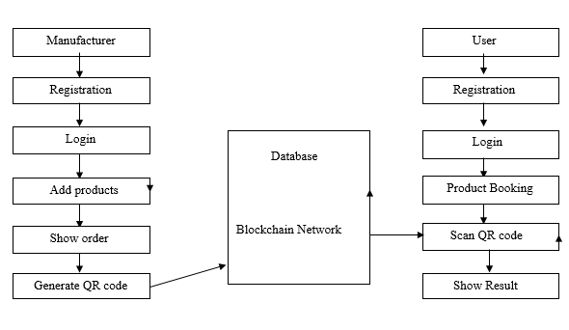

Fig.3.4.2 Architecture overview of system

## 3.5 Testing Process

### Software Testing

The duty of software testing is to validate the precision and effectiveness of programmers. Software testing is a type of scientific observational research used to inform customers about a product's quality in the environment in which it is intended to be used. This can entail looking for issues using a programme or application, but it's not only limited to that.

* + 1. **Unit Testing**

Each module is assessed separately in this instance. To recognize modules with essential functionality, the standards for defining unit test modules were chosen. An individual or a method can both be modules.

Smart Contracts - The functionality and logic of the smart contracts can be tested using unit tests. This may involve evaluating the input specifications and anticipated results for various circumstances.

Data Storage - The blockchain's data storage feature can be tested with unit tests to make sure that data is correctly stored and retrievable.

User Interfaces - Unit tests can be written to test the user interface components of the system, ensuring that users can interact with the system effectively and efficiently.

APIs - The APIs that allow for communication between various system components can be tested using unit tests.

Data Processing - To make sure that data is correctly vetted and processed before being stored on the blockchain, unit tests can be built to test the data processing capabilities of the system.

Security - To make sure the system is protected from potential attacks, unit tests can be built to test the security components of the system, such as access controls and encryption.

### Integration Testing

Integration testing is one type of testing that is essential for a blockchain-based solution for incorrect product identification. The system's integration of many components, such as the blockchain network, databases, user interfaces, APIs, and other applications, must be assessed. This testing's objective is to confirm that each component of the system complies with all necessary requirements, both functional and non-functional. Integration testing is crucial before deployment in order to identify potential issues, solve them, and make sure the system is reliable and completely functional.

### 3.5.4 Validation Testing

To ensure that a blockchain-based solution for fraudulent product identification meets the aims and objectives for which it was built, a process known as validation is performed. This kind of testing comprises assessing the system against preset acceptance criteria to ensure that it satisfies the necessary functionality, performance, and security standards. In the context of fake product identification using blockchain, validation testing may involve proving the system's ability to monitor and authenticate products, locate counterfeit products, and create accurate results. This testing can be done using a variety of testing methodologies, including user acceptance, functional, performance, and security testing. The project team can ensure that the system meets the needs of its stakeholders and is fully functional.

### 3.5.5 GUI Testing

A blockchain-based system's fraudulent product detection must be tested, and this includes the GUI. This type of testing comprises looking at the system's user interface to ensure that it is user-friendly, intuitive, and appropriate for their needs. Testing the functionality of user interface components like dashboards, reports, and login screens can be done as part of the blockchain fraud detection process. It could also involve assessing the system's navigability, accessibility, and usability for distinct user categories. By conducting GUI testing to ensure that the system is user-friendly and meets users' expectations, the project team may boost the system's adoption and effectiveness.

### Test Cases

### Fake product detection is a method that enables the detection and tracing of fake items with the use of blockchain network. Below is a detailed explanation of a test case for a system that uses blockchain to detect fake goods:

### Test Case Name: Product Registration

### Objective: To determine whether the system can create a unique product ID for each product and register it on the blockchain.

### Steps:

### On the user interface of the system, a user chooses the "Register Product" option.

### The user enters the product's specifications, including its name, its maker, and other pertinent data.

### The product is registered on the blockchain and given a special product ID by the system.

### A notification confirming that the product has been successfully registered is sent to the user.

### Test Case Name: Product Verification

### Objective: to determine whether the system is able to successfully use a product's unique product ID to verify the product's legitimacy.

### Steps:

### The "Verify Product" option is chosen by the user on the system's user interface.

### The user inputs the system with the special ID for the product.

### The system pulls the product data from the blockchain and checks to see if it corresponds to the product ID that the user submitted.

### Using the data obtained from the blockchain, the system verifies if the product is real or a fake.

### A notification informing the user of the product's legitimacy is sent to them.

### Test Case Name: Product Recall

### Objective: Evaluated whether a system can effectively recall a product in the event of a safety or quality issue.

### Steps:

### On the user interface of the system, the maker chooses the "Recall Product" option.

### The producer enters the specific ID for the product and the justification for the recall.

### The system pulls the product information from the blockchain and notifies everyone in the product's supply chain of the recall.

### The system notifies the blockchain that a product has been recalled by updating its status.

### The system monitors the manufacturer's receipt of the recalled goods and updates the blockchain accordingly.

### Test Case Name: Product Recall

* **Objective:** to test the system's ability to manage user roles and permissions-based access control to private data on a blockchain.

### Steps:

### A user enters their credentials to access the system.

### Based on the user's access permissions, the system checks their credentials and assigns them a role.

### Based on the user's given function, the system limits their access to sensitive data on the blockchain.

### The system records each user's actions on the blockchain in order to facilitate audits.

### Descriptions:

| **Test Case** | **Test Description** | **Input** | **Expected Output** | **Pass/Fail** |
| --- | --- | --- | --- | --- |
| Smart Contract Functionality | Record product on the blockchain | Product ID, Manufacturer ID, and Distributor ID | The product is recorded on the blockchain with a unique ID and can be tracked by all parties involved in the supply chain. | Pass |
| Data Storage | Store product information securely on the blockchain | Product information, such as name, description, and origin | The product information is stored securely on the blockchain and can be retrieved by authorized parties. | Pass |
| User Interface | Access user dashboard | User login information | The user is able to access their account dashboard and view information related to their products and transactions. | Pass |
| API Communication | Integrate product information from third-party application | Product information from a third-party application | The product information is successfully integrated with the blockchain and can be tracked and authenticated. | Pass |
| Data Processing | Detect counterfeit product | Product information suspected to be counterfeit | The system detects the counterfeit product and triggers an alert for further investigation. | Pass |
| Security | Deny unauthorized access | Unauthorized access attempt | The system denies access to unauthorized users and logs the attempt for further review. | Pass |

TABLE 3.5.1. DESCRIPTION OF TEST CASES

# CHAPTER 4 RESULTS AND OUTPUTS

## Result of literature survey

A review of the literature on blockchain-based fake product identification reveals three important conclusions:

|  |  |  |
| --- | --- | --- |
| **Characteristics** | **Existing Systems** | **Proposed System** |
| Application | Centralized | Decentralized |
| Security | Less Security | High Security |
| Database Access | Public | Private |

TABLE 4.1.1 COMPARISON BETWEEN EXISTING METHODOLOGIES AND PROPOSED METHODOLOGY

1. Blockchain technology has the power to prevent the sale of fake goods by creating a secure and immutable record that tracks the whole chain from manufacturer to client.
2. The importance of blockchain technology to combat bogus goods is still in its infancy, therefore more research is needed before more dependable solutions can be offered.
3. Blockchain-based approaches for detecting fake goods have been proposed by a number of researchers, including the use of smart contracts, QR codes, and digital signatures.
4. According to certain studies, employing blockchain technology can reduce the time and resources required to verify a product's legality while increasing the effectiveness of counterfeit product identification.
5. Customers will be able to verify the legitimacy and country of origin of a product thanks to improved supply chain traceability and transparency brought about by blockchain technology.
6. Implementing blockchain technology for the detection of counterfeit goods presents a number of challenges, including the need for standardization, the high implementation costs, and the complexity of integrating blockchain technology with existing systems.
7. The development of new business models and revenue streams, such as the provision of services for product identification, is possible with the use of the blockchain technology.

Overall, the result of the literature survey demonstrates the importance of the blockchain network in the fight against counterfeit goods, although further research is needed to develop more dependable and scalable solutions.

## Proposed Model Outputs

The UI was designed using React. In order to connect with the Ethereum blockchain, the JavaScript library is needed to handle tasks like sending Ethereum on blockchain network, verify transactions, reading, and writing the data from smart contracts. Metamask, a wallet that communicates with the Ethereum blockchain, must be installed on the browser in order to access an Ethereum wallet using it. In order to add the manufacturer blocks, they must need to confirm the transactions using their blockchaib Metamask wallet account which is connected to Web3 JavaScript library. The end user can scan the QR code to confirm the reliability of the product's supply chain.

The Manufacturer and User logs into their account using his username and password, as shown in Figure.

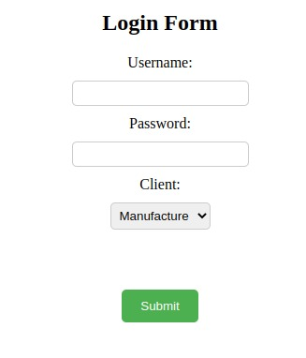

Fig4.2.1. Manufacturer login page

As seen in Figure, the blockchain network issues a special number for the products and will create its QR Code after the customer connects to his account. Before a product is delivered to another place, a QR code is added to it. The product's name and current address, which serves as both its source and its destination, are also filled out by the maker. After filling out all relevant fields, the maker hits the add block button to submit all the data to the blockchain.

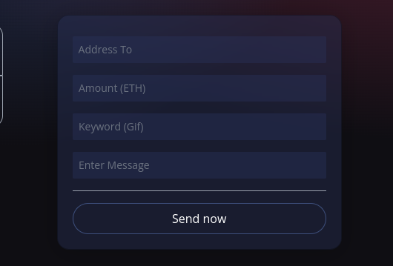

Fig.4.2.2 Product Details for transfering

After entering details, a metamask confirmation popup page is displayed which asks for the confirmation and will transfer the ownership as shown in Figure.

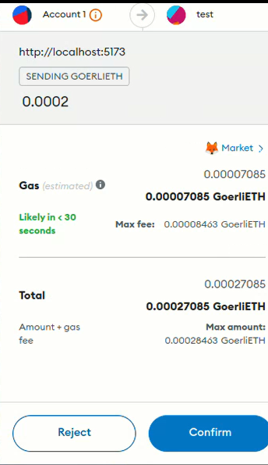

Fig.4.2.3 Product Transferring

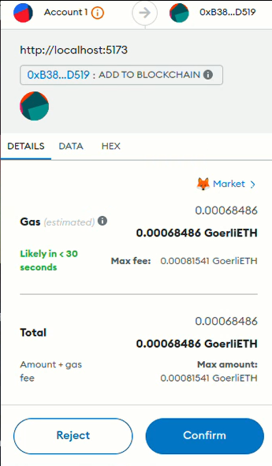

Fig.4.2.4 Ownership Transferred

After the confirmation, the block which contains all details will be added to blockchain and a success page is displayed as shown in figure.

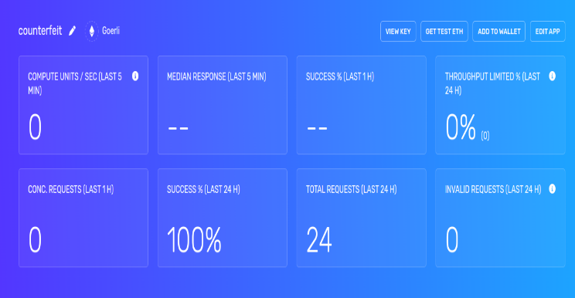

Fig.4.2.5 Confirmation page

The consumer will be aware that the product is genuine or not. After learning about counterfeiting, the purchaser comes to the conclusion that the QR code was stolen.

# CHAPTER 5 CONCLUSION

As a result, utilizing blockchain to identify fake products is a practical method for lowering the prevalence of fake goods and improving supply chain transparency. By utilizing the immutable and decentralized features of blockchain technology, the authenticity of products can be verified and tracked throughout the supply chain, ensuring that consumers receive genuine products and that manufacturers and distributors are held accountable for the caliber of their offerings.

However, putting into practice a blockchain-based solution for fraudulent product identification necessitates significant thought and planning, which includes choosing the right blockchain platform and protocols, creating smart contracts, and integrating the system with current supply chain procedures. In-depth testing and validation are also necessary to make sure the system is operating as intended and achieving its goals.

Overall, by providing a secure, transparent, and impenetrable means to check the legitimacy of products, the use of blockchain for false product identification has the potential to dramatically alter supply chain management and consumer safety. As blockchain technology advances and becomes more well-known, we should expect to see even more innovative concepts and uses in this area.

## System Usability

The usability of the system determines if any technology-based solution, including blockchain-based fraudulent product identification, is effective. Usability is a term used to define a system's ease of use, ease of learning, and overall user satisfaction.

In the context of false product detection using blockchain, the system should be developed with a user-friendly interface that enables all entities involved in the chain to access and track products information. Customers and manufacturers are both covered in this. The system should also provide comprehensive information about the goods, such as their provenance, legitimacy, and grade.

User testing and feedback are essential throughout the development process to guarantee system usability. This comprises gathering user opinions regarding the design, functionalities, and overall user experience of the system. This feedback can be used to identify issue areas and improve the system's usefulness.

Additionally, the system should be created to interface quickly with existing supply chain technologies and practices. This requires interacting with third-party apps and APIs as well as offering sophisticated data analytics and reporting features.

The system usability of a fake product detection system would depend on several factors, including the accuracy of the system, its ease of use, and the effectiveness of its feedback to users. Here are some key points to consider:

Accuracy: The system must be able to accurately identify fake products to be considered usable. False positives (i.e., identifying a legitimate product as fake) or false negatives (i.e., failing to identify a fake product) can significantly reduce the system's effectiveness.

Ease of use: Users must be able to use the system with ease and without the need for extensive training. A complicated or confusing system may deter users from utilizing it, rendering it ineffective.

Feedback: The system must provide clear and concise feedback to users about the authenticity of a product. Users should be able to easily understand the system's output and make informed decisions based on it. Integration: The system should be easily integrated into existing workflows or systems. For example, it could be integrated into e-commerce platforms, marketplaces, or other platforms where fake products are a concern.

Overall, the system's usability will determine whether fake product identification via blockchain is successful. By offering a user-friendly and intuitive system, all parties engaged in the supply chain may more easily access and track product information, ensuring that genuine products are given to customers and that counterfeits are eliminated from the market.

## Future Scope

The potential for supply chain management and the battle against counterfeit goods to be revolutionized by blockchain-based fake product identification is huge. Here are a few potential future advances in this area:

Integration with IOT: - Supply chain management is seeing a rise in the use of IOT, and its integration with blockchain-based systems for spotting fake goods can further enhance traceability and transparency. IT sensors can track products in real-time and provide precise information about their location, temperature, and other important parameters.

AI powered fraud detection: - Artificial intelligence (AI) can be used to enhance fraud detection capabilities by sifting through enormous volumes of data to look for trends and anomalies. This can help identify potentially fake goods and stop them from entering the supply chain.

Global Adoption: - As blockchain technology is used more widely, we might expect to see more countries and industries adopt blockchain-based systems for detecting fake products. This could lead to greater system standardization and interoperability, making it easier to trace products across industries and nations.

Tokenization of products: - Blockchain-based systems can tokenize products, creating a distinctive digital asset that substitutes for the real thing. This can improve authenticity and offer further traceability proof.

**REFERENCES**

1. Shivam Singh, Gaurav Choudhary, Shishir Kumar, VikasSihag& Arjun Choudhary “Counterfeited Product Identification in a Blockchain Technology”,Issue 08,2021
2. PatrikSylim, Fang Liu, Alvin Marcelo, Paul Fontelo “Blockchain Technology for detecting Falsified and substandard drugs in Distribution”, Issue 09,2018.
3. Shuchih E. Chang &Yichan Chen “When Blockchain meets Supply Chain: A systematic lit survey review on current development and potential applications” ,Issue 03,2020.
4. KratiReja, Gaurav Choudhary, Shishir Kumar Shandilya, Durgesh M. Sharma,Ashish K Sharma “Blockchain in Logistics and Supply Chain Mointoring” Issue 01,2022
5. SohailJabbar, Huw Lloyd, Mohammad Hammoudeh, BamideleAbebisi, Umar Raza “Blockchain enabled supply chain: analysis, challenges and future directions” Issue 11,2020
6. EduardDaoud, Dang Vu, Hung Nguyen and Martin Gaedke“IMPROVING FAKE PRODUCT DETECTION USING AI-BASED TECHNOLOGY”,2020.
7. A blockchain-based framework of cross-border e-commerce supply chain.https://www.sciencedirect.com/science/article/abs/pii/S0268401219304657?via%3Dihub
8. Cai, Y.J.; Choi, T.M.; Zhang, J. Platform supported supply chain operations in the blockchain era: Supply contracting and moral hazards. Decis. Sci. 2020.
9. Choi, T.M. Blockchain-technology-supported platforms for diamond authentication and certification in luxury supply chains. Transp. Res. Part E Logist. Transp. Rev. 2019.
10. A fully functional anti-product forgery system was designed by a group of researchers that uses digital signature for verification.
11. T.Shreekumar, Puneet Mittal, Sukhwinder Sharma, Rajesh N Kamath, SreejaRajesh,B.NruthyaGanapathy www.publishoa.com/index.php/journal/article/download/953/823
12. Solidity, https://docs.soliditylang.org/en/develop/
13. http-server, https://www.npmjs.com/package/http-server
14. https://www.myetherwallet.com/
15. React-Native, https://reactnative.dev/
16. Kuwari Aalain Shakeel , Rathod Vinod Sakharam , Tambe Shubham Namdev, Ghodke Rohit Daulatrao, Prof. Priyanka Jagtap. Fake Product Identification System using Blockchain Technology https://ijarsct.co.in/Paper7536

# ANNEXURE I

Research Paper for the said project has been published in Gradiva Review Journal

**Paper Title:**

Fake Product Detection using Blockchain

**Abstract:**

In recent years, the use of counterfeit goods in the manufacturing of goods has increased. The company's brand, sales, and profitability are impacted by this. The blockchain technology is utilized to distinguish between real goods and fakes. Blockchain technology keeps transactional data in the form of blocks in a network of databases connected by chains. It is a distributed, decentralized, and digital ledger. No block can be changed or compromised since blockchain technology is a secure technology. When a product is verified to be safe utilizing Blockchain technology, customers or users do not need to rely on outside users. Quick response (QR) codes offer a potent tool to combat the practice of counterfeiting goods in this project, given the expanding trends in mobile and wireless technology. A QR code scanner that connects the product's QR code to a Blockchain can be used to detect counterfeit goods. As a result, this technique may be used to store database blocks for both the product's produced unique code and its specifications. It uses the user's special code to check against Blockchain database records. The client will be informed if the code matches, and if it doesn't, the consumer will be informed that the goods is fake.

**Authors**:

Om Vaibhav, Mukul, Abhishek Sharma, Vivek Sharma

