**MINI ONLINE STORE**

*A*

*Mini Project Report*

*Submitted in partial fulfilment of the*

*Requirements for the award of the Degree of*

**BACHELOR OF ENGINEERING**

IN

**INFORMATION TECHNOLOGY**

By

**SHRUTHI KATEPALLI**

**1602-19-737-105**

**KHIZRA NAUSHAD**

**1602-19-737-076**



**Department of Information Technology**

**Vasavi College of Engineering (Autonomous)**

**(Affiliated to Osmania University)**

**Ibrahimbagh, Hyderabad-31**

**2020**

**Vasavi College of Engineering (Autonomous)**

**(Affiliated to Osmania University)**

**Hyderabad-500 031**

**Department of Information Technology**



**DECLARATION BY THE CANDIDATE**

We, **KHIZRA NAUSHAD and SHRUTHI KATEPALLI,** bearing hall ticket numbers, **1602-19-737-076**,**1602-19-737-105** hereby declare that the project report entitled **“MINI ONLINE STORE”** Department of Information Technology, Vasavi College of Engineering, Hyderabad, is submitted in partial fulfilment of the requirement for the award of the degree of **Bachelor of Engineering** in **Information Technology**

This is a record of bonafide work carried out by us and the results embodied in this project report have not been submitted to any other university or institute for the award of any other degree or diploma.

**SHRUTHI KATEAPALLI**

**1602-19-737-105**

**KHIZRA NAUSHAD**

**1602-19-737-076**

(Faculty In-Charge) (Head,Dept of IT)

**ACKNOWLEDGEMENT**

The success and final outcome of this project required a lot of guidance and assistance from many people and we are extremely privileged to have got this all along the completion of my project. All that we have done is only due to such supervision and assistance and I would not forget to thank them.

We respect and thank Mrs. Prasanna Mam, for providing us an opportunity to do the project work and giving us all support and guidance which made us complete the project duly. We are extremely thankful to her for providing such a nice support and guidance, although she had a busy schedule managing the corporate affairs.

I am thankful to and fortunate enough to get constant encouragement, support and guidance from all Teaching staffs of IT which helped us in successfully completing our project work.

**ABSTRACT**

Our mini project is Mini online Store . Shopping –It is something that we all

love to do, undoubtedly we all have to buy things from time to time .Online store

thus can save our time from driving to the store and wandering around stores .

This store contains a few categories first one being Clothing which is again sub

categorized as men and women , next Groceries and Covid accessories.

As per the users wish ,i.e registered user can login and start shopping or new

customer can register

and ,they can shop by filtering according to price and add to cart .After the user

adds to cart he can preview them and make necessary changes such as modifying

quantity and deleting an item and then view final list then checkout and the order

confirmation will be given then rating of shopping experience will be taken which

will be saved in the system.

**TABLE OF CONTENTS:**

**1)INTRODUCTION 6-7**

PROJECT OVERVIEW 6-7

**2)TECHNOLOGY 8**

A)SOFTWARE 8

B)HARDWARE 8

**3)PROPOSED WORK 9-72**

A)DESIGN 9-12

I)USE CASE DIAGRAM 11

II)FLOW CHART 12

B)IMPLEMENTATION 13-55

I)DESCRIPTION 13-54

II)GITHUB FOLDER STRUCTURE 55

C)TESTING 56-72

**4)RESULTS 73-80**

**5)ADDITIONAL LEARNING 81**

**6)DISCUSSION AND FUTURE WORK 82**

**7)REFERENCES 83**

**INTRODUCTION**

This project is an online based shopping system. The project objective is to deliver the

appliances through online mode.

Online shopping is the process whereby consumers directly buy goods or services from a

seller in real-time, without an intermediary service, over the Internet. It is a form of

electronic commerce.

In this pandemic online shopping was very helpful as people couldn’t go outside they

received their essentials through online mode.

This project is an attempt to provide the advantages of online shopping to customers of

a real shop. It helps buy the products in the shop.

Thus the customer will get the service of online shopping and home delivery.

**PROJECT OVERVIEW**:

The central concept of the application is to allow the customer to shop virtually and

allow customers to buy the items and articles of their desire from the store.

The Server process the customers and the items are shipped to the address submitted

by them.

The system recommends a facility to accept the orders 24*7 and a home delivery

system which can make customers happy.

Online shopping is rising day by day in India. Because India is the country where

computer user's are increasing day by day so as the online shopping trends are also

increasing.

This project covers the online selling of covid essentials, fashion, groceries etc.

The project shows the product category and then product details. From the product

details, the product can be added to cart and can be bought.

**TECHNOLOGY**

**SOFTWARE:**

Software requirements mainly share out with defining the software

resource requirements that need to be installed on a computer to provide

optimal functioning of a particular application.

The software required to run this application is gcc compiler along with the

source code.

Any computer which is compatible with gcc will be able to run this project.

**HARDWARE:**

Hardware requirements refer to the common set requirements defined by any

operating system or software application and are usually the physical computer

resources

The application is tested on Intel Core i3,

The Minimum requirements are:

● CPU: Intel Core i3 (6th gen)

● RAM: 6GB

● GPU: Intel HD 52

**PROPOSED WORK**

1. **DESIGN**

**ACTOR WISE USE CASES (FEATURES)**

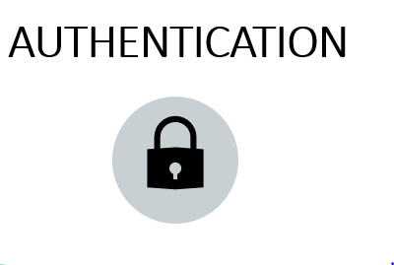











**

**II)FLOW CHART**

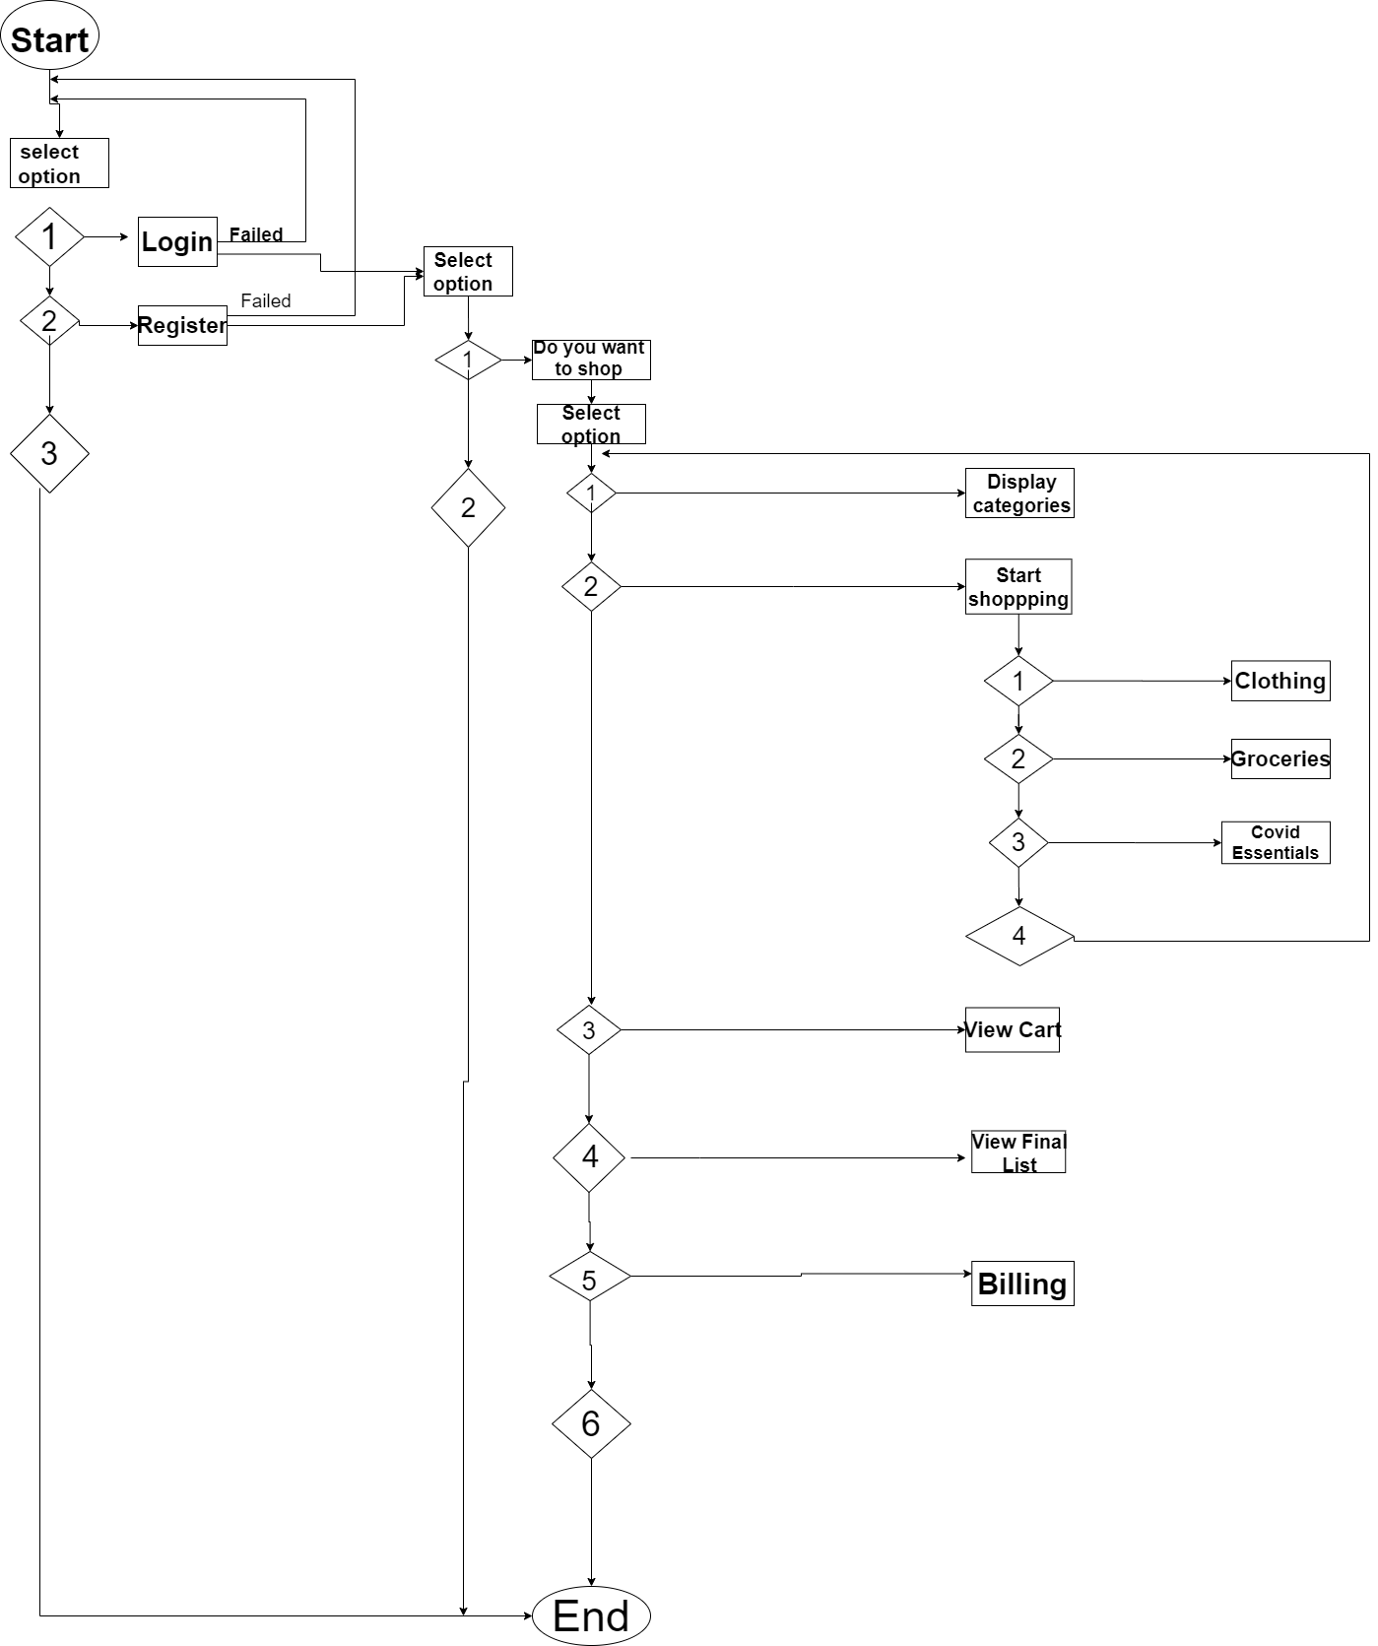

1. **IMPLEMENTATION**

**I)DESCRIPTION OF MAIN MODULES:**

**Login :**

login module prompts the user for login credentials And compares the entered

data with data stored in a file. If the entered credentials matches with the saved data

It prompts the user to Shop . Else it provides an option to Login ,Register or exit.

**Sign Up:**

The system prompts user id password and address to be entered and the

user id is checked in the check user module

**Check User:**

This module checks if a user enters an user id which already exists if

it already exists, it prompts user for new credentials.

**View Categories:**

This module allows the user to view categories .

**Shop:** This module allows user to view various categories and

subcategories by filtering according to price and add to cart

according to the user's choice.

**View Cart:**

This module allows user to View cart and allows modifications to be done i.e.

Delete an item from the cart ,modify existing quantity or make no changes but

simply view items added to cart.

**View Final List:**

This module allows the user to view the final List before checkout .Displays the list

the user added to cart after necessary modifications

**Billing:**

This Module shows the final bill after applying 10% discount for already existing

users and asks the user the confirmation to place the order ,If the user confirms it

displays the address where the order will be delivered from the saved information

while registering

**Rating:**

It prompts the user to enter rating before exiting

**CODE:**

#include <stdio.h>

#include <string.h>

#include <conio.h>

#include <stdlib.h>

#include <windows.h>

// structures

typedef struct{

char name[15];

char pass[10];

char address[30];

}user;

struct clothing{

char name[20];

char id;

float price;

}t;

struct Groceries

{

char name[20];

char id;

float price;

}t1;

struct CovidEssentials

{

char name[20];

char id;

float price;

}t2;

// declaration

void menu();

void shop();

void hidePass(char str[]);

int checkUser(char name[]);

void signUp();

void Login(char name[], char pass[]);

void displaylistofwomenclothing(struct clothing Wdetails[100]);

void sorteddisplaylistofwomenclothing(struct clothing Wdetails[100]);

void displaylistofmenclothing(struct clothing Mdetails[100]);

void sorteddisplaylistofmenclothing(struct clothing Mdetails[100]);

void displaylistofgroceries(struct Groceries Gdetails[100]);

void sorteddisplaylistofgroceries(struct Groceries Gdetails[100]);

void displaylistofCovidEssentials(struct CovidEssentials Coviddetails[100]);

void sorteddisplaylistofCovidEssentials(struct CovidEssentials Coviddetails[100]);

void addedtocart();

void Billing(int flag);

void deleteincart(int position);

int searchincart(int id);

void viewcart();

void viewfinallist();

// Global decalration

char name[15];

char pass[10];

int login=0;

char add[30];

int registeruser=0;

int static flag;

char static user_name;

int cart[50];

float total_cost[50];

int quantity[20];

int sindex;

int len;

int quanindex;

void SetColor(int ForgC)

{

WORD wColor;

///We will need this handle to get the current background attribute

HANDLE hStdOut = GetStdHandle(STD_OUTPUT_HANDLE);

CONSOLE_SCREEN_BUFFER_INFO csbi;

///We use csbi for the wAttributes word.

if(GetConsoleScreenBufferInfo(hStdOut, &csbi))

{

///Mask out all but the background attribute, and add in the forgournd color

wColor = (csbi.wAttributes & 0xF0) + (ForgC & 0x0F);

SetConsoleTextAttribute(hStdOut, wColor);

}

return;

}

COORD coord = {0,0}; ///set the cordinate to 0, 0 (top-left corner of window);

void gotoxy(int x, int y){

coord.X = x; coord.Y = y; /// X and Y coordinates

SetConsoleCursorPosition(GetStdHandle(STD_OUTPUT_HANDLE), coord);

}

void hidePass(char str[])

{

int i=0;

char c=' ';

while(i<=10)

{

str[i]=getch();

c=str[i];

if(c==13)break;

else{

printf("*");

// printf("%c",c);

i++;

}

}

printf("\n");

str[i]='\0';

}

int checkUser(char name[])

{

FILE *fp=fopen("myfile13.dat","a+");

user u[15];

int i;

fread(u,sizeof(user),20,fp);

for(i=0;i<=15;i++)

{

if(strcmp(u[i].name,name)==0)

{

fclose(fp);

return 0;

}

else

{

fclose(fp);

return 1;

}

}

}

void signUp()

{

system("cls");

int registerchoice;

char name[15];

char pass[10];

char cpass[10];

int match,l;

gotoxy(30,8);

printf("\n\n\t\t\t Enter User Name :\t");

scanf("%s", name);

if(!checkUser(name))

{

gotoxy(30,10);

printf("\n\n\n\t\t\t =============================================\n");

printf("\n\n\n\n\t\t\t User Name already exists!\n");

printf("\n\n\n\t\t\t To try again enter 1 else 2\n");

printf("\n\n\n\t\t\t =============================================\n");

int choice;

scanf("%d", &choice);

if(choice==1)

{

signUp();

}

else{

system("cls");

printf("\n\n\t\t\t =============================================\n");

printf("\n\n\n\n\t\t\t Exiting\n");

exit(1);

}

}

else

{

printf("\n\n\t\t\t Enter password :\t");

hidePass(pass);

printf("\n\n\t\t\t Confirm Password :\t");

hidePass(cpass);

if(strcmp(pass,cpass)==0){

FILE *fp=fopen("myfile13.dat", "a+");

if(fp==NULL)

{

printf("\n\t\t\t ERROR!\n");

exit(1);

}

fflush(stdin);

printf("\n\n\t\t\t Enter Address :\t");

scanf("%[^\n]%*c", add);

//puts(add);

user u;

strcpy(u.name,name);

strcpy(u.pass,pass);

strcpy(u.address,add);

fwrite(&u,sizeof(user),1,fp);

fclose(fp);

printf("\n\n\t\t\t =============================================\n");

registeruser=1;

system("cls");

printf("\n\n\n\t\t\t\t Account created Successfully!\n");

flag=1;

printf("\n\n\n\t\t\t Enter your choice \n\t\t\t 1.Do you want to shop\n\t\t\t 2.NO\n");

scanf("%d",&registerchoice);

switch(registerchoice){

case 1:shop();

break;

case 2:system("cls");

printf("\n\n\n\n\n\t\t\t\t\t EXITING!\n");

printf("\n\t\t\t\t THANK YOU! PLEASE VISIT AGAIN\n");

printf("********************************************************************************************\n");

exit(0);

}

}

else{

system("cls");

gotoxy(30,8);

printf("\n\n\n\t\t\t =============================================\n");

printf("\n\n\n\n\t\t\t Passwords doesn't match!\n");

printf("\n\n\t\t\t To try again enter 1!\n\t\t\t Enter 2 to exit:\n");

int choice;

scanf("%d",&choice);

if(choice==1)

{

signUp();

}

else{

exit(1);

}

}

}

}

void Login(char name[], char pass[])

{

system("cls");

FILE* fp=fopen("myfile13.dat","r");

int i,l;

user u[15];

fread(u,sizeof(user),15,fp);

for(i=0;i<15;i++)

{

if(strcmp(name,u[i].name)==0 && strcmp(pass,u[i].pass)==0){

flag=0;

login=1;

gotoxy(30,8);

printf("\n\n\n\t\t\t\t Login Successful!\n");

printf("\n\n\n\t\t\t 1.Do you want to shop\n\t\t\t 2.No\n");

printf("\n\n\n\t\t\t =============================================\n");

scanf("%d",&l);

switch(l)

{

case 1:shop();

break;

case 2:system("cls");

gotoxy(30,8);

printf("\n\n\n\t\t\t\t Exiting!.");

printf("\n\n\t\t\t\tTHANK YOU! PLEASE VISIT AGAIN!\n");

printf("\n***************************************************************************************************\n");

exit(1);

// break;

default:printf("\n\n\n\t\t\t\tInvalid choice try again!\n");

}

//break;

}

// break;

}

if(i==15)

{

system("cls");

gotoxy(30,8);

printf("\n\n\n\t\t\t\t NO SUCH USER FOUND!\n");

printf("\n\n\t\t\t Choose one of the following\n");

printf("\n\n\t\t\t 1.LOGIN\n\t\t\t 2.REGISTER\n\t\t\t 3.EXIT\n");

int choice;

scanf("%d", &choice);

switch(choice)

{

case 1:

system("cls");

gotoxy(30,8);

printf("\n\n\n\t\t\t Username:\t");

scanf("%s", name);

gotoxy(30,11);

printf("\n\n\n\t\t\t Password:\t");

hidePass(pass);

Login(name,pass);

case 2:

signUp();

break;

default:

system("cls");

gotoxy(30,11);

printf("\n\n\n\n\t\t\t\t THANK YOU! PLEASE VISIT AGAIN\n");

printf("************************************************************************************************\n");

printf("\n\n\t\t\t\t Exiting!\n");

exit(1);

}

}

}

struct clothing Wdetails[10]={{"Jeans",1,999},

{"Cargo pants",2,949},

{"Jackets",3,699},{"Casual Trousers",4,799},{"A-line dress",5,899},{"Tops",6,499},

{"Plazzo",7,799},{"Skirts",8,500},{"Salwar Suit",9,799},{"Sarees",10,3999}};

struct clothing Mdetails[10]={{"Jeans",11,887},

{"Track Suit",12,3399},

{"T-Shirt",13,500},{"Sweatshirt",14,899},{"Kurta",15,1099},{"Denim Jacket",16,2999},

{"Padded Jacket",17,2099},{"Track Jacket",18,899},{"Casual Shirt",19,1399},{"Suits",20,5999}};

struct Groceries Gdetails[13]={{"Milk",21,20.0},

{"Rice",22,200.0},

{"Wheat",23,699},{"meat",24,800},{"grains",25,150.0},{"Curd ",26,30.0},

{"Oils & sauces",27,799},{"Fruit bowl",28,600},{"Vegetable Bowl",29,799},{"cereals",30,399},{"Bread",31,25.0},{"Pulses",32,300},{"Condiments",33,1000}};

struct CovidEssentials Coviddetails[10]={{"Mask",34,20},

{"Sanitizers",35,50},

{"Face sheild",36,500},{"Hand Gloves",37,200},{"Head Cover",38,400},{"First Aid supplies",39,1000},

{"Hand Wash",40,300},{"Soaps",41,50},{" Vaporiser",42,250},{"Disinfect Spray",43,1000}};

void displaylistofwomenclothing(struct clothing Wdetails[100])

{

SetColor(14);

system("cls");

int i;

gotoxy(25,8);

printf("\n\t---------------------------------------------------------------------------------\n");

printf("\tS.No\t|\t\tName\t\t|\tID\t|\tPrice\t\n");

for(i=0;i<10;i++)

{

printf("%12d%25s%21d%19.2f \n",i+1,Wdetails[i].name,Wdetails[i].id,Wdetails[i].price);

}

printf("\t---------------------------------------------------------------------------------\n");

}

void sorteddisplaylistofwomenclothing(struct clothing Wdetails[100])

{

SetColor(14);

system("cls");

int i,j,k;

for(i=0;i<10;i++)

{

for(j=0;j<9;j++)

{

if(Wdetails[j].price>Wdetails[j+1].price)

{

t=Wdetails[j];

Wdetails[j]=Wdetails[j+1];

Wdetails[j+1]=t;

}

}

}

gotoxy(25,8);

printf("\n\t---------------------------------------------------------------------------------\n");

printf("\tS.No\t|\t\tName\t\t|\tID\t|\tPrice\t\n");

for(k=0;k<10;k++)

{

printf("%12d%25s%21d%19.2f \n",k+1,Wdetails[k].name,Wdetails[k].id,Wdetails[k].price);

}

printf("\t---------------------------------------------------------------------------------\n");

}

void displaylistofmenclothing(struct clothing Mdetails[100])

{

SetColor(14);

system("cls");

int i;

gotoxy(25,8);

printf("\n\t---------------------------------------------------------------------------------\n");

printf("\tS.No\t|\t\tName\t\t|\tID\t|\tPrice\t\n");

for(i=0;i<10;i++)

{

printf("%12d%25s%21d%19.2f \n",i+1,Mdetails[i].name,Mdetails[i].id,Mdetails[i].price);

}

printf("\t---------------------------------------------------------------------------------\n");

}

void sorteddisplaylistofmenclothing(struct clothing Mdetails[100])

{

SetColor(14);

system("cls");

int i,j,k;

for(i=0;i<10;i++)

{

for(j=0;j<9;j++)

{

if(Mdetails[j].price>Mdetails[j+1].price)

{

t=Mdetails[j];

Mdetails[j]=Mdetails[j+1];

Mdetails[j+1]=t;

}

}

}

gotoxy(25,8);

printf("\n\t------------------------------------------------------------------------------------\n");

printf("\tS.No\t|\t\tName\t\t|\tID\t|\tPrice\t\n");

for(k=0;k<10;k++)

{

printf("%12d%25s%21d%19.2f \n",k+1,Mdetails[k].name,Mdetails[k].id,Mdetails[k].price);

}

printf("\t--------------------------------------------------------------------------------\n");

}

void displaylistofgroceries(struct Groceries Gdetails[100])

{

SetColor(14);

system("cls");

int i;

gotoxy(25,8);

printf("\n\t--------------------------------------------------------------------------------\n");

printf("\tS.No\t|\t\tName\t\t|\tID\t|\tPrice\t\n");

for(i=0;i<13;i++)

{

printf("%12d%25s%21d%19.2f \n",i+1,Gdetails[i].name,Gdetails[i].id,Gdetails[i].price);

}printf("\t------------------------------------------------------------------------------\n");

}

void sorteddisplaylistofgroceries(struct Groceries Gdetails[100])

{

SetColor(14);

system("cls");

int i,j,k;

for(i=0;i<13;i++)

{

for(j=0;j<12;j++)

{

if(Gdetails[j].price>Gdetails[j+1].price)

{

t1=Gdetails[j];

Gdetails[j]=Gdetails[j+1];

Gdetails[j+1]=t1;

}

}

}

gotoxy(25,8);

printf("\n\t-----------------------------------------------------------------------------------\n");

printf("\tS.No\t|\t\tName\t\t|\tID\t|\tPrice\t\n");

for(k=0;k<13;k++)

{

printf("%12d%25s%21d%19.2f \n",k+1,Gdetails[k].name,Gdetails[k].id,Gdetails[k].price);

}printf("\t-----------------------------------------------------------------------------\n");

}

void displaylistofCovidEssentials(struct CovidEssentials Coviddetails[100])

{

SetColor(14);

system("cls");

int i;

gotoxy(25,8);

printf("\n\t------------------------------------------------------------------------------\n");

printf("\tS.No\t|\t\tName\t\t|\tID\t|\tPrice\t\n");

for(i=0;i<10;i++)

{

printf("%12d%25s%21d%19.2f \n",i+1,Coviddetails[i].name,Coviddetails[i].id,Coviddetails[i].price);

}

printf("\t-------------------------------------------------------------------------------\n");

}

void sorteddisplaylistofCovidEssentials(struct CovidEssentials Coviddetails[100])

{

SetColor(14);

system("cls");

int i,j,k;

for(i=0;i<10;i++)

{

for(j=0;j<9;j++)

{

if(Coviddetails[j].price>Coviddetails[j+1].price)

{

t2=Coviddetails[j];

Coviddetails[j]=Coviddetails[j+1];

Coviddetails[j+1]=t2;

}

}

}

gotoxy(25,8);

printf("\n\t----------------------------------------------------------------------------------\n");

printf("\tS.No\t|\t\tName\t\t|\tID\t|\tPrice\t\n");

for(k=0;k<10;k++)

{

printf("%12d%25s%21d%19.2f \n",k+1,Coviddetails[k].name,Coviddetails[k].id,Coviddetails[k].price);

}

printf("\t------------------------------------------------------------------------------\n");

}

void menu()

{

system("cls");

SetColor(14);

int n;

printf("\n");

gotoxy(25,8);

printf("\n ----------------------------------------------------------------------- \n");

printf(" | 1 CLOTHING | \n");

printf(" | 2 GROCERIES | \n");

printf(" | 3 COVID ESSENTIALS | \n");

printf(" ------------------------------------------------------------------------ \n");

SetColor(12);

}

void addedtocart()

{

int i;

printf("Added to cart \n");

for(i=0;i<sindex;i++)

{

printf("%3d",cart[i]);

}

}

void Billing(int flag)

{

SetColor(14);

system("cls");

struct Customerinfo

{

char address[100];

char number[10];

}customer;

//int s;

//s=m;

gotoxy(25,8);

printf("\n\t---------------------------------------------------------------------------------------------------\n");

printf(" BILL \n");

printf("\tS.no\t|\t\tName\t\t|\tID\t|\tQuantity\tPrice\tSubTotal\n");

int i,j,sno=1;

int costindex=0;

int forquan=0;

int q=0;

for(i=0;i<sindex;i++)

{

if(cart[i]>=1 && cart[i]<=10)

{

for(j=0;j<10;j++)

{

if(cart[i]==Wdetails[j].id)

{

q=quantity[forquan++];

printf("%12d%25s%21d%16d%19.2f%11.2f \n",sno,Wdetails[j].name,Wdetails[j].id,q,Wdetails[j].price,q*Wdetails[j].price);

total_cost[costindex++]=Wdetails[j].price;

sno++;

}

}

}

else if(cart[i]>=11 &&cart[i]<=20)

{

for(j=0;j<10;j++)

{

if(cart[i]==Mdetails[j].id)

{

q=quantity[forquan++];

printf("%12d%25s%21d%16d%19.2f%11.2f \n",sno,Mdetails[j].name,Mdetails[j].id,q,Mdetails[j].price,q*Mdetails[j].price);

total_cost[costindex++]=Mdetails[j].price;

sno++;

}

}

}

else if(cart[i]>=21 && cart[i]<=33)

{

for(j=0;j<13;j++)

{

if(cart[i]==Gdetails[j].id)

{

q=quantity[forquan++];

printf("%12d%25s%21d%16d%19.2f%11.2f \n",sno,Gdetails[j].name,Gdetails[j].id,q,Gdetails[j].price,q*Gdetails[j].price);

total_cost[costindex++]=Gdetails[j].price;

sno++;

}

}

}

else

{

for(j=0;j<10;j++)

{

if(cart[i]==Coviddetails[j].id)

{

q=quantity[forquan++];

printf("%12d%25s%21d%16d%19.2f%11.2f \n",sno,Coviddetails[j].name,Coviddetails[j].id,q,Coviddetails[j].price,q*Coviddetails[j].price);

total_cost[costindex++]=Coviddetails[j].price;

sno++;

}

}

}

}

int k;

float discount;

float discounted_price;

float bill=0;

for(k=0;k<len;k++)

{

bill=bill+total_cost[k]*quantity[k];

}

//printf("%f",bill);

printf("\t\t\t\t\n YOUR TOTAL BILL IS : %.2f\n",bill);

if(registeruser!=1)

{

discount=(10*bill)/100;

discounted_price=(bill-discount);

printf("\t\n YOUR TOTAL BILL AFTER DISCOUNT IS\t\t\t\t\t\t: %.2f\n",discounted_price);

}

printf("\t---------------------------------------------------------------------------------------------------\n");

FILE *fptr;

int n;

char c;

printf("\n\t\t\t 1.Confirm Order\n\t\t\t 2.Go back to main menu:");

printf("\n\n\t\t\t Enter Your Choice : \t\t");

scanf("%d",&n);

if(n==1)

{

/*fptr=fopen("Info_customer.dat","wb");

if(fptr==NULL)

{

printf("bh");

}

fflush(stdin);

printf("\n\t\t\t Enter Your Full Address :\t\t");

gets(customer.address);

printf("\n\t\t\t Enter Your Mobile Number:\t\t");

gets(customer.number);

fwrite(&customer,sizeof(customer),1,fptr);

fclose(fptr);*/

FILE* fp=fopen("myfile13.dat","r");

user u[15];

fread(u,sizeof(user),15,fp);

if(login==1)

{

for(i=0;i<15;i++)

{

if(strcmp(name,u[i].name)==0 && strcmp(pass,u[i].pass)==0)

{

printf("\n\n\t\t\tYour order will be delivered to \n");

//printf("%s",u[i].name);

//printf("%s",u[i].pass);

printf("\n\n\t\t\t%s",u[i].address);

printf("\n\n\n\n\t\t\t\t\t Your Order is Confirmed\n");

}

}

}

else

{

printf("\n\n\t\t\tYour order will be delivered to \n");

printf("\n\t\t\t%s\n",add);

}

SetColor(12);

}

}

void deleteincart(int position)

{

int i;

for(i=position; i<sindex-1; i++)

{

cart[i] = cart[i + 1];

}

sindex--;

}

void deleteinquantity(int position)

{

int i;

for(i=position;i<quanindex-1;i++)

{

quantity[i]=quantity[i+1];

}

quanindex--;

}

int searchincart(int id)

{

int i;

for(i=0;i<sindex;i++)

{

if(cart[i]==id)

return i;

}

return -1;

}

void viewcart()

{

SetColor(14);

system("cls");

gotoxy(25,8);

printf("\n\t---------------------------------------------------------------------------------------------------\n");

printf(" CART \n");

printf("\tS.no\t|\t\tName\t\t|\tID\t|\tQuantity\tPrice\t\n");

int i,j,sno=1;

int costindex=0;

int forquan=0;

for(i=0;i<sindex;i++)

{

if(cart[i]>=1 && cart[i]<=10)

{

for(j=0;j<10;j++)

{

if(cart[i]==Wdetails[j].id)

{

printf("%12d%25s%21d%16d%19.2f \n",sno,Wdetails[j].name,Wdetails[j].id,quantity[forquan++],Wdetails[j].price);

total_cost[costindex++]=Wdetails[j].price;

sno++;

}

}

}

else if(cart[i]>=11 &&cart[i]<=20)

{

for(j=0;j<10;j++)

{

if(cart[i]==Mdetails[j].id)

{

printf("%12d%25s%21d%16d%19.2f \n",sno,Mdetails[j].name,Mdetails[j].id,quantity[forquan++],Mdetails[j].price);

total_cost[costindex++]=Mdetails[j].price;

sno++;

}

}

}

else if(cart[i]>=21 && cart[i]<=33)

{

for(j=0;j<13;j++)

{

if(cart[i]==Gdetails[j].id)

{

printf("%12d%25s%21d%16d%19.2f \n",sno,Gdetails[j].name,Gdetails[j].id,quantity[forquan++],Gdetails[j].price);

total_cost[costindex++]=Gdetails[j].price;

sno++;

}

}

}

else

{

for(j=0;j<10;j++)

{

if(cart[i]==Coviddetails[j].id)

{

printf("%12d%25s%21d%16d%19.2f \n",sno,Coviddetails[j].name,Coviddetails[j].id,quantity[forquan++],Coviddetails[j].price);

total_cost[costindex++]=Coviddetails[j].price;

sno++;

}

}

}

}

printf("\t---------------------------------------------------------------------------------------------------\n");

int ch,ele,newquan;

do{

printf("\n\t\t\t1.Do you want to remove any item\n\t\t\t2.Modify quantity\n\t\t\t3.No\n");

scanf("%d",&ch);

switch(ch)

{

case 1:

printf("\t\t\tEnter Item no\n");

scanf("%d",&ele);

int pos=searchincart(ele);

if(pos!=-1)

{

deleteincart(pos);

deleteinquantity(pos);

printf("\t\t\tItem deleted\n");

}

else

printf("\t\t\tItem not added to cart\n");

break;

case 2:

printf("\n\t\t\tEnter Item id\n");

scanf("%d",&ele);

if(searchincart(ele)!=-1)

{

printf("\t\t\tEnter new quantity\n");

scanf("%d",&newquan);

quantity[searchincart(ele)]=newquan;

printf("\t\t\tQuantity Modified!\n");

}

else

printf("\t\t\tItem not added to cart\n");

break;

deafult:printf("\t\t\t\tInvalid choice!try again\n");

}

}while(ch!=3);

printf("\t---------------------------------------------------------------------------------------------------\n");

SetColor(12);

len=sno-1;

}

void viewfinallist()

{

SetColor(14);

system("cls");

gotoxy(25,8);

printf("\n\t---------------------------------------------------------------------------------------------------\n");

printf(" FINAL LIST \n");

printf("\tS.no\t|\t\tName\t\t|\tID\t|\tQuantity\tPrice\t\n");

int i,j,sno=1;

int costindex=0;

int forquan=0;

for(i=0;i<sindex;i++)

{

if(cart[i]>=1 && cart[i]<=10)

{

for(j=0;j<10;j++)

{

if(cart[i]==Wdetails[j].id)

{

printf("%12d%25s%21d%16d%19.2f \n",sno,Wdetails[j].name,Wdetails[j].id,quantity[forquan++],Wdetails[j].price);

total_cost[costindex++]=Wdetails[j].price;

sno++;

}

}

}

else if(cart[i]>=11 &&cart[i]<=20)

{

for(j=0;j<10;j++)

{

if(cart[i]==Mdetails[j].id)

{

printf("%12d%25s%21d%16d%19.2f \n",sno,Mdetails[j].name,Mdetails[j].id,quantity[forquan++],Mdetails[j].price);

total_cost[costindex++]=Mdetails[j].price;

sno++;

}

}

}

else if(cart[i]>=21 && cart[i]<=33)

{

for(j=0;j<13;j++)

{

if(cart[i]==Gdetails[j].id)

{

printf("%12d%25s%21d%16d%19.2f \n",sno,Gdetails[j].name,Gdetails[j].id,quantity[forquan++],Gdetails[j].price);

total_cost[costindex++]=Gdetails[j].price;

sno++;

}

}

}

else

{

for(j=0;j<10;j++)

{

if(cart[i]==Coviddetails[j].id)

{

printf("%12d%25s%21d%16d%19.2f \n",sno,Coviddetails[j].name,Coviddetails[j].id,quantity[forquan++],Coviddetails[j].price);

total_cost[costindex++]=Coviddetails[j].price;

sno++;

}

}

}

}

printf("\t---------------------------------------------------------------------------------------------------\n");

SetColor(12);

len=sno-1;

}

void shop()

{

system("cls");

char ch;

int num,n,op,itemnum,rating;

SetColor(12);

while(1){

printf("\n\t\t\t \xB2\xB2\xB2\xB2\xB2\xB2\xB2\xB2\xB2\xB2\xB2\xB2\xB2\xB2\xB2\xB2\xB2\xB2\xB2\xB2\xB2\xB2\xB2\xB2\xB2\xB2\xB2\xB2\xB2\xB2\xB2\xB2\xB2\xB2\xB2\xB2\xB2\xB2\xB2\xB2\xB2\xB2\xB2\xB2\xB2\n");

printf("\n\t\t\t\t---------------------------------");

printf("\n\t\t\t\t|\t1.VIEW CATEGORIES |\n");

printf("\n\t\t\t\t|\t2.START SHOPPING |\n");

printf("\n\t\t\t\t|\t3.VIEW CART |\n");

printf("\n\t\t\t\t|\t4.VIEW FINAL LIST |\n");

printf("\n\t\t\t\t|\t5.VIEW BILL | \n");

//printf("\n\t\t\t\t|\t6.RATING |\n");

printf("\n\t\t\t\t|\t6.EXIT | \n");

printf("\t\t\t\t---------------------------------\n");

printf("\n\t\t\t \xB2\xB2\xB2\xB2\xB2\xB2\xB2\xB2\xB2\xB2\xB2\xB2\xB2\xB2\xB2\xB2\xB2\xB2\xB2\xB2\xB2\xB2\xB2\xB2\xB2\xB2\xB2\xB2\xB2\xB2\xB2\xB2\xB2\xB2\xB2\xB2\xB2\xB2\xB2\xB2\xB2\xB2\xB2\xB2\xB2\n");

SetColor(12);

scanf("%d",&n);

switch(n)

{

case 1:system("cls");

menu();

break;

system("cls");

case 2:system("cls");

do{

gotoxy(25,8);

SetColor(14);

printf("\n\t\t-------------------------------------------------------------- \t\n");

printf("\n\t\t|\t ENTER CATEGORY YOU WANT TO ADD TO CART :\t\t|\n");

printf("\t\t|\t\t 1.CLOTHING\t\t\t\t\t|\n\t\t|\t\t 2.GROCERIES\t\t\t\t\t|\n\t\t|\t\t 3.COVID ESSENTIALS\t\t\t\t|\n\t\t|\t\t 4.GOBACK\t\t\t\t\t|");

printf("\n");

printf("\n\t\t -------------------------------------------------------------- \t\n");

scanf("%d",&num);

SetColor(14);

switch(num)

{

case 1:system("cls");

gotoxy(25,8);

printf("\n\n\n\t\t\t\t 1.MEN'S CLOTHING\n\t\t\t\t 2.WOMEN'S CLOTHING");

printf("\n\t\t\t\t Choose Your Option :\t");

scanf(" %d",&op);

if(op==1)

{

printf("\n\t\t\t DO YOU WANT TO FILTER BY PRICE IF YES ENTER y\n");

scanf(" %c",&ch);

if(ch=='y'|| ch=='Y'){

printf("\t\t\t\t FILTERED - LOW TO HIGH\n");

sorteddisplaylistofmenclothing(Mdetails);

}

else

{

displaylistofmenclothing(Mdetails);

}

printf("\t\t\t Enter item ID :\t");

scanf("%d",&cart[sindex++]);

printf("\n\t\t\t Enter quantity :\t");

scanf("%d",&quantity[quanindex++]);

printf("\n\t\t\t\t ADDED TO CART!\n");

system("cls");

break;

}

else

{

printf("\n\t\t\t DO YOU WANTER TO FILTER BY PRICE IF YES ENTER y\n");

scanf(" %c",&ch);

if(ch=='y')

{ printf("\t\t\t\t FILTERED - LOW TO HIGH\n");

sorteddisplaylistofwomenclothing(Wdetails);

}

else

displaylistofwomenclothing(Wdetails);

printf("\t\t\t Enter item ID :\t");

scanf(" %d",&cart[sindex++]);

printf("\n\t\t\t Enter quantity :\t");

scanf("%d",&quantity[quanindex++]);

printf("\n\t\t\t\t ADDED TO CART!\n");

system("cls");

break;

}

case 2://displaylistofgroceries(Gdetails);

printf("\t\t\t DO YOU WANT TO FILTER BY PRICE IF YES ENTER y \n");

scanf(" %c",&ch);

if(ch=='y'){

printf("\t\t\t\t FILTERED - LOW TO HIGH\n");

sorteddisplaylistofgroceries(Gdetails);

}

else

displaylistofgroceries(Gdetails);

printf("\t\t\t Enter item ID :\t");

scanf("%d",&cart[sindex++]);

printf("\n\t\t\t Enter quantity :\t");

scanf("%d",&quantity[quanindex++]);

printf("\n\t\t\t\t ADDED TO CART!\n");

system("cls");

break;

case 3: printf("\t\t\t DO YOU WANT TO FILTER BY PRICE IF YES ENTER y\n");

scanf(" %c",&ch);

if(ch=='y')

{

printf("\t\t\t\t FILTERED - LOW TO HIGH\n");

// displaylistofCovidEssentials(Coviddetails);

sorteddisplaylistofCovidEssentials(Coviddetails);

}

else

displaylistofCovidEssentials(Coviddetails);

printf("\t\t\t Enter item ID :\t");

scanf("%d",&cart[sindex++]);

printf("\n\t\t\t Enter quantity :\t");

scanf("%d",&quantity[quanindex++]);

printf("\n\t\t\t\t ADDED TO CART!\n");

system("cls");

break;

default:printf("\t\t\t\t\n");

}

}while(num!=4);

SetColor(12);

break;

case 3:viewcart();

break;

case 4:viewfinallist();

break;

case 5:Billing(flag);

break;

/*case 6:printf("\t\t\t\t Rate us from 1 to 5\n");

scanf("%d",&rating);

break;*/

case 6:system("cls");

gotoxy(30,8);

printf("\n\n\t\t\t ==========================================\n");

printf("\n\t\t\t\tRate us from 1 to 5 :\t");

scanf("%d",&rating);

system("cls");

printf("\n\n\n\t\t\t\t EXITING!");

printf("\n\n\t\t\t THANK YOU! PLEASE VISIT AGAIN\n");

printf("*******************************************************************************************************\n");

exit(0);

break;

default:printf("\t\t\t\tInvalid choice try again!\n");

}

}

}

int main()

{

//drawRectangle();

gotoxy(30,8);

SetColor(35);

printf("\n\t\t\t \xB2\xB2\xB2\xB2\xB2\xB2\xB2\xB2\xB2\xB2\xB2\xB2 WELCOME TO XYZ STORE \xB2\xB2\xB2\xB2\xB2\xB2\xB2\xB2\xB2\xB2\xB2\xB2\n");

printf("\n\t\t\t\t\tChoose one of the following: \n");

printf("\t\t\t\t\t1.LOGIN\n \t\t\t\t\t2.REGISTER\n \t\t\t\t\t3.EXIT\n");

printf("\n\t\t\t \xB2\xB2\xB2\xB2\xB2\xB2\xB2\xB2\xB2\xB2\xB2\xB2\xB2\xB2\xB2\xB2\xB2\xB2\xB2\xB2\xB2\xB2\xB2\xB2\xB2\xB2\xB2\xB2\xB2\xB2\xB2\xB2\xB2\xB2\xB2\xB2\xB2\xB2\xB2\xB2\xB2\xB2\xB2\xB2\xB2\xB2\xB2\n");

int choice;

scanf("%d", &choice);

switch(choice)

{

case 1:system("cls");

SetColor(12);

gotoxy(30,8);

printf("\n\t\t\t Username:\t");

SetColor(14);

scanf("%s", name);

SetColor(12);

gotoxy(30,11);

printf("\n\t\t\t Password:\t");

SetColor(14);

hidePass(pass);

printf("\n\t\t\t =============================================\n");

Login(name,pass);

break;

case 2:

signUp();

break;

case 3:

system("cls");

printf("\n\n\n\n\t\t\t\t\t Exiting!\n");

printf("\n\t\t\t\t THANK YOU! PLEASE VISIT AGAIN\n");

printf("**************************************************************************************************************************\n");

exit(1);

default:printf("\t\t\t\tInvalid choice try again!\n");

}

return 0;

}

**II)GITHUB FOLDER STRUCTURE**

**GITHUB LINKS:**

<https://github.com/khizranaushad/Mini-Project-1-.git>

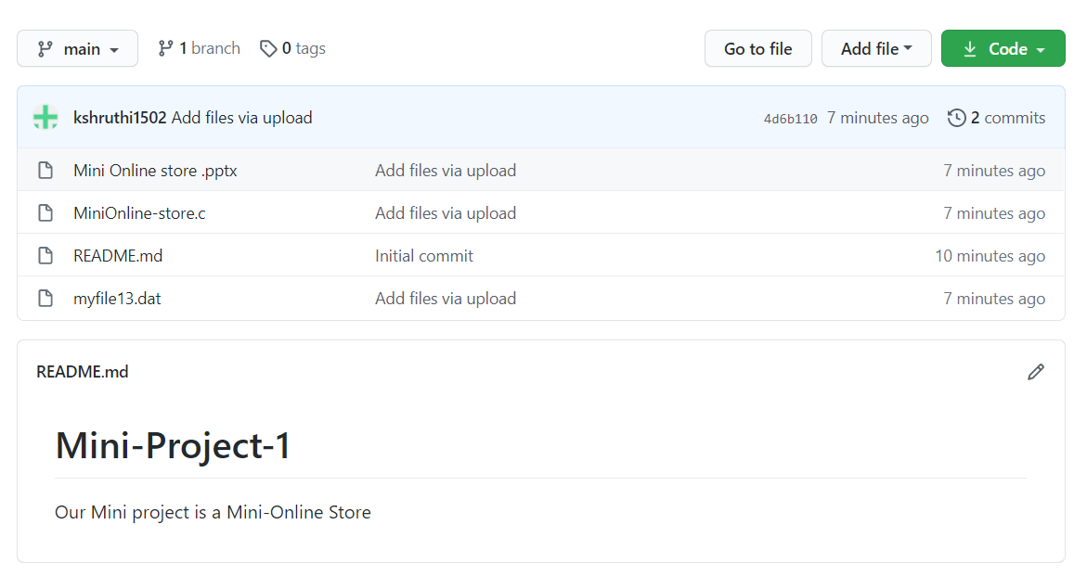

**C)TESTING**

**USE CASE ID: UC01**

**NAME: Register**

|  |  |
| --- | --- |
| **USER** | **SYSTEM** |
| 1. Choose the signup/register option |  |
|  | 2. Prompts the data required for registration |
| 3. Enters the data prompted by the system |  |
|  | 4.Validates user information   * If valid, create new account * If invalid, display error message and prompt new values |

**OUTPUTS:**

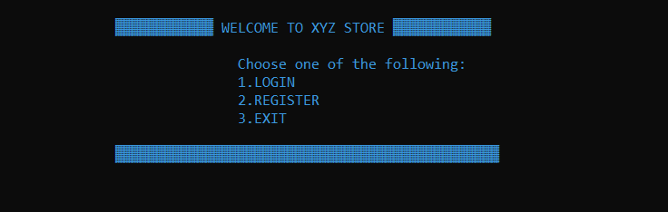

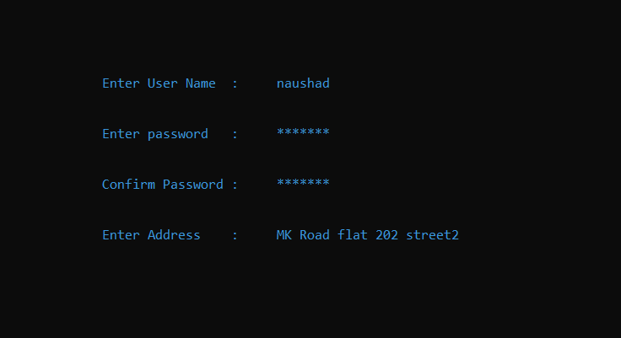

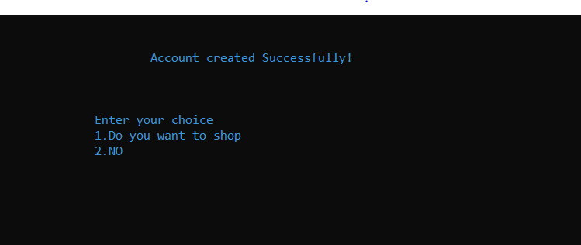

**USE CASE ID: UC02**

**NAME: Login**

|  |  |
| --- | --- |
| **USER** | **SYSTEM** |
| 1. Enter username and password and chooses Login option |  |
|  | 2. Validates username and password   * If username is invalid, displays error message and prompts for valid username * If password is invalid, displays error message and prompts for valid password * If username and password are valid, then login and display home page |

**OUTPUTS:**



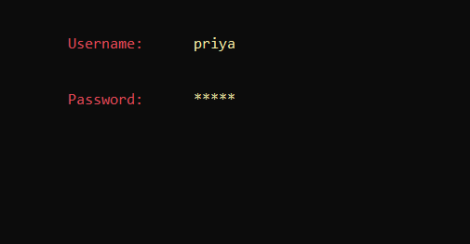

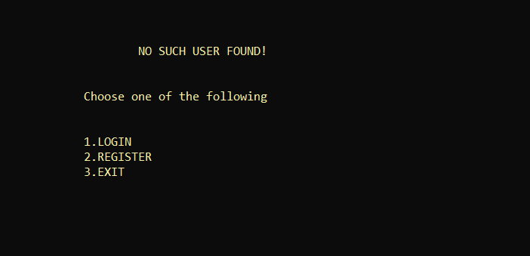

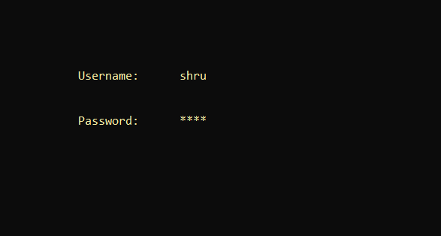

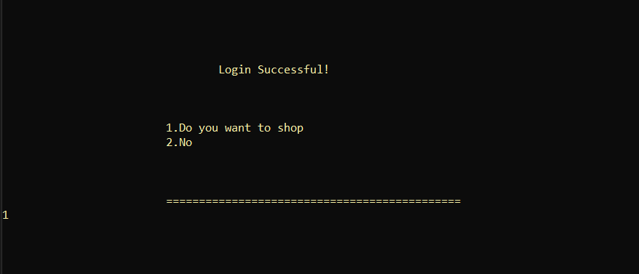

**USE CASE ID: UC03**

**NAME: View Categories**

|  |  |
| --- | --- |
| **USER** | **SYSTEM** |
| 1. Allows registered users to view various sub categories. |  |
|  | 2. Displays the subcategories and allows users to select them and provides an option to filter. |
| 3. User selects one of the sub category and adds to cart. |  |

**OUTPUTS:**

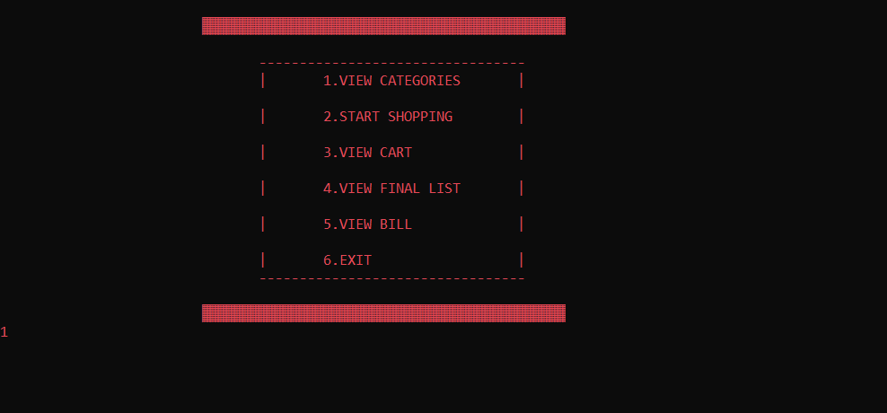

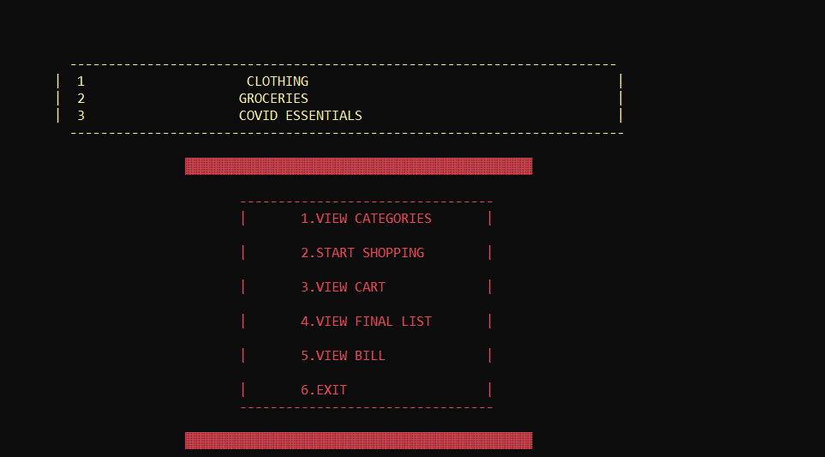

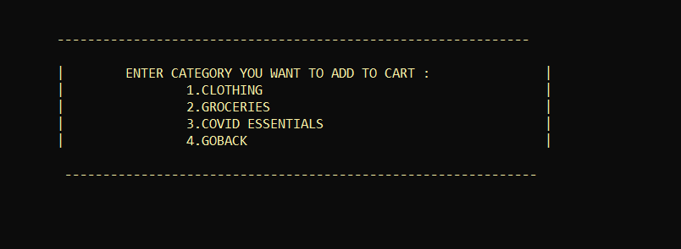

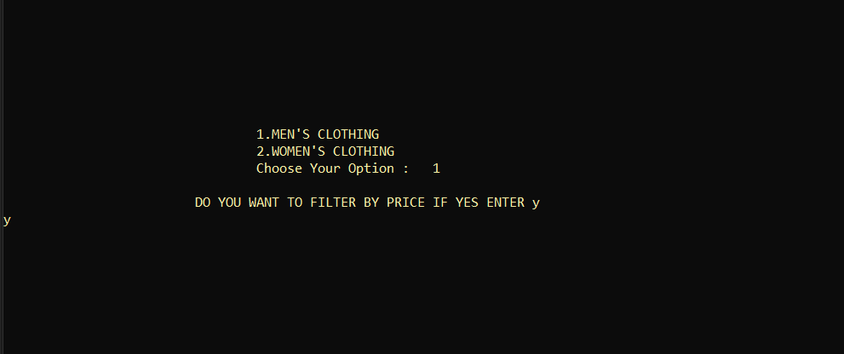

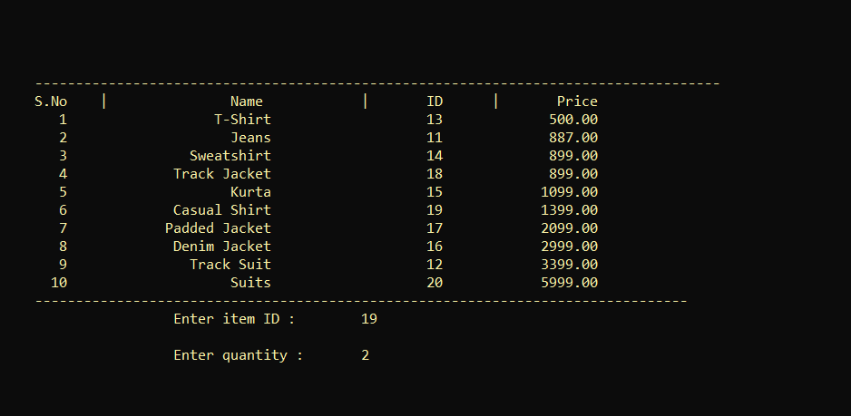

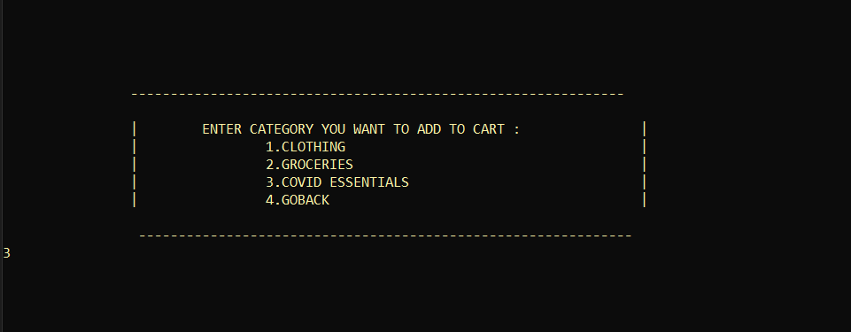

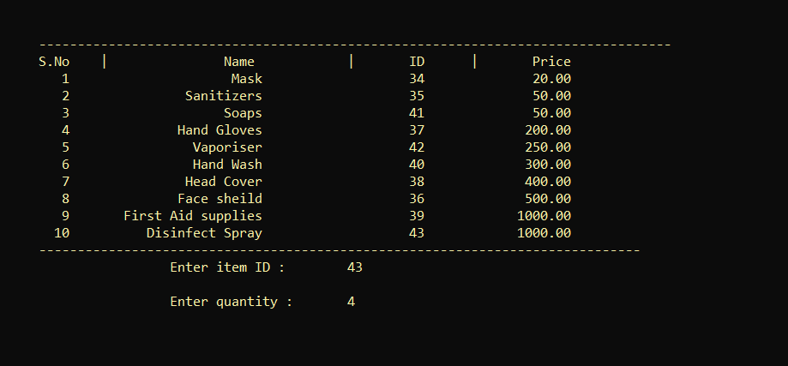

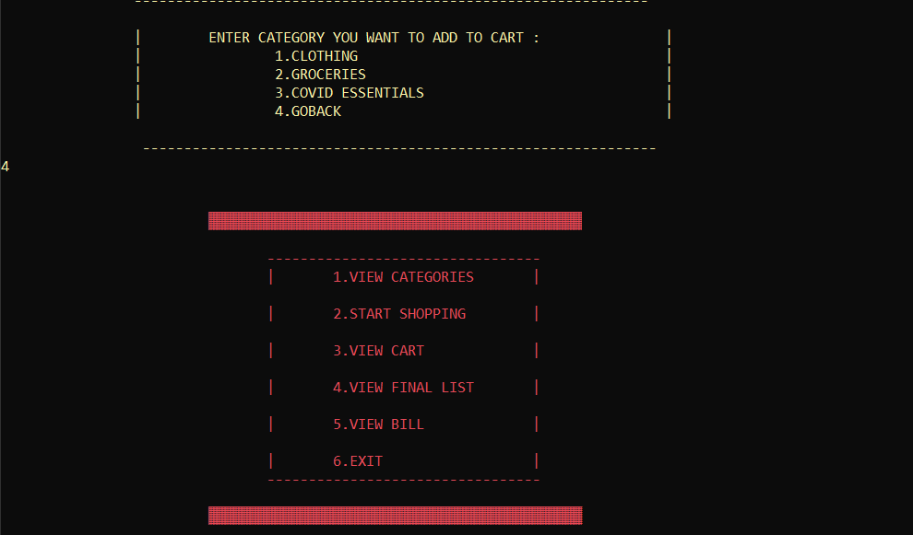

**USE CASE ID: UC04**

**NAME: Add to Cart**

|  |  |
| --- | --- |
| **USER** | **SYSTEM** |
| 1. User select on one of the category and then select on the item to be added to cart. |  |
|  | 2. System saves the item in the cart with the remaining old items |

**OUTPUTS:**

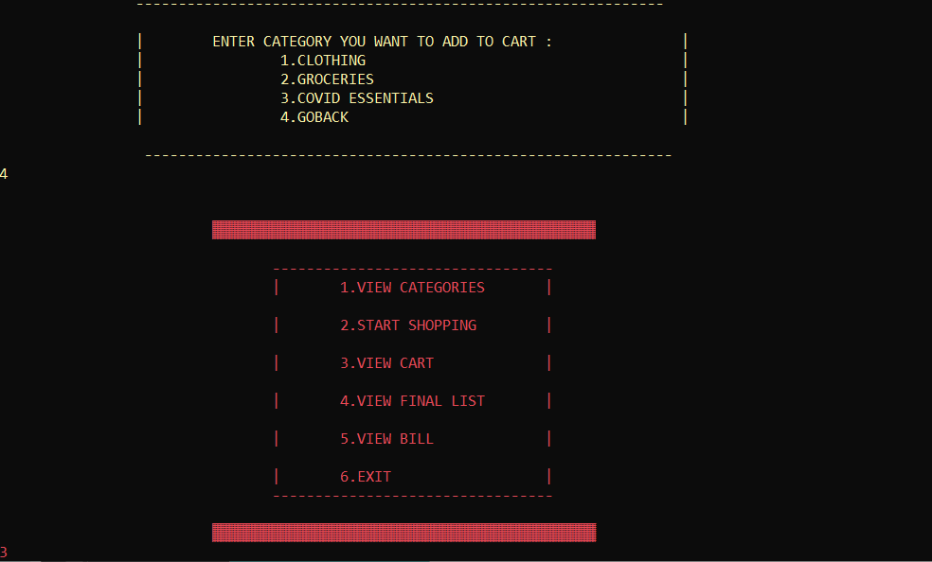

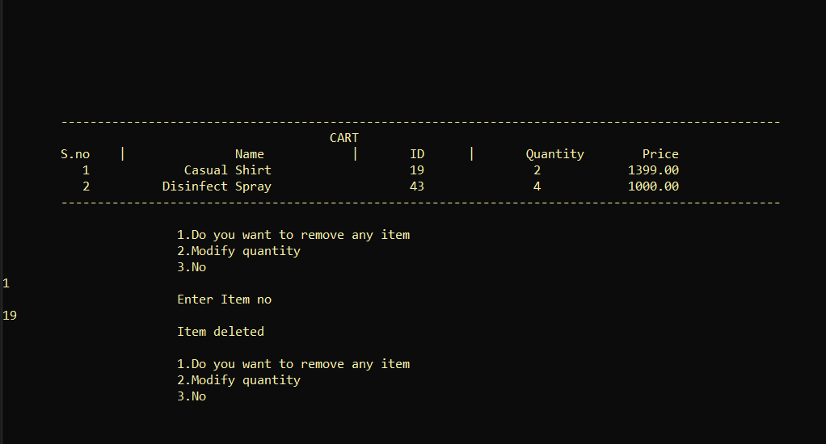

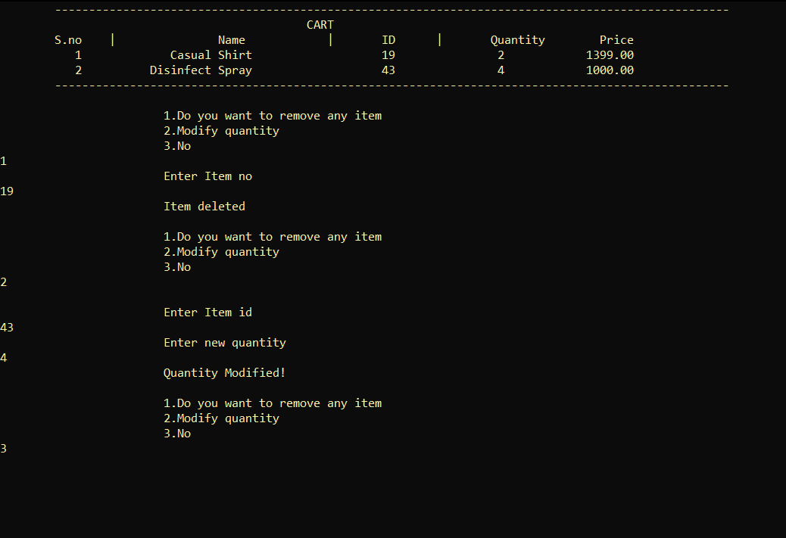

**USE CASE ID: UC05**

**NAME: View Final List**

|  |  |
| --- | --- |
| USER | SYSTEM |
| 1. User clicks on view list |  |
|  | 2. System displays the list with subtotal on the screen |
| 3. If any changes user can add or remove |  |
|  | 4. System displays the modified list and subtotal |

**OUTPUTS:**

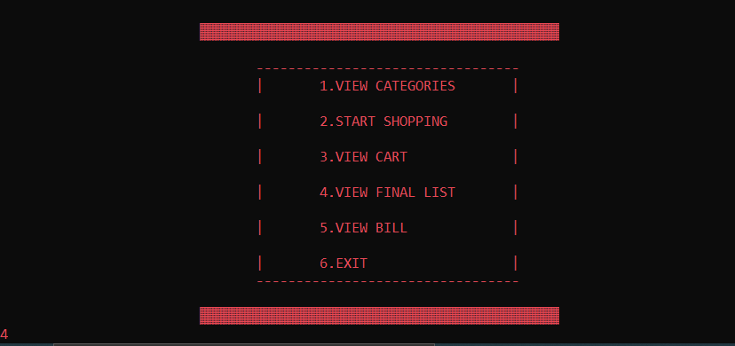

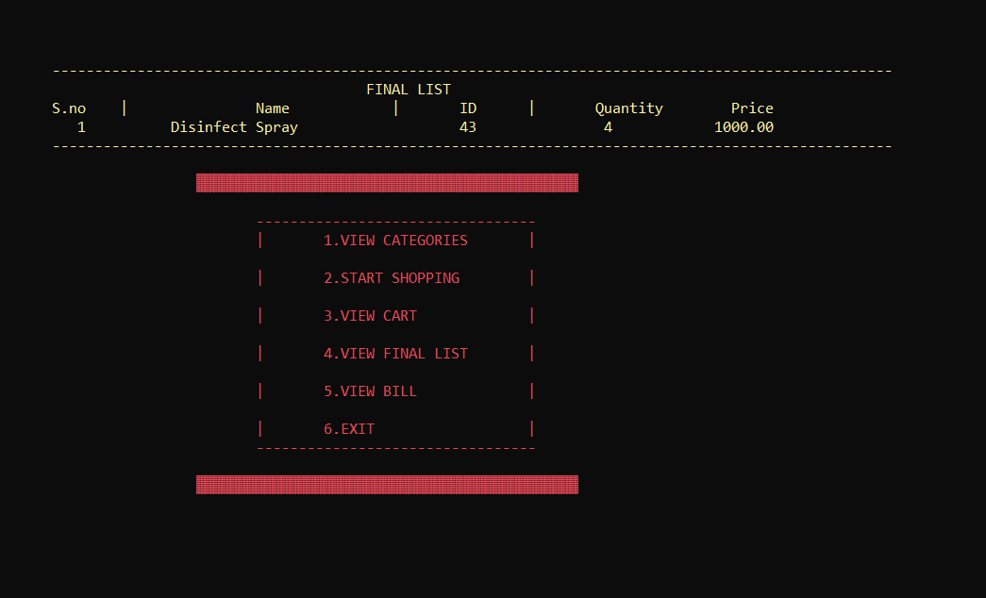

**USE CASE ID: UC06**

**NAME: Checkout**

|  |  |
| --- | --- |
| USER | SYSTEM |
| 1. User checks the final list and places the order by entering the final details. |  |
|  | 2. System takes the final details and displays the confirmation of the order. |

**OUTPUTS:**

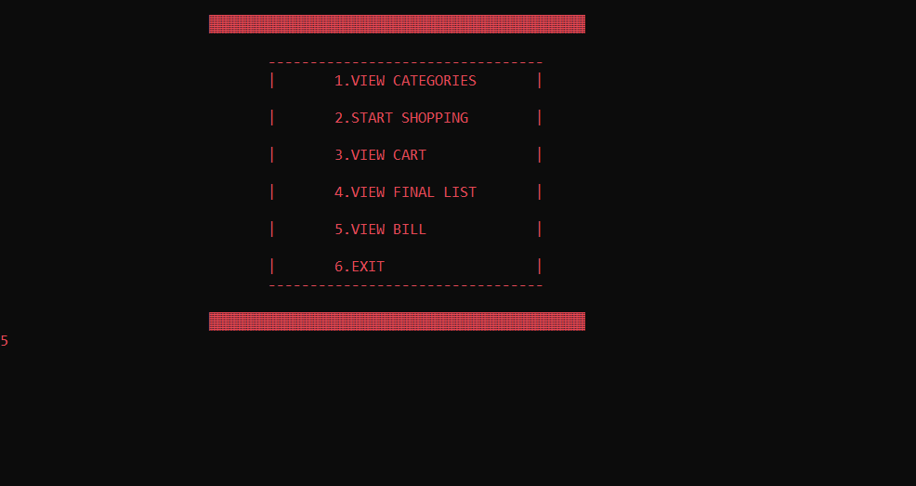

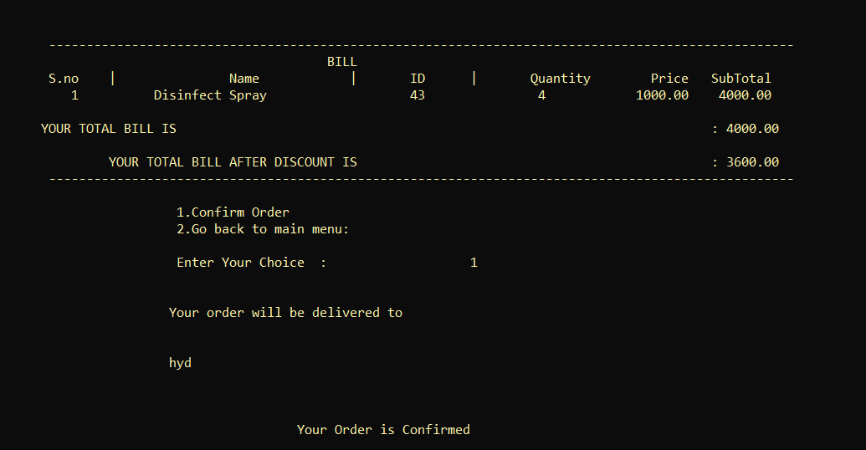

**USE CASE ID: UC07**

**NAME: Rating**

|  |  |
| --- | --- |
| **USER** | **SYSTEM** |
| 1. User enters the rating to the product. |  |
|  | **2. System saves the rating.** |

**OUTPUTS**:

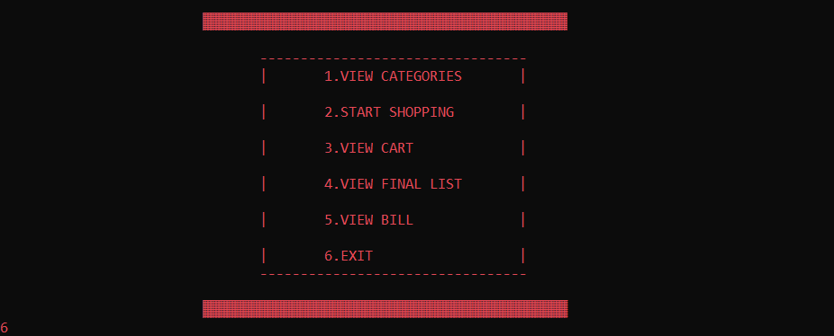

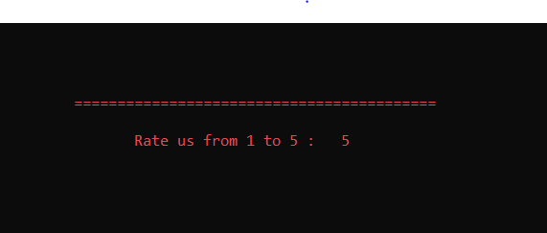



**RESULTS**

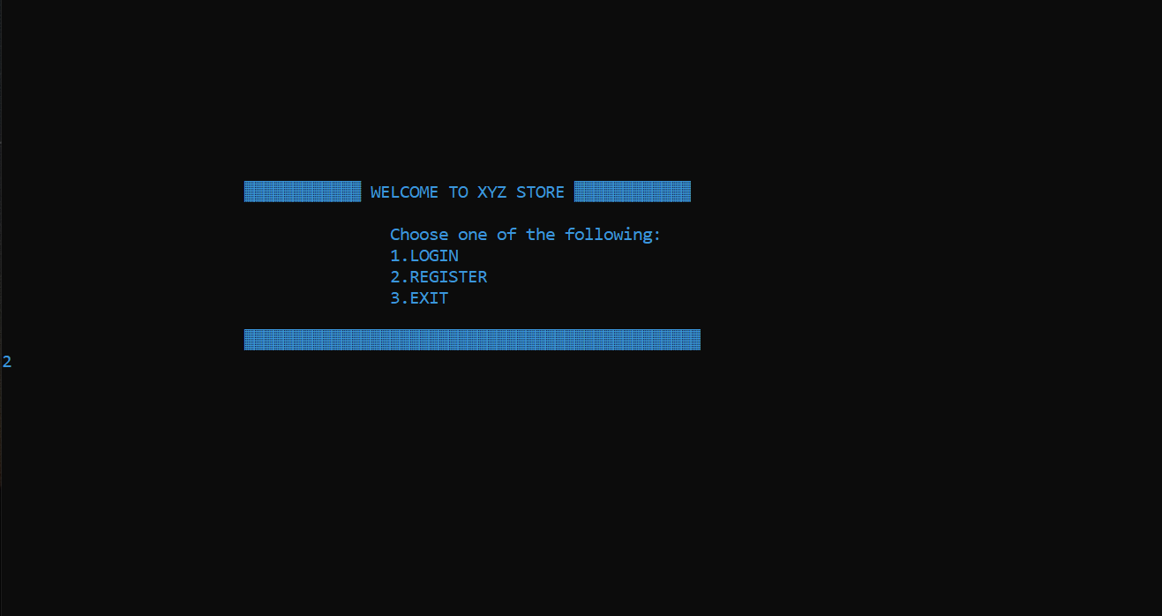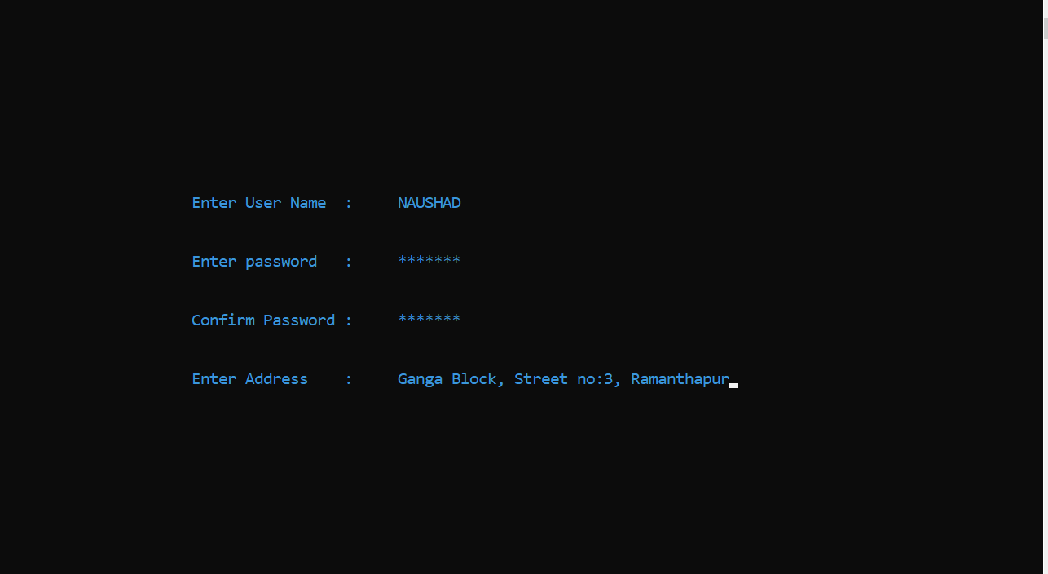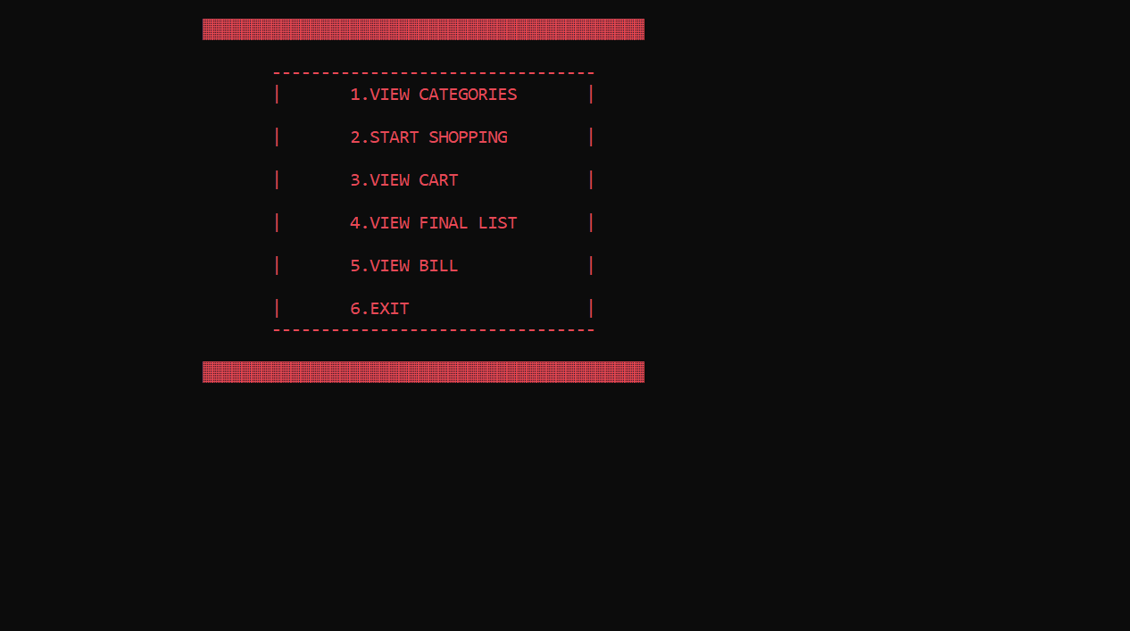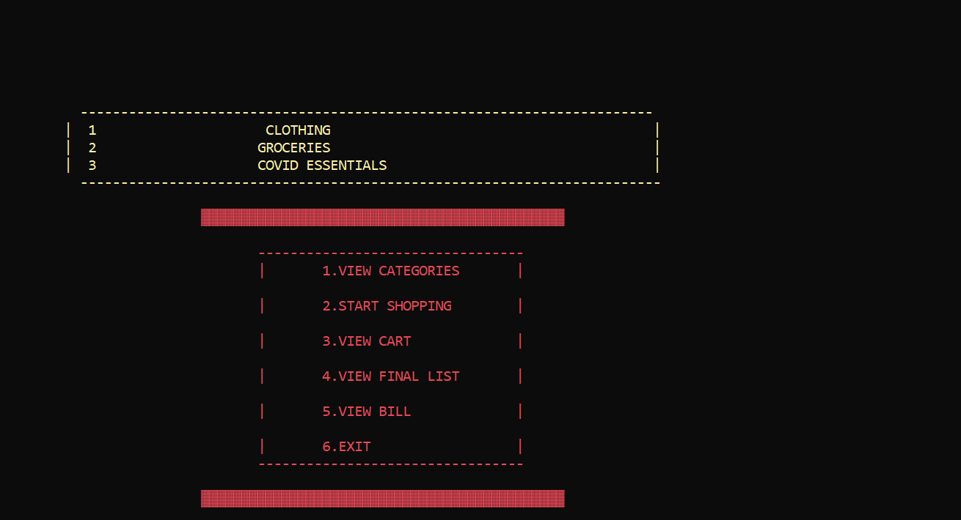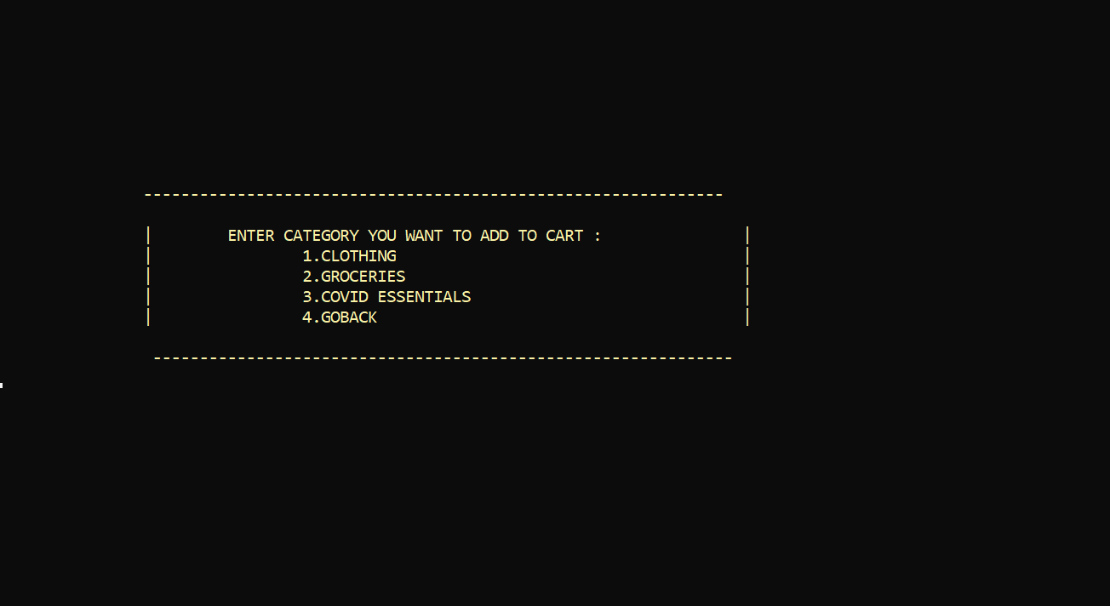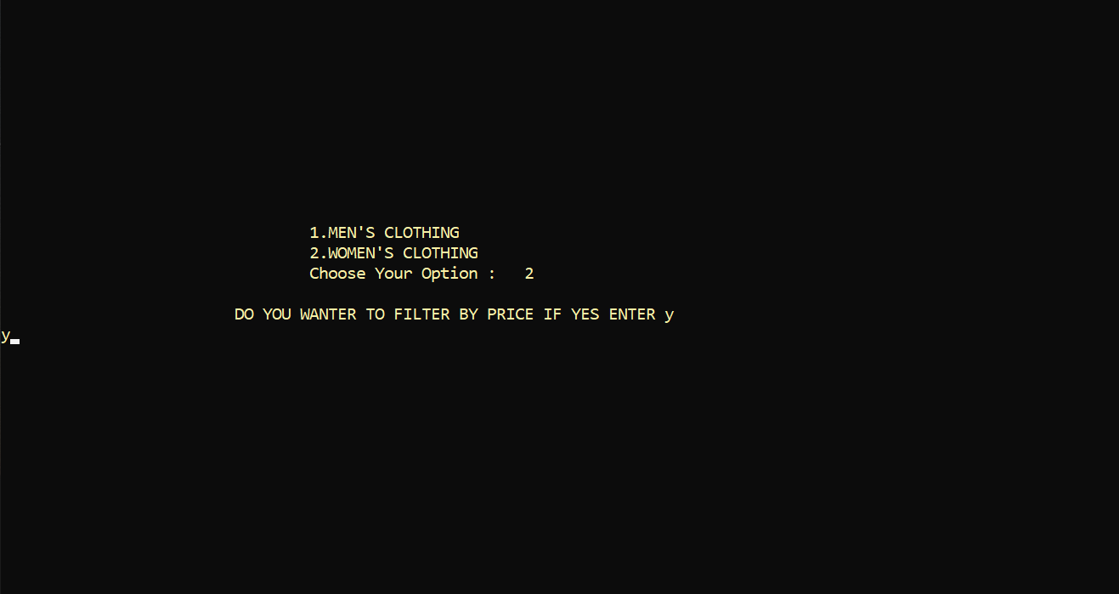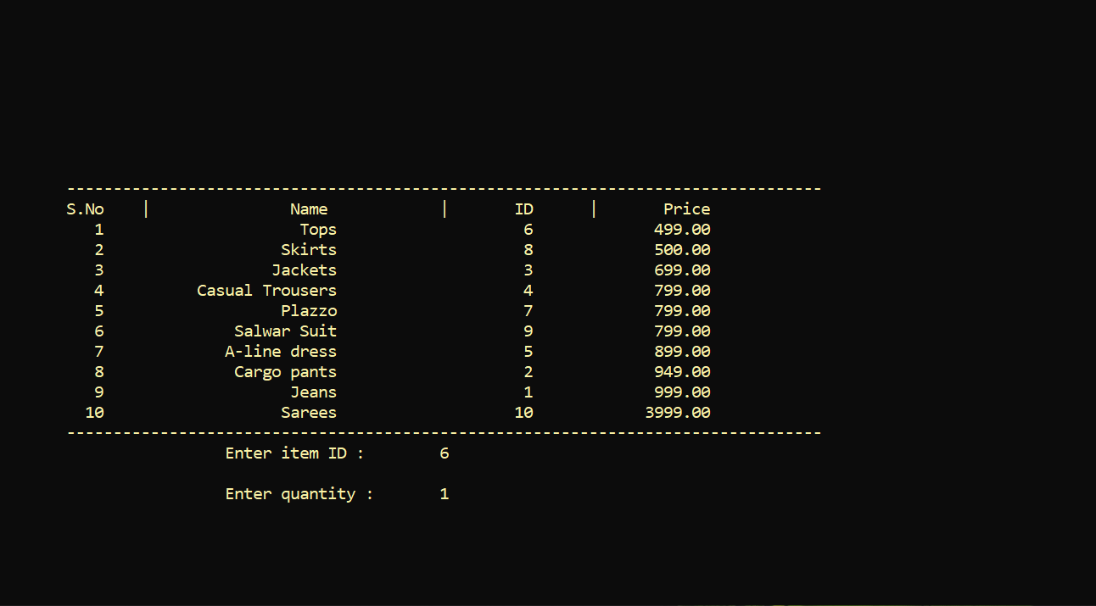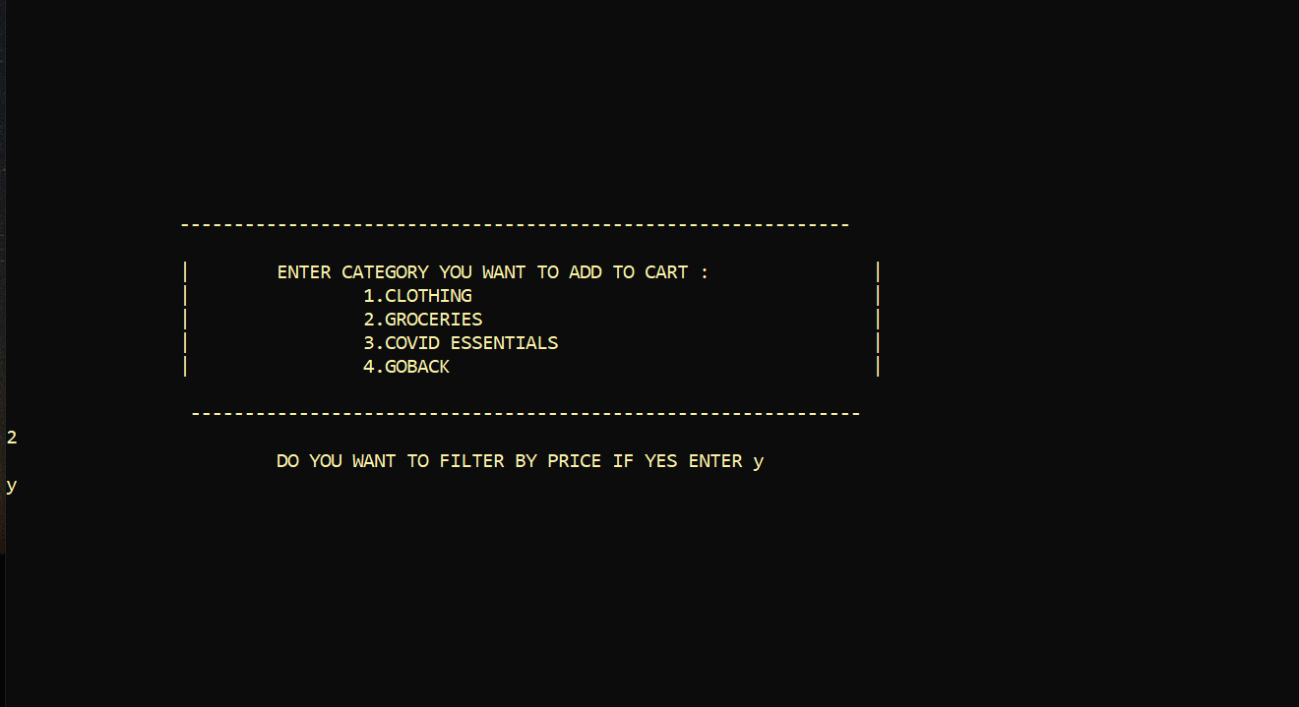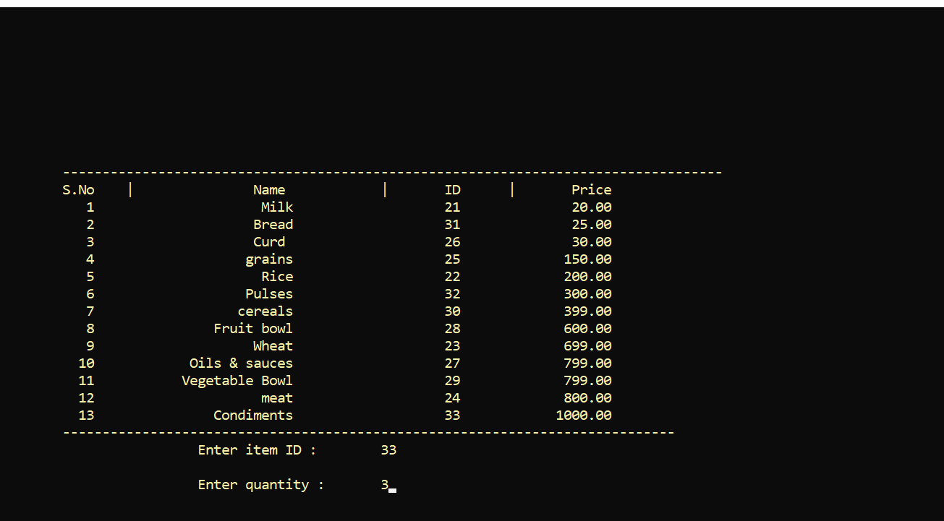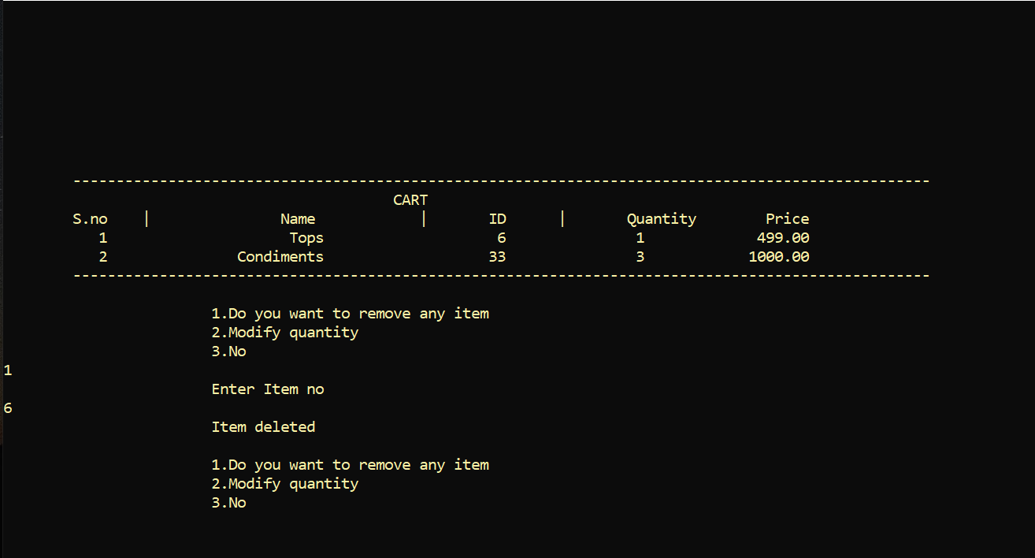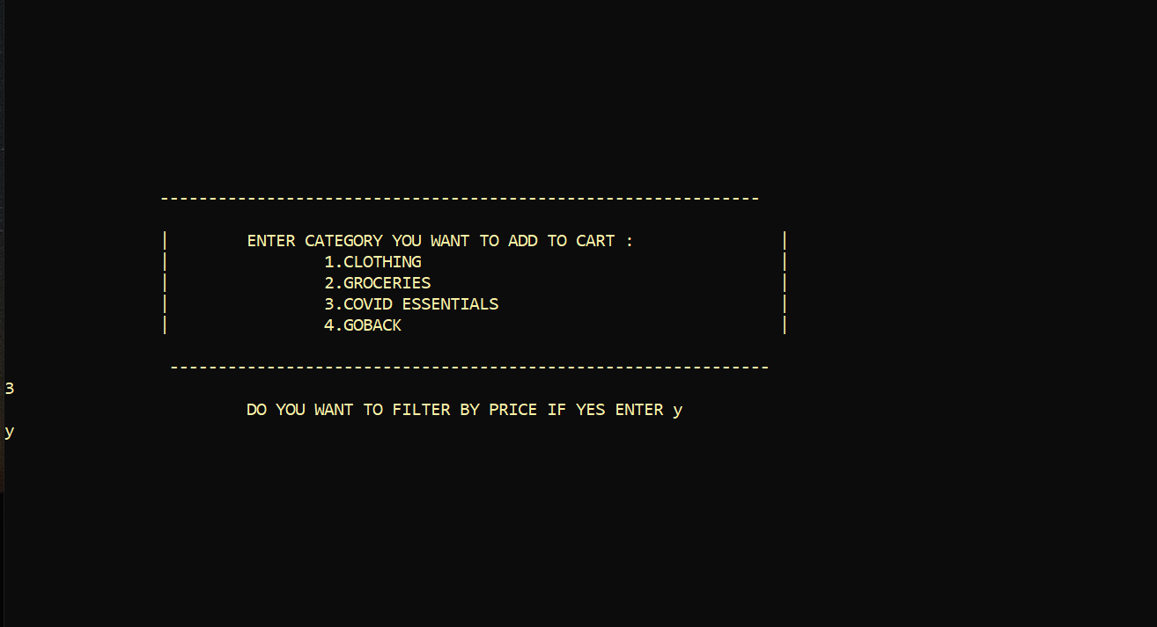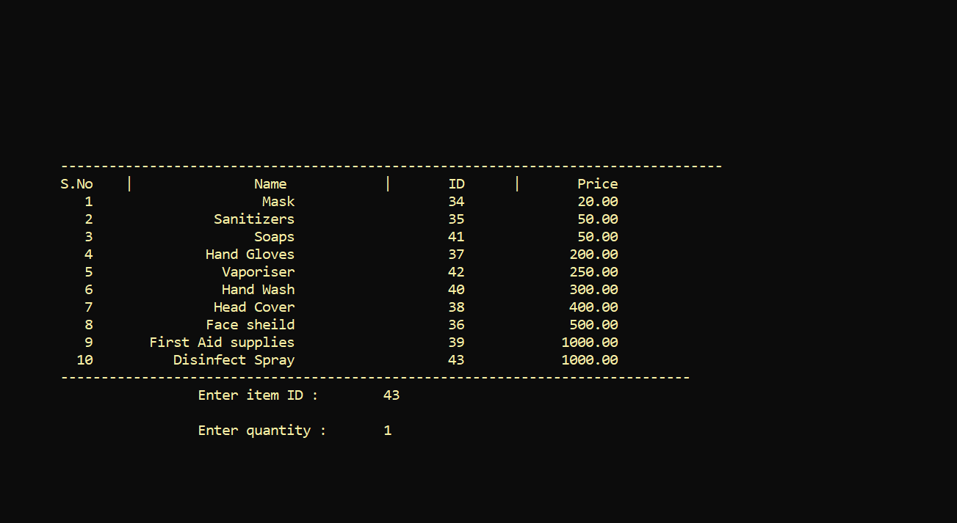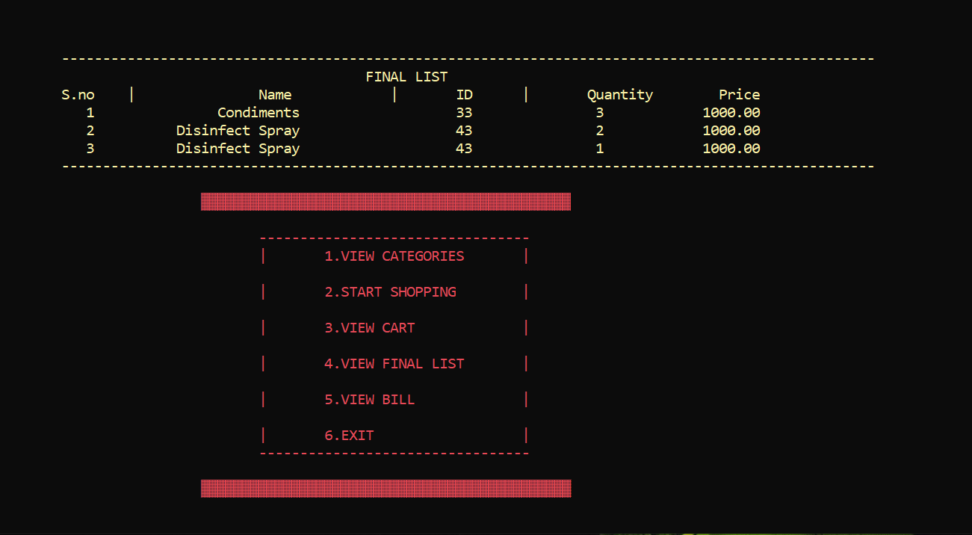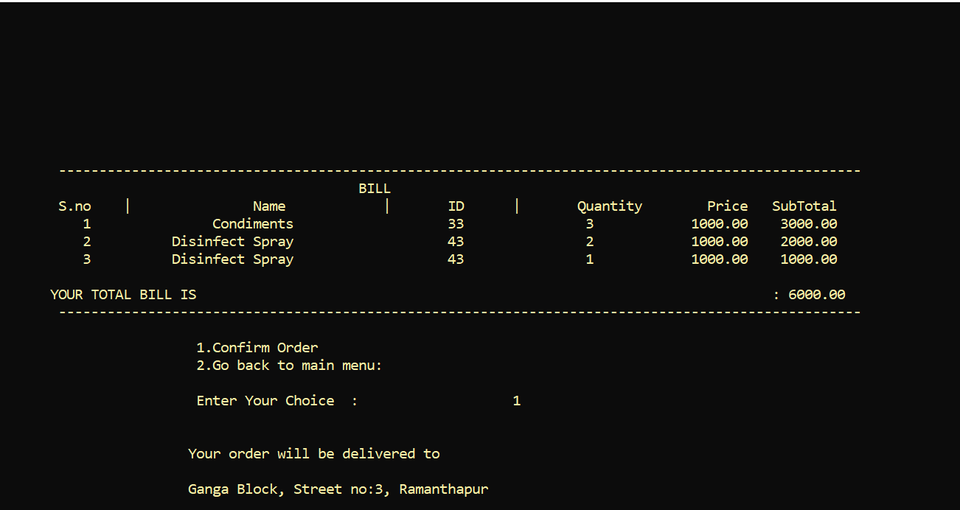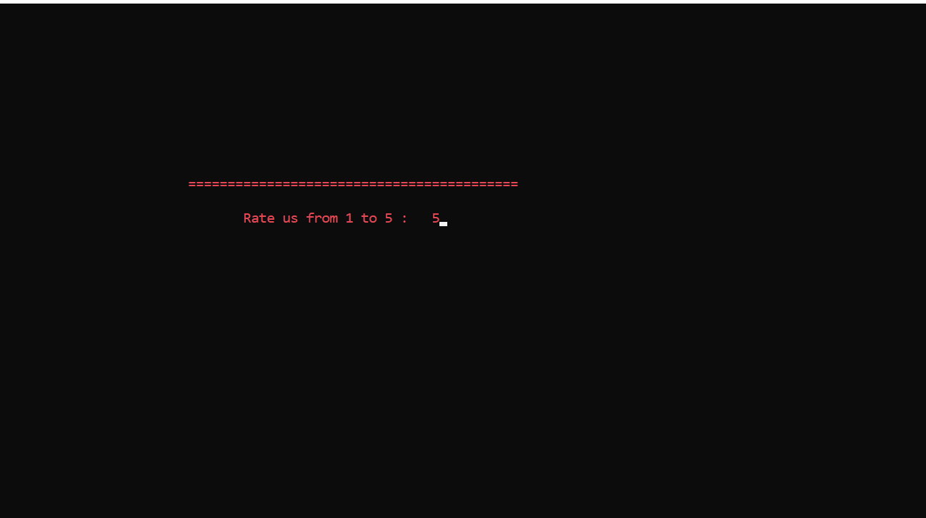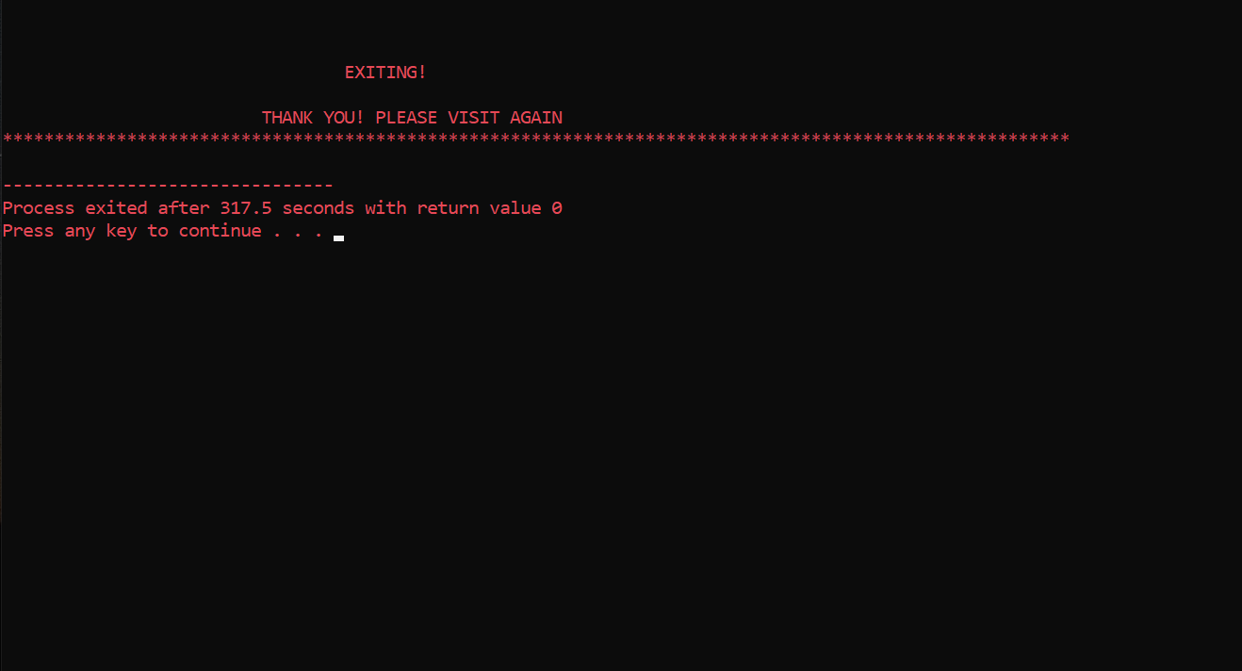

**ADDITIONAL LEARNING**

This project helped us in gaining valuable information and practical knowledge on

several topics of c programming.

While doing this project we got more clarity on files.

Also we got to know how to hide characters while taking input from the user and used

this concept for taking input of password while registering or log in without displaying

character.

And also after clearing the screen after selecting a option we used gotoxy function to

print the data at desired location.

Also we learned about graphics in c. Like adding colour to background, text, text-

background, table etc.

And also got the knowledge of alignment.

**DISCUSSION AND FUTURE WORK**

There is a scope for further development in our project to a great extent. A number of

features can be added to this system in future like providing

* Adding images, taking comments.
* Adding Online payment.
* Sending OTP through twillo.
* A few more graphics can be added to it

**REFERENCES**

<https://www.w3schools.in/c-tutorial/>

<https://www.geeksforgeeks.org/c-programming-language/?ref=leftbar>

<https://www.includehelp.com/c/graphics-functions-examples.aspx>