neurostim-safety: electrode and tissue safety limits for neural stimulation, each traced to its source
Kshitij Kumar
Indian Institute of Technology Kanpur, India
[AUTHOR: postal address and e-mail for the author line, as the template asks]

Abstract
neurostim-safety is an open-source Python package that assesses whether a neural-stimulation protocol is safe for the tissue and for the electrode that delivers it. From an electrode's geometry and material and a protocol's current, pulse width, rate, train and charge recovery, it evaluates nine established tissue-damage, electrochemical and instrument limits and reports the highest current at which none of them fails, or refuses to report one when no current is safe. Every constant carries its source and the conditions it was measured under, and those conditions travel into every report, flagging a limit applied outside them as provisional. Text, PDF, JSON, CSV, figure and desktop outputs are provided.

Keywords
neural stimulation; charge injection; electrode safety; deep brain stimulation; Shannon criterion; Python

Code metadata
Nr | Code metadata description | Metadata
C1 | Current code version | v0.16.0 (https://github.com/kshtjkumar/neurostim-safety/releases/tag/v0.16.0)
C2 | Permanent link to code/repository used for this code version | https://github.com/kshtjkumar/neurostim-safety
C3 | Legal code license | MIT License
C4 | Code versioning system used | git
C5 | Software code languages, tools and services used | Python (≥ 3.10); NumPy, SciPy, Matplotlib, pandas; optional PyQt6 (desktop GUI) and ReportLab (PDF reports); pytest, Ruff, mypy and GitHub Actions for testing
C6 | Compilation requirements, operating environments and dependencies | Pure Python, no compilation. Linux, macOS (tested in CI on Python 3.10–3.14 and 3.12 respectively); Windows expected but not tested. pip install -e ".[all]" installs the library, GUI and PDF support
C7 | If available, link to developer documentation/manual | https://github.com/kshtjkumar/neurostim-safety#readme (README); API reference generated from docstrings with python scripts/build_api_docs.py [AUTHOR: host the API reference, e.g. GitHub Pages, if you want a public link]
C8 | Support email for questions | https://github.com/kshtjkumar/neurostim-safety/issues [AUTHOR: SoftwareX may insist on an e-mail address here]

1. Motivation and significance
Electrical stimulation of the nervous system — deep brain stimulation, cortical and spinal microstimulation, cochlear and retinal prostheses — is bounded by two families of limits. Tissue limits describe the charge that damages neurons, most prominently the Shannon criterion fitted to McCreery's cat-cortex data [1, 2]. Electrode limits describe the charge an electrode can inject reversibly before irreversible Faradaic reactions, gas evolution or dissolution begin [3, 4]. Which family binds depends on electrode size [5]: large and small electrodes can be limited by different mechanisms, and microelectrodes by a charge-per-phase threshold that the Shannon criterion does not capture.
These limits are scattered across the electrochemistry and neurophysiology literature and are routinely quoted as single numbers, stripped of the conditions under which they were measured. A charge-injection capacity measured in saline at 200 µs need not hold in tissue at 50 µs: in vivo, platinum's capacity is several-fold lower than in vitro [6]. Checking a protocol therefore means recomputing each limit by hand, from several papers, for each electrode, and it is easy to apply a value outside the conditions it was measured under without noticing. [AUTHOR: add one or two sentences on why this mattered in your own work — e.g. the rodent motor-cortex microstimulation and MER experiments — and what you did before writing the package.]
neurostim-safety performs this calculation once, reproducibly, with every constant traceable to its source; the few values without a primary source are listed openly. A user describes the electrode and the protocol; the package evaluates every applicable limit, reports which one binds and at what current, and states explicitly when a limit is applied outside the conditions it was measured under. The intended users are experimenters designing stimulation protocols, engineers choosing electrode materials and sizes, and reviewers checking the safety argument of a methods section.
Related work. [AUTHOR: verify and complete. Suggested starting points: finite-element environments (COMSOL, Sim4Life) model fields and heating but do not encode the literature's damage and charge-injection limits; DBS toolboxes such as Lead-DBS and OSS-DBS estimate volumes of tissue activated rather than safety limits; published calculators and spreadsheets typically quote one limit per material without its measurement conditions. State what, to your knowledge, does not exist.]

2. Software description

2.1 Software architecture
The package is organised in layers (Fig. 1).
Inputs. Electrode geometries (disc, ring, rectangle, cylindrical band, microwire, sphere, hemisphere and arrays of these) each compute their area and access resistance, using exact solutions where they exist (e.g. Newman's disc [7]) and bounding approximations, flagged as such, otherwise. Nine electrode materials are built in, each with its charge-injection range, water window and chronic threshold; a user-measured charge-injection capacity can be supplied, with the base material's other limits kept and labelled as inherited. A protocol specifies current, pulse width per phase, frequency, train duration and duty cycle, waveform, return-phase ratio and charge recovery.
Safety core. Nine checks are evaluated for every assessment: the Shannon criterion [1]; the material charge-injection limit [3, 4]; the water window, including the DC drift of an incompletely recovered train; the validated envelope of the data behind the Shannon fit; current density against an electroporation threshold [8], with a clinical DBS reference density from [9]; the microelectrode charge-per-phase threshold [5]; chronic degradation; charge balance [10]; and the stimulator's compliance voltage, optionally with a counter electrode, which adds a tenth check on the counter's own charge injection. Each check returns a status, the current at which it would fail, the published range of that ceiling, and whether it rests on an unconfirmed constant or model.
Result. The limiting current is the highest amplitude at which no limit-bearing check fails. It is floored to the printed precision, so the printed value passes the checks it names, and it is accompanied by an interval across the published ranges (for example Shannon's k from 1.5 to 2.0). When no amplitude is safe — for example a monophasic waveform that recovers no charge — the package reports a refusal naming the check rather than a number. PROVISIONAL and INCOMPLETE flags mark results that rest on unconfirmed inputs or on a check that could not run.
Supporting layers. Literature data modules hold every constant with its source, page and measurement conditions (pulse width, polarity, electrolyte, area basis); these conditions are compared with the protocol at assessment time. Models include steady and transient Pennes bioheat heating, strength–duration fits with confidence intervals, a current–distance activation estimate and an interval-arithmetic layer with outward rounding. Finite-element field solutions can be imported and compared with the analytic estimates.
Outputs. The same assessment is rendered as a text summary, a PDF report with methods text and bibliography, JSON and an audit record carrying a SHA-256 digest of inputs, constants and answer, batch CSV tables and current sweeps, publication figures (SVG/PDF/TIFF), and a PyQt6 desktop application.
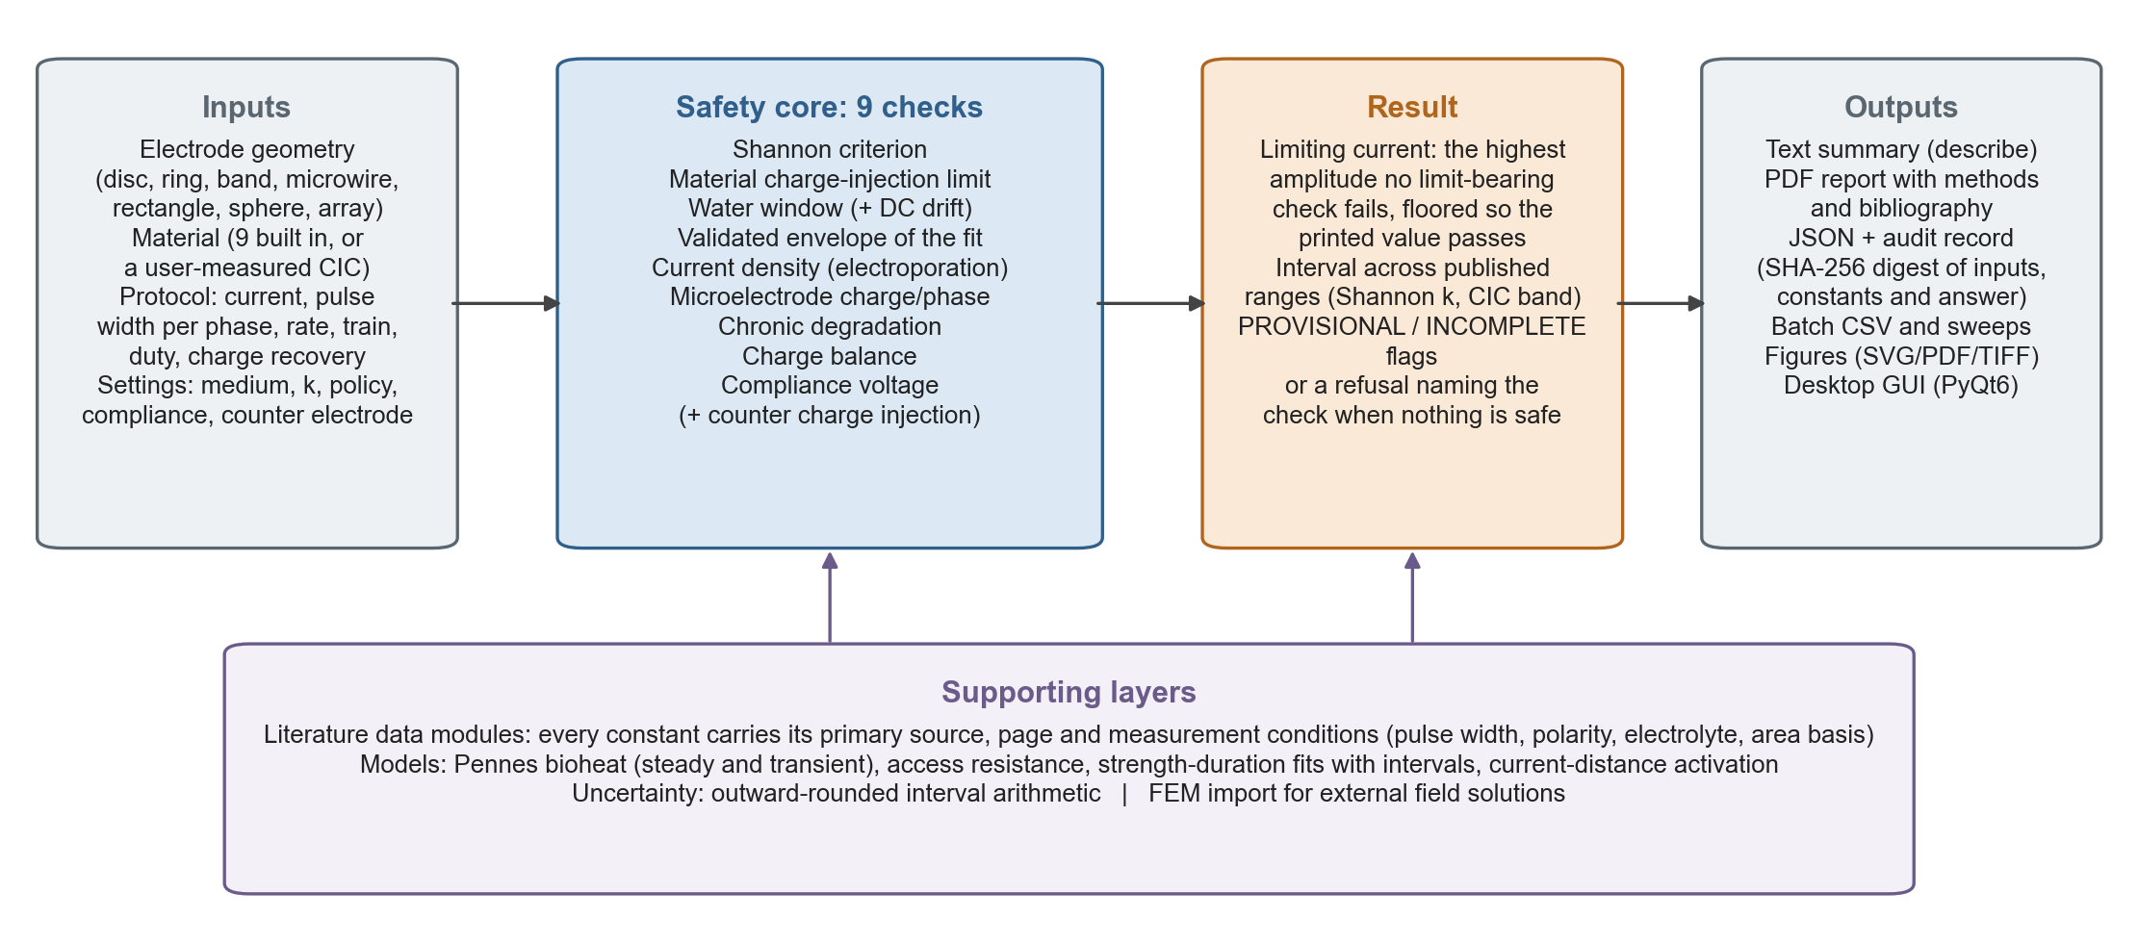
Fig. 1. Architecture of neurostim-safety. Sourced inputs are evaluated by nine safety checks; the result is a single floored limiting current with its interval and flags, or a refusal, which every output renders identically.

2.2 Software functionalities
• Protocol assessment: SafetyCalculator(electrode, protocol, ...).assess() returns every check and the limiting current; .describe() prints them with the conditions and source of each limit.
• Traceability: neurostim.bibliography() lists every source used; each check's detail names its constant, citation and measurement conditions.
• Condition checking: a limit applied outside its measured pulse width, polarity or medium is flagged provisional; the in-vivo derating of platinum is applied from the measured in-vitro/in-vivo ratio [6].
• Uncertainty: published ranges propagate to an interval on the limiting current.
• Batch and sweeps: CSV input of many protocols and current sweeps, with failed rows reported rather than silently dropped.
• Reports and reproducibility: PDF reports and JSON audit records whose digest lets a report be regenerated and verified with a later version.
• Desktop GUI for interactive use without programming.

2.3 Sample code snippet
from neurostim import SafetyCalculator, StimProtocol, get_preset
from neurostim.io import build_report
contact = get_preset("dbs_3389").electrode # 1.27 mm x 1.5 mm PtIr band
protocol = StimProtocol(3000, 60, 130, 1) # uA, us per phase, Hz, s
calc = SafetyCalculator(contact, protocol, compliance_V=10.0, medium="in_vivo")
print(calc.describe())
build_report(calc, "dbs_report.pdf")

3. Illustrative examples
Example 1: a deep brain stimulation contact. For a Medtronic 3389-style contact (PtIr cylindrical band, 1.27 mm diameter, 1.5 mm height, 0.0598 cm²) driven at 3 mA, 60 µs per phase and 130 Hz in vivo, the package reports an overall CAUTION with a limiting current of 10.94 mA, set by the in-vivo-derated platinum-iridium charge-injection limit; the interval across published ranges is 10.94–16.41 mA. The Shannon criterion passes with 7.6-fold headroom but is marked as applied outside its validated envelope, because the criterion was fitted on disc electrodes and this contact is a band. The limit is flagged PROVISIONAL because the binding constant carries a caveat. Fig. 2 shows the package's own summary figure for this case.
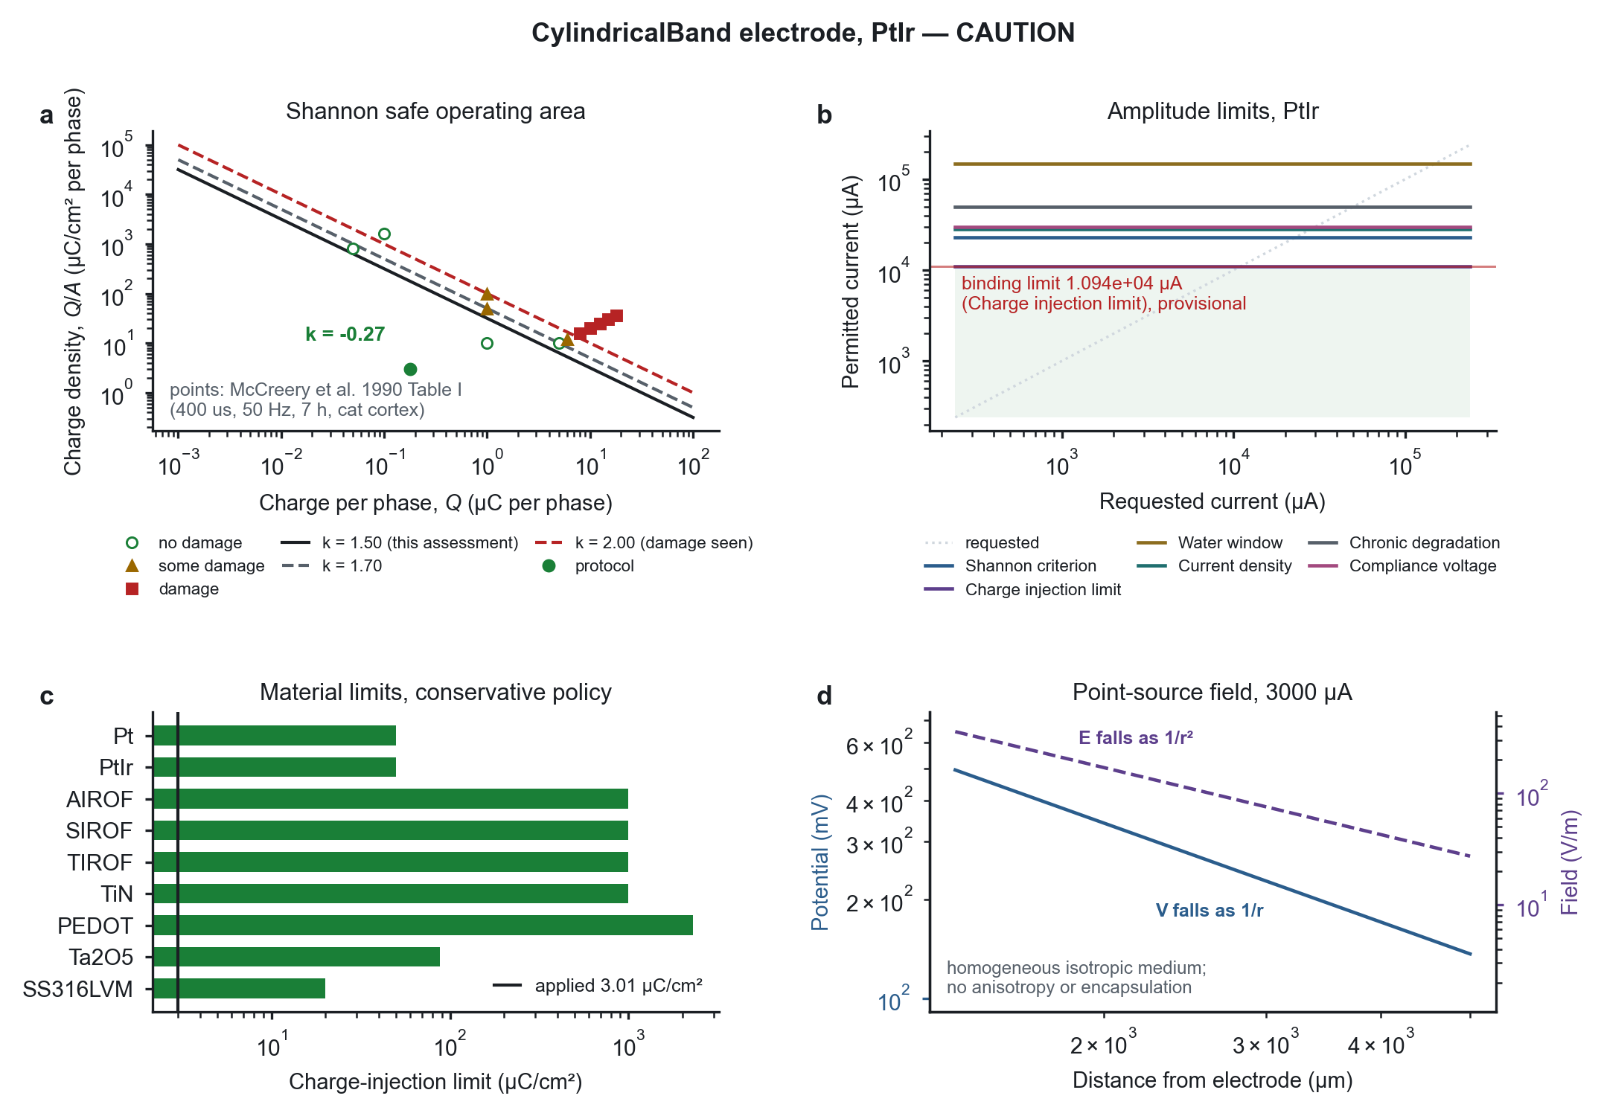
Fig. 2. Output of neurostim-safety for a DBS contact (3 mA, 60 µs per phase, 130 Hz, in vivo). (a) The protocol on the Shannon safe-operating plane with McCreery's data. (b) Permitted current per check against requested current, with the binding limit. (c) Material charge-injection limits under the conservative policy. (d) Potential and field around the contact.
Example 2: a cortical microelectrode. [AUTHOR: replace with your own experiment, e.g. a stainless-steel ring (330/270 µm, 0.000283 cm²) in rodent motor cortex at 100 µs per phase and 130 Hz. Because the area is below the micro/macro boundary, the Shannon criterion is not applied and the microelectrode charge-per-phase threshold (≈4 nC) binds: the limiting current is 40 µA, so a 40 µA protocol sits exactly at the limit. State what this changed in your protocol.]

4. Impact
[AUTHOR: this is the section reviewers weigh most. It must describe real use; do not state anything that has not happened. Suggested content, to be written from your own experience:]
• Research questions it enables: systematic comparison of electrode materials and sizes against every applicable limit at once; checking where tissue versus electrode limits bind across a design space; auditing published protocols against the limits with their measurement conditions.
• Improvement over existing practice: one reproducible calculation replaces hand-computed limits from several papers; the conditions of each limit are checked rather than assumed; reports record inputs, constants and a digest so that a methods section's safety argument can be regenerated.
• Correctness and verification: the package was audited before release, and the full record of findings, fixes and AI-assisted review passes is in the repository. The test suite (≈1,700 tests) checks constants against their sources, reproduces published results from published inputs (for example, the Pennes model gives a 0.83 K peak rise for the drive of Elwassif et al. [11] against their finite-element 0.82 K), checks the headline limit against an independent search, and is gated in continuous integration on branch coverage (85.8 %) and mutation testing (85.6 % of pre-registered generated mutants killed).
• Use: [AUTHOR: your own studies using it (rodent motor-cortex stimulation, MER datasets), collaborators or labs using it, any talks or preprints. If the package is new and not yet used beyond your work, say so plainly.]

5. Conclusions
neurostim-safety brings the tissue-damage, electrochemical and instrument limits on neural stimulation into one reproducible calculation, with every constant traceable to its source and its measurement conditions checked against the protocol. It reports a single, floored limiting current with its uncertainty, flags where a limit is applied outside its evidence, and refuses to report a number when no amplitude is safe. Its limits are the published ones, with their known weaknesses, documented in the repository: it is a research and design aid, not a regulatory or clinical tool. [AUTHOR: planned extensions, if any.]

Declaration of competing interest
[AUTHOR: e.g. "The author declares no known competing financial interests or personal relationships that could have appeared to influence the work reported in this paper."]

Acknowledgements
[AUTHOR: optional — colleagues, funding.]

Declaration of generative AI and AI-assisted technologies in the manuscript preparation process
[AUTHOR: must be truthful and specific. Suggested wording, edit to match what you did:] During the preparation of this work the author used Claude (Anthropic; Claude Opus 5 and Opus 5.5, via Claude Code) to audit and repair the software, to write most of its test suite and continuous-integration configuration, to review each change in separate AI review sessions, and to produce an initial draft of this manuscript and its figures. The author substantially rewrote the manuscript, made the modelling and source decisions recorded in the repository, and reviewed and validated the code and text. After using this tool, the author reviewed and edited the content as needed and takes full responsibility for the content of the publication.

References
[1] R.V. Shannon, A model of safe levels for electrical stimulation, IEEE Trans. Biomed. Eng. 39 (1992) 424–426. https://doi.org/10.1109/10.126616 [2] D.B. McCreery, W.F. Agnew, T.G.H. Yuen, L. Bullara, Charge density and charge per phase as cofactors in neural injury induced by electrical stimulation, IEEE Trans. Biomed. Eng. 37 (1990) 996–1001. https://doi.org/10.1109/10.102812 [3] S.F. Cogan, Neural stimulation and recording electrodes, Annu. Rev. Biomed. Eng. 10 (2008) 275–309. https://doi.org/10.1146/annurev.bioeng.10.061807.160518 [4] T.L. Rose, L.S. Robblee, Electrical stimulation with Pt electrodes. VIII. Electrochemically safe charge injection limits with 0.2 ms pulses, IEEE Trans. Biomed. Eng. 37 (1990) 1118–1120. https://doi.org/10.1109/10.61038 [5] S.F. Cogan, K.A. Ludwig, C.G. Welle, P. Takmakov, Tissue damage thresholds during therapeutic electrical stimulation, J. Neural Eng. 13 (2016) 021001. https://doi.org/10.1088/1741-2560/13/2/021001 [6] R.T. Leung, M.N. Shivdasani, D.A.X. Nayagam, R.K. Shepherd, In vivo and in vitro comparison of the charge injection capacity of platinum macroelectrodes, IEEE Trans. Biomed. Eng. 62 (2015) 849–857. https://doi.org/10.1109/TBME.2014.2366514 [7] J. Newman, Resistance for flow of current to a disk, J. Electrochem. Soc. 113 (1966) 501. https://doi.org/10.1149/1.2424003 [8] A. Butterwick, A. Vankov, P. Huie, Y. Freyvert, D. Palanker, Tissue damage by pulsed electrical stimulation, IEEE Trans. Biomed. Eng. 54 (2007) 2261–2267. https://doi.org/10.1109/TBME.2007.908310 [9] A.M. Kuncel, W.M. Grill, Selection of stimulus parameters for deep brain stimulation, Clin. Neurophysiol. 115 (2004) 2431–2441. https://doi.org/10.1016/j.clinph.2004.05.031 [10] D.R. Merrill, M. Bikson, J.G.R. Jefferys, Electrical stimulation of excitable tissue: design of efficacious and safe protocols, J. Neurosci. Methods 141 (2005) 171–198. https://doi.org/10.1016/j.jneumeth.2004.10.020 [11] M.M. Elwassif, Q. Kong, M. Vazquez, M. Bikson, Bio-heat transfer model of deep brain stimulation induced temperature changes, in: Proc. 28th Annu. Int. Conf. IEEE EMBS, 2006, pp. 3580–3583. https://doi.org/10.1109/IEMBS.2006.259425 [12] [AUTHOR: software citation — the Zenodo DOI of the v0.16.0 release, once archived]
[AUTHOR: every reference above was taken from the package's paper.bib; check author lists, volumes and pages against each paper before submitting.]

