Report for Lab Assignment 2

**Question1** : Prepare a dataset and perform k-means clustering.

**Description**: Used the dataset iris in R and performed kmeans clustering using the inbuilt function in R “kmeans”

**Screenshots:** 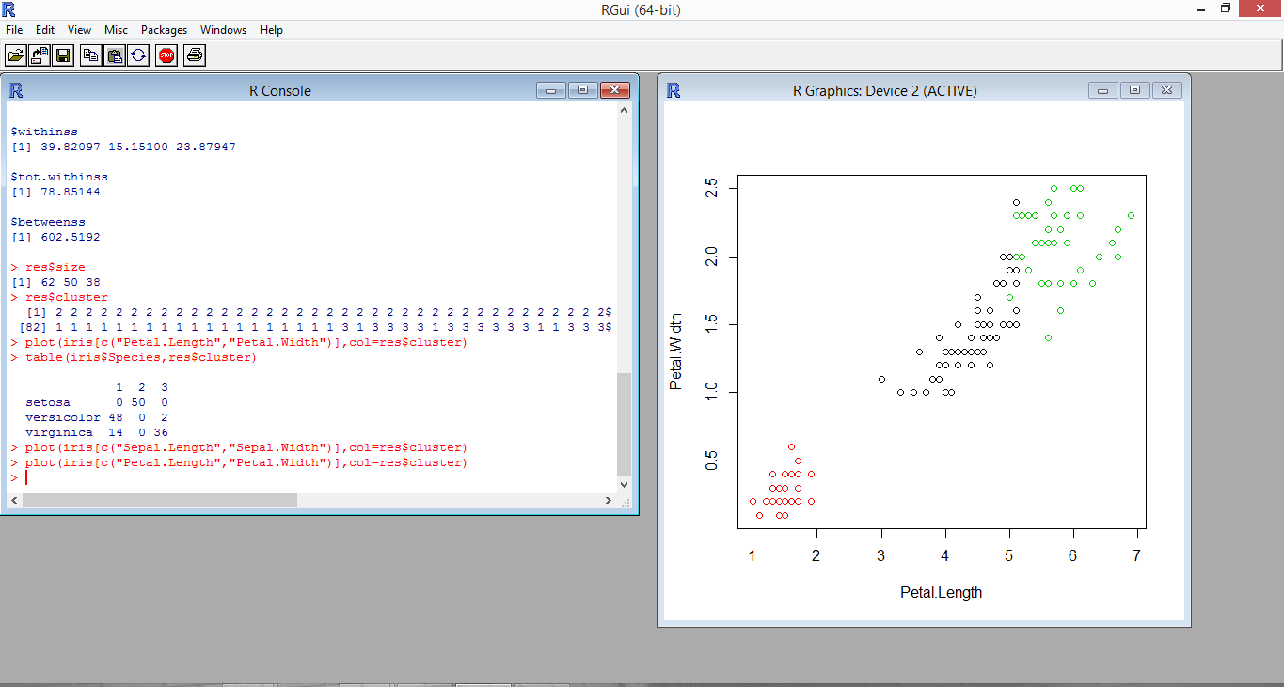

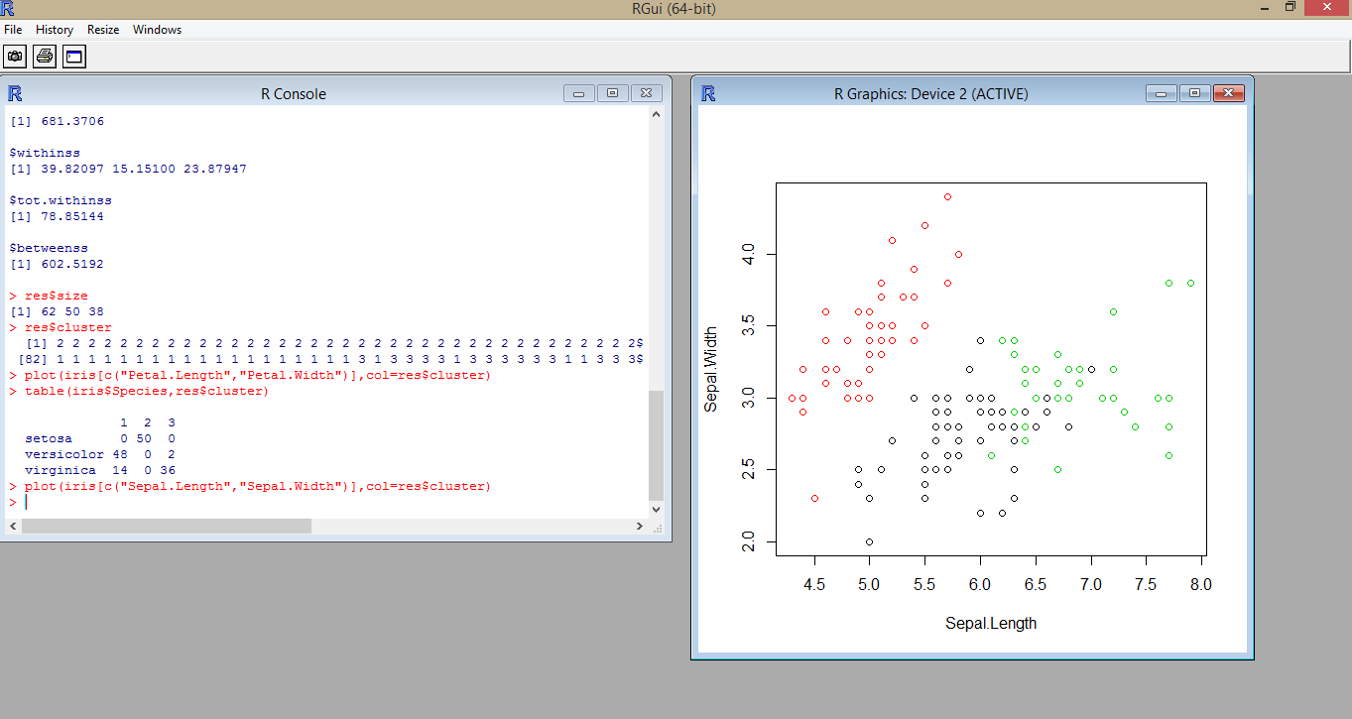

**Question 2:** Create a RoboMe and Watch App that uses weather or any API of choice.

**Description:** Created an Android Studio project using speech to text API which is in-built in Android Studio.

It accepts voice as input and converts into texts what has been said.

**Screenshot:**

