Report for Lab Assignment 3

**Question 1** : Prepare a dataset related to your own project and perform k-Means, k-Medians, Expectation Maximisation (EM), Hierarchical Clustering and report the results

**Description**: Used a medical dataset with various values like heart rate, BP, sugar level etc and performed kmeans, k median, EM, Hierarchical clustering using the inbuilt functions

**Screenshots:** K-means Clustering

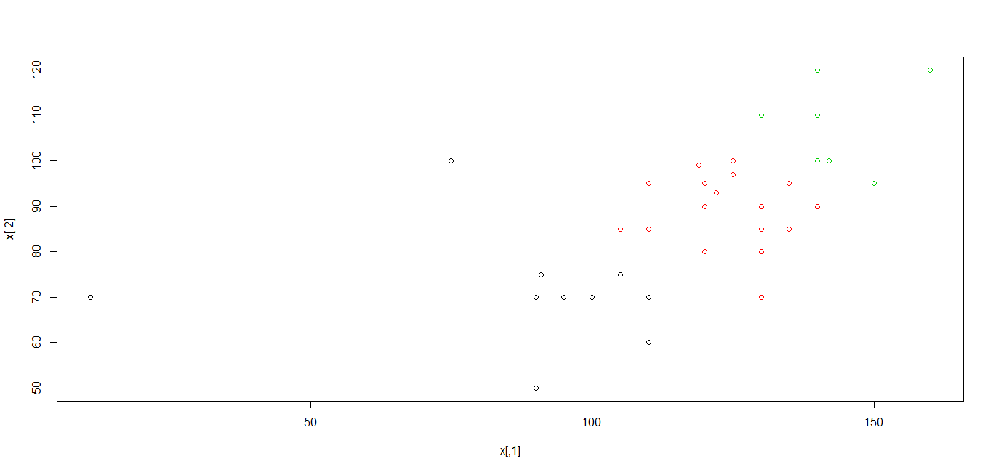Hierarchical Clustering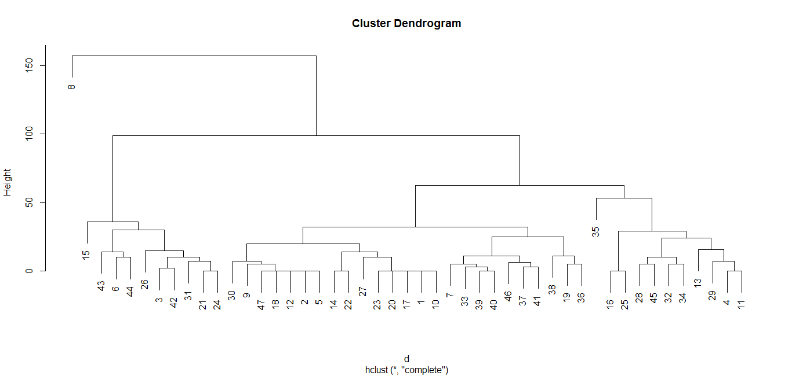

K-median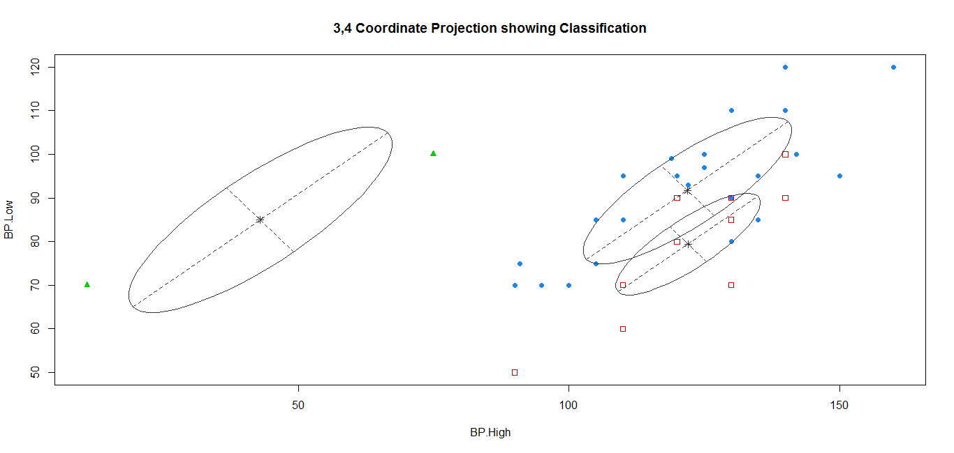

Expectation Maximization

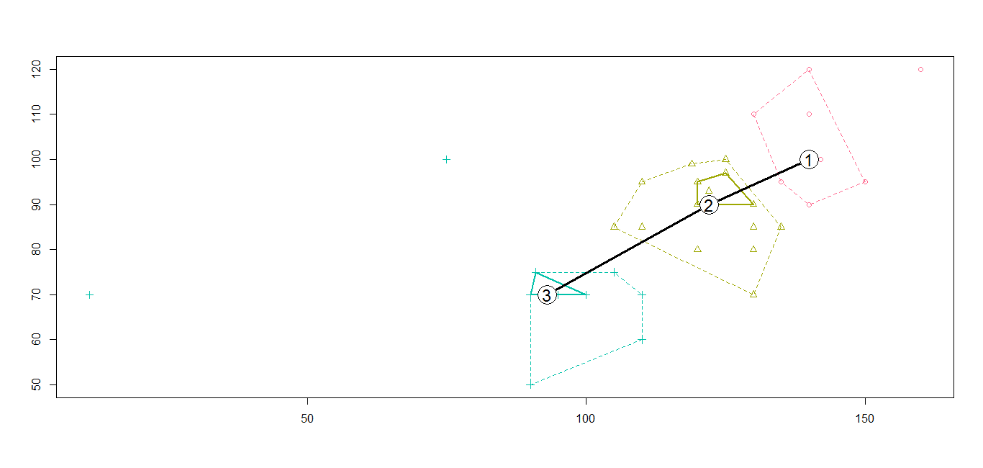

**Question 2:** Data collection related to your own project through Smart Phone and Watch, send notifications to watch using intuitive data analysis.

**Description:** Created an Android Studio project. It takes input as Text by the user.  
it has various inputs such as heart rate, Blood pressure, Sugar level etc and checks it with the normal level of the body reading to tell whether everything is normal or not as the end result.

For example, If the Blood pressure is above the normal level, then it will prompt as a Toast that “Blood pressure high”.

**Screenshot:**

