In this screenshot you can see entire data of the holidays file.

**Code:**

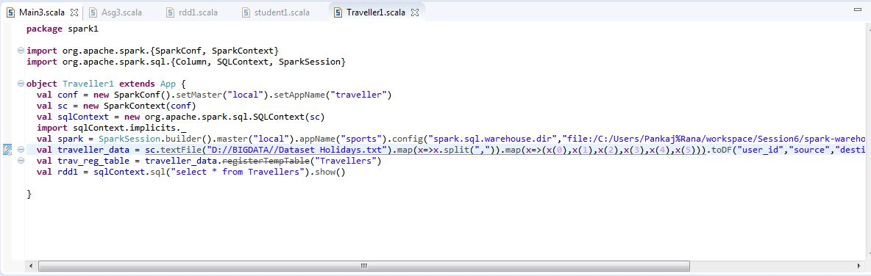

**Output:**

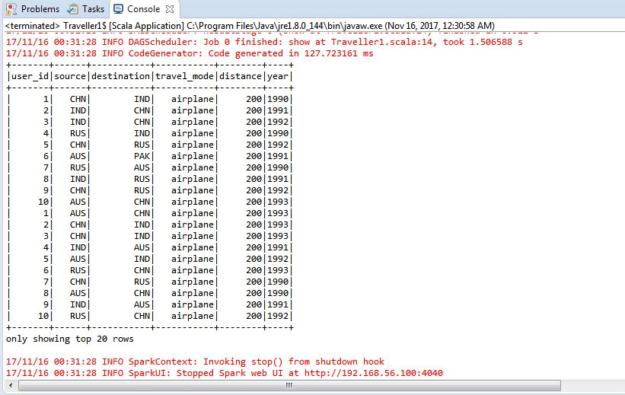

**1. What is the distribution of the total number of air-travelers per year?**

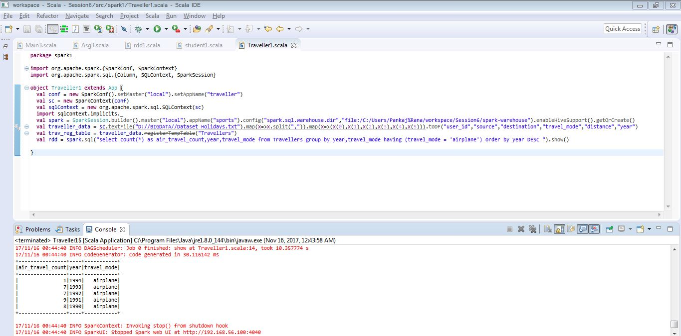

**2. What is the total air distance covered by each user per year?**

In this screenshot it has sum of air distance travelled by the each user per year.

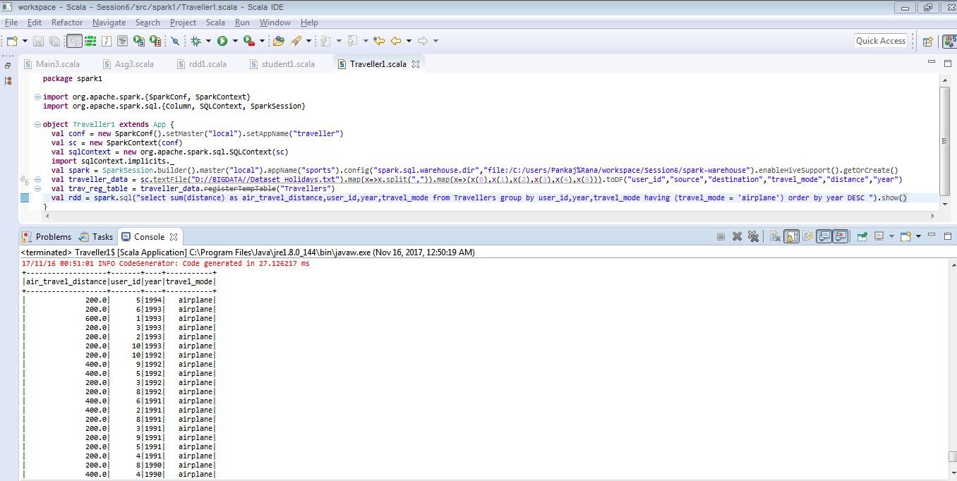

This screenshot has the aggregated result of total air distance travelled as per user wise.

3) Which user has travelled the largest distance till date?

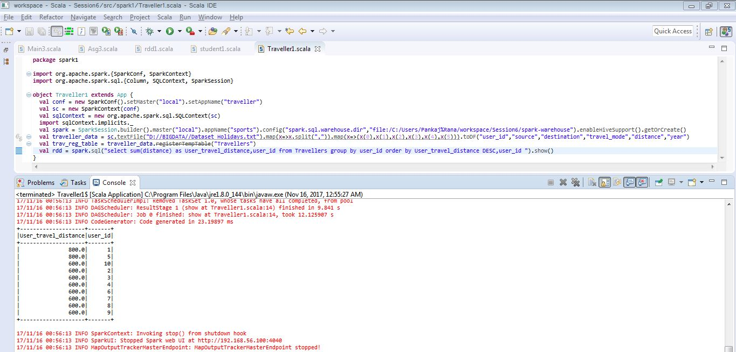

**Final Output:**

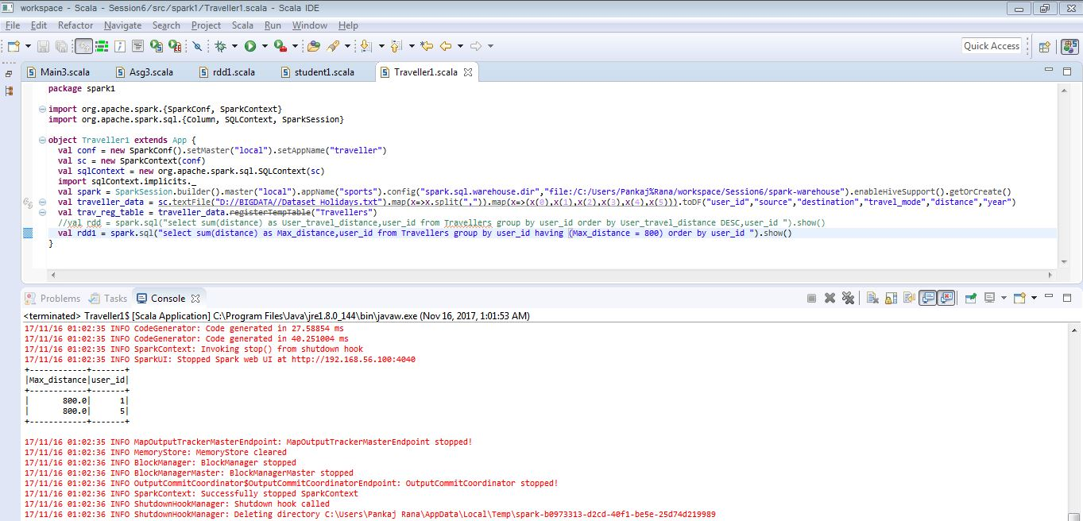

4) What is the most preferred destination for all users?

In this screenshot we can see visited count of destinations.

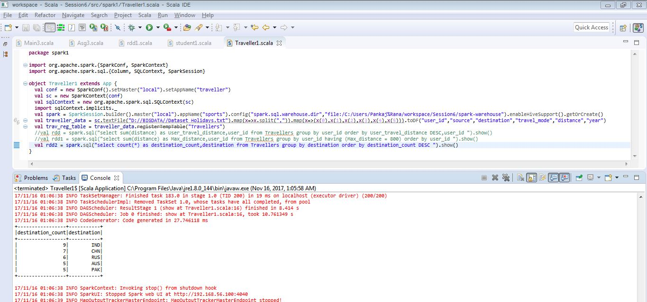

Here in this screenshot you can see the most preferred destination for all users.

