**1. Which route is generating the most revenue per year?**

*Here in this screenshot you can see the list of routes with their distances.*

*Code:*

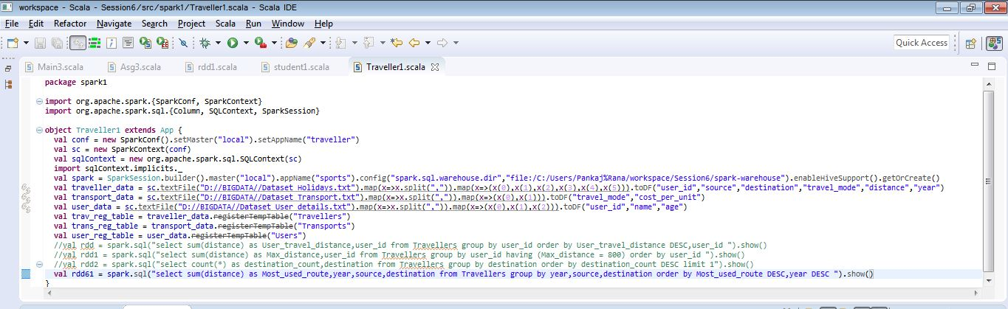

*Output:*

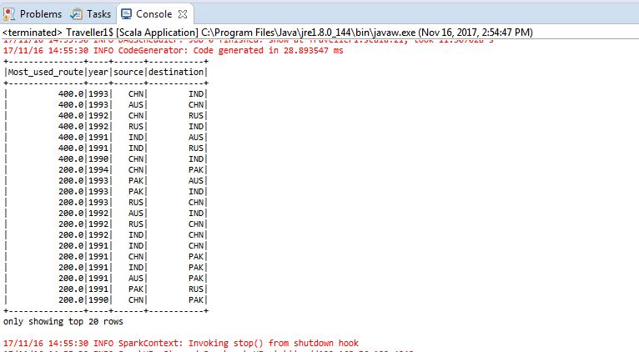

*In the below screenshot I had filtered the most used routes per year.*

*Code:*

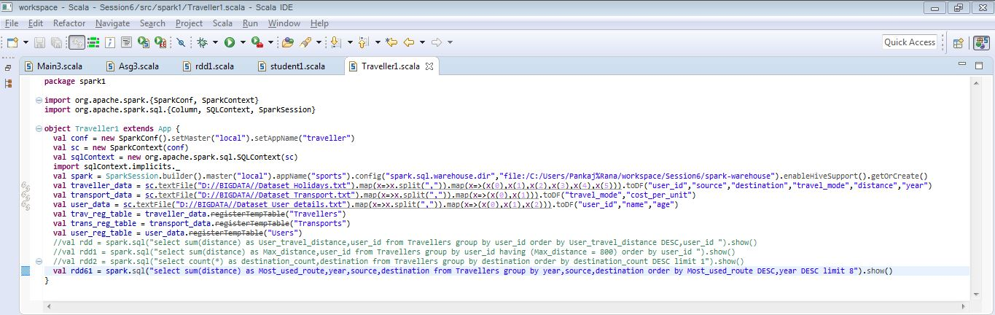

*Output:*

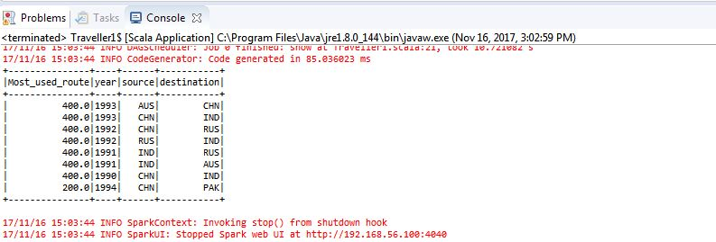

*In this one we can see the most revenue generated from these routes per year.*

*Code:*

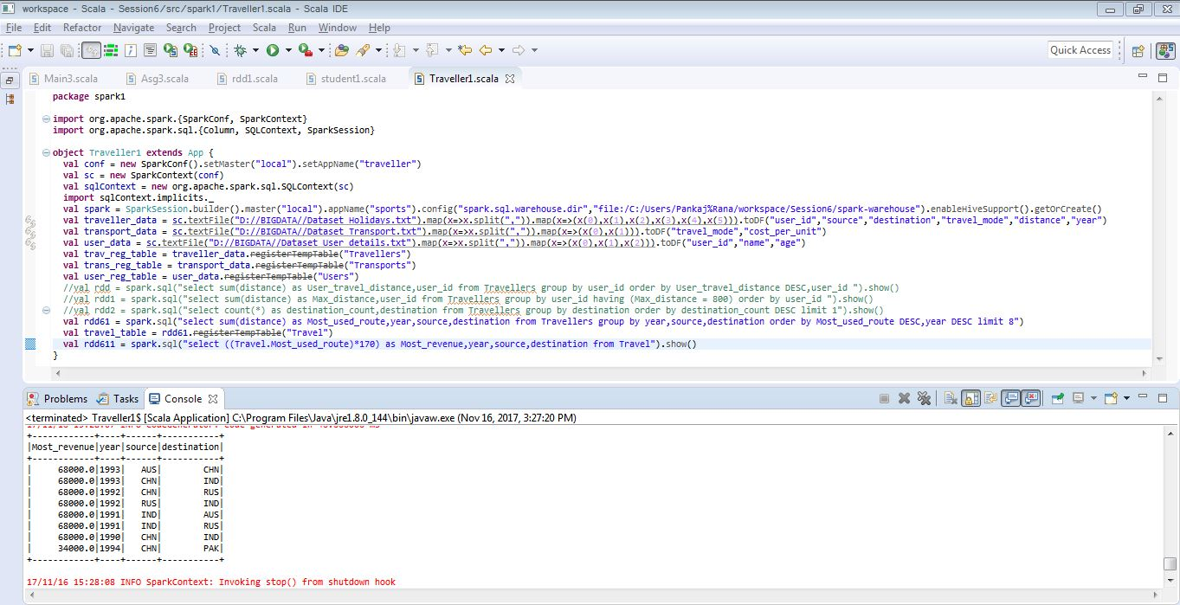

**2. What is the total amount spent by every user on air-travel per year**

*Here output is total distance covered per user per year.*

*Code:*

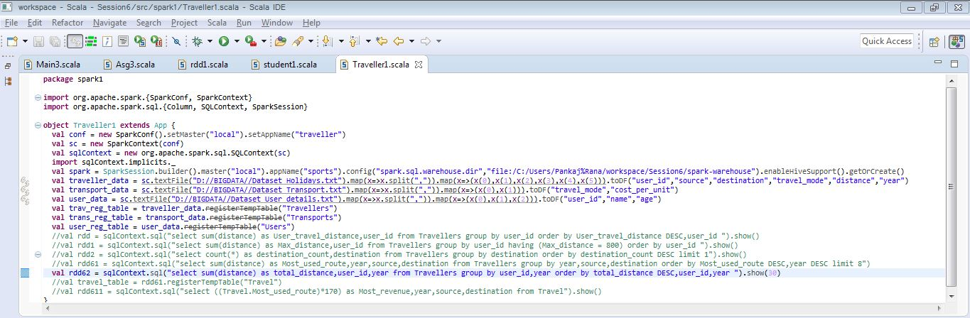

*Output:*

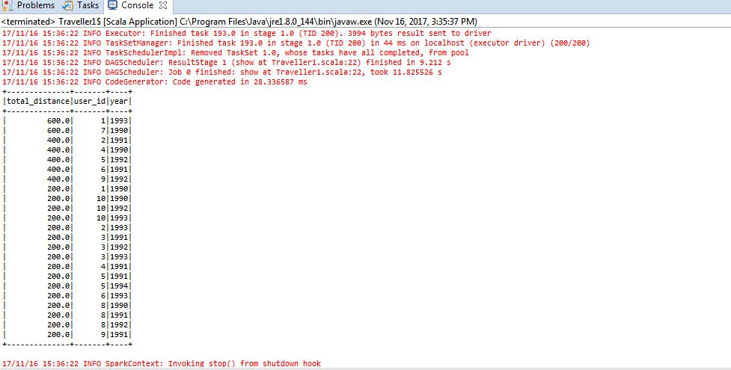

*In this below screenshot we can see the total amount (user_amount) spend by each user per year.*

*Code:*

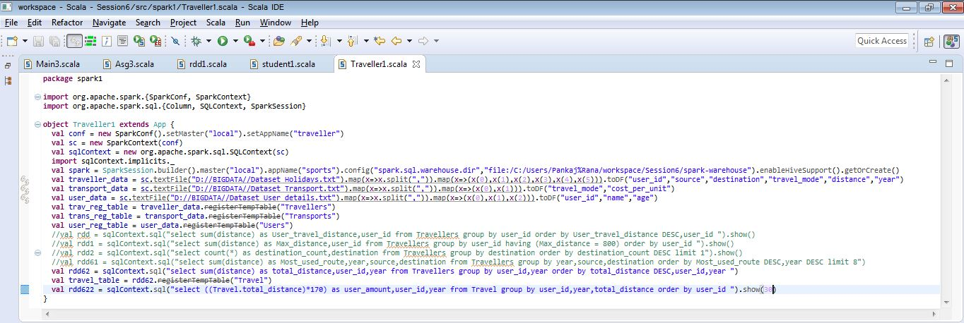

*Output:*

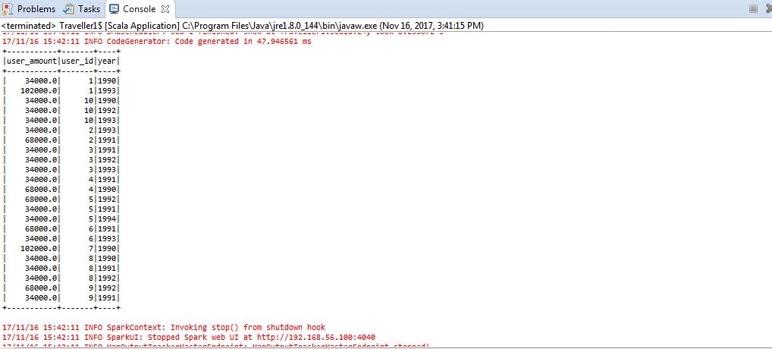

**3. Considering age groups of < 20, 20-35, 35 > which age group is travelling the most every year.**

*Code:*

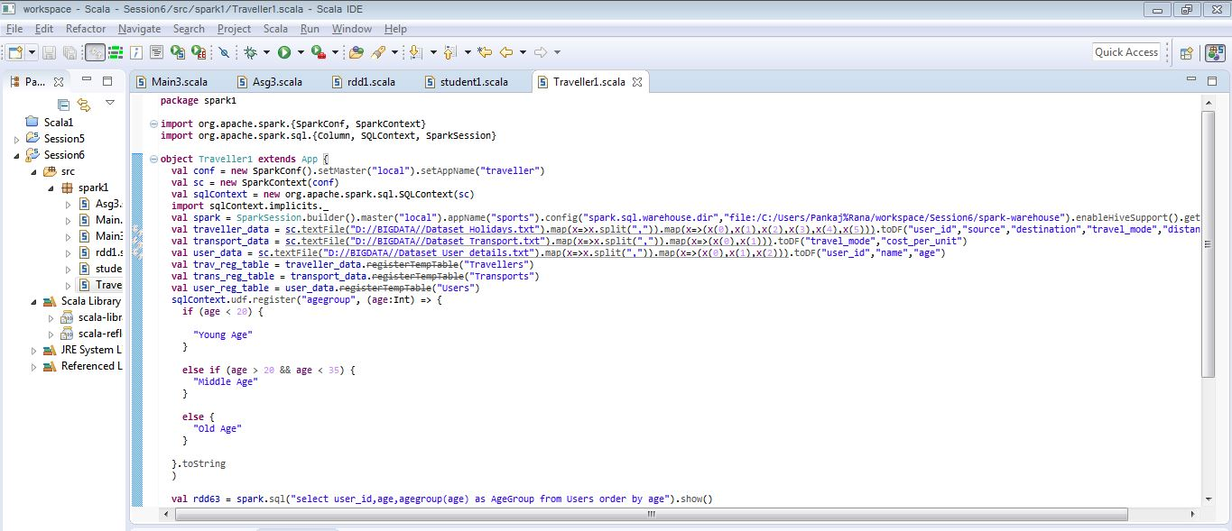

In the above screenshot we can see the users divided into age groups based on the criteria given as:

< 20 as Young Age, 20-35 as Middle Age, 35 > as Old Age

*Output:*

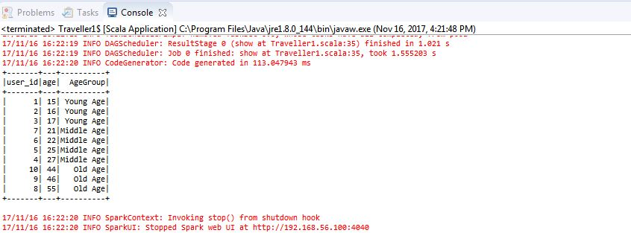

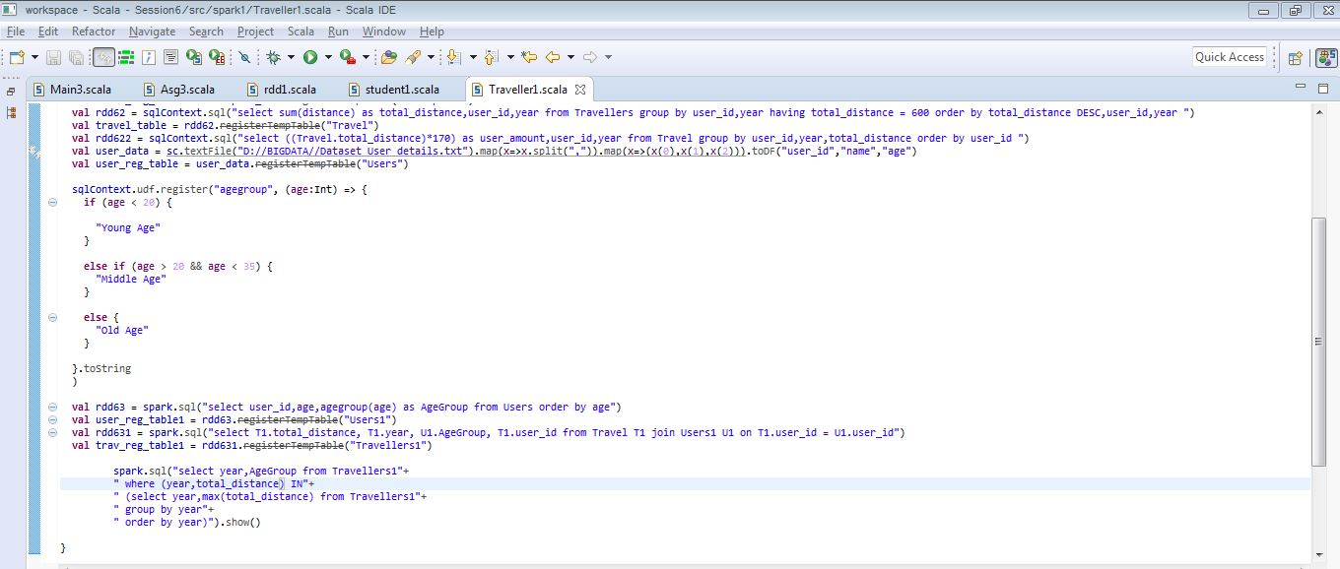

**Age group travelling the most every year.**

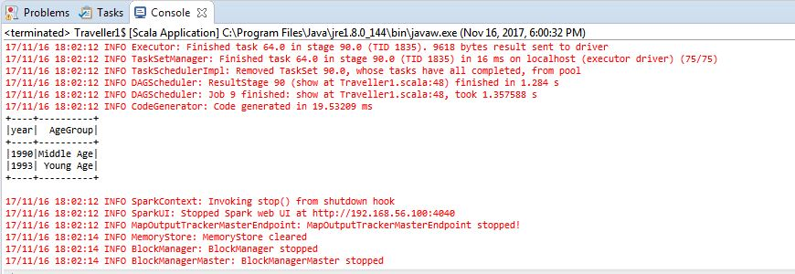

Here we got repetition of 2 years 1990, 1993 because user 2,6 for 1990 and 5,9 for 1993 has travelled max distance and they fall under same age group.