Angel Wings pack

# Table of Contents

Contents

Table of Contents 1

Overview 2

Flowing Trails 2

Bloom Effect 2

Glowing Feather 3

# Overview

Thank you for purchasing the Angel Wings pack! This document quickly goes through what was done to create some of the effects seen in this pack. It’s the first version, and with your feedback I would love to improve on this package; feel free to contact me at [sagesingularity@gmail.com](mailto:sagesingularity@gmail.com).

To view other packs I am working on, check out [sagesingularity.com](https://sagesingularity.com/2017/06/10/welcome-start-here/)!

# Flowing Trails

In Unity 5.5+, two features were added to the Shuriken particle system: Trails, and Noise. These two features are key to creating the wings in this pack. Noise creates the curves in the path of the trail, and Trails creates the actual trail itself. I shrunk the size of the actual particle itself until you either cannot see the particle, or it shows up as a small ‘sparkle’ emitting from the wings.

For Noise, I typically set it to Separate Axes and use positive Y, to negative Y.

For Trails, it’s important to set the color over lifetime to something like this:

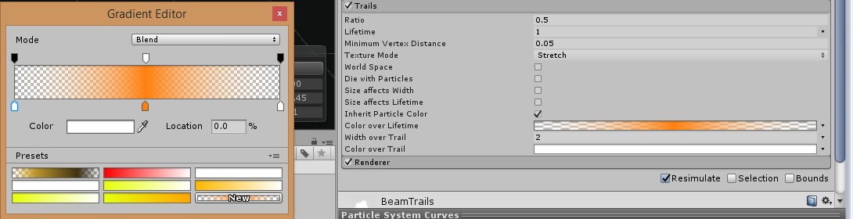

This is what lets the colors fade in and out over the lifetime of the particle, and prevents the trail from ‘popping’ in or out immediately. It also lets you ‘blend’ colors together using multiple systems!

# Bloom Effect

To add glow to the wings, I suggest importing the Standard Unity Image Effects and using the ‘Bloom’ script located in this package. You can do this by going to Assets -> Import Package -> Effects. Once you have the bloom script, you simply drag it onto the Main Camera in your scene. You can find lots of other effects to experiment with here too.

# Glowing Feather

The glowing feather is in itself, an entire particle system. The way it’s created is by emitting several additive/transparent feather particles without any speed/velocity. This creates a glowing effect like this:

