Requirements Engineering Report
Date: February 17th, 2016
Version: 1.0
Planning and requirements analysis for the Campus Quest mobile application



Team Members
Victoria Donelson, Project Manager
Bryan Silinski, Quality Assurance
Sierra Cockerill, Technical Lead

Team Members
Victoria Donelson, Project Manager
Bryan Silinski, Quality Assurance
Sierra Cockerill, Technical Lead

Contents
1. Introduction 1
1.1. Project Objective 1
1.2. Project Scope 1
1.3. Success Criteria 2
1.4. Collaboration with Stakeholders 2
2. Project Plan 3
2.1. Work Breakdown Structure (WBS) 3
2.2. Project Resources 3
2.3. Responsibility Matrix 3
2.4. Gantt Chart 3
2.5. Pert Chart 3
2.6. Cost Estimation 3
2.6.1. Function Point Estimation 3
2.6.2. Lines of Code Estimation 3
2.6.3. Cost Estimates 3
2.7. Risk Plan 3
2.8. Project Monitoring and Control Mechanisms 3
3. Requirements/Analysis Models 4
3.1. Major Software Functions 4
3.2. Use Case Diagrams 4
3.3. Use Case Descriptions (Fully Dressed) 4
3.4. Activity Diagrams 4
3.5. Sequence Diagrams 4
3.6. Requirements Class Models 4
3.7. Prototype Description 4
3.8. Data Dictionary 4
3.9. Limitations and Constraints 4
3.10. Non-functional Requirements 4
4. Problems Encountered 5
5. Bibliography 6

Introduction

Project Objective
Campus Quest will be a UNCW campus guide application for Android. The problem we are trying to solve is the confusion and/or inconvenience experienced by students, faculty/staff, and visitors when trying to find a building, bus stop, or place of interest at UNCW. Currently, all of this information is available on the UNCW website, but it is spread out across many pages and some information is difficult to find. The purpose of our application is to provide an easy and convenient solution to navigation for both new and experienced users on campus.
The main feature of our application will be to provide walking directions between buildings and/or parking lots. Users will choose a starting point and an ending point, and will be provided a customized map of the most direct route. Users will also be able to view a full map of campus, and can apply filters to place markers on bike racks, bus stops, and dining locations. We will incorporate the university’s live bus tracking system so that users can choose a route to see where the bus is in real time. Users will be able to tap on buildings to see a brief summary of useful information. They will also be able to choose from a list of “points of interest”, such as Financial Aid office, to zoom in on that location.

Project ScoPe
We will be developing our application in Android Studios with Google Maps implementation for the locational functionality. Google Maps automatically chooses endpoints for driving directions which are often inconvenient for walking, so we will be assigning custom coordinates to the main entrance of each building (some larger buildings may have two doors). We will pass in our custom coordinates when the user chooses a building so that directions are accurate for walking.
In order to highlight bicycle racks, we will walk around campus and make note of the coordinates of each rack. Google Maps will create custom markers according to these stored coordinates when the user activates the bike rack filter. We will be pulling from UNCW’s bus route tracking feature to allow users to see real-time bus locations.
We will be using Google Maps to create custom markers for buildings. Each marker will be in the form of the building’s initials when the user views the map, and when they tap on the initials there will be a pop-up window containing the building’s name, a brief description of its contents, and hours of business (if applicable). Dining locations will be emphasized by a special icon when the user chooses the Food filter. The user can then tap on one of the dining icons to see a brief description of the options (coffee, sandwiches, etc.) and hours of the chosen location.
Information for building summaries will likely be stored in an associative array or hash table within our code, and will be pulled for the appropriate building when chosen by the user. All code and documentation will be stored on Github.

Success Criteria
Campus Quest will be a functioning mobile application with the ability to provide directions and location information at UNCW. It will have a clean, attractive GUI that will be accessible for all ages and easy to learn how to use. Information will be accurate and thorough. The application will be of high enough value that any UNCW member or visitor we show it to will want to use it, as well as ourselves as students. It will be completed and delivered by April 22nd, 2016.

Collaboration with Stakeholders
In order to verify that all functionality will be worth including in our application, we will be conducting informal conversations with a variety of potential users. We will make sure to speak to at least some of each category of users – students, faculty/staff, and visitors or potential visitors. We may also speak with people who attend or have attended other colleges, to find out what functionality would be considered useful at universities in general. While adapting our software to other schools is beyond the scope of this project, it will be helpful to collect more diverse opinions.

Project Plan

Work Breakdown Structure (WBS)

Insert text of WBS.
Insert figure of WBS.

Project Resources

Responsibility Matrix
Task | Sierra Cockerill | Victoria Donelson | Bryan Silinski
Project Manager |  | X
Quality Assurance Lead |  |  | X
Technical Lead | X
Project Objective | X
Project Scope | X
Success Criteria | X
Collaboration with Stakeholders | X
Work Breakdown |  | X
Project Resources |  | X
Responsibility Matrix |  | X
GANTT Chart |  | X
PERT Chart |  | X
Cost Estimation |  | X
Risk Plan |  | X
Project Monitoring |  | X
Control Mechanisms |  | X
Major Software Functions |  |  | X
Use Case Diagrams |  |  | X
Use Case Descriptions |  |  | X
Activity Diagrams |  |  | X
Sequence Diagrams |  |  | X
Requirements Class Models |  |  | X
Prototype Description | X
Data Dictionary |  |  | X
Limitations and Constraints |  |  | X
Non-functional Requirements |  |  | X
Problems Encountered | X
Bibliography | X
Software Design | X | X | X
Implementation | X | X | X
Testing | X | X | X

Gantt Chart
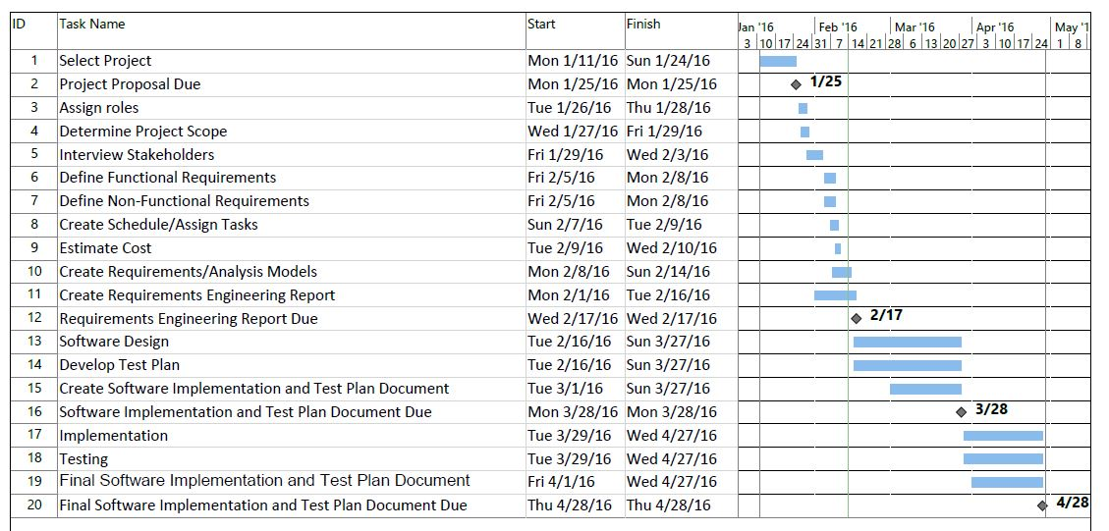

Pert Chart

Cost Estimation

Function Point Estimation

Lines of Code Estimation

Cost Estimates

Risk Plan

Project Monitoring and Control Mechanisms

Requirements/Analysis Models

Major Software Functions

Use Case Diagrams

Use Case Descriptions (Fully Dressed)

Activity Diagrams

Sequence Diagrams

Requirements Class Models

Prototype Description
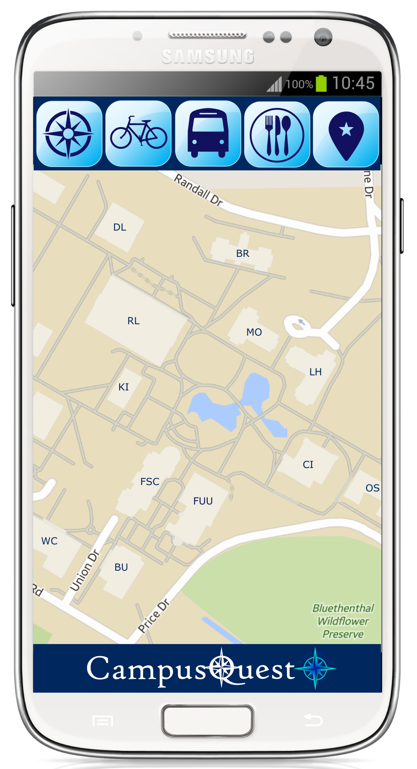
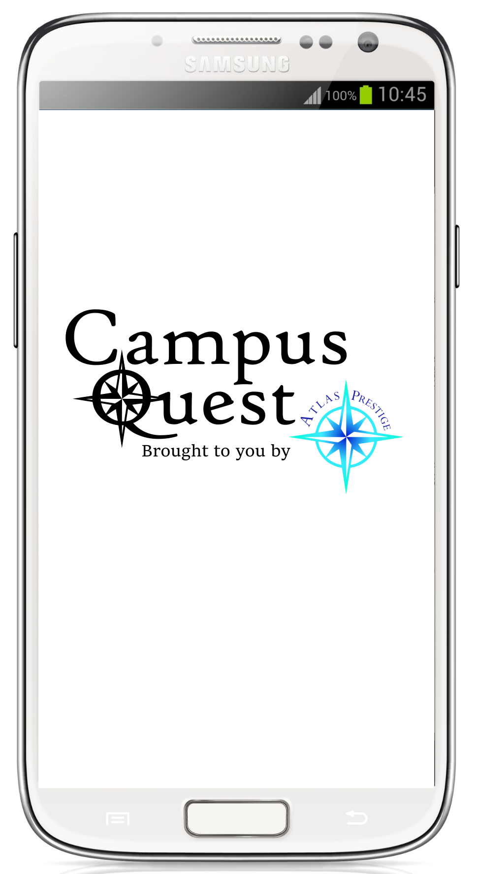
Campus Quest will have a GUI similar to the prototype mock-ups below:

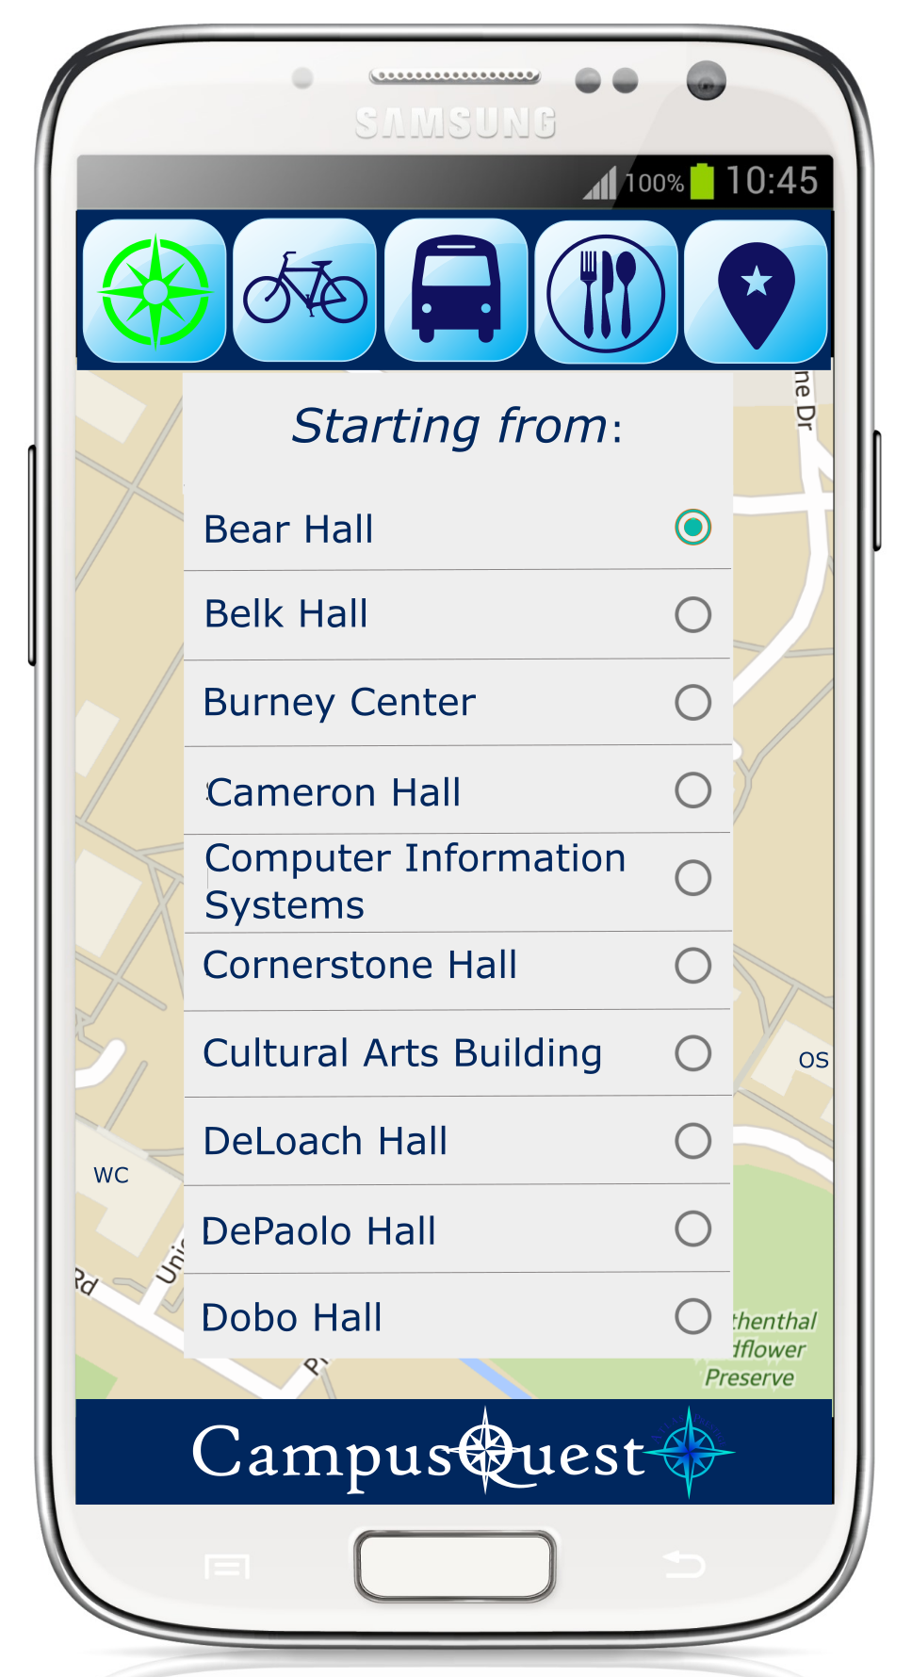
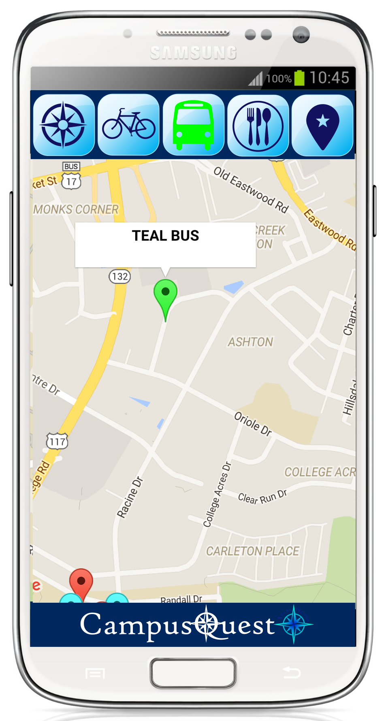

Data Dictionary

Limitations and Constraints

Non-functional Requirements

Problems Encountered
Our first official planning meeting was limited by one team member being sick. However, we were able to use Slack to communicate, and caught up between classes.
The UNCW bus tracking system is fairly unreliable and several routes often do not show up. Unfortunately we cannot do anything about this since it relies on the individual buses’ GPS systems.
One team member only has a desktop computer, which slightly limits our ability to work all at the same time. This is circumvented by using Github to store all our files, so we can always pull current files to whoever’s laptops are being used. He also plans on setting up his computer so he can remote in from the library when necessary.

Bibliography

