Software Implementation and Test Plan
Date: April 27th, 2016
Final implementation document for the Campus Quest mobile application


Team Members:
Victoria Donelson, Project Manager
Bryan Silinski, Quality Assurance
Sierra Cockerill, Technical Lead

Team Members
Victoria Donelson, Project Manager
Bryan Silinski, Quality Assurance
Sierra Cockerill, Technical Lead

Contents
Team Members 0
1. Introduction 1
1.1. Project Objective 1
1.2. Project Scope 1
1.3. Success Criteria 2
1.4. Collaboration With Stakeholders 2
1.5. Security, Ethical and Legal Issues 3
1.6. Societal Impact 3
2. Project Plan 4
2.1. Work Breakdown Structure (WBS) 4
2.2. Project Resources 5
2.3. Responsibility Matrix 6
2.4. Gantt Chart 7
2.5. Pert Chart 8
2.6. Cost Estimation 9
2.6.1. Function Point Estimation 9
2.6.2. Lines of Code Estimation 11
2.6.3. Cost Estimates 12
2.7. Risk Plan 13
2.8.1 Project Monitoring and Control Mechanisms 14
2.8.2 Possible Performance Issues 14
3. Requirements/Analysis Models 15
3.1. Major Software Functions 15
3.2. Use Case Diagrams 16
3.3. Use Case Descriptions (Fully Dressed) 17
3.4. Activity Diagrams 21
3.5. Sequence Diagrams 22
3.6. Requirements Class Models 23
3.7. Prototype Description 24
3.8. Data Dictionary 25
3.9. Limitations and Constraints 29
3.10. Non-functional Requirements 30
4. Design Models 31
4.1. Architectural Design Model 31
4.3. UML Class Diagrams 32
4.4. User Interface Design 33
4.5. Design Patterns 34
4.6. Handling Non-Functional Requirements 35
5. Test Plan 36
1.1. Static Testing 36
1.1.1. Style Guidelines 36
1.1.2. Software Metrics 36
1.2. Black and White Box Testing 36
6. Major Software Functions 37
6.1. Implemented Functions 37
6.2. Unimplemented Functions 37
7. Problems Encountered 38
8. Bibliography 39

Introduction

Project Objective
Campus Quest will be a UNCW campus guide application for Android. The problem we are trying to solve is the confusion and/or inconvenience experienced by students, faculty/staff, and visitors when trying to find a building, bus stop, or place of interest at UNCW. Currently, all of this information is available on the UNCW website, but it is spread out across many pages and some information is difficult to find. The purpose of our application is to provide an easy and convenient solution to navigation for both new and experienced users on campus.
The main feature of our application will be to provide walking directions between buildings and/or parking lots. Users will choose a starting point and an ending point, and will be provided a customized map of the most direct route. Users will also be able to view a full map of campus, and can apply filters to place markers on bike racks, bus stops, and dining locations. We will incorporate the university’s live bus tracking system so that users can choose a route to see where the bus is in real time. Users will be able to tap on buildings to see a brief summary of useful information. They will also be able to choose from a list of “points of interest”, such as Financial Aid office, to zoom in on that location.

Project Scope
We will be developing our application in Android Studios with Google Maps implementation for the locational functionality. Google Maps automatically chooses endpoints for driving directions which are often inconvenient for walking, so we will be assigning custom coordinates to the main entrance of each building (some larger buildings may have two doors). We will pass in our custom coordinates when the user chooses a building so that directions are accurate for walking.
In order to highlight bicycle racks, we will walk around campus and make note of the coordinates of each rack. Google Maps will create custom markers according to these stored coordinates when the user activates the bike rack filter. We will be pulling from UNCW’s bus route tracking feature to allow users to see real-time bus locations.
We will be using Google Maps to create custom markers for buildings. Each marker will be in the form of the building’s initials when the user views the map, and when they tap on the initials, there will be a pop-up window containing the building’s name, a brief description of its contents, and hours of business (if applicable). Dining locations will be emphasized by a special icon when the user chooses the Food filter. The user can then tap on one of the dining icons to see a brief description of the options (coffee, sandwiches, etc.) and hours of the chosen location.
Information for building summaries will likely be stored in an associative array or hash table within our code, and will be pulled for the appropriate building when chosen by the user. All code and documentation will be stored on GitHub.

Success Criteria
Campus Quest will be a mobile application with the ability to accurately provide directions at UNCW along with location information for dining, bus routes, bike racks, and points of interest. It will have a clean, attractive GUI that will be accessible for all ages and easy to learn how to use. The application will be of high enough value that any UNCW member or visitor we show it to will want to use it, as well as ourselves as students. It will be completed and delivered by April 22nd, 2016.

Collaboration With Stakeholders
In order to verify that all functionality will be worth including in our application, we have been conducting informal conversations with a variety of potential users. Here is some of the feedback we have received:
From fellow students:
- Would be very helpful when locating new classes, especially freshman year
- It would be great to be able to see “hidden” (behind buildings, etc) bike racks during rush times
- Most have a good idea where dining locations are, but would appreciate having the hours and brief summaries easily accessible
- “My parents would have loved the point of interest feature during orientation”
From a staff member:
- Would not have much use for bus and bike information
- For new hires, the directions features would make their new job transition much easier
From graduates of other schools:
- Would have saved a lot of time being lost on campus freshman year
- Bus route information was inconvenient to access while moving around, would have appreciated something like this
- Would have been convenient to have directions to hard-to-find places like Financial Aid office, Student Accounts, etc. in an easily accessible place

1.5. Security, Ethical and Legal Issues
Our application will require a relatively short list of permissions for users to agree to before installation. It will require the standard terms of service such as call information in order to allow users to receive phone calls while using the app. If we are able to implement a “From Your Location” option for directions, it will need to ask for permission to get the user’s location. However, we do not have any potential security or ethical issues because we are not implementing any kind of login or saved data.

1.6. Societal Impact
We believe Campus Quest will have a positive impact on the UNCW campus. All students will have reduced stress at the beginning of the semester finding their new classes, freshmen will more quickly gain knowledge of dining options, parents and visitors will have less confusion trying to find points of interest, and all participants will have a smoother transportation experience due to bike rack locations and bus tracking. This will contribute to the promotion of peace and reduction of anxiety for all users.

Project Plan

Work Breakdown Structure (WBS)
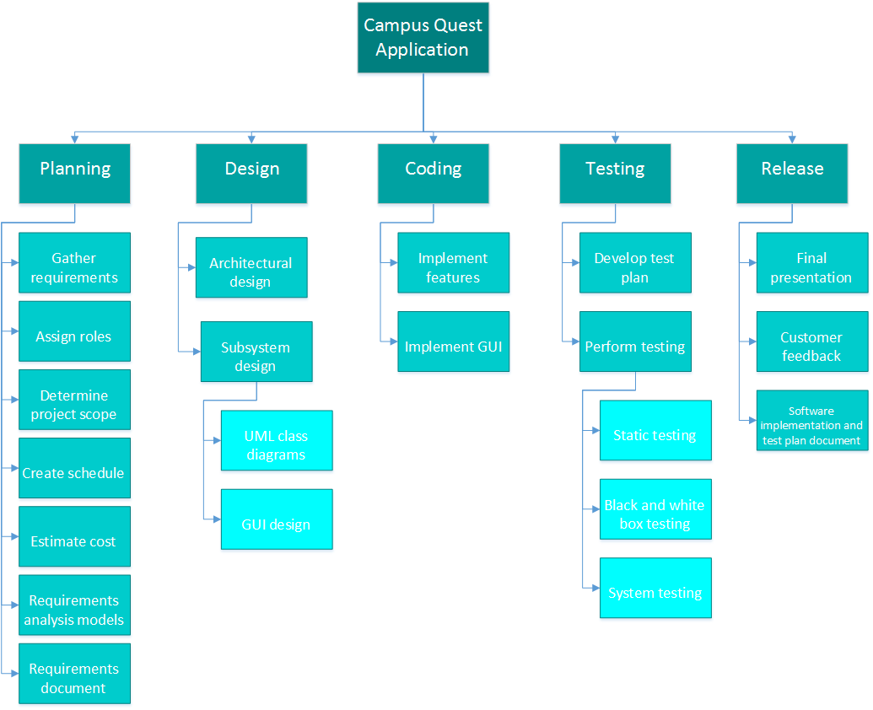

Project Resources
Name | Description | Price
Cost of labor | Software design, implementation and testing | $24,538
Android Studio | IDE for Android application development | Free
Microsoft Project | Necessary for project management, organization and scheduling | $590.00
Microsoft Visio | Required to create use case, UML and other types of diagrams | $590.00
Inkscape | Graphics editor used to create illustrations and logos for GUI | Free
Android phones | 3 phones required for testing | $1800.00
 | Total cost = $27,518

We will require a total of $27,518 to develop the Campus Quest application. We will need Microsoft Project for project management, organization and scheduling. Microsoft Visio will be required to create various diagrams necessary for software development. Each application costs $590.00. Android Studio is required to create code for the application. We will use open-source graphics editor Inkscape to create necessary graphics for the project. Both Android Studio and Inkscape are free. In addition, three Android phones will be needed for testing purposes (one phone for each software developer).

Responsibility Matrix
Task | Sierra Cockerill | Victoria Donelson | Bryan Silinski
Project Manager |  | X
Quality Assurance Lead |  |  | X
Technical Lead | X
Project Objective | X
Project Scope | X
Success Criteria | X
Collaboration with Stakeholders | X
Work Breakdown |  | X
Project Resources |  | X
Responsibility Matrix |  | X
GANTT Chart |  | X
PERT Chart |  | X
Cost Estimation |  | X
Risk Plan |  | X
Project Monitoring |  | X
Control Mechanisms |  | X
Major Software Functions |  |  | X
Use Case Diagrams |  |  | X
Use Case Descriptions |  |  | X
Activity Diagrams |  |  | X
Sequence Diagrams |  |  | X
Requirements Class Models |  |  | X
Prototype Description | X
Data Dictionary |  |  | X
Limitations and Constraints |  |  | X
Non-functional Requirements |  |  | X
Problems Encountered | X
Bibliography | X
Software Design | X | X | X
Implementation | X | X | X
Testing | X | X | X

Gantt Charts

2.4.1 Original Estimate

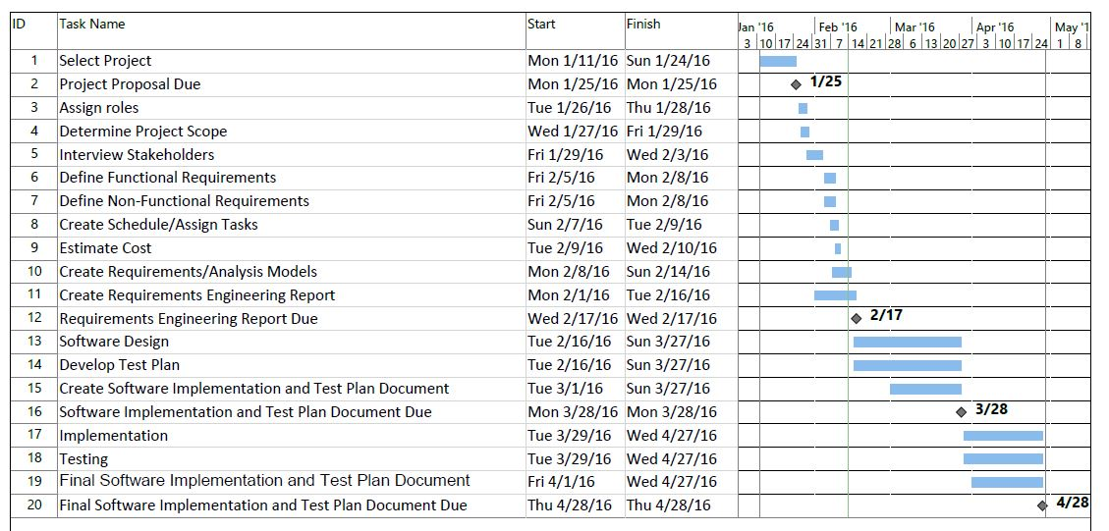

2.4.2 Actual Schedule Performance
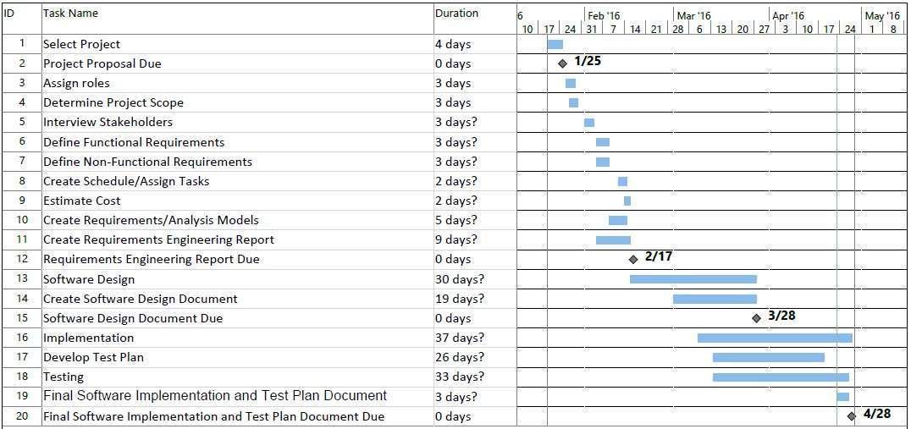

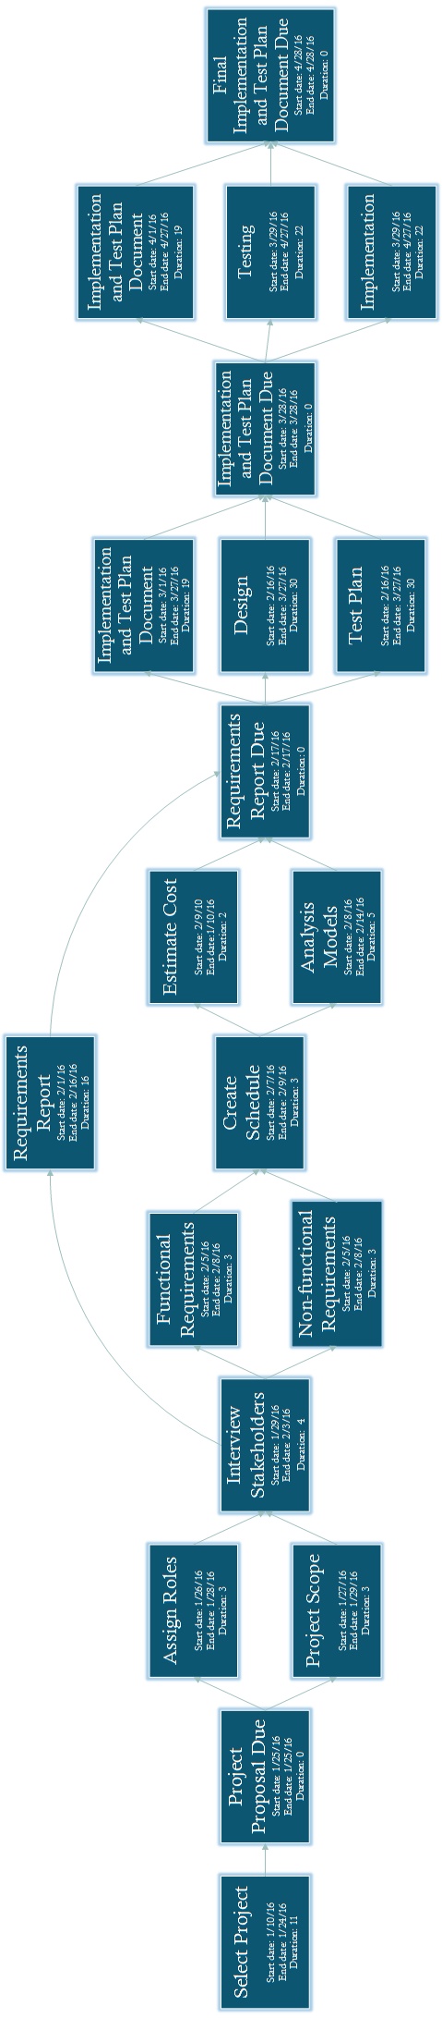
Pert Chart

Cost Estimation

Function Point Estimation
Information Domain Value | Count |  | Weighting Factor |  |  |  | FP Count
Information Domain Value | Count |  | Simple | Average | Complex |  | FP Count
External Inputs (EIs) | 2 | X | 3 | 4 | 6 | = | 6
External Outputs (EOs) | 9 | X | 4 | 5 | 7 | = | 45
External Inquiries (EQs) | 1 | X | 3 | 4 | 6 | = | 3
Internal Logical Files (ILFs) | 5 | X | 7 | 10 | 15 | = | 50
External Interface Files (EIFs) | 0 | X | 5 | 7 | 10 | = | 0
Count Total 104

Backup and recovery | 0
Data communications | 3
Distributed processing | 0
Performance critical | 4
Existing operating environment | 2
Online data entry | 1
Input transaction over multiple screens | 0
Master files updated online | 0
Information domain values complex | 3
Internal processing complex | 2
Code designed for reuse | 1
Conversion/installation in design | 5
Multiple installations | 0
Application designed for change | 1
Total | 22
0 (not important or applicable) to 5 (absolutely essential).

Using Pressman’s function point estimation equation, we calculate the number of FP to be 90.48:
FP = 104 X [0.65 + 0.01 X 22] = 90.48
According to Pressman, one FP translates into 60 lines of code. Thus, our application will contain 5,428 LOC. We assume our productivity rate to be 15 FP/pm. Since there are three of us, we can produce 45 FP/pm. Therefore, it will take us 2.01 months to complete the project. Assuming a labor rate of $5500 per person-month, the total labor cost of the project will be $33,165 (3 programmers * $5500 * 2.01).

Lines of Code Estimation
Functions | Optimistic estimate | Pessimistic estimate | Estimated LOC
User interface | 1000 | 2000 | 1500
Directions | 100 | 300 | 200
Bus tracking | 200 | 500 | 350
Filters | 100 | 300 | 200
Information pop-ups | 50 | 200 | 125
Total |  |  | 2375

We estimate our application to contain 1775 LOC, judging by approximate comparison to previous projects we have worked on. Assuming the average productivity rate of 620 LOC/person-month, it will take us 1.28 months to produce the application. Assuming a labor rate of $5500 per person-month, the total labor cost of the application will be $21,120 (3 programmers * $5500 * 1.28).

Cost Estimates
COCOMO II
Object type | Quantity | Weight | Total
Screens | 5 | 2 | 10
Reports | 4 | 5 | 20
Components | 4 | 7 | 28
Total object points |  |  | 58

NOP (new object points) = 58 X [(100 - %reuse)/100] = 58 X 1 = 58 (reuse = 0%)

PROD (productivity rate) = NOP/Person-Month
PROD = 58/13 Person-Month (Assuming Nominal PROD = 13)

Estimated effort = NOP/PROD
Effort = 58/13 Person-Month = 4.46 Person-Months

COCOMO II estimates that it will take 4.46 person-month to complete the project. Since there are 3 of us, it will take 1.487 months produce the application. Assuming a labor rate of $5500 per person-month, the total labor cost of the application will be $24,538 (3 programmers * 1.487 * $5500).

We will use COCOMO II results as our cost estimate because it is close to the average of all three models.

2.6.4 Final Evaluation of Cost Estimation

Risk Plan
Risks | Category | Probability | Impact | RMMM
Losing team member | ST | 30% | 3 | Distribute the workload between other team members
Computers crash | TE | 20% | 4 | Use computers at the library
Project takes longer than expected | PS | 30% | 2 | Put in more hours until we catch up
Failure to implement one or more features due to unforeseen problems | TE | 15% | 2 | Create a new feature somewhat related to the unimplemented feature for substitution
Lack of technical skills (steep learning curve) | ST | 10% | 3 | Find an experienced person who can teach the whole team the necessary skills in a short period of time

Risk Categories:
PS - Project size risk TE - Technology Risk ST – Staff Size and Experience Risk
Impact Values: 1 - Catastrophic 2 - Critical 3 - Marginal 4 - Negligible

2.8.1 Project Monitoring and Control Mechanisms
We believe that communication and the ability to collaborate is the key to the success of the project. Team members will use email, text messaging, and instant messaging application Slack to communicate with each other. Team members will also meet face-to-face once or twice a week. During these meetings, the project manager will make sure all team members know exactly what tasks they are responsible for, check the progress of the team to make sure the project is on schedule and take necessary actions if the project is behind schedule. In addition, every team member will go over completed tasks, ask for feedback, and make changes if necessary. This will keep everybody updated on every aspect of the project and help the project manager to make sure everybody adheres to the schedule. Team members will use GitHub to ensure that every team member has the latest version of all documents and source code.

2.8.2 Possible Performance Issues
Campus Quest will need an internet connection in order to perform most tasks. Its speed and responsiveness will be limited by the speed of the local network or phone internet service provider. Campus Quest largely depends on Google Maps. Therefore, any Google Maps performance issues will directly affect our application. Our application also uses Wave Transit Real-Time Bus Tracking web site to track buses and display bus routes. Unfortunately, not all buses are equipped with GPS trackers, or not all trackers are functional. A lot of the information provided by Campus Quest cannot be updated automatically. For example, in case of a bike rack removal or installation, or location change of point of interest, that information will have to be manually updated. Therefore, it may not always be up-to-date.

Requirements/Analysis Models

Major Software Functions

- Display Bus Routes
  - Choose route to display
- Get Directions
  - Enter start location from drop-down menu
  - Enter destination from drop-down menu
- Display Bike Racks
  - Press map marker to highlight bike racks
- Display Food Options
  - Press map marker for additional information on food options
- Find Building/ Point of Interest
  - Select building/point of interest from drop-down menu

Use Case Diagrams

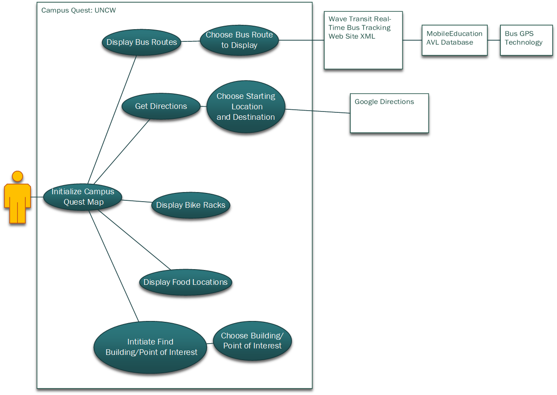

Use Case Descriptions (Fully Dressed)
USE CASE: 1 | Bus Tracking
Primary actor | User
Goal in Context | The user not only wants to see the bus routes and stops, but the user also would like to see the position of the bus.
Preconditions | The user must be connected to the internet via Wi-Fi or using mobile data in order to pull from the Wave Bus-Tracking website.
Success End Condition | User successfully sees the Google Maps marker where the bus is located.
Failed End Condition | - User is not connected to the internet and cannot pull data from the website  - User is unable to see the bus-tracking data due to the absence of bus GPS data
Trigger | User decides to see the bus-tracking data
Scenario | Step | Action
 | 1 | User taps the bus icon on the main map screen.
 | 2 | User chooses which bus routes they would prefer to see.
 | 3 | User clicks “Go”
 | 4 | System displays route information and bus stops.
 | 5 | System pulls latitude and longitude coordinates of buses that the user selected from the Wave Bus-Tracking website.
 | 6 | System displays bus position.
 | 7 | System updates bus position every thirty seconds.
Priority | Medium
Frequency | On Demand
Exceptions | None.
Open Issues | 1) How to handle letting the user know that no bus GPS data for the chosen routes is available.  2) How to alert the user know that they are not connected to the internet.

USE CASE: 2 | Display Bike Racks
Primary actor | User
Goal in Context | The map will add map markers where bike racks are located around campus
Preconditions | System has known bike rack coordinates.
Success End Condition | The bike racks are displayed on the map at the accurate location.
Failed End Condition | - Bikes racks do not appear on the screen.  - Bike racks appear in inaccurate locations.  - A bike rack has been physically removed or installed (information is outdated)
Trigger | User decides to tap on the bike logo and view the bike rack locations
Scenario | Step | Action
 | 1 | User taps the bike icon from the main map screen.
 | 2 | System changes map screen to show bike racks.
Priority | Medium
Frequency | On Demand
Exceptions | None.
Open Issues | - We need to collect the positional data in order to display the bike racks accurately.  - Need to make the map updates fast enough to correspond with the changing of the filter logo so that it may be switched on and off rapidly if needed.

Activity Diagrams

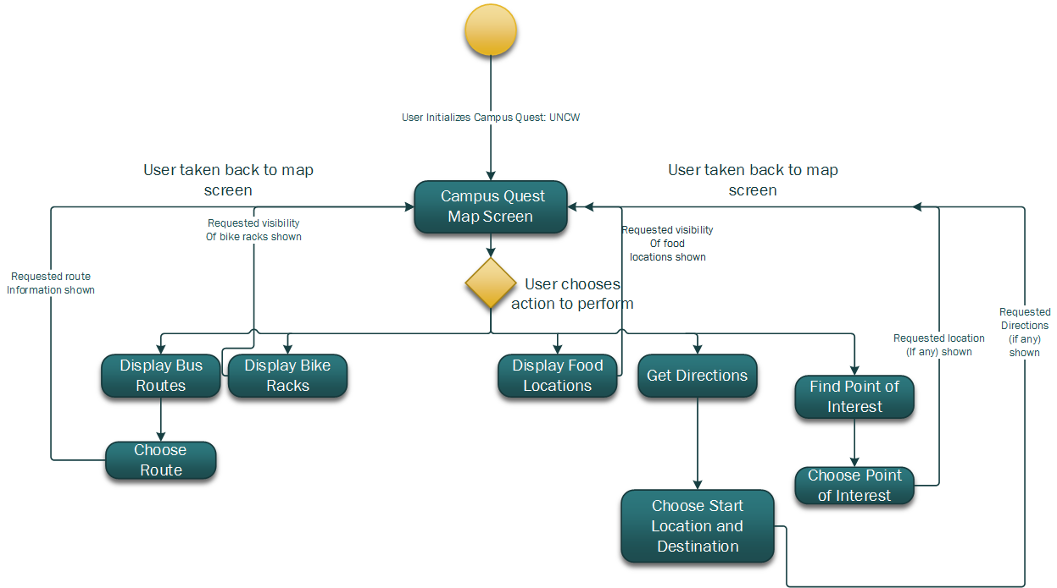

Sequence Diagrams

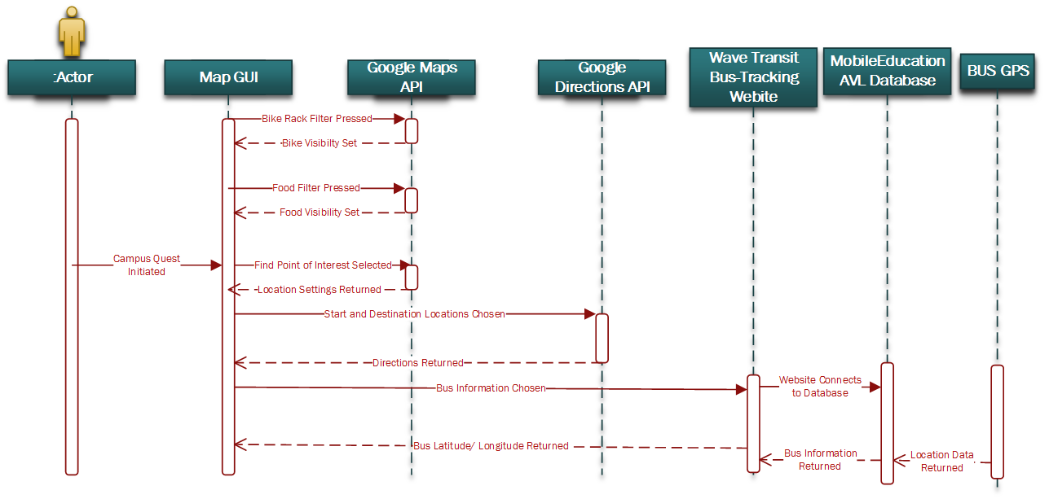

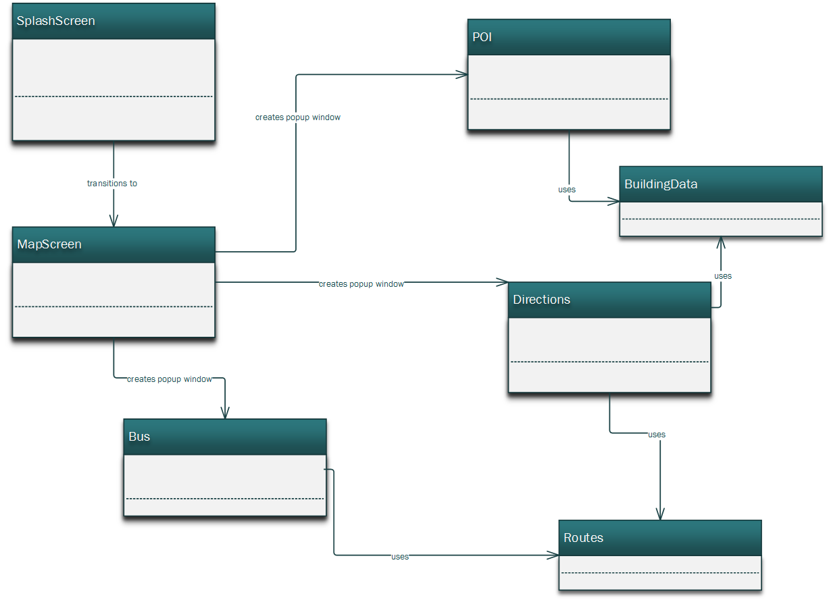
Requirements Class Models

Prototype Description
Campus Quest will have a GUI similar to the prototype mock-ups below:
Figure 1: Splash Screen
Figure 2: Main Map Screen
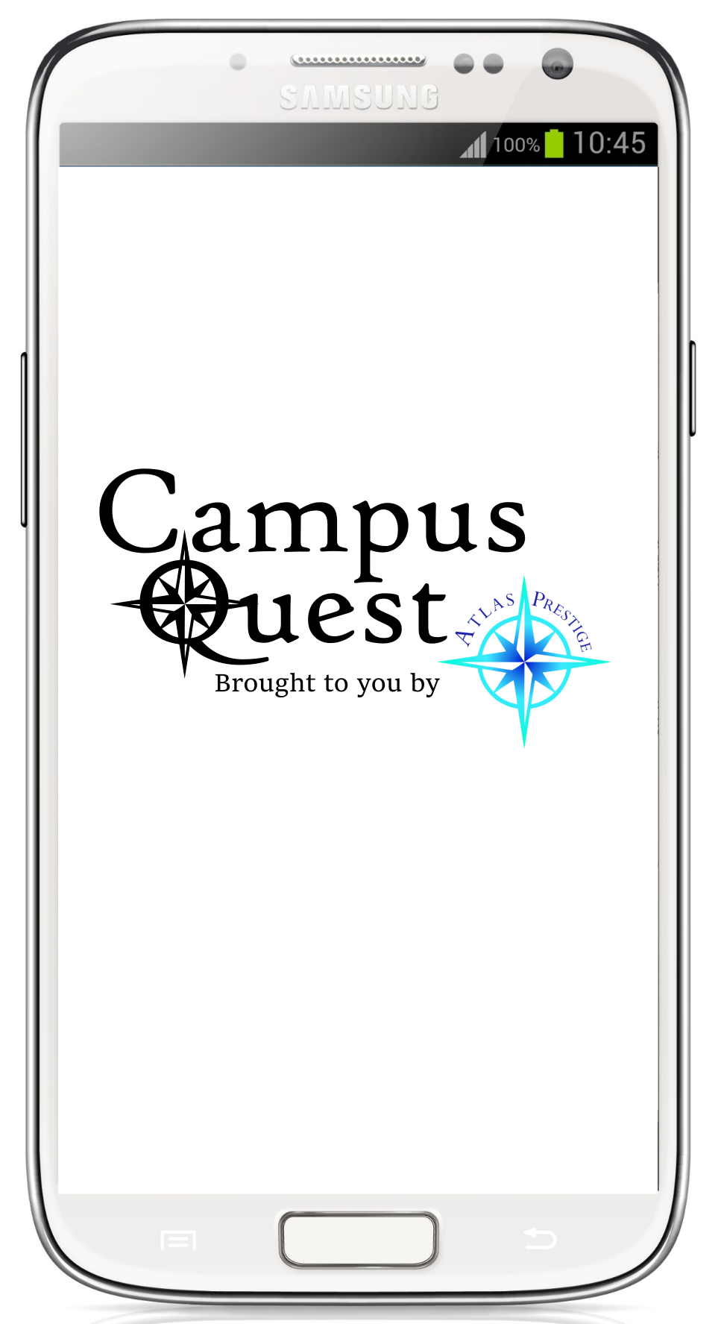
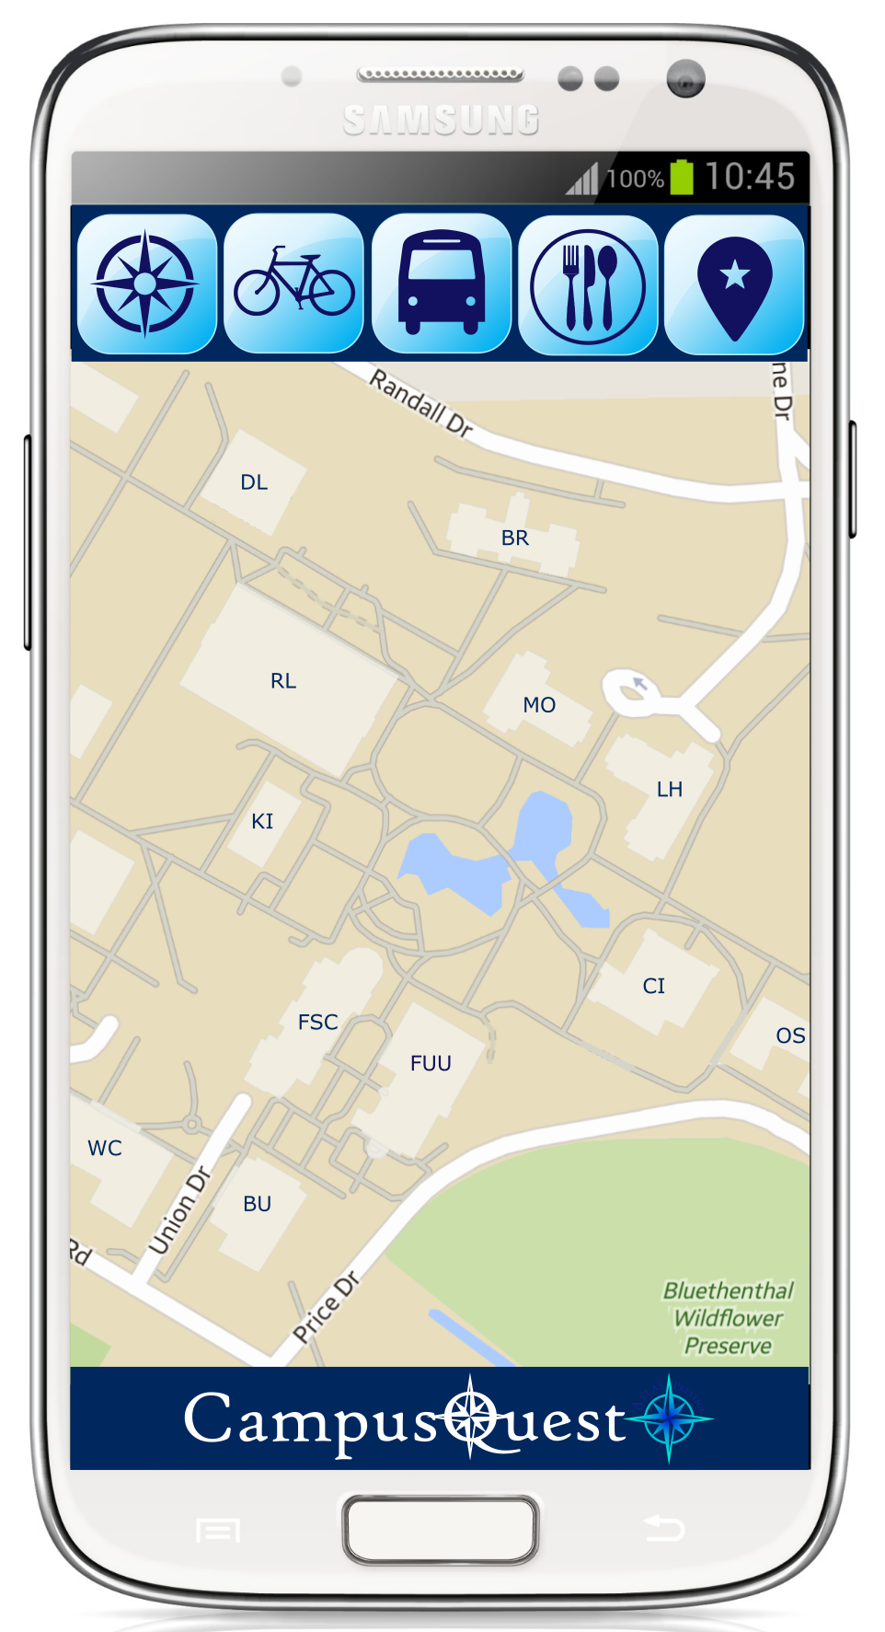

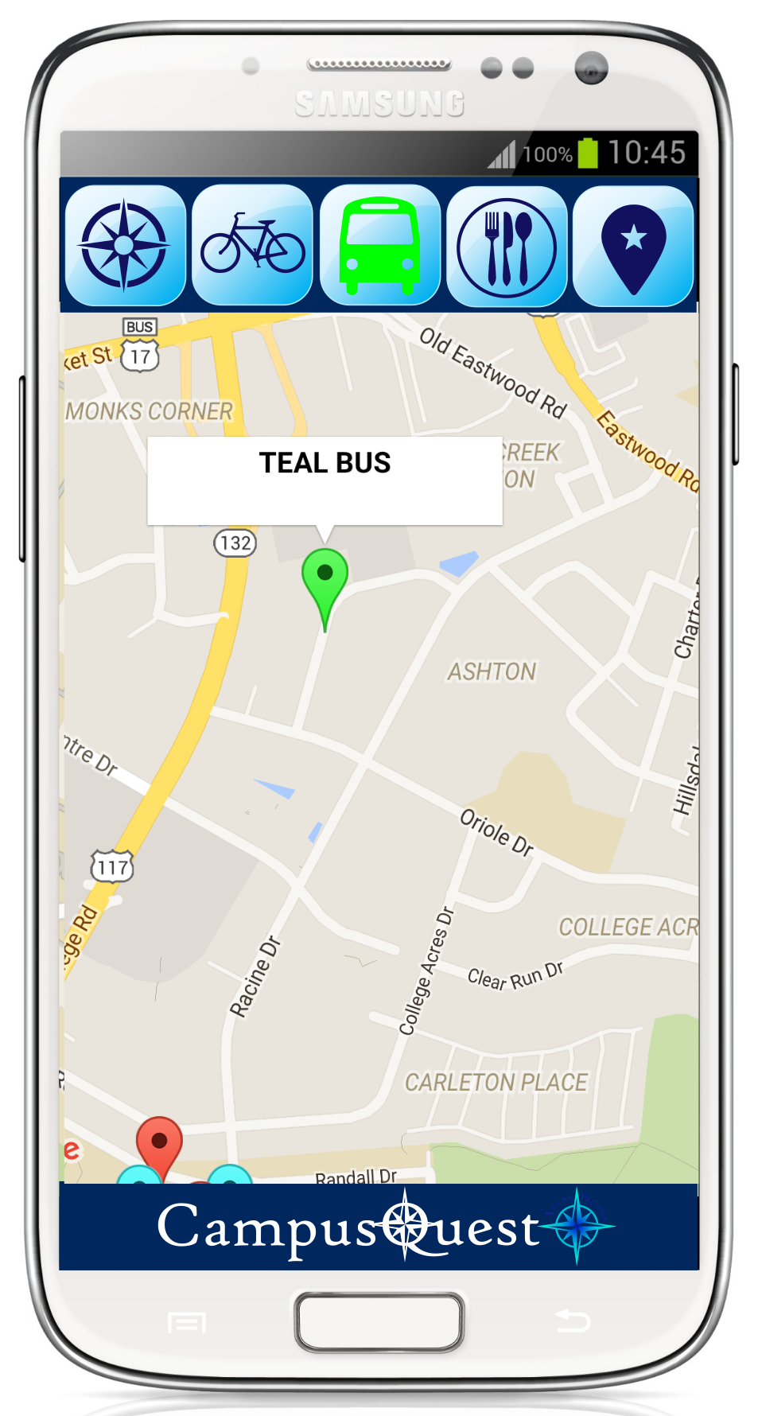
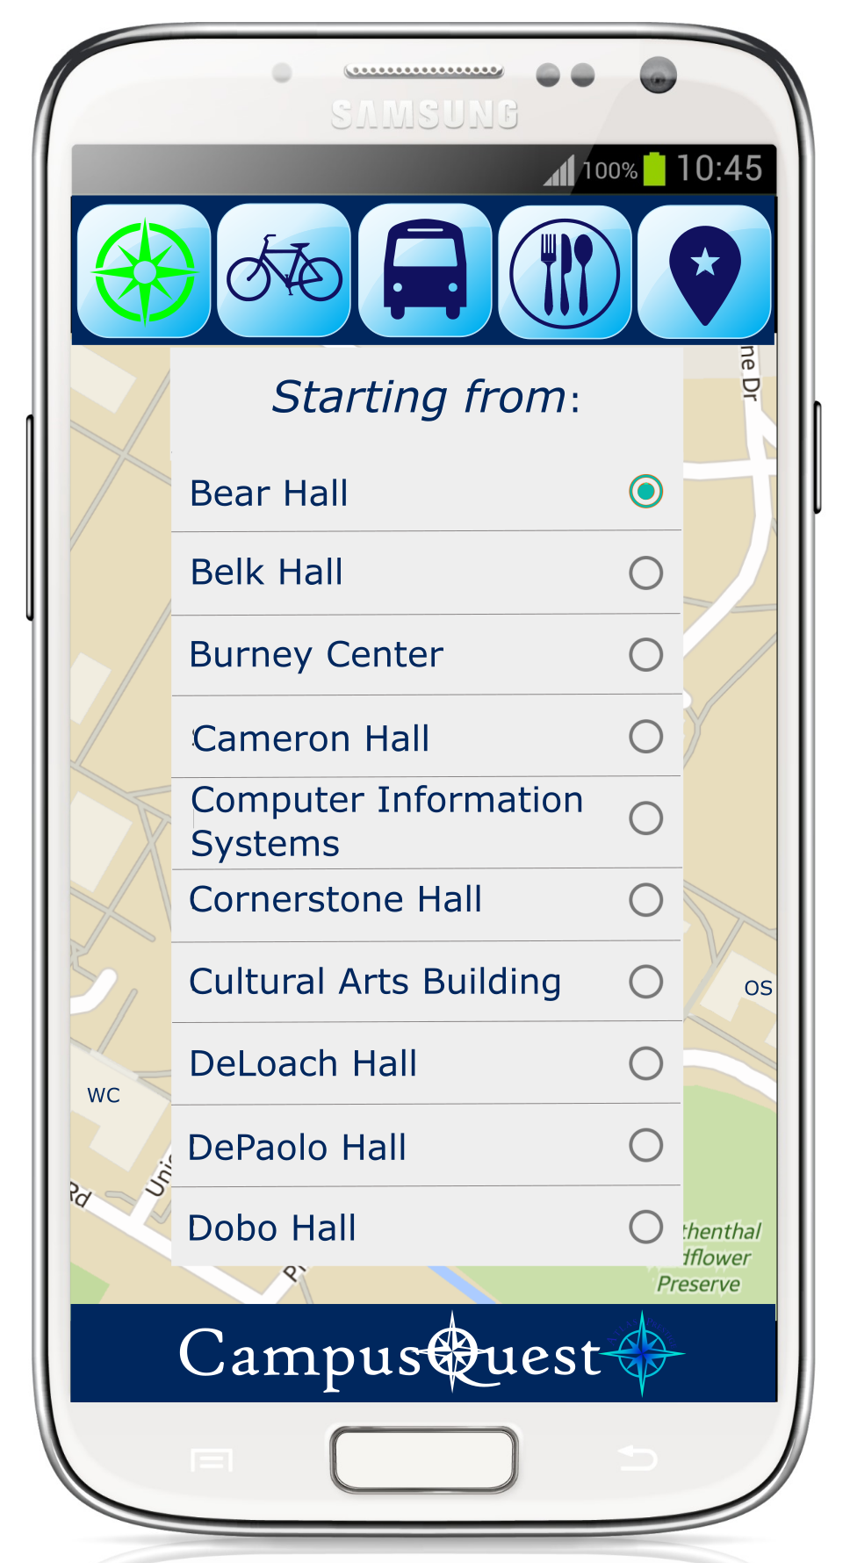
Figure 3: Get Directions Example
Figure 4: Bus Tracking Example

Data Dictionary
Entity Name | Type | Description
busButton | Button | Button which calls upon getBusInformation function
busTimer | Timer | Function: A timer that goes off every 30 seconds and calls the get bus information function.
getBusInformation | Function | Function: This function communicates with the Wave tracking website to populate map with bus location information. Also shows bus stops and route information.  Output: Google map updated with requested Markers and polylines.
foodButton | Button | Function: calls upon food information button
directionsButton | Button | Button which causes directionsWindow to appear
directionsWindow | PopUpWindow | PopupWindow with two Spinners (startLocation and endLocation) for user to set destination and start location. Also has a button which executes getDirections function
startLocation | Spinner | Spinner filled with possible locations from campus.
endLocation | Spinner | Spinner filled with possible locations from campus
directionsInitiate | Button | Calls the getDirections function
getDirections | Function | Input: Two locations provided in the directionsWindow in the Spinners.  Function: gets Google Direction API to provide directions to the area requested  Output: Map screen updates with route to take for user
findPOIButton | Button | Causes findPOI window to appear.
findPOIWindow | PopUpWindow | PopupWindow with POISpinner where user selects point of interest. Also a button to initiate getPOI function.
POISpinner | Spinner | Spinner filled with possible locations from around campus.
IntitatePOI | Button | Button that calls the getPOI function
getPOI | Function | Input: POISpinner location.  Function: sets zoom level and location of Google map to show the desired POI.  Output: updates the map to show requested area.
SplashScreen | Class | Class for first screen of the GUI. Contains text for title and app versions as well as logo for application
MapScreen | Class | Class for main screen of the GUI. Contains Google Maps object along with six buttons.
getFoodInformation | Function | Function: This function updates the map with food locations.  Output: Google map updated with requested Markers.
parkingLotButton | Button | Calls on getParkingLots Function
parkingLotLocations | ArrayList <Marker> | ArrayList of Markers to add to the map when required.
parkingLotAreas | ArrayList <Polygon> | ArrayList of Polygons to add to the map when required.
bikeRackLocations | ArrayList <Marker> | ArrayList of Markers to add to the map when required.
bikeRackButton | Button | Calls upon the getBikeRack function.
getBikeRack | Function | Function: updates the map with bike rack locations.  Output: updates the Google map for the user.
redRoute | ArrayList <LatLng> | ArrayList of latitude and longitude coordinates for route information
redStops | ArrayList <Marker> | ArrayList of Markers to add to the map when required.
blueStops | ArrayList <Marker> | ArrayList of Markers to add to the map when required.
blueRoute | ArrayList <LatLng> | ArrayList of latitude and longitude coordinates for route information
redExpressRoute | ArrayList <LatLng> | ArrayList of latitude and longitude coordinates for route information
redExpressStops | ArrayList <Marker> | ArrayList of Markers to add to the map when required.
yellowRoute | ArrayList <LatLng> | ArrayList of latitude and longitude coordinates for route information
yellowStops | ArrayList <Marker> | ArrayList of Markers to add to the map when required.
tealRoute | ArrayList <LatLng> | ArrayList of latitude and longitude coordinates for route information
tealStops | ArrayList <Marker> | ArrayList of Markers to add to the map when required
greyRoute | ArrayList <LatLng> | ArrayList of latitude and longitude coordinates for route information
greyStops | ArrayList <Marker> | ArrayList of Markers to add to the map when required
greenRoute | ArrayList <LatLng> | ArrayList of latitude and longitude coordinates for route information
greenStops | ArrayList <Marker> | ArrayList of Markers to add to the map when required

Limitations and Constraints
Due to the time constraints involved for this project, Atlas Prestige will be unable to hand-craft the routes for directions for the user. This task would have involved setting up countless anchor points on campus sidewalks and developing a path-finding algorithm. Due to the size of the campus, the task would have put the directions part of the project in jeopardy of never being completed. Due to this, this project will be using the Google Directions API. In general, Google Directions does not handle walking directions which are not on main roads very well. In efforts to improve the quality, we will be hand-picking coordinates for points of interest which will yield the most accurate directions.
The bus-tracking function of the application will be limited by how often the buses with GPS equipment run the bus routes. There exists a decent amount of bus rotation so that on any given day, there usually exists at least one bus running without GPS equipment. Because of this, Campus Quest will only be able to provide bus-tracking data as often as the Wave Transit website does.
The bus-tracking feature is also limited due to pulling data from the website, instead of the MobileEducation AVL database. Because Atlas Prestige does not have access to the AVL database, the next best option is the Wave Transit website. Because of this, any changes made to the website might interfere with the data scraping involved with retrieving the bus location information.

Non-functional Requirements
Performance
The application should perform any function requested by the user without any noticeable delay. Any responses from the application for user input should be nearly instantaneous.
The application should only temporarily peak around 70-80% of target device’s available CPU. The average CPU usage should be less than 40%.
The amount of data used by the application will ultimately be up to the user. Each function call should only use approximately 100 kb of data for bus tracking.
Campus Quest should look visually appealing for users. The application should also be graphically designed in such a way so that text explanation is kept to a minimum.
Reliability
Bus tracking will only be as reliable as the Wave Transit website is, as often times the buses are running without GPS equipment on hand.
Any force closes caused by the application should be kept to a minimum.
Availability
The application should be compatible with a variety of Android devices. The target device will be the Nexus 5 with the Ice Cream Sandwich firmware 4.0.

Design Models

4.1. Architectural Design Model
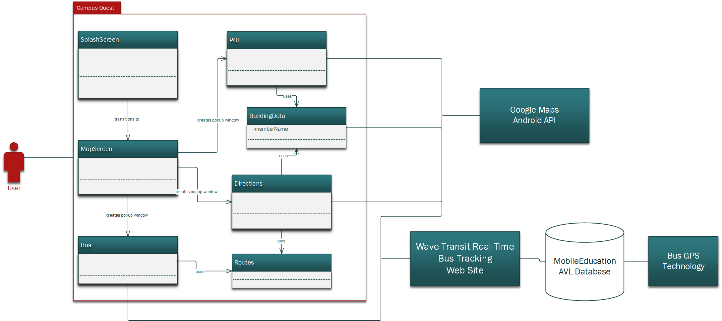
Figure 5: Architectural Design

The diagram in Figure 5 represents the graphical model of architectural design for the Campus Quest application. The application consists of 7 main classes. The majority of the classes use Google Maps Android API to get directions and to display the UNCW campus map, markers, and routes. The Bus class also uses the Wave Transit Real-Time Bus Tracking Web Site to display bus routes and track buses. In order to acquire bus tracking information, the Wave website connects to the MobileEducation AVL Database that receives tracking information from bus GPS devices.

4.3. UML Class Diagrams
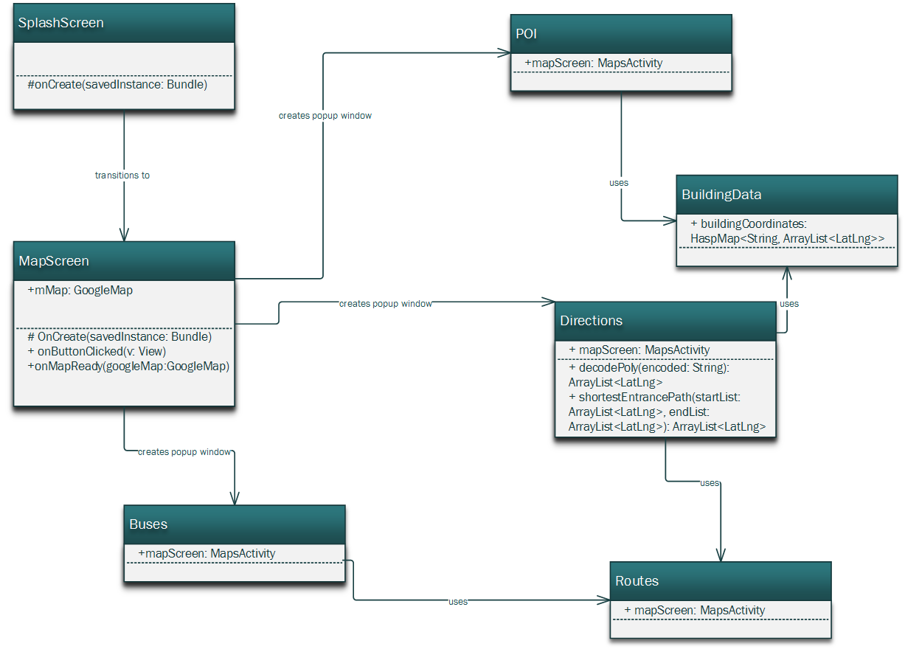

4.4. User Interface Design
Figure 6: Basic UI Design
Campus Quest will have a user interface design very close to the prototype description. To the right, Figure 6 shows the main screen without any buttons selected. This is what the user will first see on opening the app. After selecting any button, the user will be returned to this screen with the addition of the requested routes or markers.
Since our application does not implement a login or profile feature, this main screen is the only view required aside from the splash screen displayed on first launching the app. Listed on the next page are the design patterns that will be used throughout the interface.

4.5. Design Patterns
This is a list of the design patterns we will be using to create a consistent GUI:
- Buttons across the top have simple icons in a similar style to each other. These buttons will remain the same throughout use of the app. The only change will be that an icon will turn light green when its button is pressed. Only one button can be activated at a time.
- The font will be the same throughout every instance of text. This includes starting/ending locations for directions, Point of Interest list, initials displayed on buildings, and building summaries in pop-ups. We will be using a simple, clean sans-serif font in black or dark grey. The only variation in font will be size and/or bold style when emphasis is needed.
- Pop-up boxes will be simple rectangles with thin line separators as needed to keep focus on the text being displayed.

- Markers will be in the style of Google Maps: While we may vary color or other small elements of the marker design, this shape will be the most recognizable to users.
- Colors will be chosen to maintain the easily readable design of the app. We will likely choose to stay close to the prototype, which uses varying shades of blue and teal for a cool, clean design.

4.6. Handling Non-Functional Requirements
Performance
The performance goals for our application are speed and ease of use. The ease of use will be ensured by the minimalistic yet graphically appealing design. The use of text will be minimal. All of the buttons will have conventional and self-explanatory graphics. Filters and markers will be mutually exclusive in order to avoid map clutter and improve map readability. Unfortunately, we cannot guarantee the best performance of some of the application’s subsystems such as Google Maps and Wave Bus Tracking. However, our development team will ensure the efficiency of the code, which in turn will improve the application’s speed and performance.
Reliability
The Atlas Prestige development team will ensure bike rack location accuracy, and will keep building and point-of-interest information up to date. Unfortunately, bus tracking is provided by the third party and is not always available.
Availability
We chose our application to run on Android Ice Cream Sandwich and higher. Ice Cream Sandwich is an operating system that supports a variety of mobile devices including smartphones and tablets. Thus, we will ensure the compatibility of Campus Quest with the majority of Android devices in the future.
Security
Security requirements are minimal since users do not have to log in to use the application. No personal data needs to be stored.

Test Plan

Static Testing

Style Guidelines
We used normal Java and object-oriented standards as style guidelines for our code. We broke up our code into classes, each with their own methods, and documented them with JavaDoc. We stored all text files and images in the resource and drawable folders, with the XML layout files stored in assets. All XML files use indentation for organization, in the style of HTML. Button icons are named appropriately, as are the photos used in our information pop-up windows.

Software Metrics
Function | Estimated LOC | Actual LOC | Text Data | Total LOC
GUI (including XML layouts) | 1500 | 600 |  | 600
Directions | 200 | 296 | 62 | 358
Bus tracking/routes | 350 | 219 | 512 | 731
Map filters | 200 | 159 | 99 | 168
Information pop-ups | 150 | 28 | 41 | 69
Total | 2400 | 1302 | 714 | 1926

Black and White Box Testing

Major Software Functions

6.1. Implemented Functions

6.2. Unimplemented Functions

Problems Encountered
- The UNCW bus tracking system is fairly unreliable, and several routes often do not show up. Unfortunately we cannot do anything about this since it relies on the individual buses’ GPS systems.
- One team member only has a desktop computer, which slightly limits our ability to work all at the same time. This is circumvented by using GitHub to synchronize all our files, as well as utilizing the group study rooms with TV displays in the library.
- No team members had previous experience with Visio, Project, or Android Studio, so we had to spend additional time learning to use these programs.
- While acquiring the coordinates for bike racks, we ran into an inaccuracy issue. The Google Maps application we intended to use for coordinate marking turned out to not be accurate enough for our needs. We had to manually mark each bike rack on a paper map and use http://www.latlong.net website to acquire accurate coordinates. The whole process was very time consuming.
- We ran into an issue in the Google Maps API. When asked for directions, it returns an encrypted string. Occasionally, the encrypted string would contain backslashes which would crash the program. We spent a good amount of time researching this bug before we found a solution.

Bibliography

Roger S. Pressman Ph.D. Software Engineering: A Practitioner's Approach. 7th Edition. New York: McGraw-Hill, 2010.

"Getting Started." Android Developers. Accessed April 27, 2016. http://developer.android.com/training/index.html.

