To test if differences in fitness observed in the reciprocal transplant experiment are consistent in F2s raised in controlled, common conditions, we conducted a common garden study in Summer 2015 with ~100 F1 oysters from each population at the K. K. Chew Center for Shellfish Restoration and Research in Manchester, WA. Concerns over transgenerational effects would be mitigated if F2 animals reared in the same environment showed similar interpopulation differences as the F1s. Oysters from each population were spawned in 5 groups of 20 oysters to promote genetic diversity. Newly released larvae were combined based on population and reared in 100 L tanks. After reaching >160 μm in size (as determined by filtering over mesh screens), larvae were moved into a second tank and raised until close to metamorphosis (> 224 μm). Juveniles reaching metamorphosis at the same time were established on 10 cm x 10 cm PVC tiles before being placed in nearby Clam Bay to grow for 10 weeks

Reproductive output and growth rate were used as fitness proxies. Reproductive output was estimated by counting the number of spawned larvae from each group **(Fig. 1).** Similar to the reciprocal transplant experiment, oysters from Oyster Bay showed the earliest and greatest reproductive output. To measure larval growth rate, ~700 one-day old larvae were raised in 1 L beakers for 2 weeks with daily water changes, with 6 replicates per population.Samples of 100 larvae were taken 3 times throughout this period and measured using a microscope and ImageJ. In a preliminary analysis of protoshell length in 20 seven-day-old larvae from each population, size varied significantly among populations (ANOVA p-value < 0.001) and the larvae from Oyster Bay were significantly larger than those from Oyster Bay (pairwise t-test, Bonferonni corr.: p<0.001) (**Fig. 2).** After establishing on the PVC tiles, juveniles were measured at three time points over 10 weeks, from August 2015 to November 2015. A measurement of approximately 30 juvenile oysters from each population in October was consistent with the larvae measurements and reciprocal transplant results in that oysters from South Sound were significantly larger than those from Hood Canal (pairwise t-test, Bonferonni corr.: p<0.01) and size varied significantly among populations (ANOVA, p <0.01) (**Fig. 3)**. The growth rate between August and October also varied significantly among these populations (ANOVA, p< 0.01) (**Fig. 4).** While these results are preliminary, this concordant result with the reciprocal transplant indicates that phenotypic differences in size may indeed be due to genetic factors and not environmental effects.

Figure 1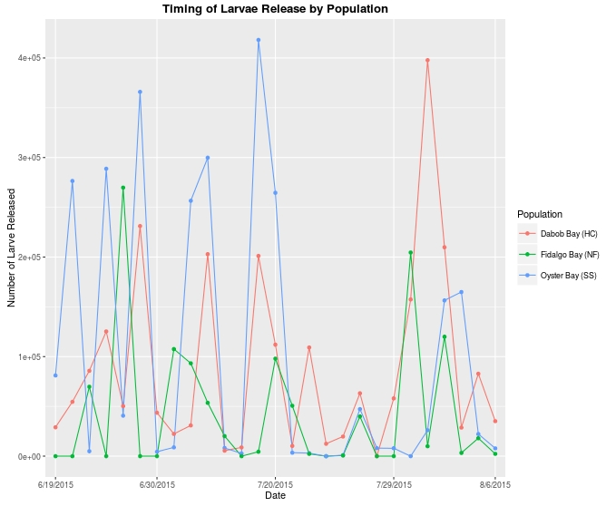

Illustration 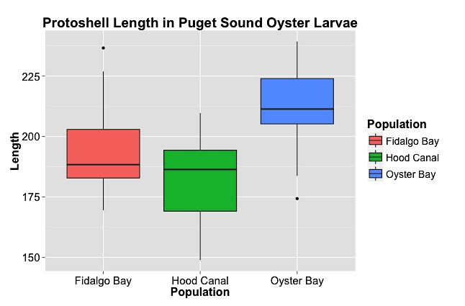1: Figure 2

Figure 4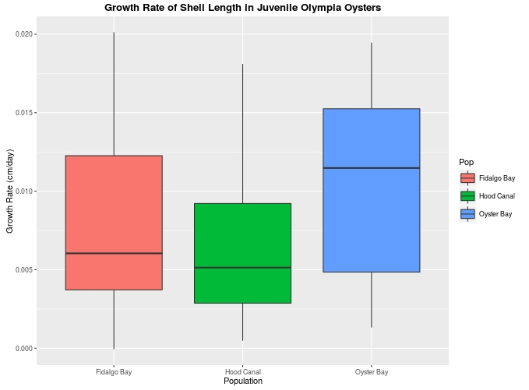

Figure 3