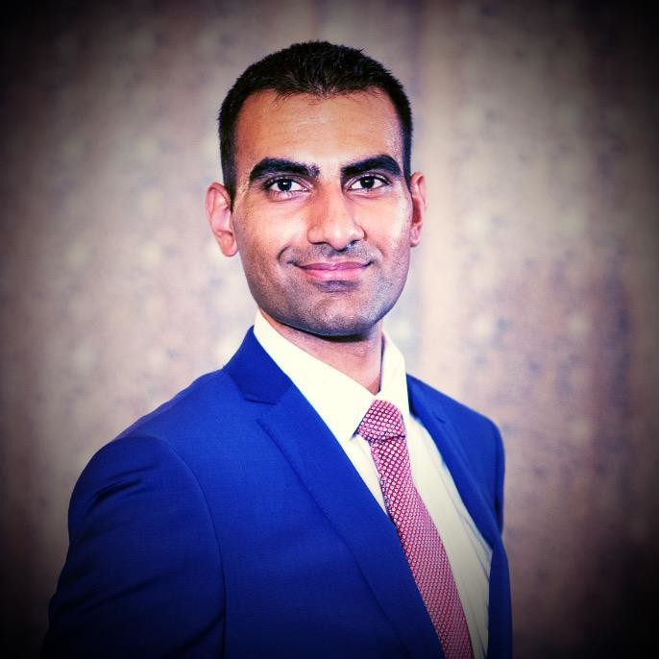

**Kulpreet Singh**

Front End UI/UX

Software Developer

Professional Business Manager with more than four years of experience in business marketing, management and development of new business interests. Now Continuing with Front End Web Development and Coding.

**WORK EXPERIENCE**

**Hotel Management**

Westwood Investments Inc. Guthrie, OK

08/2016 - Current

* Managing Employees
* Resolving reservation complications
* Clerical Duties
* Attaining new guests/clients
* Hotel ambassador working with nearby event organizers to create business through mutual gain.
* Review customer feedback to assess ways we can better the guest stay experience.

**Co-Owner/Manager**

ProExtreme Carwash Moore & Noble, OK

07/2015 - 07/2018

* Maintaining mechanical equipment with proper maintenance.
* Promoting and advertising car wash specials to get more business.
* Depositing money and ensuring all machines were stocked/filled and working.

**EDUCATION**

**B.A. in Psychology with Sociology Minor**

**The University of Oklahoma**

08/2012 - 12/2016

**Full Stack Coding Certification**

**Southern Methodist University**

03/2020 – 09/2020

**LANGUAGES**



English

Spanish

Punjabi

Hindi

**SKILLS**

**ORGANIZATIONS**

## AmeriCorps

## 08/2011- 05/2012

* Mentor to Kindergarten students
* Teacher’s aide for 5 Second-Grade Teachers

**OUIS**

Oklahoma Undergraduate Indian Society August 08/2012 – 12/2016

* Freshman Representative
  + August 2012 – May 2013
* Treasurer
  + August 2013 – May 2014

**AASA**

Asian American Student Association

08/2012 – 12/2016

* Freshman Representative
  + August 2012 - May 2013

**University of Oklahoma Big Event Volunteer** 08/2012 - 12/2016

* Community Service

**CERT**

Crisis Emergency Response Team

08/2016-12/2016

* Student Emergency Response Team Member

**REFERENCE**

**Kuljit Singh**

Americas Best Value Inn

2323 Territorial Trail

Guthrie, OK 73044

(580) 504-1445

kcmicro@yahoo.com