
Tufts Community Union President
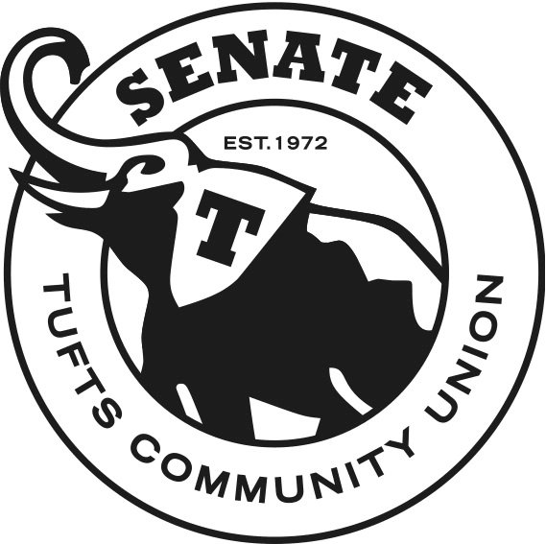
215 Mayer Campus Center
APPLICATION
Tufts Community Union Community Outreach Liaison
See last page for complete job description.
**Please submit this application to TCUSenate@tufts.edu by
5 PM, October 5, 2013 **
Please contact TCU President Joe Thibodeau with any questions or concerns at Joseph.Thibodeau@tufts.edu
Applicants may be asked to schedule an interview with members of the TCU Senate.
Name: School: A&S____ EN____
Year of Graduation: ___________________ Major(s): ______________
Local Residence: _______________________________
Phone: ____________________
E-mail:

Please answer the following questions to the best of your ability and attach an updated résumé of relevant experience and involvement.

- What activities are you involved in on campus? Have you ever served or participated in TCU student government?

- Why do you want to serve as the TCU Community Outreach Liaison? What makes you uniquely qualified to serve in this position?

- What initiatives do you plan on pursuing if appointed as the TCU Community Outreach Liaison?

- Have you ever lived off-campus? If so, briefly describe that experience.

- Would you feel qualified working alongside Tufts’ Office of Government and Community Relations and local city governments?

- What do you feel is the most pressing issue regarding Tufts University’s relationship with our host communities of Medford, Somerville, and Boston?

Please sign below (electronic signature acceptable) to affirm that all answers given are truthful, and that all written statements were composed by you alone.

_______________________________________________ (Signature of candidate)
Job Description
TCU Community Outreach Liaison has specific duties and responsibilities, including:
- To serve as a the liaison from May (here, September) to June
- To uphold the TCU Constitution
- To collaborate with the Office of Government and Community Relations
- To present monthly reports to the Senate about the state of the undergraduate-communal relationship within Medford and Somerville
- To work on initiatives aimed toward fostering positive relationships between undergraduate students, their neighbors in Medford and Somerville, and local city governments

