CUBIST: Combining and Uniting Business Intelligence with Semantic Technologies

Attempt for FP7 Call5 Proposal


DRAFT
Contents

1. Abstract 1
2. Introduction and Motivation 1
3. Research Questions 4
3.1. Architecture 4
3.2. Federating (structured and unstructured) Data 4
3.3. Integration with structured data 5
3.4. Ontology Design 5
3.5. User Interaction 5
4. Possible Business Cases 5
4.1. Semantic BI for exploring forums and blogs 5
4.2. Edinburgh Mouse Atlas Project 6
5. Envisioned Architecture and Work Packages 6
6. CUBIST Consortium 7
7. References 9

- Abstract
CUBIST aims at developping a framework which combines essential features of Semantic Technologies and Business Intelligence.
With classical BI solutions, one can federate and analyze huge amounts of structured data. Anyhow, it is expected that in the near future, additional to structured data, information from unstructured sources (like office documents or web pages) becomes essential in BI solutions as well. Moreover, classical BI solutions so far neglect the meaning of the fedated data. Finally, according to a 2008 study of information week, the biggest barrier to successful BI solutions is the complexity of BI tools and interfaces. Semantic technologies on the other hand are known to be able to deal with both unstructured and structured data and to handle the meaning of the data, but to date, they amount of data they can handle is magnitudes smaller compared to classical BI soloutions, and they lack standard BI funcionalities which deal with aggregating and analyzing huge subsets of the given data. With CUBIST, we envision a framework with the following core features:
- It will be possible to federate data from a variety of both unstructured and structured sources.
- The persistency layer of CUBIST will be a semantical Data Warehouse, having a BI-enabled triple store in its center which will be linked to a column-based database.
- CUBIST will provide novel ways of visual analytics in which meaningful diagrammatic representations of the data will be used both for navigating through and depciting the data.
- Introduction and Motivation
Business Intelligence (BI) is an umbrella term which refers to technologies, applications and practices of gathering, representing and analyzing data in order to support decision making in enterprises. BI may also refer to the collected information itself. BI usually acts on a multi-dimensional table of facts called “data cube” by means of operations like rotating, pivoting, slice and dice, drill-down and roll-up.
So far, the data used in BI systems is usually structured data gathered from Enterprise Resource Planning (ERP)-Systems. Due to a recent study of 2007 by the Data Warehouse Institute[1], it is expected that we will witness within the next few years a significant change of paradigm in Data Warehousing and Business Intelligence: the fraction of structured data used in Data Warehouses will decrease in favor of unstructured data (see Fig 1), and it is discussed how unstructured data can be incorporated in Business Intelligence systems[2]. In fact, the rate of unstructed data amongst all data is estimated to be 80% to 85%, leaving structured data clearly in a distant second place.
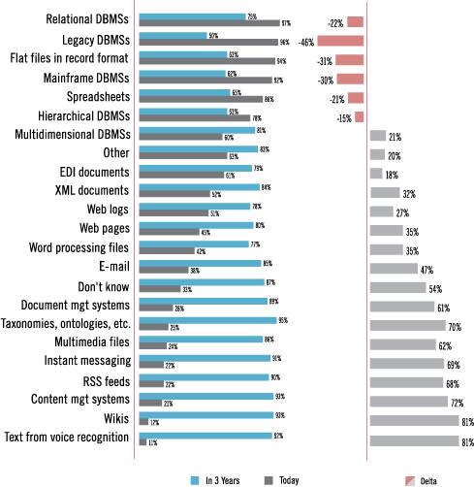
Fig1: Which Types of Data and Source Systems Feed Your Data Warehouse?
Unstructured data sources containing relevant information on products are for example office documents (word, powerpoint, etc), emails, web 2.0 sources like forums or blogs, notes from callcenters, maintainance documentations, etc. This sources contain relevant product information like (positive or negative) feedback of customers for a product, or error reports.
Using this information allows to answer questions like
- “Which products or product components caused the most questions in a company forum?”
- “How well is a new product recognized by the target audience?”
- “Which kinds of consumers do report for a given product? Group by customer types.”
- “Which features of a product are mostly discussed?” or “Which features of a product are mostly missed by users”
- “For which kind of product / products are the most error messages reported?”
- “Which products/components/functionalities are often mentioned in combination with a given product”?
Thus, compared to traditional BI, incorporating unstructured data allows new questions to be tackled by BI and thus opens new vistas. The quality of existing BI-scenarios can be improved, and certain evaluations can only be employed by using unstructed data [3]. They include:
- early recognition of quality problems
- proactive analysis of customer satisfaction
- management of reputation
- recognition of gaps in the product portfolio
As already mentioned, traditional BI applications, particularly Data Warehouses, lack the ability to deal with heterogenous, unstructured data. Here lies the strength of relatively new field of semantic technologies (ST). From a conceptual point of view, ST add meaning to data, thus lifting data into information. This enables both humans and machines to understand, share and reason with information. From an application point of view, ST are well suited for:
- information (and meaning) extraction and semantic annotation of documents
- federating different data and information silos and providing a unified view on them
- derving new information which can only be obtained by merging information chunks from different sources and performing reasoning on them
- classification of documents and information sources, and
- extended (semantic) search and navigation facilities over the federated information.
ST can so far not process classical BI functionalities like drill-down, roll up, slicing, dicing, and the like.
As Stephen Holcomb writes in [4]: “Instead of limiting yourself to a subset of data that fits a particular type of technology, find different technologies that fit all of your data!”
This proposal aims at adding BI functionalities to ST in order to allow BI applications which benefit from the strengths of ST, particularly to deal with unstructured data. Moreover, it will investigated on how the user interaction which is usually done with ST-based systems can be adopted for the BI-framework.
The essential differences between “classical BI” and “Semantical BI”, as envisioned in this proposal, is depicted in Fig 1.

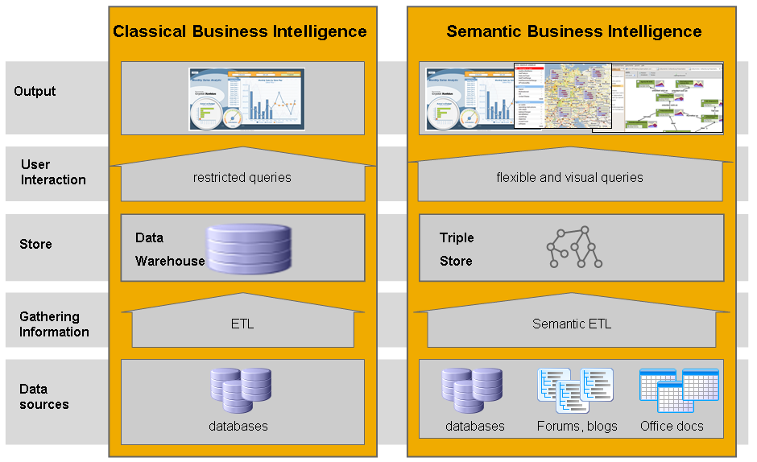
Fig 1: From Classical to Semantical BI
- Research Questions
Of course, there is a variety of research relevant challenges which have to be coped with and which will be addressed by this proposal.
  - Architecture
It has to be investigated how the architecture of a semantic BI application has to be designed. The physical store of a ST application is usually a triple store. Triple stores are often based on RDMS, but they can implemented on a proprietary basis as well. They are tuned for the special needs of STs, particularly for querying the triple store (e.g. with SPARQL) or for performing reasoning on the triples. It has to be investigated in what repect the existing systems and functionalities have to be adopted and changed in order to suit the needs of BI functionalities.
  - Federating (structured and unstructured) Data
Dealing with unstructured data, particularly with user generated content, brings in new difficulties traditional BI systems do not face. We name:
- Quality of source data: Unstructured data is often “noisy and polluted”. In text documents, we have to cope with spelling errors, use of abbreviations and acronyms, synonmyns and homonyms, etc.
- Quality of extracted data: The quality of the extracted data is not as high as extracted data from structured sources: The uncertainty of data has to be addressed.
It has to be investigated how semantic BI systems deal with these data issues.
  - Integration with structured data
Extracted data from unstructures sources has to be brought into relationship with extrated data from structured sources. For example, user generated content for a given product must be combined with sales data from an ERP system in order to evaluate whether the for example marketing campains have been successful. Thus it has to be elaborated how a semantic BI approach can combine unstructured and structured data, e.g. by linking a triple store with a Data Warehouse..
  - Ontology Design
Traditional Data Warehouses are often based on RDMS which are tailored to meet the needs of BI functionalities. A part of this peculiar DW design is the well-known database schema called “star schema” which allows for the typical BI operations. In triple stores, the pendant of the DW’s database schema is the underlying terminological part of the ontology. Design guidelines for the ontologies so that BI funcionalities are supported to the best have to be delevopped.
  - User Interaction
The interaction between users and a Data Warehouse differs to a large extent to the interaction with a semantic application. There are several access paradigms to information in a semantic application. The most important ones are:
- search frontend which look very like traditional keyword search frontend, but where the search terms are interpreted by means of a given ontology
- search frontend which are inspired by faceted search engines
- search frontends which allows for complex queries, for example by providing a graphical user interface which supports the user in building graph pattern queries
Knowledge engineers and sophisticated end users can moreover use a graph-based navigation of triple stores.
It has to be investigated how the user access to triple stores has to be adopted and changed in order to support BI, and vice versa how BI can benefit from innovative and ST-inspired UIs. For example, it might be useful to combine federated search with BI functionalities, or to emply drill-down, roll-up etc along the class hierarchy in the ontology. In Cubist, we will particularly empoy visualization techniques based on a mathematical theory called “Formal Concept Analysis”, which provides a means to visualize and explore data by means of lattices.

- Possible Business Cases
In the following, we describe some possible business cases for this proposal.
  - Semantic BI for exploring forums and blogs
Many companies, eg. SAP, maintain forums and blogs for their products. These ressources hold valuable information about user perception of (eg. new) products, user complaints, product errors etc. Applying BI over this kind of information is for product marketing and maintance issues very helpful.
  - Edinburgh Mouse Atlas Project
The UK MRC Human Genetics Unit in Edinburgh is developing a digital atlas of mouse development and database to be a resource for spatially mapped data such as in situ gene expression and cell lineage. Analysis on this atlas, together with all relevant publications, will be conducted within CUBIST.
- Envisioned Architecture and Work Packages
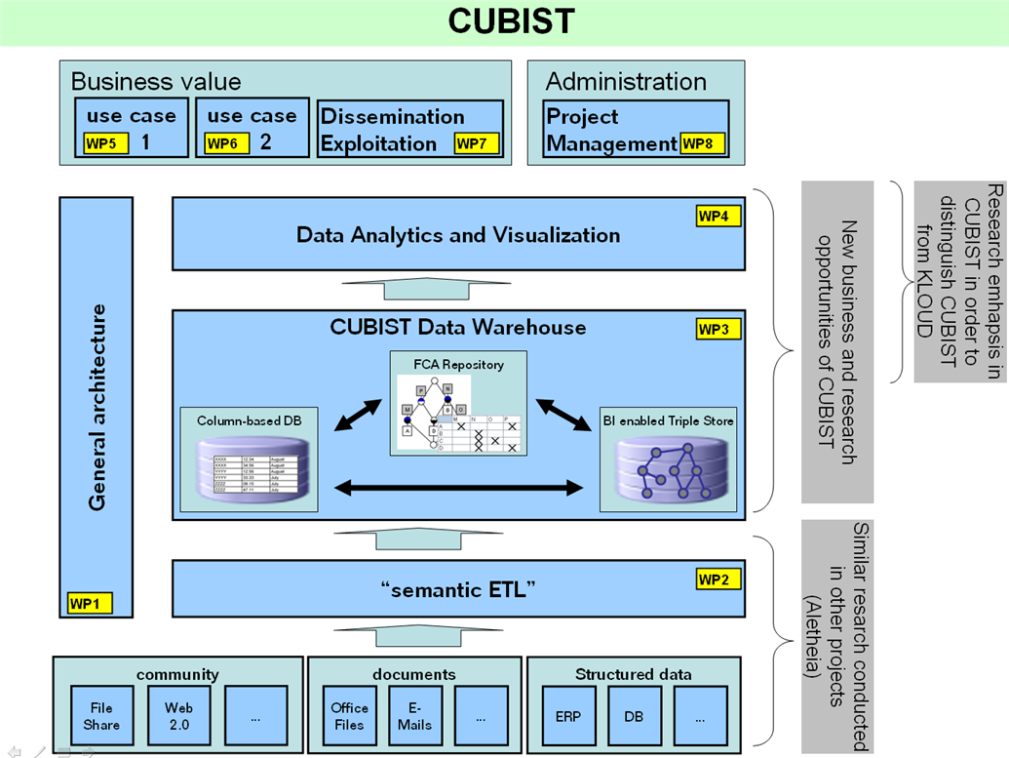

Preliminary List of Work Packages
- WP 1: CUBIST Architecture
Task 1: (Technological) State of the Art Analysis
Task 2: Generalization of the Requirements of the Use Cases
Task 3: directives for the design, implementation, test and evaluation
Task 4: Technology Architecture for CUBIST
Task 5: Integration
WP 2: “Semantic ETL” or “data integration”
Task 1: Development of a data integration platform
Task 2: Methods to dynamically harvest data from structured sources
Task 3: Methods to dynamically harvest data from unstructured sources
Task 4: data federation and mediation
- WP 3: Architecture of data persistence layer
Task 1: extensions of RDF triple stores for BI
Task 2: Integrasting the triple store with (structured data from) a data warehouse (and FCA)
Task 3: FCA Repository
Task 4: Schema
Task 5: accessing and querying the data persistence layer
Task 6: methods to dynamically add data
- WP 4: analyzing and visualizing the data
Task 1: Visual querying (querying through UI-representation)
Task 2: Visualisation (ECP, SHU)
Task 3: FCA-based querying and visualization
Task 4: Controlled user studies
- WP 5: Use Case 1. Edinburgh Mouse Atlas Project
Task 1: Requirements Analysis
Task 2: Adaption of the overall CUBIST Scenario for this use case including implementation
Task 3: Evaluation and business value
- WP 6: Use Case 2 (NN)
Task 1: Requirements Analysis
Task 2: Adaption of the overall CUBIST Scenario for this use case including implementation
Task 3: Evaluation and business value
- WP 7: Dissemination;Exploitation
Task 1: Dissemination
Task 2: Exploitation
Task 3: Standardization
- WP 8: Project Management (done due to template)
Task 1: Planning and Scheduling
Task 2: Progress & cost reporting
Task 3: Monitoring, control & quality management
Task 4: communication management and administration infrastructure

- CUBIST Consortium

SAP Research (Germany)
SAP has grown to become the world’s leading provider of e-business software solutions. With 12 million users, 96,400 installations, and more than 1,500 partners, SAP is the world’s largest inter-enterprise software company and the world’s third-largest independent software supplier, overall. SAP solutions help enterprises of all sizes around the world to improve customer relationships, enhance partner collaboration and create efficiencies across their supply chains and business operations. SAP employs about 48.000 people in more than 50 countries.
SAP Research is the technology research department of SAP and as an integral part of SAP’s R&D activities, SAP Research is responsible for identifying, researching, understanding, developing and evaluating new and emerging technologies, processes and e-business solutions that strategically influence the future of SAP business applications. SAP Research is a Global Business Unit under the direction of SAP AG operating research centres in various countries. These centres are usually co-located with academic partners and focused on specific research topics. Depending on the particular needs of the projects, SAP Research will consider to distribute work packages among its locations in order to engage researchers with the required expertise. This will increase the effectiveness and efficiency of the execution of the project. In the context of this document, SAP refers to SAP AG and its SAP Research Business Unit.
Homepage: http://www.sap.com

Ontotext (Bulgaria):
Ontotext is a leading developer of core semantic technology. Ontotext Lab was established in 2000 as a semantic technology division of Sirma Group Corp. - one of the biggest software companies in Bulgaria. In 2008 Ontotext acquired venture capital investment and was separated as a spin-off from Sirma Group Corp. Currently Ontotext’s team is comprised of about 35 researchers and engineers. Ontotext is focused on research and core technology development for:
- Knowledge Discovery & Management
- Semantic annotation of Web Services and Business Processes,
- Text-mining & semantic annotation of text
- Semantic search
- Semantic data integration
Ontotext will contribute to the project in two main directions:
- Expertise & infrastructure for scalable RDF repositories, based on its OWLIM semantic repository
- Expertise & infrastructure for extracting structured information from large number of text databases and integration of the data
Homepage: http://www.ontotext.com

Sheffield Hallam University (UK)
From its beginnings in 1843, Sheffield Hallam University (SHU) is one of the UK's most progressive and innovative universities. SHU pride itself on making a difference - to their students, staff and to the businesses the university works with. SHU’s research and business ideas, alongside its sought after graduates, contribute to the economic and social development of both its region, the UK and internationally.
SHU has a long standing relationship with SAP, and Infobright (see below). SHU will work with Infobright and the other partners with analysing the data sets provided by the use case partners as identified in the CUBIST architecture (WP3 and WP4). By using a technique known as Formal Concept Analysis (FCA), SHU will identify and inter-relate the contexts and concepts underlying the data, providing novel intelligence to the use case partner so that they can make much more informed decisions, based on their own facts hitherto hidden in their data. SHU has expertise in context creation and will help develop the software for creating the contexts from original data and for retrieving contexts in the different formats required by the FCA tools. SHU will provide/develop the tools/software for the FCA-analytics. In particular there is a need for fast concept generation given the scale of data involved, something that SHU has expertise with.
Homepage: http://www.shu.ac.uk

Ecole Centrale Paris; Applied Mathematics and Systems Laboratory (France)
Created at the turn of the century, the Applied Mathematics research group of the Ecole Centrale Paris (MAS in french) relies on the Applied Mathematics and Telecommunications and Computer Science majors at the Ecole Centrale Paris to illustrate, in the area of Digital Technologies, the Mathematics - Computer Science - Telecommunications continuum.
It is mainly focused on modelling, simulation, analysis and exploitation of complex products or systems in three major areas :
- Scientific engineering and visualization
- Information processing - Data and Images
- Information Systems engineering
All these activities are carried out in close collaboration with French and international industrials and research teams (including CEA and INRIA).
Homepage: http://www.mas.ecp.fr/

Infobright (Poland)
Founded in 2005 by a team of internationally recognized mathematicians and run by data management experts, Infobright has pioneered a new approach to analytic data warehousing. By delivering the simplest and most cost-effective analytic data warehouse, Infobright is enabling companies both large and small to achieve a whole new level of information intelligence for their business operations.
Homepage: http://www.infobright.com/

Edinburgh Mouse Atlas Project
The UK MRC Human Genetics Unit in Edinburgh is developing a digital atlas of mouse development and database to be a resource for spatially mapped data such as in situ gene expression and cell lineage. The project is in collaboration with the Section of Biomedical Sciences within the Division of Biomedical and Clinical Sciences at the University of Edinburgh. This research programme is the Edinburgh Mouse Atlas Project (emap)
The gene expression database (emage) is being developed as part of the Mouse Gene Expression Information Resource (MGEIR) in collaboration with the Jackson Laboratory, USA.
Homepage: http://genex.hgu.mrc.ac.uk/
- References
[1] Philip Russo,: BI Search and Text Analytics. Excerpt on http://www.tdwi.org/Publications/WhatWorks/display.aspx?id=8449
[2] W.H. Immon, A. Nesavich: Tapping into unstructured data: Integrating Unstructured Data and Textual Analysis into Business Intelligence. Prentice Hall, 2007.
[3] Alexander Lang, Berthold Reinwald: Nutzung unstrukturierter Daten für Business Intelligence: Datenbankspektrum Heft 25, May 2008
[4] Stephen Holcomb: Semantic Technologies: The Power of a New Wave of Analytics. Presentation. http://www.iso.com/conferences/isotech/dloads/2008/TE2.ppt Nov. 2008.

