**1. Collaborative Filtering** (Matrix Factorization, K-Nearest Neighbors)

- **Use case**: Useful when you have data about how different students perform across various subjects.

- **How it works**: The system learns from the patterns in students' performance, recommending subjects that students with similar profiles have improved on after previous poor performance.

- **Pros**: It can effectively identify common areas where students typically struggle and improve.

**2. Content-Based Filtering** (Decision Trees, Random Forests)

- **Use case**: If you want to recommend subjects based on the specific attributes of the subjects or students (e.g., difficulty level, prior scores).

- **How it works**: The system recommends subjects where improvement is possible based on the student's past performance and subject features.

- **Pros**: Focuses on individual student preferences and abilities, good for personalized suggestions.

**3. Gradient Boosting Machines** (XGBoost, LightGBM)

- **Use case**: When dealing with high-dimensional performance data, such as scores across multiple subjects, demographic information, and learning styles.

- **How it works**: These ensemble models can predict which subject recommendations would lead to the greatest improvement in student scores.

- **Pros**: Works well with diverse features and handles non-linearity in the data.

**4. Reinforcement Learning**

- **Use case**: If you want a dynamic system that learns from feedback, improving its recommendations based on students’ responses or performance after trying a recommended subject.

- **How it works**: The model continuously adjusts its recommendations based on what works for each student, focusing on subjects that maximize learning outcomes over time.

- **Pros**: Highly adaptive and can provide more personalized, evolving recommendations.

**5. Neural Networks** (Deep Learning)

- **Use case**: If you have a large dataset with complex relationships between students' scores and subjects.

- **How it works**: Deep learning models can capture intricate patterns in performance data and recommend subjects where the student is most likely to improve.

- **Pros**: Good for large-scale datasets and can model complex relationships between students and subjects.

**6. Multi-Class Classification Algorithms** (Logistic Regression, SVM)

- **Use case**: If you are treating the problem as a classification task (e.g., which subjects the student should focus on to improve scores).

- **How it works**: These algorithms classify students into different categories based on their likelihood of improvement in various subjects.

- **Pros**: Simple and interpretable, works well when you can structure the problem as a classification task.

**Building a Recommendation System for Students Based on Assessment Scores Using AI/ML**

***Steps to Develop the Recommendation System***

## 1. Defining Objectives

Establish clear objectives for the recommendation system:

- Suggest subjects based on students' previous performance.

- Enhance learning outcomes through personalized recommendations.

- Facilitate informed decision-making regarding course selection.

## 2. Data Collection

The success of the recommendation system relies on high-quality data. Collect the following types of data:

- **Assessment Scores:** Historical data of student scores in various subjects.

- **Student Demographics:** Age, academic background, and interests.

- **Course Catalog:** Information on the courses available, including prerequisites, descriptions, and level of difficulty.

## 3. Data Preprocessing

Prepare the collected data to ensure it is clean and structured:

- Cleaning: Identify and correct inaccuracies, remove duplicates, and handle missing values.

- Normalization: Scale the assessment scores to ensure uniformity, which helps in comparability.

Tools and libraries for preprocessing:

- **Pandas**: For data manipulation and cleaning.

- **NumPy**: For numerical operations and array structure.

## 4. Exploratory Data Analysis (EDA)

Perform EDA to understand patterns and relationships in the data:

- Visualizing data to explore trends and correlations between scores and successfully selected subjects.

- Identifying outliers or anomalies that might affect recommendations.

Libraries for EDA:

- Matplotlib and Seaborn: For generating visual representations of data.

## 5. Feature Engineering

Create relevant and informative features:

- Calculate average scores, subject selections, and create binary indicators for each subject based on past performance.

- Encode categorical variables, such as subjects, into numerical values to facilitate model processing.

## 6. Model Selection

Choose appropriate recommendation algorithms:

- **Collaborative Filtering:** This method recommends subjects based on similarities between users (students).

- **Content-Based Filtering:** Recommends subjects based on features derived from the subjects already liked or successful for the student.

- **Hybrid Approaches:** Combine both collaborative and content-based filtering to improve accuracy.

## 7. Model Training

Implement and train the model using the prepared data:

- Use ML algorithms such as:

- **Matrix Factorization (SVD):** Efficient for collaboration-based recommendations.

- **K-Means Clustering:** To group students with similar scores for personalized recommendations.

- **Neural Networks:** For deeper insights into the correlations using a larger dataset.

Frameworks for model development:

- **Scikit-learn:** For traditional ML algorithms.

- **TensorFlow and PyTorch:** For more complex models, including deep learning architectures.

## 8. Model Evaluation

Evaluate the model's effectiveness and accuracy:

- Use metrics such as:

- **Precision and Recall:** To assess the relevance of recommendations.

- **F1 Score**: To balance precision and recall.

- **Mean Absolute Error (MAE):** To measure the average error in prediction.

*Tools for evaluation:*

- **Sci-kit Learn**: For computing evaluation metrics with built-in functions.

9. Implementation and Deployment

Deploy the recommendation system in an educational context:

- Develop a web application using frameworks such as Flask or Django to allow student interaction.

- Create an interface for students to view recommendations and provide feedback.

10. Continuous Monitoring and Updates

Monitor the system's performance and update it with new data regularly:

- Collect feedback from students to improve recommendation accuracy.

- Re-train models periodically as new assessment data becomes available.

**Key Libraries and Tools for Implementation**

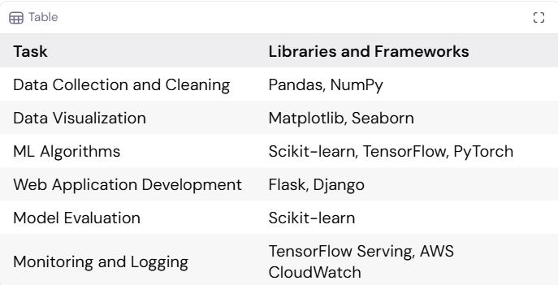

**Conclusion**

Building a recommendation system for students to suggest subjects based on assessment scores using AI and ML offers a personalized approach to education that can significantly enhance learning outcomes. By following a structured development process, leveraging appropriate technologies, and continuously refining the system with new data and feedback, educational institutions can provide invaluable support to students in navigating their academic journey.