Name: Jaison KS

Project Name: Course Management System

Date: 27-05-2022

## INTRODUCTION

## Overview

The following document provides an overview of the Course Management system. The system allows the user to create, modify, and delete students, course and map course to students.

**Tools Used:**

**Programming Languages**: C#

**Tools & Environments**: Microsoft Visual Studio, ASP.Net MVC

**Frame work**: .Net Core 5.0

**Database**: MSSQL Server

**Report**: SSRS

## SYSTEM ARCHITECTURE

## Architectural Design

Following diagram shows the architectural design of the solution. In this design structure, the web view model has no direct dependency with data access layer. Below diagram shows the architecture of the system.

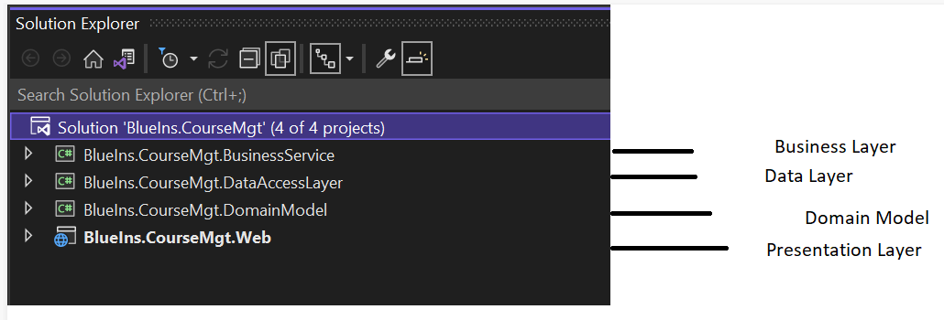

**Domain** – Holds the Entities and Interfaces. It does not depend on any other project in the solution.

**Data Access, EFCore** – Entity Framework Core interact with our Database,

**Web App** (Model, View, Control) – This is the presentation layer of the entire solution.

**Highlight of the architecture**

* Domain data model architecture implemented.
* Implemented Automapper to take advantage of time and effort needed to map the properties of incompatible types.
* Stylecop applied to get the code clean and readable.
* Dependency injection implemented.

## HUMAN INTERFACE DESIGN

## 

## Student List View

## This is the student list table where all details available with respect to students. The list contains name, surname, gender, DOB, Address 1, Address2 etc.

## 

## Add Student

## User can add student’s name, surname, gender, DOB, Address 1, Address2 etc through the add screen shown below. While click on save button the data will be saved to database and page will be redirected to Students list. There is an option to go back button to return to list page as well.

## 

## Modify Student

## User can modify the student Name, surname, gender, DOB, Address 1, Address2 through the edit screen shown below. While click on save button the data will be saved to database and page will redirected to list. There is an option to go back button to return to list page as well.

## 

## Delete Student

## The below delete screen allows the user to delete the student details. After getting the confirmation, the system will remove the data from database and page will be redirected to student list page.

## 

## List Course

## This is the student list table where all details available with respect to students. The list contains course name, Teacher name, start date, end date, no of seats etc.

## 

## Add Course

## User can add course name, teacher name, no of seats, start date and end date through the add screen shown below. While click on save button the data will be saved to database and page will be redirected to Students list. There is an option to go back button to return to list page as well

## 

## Modify Course

## User can modify the course name, teacher name, no of seats, start date and end date through the edit screen shown below. While click on save button the data will be saved to database and page will redirected to list. There is an option to go back button to return to list page as well.

## 

## Delete Course

## The below delete screen allows the user to delete the course details. After getting the confirmation, the system will remove the data from database and page will be redirected to course list page.

## 

## Map Course

## The below map screen allows the user to map the course details for a student. The mapped course will be shown in the screen.

## 