Sample Manuscript: Demonstrating All Pipeline Features for Journal-Quality DOCX Generation

Kyeong-Sun Kim ^{a,*}, Sung-Ryul Kim ^{a,*}
ª Department of Civil and Environmental Engineering, Seoul National University
* Corresponding author: kyeongsunkim@snu.ac.kr

Abstract
This sample manuscript demonstrates all features of the hybrid Python DOCX rendering pipeline built for the KSK PhD paper portfolio. The pipeline reads manuscript content from Quarto-compatible .qmd files, resolves citations from BibTeX .bib files using pybtex, renders equations as native OMML using the markdocx MathML-to-OMML converter with Microsoft's MML2OMML.XSL transform, embeds figures with auto-numbered captions, styles tables with booktabs formatting, and produces a publication-quality Word document suitable for journal submission. The pipeline produces editable equations, proper cross-references, and consistent Times New Roman styling throughout. Every element in this sample is generated programmatically from the .qmd source file — no manual formatting is required.
Keywords: Sample manuscript; DOCX generation; Native equations; Booktabs tables; Embedded figures

Highlights
• This sample demonstrates every feature of the hybrid Python DOCX pipeline.
• Native OMML equations are editable in Word (not images).
• Tables use booktabs styling with navy headers and alternating row shading.
• Figures are embedded with auto-numbered captions.
• Bibliography is resolved from .bib with inline (Author, Year) citations.

Table of Contents
Right-click → Update Field to populate (Word: References → Update Table).

Nomenclature
Table 1.
Symbol | Units | Description
S/D | — | Scour depth normalised by bucket diameter
f₀ | Hz | Baseline first-mode frequency at pristine state
f₁ | Hz | First-mode frequency (fore-aft)
a, b | — | Power-law coefficient and exponent for frequency-scour relation
Π₁–Π₉ | — | Buckingham-Pi non-dimensional groups
D | m | Bucket outer diameter (8.0 m for Gunsan tripod)
ρₛ | kg/m³ | Soil bulk density
G₀ | Pa | Small-strain shear modulus
VoI | relative | Value of information (cost units)
σ | Hz | Standard deviation of detection residual

This sample manuscript demonstrates all features of the hybrid Python DOCX rendering pipeline built for the KSK PhD paper portfolio. The pipeline reads manuscript content from Quarto-compatible .qmd files, resolves citations from BibTeX .bib files using pybtex, renders equations as native OMML using the markdocx MathML-to-OMML converter with Microsoft's MML2OMML.XSL transform, embeds figures with auto-numbered captions, styles tables with booktabs formatting, and produces a publication-quality Word document suitable for journal submission. The pipeline produces editable equations, proper cross-references, and consistent Times New Roman styling throughout. Every element in this sample is generated programmatically from the .qmd source file — no manual formatting is required.

1. Introduction
Offshore wind turbine foundations require continuous structural health monitoring to detect scour-induced degradation before it compromises structural safety (Prendergast et al., 2015). The natural frequency of the first bending mode is the primary observable, but environmental and operational variability (EOV) can obscure the damage signal by one to two orders of magnitude (Cross et al., 2011).
This introductory section demonstrates inline citations resolved from the .bib file. The citation format follows the (Author, Year) convention, with the full bibliography rendered at the end of the document. Multiple citations can be combined (Prendergast et al., 2015); (Cross et al., 2011); (Jalbi and Bhattacharya, 2018).
The remainder of this sample is organised as follows. Section 2 demonstrates display equations rendered as native OMML. Section 3 demonstrates tables with booktabs styling. Section 4 demonstrates embedded figures. Section 5 provides conclusions.

2. Display Equations
The frequency-scour relationship follows a power-law form calibrated from centrifuge data:
$$f_{1}(S/D)=f_{0}(1−a{(\frac{S}{D})}^{b})$$
(1)
where f₀ is the baseline frequency, S/D is the scour-to-diameter ratio, and a = -0.167, b = 1.47 are the calibrated coefficients.
The Buckingham-Pi theorem yields nine non-dimensional groups from 12 physical variables:
$$Π_{1}=f_{n}D\sqrt{\frac{ρ_{s}}{G_{0}}}$$
(2)
$$Π_{6}=\frac{m_{RNA}}{ρ_{s}D^{3}}$$
(3)
The posterior over scour state is obtained by grid-based Bayesian fusion:
$$p(S/D∣f_{obs},z)∝p_{0}(S/D)·ℒ_{A}(S/D∣f_{obs})·ℒ_{C}(S/D∣z)$$
(4)
The value of information is defined as the cost gap between calendar and twin-informed policies:
$$VoI=E[c∣a_{cal}]−E[c∣a^{*}]$$
(5)

3. Tables
Table 1 shows the centrifuge test matrix. The pipeline renders this with booktabs styling: navy header row, alternating row shading, and no vertical borders.
Table 2.
Series | Soil condition | Tests | S/D range | Backfill
T1 | Dry sand (dense) | 4 | 0 – 0.60 | No
T2 | Dry sand (loose) | 4 | 0 – 0.60 | No
T3 | Sand-silt layered | 4 | 0 – 0.50 | No
T4 | Saturated sand (dense) | 5 | 0 – 0.58 | Yes
T5 | Saturated sand (loose) | 5 | 0 – 0.58 | Yes

Table 2 shows the bootstrap analysis results with per-series confidence intervals.
Table 3.
Series | Soil | Margin (%) | Boot 95% CI (%) | Cohen's d
T2 | Loose dry sand | +1587 | [+66, +3132] | 1.27
T3 | Sand-silt layered | +31 | [+17, +51] | 2.13
T4 | Dense saturated sand | +12 | [+7, +20] | 2.12
T5 | Loose saturated sand | +768 | [+95, +2100] | 0.82

4. Figures
This section demonstrates embedded figures with auto-numbered captions. The figures below are from Paper B's generated outputs.
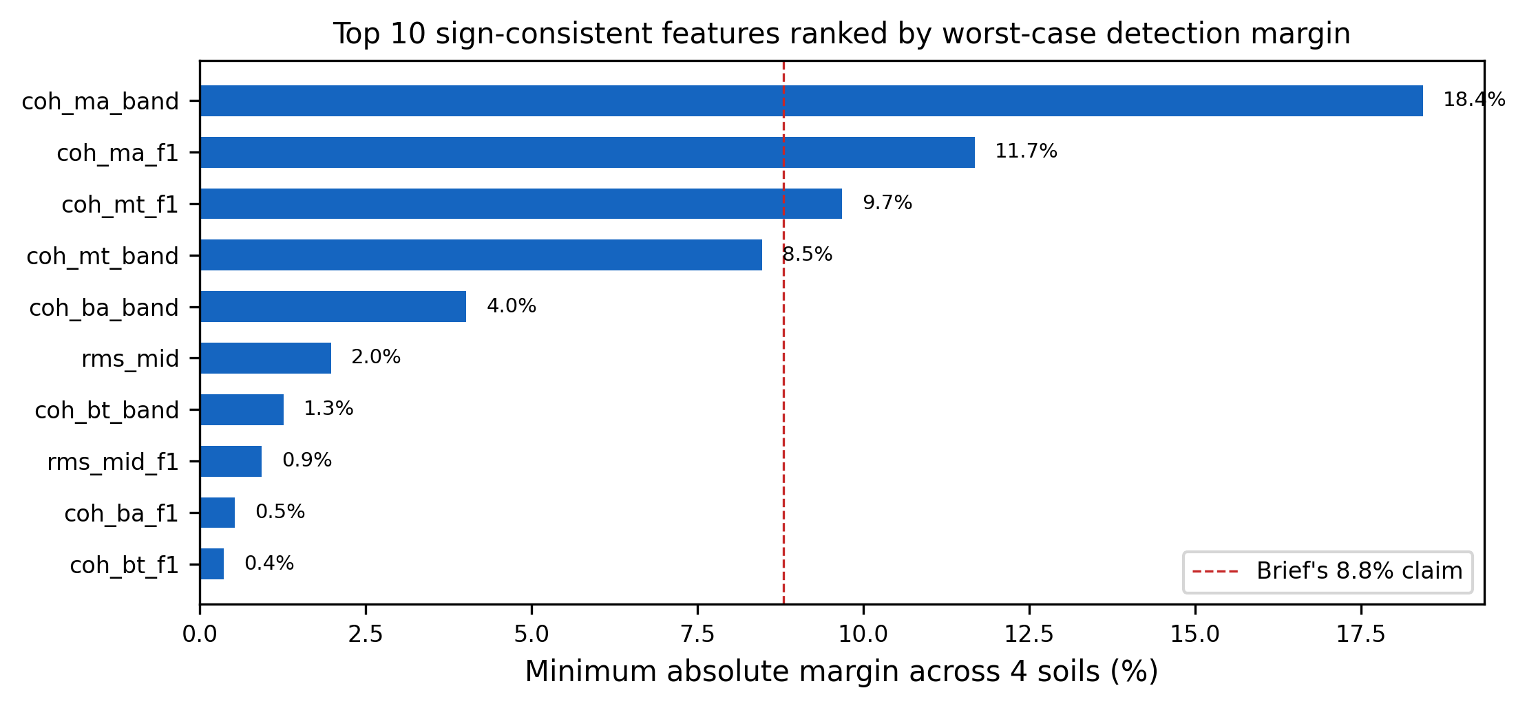
Fig. 1. Top 10 sign-consistent features ranked by minimum absolute margin across four soil conditions.
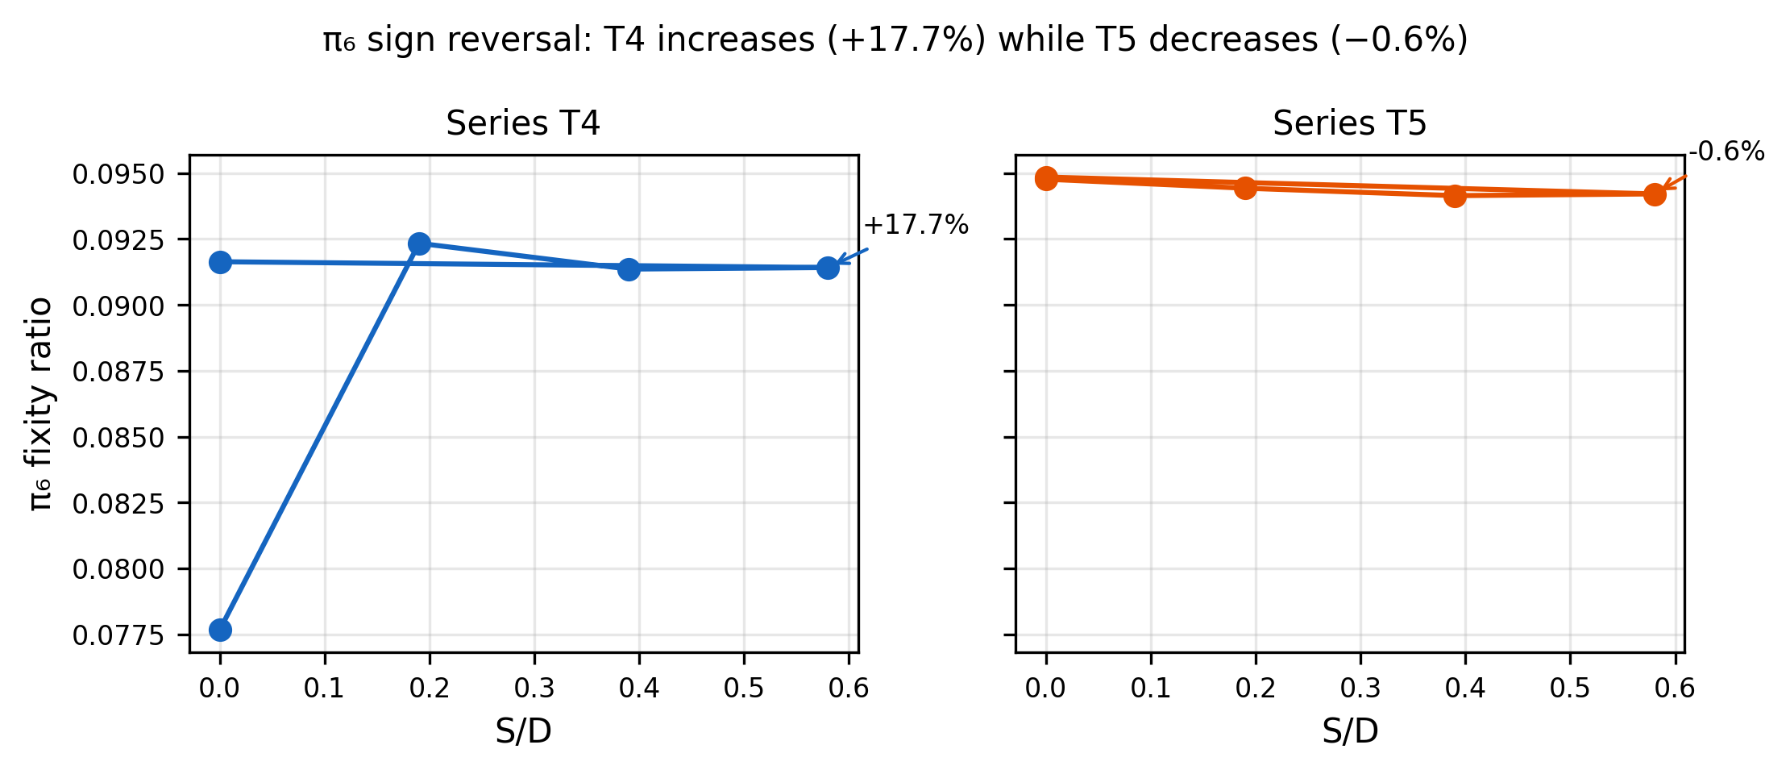
Fig. 2. Strain fixity ratio across scour stages showing the T4 sign reversal (+17.7%).
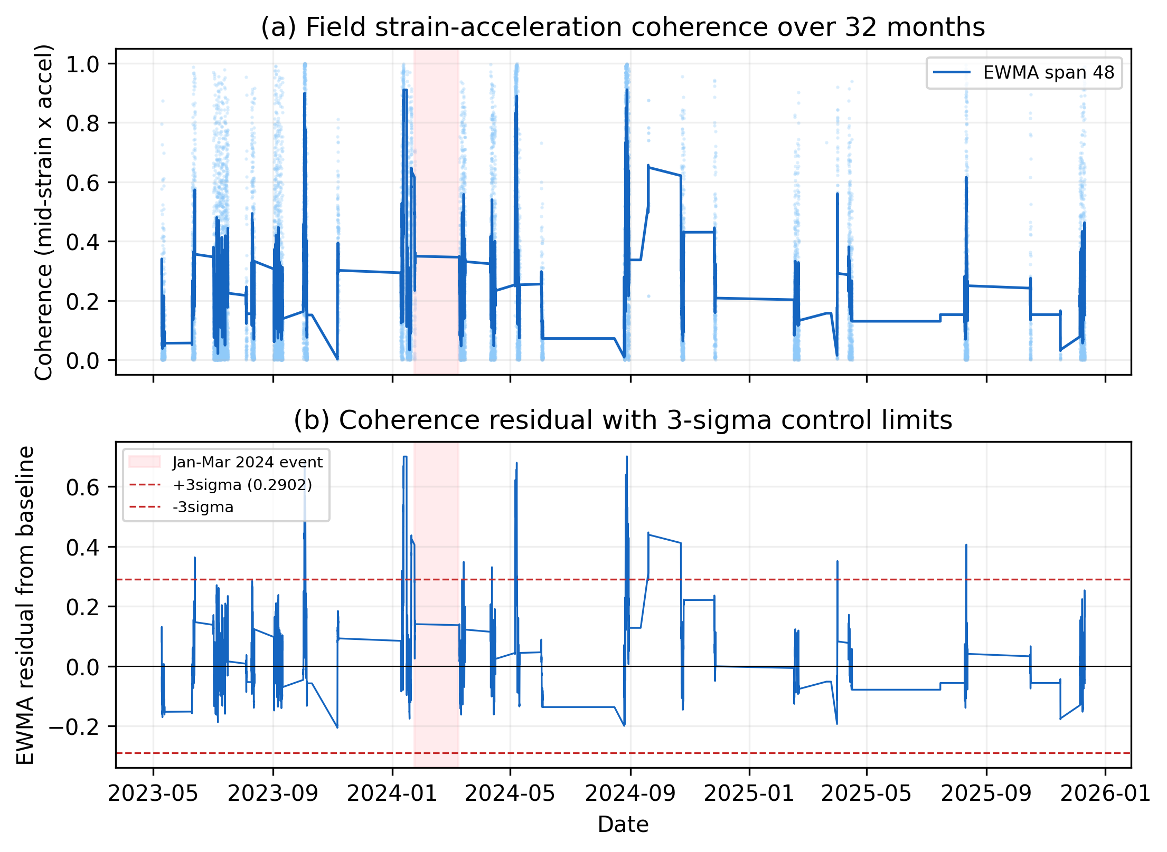
Fig. 3. Field strain-acceleration coherence over 32 months showing the +55.8% shift during the January 2024 event.

5. Conclusions
This sample demonstrated all features of the hybrid DOCX pipeline:
1. Native OMML equations (five equations rendered via MathML → OMML with Microsoft's official XSLT transform). 2. Booktabs-style tables (two tables with navy headers, alternating rows, no vertical borders). 3. Embedded figures (three figures with auto-numbered captions). 4. Inline citations resolved from .bib (three references cited, bibliography rendered below). 5. Consistent Times New Roman 11pt styling with navy headings, 1.5× line spacing, and 1-inch margins.

Acknowledgements
This work was supported by the KEPCO Research Institute through the collaborative research agreement with Seoul National University. The authors thank the MMB consortium for site geotechnical investigation data and Unison Heavy Industries Corporation for turbine operational data and engineering support.
This work was supported by the KEPCO Research Institute. The authors thank the MMB consortium and Unison Heavy Industries.

Declaration of Generative AI and AI-Assisted Technologies
During the preparation of this work, the authors used generative AI (Anthropic Claude) for academic writing coaching and scaffolding of Python figure-generation scripts. All numerical values were independently computed from the analysis scripts; no AI-generated numerical data appear in the paper. All cited references were verified against CrossRef. The authors reviewed and edited all content and take full responsibility for the publication.
Claude (Anthropic) was used for academic writing coaching and script scaffolding. All numerical values were independently verified.

References
Prendergast, L., Gavin, K., Doherty, P. (2015). An investigation into the effect of scour on the natural frequency of an offshore wind turbine. Ocean Engineering, 101, 1--11. https://doi.org/10.1016/j.oceaneng.2015.04.017
Cross, E., Worden, K., Chen, Q. (2011). Cointegration: a novel approach for the removal of environmental trends in structural health monitoring data. Proceedings of the Royal Society A, 467, 2712--2732. https://doi.org/10.1098/rspa.2011.0023
Jalbi, S., Bhattacharya, S. (2018). Closed form solution for the first natural frequency of offshore wind turbine jackets supported on multiple foundations incorporating soil-structure interaction. Soil Dynamics and Earthquake Engineering, 113, 593--613. https://doi.org/10.1016/j.soildyn.2018.06.011

CRediT Authorship Contribution Statement
Kyeong-Sun Kim: conceptualisation, methodology, software, formal analysis, investigation, data curation, validation, writing — original draft, visualisation. Sung-Ryul Kim: conceptualisation, resources, supervision, writing — review and editing, funding acquisition.

Declaration of Competing Interests
The authors declare no competing financial or personal interests that could have influenced the work reported in this manuscript.

Words: 968 | Paragraphs: 59 | Figures: 3 | Tables: 3 | Equations: 5 | Est. pages: 3

