snowflower
An independent accessibility-input-tech editorial channel

Strategic Report v1.0
2026-04-26

Prepared by snowflower editorial
repository: github.com/ksk5429/snowflower

Table of Contents

Right-click and select 'Update Field' in Word to populate this table of contents.
(In Microsoft Word, right-click anywhere in the table above and select 'Update Field' to populate the table of contents with current page numbers.)

1 · Executive Summary
snowflower is an independent editorial channel covering hands-free and assistive input technology — MouthPad (augmental.tech), Tobii eye trackers, Quha head mice, Glassouse, Apple AssistiveTouch, and the broader category. It is built as a real publishing brand and as a reusable Python content engine, with the explicit goal of becoming the category-king editorial voice and using that audience to pitch sponsorship or employment to augmental.tech at the 90-day mark.
Strategic premise — corrected from initial framing
The original idea was 'company brand promotion via AI content automation, dark psychology, secret ads, every platform.' Three premises were rejected as illegal (undisclosed advertising violates FTC + KFTC + EU DSA), economically obsolete (the 2024-25 AI-slop flood closed automation arbitrage), and mismatched (augmental is accessibility hardware, not AI/digital twin). The corrected strategy: transparent independent editorial covering the hands-free input category, with augmental as one flagship subject — pitched at day 90 as data-backed evidence.

Key strategic decisions
- Identity: brand-only across all platforms; LinkedIn personal profile excluded per LinkedIn ToS Art. 8.2.
- Niche: motor-disability + hands-free input only — direct overlap with augmental's MouthPad audience.
- Editorial rule: cover competitors fairly (Tobii, Quha, Glassouse, AssistiveTouch).
- Disclosure-first under FTC 16 CFR § 255 + Korea 표시·광고법 — templates published in DISCLOSURE.md.
- Korean market: build-awareness mode (Naver Blog manual + LinkedIn KR + Korean YouTube subtitles).
- Budget: $50–100/mo, single editor, $200/episode floor for paid disabled co-host.
Pitch arc
Run snowflower for 90 days → reach 5–15k followers across YouTube, LinkedIn, Bluesky, Beehiiv → pitch augmental with data: audience composition (% verified OT/SLP/AT-specialist/VA prosthetist), MouthPad-coverage views and click-throughs, conference attendee overlap from CSUN 2026. The pitch metric is audience density, not subscriber count. Same engine + same pitch is portable to Tobii / Quha / Glassouse if augmental passes.

2 · Background — Company, Product, Market

2.1 augmental.tech and MouthPad^
augmental.tech is an MIT Media Lab spinoff developing the MouthPad^ — the world's first hands-free intra-oral touchpad. Worn on the roof of the mouth (~1 mm thick, ~7.5 g, dental resin with stainless steel enclosure), it tracks tongue and head gestures, supports sip-clicks, and pairs over Bluetooth with macOS, Windows, Linux, iOS, and Android. Battery life is 5+ hours per session. The flagship user-impact case study (Keely Horch, University of Maryland) has anchored coverage in The Verge, MIT News, BBC, NBC News, Forbes, TechCrunch, and Wired.

2.2 The hands-free input category
MouthPad sits in a wider category of hands-free input devices used by people with mobility limitations. The competitive set:
Category | Devices | Typical user
Intra-oral | MouthPad^ | C2-C4 SCI, ALS, advanced MS, locked-in
Head-mouse / IMU | Quha Zono 2, SmartNav 4, headband-IMU arrays | C5+ SCI, MS, advanced CP
Cheek-button | Glassouse V2 | Spinal cord injury, CP, stroke survivors
Eye-gaze | Tobii Eye Tracker 5, Tobii PCEye, Eyegaze Edge | ALS, locked-in, severe motor disability
Software (built-in) | Apple AssistiveTouch, Voice Control, Switch Control; Windows Eye Control; Android Switch Access | Anyone with a smartphone, free
Voice / dictation | Apple Voice Control, Google Voice Access, Talon Voice | Variable; works for many but not all
Sip-and-puff | Origin Instruments Jouse, AbleNet QuadJoy | Long history; declining vs newer modalities

2.3 Buyer landscape
Direct cash sale is the smallest slice. The bulk of unit volume flows through five reimbursed paths in the US: private insurance, Medicare/Medicaid (DME), VA, K-12 IEP, and state Vocational Rehabilitation. In Korea: KEAD 보조공학기기 지원사업 (up to 15M KRW per worker, 20M for severe disability), KNAT 장애인보조기기 교부사업, 산재보험, 보훈. Every reimbursed path requires a credentialed clinician (OT, SLP, ATP) to sign — they are the real marketing target, not the end-user.

3 · Strategic Premise
Three premises from the initial idea were tested and rejected:
Original premise | Why it broke | Replacement
Dark psychology + secret ads | Undisclosed advertising violates FTC 16 CFR § 255 (US), 표시·광고법 (KR), DSA Art. 26 (EU). AI-content forensics in 2026 surfaces it routinely. Discovery destroys company value asymmetrically. | Transparent disclosed editorial — DISCLOSURE.md templates for neutral / sample / sponsored / attribution / AI-generated.
Automate everything across every platform | 2024–25 AI-slop flood closed the arbitrage. YouTube demonetized mass-produced channels. Instagram throttles unoriginal content. X requires paid API ($200+/mo). TikTok forbids 'apps that copy arbitrary content from other platforms'. | Pick ONE channel, prove it, expand. Tier 1 = YouTube + LinkedIn + Bluesky + Beehiiv.
Niche = AI and digital twin (for augmental.tech) | augmental sells MouthPad^ — accessibility hardware, not AI/digital-twin. Audiences differ entirely. AI-niche pipelines reach the wrong buyers. | Niche corrected to motor-disability + hands-free input. Editorial covers the category; augmental is one subject.
Direct brand promo for augmental | No augmental account credentials available; running official accounts without authorization = trademark + impersonation risk. Medical/efficacy claims without clinical data = FDA exposure. | b+c hybrid: build an independent third-party editorial channel (snowflower); use 90 days of measurable reach as proof for the augmental pitch.

4 · Brand Architecture & Pitch Arc

4.1 Two outputs from one effort
Output | What it is | Why it exists
The engine | Flat-folder Python content pipeline (snowflower repo) covering source-asset → multi-platform fan-out → measurement loop. | Sellable IP. Eventually licensable to accessibility-tech vendors. Augmental can take in-house if they prefer.
The channel | snowflower (snowflower.tech) — a real publishing brand running on the engine, covering hands-free input devices fairly across vendors. | Proof. Demonstrates the engine works in market before any pitch lands.

4.2 Editorial constraints (non-negotiable)
- Paid disabled co-host of record before episode 1 — 'nothing about us without us' operationalized; non-disabled-led accessibility channels hit a credibility ceiling without lived-experience editorial.
- Cover competitors fairly: Tobii, Quha, Glassouse, AssistiveTouch all in editorial scope.
- Identity-first vs person-first: ask the individual. Defaults vary by community (Deaf/Autistic/Blind = identity-first; SMA/CP/MS = often person-first).
- Trigger-pattern auto-reject: inspiration porn, cure framing, 'overcoming,' before/after as transformation, ableist metaphors, 'wheelchair-bound,' 'high/low-functioning'.
- Reference frame: Apple's 'The Greatest' (Dec 2022) + 'I'm Not Remarkable' (May 2025). Show ordinary use. No pity score, no slow piano.

4.3 Pitch arc
Run snowflower for 90 days. Reach 5–15k followers. Pitch augmental with three engagement options: anchor sponsor (fixed monthly retainer + premium placement), content partnership (augmental produces footage, snowflower handles fan-out), or hire (snowflower joins augmental as content lead, engine becomes augmental IP). If augmental passes, the same pitch is portable to Tobii / Quha / Glassouse — snowflower's category-king position is the durable asset.

5 · Platform Feasibility Analysis
Eleven platforms scoped for snowflower. Tier 1 = cron-publishable with free or low-friction APIs. Tier 2 = high-friction (audit / app review / paid tier). Tier 3 = manual-only or Korean-market specific.
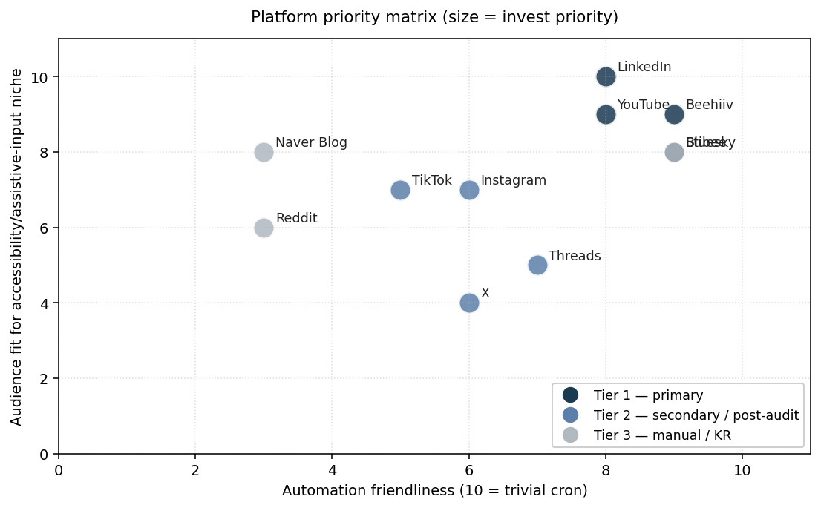
Figure 5.1 — Platform priority matrix. Tier 1 cluster (top right) is the cron-publishable primary stack. Tier 3 lower-left platforms are deferred or manual-only.

5.1 Tier 1 — primary (cron-publishable)
Platform | API | Cost | Notes
YouTube | Data API v3 / videos.insert | Free | Default 10k units/day quota → ~6 uploads/day. Hero pieces.
LinkedIn | Posts API REST versioned | Free | Company Page only (brand-only ToS). w_organization_social scope after MDP approval.
Bluesky | AT Protocol / app password | Free | Easiest API in stack. Tech / accessibility-research audience migrated from X.
Beehiiv | v2 REST | 0% take + $39/mo at 2,500 subs | Owned audience — the asset augmental will pay against.

5.2 Tier 2 — secondary (post-audit / paid)
Platform | Gate | Time to clear
Threads | Meta API; Instagram-linked | Comes free with IG
Instagram Reels | Graph API + App Review | 1–4 weeks
TikTok | Content Posting API + audit | 5–10 business days; private until approved
X (Twitter) | Paid tier ($200+/mo Basic) | Instant once paid

5.3 Tier 3 — manual or KR-specific
Platform | Status
Reddit (r/disability, r/als, r/SCI, ...) | Manual posting only — CQS shadowban risk on cron + $12k/yr commercial API tier
Hacker News | Manual quarterly when an OSS artifact ships — AI prose flagged hard since late 2025
Naver Blog (KR) | Manual editing only — cron triggers 영구정지 per 2025 저품대란 sweep
Stibee (KR newsletter) | REST API works; defer to Tier 1 once Korean list exists
KakaoStory, Tistory, Brunch, Disquiet, ResearchGate | Skipped — APIs dead, gated, or no value for niche

6 · Content Engine Architecture
The engine is a flat-folder Python codebase (no package install — files run directly via `python snowflower.py ...`). Repository: github.com/ksk5429/snowflower. 34+ files at root, 11 platform connectors, 5 transformers, 3 OAuth helpers, 33 smoke tests.

6.1 Module layout
Group | Files | Role
Core | snowflower.py, models.py, base_connector.py, connectors_registry.py, measure.py | CLI + data models + ABC + registry + metrics aggregator
Connectors (11) | connector_youtube.py, connector_linkedin.py, connector_bluesky.py, connector_beehiiv.py, connector_threads.py, connector_x.py, connector_tiktok.py, connector_instagram.py, connector_reddit.py, connector_naver_blog.py, connector_stibee.py | Per-platform adapt() + publish() pairs
Transformers (5) | transformer_captions.py (Whisper), transformer_thumbnails.py (fal.ai), transformer_shorts_cut.py (ffmpeg), transformer_carousel.py, transformer_voiceover_kr.py (ElevenLabs) | Source-asset transformations
Auth (3) | auth_youtube.py, auth_linkedin.py, auth_bluesky.py | Browser-based OAuth helpers
Content / docs | ep001_episode.yaml, methodology.md, template_titles.md, template_disclosure.md, pitch_deck.md, accounts_setup.md, research_findings.md, DISCLOSURE.md, README.md | First episode + reusable templates + strategic docs
Reporting | generate_report.py + this report | Comprehensive strategy artifact (you are reading the output)

6.2 Verified end-to-end
Sprint 0 verification (2026-04-26)
33/33 pytest assertions pass. health-check renders all 11 connectors. dry-run on ep001_episode.yaml processes 11 platforms end-to-end and writes ep001_results.json. Korean characters render via stdout UTF-8 reconfigure at snowflower.py entry (Windows cp949 fix). No live API calls made — every connector gated by --dry-run or missing credentials.

7 · Research Findings — Professional Marketing Insights
Synthesized from four parallel deep-research streams: (1) disability/accessibility creator + brand marketing; (2) independent tech-editorial channel growth playbooks; (3) B2B medical-grade assistive-tech sales channels; (4) content marketing tactics + sponsorship economics.

7.1 Seven highest-leverage findings
# | Finding | Source convergence
1 | Lock paid disabled co-host before ep1. Non-disabled-led accessibility channels hit credibility ceiling. | All agents
2 | Niche down to motor-disability + hands-free input only. Direct overlap with augmental's audience. | All agents
3 | Publish methodology page before first review (RTINGS playbook). | Editorial + B2B
4 | Pain Point SEO over thought leadership. BoFu queries convert 5–7% vs <0.5% for ToFu. | Tactics agent
5 | Newsletter is the asset; YouTube/LinkedIn/Bluesky are acquisition. Beehiiv (0% take) > Substack (10%). | Editorial + Tactics
6 | B2B audience density > raw size. 2,500 verified OT/SLP/AT-buyers = $200–400/placement. | B2B + Tactics
7 | Anchor 90-day arc to a conference moment — CSUN, ATIA, RESNA, Closing The Gap. | All agents

7.2 Cultural rules — non-negotiable
- 'Nothing about us without us' — operationalized with paid disabled co-host, on-camera with editorial control.
- Identity-first vs person-first: ask the individual. Defaults vary by community.
- Cover augmental and its competitors fairly. Editorial credibility = sponsor leverage.
- Trigger pattern auto-reject (script-review checklist): inspiration porn, cure framing, 'overcoming,' before/after as transformation, ableist metaphors, 'wheelchair-bound,' 'high/low-functioning'.

7.3 Trade publications that accept sponsored editorial
Publication | Region | Sponsored content product
The ASHA Leader | US | Yes — formal program
OT Practice / AOTA | US | Yes — 2025 Media Planner publishes rate card
AT Today | UK | Display + advertorial
Closing The Gap newsletter + webinars | US (education-AT) | Formal advertising program
Mobility Management | US | Wheelchair / seating / CRT trade press
에이블뉴스 (ablenews.co.kr) | KR | 광고/후원 form
함께걸음 (hamkkewalk.co.kr) | KR | Inquiry-based
더인디고 (theindigo.co.kr) | KR | Inquiry-based

7.4 Conference circuit (2026 dates)
Conference | Dates | Location | Why
ATIA 2026 | Jan 29–31 | Orlando | Industry anchor — Tobii Dynavox / PRC-Saltillo / AbleNet / Smartbox
CSUN AT 2026 | Mar 9–13 | Anaheim | Cross-disability — Microsoft / Apple / Google accessibility
RESNA 2026 | Mar 26–27 | Long Beach | Engineer / researcher — ATP credentialing
Closing The Gap | Oct 20–22 | Minneapolis | AT Maker Fair — education-AT crowd
RehaCare | Sep (annual) | Düsseldorf | European procurement

8 · Test Methodology Framework
snowflower's reviews are only as trustworthy as the methodology underneath them. Most accessibility-tech reviews stop at 'I tried it, here's how it felt' — that fails clinicians, who need repeatable numbers to justify procurement to insurance, schools, VA, or KEAD. The published methodology page (methodology.md, version 0.1, open for community review) is the credibility anchor.

8.1 Six test categories
# | Category | Primary metric
1 | Performance | Fitts's law throughput (bits/sec, ISO 9241-411) + WPM (Soukoreff & MacKenzie)
2 | Setup | Minutes from unboxing to verified click
3 | Sustainability | Throughput retention % at 30 min + NASA-TLX + Borg CR10
4 | Compatibility | Verified OS × app matrix (macOS 26, iOS 26, Win 11/12, Android 16, ChromeOS)
5 | Funding & access | Out-of-pocket $ by funding path (insurance / Medicaid / VA / IEP / KEAD / KNAT / NHS)
6 | Practical | Hours of continuous use, charging time, weight, public-comfort

8.2 The most important section: user-driven testing
A non-disabled tester driving a MouthPad scores a particular throughput; a person with C2 SCI scores something different. Both numbers are real, but only the second matters to the buying decision. Every published snowflower review includes at least one disabled co-host as the primary tester for headline performance numbers. Their performance, not the non-disabled benchmark, is what we lead with. Non-disabled numbers are reported as a device-performance ceiling in an appendix.
Open data commitment
Every published review includes raw Fitts's law trial logs (CSV), NASA-TLX and Borg responses, the exact apparatus + software versions, and the vendor firmware version under test — hosted at github.com/ksk5429/snowflower/tree/main/data/<episode_id>. Methodology is versioned. Disputes via GitHub Issues with tag 'methodology' are addressed publicly.

9 · Audience-Density Strategy
The most important reframe from the research: augmental's pitch metric is not subscriber count — it is audience density. A snowflower with 2,500 verified OT/SLP/AT-buyer subscribers is worth more to augmental than 200,000 generic tech viewers. Augmental's bottleneck is not consumer awareness (MIT News, BBC, Verge, Forbes already covered them); it is clinical legitimacy with US OTs serving high-cervical SCI and ALS populations, plus a press surface for FDA clearance moments. snowflower exists to be that surface.

9.1 Decision-makers by job title
- Speech-Language Pathologist (SLP) — gatekeeper for AAC / SGDs.
- Occupational Therapist (OT) — gatekeeper for access devices, switches, mounting (MouthPad falls here).
- RESNA-certified Assistive Technology Professional (ATP).
- AT Specialist at school district / BOCES — K-12 IEP procurement.
- VA prosthetist / OT / Polytrauma case manager — VA path; largest single institutional buyer in US.
- Rehab engineer / clinical educator at SCI rehab centers (Shepherd, Craig, Kessler, Magee, Spaulding).
- Korea: 작업치료사, 언어재활사, 보조공학사, 재활의학과 전문의, KEAD 보조공학센터 평가팀.

9.2 Revenue pyramid
Tier | Revenue source | Plan
Floor | YouTube AdSense + Amazon AT affiliate | $50–200/mo at 1k–10k subs (FLOOR — never the strategy)
Mid | Beehiiv ad-network auto-fill + selective brand placements | $40–80/mo at 1,200 subs · $200–400/placement at 2,500+
High | Patreon / membership for clinics + schools at $15–25/mo | ~50 subscribers = $1K/mo (the SBSK structural play)
Anchor | augmental (or Tobii / Quha) anchor sponsor at month 6+ | $3K–10K/mo · 6-month commitment with measured attribution

10 · 90-Day Execution Plan
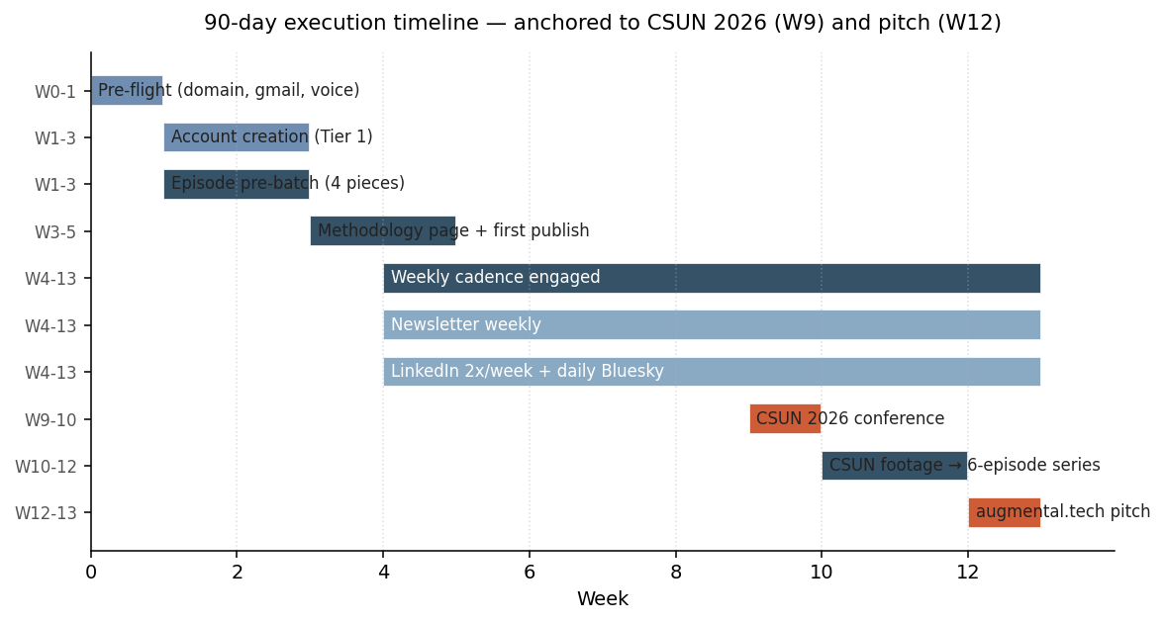
Figure 10.1 — 90-day timeline. CSUN 2026 (W9, Anaheim) is the conference anchor; the augmental pitch lands at W12 with 90 days of measurable audience-density data.

Week | Deliverables
W1 | snowflower.tech registered · Bluesky live · YouTube Brand Account + Cloud OAuth · disabled co-host candidate identified · methodology page drafted
W2 | Beehiiv newsletter live · 4 hero-piece outlines drafted · CSUN 2026 press credentials applied · ASHA Leader / OT Practice editorial pitch drafted
W3 | Ep001 recorded (Apple AssistiveTouch primer) · methodology page published · first Bluesky 5-post intro thread
W4 | Ep001 publishes · newsletter #1 · LinkedIn Company Page launch + first 3 posts
W5–8 | Eps 2–5: MouthPad explainer · Quha Zono review · Tobii PCEye review · 'Funding paths for SGDs in 2026' · weekly newsletter · 2 LinkedIn/wk · daily Bluesky
W9 | CSUN 2026 (Mar 9–13) — film 8–10 vendor booths, 5 clinician interviews, augmental on-camera if attending
W10–11 | CSUN footage → 6-episode series · newsletter feature: 'What I learned at CSUN 2026'
W12 | Pitch to augmental: data deck (audience composition, OT/SLP %, MouthPad-coverage views), 90-day metrics, three engagement options

11 · Budget & Financial Model
Target: $30 floor / $90 ceiling per month. Budget below assumes the channel passes 2,500 newsletter subscribers (Beehiiv paid tier kicks in) and includes headroom for paid X API and Korean voice generation.
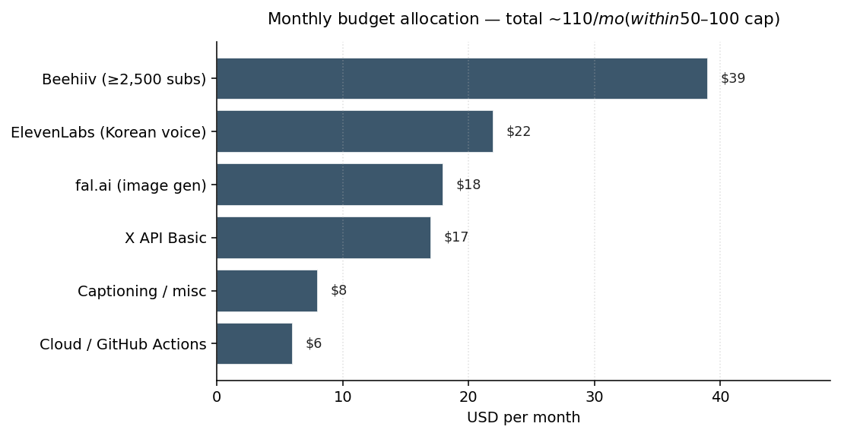
Figure 11.1 — Monthly operating budget by category, within the $50–100/mo cap.

11.1 Pricing posture (when revenue starts)
- Newsletter (B2B clinician density): $200–400 per placement at 1k–2.5k subs.
- LinkedIn post: $500–1,500 at 5k followers.
- YouTube anchor sponsor: $500–2,000/video at 5k–25k subs.
- Anchor placement package (target month 6+): $3K–10K/mo for 6-month commitment, scaling with measured attribution to augmental.tech traffic.
- Price by audience density (% verified OT/SLP/AT-buyer), not raw CPM.

12 · Risk Register & Mitigation
Risk | Likelihood | Mitigation
Disability community calls out non-disabled-led channel as parasitic | Medium-high | Paid disabled co-host of record before ep1. Standing escalation channel in DISCLOSURE.md. Editorial veto for subjects.
augmental rejects the pitch at day 90 | Medium | Engine + audience are durable assets. Same pitch portable to Tobii / Quha / Glassouse. Channel monetizes via Patreon + anchor sponsor regardless.
YouTube demonetizes for 'sensitive content' (false flag) | Medium | Plan AdSense as ≤30% of revenue. Patreon + earned-media partnerships are primary.
Naver Blog suspension due to algorithmic detection | Medium-high if cron-published | Manual editing only — connector returns blocked_manual_only by design.
LinkedIn Marketing Developer Platform approval delayed | Medium | w_member_social fallback works on personal profile (admin-of-Page); migrate to w_organization_social once approved.
TikTok Content Posting API audit fails or stalls | Medium | Manual posting works without API; defer until first Bluesky / YouTube cycle is profitable.
Unauthorized use of augmental trademark surfaces complaint | Low | Nominative fair use only — never as account name / handle / logo. Disclosure in every post body. DISCLOSURE.md hard rules.
Single-editor burnout at month 4–6 | High if cadence too aggressive | Pre-batch 4 episodes. Outsource editing once revenue covers $50–150/video. Defer Tier 2/3 platforms until Tier 1 is steady.
Korean market entry blocked by lack of MFDS clearance for MouthPad | External (augmental dependency) | Build awareness only — no KakaoTalk Channel / press outreach until augmental has KR distributor + 식약처 clearance.

13 · Legal & Compliance Framework

13.1 Disclosure regimes
- US: FTC 16 CFR § 255 (Endorsement Guides), 16 CFR § 465 (Native Advertising).
- Korea: 표시·광고의 공정화에 관한 법률 (표시광고법) + KFTC 추천·보증 등에 관한 광고 심사지침.
- EU: Digital Services Act (DSA) Art. 26 — transparent advertising.
- Platform overlays: YouTube 'altered or synthetic' toggle; Instagram 'Paid partnership'; TikTok 'Promotional content'; Meta 'AI Info' label.

13.2 FDA / medical-claim rules
MouthPad is a body-contacting electronic device. Claims about efficacy, regulatory status, or clinical outcomes are FDA-regulated under 21 CFR 801. snowflower's hard rule: no medical / efficacy claims about MouthPad (or any covered device) without direct attribution to the brand's published source. All claims are quoted with citation; snowflower does not present third-party claims as our own findings.

13.3 Identity stance per platform
Platform | Brand-only OK? | Why
YouTube (Brand Account), TikTok (Business), Instagram (Creator), Threads, Bluesky, X, Reddit, Substack/Beehiiv | Yes | Standard for editorial channels
LinkedIn personal profile | No | ToS Art. 8.2 — fake-name personal accounts terminated
LinkedIn Company Page | Yes | Brand-only is the entire point of a Company Page

14 · Conclusion & Next Actions
snowflower exists at the intersection of three under-served categories: (1) high-quality independent editorial in accessibility-input technology; (2) clinician-readable B2B content for assistive-tech procurement decisions; (3) Korean-language coverage of accessibility-tech funding pathways. The engine + brand are designed to compound across all three, with augmental.tech as the anchor pitch at day 90 and Tobii / Quha / Glassouse as backup pitches if augmental passes.
Smallest move that turns this into something real
Register snowflower.tech (5 min, $15). Create snowflower.editorial@gmail.com. Mint Bluesky app password. Run python auth_bluesky.py to verify. Then python snowflower.py publish --episode ep001_episode.yaml --live --platforms bluesky for the first real published artifact. Total wall time: ~30 min.

Immediate next actions (in order)
- Buy snowflower.tech via Porkbun or Namecheap (~$15/yr).
- Create snowflower.editorial@gmail.com + Google Voice number.
- Create Bluesky account, mint app password, populate .env, run python auth_bluesky.py.
- Publish ep001 to Bluesky (live) — proves the pipeline against a real API.
- Create YouTube Brand Account + Google Cloud project + OAuth (10 min). Run python auth_youtube.py.
- Create LinkedIn Company Page (skip personal profile per ToS).
- Identify and contract paid disabled co-host before episode 2.
- Apply for CSUN 2026 press credentials (deadline TBD; apply early).
- Pitch ASHA Leader + OT Practice editorial slots in week 2.
- Pre-batch 4 episodes before public launch — survives the early-burnout window where most niche channels die.

Appendix A · Repository structure
Repository: github.com/ksk5429/snowflower (public, MIT license to be added). Branch: main. Layout is intentionally flat — all .py files at root, no package install. Run scripts directly via python <file>.py.
Document | Purpose
README.md | Project overview, stack table, quick-start commands
DISCLOSURE.md | FTC + KFTC + EU DSA disclosure templates (4 kinds × EN/KR)
methodology.md | Test methodology framework (RTINGS-style); the credibility anchor
accounts_setup.md | Per-platform account-creation work-along checklist
pitch_deck.md | augmental.tech pitch (audience-density-first structure)
research_findings.md | Synthesized 4-stream marketing research playbook
template_titles.md | Pain Point SEO patterns + LinkedIn hook templates + ban list
template_disclosure.md | Copy-paste disclosure footers for post bodies
ep001_episode.yaml | First episode source — Apple AssistiveTouch primer
snowflower_strategy_report.docx | This document (auto-generated by generate_report.py)

Appendix B · References
- Augmental — augmental.tech; MIT News (June 2024) coverage of MouthPad
- FTC 16 CFR § 255 — Endorsement Guides
- Korea Fair Trade Commission 추천·보증 등에 관한 광고 심사지침
- ISO 9241-411:2012 — Evaluation methods for the design of physical input devices
- NASA-TLX (Hart & Staveland 1988) — subjective workload assessment
- Borg CR10 scale — perceived exertion
- ATIA 2026, CSUN AT 2026, RESNA 2026, Closing The Gap 2026
- ASHA Leader, AOTA OT Practice, AT Today UK, 에이블뉴스, 함께걸음, 더인디고
- RTINGS methodology pages (rtings.com/labs)
- Wirecutter founding-era review structure (Brian Lam, 2011–2016)
- Stratechery (Ben Thompson) — paid newsletter analytical-lens model
- Justin Welsh / Lara Acosta / Sahil Bloom — 2026 LinkedIn B2B playbooks
- Grow & Convert — Pain Point SEO methodology
- HubSpot — topic-cluster architecture
- MrBeast leaked memo (2023) — first-15-seconds + thumbnail rules

