Docker Machine and Docker Compose Environments

Kirk S. Kalvar

Wednesday, February 25, 2015

# Overview

One of the nice things about docker-machine and docker-compose is how easy you can put together a somewhat sophisticated development sandbox without the need to download separate point products and cobble everything together. It provides easy startup and shutdown that environment as well.

# Install Docker Machine

## Download VirtualBox

Download Oracle VirtualBox for your platform

<https://www.virtualbox.org/wiki/Downloads>

## Download Docker Machine

Download Docker Machine

<https://docs.docker.com/machine/>

You need to setup your environment so the docker machine executable is on your PATH. Since I use Cygwin on Windows I also set an alias since the executable name is actually quite a bit longer than the documentation reference to ***docker-machine***.

## Create Docker VM

docker-machine create --driver **virtualbox** dev

## VirtualBox Port Forwarding

In order to access from your desktop you need to add port 3000 to "port forwarding" setting for Virtual Machine in VirtualBox.

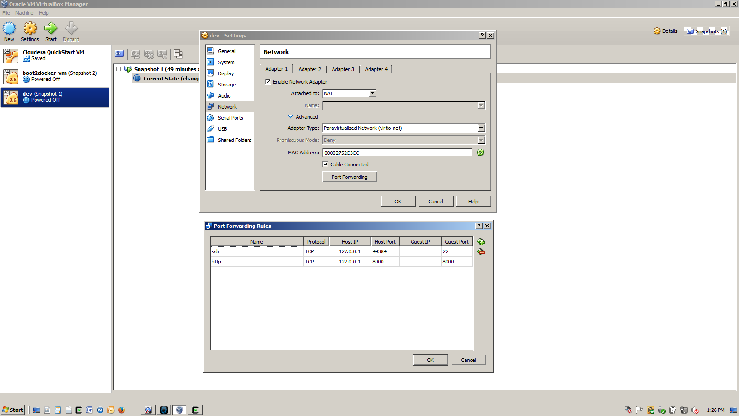

## VirtualBox Setting Up Shared Local Drive

To speed up the process we can share a local drive via VirtualBox and run scripts via the Docker VM

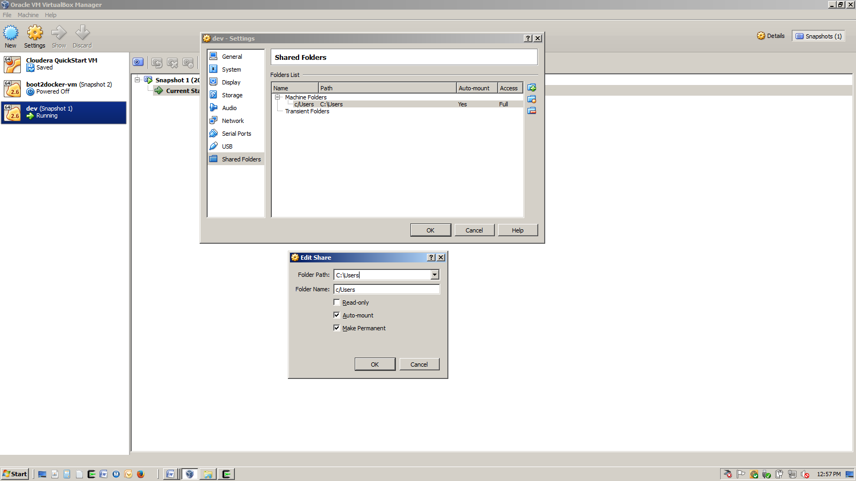

## Poweroff and Restart Docker VM

This will enable port forwarding/file sharing with the client machine

docker-machine stop dev

docker-machine start dev

# Install Docker Compose

Modify /var/lib/bootlocal.sh to create an alias that will setup docker-compose alias every time the Docker VM starts.

## Setting Up Docker Compose (Windows 7 hack)

docker-machine ssh dev

sudo touch /var/lib/boot2docker/bootlocal.sh

sudo chmod 777 /var/lib/boot2docker/bootlocal.sh

sudo cat << EOF > /var/lib/boot2docker/bootlocal.sh

echo 'alias docker-compose='"'"'docker run \

-v \$(pwd):/app \

-v /var/run/docker.sock:/var/run/docker.sock \

-ti dduportal/docker-compose:1.2.0'"'" >> /home/docker/.ashrc

EOF

## Poweroff and Restart Docker VM

This will setup docker-compose.

docker-machine stop dev

docker-machine start dev

## Testing docker-compose

docker-machine ssh dev

docker-compose

# Install MEAN

Since /c/Users/<username> is a shared directory with your client machine, once you've built mean it will be available on your client machine. Note: <username> is your windows username.

cd /c/Users/<username>

mkdir git

cd git

git clone https://github.com/meanjs/mean.git

git clone https://github.com/kskalvar/mean-stack.git # Be sure to see README.md

cd mean

git checkout 0.4.0

cd ../mean-stack

cp Dockerfile docker-compose.yml ../mean

cd ../mean

You will need to modify the following line in config/env/development.js:

db: "mongodb://db/mean-dev",

docker-compose up -d

## Testing MEAN

Test from dev directly, and your client machine using curl

curl http://localhost:30000/

# docker-compose Commands

docker-compose stop

docker-compose start

docker-compose restart

docker-compose rm

# Attaching to a Docker Container

docker exec -it app_web_1 bash