Automated Baby Care – Final Project – Data Analytics Pipeline

Lisa Thomas
Karan Sindwani
Sheetal Reddy (kr2793)

Github : https://github.com/LisaThomas9/Automated-Baby-Care-ABC-
Jira :

Table of Contents

- Introduction
- Architecture Of Big Picture
- Architecture Of MVP and Implementation
- How To Run The Model
5. Screenshots Of The Working Model

- INTRODUCTION

This project aims to design and implement a baby care monitor based on computer vision that is able to alert the parent when the baby is crying and to also play music to soothe the baby.

- ARCHITECTURE OF BIG PICTURE

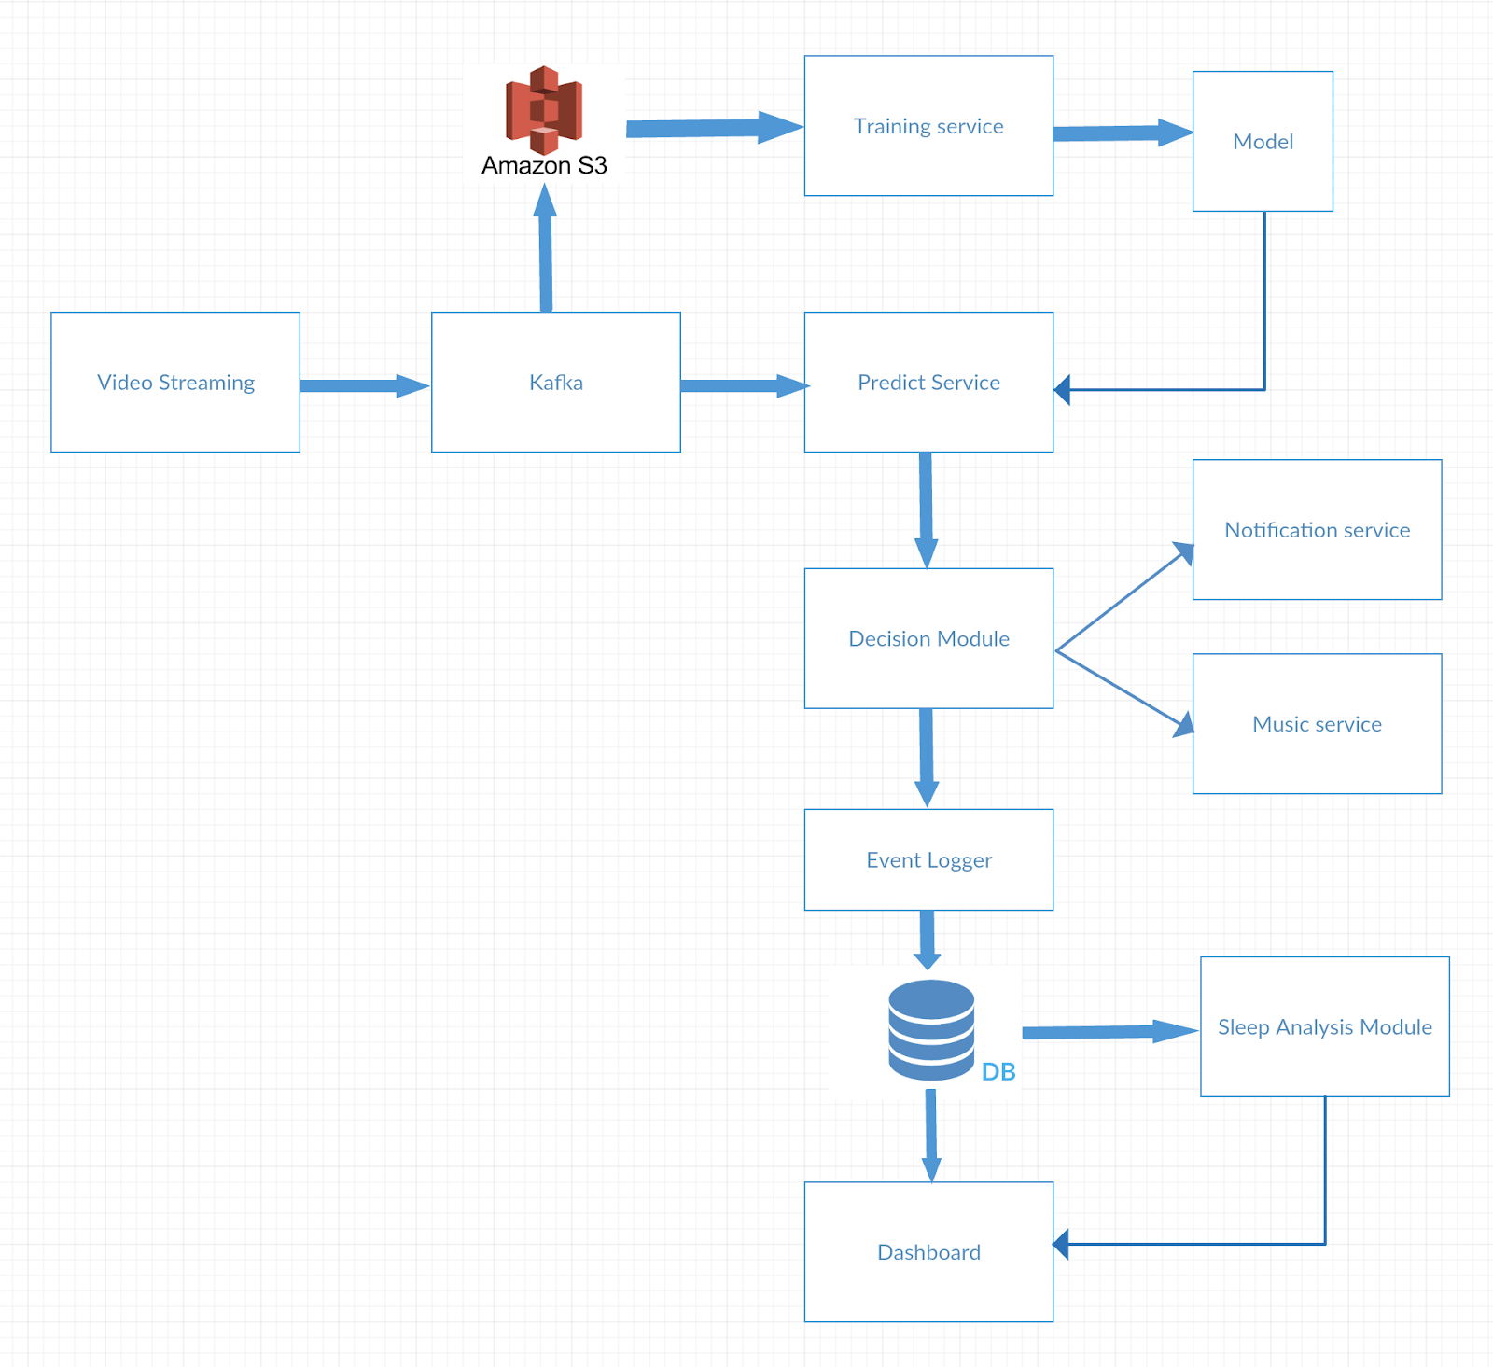

Service level descriptions:

- Video Streaming :
This module takes as input the streaming video of the baby and provides it to Kafka

- Kafka:
Apache Kafka is a distributed streaming platform that provides a system for publishing and subscribing to streams of records.

- S3 :
For video storage for use for further analytics and ability to rewatch videos.

- Training Service:
A Machine Learning training service that uses the data in S3 to build a CNN (Convolution neural network) based Image classifier.

- Processing Service :
A Machine Learning prediction service to detect the emotion of the baby to check if the baby is awake, asleep, crying etc.

- Decision Service :
The event generator which published messages onto the queue for other services to get triggered.

- Notification Service:
A service that pushes a notification to the parent’s mobile if the baby is awake/crying.

- Music Play Service:
Plays music to soothe the baby.

- Event Logger

- Database :
Saves the timestamp and the emotion detected

- Sleep Analytics Service:
Perform analytics on the data stored in the Database to analyse the sleeping patterns and quality of sleep.

- Dashboard :
Shows the emotion as well as results from sleep analysis.

- ARCHITECTURE OF MVP AND IMPLEMENTATION

- HOW TO RUN THE MODEL

5. SCREENSHOTS OF THE WORKING MODEL

