大数据分析与可视化实训报告
基于淘宝母婴购物数据的用户消费行为分析与可视化
项目名称 | 淘宝母婴购物数据分析与可视化
技术路线 | Python + Pandas + Scikit-learn + ECharts + ?? Spark SQL / MLlib ????
小组 | 第 1 组
完成日期 | 2026 年 6 月

1. 项目背景与目标
??????????????????????????????????????????????????????????????????? ECharts ????????????? Python/Pandas/sklearn ???Spark SQL / MLlib ?????????????????
- 分析商品大类销量、月度趋势、星期趋势、用户性别和宝宝年龄阶段消费差异。
- 将 cat1 数字编码映射为中文业务词，提升图表和报告可读性。
- ????????????????????????????????????????????????????????????????
- ?? Spark SQL / MLlib ???????????? Java?PySpark???? --spark ???? Spark DataFrame ???????????

2. 数据来源与预处理
?????????????????????? data/raw/ ??????? Pandas ???????????????????????user_id ???????????????????????? 29,672?
dataset | row_count | column_count | duplicate_count | columns
trade_history | 29971 | 7 | 0 | user_id, auction_id, cat_id, cat1, property, buy_mount, day
baby_info | 953 | 3 | 0 | user_id, birthday, gender
表 1 数据集概览
dataset | column | dtype | missing_count | missing_rate
trade_history | user_id | int64 | 0 | 0.0
trade_history | auction_id | int64 | 0 | 0.0
trade_history | cat_id | int64 | 0 | 0.0
trade_history | cat1 | int64 | 0 | 0.0
trade_history | property | object | 144 | 0.0048
trade_history | buy_mount | int64 | 0 | 0.0
trade_history | day | int64 | 0 | 0.0
baby_info | user_id | int64 | 0 | 0.0
baby_info | birthday | int64 | 0 | 0.0
baby_info | gender | int64 | 0 | 0.0
表 2 缺失值统计

3. 描述性统计与可视化
????????????????????????????????????????????????????????????????? cat1_name ?? buy_mount ?????????????????????
cat1 | trade_count | user_count | item_count | total_buy_mount | avg_buy_mount
喂养用品 | 12464 | 12454 | 12017 | 14228 | 1.1415
婴儿服饰 | 6791 | 6786 | 6417 | 9363 | 1.3787
尿裤湿巾 | 4770 | 4769 | 4401 | 7119 | 1.4925
孕产用品 | 1182 | 1181 | 1155 | 2929 | 2.4780
玩具早教 | 2357 | 2357 | 2105 | 2751 | 1.1672
童车童床 | 2108 | 2108 | 2046 | 2192 | 1.0398
表 3 商品大类销量统计
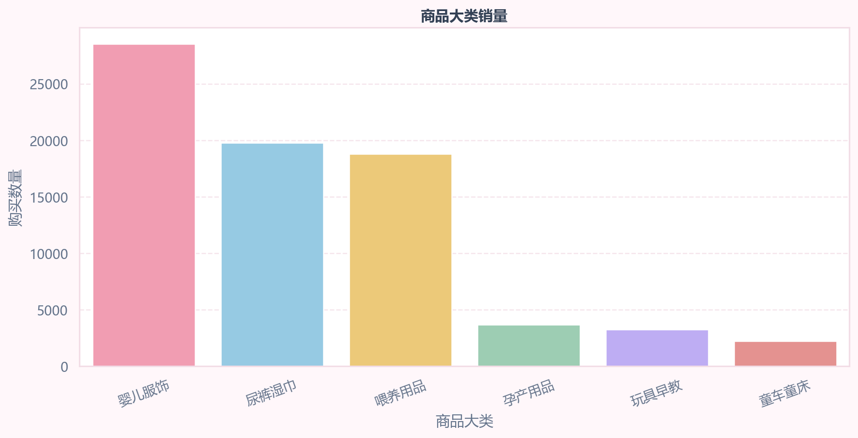
图 1 商品大类销量横向条形图
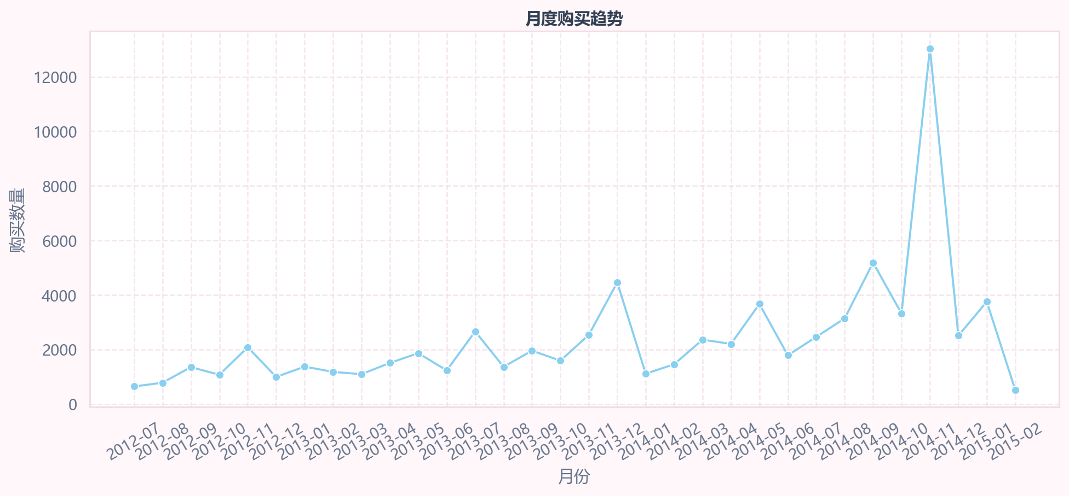
图 2 月度购买趋势平滑折线图
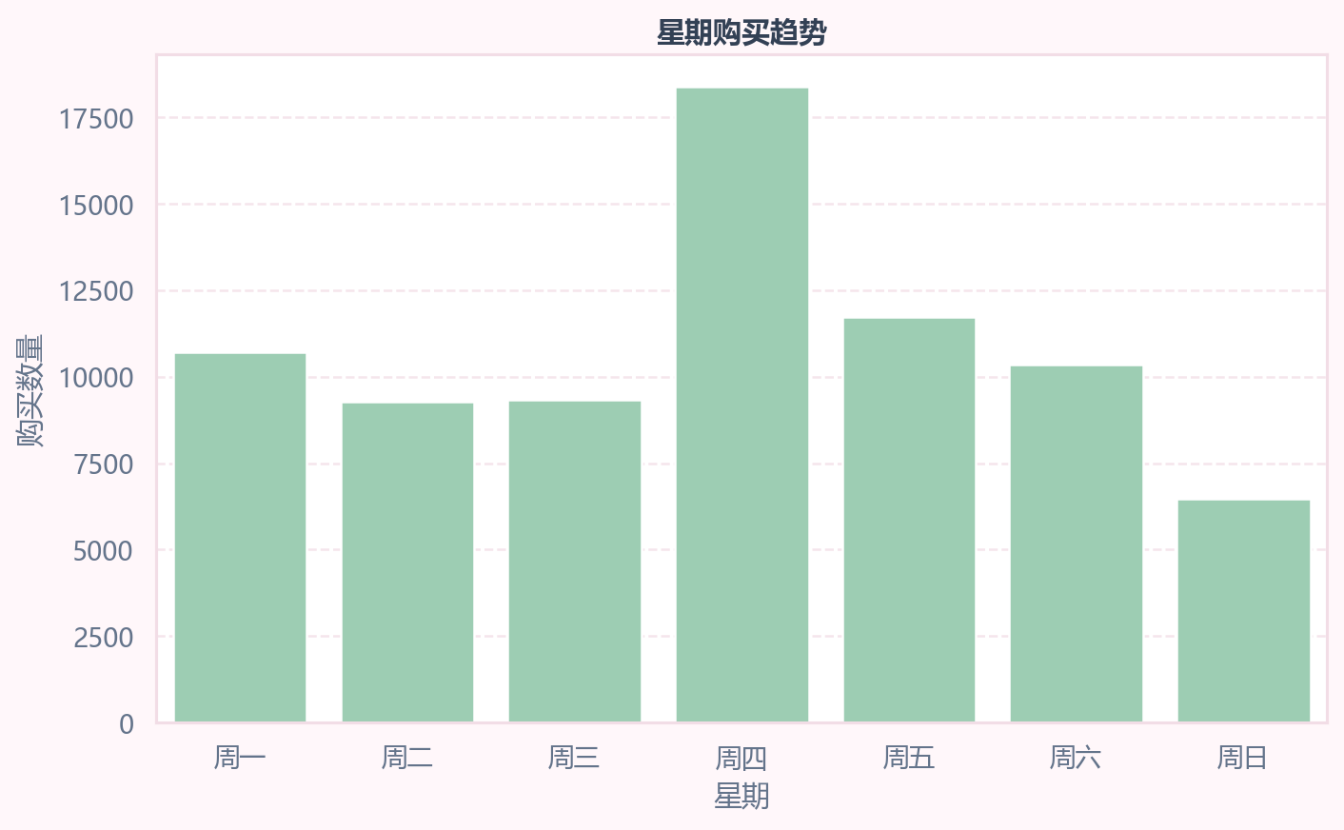
图 3 星期购买趋势图
dimension | group | trade_count | user_count | total_buy_mount
gender | female | 492 | 489 | 935.0
gender | male | 438 | 438 | 559.0
gender | unknown | 29041 | 29017 | 74756.0
baby_age_group | 0 | 240 | 240 | 339.0
baby_age_group | 1 | 254 | 254 | 515.0
baby_age_group | 2-3 | 244 | 244 | 377.0
baby_age_group | 4-6 | 138 | 138 | 179.0
baby_age_group | 7+ | 26 | 26 | 29.0
baby_age_group | unknown | 29069 | 29044 | 74811.0
表 4 用户画像消费统计
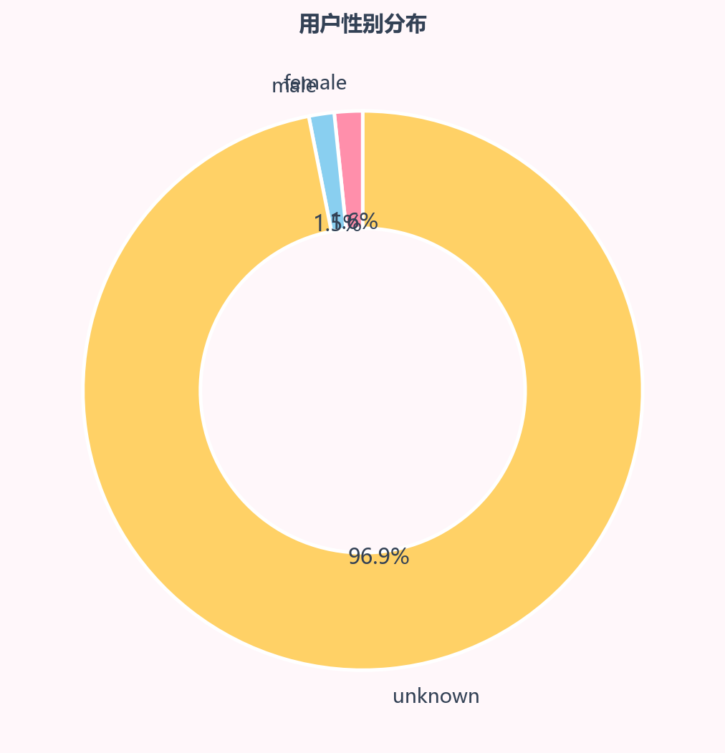
图 4 全量用户性别分布环形图
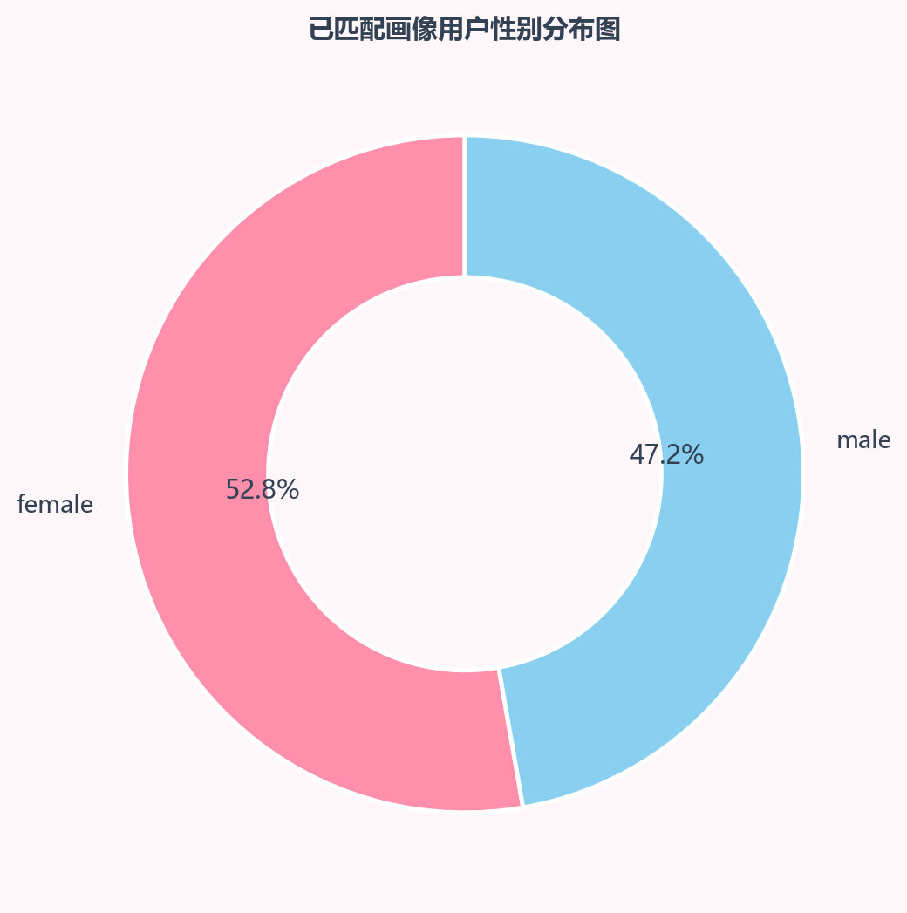
图 5 已匹配画像用户性别分布环形图
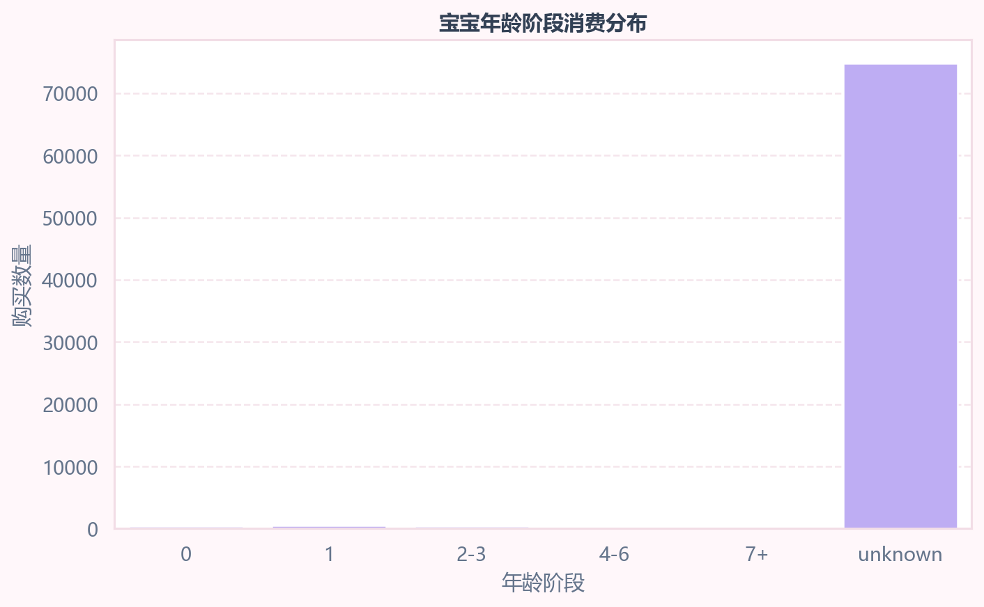
图 6 宝宝年龄阶段消费分布
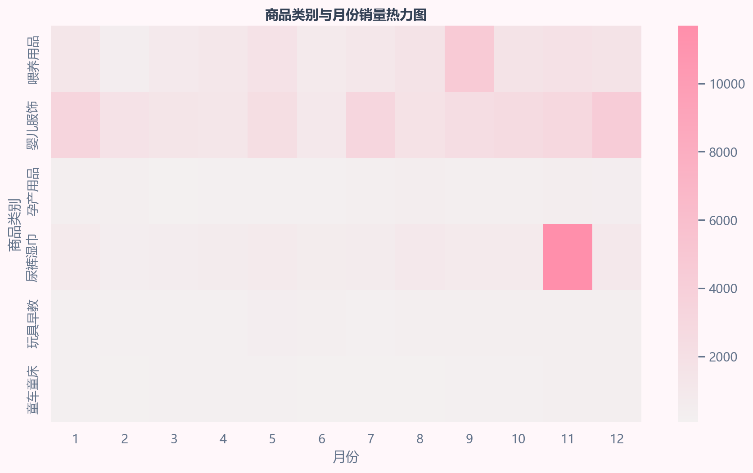
图 7 商品类别与月份销量热力图

图 8 母婴消费热点词云图

4. 建模分析

4.1 商品大类 cat1 预测模型
???? cat1 ?????????????????? cat_id?cat_id_encoded?cat_id_freq?property_freq?auction_id_freq?month?weekday?gender_encoded?baby_age?baby_age_group_encoded ?????????????????????????????????? cat1_name??????????
model | accuracy | precision_weighted | recall_weighted | f1_weighted
Logistic Regression | 0.3687 | 0.4123 | 0.3687 | 0.3652
Decision Tree | 0.9527 | 0.9578 | 0.9527 | 0.9540
Random Forest | 0.9385 | 0.9425 | 0.9385 | 0.9396
Gradient Boosting | 0.9724 | 0.9733 | 0.9724 | 0.9726
表 5 商品大类预测模型对比
feature | importance
cat_id | 0.3587
cat_id_encoded | 0.3454
cat_id_freq | 0.2701
property_freq | 0.0082
auction_id_freq | 0.0063
month | 0.0055
weekday | 0.0029
baby_age | 0.0012
baby_age_group_encoded | 0.0010
gender_encoded | 0.0007
表 6 随机森林特征重要性
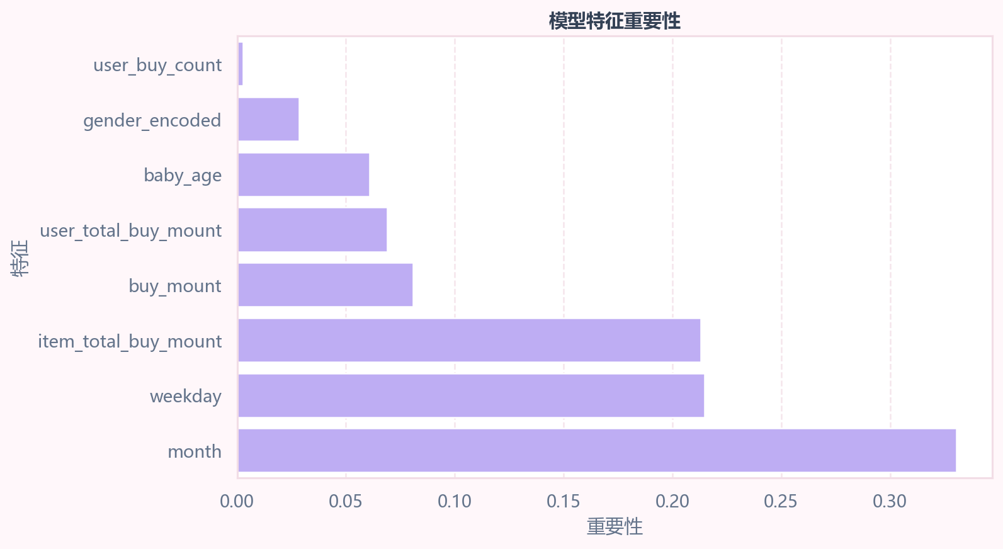
图 9 模型特征重要性图
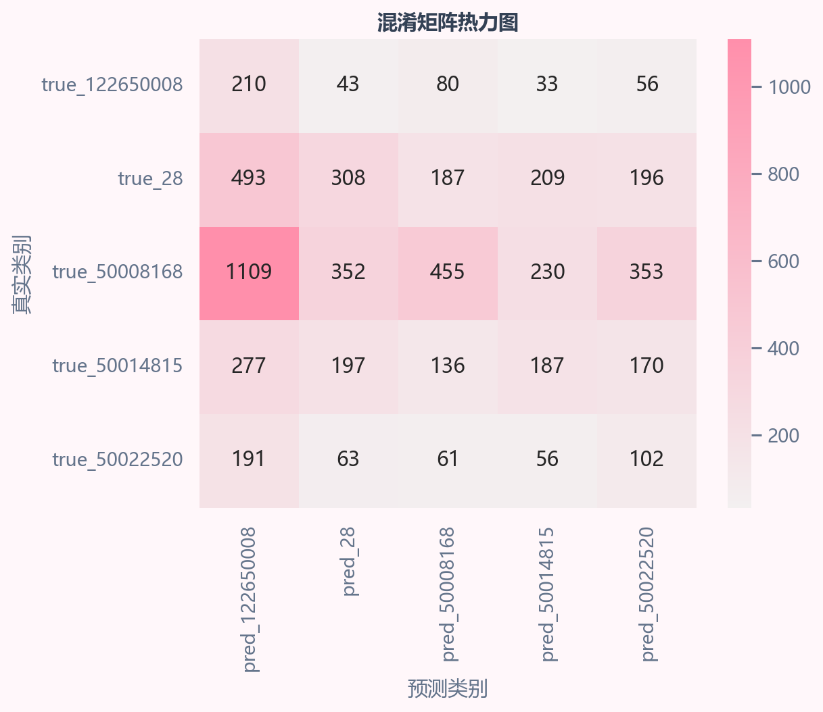
图 10 商品大类模型混淆矩阵

4.2 高购买量订单识别模型
high_buy ??? buy_mount ???? 75% ???????? buy_mount ?????????????????? buy_mount ?? user_total_buy_mount?item_total_buy_mount?cat_total_buy_mount ????????????????????????????????????????????
model | threshold_75_percentile | accuracy | precision | recall | f1 / auc
Decision Tree | 1.0 | 0.6696 | 0.1904 | 0.5967 | F1=0.2887; AUC=0.6802
Random Forest | 1.0 | 0.6863 | 0.1925 | 0.5607 | F1=0.2866; AUC=0.6791
Gradient Boosting | 1.0 | 0.8878 | 1.0000 | 0.0015 | F1=0.0030; AUC=0.6935
Logistic Regression | 1.0 | 0.8876 | 0.0000 | 0.0000 | F1=0.0000; AUC=0.5360
表 7 高购买量订单识别模型对比

5. Spark 大数据流程
???????? Python/Pandas/sklearn/ECharts ???? VMware ????? Java ? PySpark???? python mother_baby_insight.py --spark ? spark-submit mother_baby_insight.py --spark ?? SparkSession?Spark DataFrame ??????????user_id ???? Spark SQL ?????
??????????? Spark MLlib ????????Spark MLlib ???????????? StringIndexer?VectorAssembler ? RandomForestClassifier ?? cat1 ???????????? accuracy?weightedPrecision?weightedRecall?f1?

6. 可视化大屏与答辩展示
?????? outputs/html/dashboard.html?????MotherBabyInsight ?????????????????????? Tab??????? KPI???????????? TOP6???????????????????????????????????????????????????????????????????

7. VMware 复现流程
- sudo apt install -y openjdk-11-jdk python3-venv python3-pip fonts-noto-cjk
- python3 -m venv venv && source venv/bin/activate
- pip install -r requirements.txt
- python mother_baby_insight.py
???? Spark ????? Java/PySpark ????????python mother_baby_insight.py --spark ? spark-submit mother_baby_insight.py --spark?

8. 结论
????????????????????????????????????????????????? cat1 ??? Gradient Boosting?Accuracy=0.972?F1-score=0.973?Random Forest ????????????????????????????high_buy ?????????????????????????????????
????????????????????????? 29,971???????????? 29,672??????? 29,646??????? 28,141??????? 38,582????????? 3,337??????? 26,335??? 11.2%????????????? 31.7%????????????? 3.7 ??

