**POA Performance Scripts User Guide**

**-JMeter**

**Ojective:**To verify the performance of the POA application for the selected actions using JMeter.

**Approach:**To design the scenario based performance scripts with JMeter (web driver sampler)

**Steps to Install JMeter:**

**Tool Details:**Tool Name – JMeter  
Version - apache-jmeter-3.0

**Step 1) Install Java**

**Step 2) Download JMeter**

Download the JMeter software from below link <http://jmeter.apache.org/download_jmeter.cgi> (Choose the Binaries file (either zip or tgz) to download)

**Step 3) Installation**

Unzip the zip/tar file into the directory where you want JMeter to be installed

**JMeter directories:**

/bin: Contains Jmeter bat file and log file

/docs: JMeter documentation files

/extras: ant related extra files

/lib/: Contains the required Java library for JMeter

/lib/ext: contains the core jar files for JMeter and the protocols

/lib/junit: JUnit library used for JMeter

/printable_docs:

**Step 4) Launch JMeter**

Start JMeter in GUI Mode, run the bat file /bin/jmeter.bat to start JMeter in GUI mode as shown below:

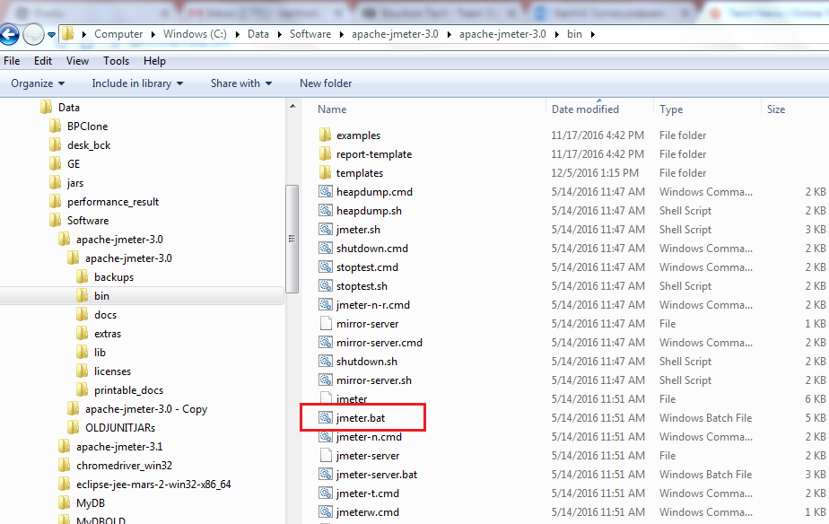

**Adding Library Files:**

Procedure to install webdriver sampler plugins into JMeter:

1)Download the plugin from below link and extract the zip file:  
                <https://jmeter-plugins.org/?search=jpgc-webdriver>

             Download Versions: [1.4.0](https://jmeter-plugins.org/files/packages/jpgc-webdriver-1.4.0.zip)

2)Open the extracted folder and copy all the jar files which is under the lib folder except ext folder files.

3)Go to the jmeter installation folder and paste the copied jars into lib folder(ex: C:\Data\Software\apache-jmeter-3.0\apache-jmeter-3.0\lib)

4)Go back to extracted folder and copy all the jar files which is under the ext folder

5)Go to the JMeter installation folder and paste the copied jars into ext folder (ex: C:\Data\Software\apache-jmeter-3.0\apache-jmeter-3.0\lib\ext)

6)Restart the JMeter

Please provide the proper path of chromedriver.exe, as below.

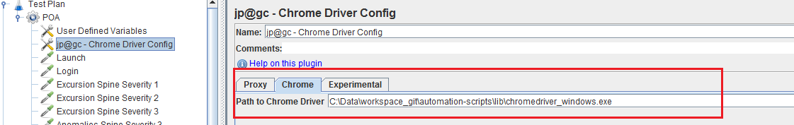

**JMeter Application:**

1. To create the Thread Group:

Right click on the test plan and create thread group: Eg: POA

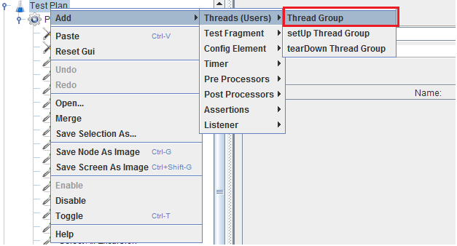

1. To Create User Defined Variables

Right click on the thread group and create User Defined Variables:  
eg: Locators path and its name

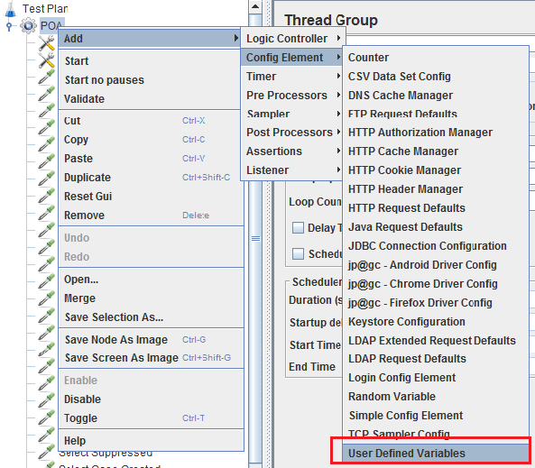

1. To create the Chrome browser driver config

Right click on the thread group and create Chrome driver config:

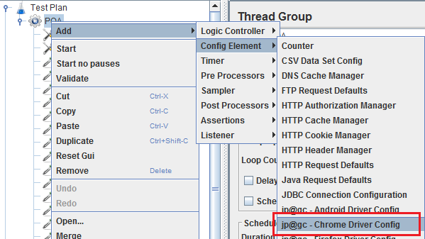

1. To create the Web Driver Sampler

Right click on the thread group and create WDS:  
Note: Here we need to write all our sampler scripts.  
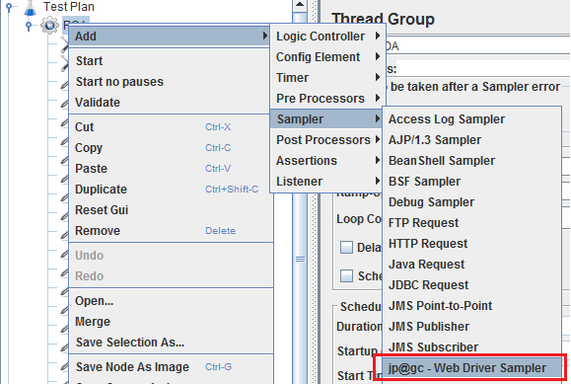

1. To View the different types of results:

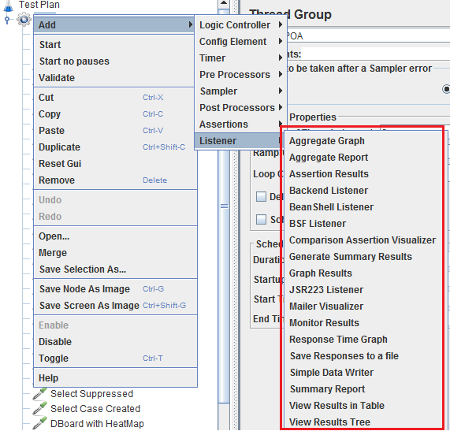

1. Jmeter Layout

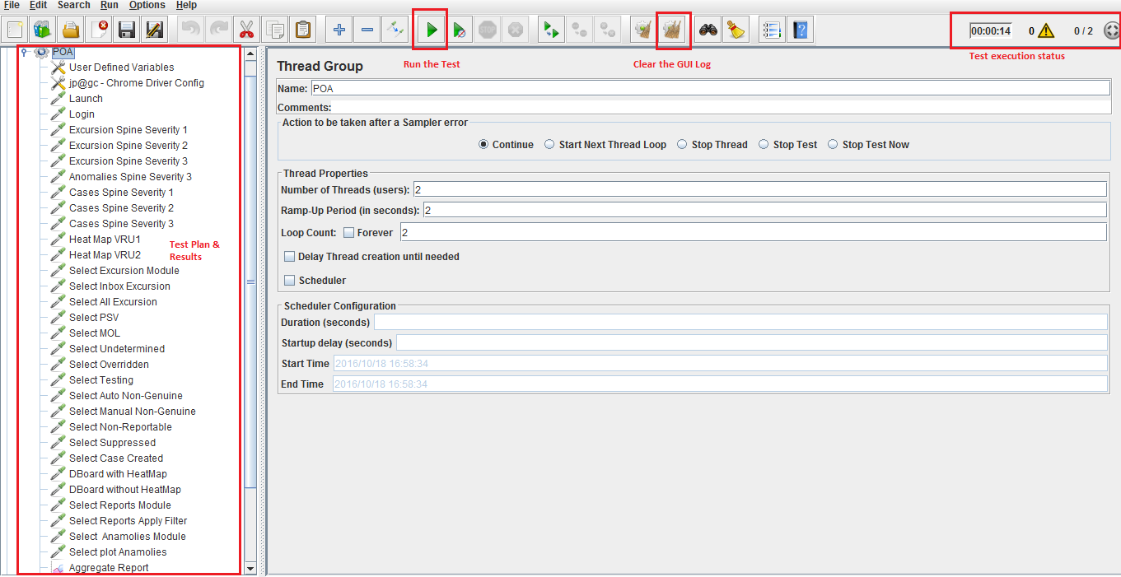

1. Results:

We can view the result in different format:

Eg: Aggregate Report

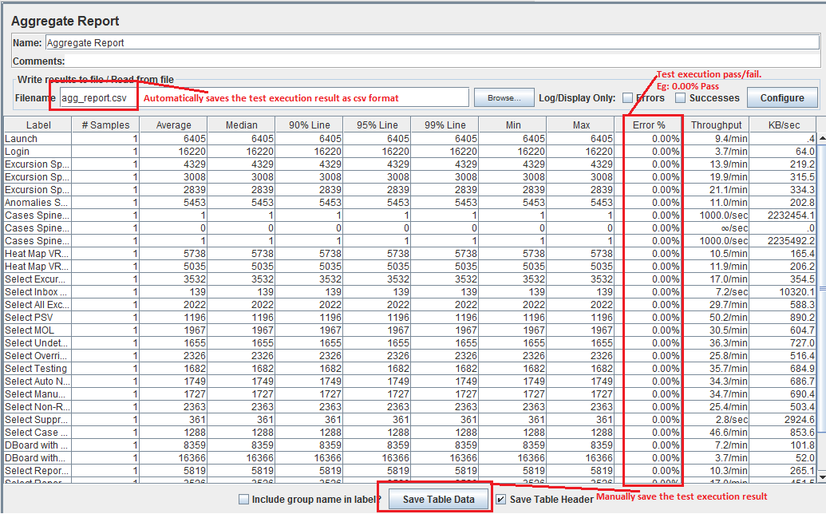

Agg_report.csv  
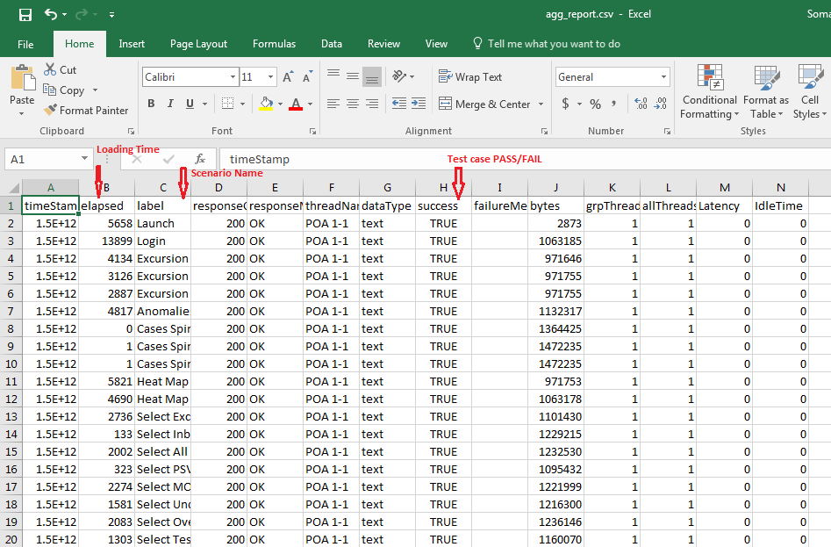

1. To load the existing script:  
   