**Date of submission:17th Oct 2014**

1. Write a program using an array that inputs exam marks for 50 students. Calculate and display the average mark, the best mark and the worst mark.
2. Write a program to search for a key element in an array using sequential (Linear search). The linear search compares each element of the array with the search key.

Sample output

|  |
| --- |
| Enter integer search key: 45 |
| This value is found in element 10 |

|  |
| --- |
| Enter integer search key: 45 |
| Value not found. |

1. Input any 20 numbers each of which between 10 and 100, inclusive. As each number is read, print it out if it is not a duplicate of a number already read. Use single subscripted array to solve the problem. 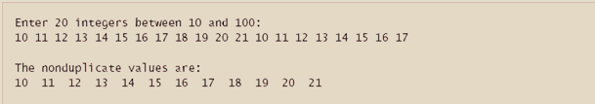

1. Write a menu driven program to sort a 10-element array in descending or ascending order and display the sorted array.
2. Write a program which would accept data into a 5 * 5 integer array and prints out the number of odd numbers, even numbers, the maximum and the minimum number and the sum of each row and column.
3. Write a menu driven program to find the sum, multiplication and transpose of two matrices.
4. Computerize the examination procedure of a class which has 60 students who have appeared for an exam in 6 subjects. Display a rank wise report which contains the total mark and percentage obtained in addition to the register number and marks in six subjects.