ConfigMaps

A ConfigMap is an API object used to store non-confidential data in key-value pairs.

Pods can consume ConfigMaps as

environment variables,

command-line arguments,

or as configuration files in a volume.

A ConfigMap allows you to decouple environment-specific configuration from your container images, so that your applications are easily portable.

Most Kubernetes objects that have a ***spec***,

a ConfigMap has data and binaryData fields.

These fields accept key-value pairs as their values

The **data** field is designed to contain UTF-8 byte sequences while the

**binaryData** field is designed to contain binary data as base64-encoded strings.

A ConfigMap is a dictionary of configuration settings. This dictionary consists of key-value pairs of strings. Kubernetes provides these values to your containers.

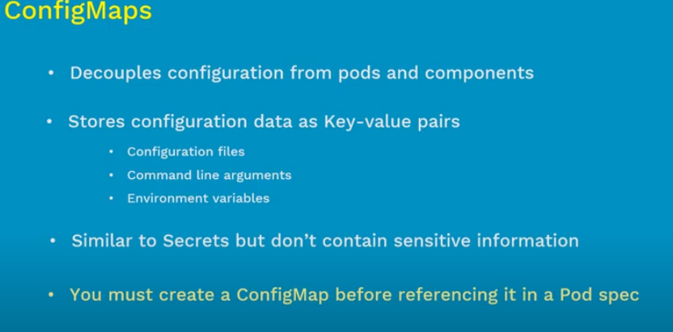

**What is a ConfigMap used for?**

A ConfigMap stores configuration settings for your code. Store connection strings, public credentials, hostnames, and URLs in your ConfigMap.

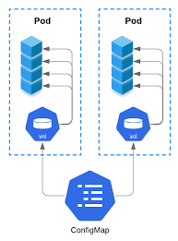

Vim configmap.yaml

apiVersion: v1

kind: ConfigMap

metadata:

name: configmap-names

data:

myname: saikiran

myarea: madhapur

organistaion: |

employees: ctel

employee1: ashish

employee2: saiteja

employee3: saikiran

managers: |

manager1: ravi.s

manager2: shiva

manager3: sunil

-------

vim config-pod.yaml

apiVersion: v1

kind: Pod

metadata:

name: configmap-pod

spec:

containers:

- name: configmap-container

image: alpine

command: ["sleep", "3600"]

env:

# Define the environment variable

- name: myarea

valueFrom:

configMapKeyRef:

name: configmap-names # The ConfigMap this value comes from.

key: myarea # The key to fetch.

- name: myname

valueFrom:

configMapKeyRef:

name: configmap-names

key: myname

volumeMounts:

- name: config-mounts

mountPath: "/config"

readOnly: true

volumes:

- name: config-vol

configMap:

# Provide the name of the ConfigMap you want to mount.

name: names

# An array of keys from the ConfigMap to create as files

items:

- key: "organistaion"

path: "organistaion"

- key: "managers"

path: "managers"