Here we bulid our own image using docker compose nd deployed in pod

We need sql database for storing values

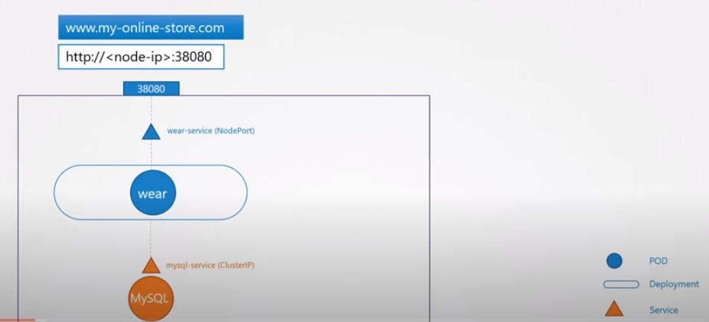

When traffic is increased , we will scale up replicas 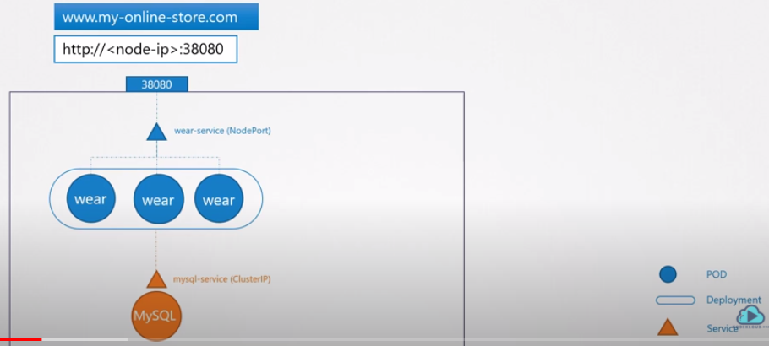

While our customers are no need to type node ip address for long you can go for domain name {DNS}

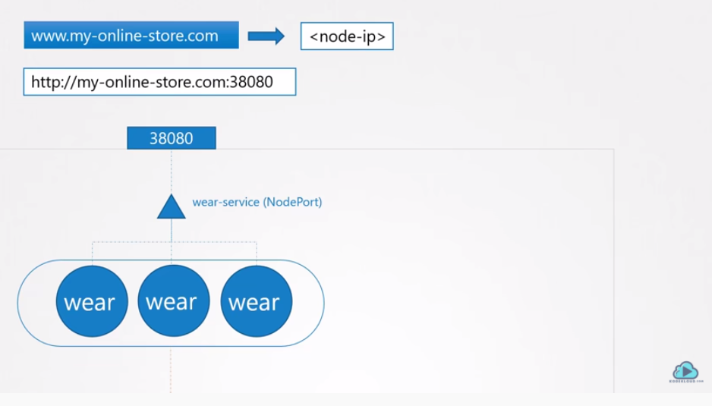

While our customers are no need to type port address 38080 for long you can go for proxy server

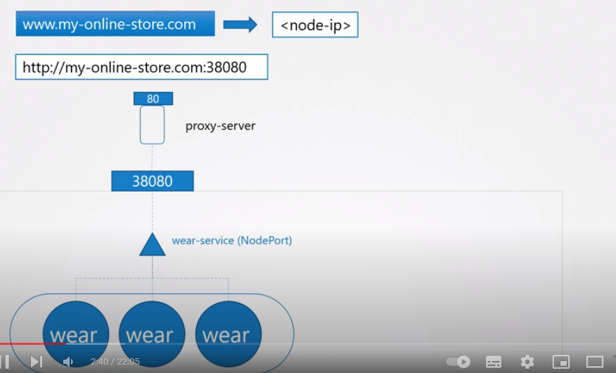

Till now we done in onpremiss , now we going to cloud platform GCP **, Then we take TYPE AS LB**

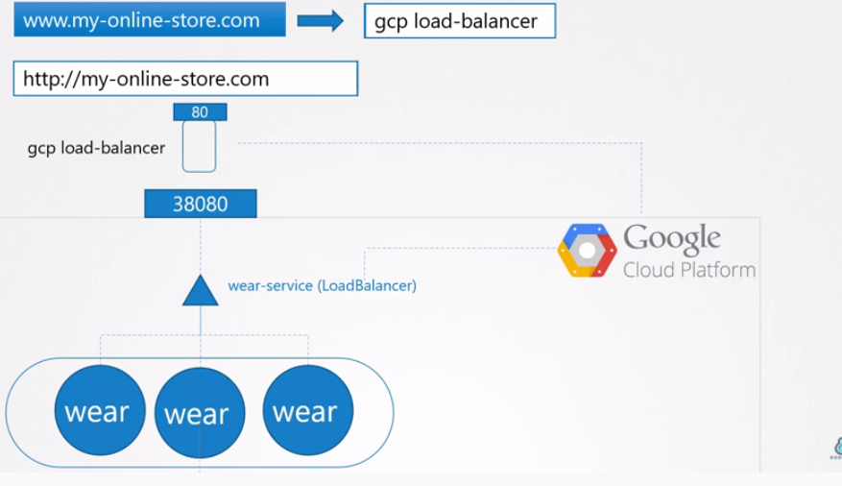

GCP provides the LB Ip idrress , then we need to attach to DNS

So now we need to add another service to app called watch



As we increasing the services we need to create new balancers and re –configure LB file

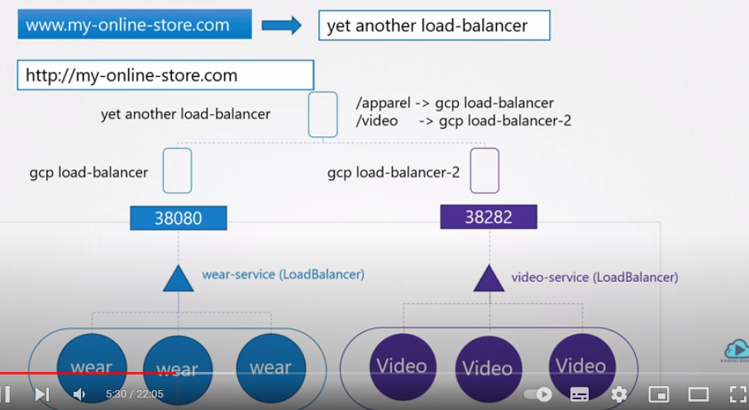

We need to do open ssl ports || we need to change http to https , it will took time to while developing all the things , here comes the **INGRESS**

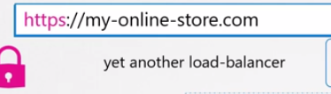

We is the solution , by default it will not come , we need to create it .

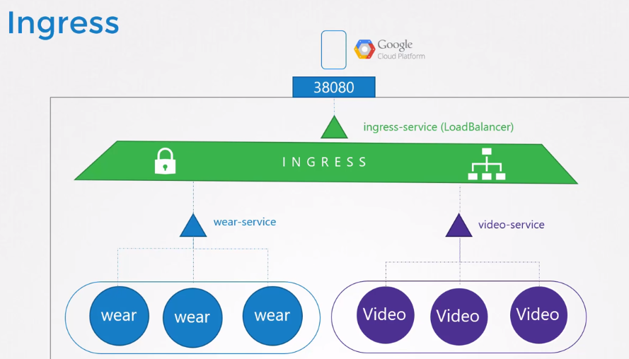

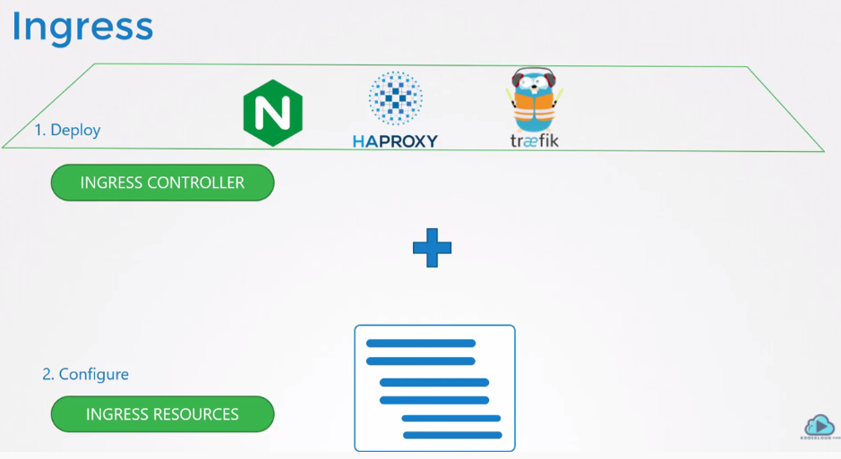

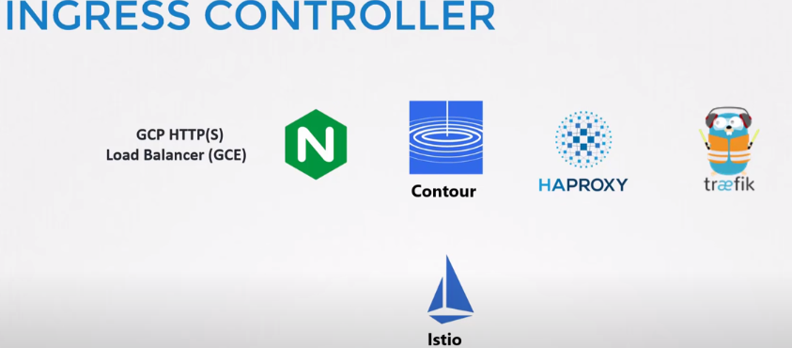

Ingress controller examples are above figure …

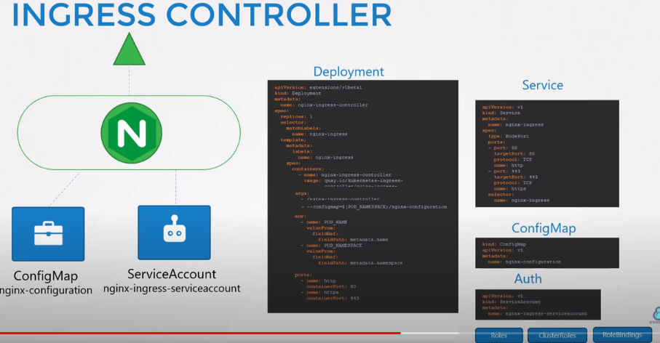

Deplyment .yaml

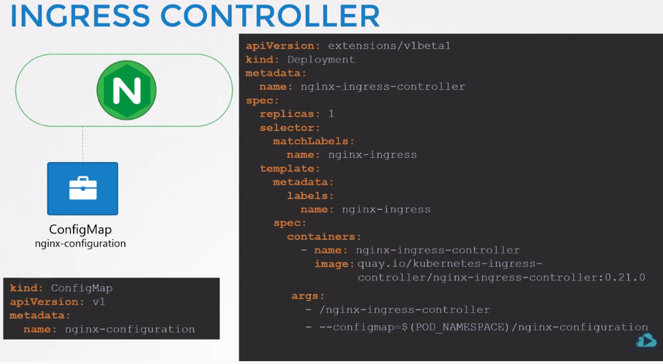

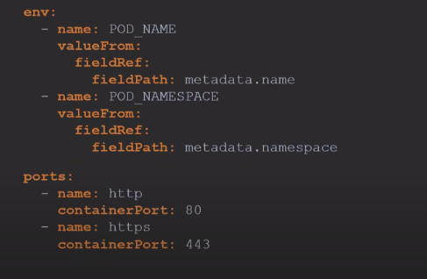

Service file

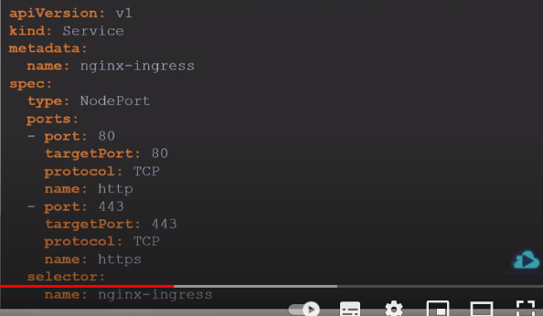

SRVICE ACC For Permissions

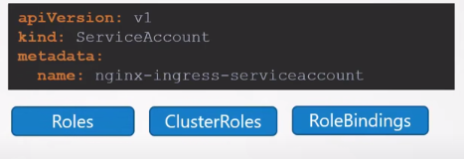

WE have several options on ingress resources

Rule !

Direct to application

Rule !!

Direct to services

Rule !!!

Directly to paths

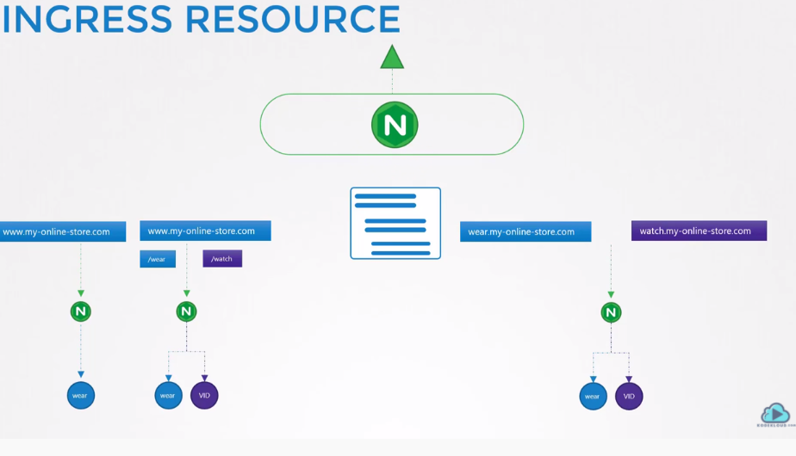

EX: off two urls to path

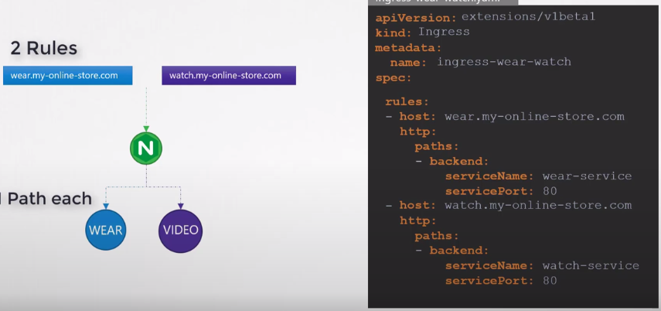

Rules of Ingress REsouces

