**ZABBIX**

Zabbix is an enterprise-class open source distributed monitoring solution.

Zabbix is software that monitors numerous parameters of a network and the health and integrity of servers, virtual machines,

applications, services, databases, websites, the cloud and more.

Zabbix uses a flexible notification mechanism that allows users to configure e-mail based alerts for virtually any event.

Zabbix has the major software components to monitor:

1. Server

2. Agent

3. proxy

4. Database

4. Web Service

It is comprissed in to three components:

1. Zabbix Server

2. Web Frontend

3. Database Storage

The Server is the central repository which stores all the configs, statistics and operational data.The zabbix Server is a central component which performs polling trapping of data, and it calculates triggers and notifications to the users, zabbix agents and proxies reports data to zabbix server on availability and intergrity of systems.

The zabbix Agent is installed on monitoring server to monitor the local resources and applications (hard drives, memory, processor statistics etc).

Zabbix agent is very efficient because it uses native system calls for gathering info, This Agent Gathers the info from local system and reports to Zabbix Server and then zabbix server notifices users.

zabbix Agents checks in two ways:

**1.Passive checks:**

Passive checks means Zabbix server asks the data to agent and agent sends back the data for requested.

**2. Active checks:**

Active checks means zabbix servers sents a list of processes for monitoring to agent and agents checks the processes one by one and sends the new values to server.

**Zabbix Proxy:**

Zabbix Proxy is the component that collects the monitoring data from one or more monitoring devices and sends to the Zabbix server. Proxy collects the data and buffers the data locally and then transfers it to the Zabbix Server.

A Zabbix proxy is the ideal solution for centralized monitoring of remote locations, branches and networks with no local administrators.

Deploying Proxy is optional, but it will be beneficial as proxy distributes the load on Zabbix server as it process the data it will help for less cpu usage and disk i/o on the server

**Zabbix Sender:**

Zabbix sender is a command line utility that may be used to send performance data to Zabbix server for processing.

The utility is usually used in long running user scripts for periodical sending of availability and performance data.

**Zabbix Get:**

Zabbix get is a command line utility which can be used to communicate with Zabbix agent and retrieve required information from the agent. The utility is usually used for the troubleshooting of Zabbix agents.

**Zabbix web service:**

Zabbix web service is a process that is used for communication with external web services. Currently, Zabbix web service is used for generating and sending scheduled reports with plans to add additional functionality in the future. Zabbix server connects to the web service via HTTP(S). Zabbix web service requires Google Chrome to be installed on the same host on some distributions the service may also work with Chromium

**INSTALLATION OF ZABBIX SERVER**

sudo apt update

sudo apt install apache2 libapache2-mod-php

sudo apt install mysql-server

sudo apt install php php-mbstring php-gd php-xml php-bcmath php-ldap php-mysql

sudo mysql_secure_installation

vim /etc/php/7.4/apache2/php.ini, edit the below confs:

memory_limit 256M

upload_max_filesize 16M

post_max_size 16M

max_execution_time 300

max_input_time 300

max_input_vars 10000

date.timezone = 'Asia/Kolkata'

wget <https://repo.zabbix.com/zabbix/5.0/ubuntu/pool/main/z/zabbix-release/zabbix-release_5.0>1+focal_all.deb

sudo dpkg -i zabbix-release_5.0-1+focal_all.deb

sudo apt update

sudo apt install zabbix-server-mysql zabbix-frontend-php zabbix-agent zabbix-apache-conf

systemctl start mysql

systemctl status mysql

mysql -u root -p

create database zabbix character set utf8 collate utf8_bin;

create user 'zabbix' identified by 'Ctel@123';

grant all privileges on zabbix.* to 'zabbix';

FLUSH PRIVILEGES;

cd /usr/share/doc/zabbix-server-mysql

zcat create.sql.gz | mysql -u zabbixctel -p zabbix

sudo vi /etc/zabbix/zabbix_server.conf

DBHost=localhost

DBName=<Database name created in mysql>

DBUser=<user created in mysql user>

DBPassword=<password given for db user>

sudo systemctl enable zabbix-server

sudo systemctl restart zabbix-server

sudo systemctl restart apache2

ufw allow 80/tcp

ufw allow 10050/tcp

ufw allow 10051/tcp

sudo firewall-cmd --reload

http://localhost/zabbix

If everything is OK, we will get

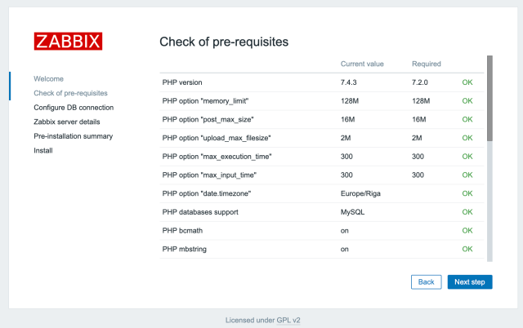

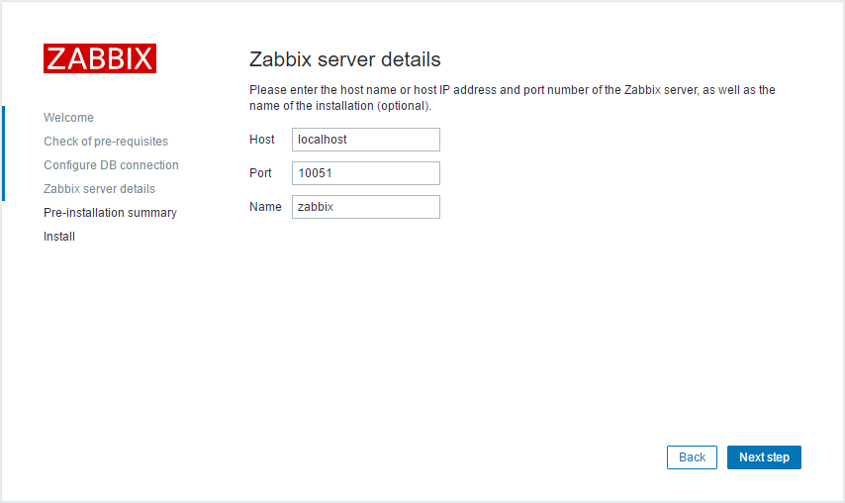

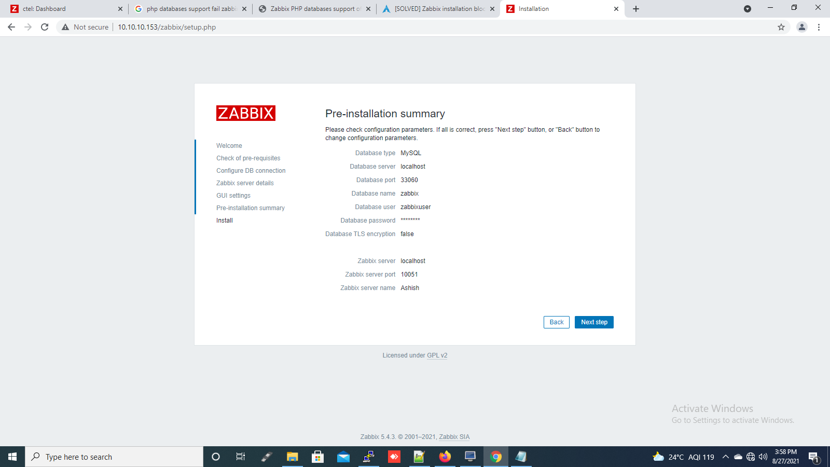

**CONFIGURING ZABBIX AGENT**

Wget http://repo.zabbix.com/zabbix/3.4/ubuntu/pool/main/z/zabbix-release/zabbix-release_3.4-1+xenial_all.deb

sudo dpkg -i zabbix*all.deb

sudo apt-get update

sudo apt-get install zabbix-agent

sudo sh -c "openssl rand -hex 32 > /etc/zabbix/zabbix_agentd.psk"

cat /etc/zabbix/zabbix_agentd.psk

You'll need to copy that key, as it'll be pasted into the web-based GUI later.

TLSKEYFILE key: b69f7d2ff9756728ed56bfd531fc6412313761afca9a6c8598597d6738ded984 //copy this key and save

sudo nano /etc/zabbix/zabbix_agentd.conf

The first setting to change is:

Server=127.0.0.1 Change that to:

**Server=IP of the server** // IP address of the Zabbix Monitor server.

Scroll down until you see the TLSConnect section. At the bottom of that section, add the following:

**TLSConnect=psk**

Next locate the TLSAccept section and add the following to the bottom:

#TLSAccept=encrypted change that to: **TLSAccept=psk**

Now locate the TLSPSKIdentity section and add the following to the bottom:

**TLSPSKIdentity=PSK 001**

Finally, locate the TLSPSKFile section and add the following to the bottom:

**TLSPSKFile=/etc/zabbix/zabbix_agentd.psk**

Save and close that file. Restart and enable the Zabbix agent with the commands:

systemctl start zabbix-agent

systemctl enable zabbix-agent

systemctl restart zabbix-agent.service

systemctl status zabbix-agent.service

**CONFIGURING NOTIFICATIONS**

**Administration** >> **Media Types >> select Email**

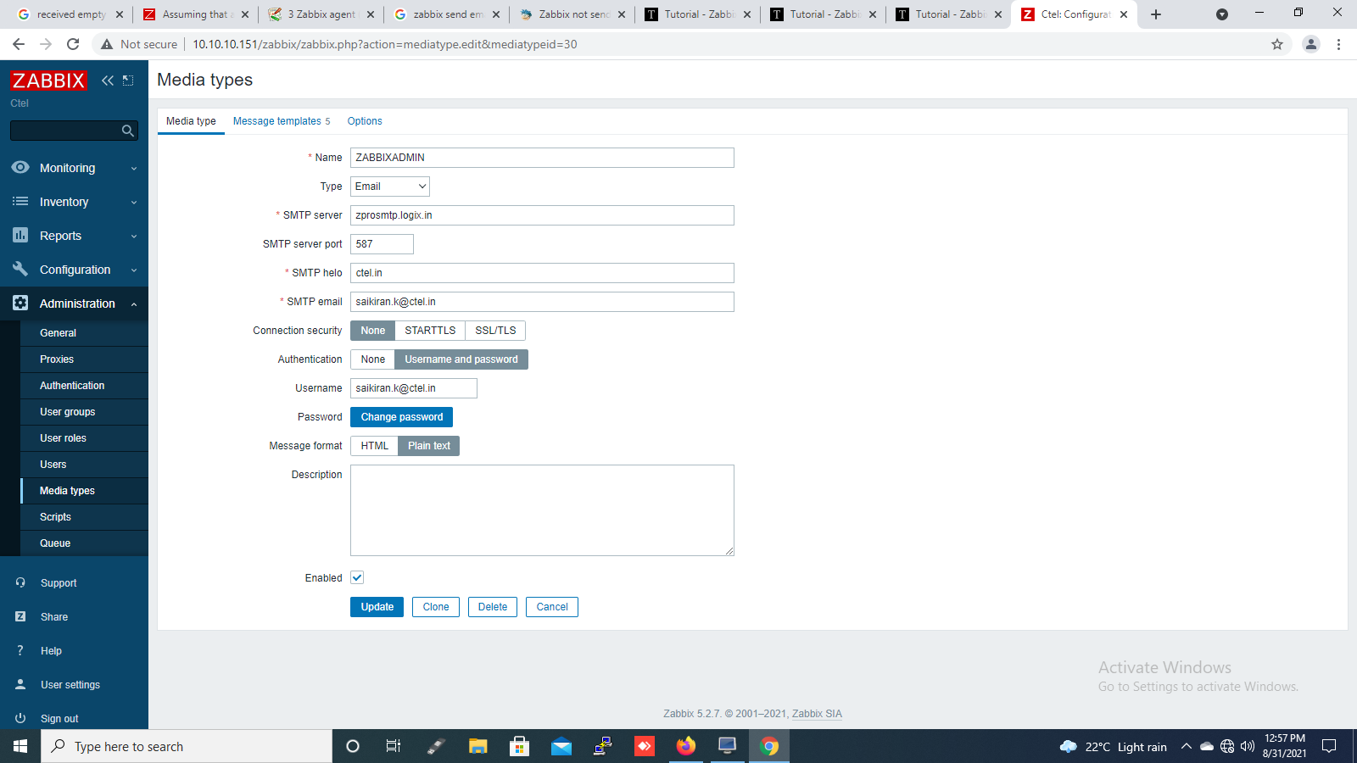

To verify the mail, test the mail by sending the basic mail.

