Swetha Kambhampati – 25MML0008
Edge Intelligence Lab Task

Task: Number plate detection using CNN

- Used Kaggle dataset - containing images of number plates along with pixel values of the license plate as shown below:

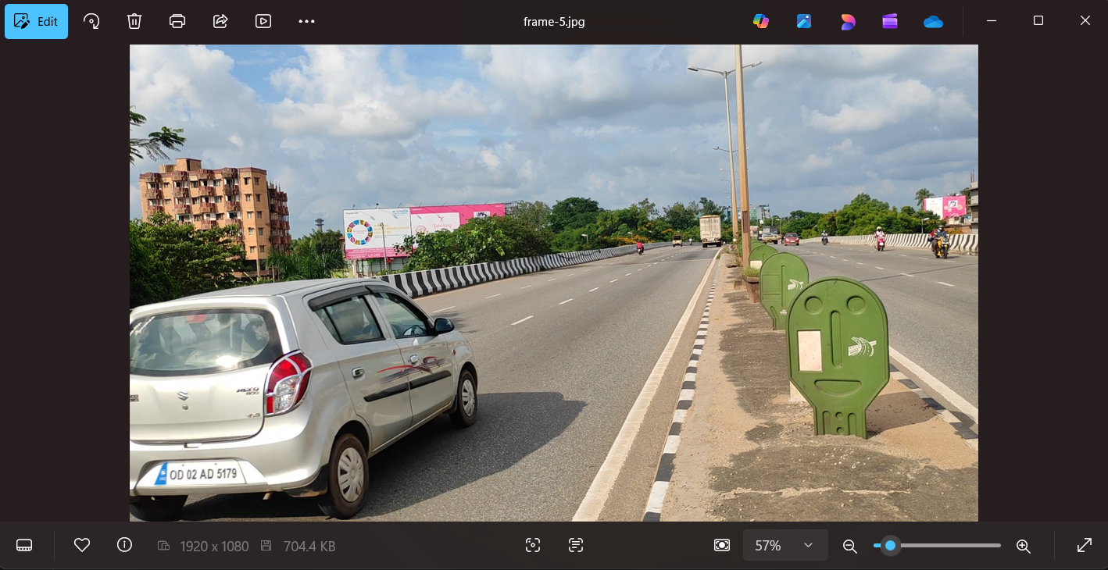

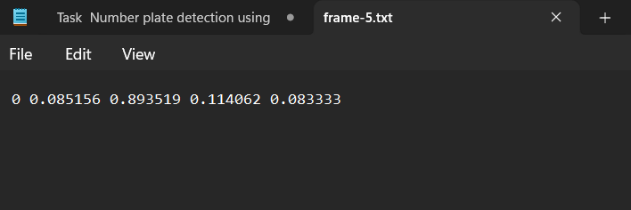
- Trained CNN – YOLO model in order to find a bounding box around image.
- YOLO model internally resizes every image to 640*640 and tries to recognise where the license plate is located in the image and creates a bounding box along with confidence level as shown below
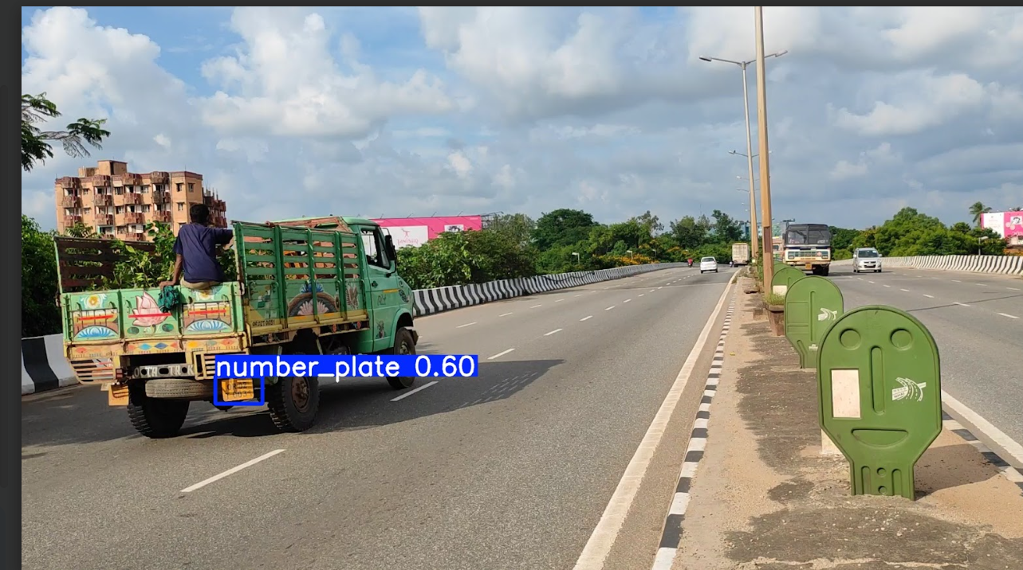

- Now our CNN model is trained, we move on to OCR.
- The idea is that we crop our image around the bounding box and then apply OCR to read the text from image – tried multiple codes – converting image to grey-scale and then reading , tried dictionary based approach to assign state codes but OCR doesn’t seem to work well.

