EDGE INTELLIGENCE LAB – 1

SWETHA K
25MML0008

ERRORS:
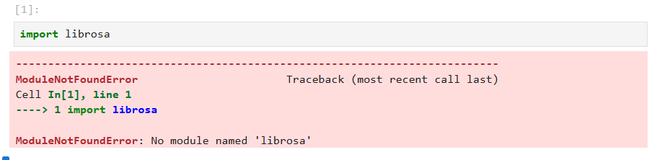

Module librosa was not installed on jupyter – !pip install librosa to resolve the error

